STUDY OF KARST DEVELOPMENT AND POSSIBLE
LEAKAGE FROM THE SAZBON DAM, IRAN

Raeisi, E., Aghdam, J., Zare, M, and Karimi, H.

Department of Geological Science, Shiraz University, Shiraz, Iran

Abstract: The Sazbon Dam site is located on Seymareh River in the upper parts of Karkheh Basin, Ilam province, west of Iran. The dam will be constructed on karstified Asmari Formation and part of the reservoir will be in direct contact with this formation. The Asmari Formation is sandwiched between the two impermeable marly formations of Pabdeh-Gurpi and Gachsaran. In 18 piezometers constructed for this purpose, the water level was measured daily during the wet season and once per week in the dry season for a period of 10 months. The major ions, electrical conductivity and temperature were measured six times in all the piezometers, springs and six locations within the Seymareh River. Based on the water level in piezometers, the direction of flow is determined to be from the dam abutments towards the Seymareh River. The piezometers were classified based on the geochemistry and permeability. Ten kilograms of uranine were injected in a 200 meter deep borehole in the right abutment and inside the reservoir. This borehole, constructed in the Upper Asmari Formation, had very high permeability. All the piezometers, springs and the six locations of Seymareh River were sampled for five months. The dye concentration was measured by a Schimadzo Spectrofluorometer. Dye was detected in four boreholes on the left abutment, two of them downstream the dam site. The dye tracing revealed that the water flows against the dip of the Lower and Upper Asmari Formations. The dye velocity was in the range indicative of a diffuse regime. Two alternative schematic models of flow direction and karst development were proposed based on the dye tracing results. One of the models was selected as the most probable alternative based on dye tracing, water table level, electrical conductivity, permeability, and geological setting. The karst aquifer in the Sazbon Dam area may still have a conduit system in spite of the dye tracing results. The low gradient of ground water level, valley development by Seymareh River, high permeability of boreholes, lack of specific discharge points, limited information from only one dye tracing, combination of diffuse and conduit flow in the flow route, and characteristics of the Asmari Formation in other regions of Zagros are collective evidences of possible conduit flow in the Sazbon Dam site.

Introduction
Leakage from dam reservoirs in karst terrains has been reported for many dams all over the world. The prerequisite to a safe and reliable dam reservoir is the proper understanding of the aquifer characteristics and the karst conduit system. The Sazbon Dam will be constructed in the west of Iran, with a height of 152 m and a reservoir capacity of 1.6 billion cubic meters. The reservoir will extensively be in direct contact with the karstic Asmari Formation. The objective of this study is to determine the flow regime(s) (diffuse and/or conduit) and to present a schematic model for flow direction in the karstic formation of Sazbon Dam, using sodium fluorescein dye tracer.

Hydrogeology of the Study Area
The study area, the Lina Anticline, is located in the Zagros Simply Folded Zone, Ilam Province, west of Iran. The exposed core of the Lina Anticline in decreasing order of age is made of Tertiary Pabdeh-Gurpi (marl and shale), Tertiary Asmari Formation (karstified limestone), Tertiary Gachsaran Formation (gypsum and marl) and Pliocene Conglomerate (Fig. 1). The Asmari Formation is divided into the Lower and Upper Asmari (Mohab Ghods, 1996). The more extensive surface karst features and massive thickness of the Upper Asmari imply that it is more capable of karst development than the Lower Asmari. The Seymareh River flows on the surface of the Gachsaran Formation, and through a narrow valley in the Asmari Formation (Fig. 1). The Sazbon Dam will be constructed on the Lower Asmari Formation of the northern flank of Lina Anticline. The reservoir water will extensively be in direct contact with the Asmari Formation and may thus leak via the possibly existing small conduits in the Asmai Formation, and consequently to the downstream sections of the Seymareh River.

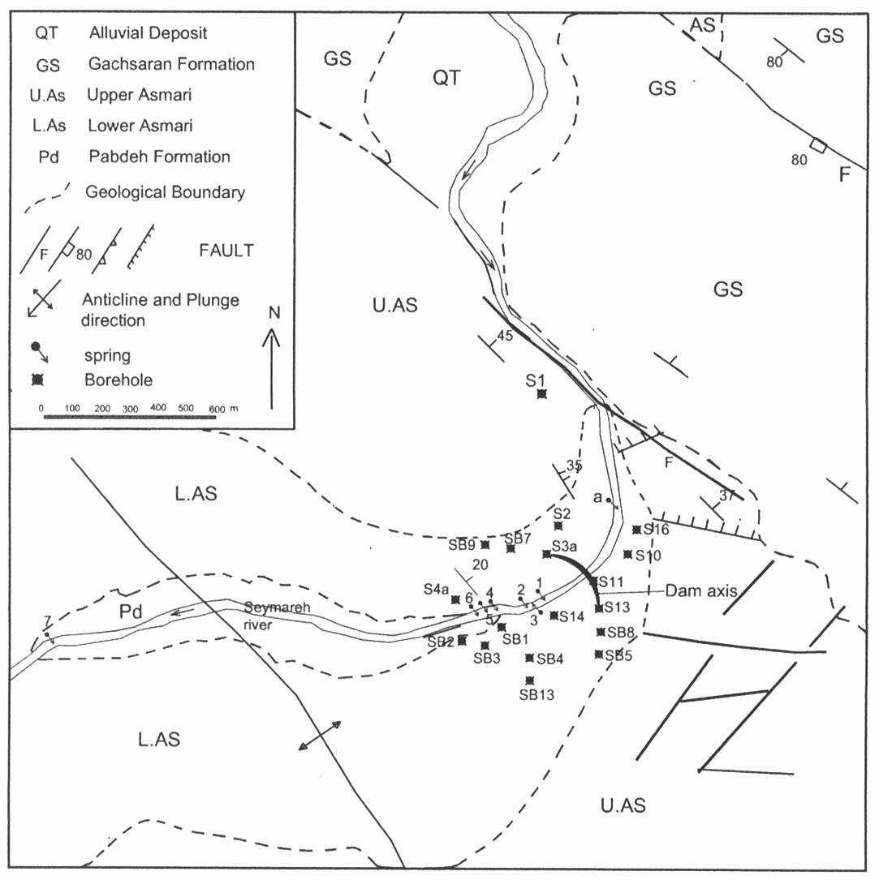

Figure 1. Geological map of the study area

Method of Study
The major ions, electrical conductivity (EC) and temperature were measured six times in all piezometers, springs and six locations within the Seymareh River. The water level in 28 piezometers was measured daily during the wet season and once per week in the dry season for ten months. An injection borehole (S₁), with a depth of 200 m, was constructed inside the reservoir on the Upper Asmari (Fig. 1). The depth to water table was about 120 m in this borehole. The permeability of S₁ was more than 100 lugeon in most parts. Ten kilograms of sodium fluorescein were injected into the S₁ borehole. Injection of water into the borehole at a rate of 1 l/s was continued for 20 days in order to push the dye into the conduit system. Water samples were collected from 14 boreholes, 7 springs, and 7 sections of the Seymareh River (Fig. 1) for a period of five months. Bags of activated charcoal were placed in all the resurgences. The sodium fluorescein concentration was measured in all water samples by a Schimadzu spectroflurometer (model RF 5000) with a detection limit of 0.001 ppb.

Result and Discussion
The water level in the piezometers shows that the flow direction in the dam site is towards the river with a hydraulic gradient of 0.001 (Fig. 2). EC increases towards the river, but the EC of the river itself is lower than the EC of the boreholes near the river, implying that river-water does not flow into the adjacent aquifer. Based on the dominant permeability, the boreholes are classified to three groups (Fig. 3), A (50 to 100 Lugeon), B (10 to 50 lugeon), and C (less than 10 Lugeon). Group C includes only SB₃ and Group B includes SB₁ and SB₉. SB₃ and SB₁ are located in the Pabdeh-Gurpi Formations and SB₉ far from the river. The high permeability of most of the boreholes is indicative of possible karst developments in the damsite. The Seymareh River discharge is more than 150 m³/s in the wet season, which decreases to 50 m³/s in the dry season. No dye was detected in any of the sampling sites except for the S_{10,} S₁₃, S₁₁ and SB₅ boreholes. These boreholes are located in the left side of the Seymareh River (Fig. 1). The dye concentration curves of the boreholes are presented in Figure 4. The maximum dye concentration was 0.529 ppb in borehole S₁₀.

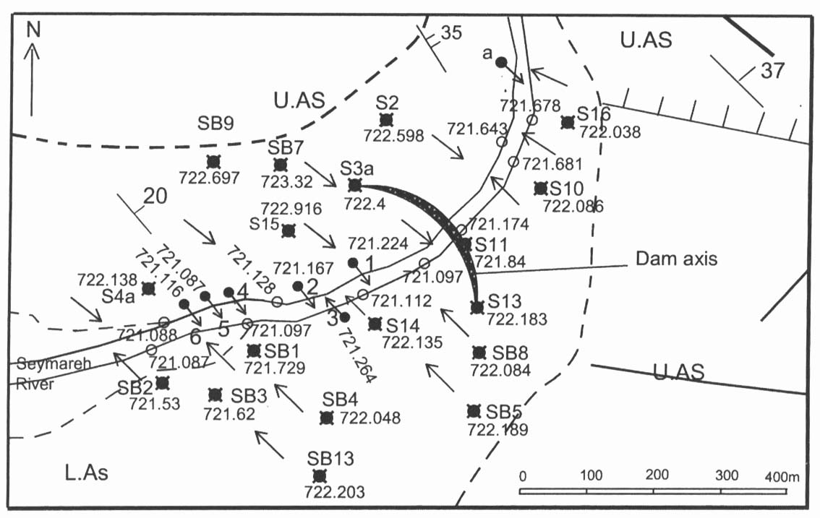

Figure 2. Piezometer’s water level above mean sea level and flow direction in the study area (Aug. 24. 2004)

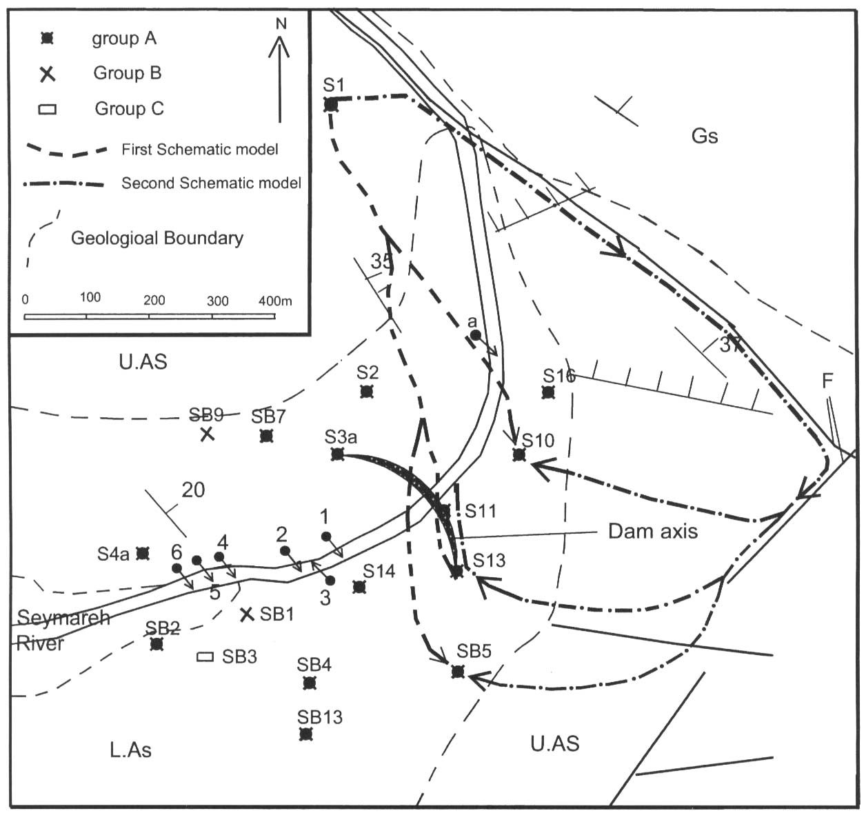

Figure 3. Schematic model of flow direction and classification of boreholes in the study area
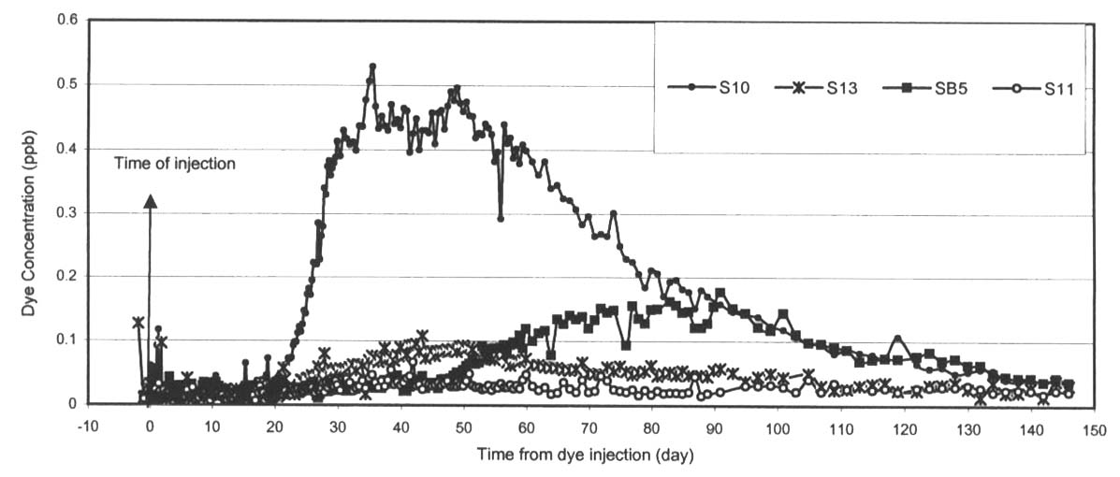
Figure 4. Dye concentration versus time in the S_{10,} S₁₃, S₁₁ and SB₅ boreholes

The dye was injected in the right side of the Seymareh River, but it was detected in the left side, so it must be flowing below the Seymareh River. Two alternative models of flow direction are proposed (Fig 3). In model A, water from the injected borehole flows from the Upper Asmari to the Lower Asmari in the left side of Seymareh River (Fig 5). Part of the water joins the Seymareh River and a part flows below the Seymareh River towards the right side of the river, being detected in the S_{10,} S₁₃, S₁₁, and SB₅ boreholes.

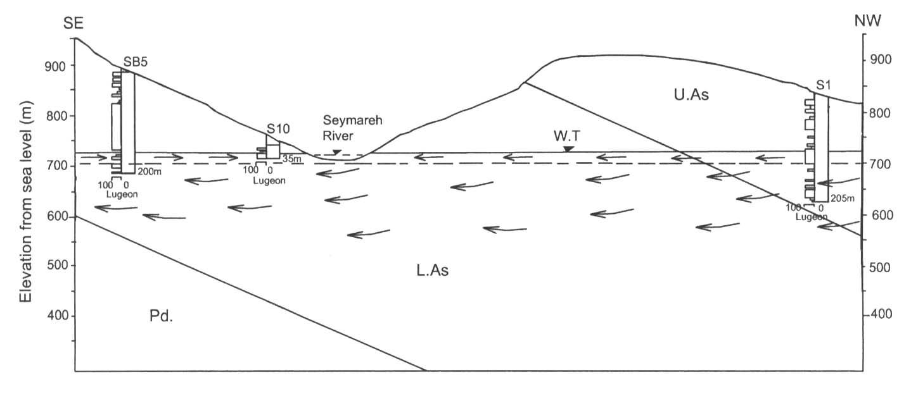
Figure 5. Schematic flow direction in model A (flow direction → )

The dye was not detected in the Seymareh River, because it was diluted by the high flow of the Seymareh River to values below the detection limit by the spectrofluorometer. The flow velocity of this model ranged from 1.15 to 2.03 m/h based on the first appearance of dye in the boreholes, and 0.67 to 0.97 m/h based on time to peak dye concentration, assuming a tortuosity of 1.5. The isopotential map shows that the direction of flow is from the left side of the Seymareh River towards the river while the dye flows beneath the river, being observed in the boreholes on left side of Seymareh River (Fig.5). The flow of groundwater in two different directions is hydraulically possible (Freeze and Cherry1979), but it requires discharging points for each direction. This seems to be an unlikely model for the following reasons:

- The S₂ borehole is located near the path of this model, therefore the dye is expected to be detected in this borehole, at least as a result of dispersion.
- The groundwater must have a discharging point after flowing beneath the Seymareh River. No discharging points can be determined for this model.
- The flow route is mainly through the Lower Asmari Formation, which is less karstified than the Upper Asmari Formation.

In the second model (B), the water of the injected borehole flows towards the left side of Seymareh River in the upstream region (Fig. 3). Part of the water joins the Seymareh River and part flows below the river. The dye was not detected in this part of the river because the flow of Seymareh River reduced the dye concentration below its detection limit by the spectrofluorometer. The water then moves against the dip of the Upper Asmari Formation parallel to the Seymareh River. Small fractures transfer the water to the area of the S_{10,} S₁₃, S₁₁, and SB₅ boreholes and finally to the river itself. This model is based on the following reasonings:
- Water flows in the Upper Asmari Formation in most parts of its route. This formation is more capable of karst development than the Lower Asmari.
- The direction of water from the right side to the left side corresponds with bedding planes and a fault.
- Several small faults perpendicular to the dip of the Upper Asmari Formation increase the chance of a water route in this direction.
- The water table level and EC maps confirm the flow direction of the proposed model in the region of the damsite on the left side of Seymareh River.
- The discharging points are the Seymareh River, but the dye cannot be detected in the river because of high Seymareh River flow rates.

In model B, the flow velocity in all the boreholes varies from 1.7 to 3.27 m/h based on the first appearance of the dye, and from 0.94 to 1.64 m/h based on the time to peak dye concentration. What follows justifies a diffuse flow regime in the dam site area based on the dye tracing results:
- Flow velocities through karst conduits for straight lines of more than 10 km range from 4.5 to 1450 m/h (Aley, 1973; Bakalowicz, 1973; Kruse, 1980; and Williams, 1977). Millanovic (1981) reports that from 281 dye tests carried out in Dinaric karst, flow velocities varied over a range of 7.2 to 1880 m/h. Velocities less than 18 m/h involve long underground retentions (Ford and Williams, 1989). The maximum velocities of both models are less than 3.27 m/h based on the first appearance of dye, and less than 1.64 m/h based on the time of peak dye concentration, therefore it may be concluded that the type of flow is mainly diffuse.
- No cavities were observed in any of the boreholes.
- No sinkholes were evident on the Asmari Formation outcrops.

Determination of the flow type is mainly based on the results of dye tracing, but other criteria suggest that a conduit system may well exist in the study area:
- The valley has developed by the action of the Seymareh River. This river was in direct contact with the different sections of Asmari Formation for a long period, and the river water flowed inside the joints and bedding planes, especially during high floods, making possible the development of a conduit system.
- The slope of water table on both sides of the Seymareh River is about 0.001, which denotes the development of karst above the water table. The Seymareh River acts as a base of erosion, therefore the recharge water must be discharged in the Seymareh River.
- The dye tracing results are only applicable below the water table. The permeabilities of most of the boreholes above the water table are in the range of 50 to 120 Lugeon which imply a possible conduit flow above the water table.
- The injected borehole may be located in a region of diffuse flow, taking the dye a long time to reach the main conduit. The dye-detected boreholes may not be intersected with the main conduit, but the water diverts to the boreholes via small fissures, increasing the dye travel time. In other words, the dye route may be a combination of diffuse and conduit flow, but the longer travel time of a diffuse flow system reduces the average velocity to the range typical of diffuse flow.
- The detection of dye in a specific discharge point such as a spring is the most reliable method to determine the type of flow regime. The discharge points are most probably beneath the surface of Seymareh River. The absence of a distinguishable discharge point reduces the credibility of the calculated velocity.
- Big springs emerge from the Asmari Formation in other regions of Iran, suggesting that this formation has the potential of conduit development (Raeisi et al., 1999; Karimi et al., 2003; and Raeisi, 2004) but the high flow rate and depth of the Seymareh River conceals the springs.
- The entrance of fossil caves are most probably filled by sediment washes on the steep slopes of anticlines in the Zagros (Raeisi and Laumanns, 2003), therefore, the absence of big caves on the steep slopes of Lina Anticline is not necessarily a proof of diffuse flow in the region.

Dye tracing presents the characteristics of a karst aquifer from the injected boreholes to the dye-detected boreholes. Therefore, it is not capable of determining karst characteristics above the water table and in regions outside of the dye route. It may be concluded that the results of the present study are not conclusive enough to determine the type of flow and degree of karstification in the study area, and consequently, the dimensions of the grout curtain. A short grout curtain may increase the leakage from the reservoir and a long one is very expensive. An extensive study on karst hydrogeology, including hourly variations of water table in boreholes and river level during the wet season, distribution map of surface karst features, valley evolution, water balance of Lina Anticline, geomorphology, and geophysics is required to give a deep insight of the study area. One dye tracing test does not provide enough information to determine the karst hydrogeology of the study area. It is recommended that at least two dye tracings be done on both abutments of the damsite. The dye injected borehole should be located in front of the proposed grout curtain, as close as possible to the dam, thus allowing the determination of karst development before and after the proposed grout curtain.

Conclusions
The future Sazbon dam abutments and part of the reservoir are in direct contact with the karstic Asmari Formation. Dye was injected into a borehole inside the reservoir of this future dam. The dye was detected at low concentrations in four boreholes on the left side of Seymareh River. The dye velocity was in the range of diffuse flow. The most probable schematic flow model is proposed considering the dye tracing results. Based on this model, the water flow path is from the right side to the left side of the Seymareh River in the bedding plane of the Asmari Formation, then it changes its direction perpendicular to the dip of the Asmari Formation. The small fissures transfer the water to dye-detected boreholes and finally to the Seymareh River. The karst aquifer in the Sazbon Dam region may have a conduit system in spite of the dye tracing results. The low gradient of groundwater level, valley development by Seymareh River, high permeability of boreholes, lack of information of specific discharge points, limited information from only one dye tracing, combination of diffuse and conduit flow in the flow route, and characteristics of the Asmari Formation in other regions of the Zagros are collective evidences of possible conduit flow in the Sazbom Dam site. Extensive karst hydrogeological studies and at least two more dye tracings are recommended to determine the possible conduit system in the study area.

Acknowledgements
The authors gratefully acknowledge the financial support for this research, by the Power and Water Resources Development Company of Iran. Thanks are also due to Shiraz University for providing the facilities and leave-time to work on this research.

References
Aley, T. 1975. A predictive hydrological model for evaluating the effect of land use on the quantity and quality of water from Ozark Spring. Ozark Laboratory, Missouri.
Bakalowicz, M. 1973. Les Grandes manifestations hydrologiques des karsts dans le monde. Spelunca 2. 38-40.
Freeze, R. A. and J. A. Cherry. 1979. Groundwater. Englwood Cliffs, Prentice-Hall, Inc., 604pp.
Ford, D. and P. Williams. 1989. Karst geomorphology and hydrology. Unwin Hymam, London. 601pp.
Karimi, H, E. Raeisi and M. Zare. 2003. Hydrodynamic Behavior of the Gilan Karst Spring, West of the Zagros, Iran. Journal of Cave and Karst Science. Vol. 30, No. 1, pp 15-22.
Kruse, P. B.1980. Karst investigation of Maligne basin Jasper National Park, Alberta. MSc Thesis , University of Alberta, Canada.
Millanovic, P. T. 1981. Karst hydrogeology. Colorado Water Resources Publication.
Mohab Ghods Consulting Engineers. 1999. Engineering Geology Report of the Sazbon Dam. Power and Water Resources Development Company of Iran.
Raeisi, E., M. Zare and P. Eftekhari.1999 . Application of dye tracing for determining characteristics of Sheshpeer karst spring. Theoretical and Applied Karstology, Vol. 11-12, pp. 109-118.
Raeisi, E., and M. Laumanns. 2003. Cave Directory of Iran. Berliner Hohlenkundliche Berichte, ISSN 1617-8572, Berlin.
Raeisi, E. 2004. Iran cave and karst in Encyclopedia of Cave and Karst, Editor John Gunn, Fitzroy Dearborn, New York.
Williams, P. W. 1977. Hydrology of the Waikoropupu Springs: a major tidal karst resurgence in northwest Nelson (New Zealand). Journal of Hydrology, 35, 73-92.

