The Speleogenesis of the Caves in Crnopac Mt. Area

Mladen Kuhta & Andrej Stroj

Institute of Geology, Sachsova 2, Hr-10000 Zagreb, Croatia
E-mail: kuhta@igi.hr; astroj@igi.hr

Abstract

Velebit Mt. is the longest (145 km) mountain range of Croatia. The Velebit region is the part of Dinaric karst that covers southern half of Croatian territory. Its strikes in the NW-SE direction along the Adriatic coast, and although the distance from the sea is only several km, the region of Velebit Mt. has a mountain climate type.
Crnopac Mt. is located on the most southern part of the Velebit massif. As a morphological barrier (up to 1403 m a.s.l.) between the Lika region (550 m a.s.l.) in the north, and the Krupa and Zrmanja River valleys that lie close to the sea level, in the south, the area of Crnopac Mt. was exposed to intensive karstification processes. Its surface geomorphology indicates an advanced karstification which is even more stressed in the underground. Up to date 119 caves were discovered and explored.
Due to the complexity of natural conditions including, horizontal groundwater flow through the massif from the sinking zone in the Lika polje (550 m .a.s.l.) to the discharge area along Krupa and Zrmanja River valleys, and simultaneous vertical circulation through a deep unsaturated zone, different types of caves were formed. The speleogenesis of the most important caves was analysed in respect to the lithological characteristics of rocks, geological structure, hydrographic network, and hydrogeological relations.

Introduction

The Velebit region is the part of Dinaric karst that covers southern half of Croatian territory. It strikes in the NW-SE direction along the Adriatic coast in length of 145 km. Crnopac Mt. is located on the most southern part of the Velebit massif and it forms the morphological barrier (up to 1403 m a.s.l.) between the Gračačko polje (547-560 m a.s.l.) in the north, and the Zrmanja and Krupa River valleys which lie close to the sea level (0-150 m a.s.l.) in the south. According to its geomorphologic and hydrogeological characteristics, the Gračačko polje is a classical example of a karstic field covering the area of about 10 km². The Otuča River flows along the field (medium annual flow …m³/s) which sinks underground along its southern border, i.e. at the foot of steep northern slopes of Crnopac Mt. Despite the fact that average annual precipitations in the Crnopac area reach around 2500 mm, mountain area is entirely waterless. Extreme indentedness, in which numerous and frequently rather deep dolinas often occur, indicates an advanced karstification which is even more stressed in the underground. Up to date 119 caves were discovered and explored in the area of about 40 km².

Review of exploration

First speleological explorations of this area date from the beginning of 20th century (Poljak, 1929) but they were primarily connected to the discovery of Cerovačke Caves (in 1912 during the construction of the railroad) and to explorations of smaller objects in its surroundings. Detailed speleological explorations of mentioned caves started in 1948. Besides significant length; Gornja (Upper) Cerovac Cave about 1200 m, Donja (Lower) Cerovac Cave about 2000 m, paleontological explorations pointed out that these caves are a significant Paleolithic locality. Both caves belong to the group of typical "Bear Caves". Furthermore, descriptions of the first findings of Upper Paleolithic man in the Dinaric Karst originate from the Upper Cave (Malez, 1956).

First Speleological explorations in the higher parts of Crnopac Mt. started in 1978 and lasted till 1990 (JALŽIĆ, 1984; LUKIĆ 1991; KUHTA, 1992). During that period about 50 caves were explored including Burinka (-295 m) and Munižaba (-448 m). A new phase of explorations has initiated during the year 2000 and up to date it resulted in a discovery of 64 new caves (KUHTA, 2003; KUHTA et al., 2004; BOROVEC, 2005).

Geological and Hydrogeological settings

The oldest rocks in the area of the Crnopac massif are dolomites and limestones originating from the Middle and Upper Triassic (T₂², T₃^{2,3}) which cover NW slopes from the level of the Gračačko polje to around 850 m above sea level. On the Triassic sediments continuously follow Jurassic carbonate development (dolomites and limestones) in the stratigraphic range from Lower Lias (J₁^{1,2}) to Middle Malm (J₃^{1,2}). Outcrops of Jurassic sediments are noticeable along NW slopes, all the way from the very massif bottom to maximum 1100 m a.s.l.. Cretaceous sediments built up the southern slopes of Crnopac and valleys of the Zrmanja and the Krupa rivers. They are represented by carbonate breccias (K_{1,2}) in the lower part and limestones from Upper Cretaceous Age (K₂^{1,2}). Central parts of the massif, and a part of NE slopes all the way to the level of the Gračačko polje, are constructed of Tertiary carbonate breccias (Pg,Ng) also known as Jelar-deposits. As the youngest lithostratigraphic member, they lied down unconformably on all older sediments. The largest number of explored speleological objects was formed precisely in these sediments.

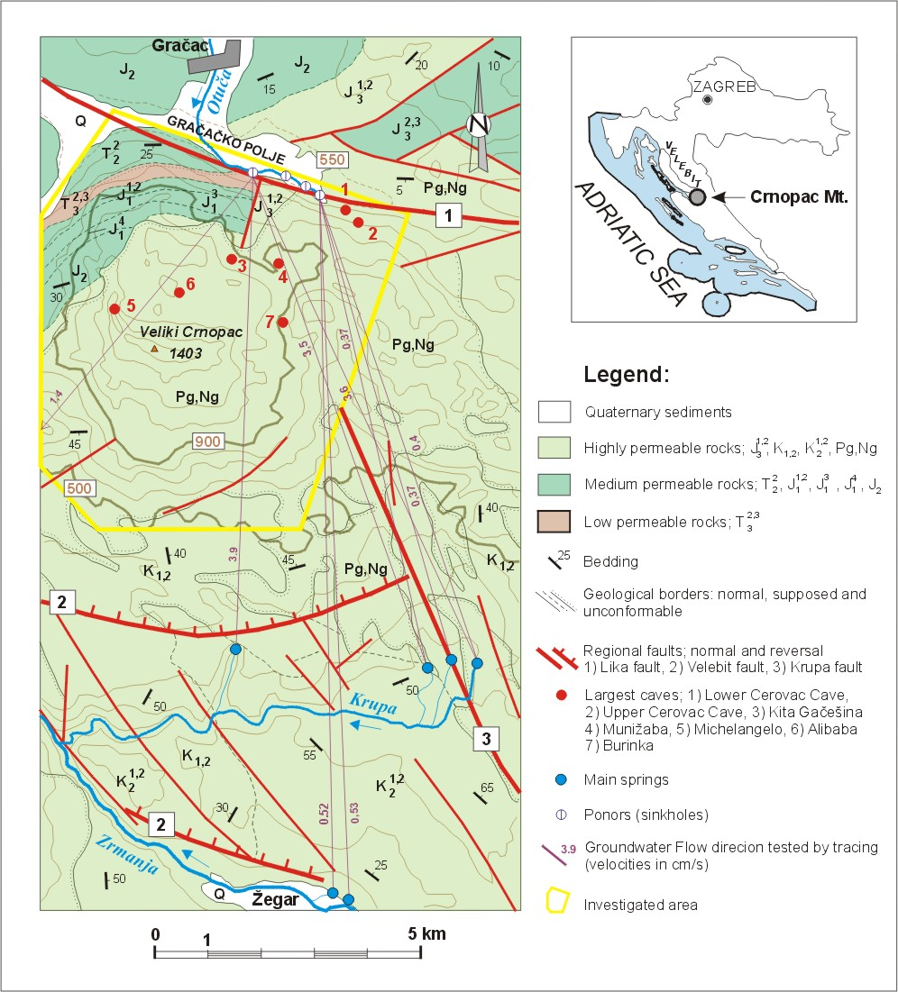

Fig. 1 Simplified hydrogeological map of the investigated area (geology after: IVANOVIĆ et al., 1973 and PAVIČIĆ, 1995)
The investigated area, as well as the whole Velebit Mt., is situated within structural complex of the Dinaric carbonate platform along its contact zone with Adriatic carbonate platform (HERAK, 1986). The recent geological structure is a consequence of two main periods of tectonic activity. During the Tertiary tectonic cycle, which lasted from Eocene to the end of Miocene, compressive movements oriented NE-SW reached their cumulative maximum with orogenesis of the Dinarides. As a consequence of the mentioned regional tangential stress, the deep nappa structures, folds and regional faults have been formed. Beside that, the formation of carbonate clastic Jelar-deposits is to be considered as the process accompanying the rupture deformations caused by mentioned orogenic movements (BAHUN, 1974). During the later, Neotectonic period, the main stress changed to N-S, resulting in further uplift and transpressive deformation of older structures, which were broken in the smaller structural units and tectonic blocks. In the area of Crnopac Mt. the summary amplitudes of vertical neotectonic movements were estimated to the more than 900 m (PRELOGOVIĆ et al., 1979).

Although the considered area is entirely made of carbonate sediments, they can be classified into three categories (Fig. 1) concerning their permeability to water and hydrogeological characteristics. The largest part of the terrain is built up of highly permeable and intensively karstified Cretaceous breccias and limestones (K_{1,2}, K₂^{1,2}), and especially Tertiary carbonate breccias (Pg, Ng). In the same category belongs Upper Jurassic limestones (J₃^{1,2}) too. The sediments of the Middle Triassic Age (T₂²), Lower (J₁^{1,2}, J₁⁴) and Upper Jurassic Age (J₂) go into the category of the rocks of medium permeability. The permeability of these sediments depends on the share of dolomites. Precisely due to a bigger presence of dolomites in relation to limestones, Upper Triassic sediments (T₃^{2,3}) belong to the group of rocks of low permeability. Hydrogeological relations are defined by the position of the massif between the Gračačko polje (547-560 m a.s.l.) in the north, and the Zrmanja and Krupa River valleys that lie close to the sea level (0-150 m a.s.l.) in the south. Results of groundwater tracings showed a connection of the River Otuča ponors (sinkholes) to springs in the valleys of the Krupa and Zrmanja. The groundwater flow velocities range from 0,37 to 3,85 cm/s, depending on hydrologic conditions at the time of tracing.

Cave geomorphology and genesis

As already mentioned up to date 119 speleological objects have been explored in the Crnopac area. Concerning their depth and length, they are classified into 4 categories shown in Table 1. The smaller caves with depth or length below 50 m prevail in this area. The most significant speleological objects are Munižaba (-448 m, 3700 m), Kita Gačešina (-338 m, 1002 m), Burinka (-290 m, 325 m), Michelangelo (-274 m, 65 m) Alibaba`s Jama/Pit (-212 m, 250 m), Gornja Cerovačka Cave (-42 m, 2682 m) and Donja Cerovačka Cave (-22 m, 1295 m). We also have to mention that explorations of Munižaba i Kita Gačešina have not yet been finished. .

Table 1 Review of speleological objects by their dimensions

Depth category | Number of Caves | Length category | Number of Caves
< 50 m | 75 | <50 m | 83
50-100 m | 26 | 50-100 m | 20
100-200 m | 13 | 100-500 m | 12
>200 m | 5 | >500 m | 4
Total | 119 | Total | 119
Total depth (m) | 6691 | Total length (m) | 13565
Average depth (m) | 56 | Average length (m) | 114

In a geomorphologic sense, the explored area can be divided into two zones. The area of side slopes spreads from 550 m a.s.l. (the sea level of the Gračačko polje) to approximately 900 m a.s.l. The area above 900 m a.s.l. all the way to the very top (Veliki Crnopac, 1403 m a.s.l. ) can be considered the peak part of the massif. Although the karstic plateau spreading in the area of the Krupa and Zrmanja canyons can be also put among the massif slopes, this area was not taken into consideration here.
The researches have not been finished and it is expected that further objects will be discovered; however, the existing sample can be representative enough for a basic statistical analysis. In the area of the massif slopes, only 20 caves were explored (17 %). The total depth of those objects is 1170 m, and the total ground-plan length is 5970 m. This evidences that mostly horizontal speleological objects are present in this area. The fact that Upper and Lower Cerovačka Cave (all together 3977 m long) are situated in this area certainly contributes strongly to such results. Based on the stated data, the relation of the vertical and horizontal karstification component was calculated to 1:5,1. In the peak massif part (>900 m a.s.l.) there are entrances into 99 objects (83 %). Although pit-type objects prevail here, the total depth of the explored objects is 5521 m while their total ground-plan length is 7595 m. The relation of the vertical and horizontal karstification component is 1:1,4. The mentioned length of underground channels, i.e. the horizontal karstification component, is a consequence of the large length of Munižaba (-448 m, 3700 m) and Kita Gačešina (-338 m, 1002 m). Concerning the fact that entrances into these two caves are rather low, i.e. at 915 and 940 m a.s.l., their horizontal parts are entirely developed in a lower hypsometric zone. If the total length of channels in the peak zone decreased for their length, and is added to the length of channels in the area from 550 to 900 m a.s.l., the relation of the vertical and horizontal karstification component in the peak zone changes to 2:1, and in the lower (slope) zone to 1:9,1. Ratios of the vertical and horizontal karstification component calculated in this way, fit rather well in the essential frame of the genesis of speleological objects in the Crnopac area.

Recent studies performed in the Dinaric karst terrain indicate that the present landscape is very young. The majority of the most important and most developed morphological features were created during the Pleistocene and Holocene (FRITZ, 1992).

In the explored area the general karstification processes were directed by the position of local erosion basis i.e., the Gračačko polje (550 m a.s.l.) in the north and Zrmanja and Krupa River valleys (0-150 m a.s.l.) in the south. Under such circumstances, as a morphological barrier Crnopac Mt. has a very important role and controls the groundwater conditions and underground discharge from Gračačko polje toward south. At the same time, the underground of Crnopac Mt. was exposed to strong karstification. Constant tectonic uplift of Velebit Mt contributed to the development of such strong karstification processes in the studied area. As it was already mentioned, the summary amplitude of Neotectonic movements for Crnopac area is estimated to more than 900 m. Simultaneously, the Gračačko polje north of the Lika fault, as well as Krupa and Zrmanja valleys south of the Velebit fault, represent relatively descended blocks. The groundwater flows through the carbonate massif from the Gračačko polje toward the spring zone along the Krupa and Zrmanja valleys tended to compensate these movements and thus it developed a network of deep underground channels and the cave systems. The described mechanism took important part in development of largest explored caves.

The Cerovac Caves that lie on 624 and 671 m a.s.l. represent old ponors (sinkholes) of the Otuča River. Recent, permanently or temporally active, ponors developed along the south border of the Gračačko polje (550 m a.s.l.). Their entrances are choked up by deposited matter thus making speleological explorations impossible. In spite the fact that the entrances elevation of the two large caves Munižaba (915 m a.s.l.) and Kita Gačešina (940 m a.s.l.) belong to the higher morphological unit (zone), their development should be related to the same genesis pattern, as well as the activity of sinking waters from the Gračačko polje. Namely, the largest parts of mentioned caves represents generally horizontal channels which developed within altitude range from 500 to 650 m a.s.l. Lower channels characterised by large dimensions have been developed by strong and concentrated underground flow. Recently discovered entrance vertical shafts should be considered the youngest parts. The lowest point in Munižaba reached the elevation of 467 m a.s.l., that is about 80 meters below the altitude of Gračačko polje, but there is still no evidence of any active groundwater circulation.

The speleological and cave-diving explorations in the discharge area, both in the Krupa and Zrmanja River valleys, pointed out the existence of several permanently or temporally active spring caves. The caves are up to several hundred meters long.

The genesis of the caves in the higher zone (900-1400 m a.s.l.) is related to dominantly vertical circulation through a deep unsaturated zone. The large number and density of caves is the consequence of a favourable lithology. Namely, the uppermost part of terrain built up the massive calcareous breccias that are very liable to karstification. The results of cave exploration conducted in same deposits on other parts of Velebit Mt prove the mentioned fact (KUHTA & BAKŠIĆ, 2001). The largest pits Michelangelo (-274 m) and Alibaba`s Pit (-212 m) are located on altitudes of 1283, i.e. 1080 m a.s.l. and they are too shallow to reach even the zone of ancient horizontal circulation.

Conclusions

Although difficult access and movement along the terrain as well as the lack of potable water makes explorations significantly difficult, the area of Crnopac Mt. is very attractive for speleological explorations. Central parts of Crnopac are built up of Neogenic carbonate breccias, also known as Jelar deposits. Lower parts of the mountain northern slopes are composed of Triassic and Jurassic carbonate rocks while the Cretaceous sediments are in the south. Their common hydrogeological characteristic is a good permeability which has enabled underground discharge of surface flows from the Gračačko polje (Otuča River) towards the springs in the Krupa and Zrmanja River valleys. In these circumstances significant horizontal speleological objects have been formed in the border, hypsometricaly lower parts of the massif while jamas/pits prevail in the higher parts of the terrain, i.e. in the zone of emphatically vertical circulation. Although the zone of active underground flow for the time being has not been reached anywhere, such enterprise would result in an extremely deep (and probably also a very long) object. Taking into account the fact that peak parts of the massif go as high as 1400 meters above sea level and that the spring zones of the Krupa and Zrmanja valley are situated at elevations from 70 to 150 meters above sea level, the depth potential of Crnopac is up to 1000 meters.

References

BAHUN, S. 1974: The tectogenesis of Mt. Velebit and the formation of Jelar deposits. Geološki vjesnik 27, Zagreb : 35-51.

BOROVEC, M. 2005: Alibaba,s Jama on the Crnopac Mountain. Speleolog 52, Zagreb : 18-22.

FRITZ, F. 1992: Effect of recent sea level change on the development of Karst phenomena. Proceedings of the International Symposium "Geomorphology and Sea". Mali Lošinj : 85-92.

HERAK, M. 1986: A new concept of geotectonics of the Dinarides. Acta geologica 16/1, Zagreb : 42 p.

IVANOVIĆ, A., SAKAČ, K., MARKOVIĆ, B., SOKAČ, B., ŠUŠNJAR, M., NIKLER, L. & ŠUŠNJARA, A. 1973: Basic Geological Map, scale 1:100 000, sheet Obrovac, State Geological Survey, Beograd.

JALŽIĆ, B. 1984: Bezdanka kod Čabrića on Velebit Mt. Naše planine 11-12, Zagreb.

KUHTA, M. 1992: Caving explorations of the Crnopac area in the Velebit Mt. Speleolog 38/39, Zagreb : 25-28.

KUHTA, M. & BAKŠIĆ, D. 2001: Karstification Dynamics and Development of the Deep Caves on the North Velebit Mt. - Croatia. 13 International Congress of Speleology, Proceedings, Brasilia.

KUHTA, M. 2003: Some recent results of speleological exploration on Mt. Crnopac. Speleolog 48/49, Zagreb : 36-44.

KUHTA, M., BOROVEC, M. & BOSNER, N. 2004: Cpeleological explorations of Crnopac from 2002 and 2003. Speleolog 50/51, Zagreb : 48-55.

LUKIĆ, O. 1991: Speleological explorations of the Crnopac area on the Velebit Mt.. Speleolog 36/37, Zagreb : 14-26.

MALEZ, M. 1956: Erster Found des oberdiluvialen Menschen im dinarichen Karst. Bull. sci. Cons. Acad. Yougosl. 3/2, Zagreb : 47-48.

PAVIČIĆ, A. 1995: Hydrogeological conditions for the construction of reservoirs in the Velebit Mt. hinterland. Unpublished. Ph.D. Thesis, University of Zagreb, Croatia, 124 p.

POLJAK, J. 1929: Mountaineering Guidebook on Velebit Mt. Zagreb.

PRELOGOVIĆ, E. 1979: Seismotectonic activity in the area of the Zrmanja valley. Geološki vjesnik 31, Zagreb : 123-136.

