Milk teeth of Quaternary carnivores
from Northern Greek Caves
Preliminary Report
by
Spyridoula PAPPA¹, Evangelia TSOUKALA¹, Georgios Lazaridis¹ & Gernot RABEDER²
- School of Geology, Aristotle University, 54124 Thessaloniki, Macedonia, greece
2. institute of Paleontology, University of Vienna, Althanstrasse 14, A-1090, vienna, Austria

Abstract: From extensional studies on Quaternary faunas it is concluded that certain caves were habited by animals (carnivores). The habitation is established by the presence of milk teeth and bones with infused epiphyses, the food remains and the coprolites. The most important site of Greece with abundant material of fossilized milk teeth, in spite of their fragility, is the Late Pleistocene Loutra Arideas (Pella, Macedonia) bear-cave. Thousands of isolated deciduous teeth – very few in situ- have been collected from the systematic excavations that were carried out in the cave. In Middle Pleistocene Petralona cave, even though there is abundant ursid material, the presence of milk teeth is rather rare. On the other hand, there are hyaenid mandibles with milk teeth belonging to the Middle Pleistocene Crocuta spelaea intermedia and pliohyaena perrieri as well. These milk teeth are compared with those of the Late Pleistocene crocuta crocuta spelaea from Agios Georgios cave (a typical hyaenid den in Kilkis, Macedonia). The evolutionary stage of these animals is preliminarily under discussion.

Introduction
Three caves of Macedonia (N. Greece) with milk teeth are referred in the present study: The Petralona cave (PEC), 45Km SE, the Agios Georgios-Kilkis (SGK), 45Km NNW and the Loutra Arideas Bear-Cave (LAC), 120 Km NW of Thessaloniki (Fig. 1). The Petralona material of juveniles comes from the “old excavation” and surface collections by professors of the Thessaloniki University, which was found in association with the famous hominid skull. The milk teeth are very few in contrast to the rest findings that are thousands of well preserved specimens, representing 22 different species of Middle Pleistocene large mammals (TSOUKALA, 1989/1991). The Agios Georgios-Kilkis cave is the unique up to now, exclusively hyaenid den of Greece of Latest Pleistocene, as the most specialized scavenger, the real cave hyaena, lived in. The presence of the milk teeth, the coprolites and the food remains establish the habitation. The juveniles are represented either by milk teeth or by post cranial skeleton (TSOUKALA, 1992a,b). The investigation in the Loutra Arideas area started in 1990 and the first excavation circle in the Bear Cave started in 1992. The sieving process and the systematic collection of the milk teeth started in 1993 up to now. Ten systematic excavation circles, under strictly archaeological rules, including micromammalian research took place. All the sediments of the 189 levels (about 5 cm of thickness each) have been washed into a system of double sieves, one for micromammals CHATZOPOULOU, (this volume) with a mesh of 0.8 mm and the other of 3 mm for large mammalian remains, both with milk teeth. Then the material was dried out, conserved and recorded for further study. Additionally few bigger specimens were numbered and collected in place with their coordinates during the excavation (TSOUKALA 1994, 1996, TSOUKALA et al. 1998, 2001, PAPPA, 2004). All the material above is stored in the Paleontological Museum of Aristotle University of Thessaloniki.
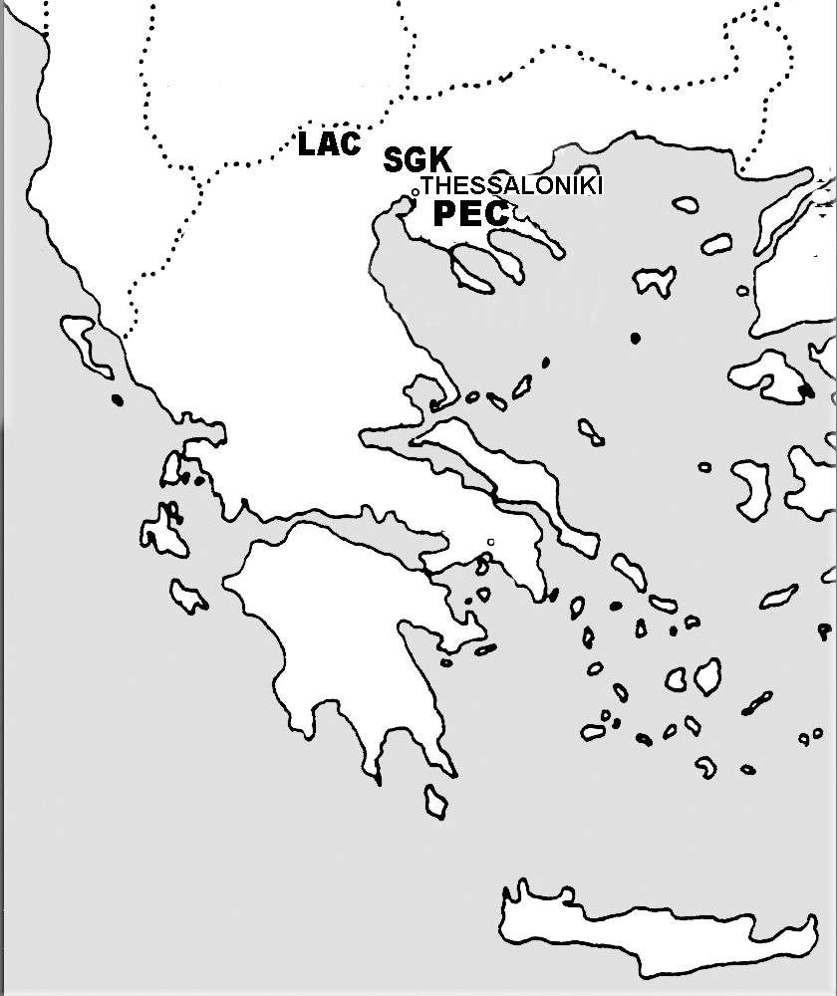
Figure 1. Map of Greece with the three localities (PEC: Petralona Cave, SGK: Agios Georgios-Kilkis Cave, LAC: Loutra Arideas Cave) depicted.

Paleontology
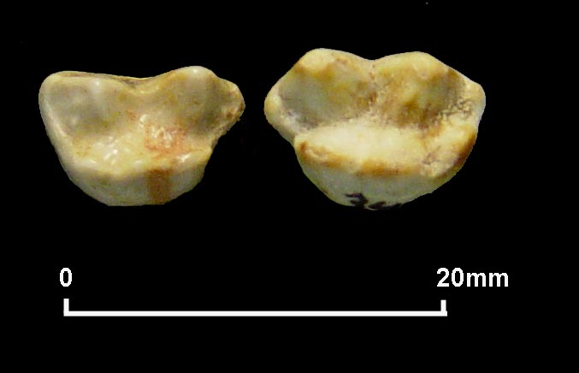
Figure 2. D⁴ occlusal view: a) Left, Petralona cave, U. deningeri PEC 1020 dex and b) Right, Loutra Arideas Bear cave, U. ingressus LAC 12557 sin.

a) Petralona Cave, Middle Pleistocene
Taxonomy
Order: Carnivora BOWDISH, 1821
Sub-order: canoidea simpson, 1931/ Arctoidea FLOWER, 1969
Family: Ursidae GRAY, 1825
Genus: Ursus LINNAEUS, 1758
U. deningeri v. REICHENAU, 1906
Material: dC PEC 1028, dI³ PEC 1040 dex, D⁴ PEC 1020 dex

Description: the milk canine is little worn and the root is broken, the third upper milk incisor is slightly worn and most of the root is preserved. The upper milk carnassial is well preserved (D⁴, fig. 2a) as only little part of the roots is missing. The external cones are pointed and straight on their labial side, the paracone is well developed and the metacone bears longitudinal palatinal crest. There is a small parastyle, while there is trace of a cingulum like metastyle. The morphotype seems to be a simple one.

Sub-order Feloidea simpson, 1931
Family: Hyaenidae gray, 1869
1) Genus: Crocuta kaup, 1828
Crocuta spelaea intermedia M. de SERRES, 1828
Material: Mandible fragment with D₃ - D₄ PEC 15 dex.

Description: Of the brachygnath mandible most part is preserved with the D₃ and D₄ both slightly worn (fig. 4.1). Of the D₃ the protoconid is intense, and there are an anterior and two posterior small accessory cuspids. Of the milk carnassial, the paraconid and protoconid are pointed, the metaconid is absent and the large talonid is bicuspid as the hypoconid is reduced, but well developed the entoconid and hypoconulid. The M₁ is unerupted.

2) Genus: Pliohyaena KRETZOI, 1938
Pliohyaena perrieri CROIZET & JOBERT, 1828
Material: Cranium with dC^{s} sin, D² – D⁴ sin+dex, P⁴ dex, M¹ sin PEC 28, 2 mandible fragments with D₂ - D₄, M₁ PEC 14 dex and 13 sin, D₃ PEC 35 sin, D₄ PEC 44 sin.

Description: The skull is almost well preserved and it bears almost all the slightly worn milk teeth and the unerupted left carnassial and the right M¹ as well. The I² dex and the C^{s} sin are under eruption (fig. 3). The milk canine is slender, with an intense posterior and an anteropalatinal crests with a well developed cingulum on the base of the latter. There are only the alveoli of the single root D¹. The D² is elongated and its longitudinal axis is directed palatinal. There are a small anterior and a well distinguished posterior accessory cuspid and an intense palatinal cingulum. The D³ is the largest tooth with well separated parastyle, long metastyle and a very low protocone in the middle. On the basis of the amphicone there is an intense triangular cuspid. The molar like D⁴ is small, triangular, transversally developed.

Of the hypsognath mandible, most part is preserved with the slightly worn D₂, D₃ and D₄ (fig. 4.2,3). Of the long D₃ the protoconid is intense and posterior inclined, and there are anterior and posterior accessory cuspids. Of the milk carnassial D₄ that is clearly distinguished the paraconid and protoconid are less pointed, the metaconid is present and the large talonid is tricuspid as the hypoconid, hypoconulid and entoconid are well developed, with the latter one being the most strong. The M₁ is unerupted, with the metaconid well distinguished. It must be noted that in all milk teeth there is an intense labial cingulum. Only two isolated well preserved teeth have been found (fig. 5.5,6). The dimensions of the specimens are given in tab. 1.
Table 1. Pliohyaena perrieri - Crocuta spelaea intermedia PEC
Measurements of milk teeth (in mm)
Pliohyaena perrieri
Cranium | PEC 28 |  |  | PEC 35
LdC^{s} | 8.12 | LD₃ |  | 16.99
BdC^{s} | 5.90 | BD₃ |  | 7.35
LD¹alv. | 6.50 |  |  | PEC 44
BD¹alv. | 6.40 | LD₄ |  | 19.89
LD² | 16.00 | BD₄ |  | 8.82
BD² | 7.54 | LD₄tr^{d} |  | 15.15
LD³ | 25.50 | LD₄ta^{d} |  | 4.61
BD³ | 14.00 | HD₄crown |  | 10.82
LD⁴ | 9.60 | Md PEC14, PEC13 |  | n |  | xˉ | min | max | s | v
BD⁴ | 15.64 | LD₂-D₄ |  | 2 |  | 50.00 | 49.50 | 50.50 | -
LM¹ | 7.40 | LD₂ |  | 2 |  | 13.65 | 13.60 | 13.70 | -
BM¹ | 14.17 | BD₂ |  | 2 |  | 6.25 | 6.20 | 6.30 | -
Ldiastema | 2.87 | LD₃ |  | 3 |  | 17.20 | 16.90 | 17.60 | 0.35 | 2.03
LD¹alv.-D⁴ | 52.00 | BD₃ |  | 3 |  | 7.56 | 7.50 | 7.70 | 0.11 | 1.46
LdC^{s}ant.-M¹post. | 85.00 | LD₄ |  | 3 |  | 20.50 | 19.90 | 21.00 | 0.56 | 2.73
LdC-D⁴ | 67.49 | BD₄ |  | 3 |  | 8.47 | 8.40 | 8.60 | 0.12 | 1.43
LD²-D⁴ | 42.76 | Crocuta spelaea intermedia
LD² | 16.00 |  |  |  | PEC15
BD² | 7.83 |  | LD₂-D₄ |  | 43.00
LD³ | 25.70 |  | LD₂ |  | al.9.60
BD³ | 15.53 |  | BD₂ |  | al.5.20
LD⁴ | 9.68 |  | LD₃ |  | 12.90
BD⁴ | 15.70 |  | BD₃ |  | 6.50
DTD³-D³post. | 85.30 |  | LD₄ |  | 20.10
DTD²-D²ant. | 43.60 |  | BD₄ |  | 7.70
Abbreviations: L=length, B=breadth, alv.=alveolus, md=mandible

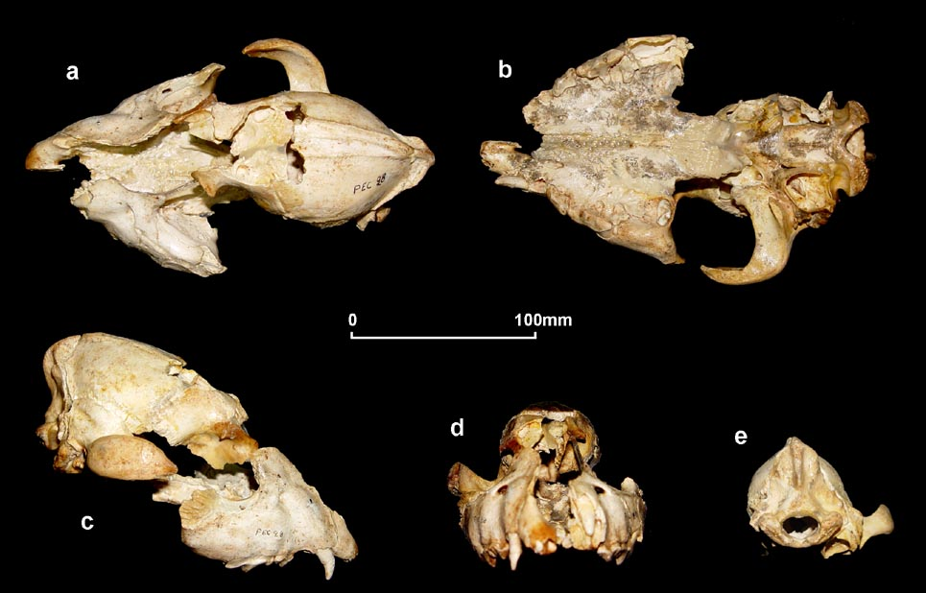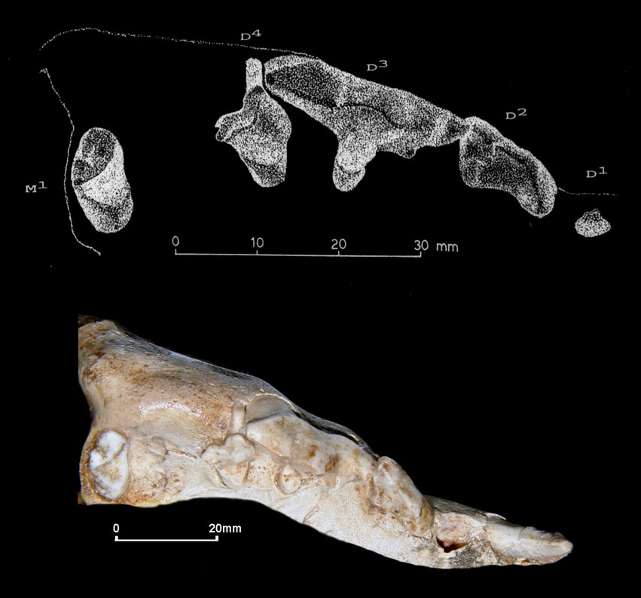
Figure 3. Pliohyaena perrieri, Cranium with dC, D² – D⁴, M¹ PEC 28, Left: a) dorsal, b) basal, c) right lateral, d) anterior and e) posterior (occipital region) view. Right: Detail of the right tooth-row, occlusal view.

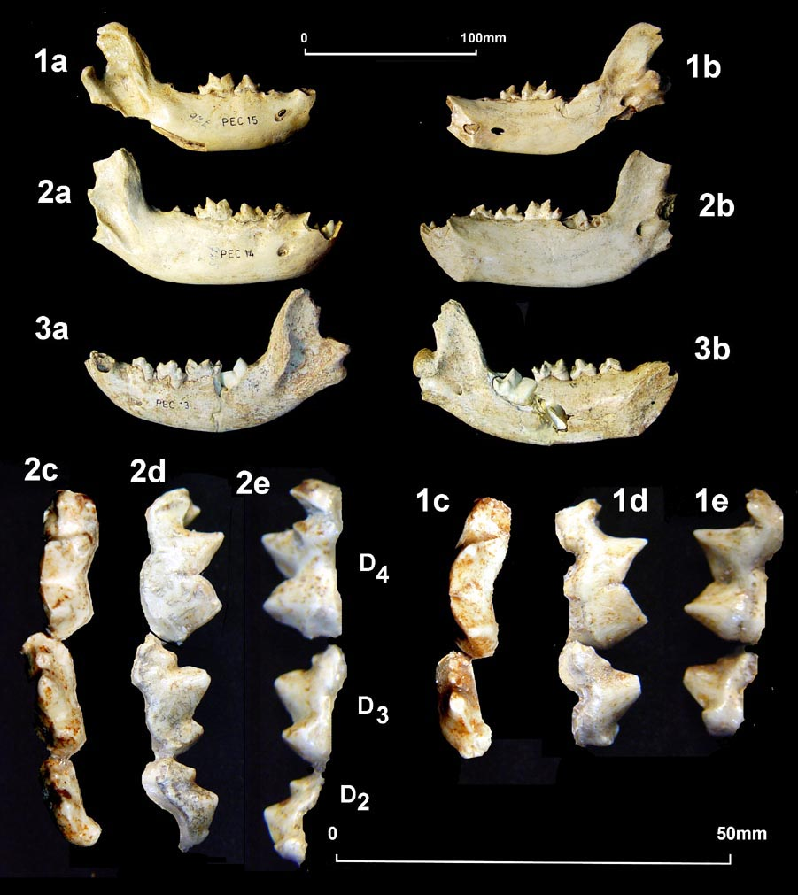  Figure 4. Crocuta spelaea intermedia: 1) mandible fragment with D₃ - D₄ PEC 15 dex, Pliohyaena perrieri, 2) mandible fragment with D₂ – D₄, M₁ PEC 14 dex and 3) mandible fragments with PEC 13 sin.  a,d) labial, b,e) lingual, c) occlusal view | 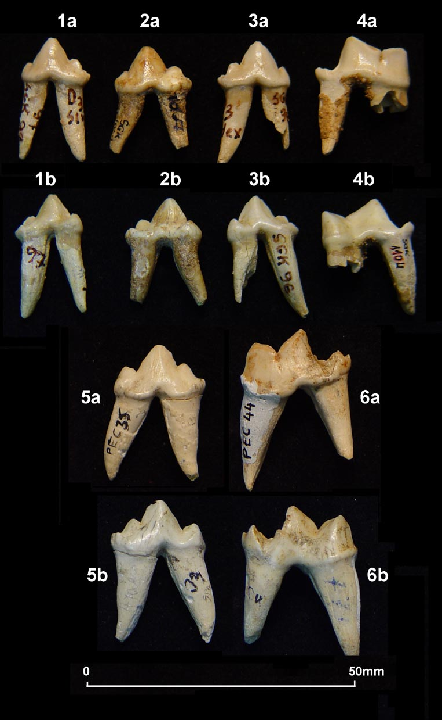  Figure 5. Crocuta crocuta spelaea: D₃ 1) SGK 97 dex, 2) SGK 1067 sin, 3) SGK 96 dex, 4) D₄ SGK 1104 dex. Pliohyaena perrieri: 5) D₃ PEC 35 sin, 6) D₄ PEC 44 sin a) labial, b) lingual view.

b) Agios Georgios (Kilkis) cave
3) Crocuta crocuta spelaea (goldfuss, 1832)
Material: mandible fragment with D₄ SGK 90 sin, 3 D₃ SGK 96, 97 dex, 1067 sin, D₄ SGK 1104 dex, 2 D₄ fragm. SGK 689, 690 dex.

Description: Of the mandible only the posterior part with condylus, the processus coronoideus as well as the lower slightly worn milk carnassial are preserved (fig. 6). There are also isolated teeth, D₃ and D₄, very well preserved (fig. 5.1-4). Of the D₃ the protoconid is intense, and there are anterior and posterior accessory cuspids. Of the milk carnassial, the paraconid and protoconid are less pointed, the metaconid is absent and on the large talonid not well distinguished cuspids were observed. The dimensions of the specimens are given in tab. 2. Further more, post cranial bones with infused epiphyses were found.

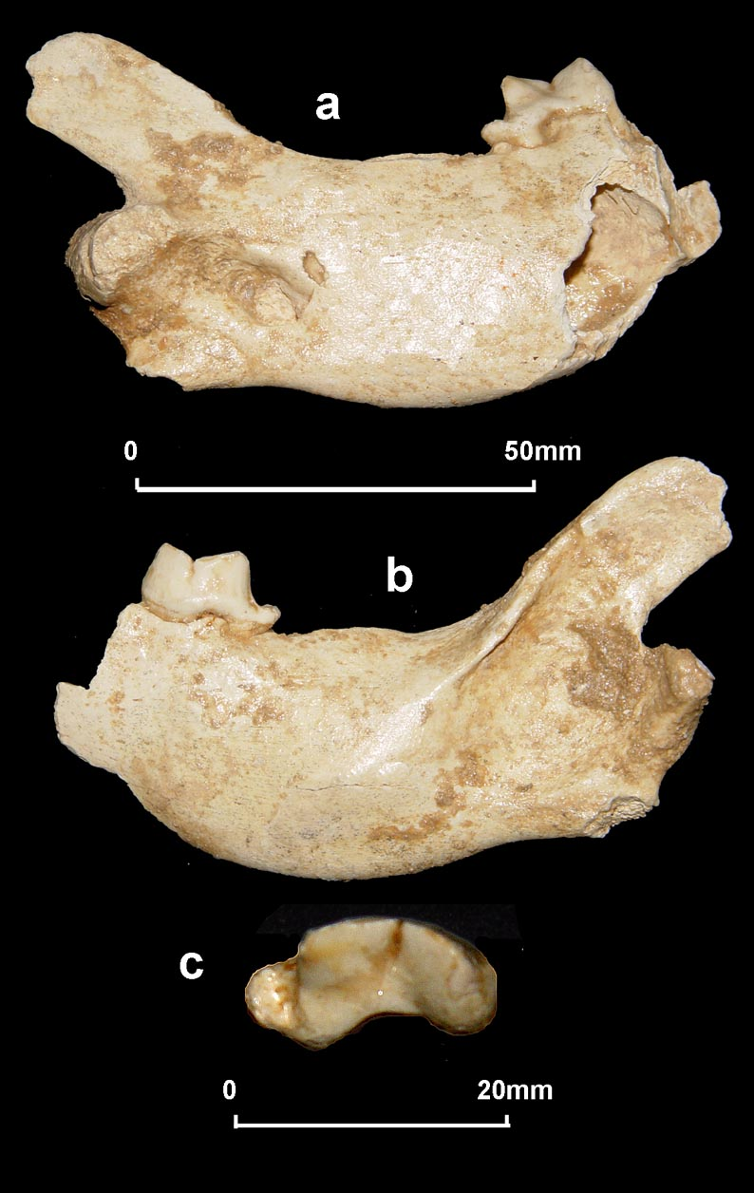  Figure 6. Crocuta crocuta spelaea: SGK 90. a) lingual, b) labial, c) D₄ occlusal view | Table 2. Crocuta crocuta spelaea SGK:  measurements of milk teeth (in mm)
  LdC | SGK 906  6.47
  BdC | 4.79
  LD₃ | SGK 96  13.95 | SGK 97  13.30 | SGK1067  14.66
  BD₃ | 6.57 | 6.58 | 7.09
  LD₄ | SGK 1104  18.10 | SGK 689  - | SGK 690  -
  BD₄ | 7.92 | 7.04 | 6.72
  md | SGK 90
  LD₄ | 17.62
  BD₄ | 8.11
  H md D₄ pοst. | 28.78
  H md proc.coron. | 44.19
  H md cond | 12.16
  Abbreviations: see tab.1and H=height, proc.coron.=processus coronoideus, cond.=condylus

c) Loutra Arideas Bear cave
Ursus ingressus RABEDER, 2004
Material: Mandible fragment with dC_{i}, D₄, M₁ unerupted LAC 1389 dex, 12 dI¹, 105 dI², 695 dI³, 6 D², 26 D³, 240 D⁴, 52 dI₁, 29 dI₂, 180 dI₃, 7 D₂, 62 D₃, 285 D₄, 1600 dC,

Description: In spite of the abundance of the milk teeth, among of which 3.259 are studied and measured (tab. 3) the mandibles are extremely rare, as only one is almost well preserved. The dC is slightly worn, as well as the lower milk carnassial; on the other hand the M₁ is germ and unerupted (fig. 7). The mandible with I₃, C, M₁, M₂ and M₃ unerupted LAC 4114 belongs to a sixteen months bear (after Dittrich in ANDREWS & TURNER, 1992) (fig. 8). The dI¹ is a small and slender tooth. There is a palatinal well developed cingulum and the root is elongated, slightly curved and conical. The dI² is much stronger than the first one, and also bears a well developed palatinal cingulum. The crown is curved and the root is conical and anterior flattened. The dI³ is the largest upper milk incisor that is similar with the milk canine, except the more convex crown and the intense palatinal cingulum. This tooth seems to be the most abundant among the LAC material. The D² is the smallest of the cheek milk teeth, the less differentiated. The root is small and conical. The D³ is more differentiated with developed talon and two roots. The upper milk carnassial D⁴ is the most important tooth because it contributes to the study of the evolutionary stage according to its morphotype (RABEDER, 1983, 1991, 1999). It is molar like and has one palatinal and two labial roots. The occlusal shape is rounded and sometimes there is a palatinal cuspid-like cingulum (fig.9).
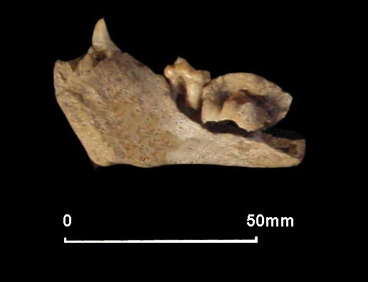  Figure 7. Ursus ingressus LAC. Mandible fragment with dC_{i}, D₄, M₁ unerupted LAC 1389 dex | 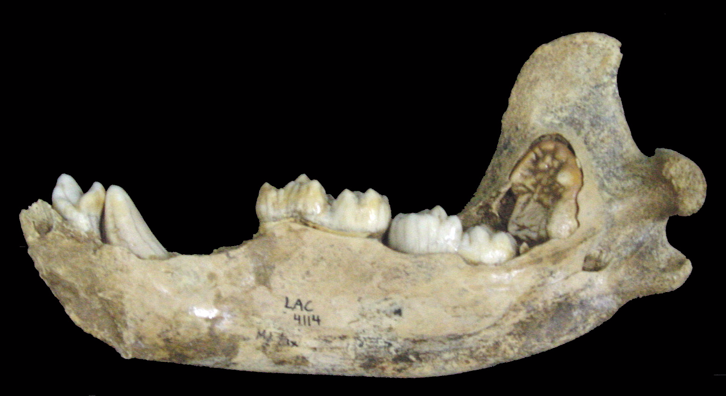  Figure 8. Ursus ingressus LAC Mandible with I₃, C, M₁, M₂ and M₃ unerupted LAC 4114.

The dI₁ is very small tooth, with small crown and cylindrical root, the end of which is slightly convex. The dI₂ is much stronger than the first one, with triangular crown and elongated root. The dI₃ is the largest lower milk incisor with triangular crown and well developed root. There are two lingual accessory cuspids, jointed with a small cingulum.

The D₂ is the smallest of the cheek milk teeth and the less differentiated. It grows inclined, with no root. The D₃ are of elongated crown and have two roots that are well separated or fused in some specimens RADULESCU & SAMSON (1959). The lower carnassials D₄ are much more various than that of the maxillar one, with crown bearing at least 5 cusps and two roots (fig.9).

The milk canines are large and abundant, but difficult to be distinguished in maxillars and mandibulars, thus both are described as long and flattened teeth (fig. 10).

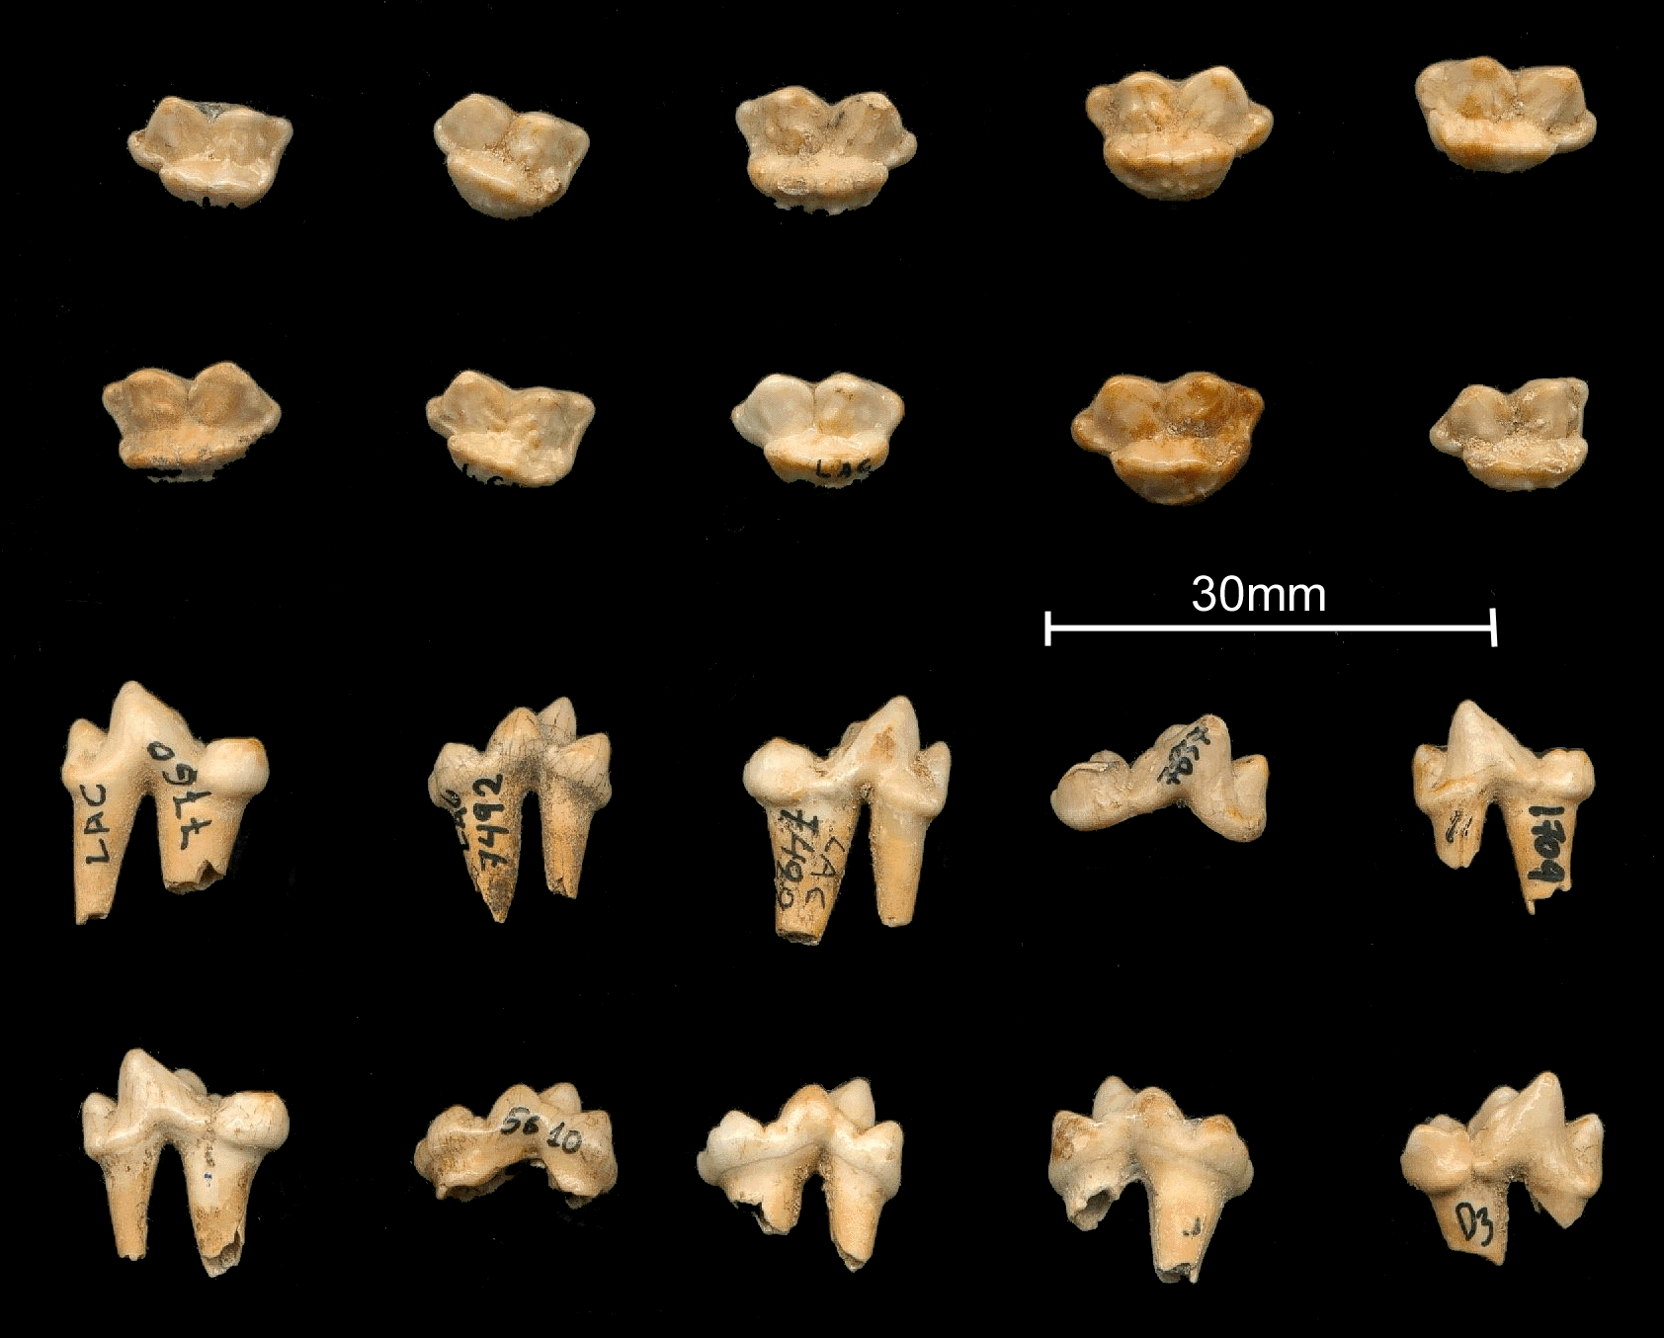 | 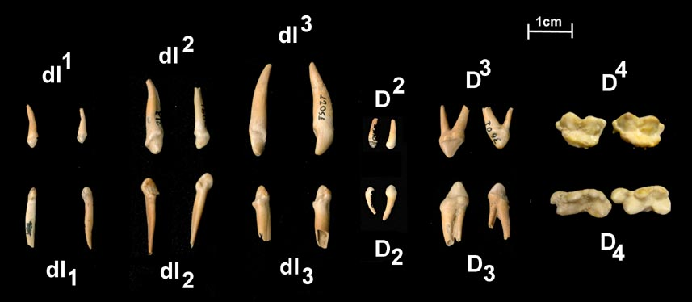
Figure 9. Ursus ingressus LAC: Representative material of the milk carnassials showing the variability of the morphotype.
Left: Two upper the D⁴ and two lower rows the D₄. Right: First upper and second row lower milk teeth

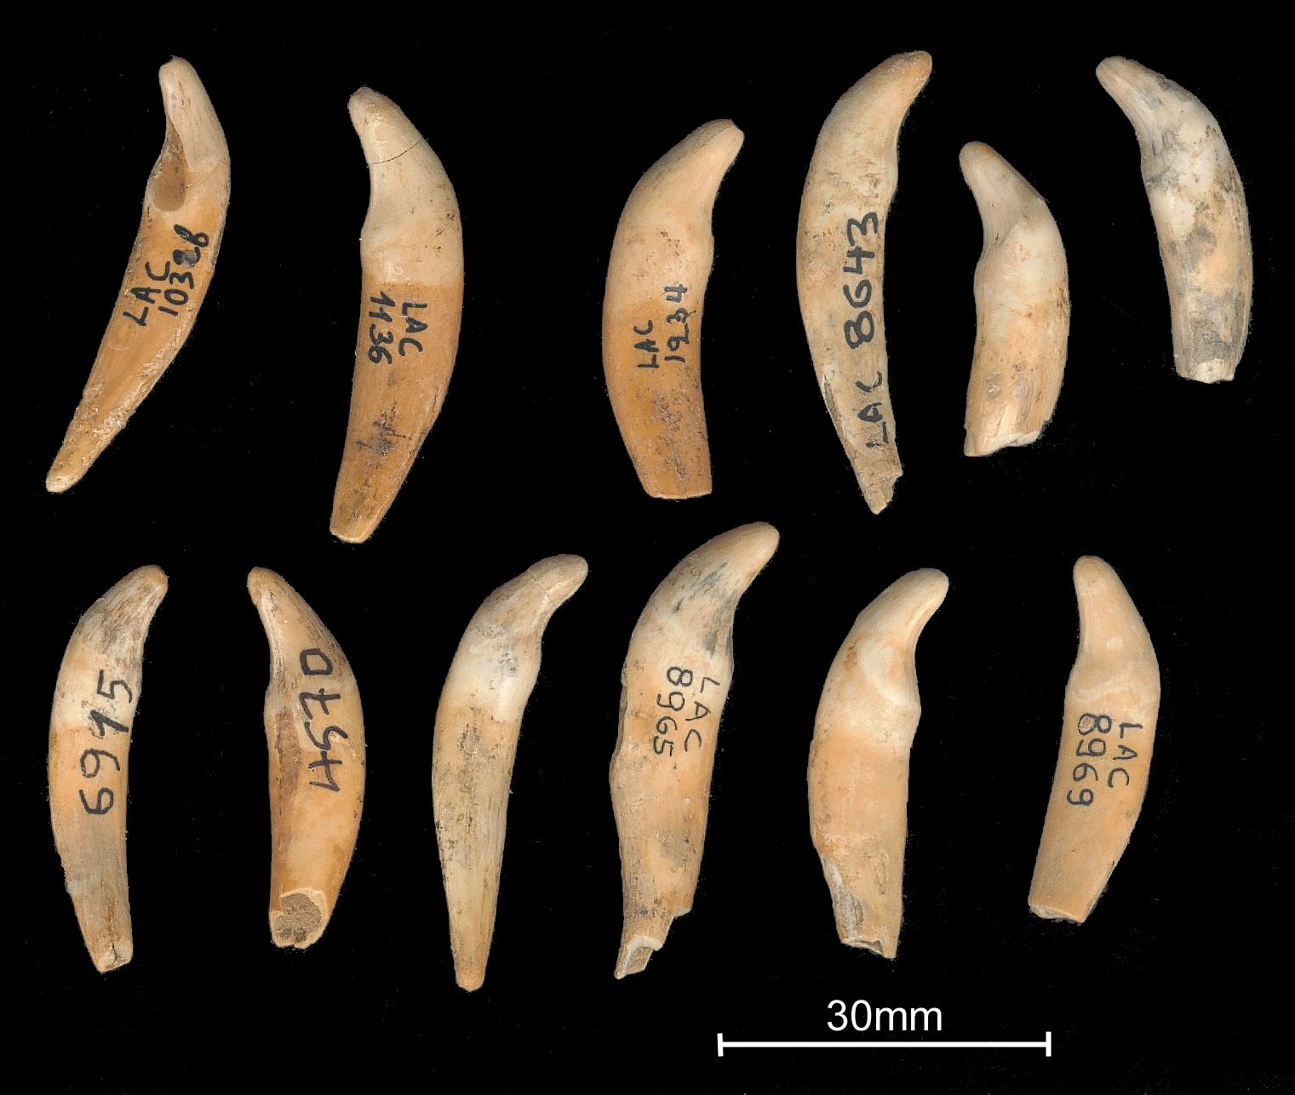  Figure 10. Ursus ingressus LAC. deciduous canines. | 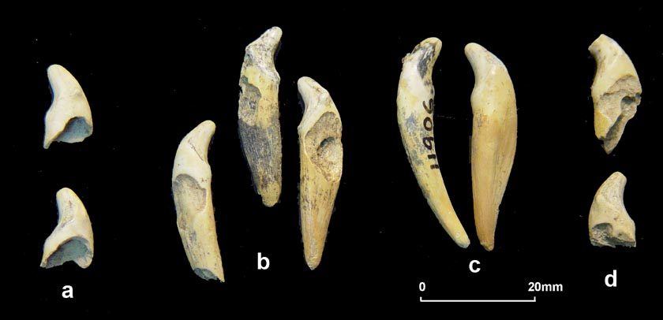  Figure 11. Ursus ingressus LAC. Various categories of deciduous canines (KURTEN 1976). a) Germs, b) Full teeth with root showing resumptions marks, c) Full teeth, d) shed canines.
Table 3. Ursus ingressus LAC: Measurements of the milk teeth (in mm)

 | n | min - max | x | s_{n-1} | v
LdI¹ | 12 | 1.77-2.95 | 2.44 | 0.32 | 13.15
BdI¹ | 12 | 1.57-2.68 | 2.21 | 0.35 | 15.58
LdI² | 103 | 3.02-4.63 | 3.85 | 0.32 | 9.46
BdI² | 103 | 2.72-4.97 | 3.35 | 0.32 | 8.24
LdI³ | 671 | 4.03-6.62 | 5.23 | 0.38 | 7.30
BdI³ | 671 | 4.01-6.77 | 5.05 | 0.42 | 8.31
LdC | 1507 | 5.08-9.58 | 7.31 | 0.60 | 8.23
BdC | 1507 | 3.96-7.25 | 5.52 | 0.45 | 8.23
LD² | 6 | 2.10-2.76 | 2.40 | 0.25 | 10.60
BD² | 6 | 1.99-2.65 | 2.25 | 0.26 | 11.75
LD³ | 26 | 3.97-7.30 | 6.21 | 0.62 | 9.96
BD³ | 26 | 3.07-4.17 | 3.72 | 0.26 | 7.04
LD⁴ | 124 | 9.20-12.85 | 11.13 | 0.74 | 6.69
BD⁴ | 124 | 6.42-11.60 | 7.56 | 0.64 | 8.43
LdI₁ | 52 | 1.45-2.73 | 2.17 | 0.29 | 13.54
BdI₁ | 52 | 1.21-2.09 | 1.73 | 0.21 | 11.87
LdI₂ | 27 | 3.50-4.76 | 4.02 | 0.29 | 7.25
BdI₂ | 27 | 2.42-3.83 | 2.94 | 0.36 | 12.32
LdI₃ | 173 | 4.10-6.32 | 5.21 | 0.47 | 9.12
BdI₃ | 173 | 3.02-5.33 | 4.05 | 0.37 | 9.23
LD₂ | 6 | 2.12-2.82 | 2.43 | 0.29 | 11.80
BD₂ | 6 | 2.12-2.57 | 2.29 | 0.18 | 7.97
LD₃ | 59 | 2.98-6.49 | 4.98 | 0.94 | 18.94
BD₃ | 59 | 2.38-4.02 | 3.29 | 0.38 | 11.69
LD₄ | 242 | 10.21-14.98 | 12.76 | 0.77 | 5.10
BD₄ | 242 | 5.03-9.70 | 6.31 | 0.58 | 9.17

Nordmann was the first who studied the bear milk teeth in 1858, Schlosser in 1909, Kormos in1916, Pohle in1923, Ehrenberg in 1931, Friant & Stehlin in 1933, Mottl in 1934, 1939, Zapfe in 1946, Koby (1952), ERDBRINK (1953), RADULESCU & SAMSON (1959), EHRENBERG (1964), KURTEN (1968), TERZEA (1969), TORRES (1988), ANDREWS & TURNER (1992), DEBELJIAK, 1996, 1997 etc .

The study of the milk teeth and bones showed the presence even more of unborned bears. On the other hand, completely worn milk teeth were also observed, thus there was difficulty in chewing so the individuals could not survive a long winter, as this last glacial period of Würm. These animals died exhausted at the end of the winter, even though they could survive more (KURTEN 1968, 1976). The milk carnassials D⁴ and D₄ are the most important deciduous teeth as the study of the morphotype can give evidence for their evolutionary stage (RABEDER, 1983). The D⁴ LAC is molar like with one palatinal and two labial roots. The occlusal shape is rounded and sometimes there is a palatinal cuspid-like cingulum. The paracone is well developed and the metacone bears longitudinal palatinal crest. there is small parastyle while there is a trace of cingulum like metastyle. finally there is hypocone crest like. It is similar to the Gamssulzenhöhle (Austria) morphotype (fig. 13). The lower carnassials D₄ LAC are much more variable than those of the upper ones, with crown bearing at least 5 cuspids. Paraconid, metaconid and protoconid are well developed. There is a small hypoconid and endoconid. Apart from some differences D₄ is similar to the Gamssulzenhöhle as well (fig. 14).
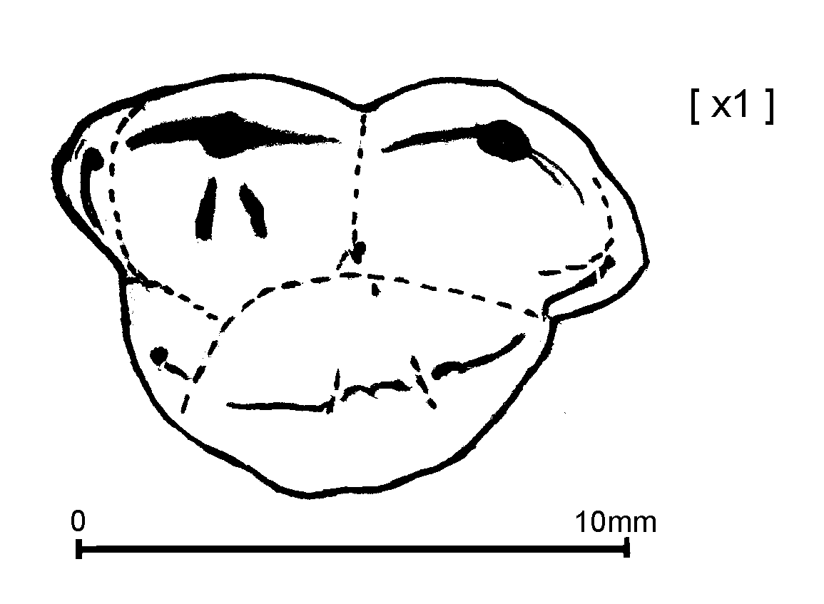  Figure 13. Ursus ingressus D⁴ LAC 12557 sin, occlusal,  with the morphotype | 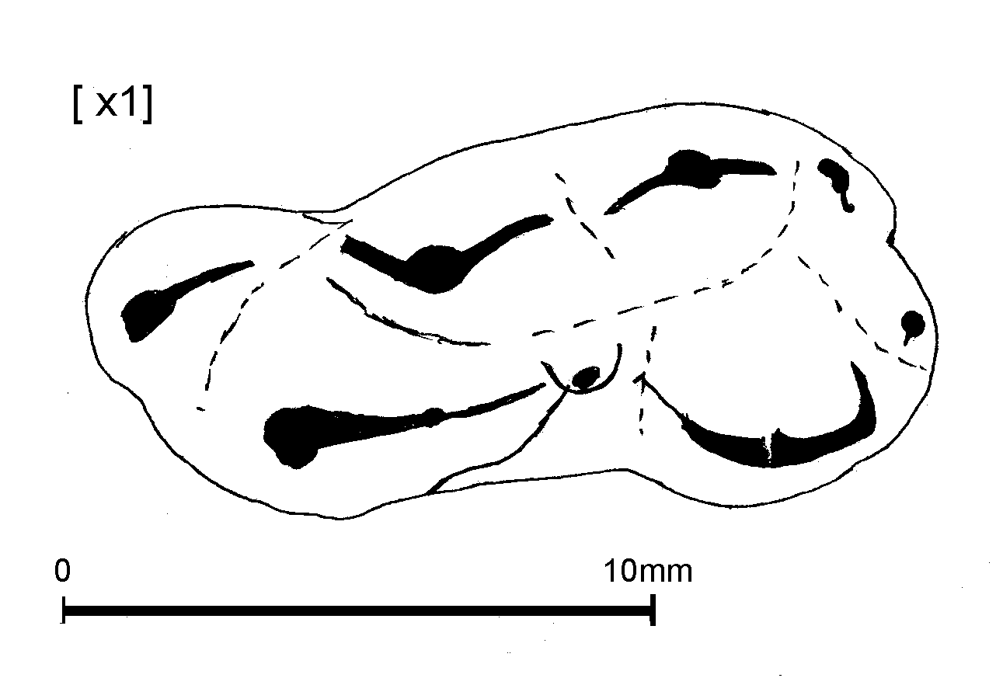  Figure 14. Ursus ingressus D₄ LAC 12560 sin, occlusal,  with the morphotype.
Concerning the milk canines, the material can be attributed to categories (KURTEN, 1976) (tab. 4): (A) by few germs – milk canines consisting by an enamel cap and a root that has barely started to form (fig. 11a), (B) by few complete teeth with unworn occlusal and fully formed roots (fig. 11c), (C) by complete teeth with root showing resumptions marks (fig. 11b). This is a preliminary stage to the tooth being shed and as the root is gradually dissolved by the osteoclast (KOBY 1952). there is a very large crop of shed milk canines (D) in which the root has dissolved completely (fig. 11d). The (E) category includes the heavy wear stage of deciduous. Finally the (F) includes worn deciduous canines with resorbed root.

Table 4. Ursus ingressus LAC: Wear stages of cave-bear deciduous canines
Wear stage (dC) | Description |  | Number of specimens  LAC | Westbury ANDREWS & TURNER 1992 | Odessa KURTEN 1976
A | Unerupted | Neonates | 132 | 22 | 13
B | Erupted | Neonates | 500 | 10 | 26
C | Unworn |  | 83 | 32
D | Slightly wear | Yearl-ings | 130 | 39 | 165
E | Heavy wear | Yearl-ings | 600 | 80
F | Worn with resorbed root | Yearl-ings | 155 | 8
Unerupted, when the crown is formed but the root is not; erupting, when some root development has taken place; unworn, when the root is fully formed but the crown has no wear; slight to moderate wear; heavy wear.

From the distinction of the dI³, D⁴ and D₄ in rights and lefts the MNI (minimum number of individuals) can be calculated to 355 individuals based on dI³ (the left ones) and 400 (not reliable, based on milk canines with the total 1600 rights and lefts plus uppers and lowers divided to 4)(tab. 5).

Table 5. Ursus ingressus LAC: Distinction of the dI³, D⁴ and D₄ in rights (dex) and lefts (sin)
for calculation of the minimum number of individuals (MNI).
Category of Teeth | Number of lefts (sin) | Number of rights (dex)
dI³ | 355 | 340
D⁴ | 120 | 120
D₄ | 139 | 146

Discussion, Conclusions
- Three caves of northern Greece present the most important milk teeth material of Pleistocene: the Petralona cave (PEC) with hyaenids and bears, the Agios Georgios, Kilkis cave (SGK) with hyaenids and Loutra Arideas Bear-cave (LAC) with bears.

- The most important remarks are preliminarily shown in table 6, as the research is in progress.

- In Middle Pleistocene Petralona Cave, the material representing the hyaenids comprises well preserved skull with almost all the slightly worn milk teeth and the unerupted left carnassial and the right M¹ as well as mandibles with the milk cheek teeth that give evidence, parallel to adults, the two genera crocuta and hyaena to be distinguished. For example the presence (Pliohyaena) or not (Crocuta) of the metaconid in the lower carnassials M₁ follows the milk carnassials D₄ respectively. For the bears only the upper carnassial can be compared with that of LAC and the main remark is that the morphotype is more complicated in LAC specimens than that from PEC.

- The Agios Georgios-Kilkis cave is the unique, up to now, exclusively hyaenid den of Greece, as the most specialized scavenger – Crocuta crocuta spelaea- the real cave hyaena, lived in. The presence of the milk teeth, the coprolites and the food remains establish the habitation. In other caves with quaternary faunas, the presence of the most common cave-bear is notable. A sample of hyaena tooth (upper carnassial) enamel was ESR dated giving an age in the range 12.2+2,5 Kyr BP. This indicates Greece as a refugee for the hyaenas, when they were largely excluded from northern and central Europe during last glacial. Further more, post cranial bones with infused epiphyses were found.

- The Late Pleistocene Loutra Arideas bear-cave is very rich in paleontological material of ursid milk teeth. thus the site can be considered as the unique place of Greece where so abundant and well stratified deciduous teeth from 189 excavated layers (5cm of thickness each) have been collected.

The abundance of the milk teeth, in spite their fragility, is very remarkable.

The majority of the tooth and bone remains belong to juveniles and sub-adults, while very few belong to very old individuals and few to adults.

Among the material there are specimens such as skull and mandibles with deciduous teeth and postcranial bones, especially metapodials with the distal epiphysis infused. Therefore all ages from juvenile to senate individuals are represented. The majority of the tooth and bone remains belong to juveniles and sub-adults, while very few belong to very old individuals and few to adults, indicating thus an extremely high incidence of young and neonate mortality.

The study of the milk teeth proved the presence either of unborn bears.

There are many bear carcasses as a result of death during hibernation. All this evidence establishes the inhabitation. On the other hand, many milk teeth must have been brought into the cave with the sediments.

The morphotype of the milk carnassials from Loutraki is similar to those from Gamssulzenhöhle (Austria).

Table 6. Some morphological characters on milk teeth of Pleistocene carnivores from Greek caves for comparison
 | U. deningeri | Crocuta spelaea intermedia | Pliohyaena perrieri | Crocuta crocuta spelaea | Ursus ingressus
 | Petralona  Middle Pleistocene |  |  | Agios Georgios, Kilkis  Latest Pleistocene | Loutra Arideas Bear-cave  Late Pleistocene
Mandible |  | brachygnath | hypsognath
D⁴  occlusal | More squarish |  |  |  | More rounded
paracone-metacone | More pointed and diverged |  |  |  | Lesser pointed and lesser diverged
Morphotype | Lesser complicated |  |  |  | More complicated
D₃ protoconid |  | Lesser intense  More erect | More intense  Inclined posterior | Lesser intense  More erect
Accessory cuspid |  | Anterior and two posteriors,  all small | anterior and posterior, clearly more developed | Anterior and two posterior small  clearly lesser developed
D₄ paraconid and protoconid |  | Pointed  Open angle | Pointed  Lesser open angle | Lesser pointed  More open angle
metaconid |  | absent | present | absent
talonid |  | Bicuspid:  hypoconid reduced, but entoconid & hypoconulid well developed | Tricuspid  All well developed | Not developed
cingulum |  |  | labial intense  in all milk teeth
Morphotype | Lesser complicated |  |  |  | More complicated

References
ANDREWS, P. & TURNER, A., 1992. Life and death of the Westbury bears. - Ann. Zool. Fennici, 28: 139-149, Helsinki.
CHATZOPOULOU (this volume). The small mammal fauna from the Loutra Arideas Bear-Cave (Pella, Macedonia, Greece) with emphasis on the third chamber.
DEBELJIAK, I., 1996. Ontogenetic development of dentition in the cave bear. – Geologija, 39: 13-77, Ljubljana.
DEBELJIAK, I., 1997. Age composition of the cave bear population from the Divje babe I Cave. – Int. Meeting on man and Bear, Auberives - Pont en Royans (Vercors – Isère).
EHRENBERG, K. 1964. Ein Jungenbärenskelett und andere Höhlenbärenreste aus der Bärenhöhle im Hartlesgraben bei Hiflau (Steiermark).- Ann. Naturhistor. Mus. Wien, 67: 189-252.
ERDBRING, D. P., 1953. A review of fossil and recent bears of the old world. 1-2. Jan de Lang, Deventer
KOBY, F.-Ed., 1952. La dentition lacteale d’ Ursus spelaeus. - Rev. Suisse Zool., Geneve. 59(27): 511-541.
KURTÉN, B., 1968. Pleistocene Mammals of Europe. Aldine Publishing Company, Chicago: 1 – 317.
KURTEN, B., 1976. The cave bear story. Life and death of a vanished animal.- Columbia University Press, 1-163, New York.
PAPPA, S., 2004. Study on the milk teeth of the cave bear from the excavational research in Loutra Arideas Cave.- Diplomatic work with unpublished data submitted to the school of Geology, Aristotle University, 1-81, Thessaloniki
RABEDER, G., 1983. Neues vom Höhlenbären. Zur Morphogenetik der Backenzähne. Die Höhle, H. 2(34): 67-85, Wien.
RABEDER, G., 1991. Die höhlenbären der Counturines.- Verlagsanstalt Athesia, 1-124, Bozen.
RABEDER, G., 1999. Die Evolution des Höhlenbärengebisses.- Mitt. Kom. Quartärforch. Östrerreich. Akad. Wiss. 11: 1-102, Wien.
RADULESCU, C. & SAMSON, P., 1959. Contribution a la connaissance de la dentition lacteale d’Ursus spelaeus. Eiszetalter und Gegenwart, 10: 205-216, Ohringen.
TERZEA, E., 1969. Nouvelles données sur la dentition lacteale de l’Ursus spelaeus.-Act. IV. Congr. Int. Speleaol. 4-5: 383-389.
TORRES PEREZ-HIDALGO, T.J., 1988. Osos (Mammalia, Carnivora, Ursidae) del Pleistoceno de la Peninsula Iberica. Boletin Geologico y Minero, Madrid (publ. espec.), 1-4: 1-316.
TSOUKALA, E., 1989. Contribution to the study of the Pleistocene fauna of large mammals (CARNIVORA, PERISSODACTYLA, ARTIODACTYLA) from Petralona Cave (Chalkidiki, N. Greece). Doctorate Thesis, Aristotle University of Thessaloniki, Sci. Ann., School of Geology, 1(8): 1-360, 124 fig., 64 tabl., 62. pl., summary in English. - C.R.A.S. Paris 312 (II): 331-336, 1991.
TSOUKALA, E., 1992a. The Pleistocene large mammals from the Agios Georgios Cave, Kilkis (Macedonia, N. Greece). – Geobios, 25 (3): 415-433, Lyon.
TSOUKALA, E., 1992b. Quaternary faunas of Greece- Courier Forsch. - Inst. Seckenberg, 153: 79-92, Frankfurt a.M.
TSOUKALA E. 1994. Bärenreste aus Loutraki (Mazed., Griechen.) -“Ursus spelaeus”: 2nd Höhlenbären Sympos. (Corvara, 15-18/9/94), Italy.
TSOUKALA, E. 1996. Comparative study of ursid remains from the Quaternary of Greece, Turkey & Israel. – Acta Zool. Cracoviensa., 39(1): 571-576.
TSOUKALA, E., RABEDER, G. & VERGINIS, S., 1998. “Ursus spelaeus and associated faunal remains from Loutraki (Pella, Macedonia, Greece) - Excavations of 1996. Geological and geomorphological approach”.- 4th International Höhlenbären Symposium, 17-19/9/98, Velenje, Slovenia.
TSOUKALA, E., RABEDER, G. & †VERGINIS, S., 2001. Ursus spelaeus and Late Pleistocene associated faunal remains from Loutraki (Pella, Macedonia, Greece). Excavations of 1999. – Cadernos Lab. Xeolóxico de Laxe, 26: 441-446, Coruña.

