KARST FIELD STUDIES, OFFERED BY WESTERN KENTUCKY UNIVERSITY’S
CENTER FOR CAVE AND KARST STUDIES, AND
THE MAMMOTH CAVE NATIONAL PARK INTERNATIONAL CENTER FOR SCIENCE AND LEARNING

Leigh Ann Croft*
Nicholas C. Crawford
Center for Cave and Karst Studies
Applied Research and Technology Program of Distinction
Department of Geography and Geology
Western Kentucky University
Bowling Green, Kentucky, USA

Rickard Toomey*
Mark DePoy
Mammoth Cave International Center for Science and Learning
Mammoth Cave National Park
Mammoth Cave, Kentucky, USA

ABSTRACT

The first cave and karst center in the USA, the Center for Cave and Karst Studies (CCKS), was established at Western Kentucky University in 1978 by Nick Crawford. The objectives of the center are to perform basic and applied research on karst environmental problems and to provide educational programs about caves and karst. The CCKS is a part of the Department of Geography and Geology and one of the centers within the Applied Research and Technology Program of Distinction. The CCKS has attracted numerous undergraduate and graduate students over the past 27 years.

In 1979, the CCKS and Mammoth Cave National Park (MCNP) agreed to jointly sponsor the Karst Field Studies Program to offer courses/workshops on caves and karst. The philosophy was to establish a program based upon quality instead of quantity. It was necessary to restrict the enrollment in each course to a maximum of 20 participants for safety reasons and to ensure minimum impact to the cave environment. The combination of outstanding karst scientists as instructors and the use of the world’s longest cave as a laboratory has attracted participants for the past twenty-five years from throughout the USA as well as from Great Britain, Slovenia, China, Brazil, Australia and other countries. This cooperative program between the CCKS and MCNP has played an important role in educating students, environmental consultants, government employees and others about caves and karst. Many of the program’s participants have gone on to educate others about karst and the environmental sensitivity of caves, karst groundwater and karst landscapes.

CENTER FOR CAVE AND KARST STUDIES

The CCKS personnel consists of director and affiliated faculty, chemist/laboratory manager, research hydrologist, education coordinator, office coordinator and 16 graduate and undergraduate assistants.

The objectives of the CCKS are as follows:

- To be a research center dealing with all aspects of cave and karst studies, with an emphasis on solving environmental problems associated with karst;
- To provide educational programs concerning cave and karst studies: a) undergraduate and graduate instruction, b) cooperative education program with Mammoth Cave National Park International Center for Science and Learning, c) workshops, seminars, and scientific meetings;
- To provide public service by assisting individuals, private firms, and government agencies with karst environmental problems.

Over the past twenty-seven years, the CCKS has attracted outstanding undergraduate and graduate students from various parts of the United States. Graduate and undergraduate research assistants are actively involved in the research efforts of the CCKS. Both graduate and undergraduate students usually graduate with a substantial number of publications and presentations to their credit. Students get “hands-on” experience in dealing with karst environmental problems through CCKS research for government agencies, as well as for private business. Graduates have been very successful in obtaining positions with both government and private consulting firms.

The CCKS is one of the centers in the Applied Research and Technology Program of Distinction (ARTP) at WKU. The ARTP is a multidisciplinary program consisting of 12 scientific and service-oriented centers designed to prepare students for the knowledge-based economy. These centers meet the needs of the community, state, and nation while providing unique opportunities for undergraduate and graduate students to transition from academia to the workplace through participation in supervised, hands-on applied research and technological projects. Each center operates within a cooperative and interdisciplinary framework to apply state-of-the-art science toward solutions to the technological problems of government, industry, and the environment.

The CCKS offices and labs are located within the Department of Geography and Geology in the Environmental Sciences and Technology Building at Western Kentucky University. The Department of Geography and Geology is comprised of 22 full-time faculty members and serves about 275 undergraduate majors, 80 minors, and 30 graduate students in a variety of specializations. The Department offers a B.S in Geography, a B.S. in Geology and a M.S. in Geoscience. In addition to the CCKS, several other educational, research, and public service facilities are housed within the Department that provide exciting opportunities for a combination of theoretical and practical work. The Kentucky Climate Center, also one of the ARTP’s centers, is staffed by the State Climatologist and maintains an extensive set of Kentucky climatic data. It has several graduate and undergraduate research assistants involved in meteorological and climatological research. The College Heights Weather Station maintains a fully equipped weather station with remote radar capability. The Hoffman Environmental Research Institute, part of the Center for Water Resource Studies, one of the ARTP centers, is a consortium of scientists and students dedicated to research and higher education at the cutting edge of environmental science. Its primary mission is to be a leader in the development of innovative, basic, and applied research programs aimed at understanding the dynamics of human-landscape-atmosphere interactions. The Department of Geography and Geology offers a GIS certificate through its new Geographic Information Science (GIS) Laboratory. A major goal of the Department's activities is to involve undergraduate and graduate students actively in all aspects of research as an integrated part of their academic programs with the purpose of nurturing their intellectual growth, critical-thinking skills, and technical experience.

MAMMOTH CAVE INTERNATIONAL CENTER FOR SCIENCE AND LEARNING
The Mammoth Cave International Center for Science and Learning (MCICSL) is a new collaboration between Western Kentucky University (WKU) and the National Park Service (NPS). Its mission is to improve understanding, management, and interpretation of karst resources in the Mammoth Cave, Kentucky area, nationally, and internationally. Primary goals include 1) developing partnerships to improve karst science, education, and conservation; 2) assembling research catalogs so that karst managers and researchers can readily work together; 3) developing new and enhanced opportunities for undergraduate, graduate, and professional research; 4) increasing international collaboration by providing opportunities for exchange of professional scientists and students; 5) bringing new developments in karst science and management to the public through education outreach; and 6) extending the reach and impact of the CCKS Karst Field Studies Program.

The Center, which was formally inaugurated in August 2004, is jointly funded by WKU and the NPS. It is housed at WKU's Bowling Green, Kentucky campus and at Mammoth Cave National Park. Eventually much of its operation will be based at a renovated classroom, laboratory, dormitory, and research residence complex in the Mammoth Cave National Park. In addition to its cooperative program with WKU, it is also one of the United States National Park System's network of Research Learning Centers. These Research Learning Centers are a program to facilitate research efforts and provide educational opportunities centered on National Parks.

The recently formed MCICSL’s programs are still in the development phase. Dr. Rickard Toomey recently took the position of Director of the Center. He is currently working on one of the top priorities which is to actively develop partnerships with various organizations to assist with karst research, management and education.

KARST FIELD STUDIES PROGRAM

General information
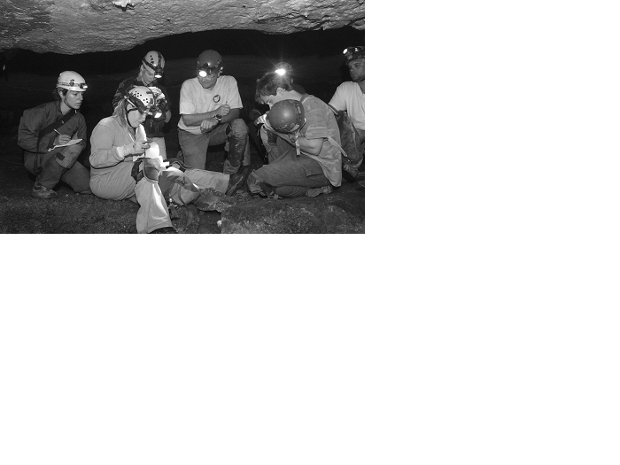
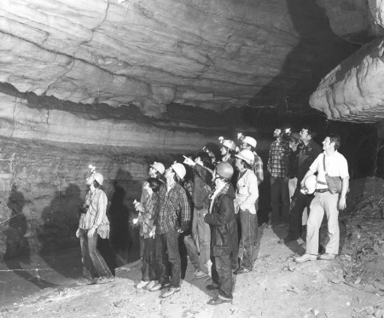
The Karst Field Studies program consists of a series of one-week summer courses focusing on caves, karst and caving. Course professors have been chosen who are internationally-recognized authorities in their fields. While some courses require previous subject knowledge, other courses are designed for those with merely an interest in caves. Several courses have been offered over the years that focus on cave development and genesis such as Karst Geology, Karst Geomorphology (Figure 1) and Speleology. Others courses have dealt with the history of Mammoth Cave, such as, Exploration of Mammoth Cave and Cave Archaeology. Courses dealing with cave life include Cave Biology, Cave Ecology (Figure 2) and Cave Geomicrobiology. Other courses include Cave and Karst Stewardship and Cave Surveying and Cartography, which focus on ways to preserve cave systems through research, resource management, mapping and resource database documentation. Three courses focus on karst hydrology. Two of these courses, Hydrology of the Edwards Aquifer and Management of Karst Aquifers are taught in San Antonio, Texas, USA. Karst Hydrology is taught in Bowling Green, Kentucky, USA and concentrates on environmental problems associated with karst, research techniques in karst hydrology, and methods for remediation of karst environmental problems.
Figure 1: Participants in Dr. Paul Williams’ 1981 Karst Geomorphology course.

Format of the courses
Professors typically lecture in the mornings with cave and surface trips and/or field or laboratory exercises scheduled for the afternoons. Special talks, slide shows, and trips into the cave are often scheduled after dinner. Activities may include: 1) all-day trips into Mammoth Cave, 2) surface trips into the Park and surrounding area, 3) various field exercises including geophysical techniques for investigating karst subsurface features, and 4) dye tracer tests to determine groundwater flow, and 5) laboratory analysis.
Figure 2: Participants in Dr. Horton Hobbs’ 2004 Cave Ecology course.
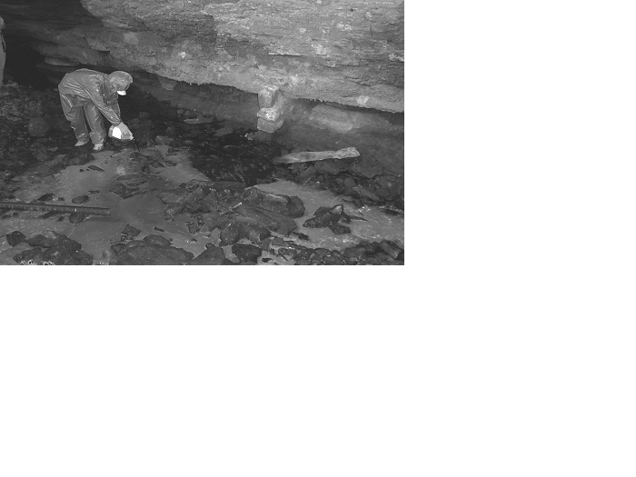

Figure 3: Participant injecting Fluorescein dye in the 2004 Karst Hydrology course taught by Dr. Will White and Dr. Nick Crawford.

e 3: Participant of the 2004 Karst Hydrology Course injecting Fluorescein dye.

Professors and Curriculum.
The following are some of the professors who have served as CCKS adjunct faculty and taught courses/workshops over the 25 year history of the program:

- Paul Williams, Ph.D. Karst Geomorphology
- Derek Ford, Ph.D. Karst Geomorphology
- Will White, Ph.D. Karst Hydrology
- Art Palmer, Ph.D. Karst Geology
- Tim Atkinson, Ph.D. Karst Hydrology
- Peter Smart, Ph.D. Karst Hydrology
- Jim Quinlan, Ph.D. Karst Hydrology
- Nick Crawford, Ph.D. Karst Hydrology
- Patty Jo Watson, Ph.D. Cave Archaeology
- Horton Hobbs, III, Ph.D. Cave Ecology
- Hazel Barton, Ph.D. Cave Geomicrobiology
- George Veni, Ph.D. Karst Hydrology of Edwards Aquifer
- Chris Groves, Ph.D. Karst Geomorphology
- Tom Barr, Ph.D. Cave Biology
- Tom Poulson, Ph.D. Cave Biology
- Stan Sides, M.D. Exploration of Mammoth Cave
- Patricia Seiser, Ph.D. Cave and Karst Stewardship
- Roger Brucker Speleology
- Joe Meiman, Hydrologist, MCNP Karst Geomorphology
- Daryl Grainger, Ph.D. Karst Geomorphology
- Ron Kerbo, Nat’l Cave Mgmt Coordinator, NPS Cave and Karst Stewardship
- Rick Olson, Ecologist, MCNP Cave Ecology
- Pat Kambesis Cave Surveying and Cartography

PLANS FOR THE FUTURE

A major goal for the CCKS and the MCICSL is to attract more international scientists and students to participate in the Karst Field Studies Program at the newly established Mammoth Cave International Center for Science and Learning by offering scholarships and course fee waivers to international participants. The CCKS and the MCICSL would also like to offer courses in other countries in cooperation with other cave and karst centers.

