APPLICATION OF DYE TRACER TECHNIQUES
IN THE PREPARATION OF A CONCEPTUAL HYDROGEOLOGIC MODEL
FOR A CONTAMINATED KARST AQUIFER: SAAD SUPERFUND SITE, NASHVILLE, TENNESSEE, USA

Nicholas C. Crawford, Ph.D.
Center for Cave and Karst Studies
Applied Research and Technology Program of Distinction
Department of Geography and Geology
Western Kentucky University
Bowling Green, Kentucky, USA

Abstract
The SAAD Oil Company, a U.S. Environmental Protection Agency (USEPA) Superfund site, is located in Nashville, Tennessee, USA. SAAD Oil Company extracted impurities from used motor oil to enable recycling, and the USEPA suspected it was the source of over 20 years of contamination flowing from Croft Spring which is located approximately 762 m (2,500 ft) southeast of the SAAD site and the headwaters of a stream that flows through the Nashville Zoo. After SAAD Oil declared bankruptcy, over 200 of its clients who had sent used oil to them for recycling were named as the primary responsible parties (PRPs) for the contamination, and according to U.S. law, for its clean-up. Attorneys for the PRPs believed the source of contamination to be from two other sites, 1) the General Electric factory to the east that had lost polychlorinatedbiphenyls (PCBs), and 2) the CSX Railroad Radnor Switching Yard (CSX Radnor Yard) located adjacent to the SAAD site to the west that had a groundwater contamination problem due to loss of diesel fuel. Therefore, the USEPA funded a hydrogeologic investigation by Crawford to determine which facility or facilities were responsible for the contamination. The results of a karst hydrogeologic inventory which included over 100 dye receptor locations, a water table surface elevation investigation, a stage height investigation at Croft Spring, six dye tracer tests, and a matrix interference analysis revealed that both the SAAD Oil Company and the CSX Radnor Yard were responsible for the contamination at Croft Spring. Results are presented in a map showing the karst hydrogeologic features, water table contours, and the approximate dye trace flow routes and groundwater basin boundaries. Also included is a hydrogeologic profile across the site showing the geologic stratigraphy, the water table surface and a general model of the interrelationship between groundwater flow and geology.

Karst Hydrogeologic Inventory

A hydrogeologic inventory was performed to locate all springs, water wells, monitoring wells, caves, karst windows, sinkholes and other karst features within an area that covered approximately 103.6 km (40 sq mi). This required several weeks of field work by karst scientists trained to locate these features. Activated coconut charcoal dye receptors were placed in over 100 springs, wells (primarily monitoring wells), and surface streams, and automatic water samplers were placed at Croft Spring and at the Radnor Yard Outfall (this storm sewer outfall is actually a spring that discharges both groundwater and storm water runoff from the CSX Radnor Yard).

Water Table Investigation

The water table surface for the uppermost karst aquifer was contoured by measuring the water levels in the numerous monitoring wells at various factory sites that were screened into the water table aquifer. In addition, spring and surface stream elevations were determined by leveling from nearby benchmarks. This data permitted the water table surface to be contoured during both a dry period in October and a wet one in March. The water table elevation fluctuated only a small amount between these two periods. The water table data provided very important information concerning groundwater flow direction. It indicated a water table ridge that extended northeast-southwest in the vicinity of the SAAD Oil and CSX Radnor Yard sites, and it revealed troughs in the water table that extended from the water table ridge downgradient to the east toward Croft Spring and to the northwest toward the Radnor Yard Outfall Spring.

Dye Tracer Investigation of Groundwater Flow

Groundwater flow direction could not be established from the water table data since all three sites were in the vicinity of the water table high. Therefore, six dye tracer tests were performed to better define groundwater flow direction. Previous to dye injection, fluorescent dye background levels were established at all monitored locations to determine dye selection and to observe the fluctuation in background levels for the various dyes being considered. Both one-week and two-week background levels were established, with background monitored during at least one significant storm event.

Matrix Interference Analysis

There were three concerns relating to the groundwater contaminants’ possible effect upon the dyes being considered for injection. Some of the contaminants might: 1) diminish the dye’s fluorescence, 2) diminish the ability for the dyes to be adsorbed onto the charcoal dye receptors, and/or 3) impact the ability of the Smart Solution (Smart and Laidlaw, 1977) to elute the dyes adsorbed onto the charcoal. Therefore, a three-part laboratory matrix interference analysis was performed on four-liter (1.06 gal) grab water samples from the following locations in order to quantify these variables for the dyes being considered for use: 1) Croft Spring, 2) Radnor Yard Outfall Spring, and 3) contaminated groundwater from wells in the vicinity where the dyes were to be injected.

The matrix interference analysis did not indicate a significant impact on the fluorescence ability of the dyes investigated, nor upon the adsorption capacity of the activated charcoal, nor upon the eluent’s (Smart Solution) ability to elute the dyes from the charcoal.

Hydrogeologic Investigation

U.S. Geological Survey, 7.5 minute, geologic quadrangle maps were investigated for the SAAD site vicinity. In addition, numerous well logs from monitoring wells at several industrial sites in the area were studied. Although regolith is typically very thin above bedrock throughout much of the vicinity, this data indicated that the regolith (residuum) in the vicinity was over 15.4 m (50 ft) thick in some areas. In addition, data revealed that, in order to prepare a level surface for the CSX Radnor Yard, approximately 9.1 to 15.2 m (30 to 50 ft) of fill material had been placed over a large area above the regolith. The geologic data indicated that the regolith was underlain by the Ordovician Bigby-Cannon Limestone which was typically 6.1 to 12.2 m (20 to 40 ft) thick. Below the Bigby-Cannon was the Ordovician Hermitage Formation, an argillaceous and shaley limestone which tends to be a confining layer. Croft Spring and the Radnor Outfall Spring are located directly upon or slightly above the Hermitage Formation. Therefore, the karst aquifer was located within the Bigby-Cannon Limestone. At most places, the water table was located in the regolith, well above the top of the Bigby-Cannon Limestone. This fact indicated laminar groundwater flow through the regolith until it reached a conduit in the underlying Bigby-Cannon Limestone. It also indicated that the dye traces would be difficult, and that dye would move slowly through the regolith until finally getting into an open conduit in the underlying Bigby-Cannon Limestone.

Stage Height Investigation at Croft Spring

Croft Spring, an obvious karst spring, was reported to rapidly rise and fall over 1.22 m (4 ft) after heavy rains. This information tended to indicate a turbulent flow karst aquifer with rapid recharge through sinkholes and sinking streams. However, the landscape in the area does not have noticeable sinkholes or sinking streams and the hydrogeologic investigation indicated that the water table was in the regolith well above bedrock, indicating more diffuse flow with slow recharge rather than rapid conduit flow. Precipitation and stage were monitored at Croft Spring with a pressure transducer/data logger during the dye tracer tests for a period of approximately 10 months. Even though several large rain events occurred during this period, the spring stage only fluctuated .06 m (0.2 ft), indicating that recharge was primarily from slow percolation through the thick regolith down into the solutionally-enlarged conduits in the Bigby-Cannon Limestone. This data provided very useful information concerning the nature of the karst aquifer and the relatively slow dye flow rates.

Dye Traces

Previous consultants had drilled and installed monitoring wells over 45.7 m (150 ft) deep in the vicinity of the General Electric factory. An investigation of the well logs indicated that monitoring wells had been drilled completely through the Hermitage confining layer and screened into a confined aquifer in the underlying Carters Limestone. Further examination of the logs revealed that one of the wells had encountered a 2.1 m (7 ft) void only 7.3 m (24 ft) underground in the Bigby-Cannon Limestone directly above the Hermitage. The drillers did not encounter sufficient water at this depth, so this void was cased off, and drilling continued through the Hermitage down into Carters Limestone confined aquifer.

For this investigation, a new well was drilled approximately 0.9 m (3 ft) from the well that intersected the 2.1 m (7 ft) air-filled void, and Sodium Fluorescein (Color Index: Acid Yellow 73) dye was injected and flushed with 7,570 l (2000 gal) of potable water. The dye did not resurge at Croft Spring but instead resurged 45 days after injection at McNally Drive Spring located about 609.6 m (2,000 ft) east of the site. This data agreed with the flow direction indicated by a downgradient trough in the water table. Therefore, the dye tracer results indicated that the General Electric facility was not responsible for the contaminants resurging from Croft Spring.

Five additional dyes were injected into monitoring wells and open excavated pits in the vicinity of the SAAD Oil facility and CSX Radnor Yard. Eosine (Color Index: Acid Red 87) dye injected into a pit at the SAAD Oil site was detected 103 days later at Croft Spring, and interestingly, also detected 103 days after injection at the CSX Radnor Yard Outfall Spring. Rhodamine WT (Color Index: Acid Red 388) dye injected into a monitoring well at the CSX Radnor Yard site was detected at the Radnor Yard Outfall Spring 102 days later and at Croft Spring 174 days after injection. Three other dyes injected in the vicinity of the SAAD Oil site and at CSX Radnor Yard were also detected at both springs with dye flow rates that varied from 5.25 to 9.43 m (17.24 to 30.93 ft) per day. Interestingly, slug tests performed on several monitoring wells in the vicinity by previous consultants indicated an approximate flow rate of 40.2 m (132 ft) per year. Slug and pumping tests do not provide valid data in most karst aquifers as has been demonstrated on numerous occasions by dye tracer tests.

The dye tracer investigation revealed that groundwater flow from the General Electric factory flows directly to McNally Drive Spring and does not flow to any other location. The results of the dye tracer investigation indicated that groundwater from the SAAD Oil and the CSX Radnor Yard sites, both located along a ridge in the water table, flowed to both Croft Spring to the east and to the Radnor Yard Outfall Spring to the west.

Site Conceptual Hydrogeologic Model

Figure 1 is a site conceptual hydrogeologic model showing the water table contours, the results of the six dye traces and the approximate location of the groundwater divide boundaries between the Croft Spring Groundwater Basin, the Radnor Yard Outfall Spring Groundwater Basin and the McNally Drive Spring Groundwater Basin. The diagram clearly shows that five of the dyes injected along the top of the groundwater ridge flowed downgradient to both Croft Spring to the east and Radnor Yard Outfall Spring to the west.

Figure 2 is a hydrogeologic profile from Radnor Yard Outfall Spring across the drainage divide to Croft Spring, and it clearly reveals how groundwater flows to both springs. The placement of 9.1 to 15.2 m (30 to 50 ft) of fill material along the headwaters of Brown Creek by the CSX Railroad had a damming effect upon groundwater flow. Not filling the area near the headwaters of Brown Creek created a large depression approximately 457 m (1,500 ft) in diameter. CSX Railroad installed a storm sewer to drain this large depression which extended under CSX Radnor Yard to discharge at the Radnor Yard Outfall. The fill material increased infiltration and reduced storm water runoff causing the water table to rise above the storm sewer, even during base flow conditions as indicated in Figure 2. Therefore, groundwater has been flowing out the Radnor Yard Outfall since its construction in the 1950s. It also appears that this large area of fill material displaced the water table divide to the west, and the divide is now located directly under the Radnor Yard surface depression (Figure 2). Since the dyes injected in the vicinity of the SAAD Oil and the CSX Radnor Yard sites were injected into the regolith (residuum) along this divide, some of the dye traveled to Croft Spring, but some also flowed into the storm sewer to discharge in the opposite direction at the Radnor Yard Outfall Spring. Therefore, the site conceptual hydrogeologic model indicates that SAAD Oil and CSX Railroad are both responsible for the groundwater contamination of Croft Spring and Radnor Yard Outfall Spring. This investigation provides a good example of the application of dye tracer techniques in the preparation of a conceptual hydrogeologic model for a contaminated karst aquifer. It provided definitive evidence of contaminant flow through this karst aquifer, and the results have withstood serious scrutiny by not only government regulatory agencies but also numerous attorneys representing all three companies.

References

Crawford, N.C. (1995). “Hydrogeologic investigation: SAAD Trousdale Site, Nashville, Davidson County, Tennessee”, Volumes 1-9, Report submitted to Roy F. Weston, Inc., U.S. Environmental Protection Agency Technical Assistance Team.

Smart, P.L. and Laidlaw, I.M.S. (1977). “An Evaluation of Some Fluorescent Dyes for Water Tracers”, Water Resources Research, 13(1): 15-33
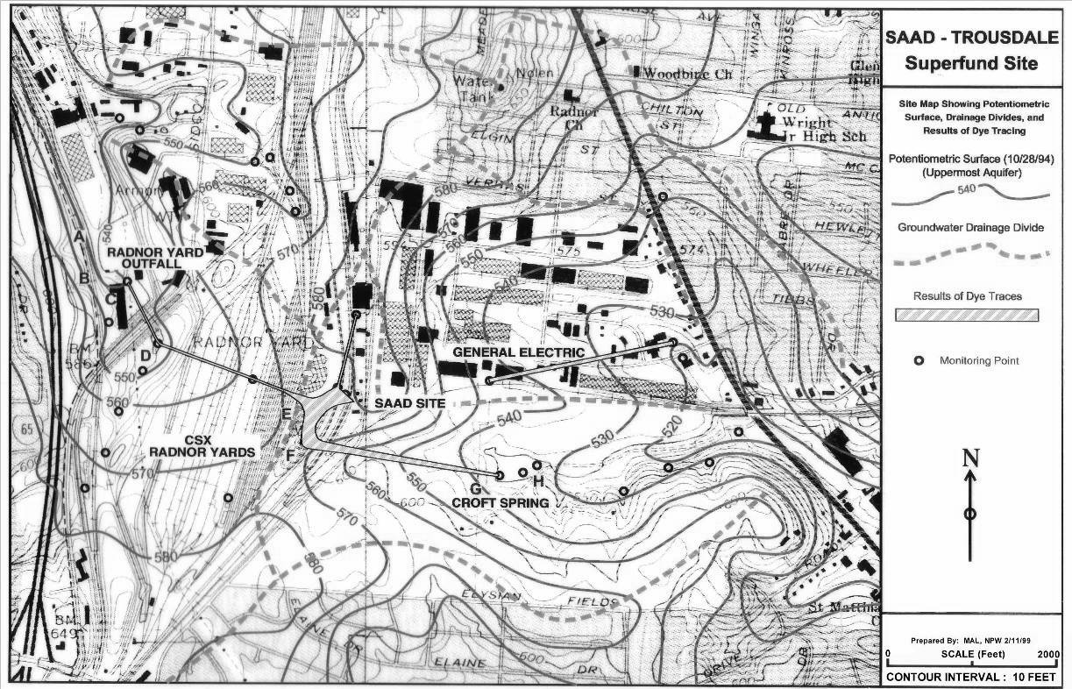
Figure 1. Site conceptual hydrogeologic model showing water table contours, groundwater basin drainage boundaries and dye traces.

Figure 2. Hydrogeologic profile from Radnor Yard Outfall Spring to Croft Spring.
