Explorations and Geomorphology of the Velebita–Dva Javora Cave System on North Velebit Mt. in Croatia - World’s Deepest Subterranean Shaft

Darko Bakšić¹, Andrej Stroj² & Mladen Kuhta²

¹ Faculty of Forestry, Svetošimunska 25, Hr-10000 Zagreb, Croatia
² Institute of Geology, Sachsova 2, Hr-10000 Zagreb, Croatia
E-mail: baksa@hazu.hr; astroj@igi.hr; kuhta@igi.hr

Abstract

The North Velebit massif according to the recent exploration results is speleologicaly the most important Dinaric karst region. Over the last 14 years about 300 caves were discovered and explored. The system Lukina jama - Trojama (-1392 m) and Slovačka jama (-1301 m) are the deepest caves in Croatia and rank as 16th and 21st deepest caves in the world. Furthermore, significant depths were reached in the Meduza (-679 m), Patkov gušt (-553 m), Ledena jama (-536 m) and Jama Olimp (-531 m) caves. The karstification processes are dominantly controlled by vertical groundwater circulation through the deep unsaturated zone built up of fractured carbonate rocks. As the result about 97 % of explored caves may be classified as pits with long vertical sections as their major morphological characteristic. For instance, the 553 m deep pit Patkov gušt practically consists of one vertical shaft, the final part of Meduza represents a 390 m deep vertical shaft. Vertical sections longer than 200 m can be found in almost all deeper caves.
The intense vertical karstification processes and genesis of extremely deep speleological objects in this area are confirmed by the last explorations in the Velebita pit. This 580 m deep cave system morphologically has a 513 m subterranean (internal) vertical section, which is the world’s deepest known subterranean shaft.

Introduction

The discovery of the cave Lukina jama in 1992 in the North Velebit Mt. area started off intensive speleological researches. In the period from 1992 to 2004 more than 250 caves were explored in this area. The cave system Lukina jama – Trojama (-1392 m) and cave Slovačka jama (-1320 m) are the deepest speleological objects in Croatia and are the 16th and 21st deepest cave in the world. Another 5 caves deeper than 500 m were explored; Meduza (-679 m), Patkov Gušt (-553 m), Ledena Jama (-536 m), Olimp (-531 m) and Lubuška Jama (-521 m). During the Croatian-French expedition, the aim of which was to continue the explorations in cave Meduza, members of the speleological department of the mountaineering society “Velebit” found the entrance into cave Velebita, called after the society and the mountain range where the cave is situated. The cave was explored to the depth of -376 m in that same year. The explorations continued in August 2004 and went to the depth of -580 m. The second entrance into the cave (cave “Dva Javora”) was also found and explored.

Geological, hydrogeologic and geomorphologic setting of the terrain

North Velebit Mountain is built of rocks dating from the Jurassic period to Palaeogene. The Jurassic period is represented by carbonate sediments in which limestone predominate but there are also dolomites in them. The Cretaceous sediments have been arranged on the border parts of North Velebit Mt. in the direction of the Lika region (hinterland of the massif) and in the coastal part too. They consist of limestone, carbonate breccias and dolomites. In hydrogeologic sense, rocks from the Jurassic and the Cretaceous period are highly permeable.
Palaeogene is represented by “Jelar” carbonate breccias widely spread in northern and western parts of Velebit. In the southern part of North Velebit Mt. these sediments cover the entire profile from sea coast on the west to the Lika region on the east side of the mountain. Jelar breccias are very significant due to their singular submissiveness to karstification processes, KUHTA (2001). Areas having the most intensively developed karstic morphology, as well as entrances into all deepest objects on North Velebit, are found in the area built of these rocks. It also frequently happens that shafts or entire caves stop on the point of the contact of Jelar sediments and Jurassic carbonate rocks; thus the bottom of the big shaft in cave Velebita is rather close to this contact. The data on the thickness of Jelar sediments up to 300 m are mentioned in Literature, BAHUN (1974), although during explorations of cave Velebita the contact of Jelar breccias and Jurassic rocks was identified on the depth larger than 500 m.
Geological structure of North Velebit Mt. also conditions hydrogeologic situation inside the massif. Since low permeable rocks, which are found on the very surface in the Middle and Southern Velebit, are much deeper here, the sea level becomes the erosion base of karstification. As a consequence of such situation there is present a deep unsaturated zone with dominantly vertical water flows in north Velebit massif. Only two deepest caves Lukina jama and Slovačka jama in their bottom parts reach recent and sub-recent levels of saturated zone where systems of horizontal channels occur. When waters which fall on a permeable terrain as precipitations reach the saturated zone, they join the waters form the River Gacka and the River Lika. These two rivers sink underground next to east borders of north Velebit and their waters spring on the numerous coastal springs and vruljas along the western border of a Velebit massif.
As a consequence of such situation, the most singular feature of speleological objects in the area of north Velebit is their verticality. Thus cave Patkov Gušt is a 553 m deep shaft from its top to the bottom which makes it the second deepest shaft in the world. The 513 m deep shaft “Divke Gromovnice” in the cave system Velebit – Dva Javora is the deepest known shaft in the world having no outside entrance. We should also mention 390 m deep shaft “Bojim, bojim” in the cave Meduza. Shafts deeper than 200 m can be found in majority of more significant caves on North Velebit. Precisely these characteristics make area of the North Velebit Mt. unique in the world.

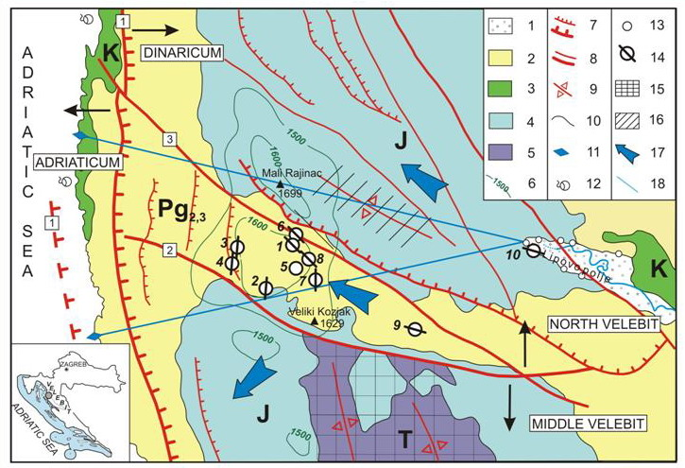
Fig. 1 Simplified geological map of the North Velebit area. Legend: 1) alluvium deposits; 2) calcareous breccias of Upper Palaeogene; 3) Cretaceous carbonate rocks; 4) Jurassic carbonate rocks; 5) Triassic carbonate and clastic rocks; 6) summary amplitudes of vertical neotectonic movements (in metres); 7) reverse faults, (1) Velebit fault; 8) normal faults, (2) Bakovac fault, (3) Lomska duliba fault; 9) anticline axis; 10) geological boundary; 11) coastal spring; 12) submarine spring (vrulja); 13) sinkhole; 14) deep caves, (1) Lukina jama, (2) Slovačka jama, (3)Meduza, (4) Velebita, (5) Patkov gušt, (6) Ledena jama, (7) Olimp, (8) Lubuška, (9) Paž, (10) Markov ponor; 15) area of Velebit complex barrier; 16) relative barrier; 17) general groundwater flow direction; 18) groundwater flow direction tested by tracing.

Morphology of the Velebita– Dva javora cave system

The entrance into the cave Velebita is located on steep western slopes of the central part of the North Velebit Mt. It is hidden by collapsed rock blocks and it is hardly noticeable. A narrow passage leads into the first shaft 35 m deep. On its bottom, there is another narrow passage, called “Striborov Prolaz”, leading into the second 25 m deep shaft. The system becomes rather indented in this part. Meanders prevail, out of which some end in narrowings (Palčičev Meandar), and some in shafts (Malikova Igrarija, Perunov Meandar). Besides the shaft “Divke
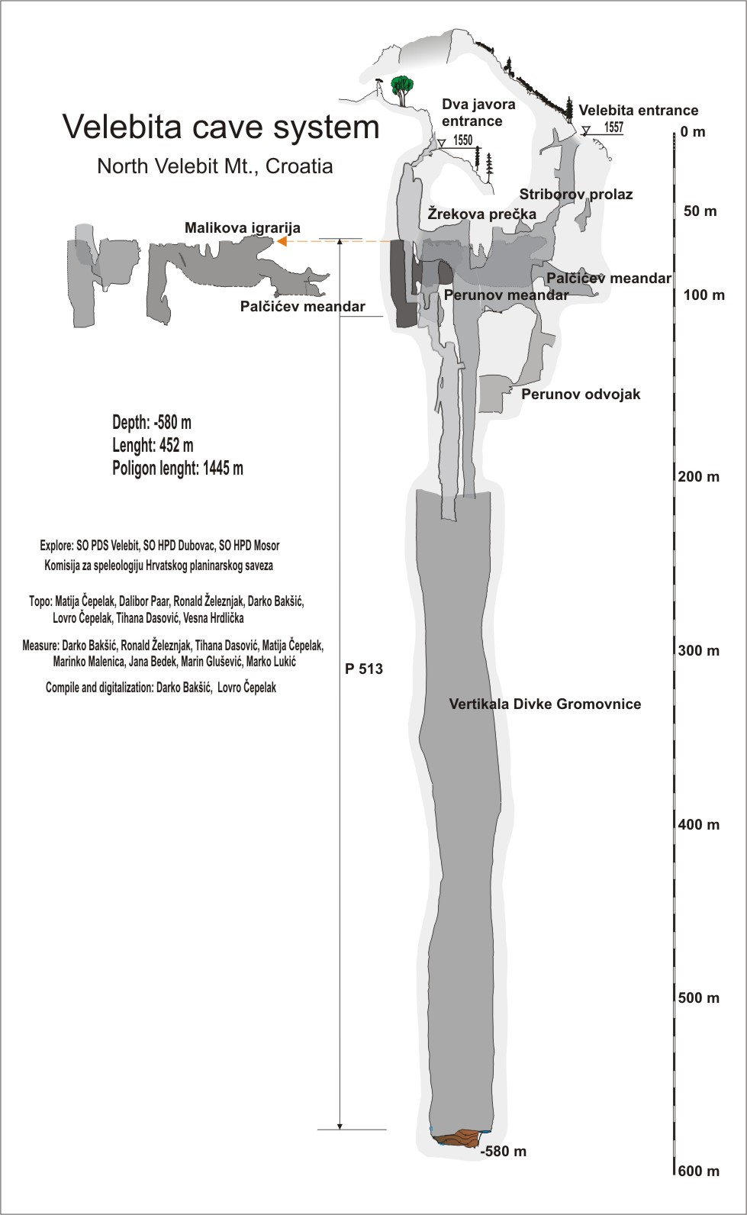

Fig. 2 Topographic plan of the Cave system Velebita-Dva javora
Gromovnice”, these shafts terminate on depths between 110 and 150 m. A narrow meander continues from the shaft “Perunov Odvojak” to the depth of around -160 meters and terminate with a narrowing. Perunov Meander provides the entrance into the shaft “Divke Gromovnice”.

The higher entrance into the shaft “Divke Gromovnice” can be reached from cave Dva Javora. The entrance into cave Dva Javora is located around 65 m north-west and 7 m lower than the entrance into Velebita cave. Cave Dva Javora is also morphologically complicated. Narrow meanders and shafts alternate. On the depth of -55 m meander “Žrekova Prečka” is separating from the 80 m deep shaft; the higher entrance into the shaft “Divke Gromovnice” is reached by traversing this meander. In the opposite direction, the cave continues with narrow meanders and smaller shafts all the way to a hall on the depth of around -120 m. This hall provides the entrance into the final 98 m deep shaft.

The shaft “Divke Gromovnice” in about first hundred meters has an elliptic diameter of an average size 8 m by 3 m. On the depth of -210 m from the entrance into the Velebita cave several smaller shafts join together into a single shaft with approximate size 40m by 15 m. After that part the shaft has a similar form all the way to its bottom on the depth of -580 m. The bottom is slanting and is covered in big stone blocks.

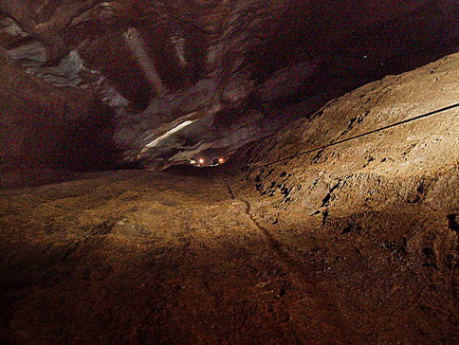

Fig. 3 Shaft “Divke Gromovnice” in its wider part.

Geological and hydrogeological features of the cave system

The Velebita – Dva javora cave system is almost entirely developed in Palaeogene Jelar carbonate breccias. The contact between Jelar breccias and Jurassic limestone is found to be at approximately 530 m of depth. The bottom part of the cave is developed in well bedded Jurassic limestone and the very bottom is covered with Jelar breccias blocks which were transported by gravity from upper parts of the shaft.

Jelar breccias have massive structure, and the discontinuities in them are connected exclusively to faults and joints. The dominant stretching orientation of fractures is NNE-SSW and less distinctive E-W. Dip angles are mostly between 70 and 90°. Discontinuities mostly have relaxation character with compact walls and without fractured zones. Precisely such discontinuities character enables the creation and the stability of big underground spaces in the cave. The mentioned discontinuities are connected to a younger neotectonic straining phase.

During explorations, larger groundwater flows were not noticed in the cave. Water flows are present in the form of dripping water and a thin water film on the walls of shafts. In the hall on the bottom of shaft “Divke Gromovnice” there is a concentrated small capacity groundwater flow which is sinking further among stone blocks. During heavy precipitations larger groundwater flows having mostly vertical character probably occur in the cave. Their occurrence and duration are directly connected to outside precipitations or periods of intensive snow melting.

According to the analogy with Lukina and Slovačka caves, the level of a phreatic zone under Velebita cave is located on between 50 and 100 m above sea level. Taking into consideration this presumption, there is a perspective of reaching the depth of around 1500 m in the cave.

The cave genesis

The genesis of the cave system Velebita – Dva javora is connected to a vertical water flows in a vadose zone through karstification prone carbonate rocks. The bottom of the cave is situated high above phreatic zone. The massive structure and a steep to vertical angle of the main discontinuities in Jelar breccias are, together with a vertically directed water pressure gradient, main reasons of the non-existence of horizontal channels in the cave.
The water which falls through precipitations on the terrain surface quickly enters into the upper epikarstic zone. The water from this zone is strained in the direction of the most permeable discontinuities in the rock mass and it also widens them to the dimensions of meanders and shafts by its corrosive effect. This process of the widening of underground spaces is active until hydrological conditions are changed or until the enlargement of the cavity causes instability and collapsing.

Groundwater flows concentrate with depth and usually the indentedness of caves decreases. Thus in the cave system Velebita – Dva javora the lower wider part of the big shaft was created by joining of several smaller shafts into a single one and the cave is the most indented by the depth of around 150 m.

In the initial stage of the genesis of shafts, the water which flows as a thin film on the walls of widened fractures has the main role. Since fractures become wider and wider dripping water gets more and more important role, BARON (2002). The water that drops is suddenly enriched with CO₂ through its falling through the CO₂ rich cave atmosphere; thus its aggressiveness grows while the water flowing on walls of fractures gets saturated with CaCO₃ and loses dissolution capacity. On the places where water drops fall, the corrosion is the most intense and the vertical growth is the fastest. Thanks to this mechanism it is possible to explain the phenomenon of almost flat bottom of big shafts in the continuation of which water further flows through narrow passages. If fractures are not vertical but leaned under a certain angle, typical triangle shapes of shafts are created having one wall slanting and the other vertical (Perunov Odvojak). The slanting wall of the vertical is connected to the position of primary fracture, while the vertical wall was created due to a corrosive effect of the dripping water. Channels of step-like shapes can be formed by simultaneous growth of more shafts all connected to the same fracture. Passages connecting such shafts are frequently narrow and developed along primary fracture (Striborov Prolaz). Intersections of several fractures can also speed up processes of the creation of shafts.

The creation of narrow passages and meanders is connected to water flow in the form of a thin film on walls of vertical discontinuities. Due to a slower dissolution dynamics, channels get their characteristic shape, extended along the stretching of the primary fracture. The majority of underground spaces was created by a combination of water film and dripping water action and narrow meanders frequently turn into shafts and vice-versa (Perunov Meander, Malikova Igrarija, Perunov Odvojak). The collapsing processes also have an important role in the shaping of underground spaces, and they result in a decrease or total burying of some channels.

In the Velebita – Dva javora cave system, the same as in the majority of other caves in North Velebit area, the corrosion processes are still active, with an almost total lack of speleothem sedimentation.

Conclusions

The genesis and the morphology of the cave system Velebita – Dva javora are a consequence of geological, hydro-geological and hydrological features of the surrounding terrain. The object was developed in massive and karstification prone Jelar carbonate breccias. The bottom of the deepest shaft in the system is located close to the contact of Jelar breccias and Jurassic limestone. The most important morphological characteristic of the cave are the alternations of spacious shafts with narrow passages and meanders. The cave is rather indented in its upper parts, while on the depth of around -100 m turns into a shaft more than 500 m deep, the deepest known underground shaft in the world. Morphology of the cave is are a consequence of a dominantly vertical water flow in a deep vadose zone along vertical and sub-vertical fractures. With regards to the presumed groundwater level, there is a perspective that the maximum depth of the cave could reach around 1500 m.

References:

BAKŠIĆ, D. 2004: Cave system Velebita-Dva Javora. Subterranea croatica, 3, Karlovac: 2-6.

KUHTA, M. I BAKŠIĆ, D. 2001: Karstification dynamics and development of the deep caves on the north Velebit Mt. – Croatia. – Proceedings to 13th Speleological Congress, Brazil.

PAVIČIĆ, A. 1995: Hydrogeological conditions for the construction of reservoirs in the Velebit Mt. hinterland. Unpublished. Ph. D. Thesis, University of Zagreb, Croatia, 124 p.

PRELOGOVIĆ, E. 1989: Neotectonic movements in the Northern part of Mt. Velebit and a part of Lika (SW Croatia). Geološki vjesnik, 42, Zagreb: 133-147.

BAHUN, S. 1974: The tectogenesis of Mt. Velebit and the formation of Jelar deposits. Geološki vjesnik, 27, Zagreb: 35-51.

BAHUN, S. 1984: The tectonic and hydrogeologic significance of the areas composed of the Jelar formation. Krš Jugoslavije, 11/1, Zagreb: 1-11.

WHITE, W. B. 2000: Speleogenesis of vertical shafts in the eastern United States. Speleogenesis, Nat. Spel. Soc., Alabama: 378-381.

BARON, I. 2002: Speleogenesis along sub-vertical joints: A model of plateau karst shaft development: A case study: the Dolny Vrch Plateau (Slovak Republic). Cave & Karst Science, 29 (1), 5-12.

