Groundwater Basin Catchment Delineation and Generalized Flow Routes
Through the Karst Aquifer Beneath Bowling Green, Kentucky, USA

Joshua Brewer*
Nicholas C. Crawford
Center for Cave and Karst Studies
Applied Research and Technology Program of Distinction
Department of Geography and Geology
Western Kentucky University
Bowling Green, Kentucky USA

Abstract

The major groundwater basin catchment areas and the generalized groundwater flow routes through the karst aquifer in the vicinity of Bowling Green, Kentucky, USA were determined using the following techniques: 1) dye tracing, 2) water table measurements, 3) cave mapping, and 4) cave location by microgravity and electrical resistivity. The research was directed by Nicholas Crawford and performed by the faculty, professional staff and students of the Center for Cave and Karst Studies (CCKS) from 1976 to the present.

Bowling Green is located entirely upon a low-relief sinkhole plain with large, shallow sinkholes with large catchment areas. Since these large sinkhole basins are almost flat, many homes and buildings have been constructed within these sinkhole basins. Sinkhole flooding is, therefore, a major problem for the city, and it has responded by requiring delineation of sinkhole flood plains and the construction of storm water detention basins. Although storm water sinks directly into the karst aquifer at numerous open-throat sinkholes and cave entrances, the city has drilled or constructed over 1,000 storm water drainage wells. The U.S. Environmental Protection Agency (USEPA) classifies these storm water drainage wells as Class V Storm Water Injection Wells. Until recently, the city has not made any serious attempts to improve the water quality of the storm water runoff sinking into the karst aquifer. USEPA now requires all towns with populations above 10,000 to comply with its Phase II Storm Water Management Plan Requirements. This has resulted in Bowling Green passing a tax increase and hiring five employees to deal with storm water quality. In an attempt to assist the city to meet the new EPA requirements, the CCKS has compiled much of its data collected over the years into a GIS map showing the major springs, caves, karst windows, sinking streams and other karst features. The map shows the numerous dye traces as red lines with arrows and the water table elevation contours as blue lines. They were estimated from measurements taken from open borehole water wells and storm water drainage wells that extend below the water table, cave streams, springs, and perennial surface streams. The approximate groundwater basin catchment boundaries, based upon dye traces and water table elevations, are shown as dashed green lines. The map identifies the approximate groundwater flow routes and groundwater basin catchment areas for the six major springs that drain the karst aquifer beneath Bowling Green.

Dye Tracing

Over 100 dye tracer tests have been performed using as many as 13 different dyes. However, most of the traces were performed using: Sodium Fluorescein (C.I. Acid Yellow 73), Eosine (C.I. Acid Red 87), Sulphorhodamine B (C.I. Acid Red 52), and Tinopal CBS-X: Fluorescent Brightening Agent 351. Most of the dye traces were qualitative, using activated coconut charcoal dye receptors, but other traces were quantitative, using up to five ISCO automatic water samplers. The dye analysis was performed at the CCKS Dye Tracer Laboratory on a Shimadzu spectrofluorophotometer. Dye traces and water table contours northeast of the Barren River performed by the late James Quinlan and Joe Ray (1981, revised 1989) were included in the GIS map.

Water Table Elevation

Water table elevations were measured at springs, cave streams, karst windows, and perennial streams and in over 100 open borehole drainage wells that extended below the water table.

Groundwater Basin Catchment Boundaries

The approximate groundwater basin catchment boundaries were established for the karst watershed for the following major springs: 1) Lost River Rise, 2) Graham Springs, 3) Hobson Grove Springs, 4) Double Springs, 5) Mt. Ayr Blue Hole and Bluff Springs, and 6) Harris Spring. Figure 1 is a black and white representation of a portion of the GIS color map. Topographic contour lines and cultural features have been omitted to reduce confusion of graphics on the black and white copy.

Cave Mapping

Accessible caves were mapped and corrected using magnetic induction transmissions (cave radio) at selected locations. The caves were plotted on the GIS map. Other caves without entrances were located using a combination of microgravity and electrical resistivity traverses perpendicular to cave trends established by dye tracing and water table measurements. Both LaCoste and Romberg Model D and a Scintrex CG-3M microgravity meters were used to locate low-gravity anomalies (Crawford and others, 1999). A Sting/Swift electrical resistivity meter was used to locate high-resistivity anomalies. The low-gravity, high-resistivity anomalies were explored by borings, both into the anomalies and on both sides to confirm the location of caves (Figure 2). Dye traces were then performed to identify the cave stream flowing past the well drilled into the cave. Once a cave stream was confirmed, its route was established by taking additional microgravity and electrical resistivity traverses in a “leap-frog” fashion (Figure 3).

Intended Use of Map

The GIS map identifies the approximate groundwater flow routes within the karst aquifer in the vicinity of Bowling Green. Since almost all surface runoff sinks rapidly through sinkholes, sinking streams, storm water drainage wells or the relatively thin and permeable soils into the karst aquifer, the map should assist the Bowling Green Fire Department, Bowling Green Department of Public Works, Bowling Green Municipal Utilities, Kentucky Environmental Response Team, Kentucky Division of Water, Kentucky Division of Waste Management and other agencies concerned with spills and leaks of hazardous materials. The map is intended to aid the Bowling Green-Warren County Planning and Zoning Commission and the Bowling Green Public Works Department with landuse management decisions and sinkhole flooding problems as well as assisting the Warren County Health Department with decisions concerning on-site waste disposal systems (septic tanks). It provides useful information that will help Bowling Green and Warren County to meet the U.S. Environmental Protection Agency Phase II Storm Water Management Plan Requirements. It should also assist Bowling Green Municipal Utilities in protecting the water quality upstream from its water intake on the Barren River (Figure 1). Although the map may assist commercial and industrial businesses with groundwater flow direction, the map clearly indicates that monitoring wells are not appropriate in most of the Bowling Green area unless they are drilled directly into the karst conduit that drains the facility and then confirmed by a dye trace.

Hopefully, the map will serve to educate the public by illustrating that surface runoff, spills and leaks of hazardous liquids, septic tank effluent, herbicides, pesticides, fertilizers, soil erosion, animal waste and other potential contaminants sink directly into the ground and then flow rapidly through cave conduits beneath the city to springs and surface streams. In the past, spills and leaks of hazardous chemicals, such as, gasoline, into the karst aquifer have resulted in dangerous vapors rising into homes and buildings (Crawford 1989 and 2001). Bowling Green and other cities built upon karst must, therefore, be extremely careful to protect groundwater and caves from contamination. The map clearly indicates that contaminants that sink into the karst aquifer not only threaten groundwater, caves, and rare and exotic cave life, they also endanger the people who live above the karst aquifer. The CCKS intends to periodically update the GIS map. Hopefully, it will assist in the protection of groundwater quality in the karst aquifer beneath Bowling Green and the surrounding area.

References

Crawford, N.C. (1989). “Groundwater contamination in Warren County, Kentucky: toxic and explosive fumes rising from contaminated groundwater flowing through caves in Bowling Green”. In Crawford (ed.), Karst Landscape Analysis, Warren County, Kentucky , Bowling Green-Warren County Comprehensive Plan Update, pp. 117-143.

Crawford, N.C. (2001). “Environmental problems associated with urban development upon karst, Bowling Green, Kentucky”. In Beck and Herring (eds), Geotechnical and Environmental Applications of Karst Geology and Hydrology, Swets and Zeitlinger, Lisse, pp. 397-424.

Crawford, N.C. (2005). Karst groundwater flow in the vicinity of Bowling Green, Kentucky, map prepared by Center for Cave and Karst Studies, Applied Research and Technology Program of Distinction, Department of Geography and Geology, Western Kentucky University.
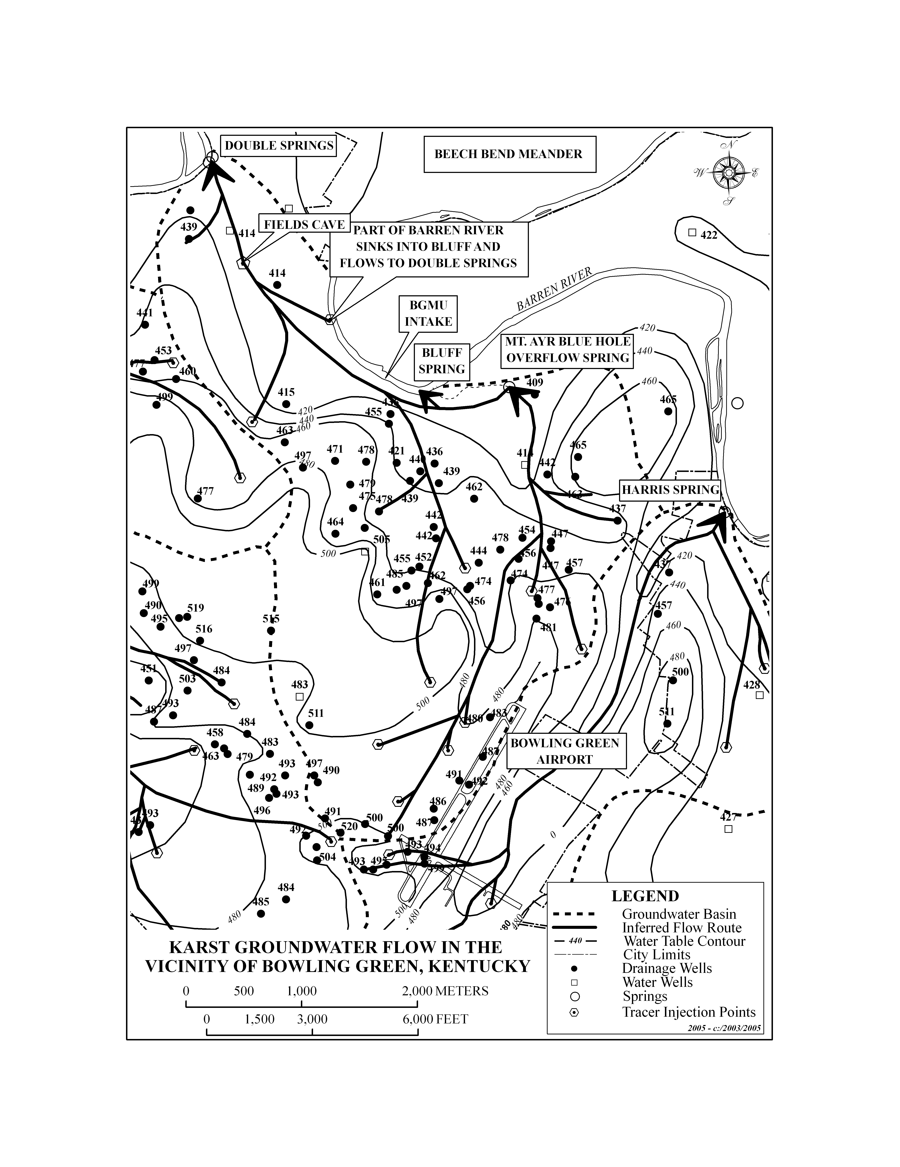
Figure 1. A black and white representation of a portion of the GIS color map.

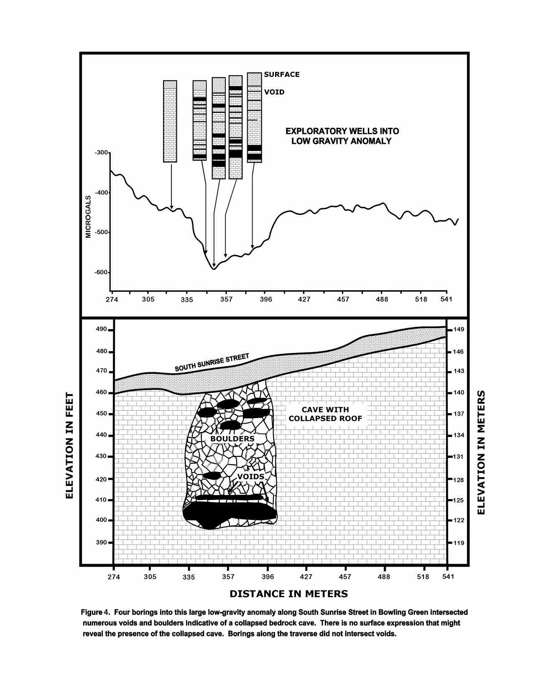
Figure 2. Four borings into this large low-gravity anomaly along South Sunrise Street in Bowling Green intersected numerous voids and boulders indicative of a collapsed bedrock cave. There is no surface expression that might reveal the presence of the collapsed cave. Other borings along the traverse did not intersect voids.

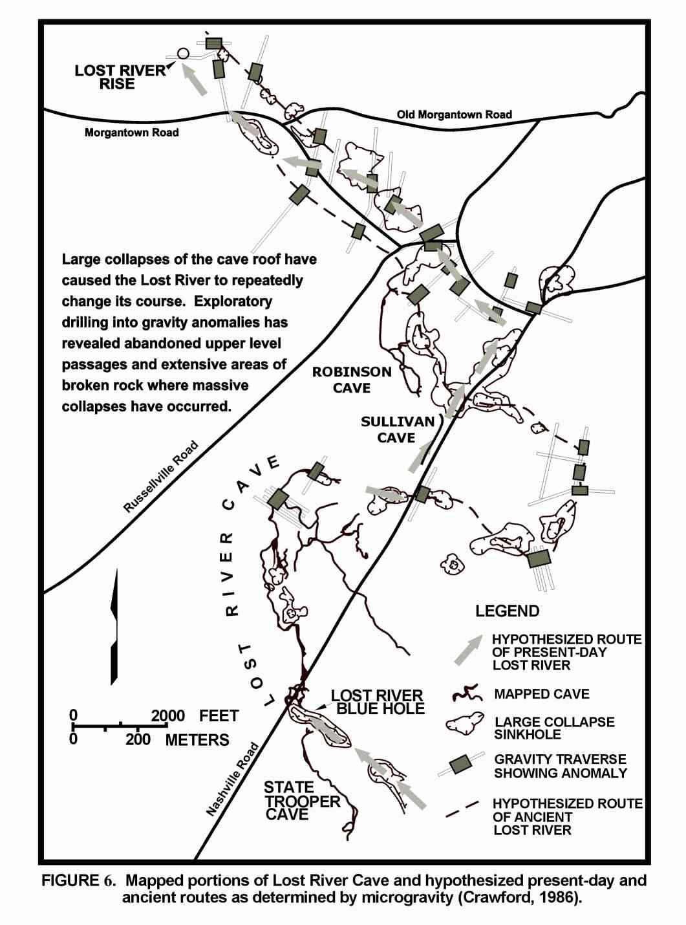
Figure 3. Mapped portions of Lost River Cave and hypothesized present-day and ancient routes as determined by microgravity. Source modified from Crawford and others (1999)
Crawford, N.C., Lewis, M.A., Winter, S.A., and Webster, J.A. (1999). “Microgravity techniques for subsurface investigations of sinkhole collapses and for detection of groundwater flow paths through karst aquifers”. In Beck, Pettit, and Herring (eds.), Hydrogeology and Engineering Geology of Sinkholes and Karst. Balkema, Rotterdam, pp. 203-218.

Quinlan, J.F. and Ray, J.A. (1981) (Revised 1989), “Groundwater basins in the Mammoth Cave region, Kentucky showing springs, major caves, flow routes and potentiometric surface”, Friends of Karst Occasional Publication 2.

