DEvelopment of innovative karst hydrogeologic research techniques
for solving karst environmental problems

Leigh Ann Croft*
Nicholas Crawford
Chris Adair, Josh Brewer, Matt Coffelt, Ronson Elrod,
Mike Firkins, Brian Ham, Joe Howard, Chad Martin
Patricia Kambesis, Rolland Moore
Chris Ray, Jeremy Tallent,
Ron Taylor, Ashley Williams, Andy Zimmerman

Center for Cave and Karst Studies
Applied Research and Technology Program of Distinction
Department of Geography and Geology
Western Kentucky University
Bowling Green, Kentucky USA

ABSTRACT

Since its inception in 1978, The Center for Cave and Karst Studies has played a major role in the development of innovative techniques to facilitate the work of geologists, hydrologists and engineers in karst terrains. These techniques include: cave exploration and mapping, dye tracer tests to determine groundwater flow through karst aquifers, and microgravity and electrical resistivity to investigate karst subsurface conditions. The techniques provide accurate karst hydrogeologic information to engineers and planners who can then make informed decisions on how to best protect the public and karst environment. Karst hydrogeologic investigations have dealt with proposed routes for highways, dam locations, foundations for proposed buildings, storm water runoff, and various groundwater contamination, sinkhole collapse and sinkhole flooding problems. The Center has received numerous grants and contracts from various federal, state and local government agencies as well as numerous engineering and environmental consulting firms from throughout the U.S.A. as well as several foreign countries. Several applications are provided within this paper.

The applied research within the Center provides a major learning experience for Western Kentucky University undergraduate and graduate students. They have the opportunity to work on “real world” problems in cooperation with Center faculty and professional staff. These research experiences facilitate their employment after graduation. Several graduate and undergraduate students are listed as coauthors of this paper.

INTRODUCTION

The Center for Cave and Karst Studies, established in 1978 at Western Kentucky University, was the first center established primarily to deal with karst problems in the U.S. The Center’s offices and labs are located within the Department of Geography and Geology in the Environmental Sciences and Technology Building at Western Kentucky University. The Center’s personnel consist of a director, chemist/laboratory manager, research hydrologist, education coordinator, office coordinator and graduate and undergraduate assistants.

The objectives of the Center are as follows:
(1) To be a research center dealing with all aspects of cave and karst studies, with an emphasis on solving environmental problems associated with karst;
(2) To provide educational programs concerning cave and karst studies: a) undergraduate and graduate instruction, b) cooperative education program with Mammoth Cave National Park International Center for Science and Learning, c) workshops, seminars, and scientific meetings;
(3) To provide public service by assisting individuals, private firms, and government agencies with karst environmental problems.

Over the past twenty-seven years, the Center has attracted outstanding undergraduate and graduate students from various parts of the United States. Graduate and undergraduate research assistants are actively involved in the research efforts of the Center. Several graduate students, and even a few undergraduate students, have a substantial number of publications and presentations to their credit. Students get “hands-on” experience in dealing with karst groundwater problems through the Center’s research for government agencies, as well as for private business. Our graduates have been very successful in obtaining positions with both government and private consulting firms.

SUBSURFACE INVESTIGATIONS

Microgravity
Gravity surveys are used to detect variation in the density of subsurface materials. Variations in the earth’s gravitational field higher than normal indicate underlying material of higher density while areas of low gravity indicate areas of lower density. In most karst areas, the following average density values are assumed:
Air = 0 g/cm³ Water = 1.0 g/cm³ Sandstone = 2.35g/cm³
Regolith or cave sediments = 1.5 g/cm³ Limestone = 2.5 g/cm³
Therefore, density contrasts of 1.0 to 2.5 g/cm³ are anticipated for any subsurface cavity, depending on whether the cavity is filled with air, water or sediment. This makes the microgravity method a good technique to investigate subsurface conditions in the vicinity of sinkhole collapses. Microgravity provides useful information concerning a) depth to bedrock, b) extent and shape of a void below the surface, c) location of a crevice, or crevices, through which regolith and water are sinking and d) additional regolith voids in the vicinity of a sinkhole collapse (Crawford 1999 and 2000). In order to detect voids or cavities, very high precision is required. A SCINTREX CG-3M Autograv Microgravity Meter that has a 0.5-microGal sensitivity is used by the Center.

After all corrections have been calculated, the reduced data consists of a Simple Bouguer Gravity value for each measured point. Increasingly negative values for Bouguer gravity indicate greater deficits in mass below each measurement point. Graphic plotting of data produces a trend line that illustrates the relative fluctuations in gravity along each traverse.

Electrical resistivity
Electrical resistivity surveys provide an image of the subsurface resistivity distribution. Features that are not good conductors of electricity, such as air-filled voids in the regolith or a cave in the bedrock, result in high resistivity anomalies. This makes the resistivity method a good exploratory technique for investigating karst subsurface features, or where depth to bedrock is needed.

Several different electrode configurations can be used to collect resistivity data. These include the Schlumberger, Wenner, Pole-Pole, Pole-Dipole, Square arrays, and Dipole-Dipole. The Dipole-Dipole array generally provides the highest precision, permits reasonable depth investigation and has the greatest sensitivity to vertical resolution and data coverage (Loke, 1998).

The resistance measurements gathered by the field survey are reduced to apparent resistivity values. This conversion is performed by the AGI Administrator Version 1.1.0.4 program. The RES2DINV program is then used to convert the apparent resistivity values into a resistivity profile model that permits interpretation of the subsurface. The modeled results along a traverse are calibrated by comparing observed anomalies with physical data, such as, topographic maps, geologic quadrangles, rock outcrops, and drilling/boring data.

Cave mapping
Many jobs require caves within or near investigated sites to be explored and mapped in order to determine if the underlying cave is within the proposed project area. Surveying is done with a nylon tape, Suunto compass and clinometer. Backsights are taken within one degree. The cave passages are surveyed and sketched and profile sections of the cave dimensions are provided on the cave maps. Dimensions such as shot length and bearing can be inputted into a program known as COMPASS which produces a line plot of the survey data. However to gain more information on the size, shape and orientation of the rooms so that more can be learned of the geology, hydrology and origin, more information such as left, right, up and down measurements must be added so that a 3-D model can be created.

Cave radio
In order to better coordinate the subsurface position and depth of a cave with that of surface features, an instrument referred to as cave radio is used. This technique uses a receiver antenna to locate the position of a transmitter beacon, called a cave radio, placed inside the cave, which emits a very low frequency signal, generated by an amplifier attached to the transmitter antenna, resulting in a magnetic field (Figure 1). Therefore, the technique works through magnetic induction rather than audible radio waves. When the receiver antenna is in such a position that it no longer detects the magnetic field, the exact position of the underlying transmitter beacon can be determined (Gibson 2002).
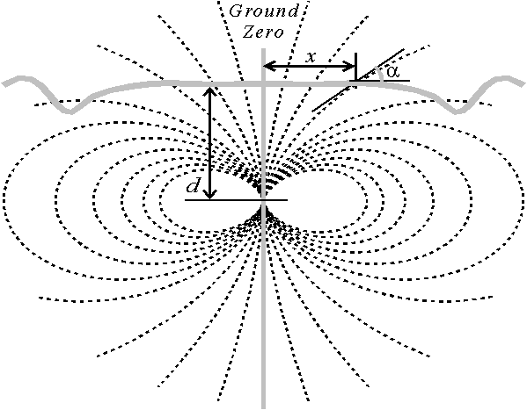

Figure 1: Magnetic field lines from an underground transmitter. Image courtesy of www.caves.org.uk/radio/radioloc_for_cave.html

DYE TRACER INVESTIGATIONS

Research Procedures
Karst hydrogeologic inventory
The field survey for the Karst Hydrogeologic Inventory is conducted under conditions ranging from moderate to high flow during a wet period when all resurgence points are active. The survey is conducted by walking or floating all streams and associated impoundments (lakes, ponds) in the study area to visually identify karst features including but not limited to: Springs, seeps, sinkholes, swallets, karst windows, sinking streams and caves.
The features are located on a 7.5-minute series topographic map. Each feature is given a name and a unique inventory number. General information and physical characteristics of the feature are recorded on the Karst Feature Inventory Form. The physical characteristics of inventoried springs, streams, and wells include a measurement or estimate of the discharge and measurement of the temperature, specific conductance, and pH. The feature is photographed to complete the inventory record. The results aid in the dye receptor location placement.

Lineament analysis
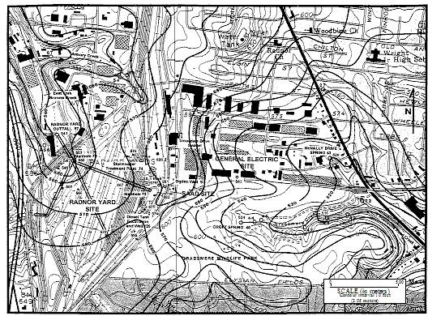
A lineament analysis is performed for the area within and surrounding the study area using topographic and geologic maps, the county soil atlas and aerial photographs. A field investigation is necessary to confirm the accuracy of the geologic map and to identify important geologic features not on the map, such as joint sets, prominent bedding plane partings, chert or shale beds that might constitute confining layers, etc. This information combined with field measurements of joints, strike and dip, etc. provide indicators of possible groundwater flow routes. It also provide important information for locating monitoring wells if needed.

Potentiometric surface mapping
All accessible water wells and monitoring wells in the area are measured during a dry period and the depth to water subtracted from the ground surface elevation. In addition to wells, the elevations of springs, karst windows and selected points along streams and lakes are measured by leveling. These elevations and terrain features, such as, topography, sinkhole distribution, sinking streams, cave locations, etc. are used to construct a map of the water table (Figure 2) for the uppermost aquifer. If sufficient wells are available, it may be possible to delimit groundwater basin divides.

Figure 2: Potentiometric Surface map of investigated site.

Background monitoring and matrix interference
The Background Fluorescence Monitoring task involves the monitoring of springs, wells and streams in the study area for background concentrations of dye from previous dye traces, pollution, and natural interference. The results of the background monitoring is used to evaluate the appropriate dyes and dye concentrations to be used for the dye tracer investigation. In addition, a matrix interference investigation may be needed previous to selection of the dye or dyes to be used. This involves a laboratory investigation to measure the potential impact of chemicals in the groundwater on the dye concentration, the adsorption of the dye by the charcoal or the release of dye from the charcoal during elution.

Analysis Procedures
Charcoal and water analysis
Analysis on a scanning spectrofluorophotometer provides the lowest detection limits and most reliable dye analysis. For a typical analysis for Tinopal CBS-X, Direct Yellow 96, Fluorescein, Rhodamine WT, Eosine, FD&C Red 3, D&C Red 28 or Sulphorhodamine B, a synchronous scan is performed where the excitation and emission monochromators are kept at a fixed wavelength separation during the scan. If the scan indicates positive results for fluorescent dye, a second printout is made utilizing spectrum integration and calibration curves stored in the computer to determine the concentration of the dye or dyes. If the sample is a water sample, the scanning parameters are adjusted to compensate for shifts in the excitation and emission maximum wavelengths as well as differences in the Stoke’s shift caused by the differences in pH and polarity of water as compared to elutent.

Quantitative dye tracing
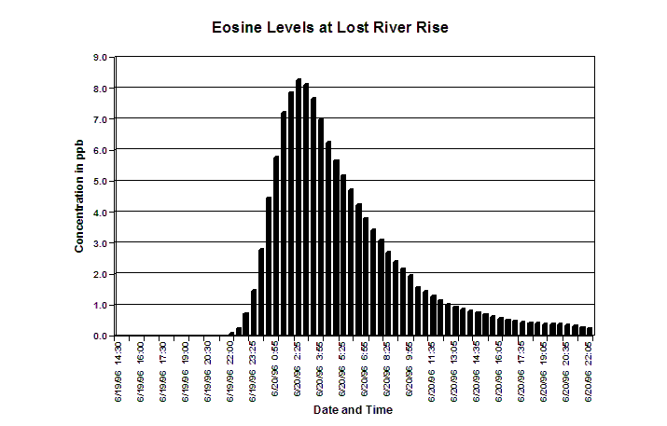
Quantitative dye tracing involves installing ISCO automatic water samplers at the hypothesized spring or springs. The collected samples are then analyzed according to water sample analysis procedures. This provides a graph of the complete dye breakthrough curve at the spring or springs (Figure 4). A quantitative trace is often performed simultaneously with the qualitative dye receptor trace. It provides more definitive proof of dye flow to a spring since the dye concentration in the water is measured during the entire passage of the dye cloud as it flows from the spring.
Figure 4: Histogram showing breakthrough curve during quantitative trace.

CASE STUDIES

Proposed highways
Microgravity and electrical resistivity were used to locate possible voids in the regolith and/or bedrock under the proposed roadway for the new Highway 27 route in east Kentucky. In addition, the area contained three caves whose entrances were near the investigated site. The research approach was to conduct microgravity and electrical resistivity traverses down the center of the northbound and southbound lanes and along each shoulder and to explore and map each cave. The microgravity stations and the resistivity electrodes were placed in the same locations so that the data could be compared. The cave passages were surveyed and mapped so that the caves could be placed on a site map for comparison with the locations of the roadways. This research confirmed that the engineers would not have to adjust their plans due to the caves, but that changes had to be made to deal with large amounts of deep, unexpected clays during construction of the road and to plan for deeper depths to bedrock that were discovered during the investigation (Figure 5).
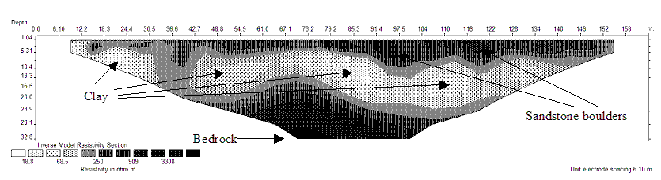
Figure 5: Electrical resistivity profile showing deep depths to bedrock and the presence of conductive clays below resistive sandstone boulders.
Sinkhole Collapse
Microgravity was used to locate a possible sinkhole collapse underneath a preexisting distribution warehouse. The area, prior to construction, had been pockmarked with sinkhole collapses that where repaired before the building was completed. However, a sinkhole collapse occurred at the east end of the building years later. The business was concerned of the possibility of other collapses occurring in less accessible locations beneath the building. Areas of low gravity that could be considered hazardous and subject to surveillance were located. The previous collapse was visible on the microgravity data (anomalies E and F, Figure 6) due to a remediation failure, along with other lesser anomalies (anomalies A-D, Figure 6). A profile extending from areas of higher gravity to areas of lower gravity can be seen in Figure 7.
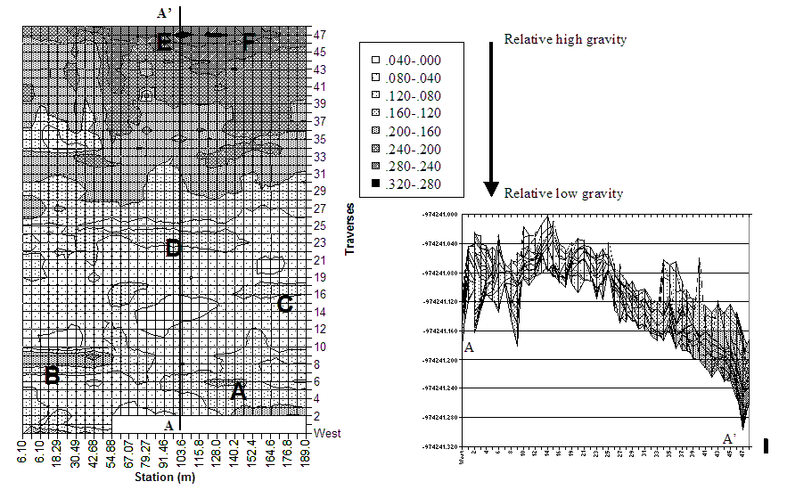
Figure 6: Contoured microgravity
Figure 7: Microgravity profile along Line A-A'

Ground water contamination
An oil leak from a pipeline company line was discovered in Central Tennessee. As part of the emergency response a dye trace study was conducted. The study intended to determine probably resurgence points of the oil at springs or surface streams. Dye tracing, Potentiometric mapping and geologic mapping were used to determine site hydrology (Figure 9).

The dyes injected at the pipeline spill site resurged at Four Spring on the opposite side of the Stones River. The research revealed that a cave stream from the site flowed under the perennial Stones River, which is flowing upon the Lower Ridley Limestone confining layer at this location. The flow through the karst aquifer was downdip toward a structural low located on the opposite side of the Stones River.
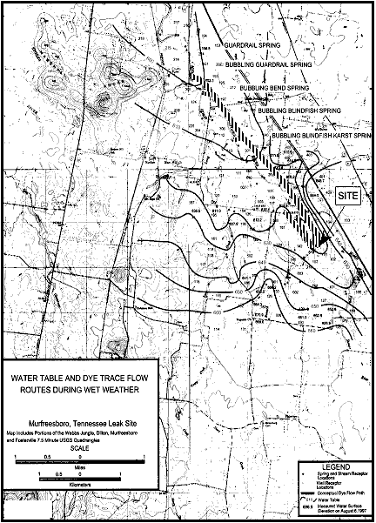
Figure 9: Portion of the map showing water table and dye trace flow routes.

REFERENCES
Crawford, N. C. 2000. Microgravity Investigations of Sinkhole Collapses Under Highways, Geophysics 2000 Proceedings, First International Conference on the Application of Geophysical Methodologies to Transportation Facilities and Infrastructure, St. Louis, Missouri, 13.

Crawford, N.C.; Lewis, M.A., Winter, S.A. and J.A. Webster 1999. Collapses and for Detection of Groundwater Flow Paths Through Karst Aquifers, in Beck, Pettit and Herring (edr.) Hydrogeology and Engineering Geology of Sinkholes and Karst, Balkema, Rotterdam, ISBN 90 58090469

Gibson, David. 2002.Radio location for Cave Surveying. http://www.caves.org.uk/radio/radioloc_for_cave.html

Loke, M.H. 1998. RES2DINV for Windows 95, Rapid 2D Resistivity & IP inversion using the least-squares method.

