A SCHOOL FOR CAVE RESCUE MANAGERS
Corrado Camerini, Graziano Ferrari
CNSAS - Corpo Nazionale Soccorso Alpino e Speleologico
Via Petrella 19, I-20124, Milano, Italy – segreteria@cnsas.it

SUMMARY

In 1999 the Italian Cave Rescue adopted a formal technical training model, structured in seven steps, up to National Instructor. A national technical school was established.
In addition to the technical training, the need for a formal training of cave rescue managers appeared of the utmost importance. In 2004 an experimental manager school was established and a three-years comprehensive training model was outlined. Courses subjects range from high-level management of rescue operations to bureaucracy, funding, relations with mountain rescue organizations and so on.
The paper details the rationale of the training model and reports about the first year experience.

Introduction
21 Regional Mountain and Cave Rescue Services
32 Mountain Rescue Zones
255 Mountain Rescue Stations
15 Cave Rescue Zones
32 Cave Rescue Stations
7,151 Rescuers (243 Physicians)
5,188 Rescue Operations
5,595 Rescued People
29,983 Involved Members (Member/operation)
3,485 Helicopters

Cave rescue in Italy is performed by a specialized structure established in 1966. It collects volunteers selected from the caving community. The Cave Rescue belongs to the Corpo Nazionale Soccorso Alpino e Speleologico (CNSAS – National Mountain and Cave Rescue Corp), which in turn is part of the Club Alpino Italiano (CAI – Italian Mountain Club). CAI is a large non-profit association established in 1863, with about 300,000 members. The Mountain Rescue in turn was established in 1954; the table at left summarizes some facts about CNSAS in 2004 (CNSAS, Annuario 2004).
The CNSAS is a national structure, with an Assembly of Representatives, a Council Board, a President and two Deputy Presidents. On the mountain rescue training side, a National Technical School was established. In 2004 it relied on 29 National Technical Instructors. Specialized Schools for physicians, avalanche search dogs and surface search dogs are also present. On the local side, the CNSAS is structured in Regional Services, Zones and Stations. The Rescue Station is the operative branch. It manages most rescues, under the direction and the responsibility of a Station Head and a Deputy. The Zone is the management structure: it collects several Stations under a Zone Head and a Deputy. A Regional Service collects several Zones. It manages the general Regional activity, on both the operative and training side. Furthermore, it manages political contacts with the Regional Public Administration. In several Regions, the CNSAS has an agreement in order to provide an highly specialized mountain and cave rescue service, in the framework of the Public Emergency Service (usually identified with the toll-free emergency phone number “118”). Several National and Regional Laws recognize the CNSAS structure; CNSAS is a component of the Civil Defense at national level.

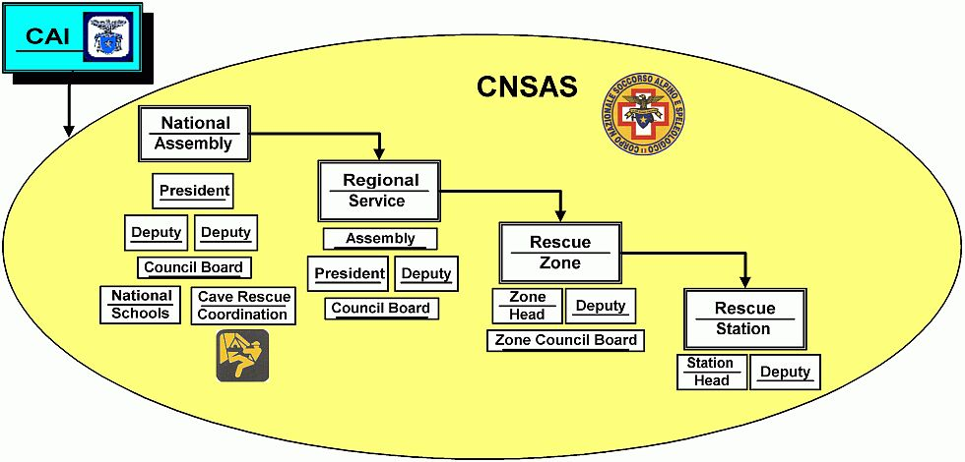

The Cave Rescue in Italy
The Cave Rescue is a specialized structure inside the CNSAS, with some autonomy. It collects about 700 members and it is managed by a National Head and a Deputy, together with a Council Board and a Zone Head Board. Each Cave Rescue Zone is usually related to a single Region. At national level, several specialized commissions were established: medical, technical, cave diving, blasting techniques, news agents. In Cave Rescue, Station Heads are usually the operational team leader inside the cave, while the overall operation management and responsibility falls on the Zone Head and its Deputy.
In addition to cave accidents, the Cave Rescue is involved also in canyoning accidents. This means that a canyoning commission was established, too. In many areas, Mountain Rescue Stations can provide an important support in canyoning rescues. Many minor canyoning accidents are quickly resolved by the Mountain Rescue alone.
Luckily, cave accidents are infrequent (in 2004: 13 accidents with 24 victims). However, a cave rescue is often considered a big emergency, due to its duration, large number of involved rescuers and impact over the media both at local and national level.
On the technical training side, a training plan was adopted. The plan defines five steps:
- Admission tests and introductory training;
- Cave Rescue Operator (in-cave basic rescue techniques);
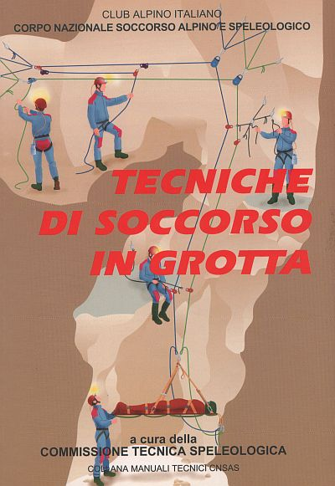
- Cave Rescue Technician (further technical and medical training, helicopters, eventual snow and avalanche training);
- Specialized Technician (advanced rescue techniques);
- Team Leader (in-cave operations management, human resources management, cooperation with the operation head).
Steps 2 to 5 are usually defined by three events: an initial prerequisite test, a specific training (with final evaluation) and a periodic maintenance test. Each new entry must reach level 3 within four years.
A Cave Rescue Technical School was established in 2001 with the task to provide technical training to all members of the Cave Rescue. The Technical School is structured in a National School (28 National Instructors) and in Regional Schools, with Regional Instructors. Steps 1 to 3 are provided by the Regional School, while the national structure provides training to levels 4 and 5 and to Regional and National Instructors. In cooperation with the technical commission, an Operation Manual (“Tecniche di Soccorso in Grotta”, at left) was published in 2002. In few years, the Technical School was able to establish an organic training program and to raise the general technical level of the Cave Rescue. The technical training model is now reaching maturity. Its definition relied on past work bt the commissions (mainly the technical one) and by the Zone Head Board; a first edition Cave Rescue Handbook was published as several booklets from 1992 to 1996.
A National School for Cave Rescue Physicians was also established, in order to update and to share experiences and techniques.

The managing heads
In Cave Rescue, the Zone Head is usually the general manager of a rescue operation, with help from the Deputy Head. However, the overall management is a very complex and demanding task, with several components to take care of:
- Coordination of the operation teams;
- Management of external radio and internal phone communications;
- Management of contacts with Local Authorities;
- Management of human and material resources, logistics and warehouse;
- Contacts with the Media;
- Contacts with the Air Force (helicopters);
- Contacts with other Zones;
- Contacts with the Regional Service;
- Contacts with the Cave Rescue National Head and the Commission Heads.
Technical, operational, logistic, media and political competences are needed, in the framework of a medical and technical emergency. The Zone Head becomes a “disaster manager” of a very special kind. Of course a single person is not able to sustain such a workload. Usually contacts with Media are deputed to a news agent, logistics and warehouse to a specific responsible. Nevertheless, the operations management needs a small direction team as the Head of Operations Staff.

The normal management of a Cave Rescue Zone is also very demanding. The main tasks of a Zone Head are listed here:
- General Zone management: accounting, logistics, warehouse, communications, staff, updating
- Organization of cave rescue practices
- Organization of training events
- Organization of promotional events
- Participation to regional and national events
- Funding
- Contacts with the Public Authorities: Administrative Authorities, Police, Civil Defense, Medical Emergency Service (118), Media and so on.
Also in this case the Zone Head needs a small staff of people who take care of the different responsibilities. Some of these tasks come from the fact that a Zone Head should act also as an “image promoter” for his/her structure. Actually, in order to effectively manage all facets of the charge, a Zone Head should be endowed with competences and experience comparable to those of a high level company manager. Furthermore, the legal responsibilities of the Zone management are relevant. However, Cave Rescue members and heads are volunteers; the time devoted to the Zone management is usually stolen from the actual work or from the social and family life.
Managing charges are elective. This means very few people have the needed experience, training and free time to be considered optimal candidates. However, the organization needs to improve as far as possible the training of its managing heads; it needs also to convey the experience of its long-time heads to the newly appointed ones. Furthermore, a common knowledge background is a strategic asset in establishing and improving the competence and the efficiency of the organization as a whole.
As a first step in the Operations Head training, a "Zone Head Handbook" was developed; it was included in the Cave Rescue Handbook as a separate booklet. In this way, each member of the Cave Rescue was able to understand and accept the logics of the rescue management directions. This means a further step toward the improvement of the overall structure effectiveness.
A simulated cave rescue operation was developed. It resulted in a “role playing game”: a “game master” (a long time head of operations) proposes several typical situations, from the emergency phone call to the operation development and completion. Each participant reacts to the single situation and states its proposed actions for the future operation development.
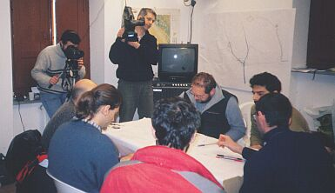

The role playing game at the 1999 Zone Head stage

The periodic Zone Head Board meeting often resulted in a brainstorming about actual accidents management. In 1998 a three-days specific Operations Head stage was designed to share experiences and to train on specific topics. It was the first step toward a formal training plan. The stage was open also to interested Cave Rescue members, with the aim to train in advance people who are willing to share the Zone management load with the actual Zone Head. In this way, Zone Heads to-be were able to gain competence and confidence long before the elections. The Operations Head stage was organized annually until 2002.
In 2001 a large simulated operation was designed in order to test the Cave Rescue at a national level on a high depth and long duration emergency. From the Operation Heads point of view, it acted as a very detailed and comprehensive field training.
However, a more detailed and formalized training plan was needed.

The school for cave rescue managers
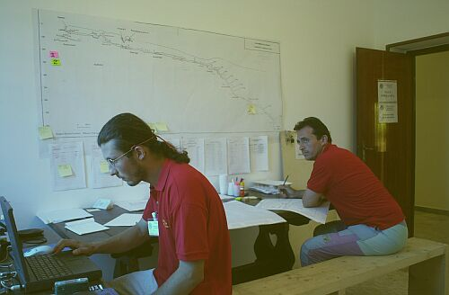

The Operations Room at the national high-depth practice Matese 2001
At the end of 2003, the Zone Head Board charged a small team of experts with the task to define the draft of a training plan. After several meetings, a training plan was defined and approved. It is structured over three years, with three training courses and three updating courses.

Training courses:
T1 Operations management
T2 Basic Zone management (Laws, Insurances, External contacts, Training)
T3 Advanced Zone management (Planning, Resource management, Macro-emergencies)

Updating courses:
U1 Basic update: Communications
U2 Basic update: Role playing game on operations management
U3 Advanced update: Accounting, assessment, technical update, other CNSAS structures, Public Administrations

In each year, a T course and a U course are organized. This means the whole plan is as follows:

Year 1:
T1 Operations management
U1 Communications
Year 2:
T2 Basic Zone management
U2 Role playing game
Year 3:
T3 Advanced Zone management
U3 Advanced update

Such plan has two main rationales:
- In a three year period, all basic and advanced training is provided. The three year period is phased with the elective period of the CNSAS offices. This means an newly appointed Zone Head or Deputy can have its training within the office period. On the other side, an interested but not yet appointed member can have a complete training in an office period, so as to be a competent candidate in the next period.
- The most important and urgent training, operations management, is the first one to be provided. It is stressed again in the second year, in the role playing game. The third year is reserved to advanced topics.
Furthermore, the School for cave rescue managers has no fixed Instructor staff. The expert team manages the course organization and defines a detailed program. Each relation is assigned to a specific topic expert. In this way, actual field experience is gathered together to build a whole training framework.
Each T course is planned to last three days, and each U course is planned to last two full days. The following tables show the six courses program in deeper detail.

T1 – Operations management
Structure of CNSAS
Operations 1 – The call, summoning of teams
Operations 2 – Operations planning
Operations 3 – Operations execution
End of operations
How to prepare for an emergency
Case studies

T2 – Basic Zone management
Duties and responsibilities of CNSAS offices
The operative center, the warehouse, vehicles
Practices planning
Laws and rules, Zone bureaucracy, purchase of goods, assembly summoning
Personnel assessment
Contacts with local and national CNSAS structures
Case studies

T3 – Advanced Zone management
Purchase rules, bids
Accounting assessments and inspections
Disciplinary actions
Persuasion techniques
Operational limits (in-scope and out-of-scope operations)
Planning of inter-Zone or national practices
Accident to a technician in operation
Macro-emergency: definition and operative strategies
Case studies

U1 – Communications
Internal communications: theory of communication models, disaster manager and communication
Public communications: the news-agent task, the media system, the press conference, the TV interview
Communications tools: cave phones, mobile phones, radios, radio-links, mobile phone links
Exercises: bulletins, interviews, press conferences.

U2 – Role playing game
Full simulation of an operation
Management of a Macro-emergency
External and internal search in an area with many caves
Search of missing people in cave (management of several search teams in parallel)

U3 – Advanced update
Quality control and assessment
ISO 9000 rules
CNSAS techniques
Mountain rescue techniques:
- Canyoning
- Avalanche search dogs
- Surface search dogs
Public Administrations and Corps:
- Fire Brigades: organization and operations
- Financial Police: organization and operations
- National Forester Corp: organization and operations
- Civil Defense: organization and operations
A note about the Public Corps: in Italy the Financial Police traditionally patrols the national boundaries. It performs mountain rescue with helicopters; also the Forester Corp, which patrols public forested areas, performs mountain rescue. On the other side, Fire Brigades raised a structure trained in technical rescue (river, mountain and cave).

In 2004 the first courses were organized: T1 - Operations management and U1 – Communications. Each of them gathered most Zone Heads and Deputies, and many other interested Cave Rescue members. About 40 people attended each course. Among the T1 invited speakers, there were six in-charge- or past-National Heads or Deputies and the two CNSAS Deputy Presidents. Relations detailed all aspects of a cave rescue operation and the various management tasks. It was a very comprehensive experience and it provided the participants with a brainstorming about the many peculiarities of a cave rescue operation. Furthermore, the experience of the older heads was collected and rationalized to the advantage of the younger ones.
The communication course was compressed in just one day and a half, due to external reasons. In this way, it resulted too intensive and it missed most exercises. Anyway it provided a complete framework of cave rescue communication, from internal communication between operational teams and the operation heads to media management. Also some Station Heads attended this course.
In 2005 a second national long-duration practice is planned to be organized in Sardinia in September. This is a large role playing game about a cave rescue operation by itself, so the planned U2 course will be converted to a set of actions in parallel with the main practice: internal search of missing people, simulation of a second accident and so on.
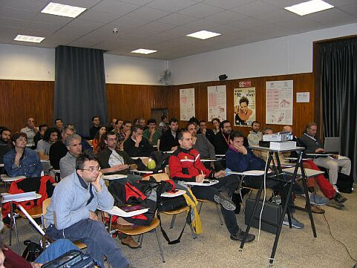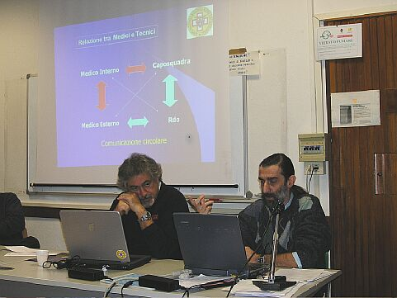

The course U2 – Communications (Bologna 2004): the attendance (left),

communication between the in-cave physician(s) and the Operations Management (right).
The Cave Rescue managers training plan arouse interest in the Mountain Rescue side of the CNSAS. Considering the National Heads, the Regional Services Heads, the Zone Heads and Deputies and the Station Heads and Deputies, the CNSAS has more than 600 managers to be trained. Most mountain rescue operations are performed by small teams, in cooperation with the Medical Emergency Service (118). However, several operations (canyoning, avalanche, surface search, big emergencies, …) deploy in a way similar to a typical cave rescue operation (long duration, many technician involved, several teams in parallel, several helicopters, interaction with Public Corps, high media profile, …). In this sense and in the general management of a rescue organization, the experience raised by the School for Cave Rescue Managers may be very useful to the CNSAS as a whole.

Acknowledgements
The authors wish to thank:
- Luca Calzolari and Paolo Verico, the other two members of the organizing ‘expert team’: common passion and enthusiasm in the project produced hours and hours of intensive brainstorming all together;
- The participants to the 2004 courses, both on the speaker side and on the attendant side: all people were eager to share experience and competence.

Bibliographic references
Camerini C., 2005. La scuola per direttore delle operazioni. Una nuova sfida per il soccorso. Notizie del C.N.S.A.S., 32: 15-16.
C.N.S.A.S., 2005. Annuario 2004, Supplement to Notizie del C.N.S.A.S., 31
Ubertino A., 2005. SpeleoSoccorso: riflessioni sul Corso di aggiornamento “La comunicazione come tecnica di soccorso”. Notizie del C.N.S.A.S., 32: 26-27.
Verico P., 2005. SpeleoSoccorso: Corso Quadri. Notizie del C.N.S.A.S., 32: 25-26.
Verico P., C. Camerini & L. Calzolari, 2004. SpeleoSoccorso: Corso Quadri. Notizie del C.N.S.A.S., 31: 17-18.

