SEA CAVES AT LAMPEDUSA (ITALY)
Graziano Ferrari
(No affiliation)
Via Vignati 18, I-20161, Milano, Italy – gwferrari@gwferrari.it

SUMMARY

Lampedusa is the southernmost island in Europe (N 35° 30' latitude). From the geological point of view, it is a pack of nearly horizontal limestone beds, of Tortonian-Messinian age (about 10-7 My b.p.). No caves were registered, and few references were found in literature.
Actually, the island is rich in littoral caves, and several submerged caves are reported by the local diving centres.
Preliminary results of a survey campaign are presented: 86 littoral caves and 15 submerged caves are positioned. Developments are small, but rich sea habitats are present, mainly in Poriphera.

Introduction
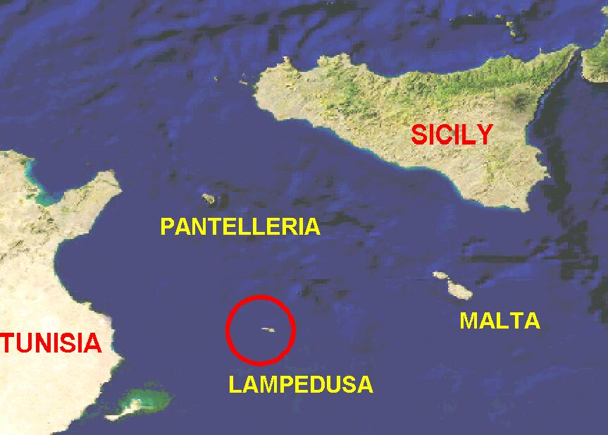
In the central Mediterranean Sea, between Sicily and Africa, the Pelagie Islands belong to Italy but they are placed on the North rim of the African plateau. The word "Pelagie" comes from the ancient Greek, meaning "high sea islands". Lampedusa is the main island (extension 20.2 km², coastal development 33.3 km, maximum elevation 133 m). It has a roughly triangular shape, 10 km long in the East-West direction, with a maximum width of about 4 km in the eastern half. A single town (about 5000 people) is also named Lampedusa. Tourism is the main revenue, followed by fishery. The island is an important scuba diving place. The Rabbits’ Beach, in the middle of the southern coast, is a breeding ground for sea turtles (Caretta caretta); in 1995 a land protected area was established in the place. In 2002, most of the sea around Lampedusa was established as a sea protected area.
From the geological point of view, Lampedusa is a flat table of Tortonian-Messinian limestones and grainstones (Grasso & Pedley, 1988). Beds are nearly horizontal. The north coast is a cliff, 50 to 130 m high, while the south-eastern side slopes gently into the sea. On the northern and eastern sides, the sea bed quickly reaches a depth of about 60 meters while on the southern side the sea is shallower. Several bays mark the southern side of the island. Just south of the town lies Maluk Cape, the southern point of land in Europe (N 35° 29' 24").
Apparently, no caving researches were performed at Lampedusa in the past. No caves were registered in the Sicily Cave register (Messana & Panzica La Manna, 1994). Just two references were found in caving literature (Frassoni, 1967; Criscuolo & Miragoli, 1988). Both papers are reports about short trips in the area. They point out the presence of some interesting caves.
In 2001, during a scuba diving holiday at Lampedusa, the author positioned about 50 littoral caves. Furthermore, the local diving centres reported several references to underwater caves. At that time, the author was involved in the development of the Census of Italian sea caves (Cicogna et al., 2003). A small research campaign was designed. Each year, the author spends one October week scuba diving and positioning sea caves. In the meantime, some land caves and several WW II bunkers were reported and positioned. Presently, 151 caves are identified; 16 of them were surveyed. It is a very relaxed caving activity, with little effort and small results. Unfortunately, caves on the northern side and on the westernmost half of the southern side are reacheable only by boat, so most of them are just positioned and they are not described in this paper.

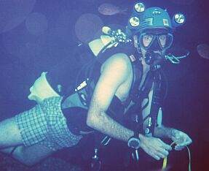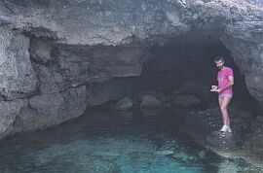

“Take it easy” sea caving: M. Giordani surveys at L84 (left, 2002); G. Ferrari surveys at L5 (right, 2002)

The next chapters report about known caves at Lampedusa. Just certainly identified caves are reported. Many other large and small entrances are known and positioned, but they are not yet explored and/or surveyed.
Caves are divided into two categories: submerged and littoral (semi-submerged). Caves with completely underwater entrances are considered “submerged”; they are identified by a letter “S” and a progressive number. Caves with partly water-filled entrances are littoral; they are identified by a letter “L”.

Submerged caves
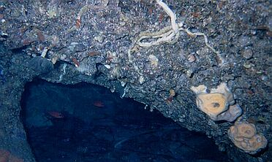

Dark cave biocoenosis in S10
Several small underwater caves are reported. Most are tunnels, at shallow or medium depth. Some caves are reported at greater depths. Most caves show a phreatic origin. Some of them are short tunnels and S1 is just a longer one. On the other side, S14 is more complex: an emerged domed room is connected to a larger semi-submerged one, which in turn is connected to the sea by a large tunnel (24 x 16 x 7 m).
Most caves (S1, S6, S7, S10, S11, S14) show a WNW-ESE main direction, parallel to the main island direction, or an orthogonal one (S3, S13).

Code | Name | Depth | Devel. | Survey | Notes
S1 | Taccio Vecchio cave | -20 - -12 | 57 | Yes | Tunnel, three entrances. Nice and easy dive.
S3 | Our Lady’s cave | -15 - -5 | 11 | Yes | Tunnel, two entrances. Nice and easy dive.
S4 | 1st Scoglio di Fora cave | -17 - -10 | 16 | Yes | Tunnel, two entrances. Nice and easy dive.
S6 | Punta Russeddu cave | -5 - -0.5 | 17 | No | Tunnel, two entrances.
S7 | Punta Pesce Spada cave | -15 - -11.5 | 16 | No | Tunnel, two entrances. Southernmost cave in Europe.
S10 | 1st cave SE of Eastern Grottaccia | -11 - -7 | 11 | Yes | Tunnel, two entrances. Rich in sponges and serpuloideans.
S11 | 2nd Scoglio di Fora cave | -12 – 0 | 20 | Yes | Large tunnel. Nice and easy dive.
S12 | 3rd Scoglio di Fora cave | -9 | 6 | Yes | Small chamber.
S13 | Punta Cappellone cave | -18 - -10 | 16 | Yes | Two entrances.
S14 | 2nd Taccio Vecchio cave (Salvo’s cave) | -12 - +8 | 61 | Yes | Tunnel + large semi-submerged chamber + emerged chamber. Nice light effects.
S16 | 2nd cave SE of Eastern Grottaccia | -15 - -11 | ~10 | No | Three entrances. Rich in sponges.
S21 | 2nd Punta Guitgia submerged cave | -4 - -2 | ~10 | No | Two entrances. Chamber.

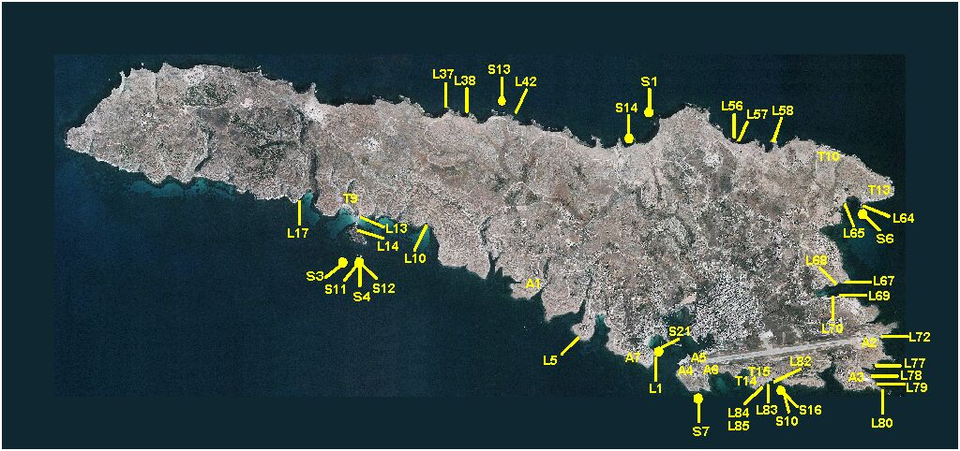

Lampedusa: cave positions

Littoral caves
86 littoral caves are positioned. They are distributed all along the island coast. In summer, tourist boats offer scenic tours of the island; they visit several littoral caves. The north cliffs show a large number of domed or triangular entrances (L26-L63). On the eastern side, just under the end of the airport runway, there is a number of large littoral caves (L71-L77). Two of them are named from the monk seal (Monachus monachus). Another area, named “Le Grottacce”, is on the south-eastern side (L82-L85).
Cala Pulcino cave (L17) deserves a special note: it is a 32 m long tunnel half filled with water. It is placed on the side of a bay in the southern side of the island. Its entrance is protected from the waves, since it faces the inner part of the bay.
Most littoral caves are simple, horizontal straight tunnels with one or two entrances. L42 has a submerged side branch with a fresh water spring. Up to now, this is the only case of fresh water spring in Lampedusa caves.
As submerged caves, several littoral caves show a WNW-ESE main direction (L5, L14, L42, L67, L68, L85) or an orthogonal one (L84).

Code | Name | Elevation | Devel. | Survey | Notes
L1 | Punta Guitgia cave | 0 | ? | No | Small horizontal cave. Some garbage.
L5 | 4th Punta Pagghiareddu cave | -3 - +2 | 14 | Yes | Small horizontal cave. Very nice pool in the entrance.
L10 | 1st Tabaccara cave | -1 | 10 | Yes | Large cavern. Not a cave.
L13 | Rabbits’ Beach cave | 0 | ? | No | Tight semi-submerged passage. Too small.
L14 | 1st Rabbits’ Island cave | -1 - +2 | 20 | Yes | Tunnel.
L17 | Cala Pulcino cave | -5 - +4 | 32 | Yes | Tunnel.
L37 | Solaro caves | 0 | ? | No | Wide entrance half filled with water. Probably connected with L38.
L38 | ‘A Rutta delli Palunni Selvaggi (Wild Pigeons’ cave) | 0 | 30 | No | Large cavern half filled with water. Probably connected with L37.
L42 | 4th Punta Cappellone cave | -7 - 0 | ? | No | Large half filled cavern. A 16 m long side branch brings fresh water.
L56 | 4th Cala Alaimo cave | 0 | ? | No | Large half filled triangular entrance.
L57 | 5th Cala Alaimo Cave | 0 | ? | No | Large half filled domed entrance.
L58  L59 | ‘A Rutta dell’Innammorati (Lovers’ cave) | 0 | ? | No | Large half filled cavern. Two entrances.
L64 | Punta Russeddu arch | 0 | ? | No | Large tunnel. Two entrances.
L65 | 2nd Mare Morto cave | 0 | ? | No | Half filled cavern with a large underwater room.
L67 | 1st Cala Pisana cave | -6 - +5 | 18 | Yes | Horizontal half filled chamber.
L68 | 2nd Cala Pisana cave | -6 - +2 | 24 | Yes | Horizontal nearly filled tunnel.
L69 | 3rd Cala Pisana cave | 0 | 17 | Yes | Small cavern. One sea and one land entrance.
L70 | 4th Cala Pisana cave | 0 | ? | No | Small half filled tunnel with a second submerged entrance.
L73 | Sea Monk’s cave (1st) | 0 | >100? | No | Large half filled cavern. A small beach at the end.
L77 | Sea Monk’s cave (2nd) | 0 | ? | No | Very large half filled tunnel.
L78 | Punta Sottile tunnel | 0 | ? | No | Small half filled tunnel. Two entrances.
L79 | 1st Vacca Aranciu cave | 0 | ? | No | Very large cavern. Not a cave.
L80 | 2nd Vacca Aranciu cave | 0 - +4 | ? | No | Two entrances, pipe cave. Horizontal half filled entrance from the sea; vertical pit in the plateau.
L82 | Eastern Grottaccia | 0 | ? | No | Very large round half filled collapsed dolina. Not a cave.
L83 | Sima | 0 – +10 | ? | No | Vertical shaft in the plateau reaches sea level.
L84 | Cave East of Western Grottaccia | -6 - +1 | 17 | Yes | Large nearly filled tunnel with short submerged continuation.
L85 | Western Grottaccia | -6 - +10 | ? | No | Large open roofed channel with a terminal cavern.

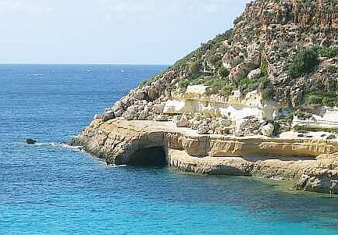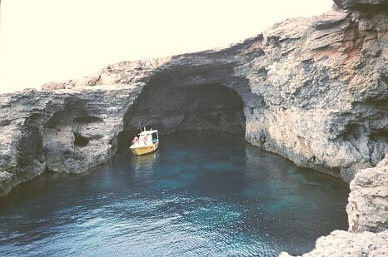

Littoral caves: Cala Pulcino cave (L17, left), Western Grottaccia (L85, right).

Land caves and artificial caves
No special research was performed on land caves. However, 24 references were registered. Some of them are small caverns. Postu Maraventanu cave (T10, in local dialect Postu Maraventanu means “place of bad wind”) is a set of small orthogonal phreatic tunnels in the northern cliffs. On the other side, Capo Grecale cave (T13) is a very high tunnel that opens at sea level just under the Capo Grecale lighthouse. Apparently it is not a littoral cave, since the sea water does not reach the cave entrance. However, the internal reaches are not yet explored.

Code | Name | Elevation | Devel. | Survey | Notes
T9 | Rabbits’ Beach pit | +65 | ? | No | Vertical shaft on the cliff just over the Rabbits’ Beach. Closed by an iron grating.
T10 | Postu Maraventanu cave | +15 | ? | No | Small orthogonal passages on three levels.
T13 | Capo Grecale cave | 0 | ? | No | Very large cave just under the Capo Grecale lighthouse. Can be reached only by boat.
T14 | 1st cave West of Western Grottaccia | 2 | ? | No | Small passage on a side wall of Western Grottaccia.
T15 | 2nd cave West of Western Grottaccia | 2 | ? | No | Small room just outside Western Grottaccia.

Lampedusa is also rich in artificial caves. In the past, local people mined several small rooms in the soft grainstone. Furthermore, during the second World War, Lampedusa was a strategic place for the control of African supply lines. The Italian Army built a large number of bunkers, mainly on the southern side of the island, as a protection for the harbour. Several bunkers were nearly destroyed by bombing. A special case is a bunker on the eastern side of the harbour entrance: it is placed on the cliff side, just above the entrance of L86, a littoral cave.

Biologic notes
Usually littoral caves suffer from a heavy hydrodynamism. Their wall population is poor, mainly algae. On the other side, in several occasions rich schools of fish were observed, in particular juvenile specimens. In this sense, littoral and submerged caves act as shelters and help in the replenishment of the fish population.
Underwater caves, on the other hand, usually show rich habitats, with several species of algae, sponges, hydroids, scleractinians, polychaetes. In some cases, lobsters were observed; fish schools are common in minor caves. A rumour reports that an undetermined hydroid is present in the mixed salt-fresh water submerged side branch of L42.
A notable exception to the rich population of submerged caves is S1, Taccio Vecchio cave. It is one of the largest known submerged caves, a 57 meters long tunnel with three entrances. Its tunnel portion is quite dark and poorly populated. Probably this is due to the heavy frequentation by divers. The cave is one of the most important and frequented diving places in Lampedusa.

Conclusions and future developments
Clearly, the present work is a low level one, with the simple aim of having a nice time in a nice place at positioning and surveying Lampedusa sea caves. Up to now, just part of the coast was examined in detail. An obvious future development is to carry on cave positioning and survey, in order to gather complete, detailed knowledge of sea caves at Lampedusa. Furthermore, other islands in the Pelagie archipelago have much to show: Lampione is a small uninhabited rock 10 km NW from Lampedusa, with a 300 m side length and a 36 m maximum elevation. It is made by Lutetian-Priabonian grainstone. A very quick survey revealed two submerged (S8, S9) and two semi-submerged small caverns (L23, L24). The sea bottom drops quickly to 50 meters. Lampione needs a more detailed underwater survey.
Linosa is a volcanic island 57 km NE of Lampedusa, with a 5,43 Km² extension. From the caving and sea caving point of view, it is yet unexplored. Some diving or tourist reports about lava tubes are present.
Since the biologic and economic relevance of both submerged and littoral caves at Lampedusa, a detailed study would be very useful in assessing the biologic and tourist resources and the sustainability of their exploitation.

Acknowledgements
The author expresses thanks to:
- Simone d’Ippolito and Daniele Barozzi (Pelagos Diving Center, Lampedusa) for the continuous support to the research work;
- Marco Giordani, Elena Rognoni and Simona Rognoni for the help in the research, positioning and survey work.

Bibliographic references
Cicogna F., C. N. Bianchi, G. Ferrari & P. Forti (eds.), 2003. Le grotte marine: cinquant'anni di ricerca in Italia. Ministero dell’Ambiente e della Tutela del Territorio, Roma. 1-505.
Criscuolo M. C. & M. Miragoli, 1988. Lampedusa e Malta, un po’ di carsismo... Il Grottesco, Bollettino del Gruppo Grotte Milano, 48: 95-105.
Frassoni F., 1967. Esplorazioni del Gruppo Grotte S. Pellegrino Terme nelle isole mediterranee. Rassegna Speleologica Italiana, 19 (3): 105-113.
Grasso M. & H. M. Pedley, 1988. Carta Geologica dell'Isola di Lampedusa. Ministero della Pubblica Istruzione e Regione Sicilia.
Messana E. & M. Panzica La Manna, 1994. Consistenza attuale del Catasto delle grotte della Sicilia. In: Atti del II Congresso regionale di Speleologia, Catania, 8-11 dicembre 1994, Bollettino dell'Accademia Gioenia di Scienze Naturali, 27 (348): 373-376.

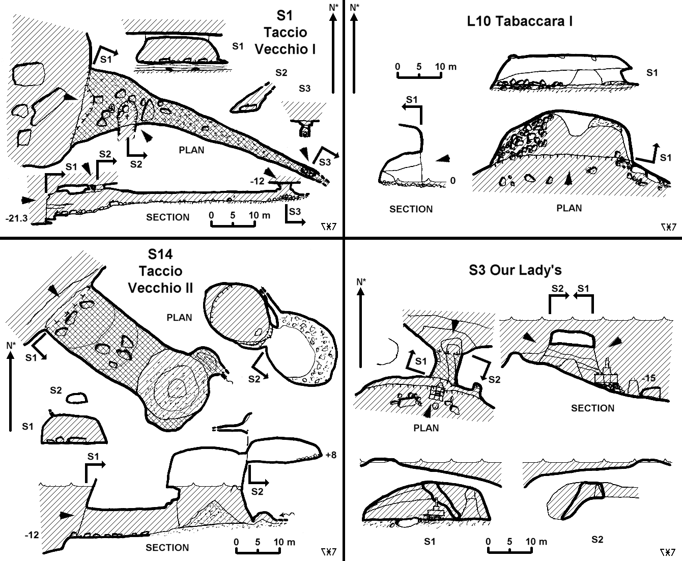

Surveys 1 (Author: G. Ferrari, 2005)
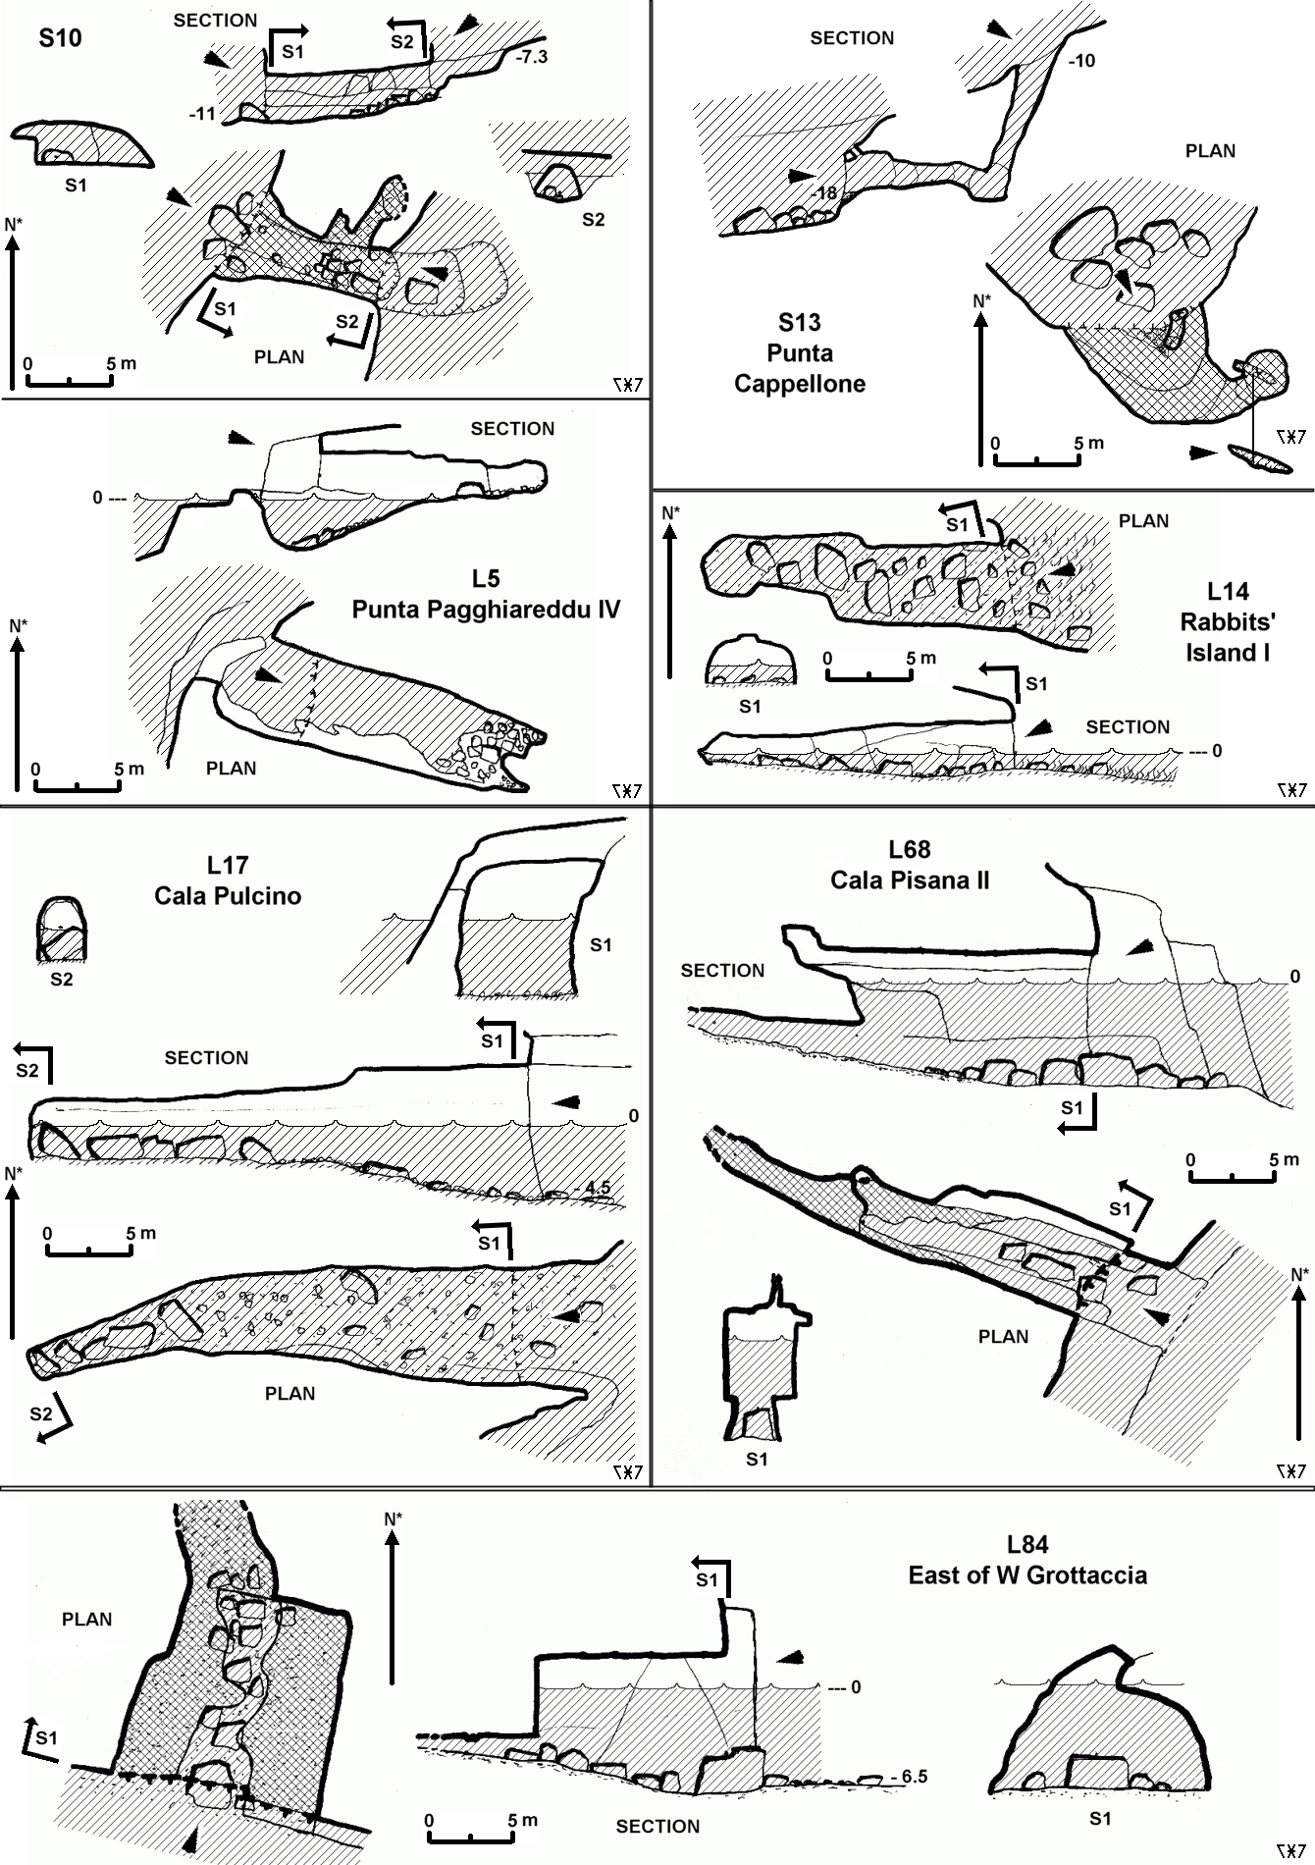

Surveys 2 (Author: G. Ferrari, 2005)

