Karst as a settling factor

Viacheslav Andrejchuk
University of Silesia, Bedżińska 60, 41-200 Sosnowiec, Poland
Abstract. Karst is a natural factor, which influence actively on to human settling on karstified territories and on to their economic developing. Karst transforms all components of a landscape and forms a specific environment of human life. A water component of karst landscape is subjected to transformation in the most degree. Just it – presence or absence of water – is a main factor that limits or stimulates the settling processes in karst areas. Presence or absence of water in karst landscapes is determined, first of all, by the depth of ground (karst) water table location that, in one’s turn, is depended on the hypsometric character of karst massives (mountains, highlands, flats etc.). Significant importance has also climatic position of karst landscape: depending on zone of nature (coefficient of humidifacation) karst can drain or dry up a landscape and, thus, to improve (in areas with redundant humidification) or to worsen (in areas with deficiency of water) an environmental conditions of human life.

Introduction
Transforming a landscape, karst forms the specific environment of life and activity of the human. Karst areas are long since populated by the human. At the initial stages of their developing the presence of natural shelters - grottoes and caves, was determinative. After transition to productive activity (first of all, to cultivation of plants and animals) the presence of water, an opportunity of soils cultivation and cattle pasture began to get a principal value. Not all karst landscapes met to the marked requirements, therefore their settling occurred differentially. Distinctions in a degree of development of different types of karst landscapes, including, in comparison with non-karstic, are well appreciable even now. On several examples we shall consider peculiarities of karst inhabitancy of the human from the point of view of the natural landscape preconditions described above.
Certainly, determinative importances in development of karst landscape by the human had and have such factors, as presence (an opportunity of access) of water, making possible or impossible his ability to live, and also a degree of humidifying of territory, a secondary from mutual imposing of climatic and karstic factors. Considering the marked factors the karst landscapes may be divided on favourable and unfavourable concerning human life (fig. 1, A, B).
The first factor – the availability to water, depends, mainly, on depth of karst water table. As deeper they are bedded, as less accessible they are for use. Depth of water surface is determined, first of all, by height of a karst massif. On fig. 1-A this regularity is reflected in the generalized kind, and its features are uncovered in the text on the examples designated in figure.

Karst influence on settling processes in mountain and upland regions
High-mountainous karst massives, as a rule, are dehydrated and lifeless. Their surface is rocky, is dotted by karst dolines and depressions, fractures filled with fragments of frosty weathering of rocks. Primitive soils may be formed only in karst depressions where clayey eluvium accumulates. In middle-mountains the karst massives are frequently covered with a forest, however their high karstification and aridity also predetermine the absence of stable settlements. Their use by the human is limited to the summer period - pasture of cattle on mountains (and that in case if on a massif suspended lakes for a pond are available). At the high and middle mountain karst, as a rule bared or soil-covered, the underground water are situated on depth inaccessible to use and measurable in hundreds and in thousand meters.
As much lifeless (in relation to the human) are mountain-karst massives, as densely their periphery is populated. Foots of massives with powerful karst water effusions and abundance of eluvial material with fertile soils, differ by “concentration of life”. Karst massives of Mountain Crimea (Ukraine), Caucasus, as well as many regions of the Mediterranean with a strip of continuous settlements and resort cities at their bottom can serve classical examples in this respect. Thus, being waterless, mountain karst massives frequently irrigate the non-karstic surroundings, predetermining its settling and active economic development.
Low-mountain and upland karst areas and uplands also lack the surface moisture. Despite of, as a rule, bigger than in high mountains thickness of eluvial deposits and vegetation covering, karst waters are situated there on depths of 50-100 and more meters, that also makes their use (by traditional ways) impossible or rather inconvenient. The network of settlements and also a transport network in such regions are rarefied, but their percentage of forestlands is higher. The Ufa Plateau (Pre-Urals, Russia) is an example of such region. It represents the upland (350-400 m a.s.l.), built with the Permian limestone and towering above the neighbouring territories on 50-100 m. Its surface is karstified, but significant thickness of residual eluvial material allows forest vegetation to exist here. Because of a freely filtration of precipitation through cracks and karst channels, the upland is waterless. Underground waters are situated on depths of 70-100 m and river valleys (except for the large transit rivers) are dry. The given circumstance has predetermined weak economic development of the region and preservation of almost continuous forest cover (92 %) within its borders, while in its surroundings the forest coverage is only 47 % (fig. 2-A). It would be visible from the fig. 2-B that the density of settlements as well as roads on the upland is lower, than on the next territories. Both settlements and roads within its borders gravitate to valleys of rivers crossing through the Upland (the factor of water).
At the same time, as well as in the case of mountain landscapes, along borders of the Plateau and on the next territories the increase of quantity of settlements and a closeness of roads network are observed.

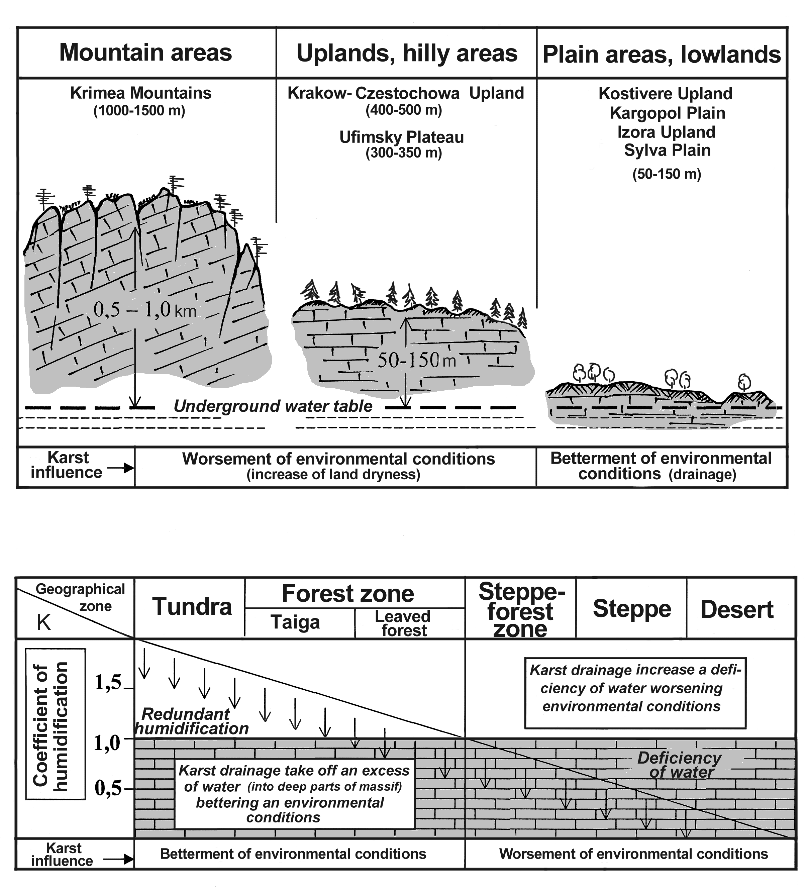
Fig.1. Position (depth from a surface) of underground water table (inside the karst massives)
(A) and degrees of humidification (B) as a man-related environmental factor.
A

B

As well as in the previous case, the main reasons of this phenomenon are the plentiful karst water effusions (springs with the discharge of 0,1-1,0 m³/s) with water of high quality. The debit of the largest (the Krasny Kluch) peripheral spring (of the vaucluse type) in average annual expression is 12 m³/s, but its maximal debit achieves 58 m³/s. Near the large springs, which are the sources of rivers, large and rich settlements with ponds, water mills etc. arose. It is remarkable, that names of many settlements specify their landscape localisation - near karst springs and lakes – Kluchi (springs), Kluchiki (little springs), Ozera (lakes), Ozerki (little lakes) etc. On the fig. 2-B the names being toponymic reflection of the described phenomenon are given.

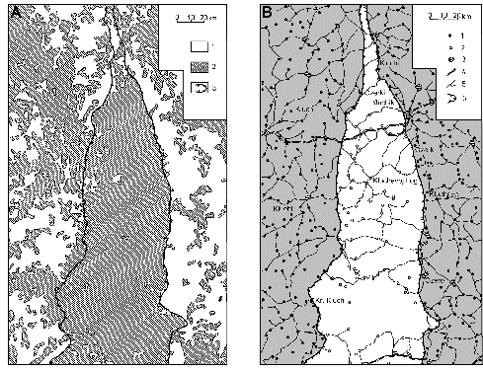
Fig. 2. Forestation degree (A) and transport- settlement infrastructure (B) in the Ufa karst Plateau: A: 1 – non-forested areas, 2 – forested areas, 3 – Ufa Plateau area; B: 1 – villages outside Plateau, 2 - villages within the limits of the Plateau, 3 – settlements, 4 – railways, 5 – roads, 6 - Ufa Plateau area.

The Krakow-Czenstochova Upland (in Poland) built with Jurassic limestone, may serve as the other, not less interesting example of the environment of karst uplands. Inside the Upland bounds the same regularities, as in the previous case (a rarefied river network, considerable forest-covering, smaller density of settlements and roads, a peripheral concentration of settlements etc.) are observed. However, owing to the historical reasons (position inside a populous part of Europe) and the less depth of underground waters occurrence (50-80 m) we find set of examples of rational water use in this region. The basic distinction in character of water use within the borders of the karst upland and out of its bounds is observed. For the population of Upland water is the wealth, which difficult getting (deep, up to 70 m pits) predetermines its very rational use (down to exception of vegetable gardens watering). Outside of the Upland, or along its periphery with karst springs, water is a basis of transforming activity in a landscape (melioration, irrigation, power production etc.), supposing the other attitude to it (the mental moment).
The described examples show that with decrease of the karst massives heights from mountains to uplands the degree of their adversity for settling and economic development is reduced. Nevertheless, as a whole, the karst environment of regions with deep karst waters occurrence excludes or considerably complicates life of people and is adverse. The regions with “mature” karst present some exception in this respect. Owing to long-time karst denudation large forms (for example, poljes), which bottoms are covered with thick accumulation of waterproof clay
deposits (residual deposits) and their depth reaches the local drainage bases, were formed (for example, Karst Upland in Slovenia, many low-mountain and high karst regions of tropical areas). The age of karst softens dependence of the human on the water factor.

Karst influence on settling processes in plain and lowland regions
The picture varies in case of lowlands or plains. Despite of relative aridity and rarefaction of a surface network, the close (5-50 m) underground waters occurrence (a constant source) and simple ways of their extraction promote settling within their borders. Moreover, the karst drainage, in most cases, is the positive factor for the agricultural activity, creating within the borders of karst landscapes the better edaphic conditions than on surrounding, frequently over-damped or boggy territories. Let's consider the given thesis on the several examples concerning the right part of fig. 1-A, while moving by the Eastern-European region from the north to the south.
Within the Onega River basin on sites of limestone development under plain-lowland conditions (130-230 m a.s.l.) the high karst sites called susha (dry land area among swamped territories) were formed. Landscape of Kargopol’ Susha is the most known. The region is situated in taiga zone with over-humidifying and is surrounded with bogs, as well as others sushas. Within borders of Susha, owing to drainage impact of karst, boggy sites are almost absent, fertile derno-carboniferous soils were formed, that promoted agricultural development of the territory. The network of settlements and roads developed here. In 14-20-th centuries the region of sushas was a granary of the Russian North, and its towns became large trade centres (as for example, Kargopol) - with stone houses, churches and with cultural life. The local resident told, that people on Kargopolye are more portly and healthy, “thoroughbred” and in the whole richer, than at the Susha surrounding districts. Within borders of sushas the grassy cover is more plentiful, the swarm of midges is less, the cattle better gain weight and skins of fur animals are of better quality, than in surrounding marshy areas (Торсуев, Левин, 1980).
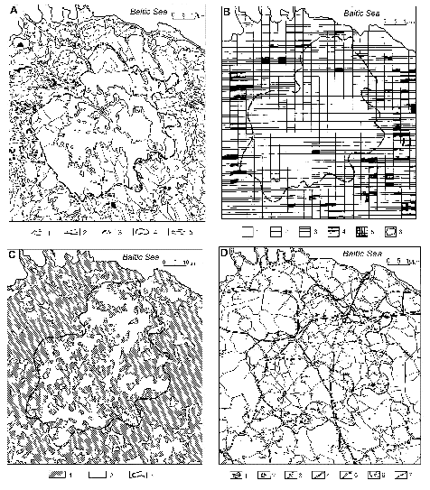
The other example of agricultural “oasis” in taiga zone is the mentioned earlier Izhora Upland* (120-150 m a.s.l.), located to the south from Saint Petersburg. Within the borders of the region built with Ordovician limestone, due to karst drainage and fertile rendzinas the initial southern-taiga (mixed) forests were substantially (up to 30-40 %) cut down and replaced with agricultural landscapes (Чикишев, 1979). Forest covering of the territories next to the upland is 83-95 % (Исаченко, 1991).

Fig.3. Kostivere karst Upland in Estonia:
А – contour line scheme: 1 – river net, 2 – channels, 3 – lakes, 4 – the border of Upland area, 5 – swamps; B – scheme of river net density: 1 – 0,0 кm/кm², 2 – 0,10 - 0,30 кm/кm², 3 – 0,31 – 0,70 кm/кm², 4 - 0,71-1,0 кm/кm^{2,}, 5 – >1,0 кm/кm², 6 – the border of Upland area; C – degrees of forestation: 1 – forested areas, 2 – non-forested areas, 3 – the border of Upland area; D – scheme of roads and settlements: 1 – towns, 2 - villages, 3 - farms, 4 – railways, 5 – main roads, 6 – local roads, 7 – the border of Upland area.
Vivid examples of positive karst influence on territory development are Baltic uplands, for example Kostivere Upland in Estonia, located in a zone of the mixed forests. It is built with Silurian limestone and towers a little (on 50-70m) above surrounding territories (fig. 3-A). It differs by smaller relief dissection and rarefied river network (0,1-0,3 km/km² in comparison with an environment - 1,0-1,5 km / km²). Low, in part boggy territories (fig. 3-B) surround the upland (Каск, 1963). As well as in the previous cases, karst drainage and the better conditions have predetermined here lower rate of territory forest-covering (39,8 %), than in its surroundings (76, 4%) and, accordingly, higher rate of agricultural grounds (fig. 3-C). The higher density of settlements (3,5 per 100 km²) and communication networks (0,62 km/km²) reflects the increased economic activity of the population within the borders of the Upland (fig. 3-D). On territories surrounding the upland these parameters are, accordingly, 2,0 per 100 km² and 0,02-0,05 km/km². This region of Estonia is among the optimum ones from the agricultural point of view (the first of eight categories of a regional scale) and is used for cultivation of a winter wheat and neigh, while on next territories the potato and fodder plants are cultivated. The similar situation takes place within Zemgal'skaja Plain in Latvia, built with strongly carbonated and permeable moraine with fertile rendzina on it. Agricultural grounds occupy 80 % of territory of the Plain. Because of high crop capacity the region is called “Ukraine” of Latvia (Жучкова, Cмирнова, 1963).
Plenty of examples of karst improvement of the grounds can be found in east part of the Eastern European region where alongside with carbonate rocks, gypsum have a wide distribution. One of such areas covers the downstream of the Sylva River (to a southeast from Perm City). Under conditions of rather shallow (up to 50 m) dissection of area, close (2-20 m) underground water occurrence and normal (K≈1) or some increased humidifying (the southern part of forest zone), karst provides a good drainage and promotes formation of forest-steppe landscapes with fertile grey forest soils and chernozem-like soils here. The ground resource, in turn, promoted settling of this area. Now the density of settlements here is 8,9 per 100 km², while on the next non-karstic territories only 2,6 (fig. 4).
Above mentioned examples are taken from zones with the excess humidifying. In all examples the karst positively influences the natural environment in aspect of opportunities of its use by the human. In N.P.Torsuev's opinion (1980), the maximum positive effect of karst impact on environment in taiga zone is observed.
To the south from the forest-steppe zone, in geographical zones with lack of moisture (steppe, semi-desert and desert, dry savannah), the karst drainage of area is transformed from the positive factor into negative one (fig. 1-B). It causes dehydration of a territory, strengthening its aridity. For example, it almost excludes growth of forest vegetation in a steppe zone, even in valleys and depressions, where rain or subsoil waters may collect.

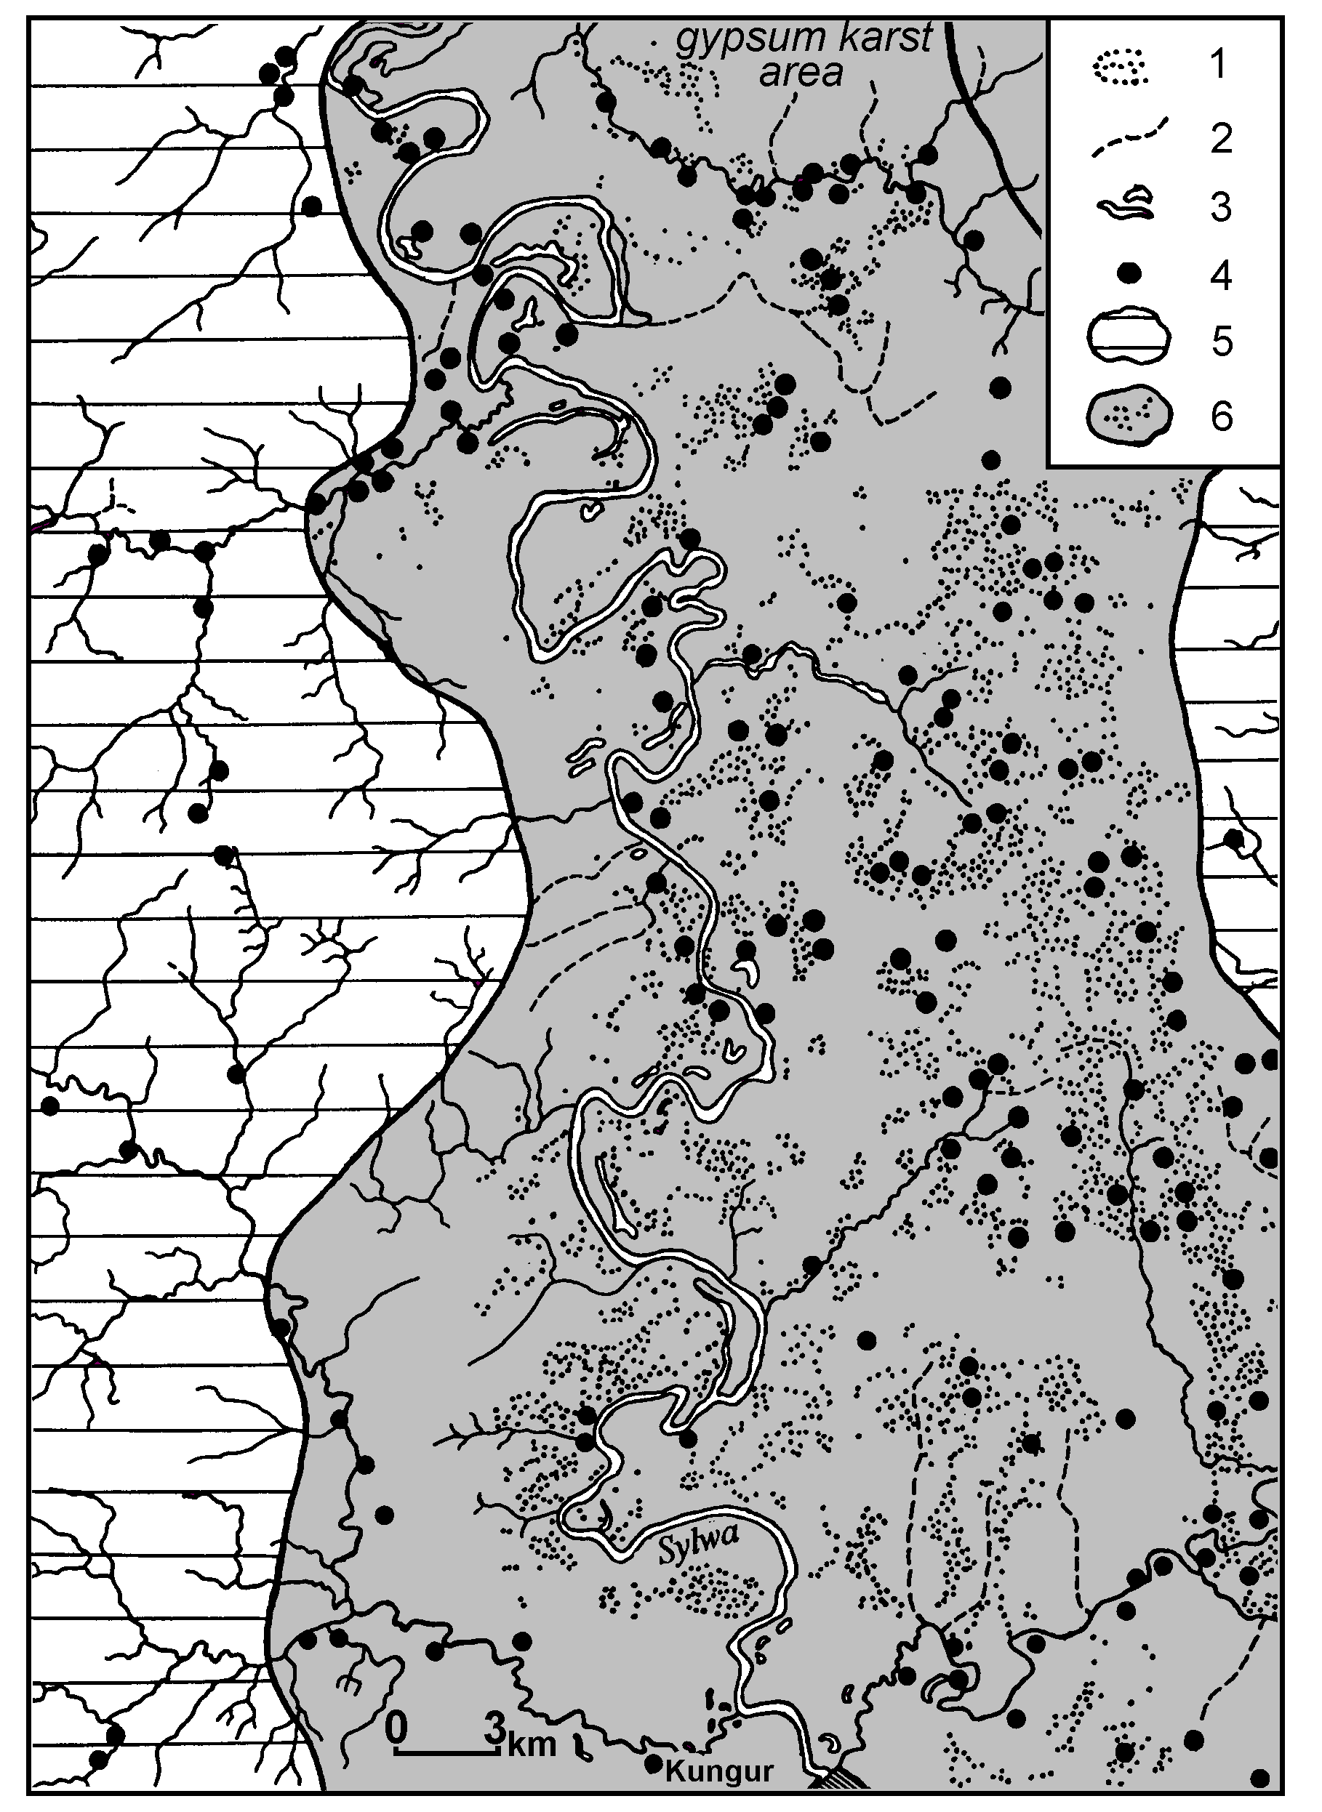
Fig.4. Irregular distribution of settlements in the lower part of the Sylva River valley (Pre-Urals, Russia): 1 – karst forms, 2 - dry valleys, 3 – small towns, 4 – villages, 5 – non-karstic areas, 6 – gypsum karst area.

References
- Жучкова В.К., Cмирнова Е.Д., 1963. Физическая география СССР.МГУ. Москва. 68с. (Zhuchkova V.K., Smirnova E.D., 1963. Physical geography of the USSR. MGU. Moscow. 68 p.) (In Russian)
- Исаченко А.Г., 1991. Ландшафтоведение и физико-географическое районирование. Высшая школа. Москва. 366с. (Isachenko A.G., 1991. Landscape science and physical-geographical regionalisation. Vysshaja shkola. Moscow. 366 p.) (In Russian)
- Каск А.Г., 1963. Исследование минимального стока рек северной Эстонии в связи с карстовым питанием. В: Сб. Работ по гидрологии, №3. Гидрометеоиздат. Ленинград. (Kask A.G., 1963. Research of the minimal flow of rivers of Northern Estonia in connection with karst recharge. In: Sbornik rabot po gidrologii, #3. Gidrometeoizdat. Leningrad.) (In Russian)
- Торсуев Н.П., Левин С.А., 1980. Географические аспекты изучения равнинного карста. Казанский университет. Казань. 207с. (Torsuev N.P., Levin S.A., 1980. Geographical aspects of karst research of plains. The Kazan University. Kazan. 207 p.) (In Russian)
- Чикишев А.Г., 1979. Проблемы изучения карста Русской равнины. Москва. 302с. (Chikishev A.G., 1979. Problems of karst studying of Russian plain. Moscow. 302 p) (In Russian)

* In this case, as well as in below following examples, the presence at the name of region of the word “upland” reflects their property to tower a little above low boggy or flat over-humidified territories. Taking into consideration their height above sea level (150-250 m!) they are hypsometrically flat territories

