Investigation of Zagedanskaya in the honor of A.V. Alexeev cave system (North Caucasus)

Alexander S. Gusev (1,2), Sergey Yu. Lipchenko (3), Oleg B. Tsoy (4), and Alexey L. Shelepin (2)
1 Moscow State University, Moscow, Russia, 2 Russian Geographic Society, Moscow, Russia, 3 SSCC Hydrogeoecology, Cherkessk, Russia, 4 Saratov State University, Saratov, Russia (e-mail: gusev@sai.msu.ru)
Abstract. The results of the speleological investigations in 1995-2001 in the earlier unexplored area of Zagedan-Urup karst massif of Abishira-Akhuba mountain ridge (North Caucasus - Karachaj-Cherkessian Republic, Russia) are presented. There was founded and explored rather large cave system named “Zagedanskaya in the honor of A.V. Alexeev” (amplitude is 570 m (+19/-551), longways 5500 m). The description and the history of exploration of the cave system are presented. The tracing of the cave stream allowed us to discover the cave discharge spot (Atsgara vauclusian spring), located at interval of 6 km. We support the discovered karst system joins all the largest caves in the massif.

Introduction. In the last decade of the 20th centure former Soviet cavers were cut off from the deepest Abkhazian caves because of the military conflict in Abkhazia. It is given a good impulse for the investigation in caves located in Russia. In result, several new large were found and explored in the “old” N. and W. Caucasus regions (Mt. Fisht plateau, Mt. Dzhentu massif, and Abishira-Akhuba mountain ridge, mainly). One of the new cave systems was found and explored by our team in Abishira-Akhuba ridge (Gusev et al., 2000; Lipchenko et al., 2004). It was named “Zagedanskaya in the honor of A.V. Alexeev”. Mr. Alexeev was one of leaders of Saratov caving. He was one of the pathbreakers in the caves of Zagedan massif during our first expedition in 1995, and was died in a car accident in 1996.

Geology and geography of Abishira-Akhuba mountain ridge and Zagedan-Urup karst massif. Abishira-Akhuba ridge is located on N.-W. Caucasus, between Bolshaya Laba and Bolshoj Zelenchuk rivers, being a part of the Lateral Ridge and is located in parallel of the Main Caucasus Range. Abishira-Akhuba ridge being separated from the Main Range by Arkhyz-Zagedan tectonic depression.

In the tectonic attitude Abishira-Akhuba ridge represents the asymmetric anticline lasting from northwest on a southeast more than on 30 km. The axis of an anticline is displaced to the north from the watershed line of a ridge having marks about 3000 m a.s.l. The southern slope of an anticline abruptly falls aside Arkhyz-Zagedan depression, the northern one hollow goes down aside North-Jurassic depression. The ridge has been shattered into separate blocks of various orientation in Hercynian stage of mountain formation. It tested a raising in the subsequent mountain formation epoch, as a result of which active processes came to life again.

Tectonic processes in aggregate with river erosion and activity of ancient glaciers have predetermined modern orography of Abishira-Akhuba ridge. Its southern slope is dismembered poorly. Traces of an ancient congelation are expressed here by the small sizes relicts karrens which have placed at altitude above 2750 m a.s.l.. Northern slope is dismembered by the river valleys on spurs. The spurs stretch to the northeast direction and has extent from 5 up to 30 km.

The highest points of a ridge are peaks with marks about 3200 m a.s.l. Glaciercial forms of a relief (circuses, valleys, karrens) are developed on a watershed line of Abishira-Akhuba ridge and its northern spurs. Heads of the rivers flowing down on northern slope had glaciers in length from 6 up to 18 km with capacity of an ice up to 300 m. Circuses meet on a watershed part of a ridge is more often. Top from its have merged in the uniform circus. It stretches along the ridge in the form of a trench, representing a chaotic heap of blocks, rocks and taluses. The bulk of sloping snow tongues, feeding the rivers of northern slope (Kjafar-Agur, Kjafar, Chilik, Malyj Urup, Atsgara, Bolshoj Urup) concentrates here. Age of a hydrographic network of Abishira-Akhuba ridge is earlier than Ice Age. Channels of the basic rivers used lines of dumps or axes of syncline folds.

Paleozoic metamorphized volcanogenic-sedimentary thickness and magmatic rocks take part in a geological structure of a high-mountainous part of Abishira-Akhuba ridge. The most ancient characterized sedimentary rocks in riverheads Urup are Paleozoic (D3-C1) limestones of Dzhentu series. Its stretch along a watershed line of Abishira-Akhuba ridge from Bolshaya Laba river up to Bolshoj Zelenchuk river. The area has a complex structure with a lot of explosive infringements of various directions, depths and ages.

Stated testifies to an opportunity of development a powerful underground karst here. Favorable geological (the pure limestones, tectonic breaches), climatic (an abundance of deposits and presence of an ancient congelation), and geomorphological (monocline seam of rocks) conditions to promote one.

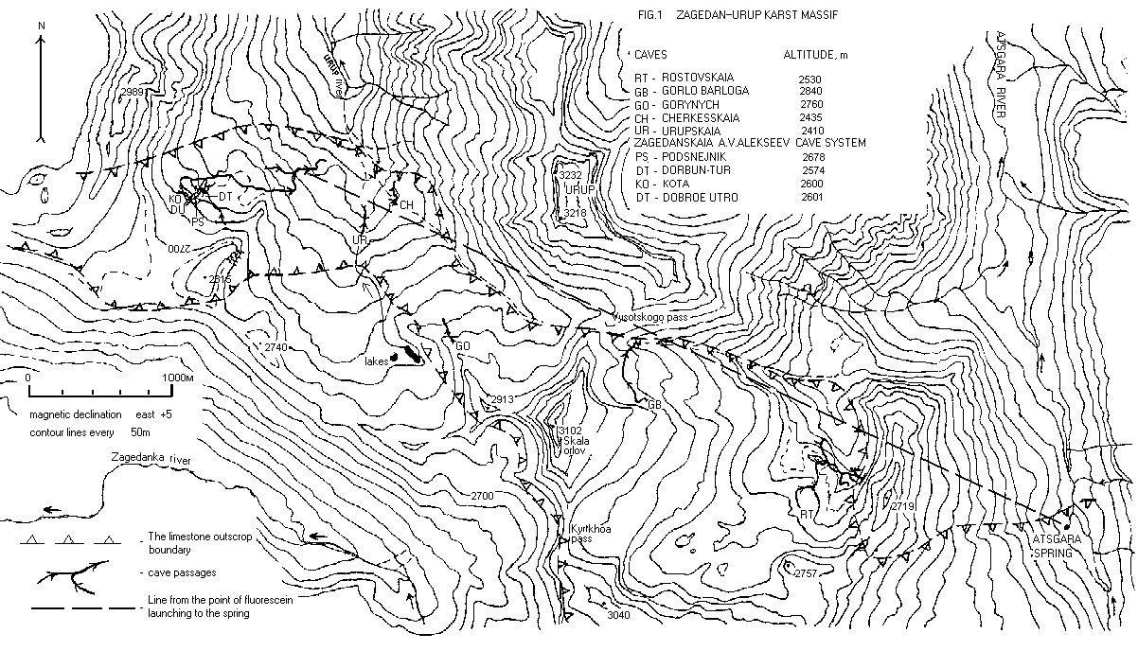

Figure 1. Zagedan-Urup karst massif.

Zadegan-Urup karst massif is located on the western spur of Abishira-Akhuba ridge to the north from the Main Caucasus Range. The massif is separated from the main part of Abishira-Akhuba ridge by Atsgara river valley. West boundary of the massif is Zadegan Mountain, south one is a watershed crest, and north one is Urup Mountain. Surface limestone extends from Zadegan Mountain on the west to Atsgara river to the east. Its length is 8 km and width from 0.5 up to 2 km, altitides are 1900-3100 m a.s.l. The highest point of the massif is Skala Orlov (“Cliff of Eagles” Peak, 3102 m a.s.l.).
Atsgara and Urup rivers watershed divides Zadegan-Urup karst massif by the west and the east parts. The east part of the massif include Lagernoe plateau (the deepest cave of the plateau is Gorlo Barloga (3000 m/-900 m), it is the deepest cave in Russia), Rostovskoe plateau (Rostovskaya Cave System, 4650 m/-550 m) and Atsgarinskoe plateau. The west part include Urupskoe plateau (Gorynych Cave, 680m /-383 m) and Zagedanskoe plateau (fig. 1). Explorations of Zagedanskoe plateau are discribed in this paper.
Zagedanskoe plateau is a westest plateau of the massif. The area of one is about 1 km2. The western border of the plateau is the Zadedan Mountain spur, the eastern one is the steep slope to the Urup river valley. Surface karsted rock at the plateau extends from the mountain ridge top (altitude 2740-2800 m a.s.l.) in the northern direction toward Urup river. Limestone goes under an non-karsted rock on the 2400-2450 m a.s.l. altitude. Capacity of the karsted rock at the plateau nearly 220 m, the slope is 30-40 degrees with an azimuth is about 0.
There are more ten cave entrances on the Zagedanskoe plateau are known now. All entrances are on the 2500-2700 m a.s.l. altitude. The main ones are marked by greek letter "Ψ". Five entrances was united into a cave system.

Morthology of Zagedanskaya cave system. Zagedanskaya in the honor of A.V. Alexeev cave system have amplitude is 570 m (+19/-551), total length is 5500 m. The system includes 5 caves: Podsnezhnik ("Snowdrop", Ψ-1), Dorbun-Tur ("Round Cave", Ψ-2), Ψ-14, KOTA (Ψ-22) and Dobroe Utro ("Good morning", Ψ-3). The altitudes of the entrances are presented in the fig. 1.
The system is divided on the two main parts by morthology. The first part (Podsnezhik Cave) is a dry, more ancient labyrinth with huge rock-slided halls and large passages. A lot of deposits and accumulated formations are observed here. The second, more younger and irrigated part is a channel for modern underground drain. Dorbun-Tur, KOTA and Dobroe Utro caves are the tributaries of the river-bed. This division is clear illustrated in fig. 2. There are two levels of cave development exist. The first (I) is an old dry level inside of limestone. The second (II) is an young irrigated level along lower boundary of a karsted rock. The length of the passages for level (I) is nearly 2 km, the one for level (II) is nearly 3.5 km.
The cave system develops both in the north (vertical and sloping passages) and the east (horizontal passages) directions. Podsnizhnik entrance is the uppest one of the system. It altitude is 2678 m a.s.l. The entrance is disposed nearly upper boundary of a large sloping snow tongue. The snow tongue have a size nearly 350x120 m. It is a basic spring of nutrition of a system underground drain. The upper part of Podsnezhik cave is a large (diameter 3-6 m) sloping tunnel was named Truba (The Tube). On the -120 m depth it results in a system of rock-slided halls. From this system of halls a lot of passages are begun (Rukavitsy (Passage of Mitten), Leoshin (Passage of Alexey), Syrnyj (Cheese Passage), Obez'yanka (Monkey Passage), and others). Truba is united with a lower part of the cave in two places, through P44 (the largest pit of the cave system) and P21. The lower part of the cave is an irrigated (nearly 10 l.p.s.) meander. It has several small pits. A length of meander is 700 m. We named it "Tropa normal'nykh geroev" (Normal Heroes Path). The end of the meander is a deepest point of Podsnezhnik cave (-320 m). It is an irrigated narrowness named Oksankin laz (Manhole of Oxana). In this place Podsnezhnik and Dorbun-Tur caves are connected.
Cave Ψ-14 is a narrow vertical 30-m chink entered in Zal Snezhnogo Os'minoga (Snow Octopus Hall). Usually the Ψ-14 entrance is blocked up by snow.
The entrances of Dobroe Utro, KOTA and Dorbun-Tur caves are along lower boundary of the sloping snow tongue. The Dorbun-Tur cave entrance is a lowest one of the Zagedanskaya cave system (2574 m). It Begin as series of narrow dry low-sloping passages. The last passage result in the first pit of Dorbun-Tur cave. The 150-m series of irrigated pits of Dorbun-Tur result in meander. In this place (-330 m from Podsnezhik cave entrance) Dorbun-Tur cave stream (5 l.p.s.) is connected with Podsnezhik cave one (fig. 3). Long (the length is about 800 m) quasi-horizontal part of the cave is developed from this point to the east direction. It is an irrigated (30-40 l.p.s.) passage with the several inputed poor (less 1 l.p.s.) inflows. This part have a complex morthology. It is a combination of narrow passages, small halls, projections, siphon manholes, and wide meanders. Semi-siphon (length 4.5 m, air layer 10-15 cm) is located in 250 m from the beginning of the passage. A narrow unexplored siphon is located in 200 m further than the semi-siphon. An entrance to the upper dry level of the cave was found near the siphon. Next 300 m in the cave were exploted by the second level (these levels are local ones, different from global levels of the cave system discussed above).
The second level is a narrow dry passage in a clay. There are no deposits here, however, we found looses of calcium crystals on the floor. Morthology of the third (uppest) level named Vudu Gallery quite different from the second level. Numerous original deposits (excentric stalactites and helictites) are located here.
There are four expanded artificially passages (length 6-15 m), named as “dry siphones”, are located in the local drops of the second level passage. Its were real siphones in the past. Second level passage comes to the 11-m pit after the fourth dry siphone. An ascending meander (length 230 m) was found in the top of the pit. The bottom of the pit is a first (lower) level. It is an irrigated (about 40 l.p.s.) gallery goes to the east direction to the last siphon manhole. The path turns to north direction after the man hole. The cave develops by the contact with a bottom non-karsted rock here. This is a high inclinated (30-40 degrees) gallery with several projections, named Chiornaya Truba (Black Tube). It is finished as a series of irrigated pits. A hall, named Vishniovyj Liker (Cherry Liquor Hall), were found in the bottom level of the series of pit. There are some paths from the hall. Basic water stream falls away in stones in the bottom of a last 10-m pit. This point is a bottom of the cave system (-551 m). Three passages beginning in Vishniovyj Liker hall were explored. Short descending passage comes to the siphon. The level of the siphon is approximately equal to the bottom of the cave. Two horizontal meanders (length 200-250 m) were explored to the narrow chink in a clay and to the ascending pit, accordingly. At least two last paths are perspective for the further investigation (fig. 3).
Zagedanskaya cave system is a sufficiently cold cavern. Temperature measurements were carried out in Dorbun-Tur Cave, basically. Air temperature grows since +0.2°C in the up of the first pit in the cave (-50 m from the Dorbun-Tur Cave entrance) to +1.0°C in the beginning of the horizontal part (-220 m). Summer air temperature in the first hall in Podsnezhnik Cave (+4.6°C) is not constant and depends from a ground air temperature.
Zone of supply of Zadeganskaya cave system is an upper part of a ridge, and the basic source is a large sloping snow tongue. Old borders of the sloping snow tongue are traced by features of a relief. As well as a glacier on Mt. Fisht plateau, the sloping snow tongue was greater size in the past. A valley with precisely expressed channel of the significant surface water stream, coming to an end as ponors on altitude is about 2500 m a.s.l.. It gives the instruction on existence on Zagedanskoe plateau of one more large cavity located below on a slope.
History of exploration. Idea of investigation in Zagedanskoe plateau was advanced by O. Tsoy in 1993-1994. Zadegan-Urup karst massif was a poor investigated speleo region with a indefinite speleological potential. Exploration of the massif was begun in 1983. Urupskoe plateau were explored firstly. Caving investigations went to the east direction later. The most western Zagedanskoe plateau was unexplored, in result. Rostovskaya Cave was a deepest one (depth –550 m) on the massif in 1995.
First expedition by leadership of O. Tsoy was carried out in August, 1995. It had an investigated purpose. The team includes four cavers from Penza and Saratov, only. Lagernoe, Rostovskoe, Atsgarinskoe, and Urupskoe plateaus were examined. Basic investigation was carried out on Zagedanskoe plateau. Two large caves were found here. Podsnezhnik Cave was studied to the chink on –110 m depth. Dorbun-Tur Cave was explored to the irrigated pit on –90 m depth. Expedition shows a perspectivity of the caves on Zagedanskoe plateau.
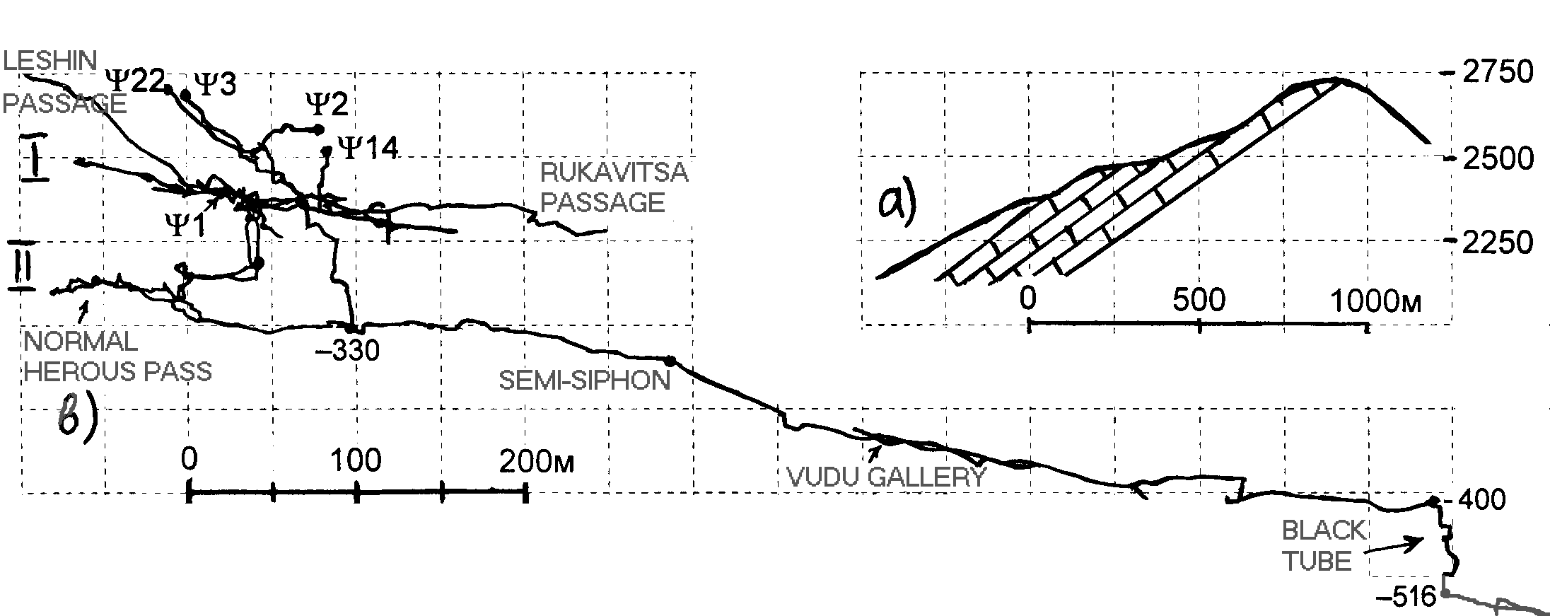
Figure 2. Position of karsted rocks (a), levels of the cave system (b).
Four cavers from Penza (leader is O. Tsoy) took part in the second expedition in August, 1996. However, three cavers left the plateau soon after beginning of the expedition because of a serious disease with one of cavers. In result, O. Tsoy investigated the caves alone. He stopped near the end of a vertical part in Dorbun-Tur Cave (-210 m), and in the system of halls in Podsnezhnik Cave on –190 m depth. Entrances in Dobroe Utro and KOTA Caves were detected.
No cavers from Penza and Saratov could go in an expedition in August, 1997. However, large experienced caving team from Moscow (Moscow University, mainly) by leadership of A. Shelepin visited the caves in agreement with O. Tsoy. The team works on Mt. Fisht plateau in 1993-1996 (Reisner and Shelepin, 1997). Numerous passages (Rukavitsy, Leoshin, Syrnyj, Obez'yanka, and others) were explored in Podsneznik Cave. Cave “Ψ-14” was found and connected with Podsneznik Cave. Most interesting result in Podsneznik Cave was obtained in “Khod 1997 goda” (Path 1997). Ultimately narrow chink stopped the cavers in –320 m level in only 30 m by horizontal from Dorbun-Tur Cave. Cavers working in Dorbun-Tur Cave explored a subhorizonal high irrigated part of the cave. The expedition was stopped on an excavation of the second dry siphon. In result, total length of the caves reaches 2.5 km, a general water stream was found, but the caves were not united in a cave system.
The problem of association of the caves in uniform system was reached on joint Moscow-Saratov expedition (leaders are A.Shelepin and O.Tsoy) in August, 1998. Searches of connection of the caves were conducted both from Podsnezhnik and Dorbun-Tur Caves. In Podsnezhnik Cave researchers found the new site, named “Tropa normal'nykh geroev” (Normal Heroes Path). It was the longest and complex path to a bottom part of the cave. However, during its pathfinding it was possible to connect both caves. Thus there was rather improbable event, two independent groups of cavers were in different caves, have heard each other. The established voice communication helped to pass from the different parties through narrownesses and to meet in a small Zal Vlyublionnykh (Hall Enamoured) on depth -320 m from the top entrance of the system. In Dorbun-Tur Cave was completed an excavation of the dry siphons (the underground camp was established). Cavers came to the pit which has deduced again on the irrigated level. Further has begun inclined, high irrigated Chiornaya Truba (Black Tube), to pass which up to the end it has prevented lack of time and equipment. There was explored KOTA Cave, on depth -75 m incorporated with Dorbun-Tur Cave and become by the fourth entrance in the system. Thus, as a result of the expedition in 1998 on Zagedanskoe karst plateau there was a large cave system with total length 4.5 km and amplitude of 465 m, with four entrances and free continuation in several directions.
Cavers from Moscow (leaders are A.Shelepin and A. Rychagov), Saratov (leader is O. Tsoy), Penza, and Ufa took part in the next expedition on the plateau in August, 1999. One of the basic purposes of the expedition was a definition of a cave system underground water unloading place. Tracing of a cave water stream using a fluorescein has been lead (see below). In Dorbun-Tur Cave a series of high irrigated pits was explored. The depth of the system of -546 m was reached. In Podsnezhnik Cave a number of new passages (Aktiniya (Actinium Passage), Kol’tso (The Ring Passage), and others) were found. There is passed connection Dobroe Utro Cave (-115 m) with Dorbun-Tur Cave that has added the fifth entrance in the cave system.
Small expedition of Moscow and Saratov cavers (leaders are A. Gusev and O.Tsoy) was carried out in August, 2000. Researches were conducted in a bottom part of Dorbun-Tur Cave. Two from several passages were explored in Vishniovyj Liker hall. A siphon stopped investigators in the short (50 m) descending passage, and a narrow chink in a clay stopped ones in the horizontal (length 250 m) meander.
Seven cavers from Orenburg (leader is V. Samsonov) has continued an exploration in the final expedition in August, 2001. Two new meanders were found in Dorbun-Tur Cave. The first is an ascending 230-m meander in the top of 11-m pit after the fourth dry siphone. The second is a horizontal 200-m passage in the bottom part of the cave. It comes to an end with the ascending pit. Topo of the last passage was not done. So, an explored part of the cave system has longways 5700 m (it is on 200 m more, than data officially presented by us).
Tracing of the cave stream and hydrology of the massif. The question on unloading underground streams of Zagedanskoe plateau up to 1999 remained opened. The nearest significant surface water stream is Urup river. Falling of karsted layers is directed to Urup river valley. The charge of water in Zagedanskaya cave system at an altitude of 2118 m a.s.l. (nearby 30 l.p.s.) is comparable to the charge of Urup river source appearing in 750 m to the north from a stony talus at 2100 m a.s.l. altitude. Presence of several surface water streams above Urup river source, the several streams flowing into the talus, and also existence of some caves (Urupskaya, Gorynych, Cherkesskaya) with significant water streams in area allowed to doubt that unloading of caves water streams of the plateau occurs in Urup river. The nearest large vaucluse (Atsgara river spring) is in 6 km on a straight line from the east edge of Zagedanskoe plateau, at altitude about 1900 m a.s.l. An unloading of Zagedanskaya cave system water stream here is unevident, as the stream would pass under a watershed of Urup and Atsgara rivers in this case.
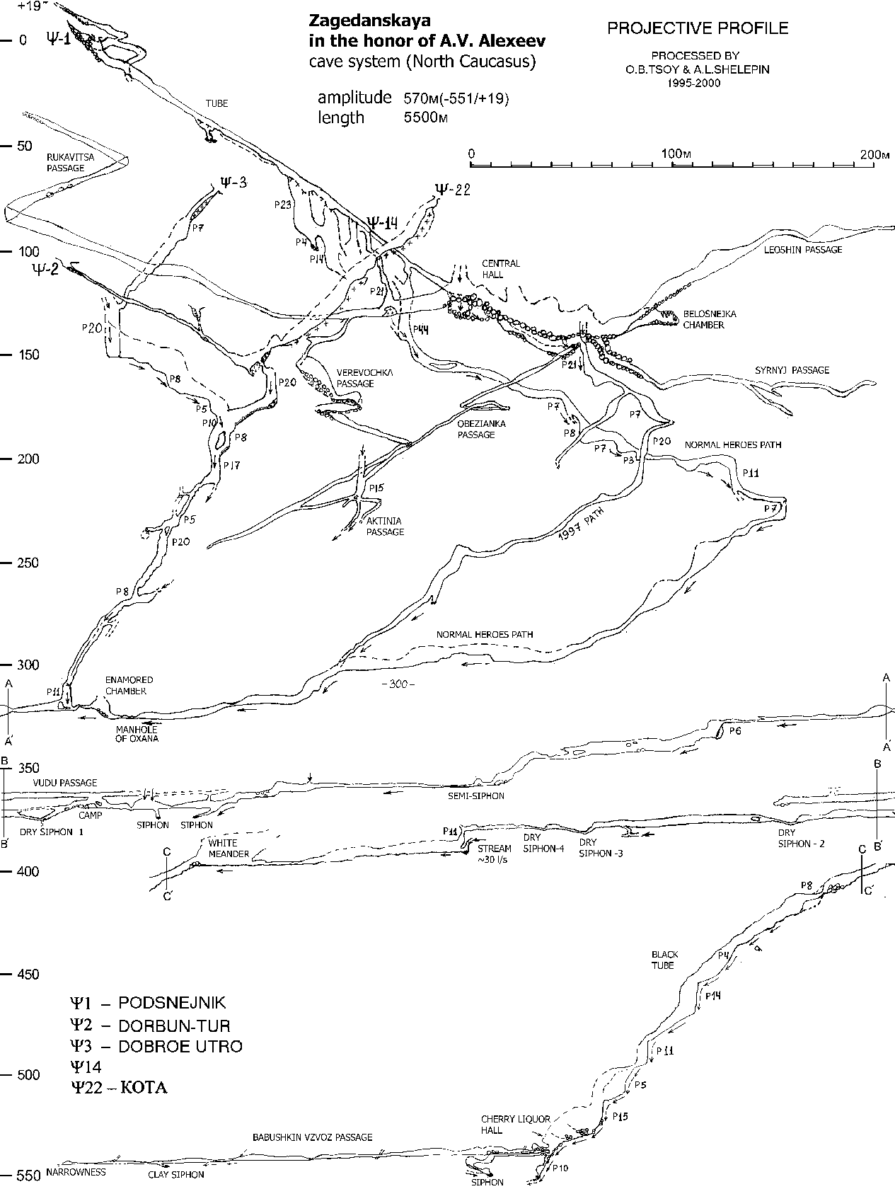
Figure 3. Projective profile of the cave system.
For the decision of the question an experiment on tracing a cave system water stream was carried out in August, 1999. Fluorescein (1 kg) was mixed with NaOH (1 kg) and diluted up to water (5 lts). The solution has been started in a stream of the last pit in Zagedanskaya cave system (-540 m) at 7 p.m., 20.08.99. The charge of a stream was estimated as 30 l.p.s. Traps were placed on all nearest significant surface water streams 2-4 days prior to the experience (Urup river, altitude 2000 m a.s.l., projective distance to the end of Zagedanskaya cave system is 2 km; Urup river, altitude 1900 m a.s.l., distance 3 km; Zagedanka river, altitude 1500 m a.s.l., distance 4 km; Atsgara river vaucluse, altitude 1922 m a.s.l., distance 6 km; Gorlo Barloga Cave, altitude 2000 m a.s.l., distance 3 km).
The traps represented porous kapron packings with 2.5-3 gr (10-12 tablets) the activated coal. Packings were located in the open plastic cylinders (length 8 cm, diameter 2 cm), having apertures on the surface. 3 traps (1 control, and 2 skilled) were established in each point. Control traps have been removed before a fluorescein start, and skilled ones have been removed from both Urup river points at 12 a.m.-1 p.m., 23.08.99, from Zagedanka river point at 10 a.m., 24.08.99, and from Atsgara river vaucluse at 2 p.m.-3 p.m., 23.08.99. The traps have been placed in individual polyethylene packages and transferred in laboratory of Saratov State University. Standard technique was used for the analysis: tests were located in 5% alcohol solution of KON, presence of fluorescein was defined both visually and spectrophotometrically.
Output of the water stream dyed in green color has been noted visually by several observers before the removing of the traps from Atsgara river vaucluse both in vaucluse and in 2-3 km below on current Atsgara river. Unfortunately, duration of an fluorescein output has not been fixed. It has occured between 2 p.m. and 3 p.m.. So, the traps have lain in the dyed stream of less hour. We estimate an upper level of a fluorescein concentration value in a stream is 0.1-0.8 mg.p.l. (considering a debit of a source is about 2 m3/s and duration of dye output is 10-60 min.). This fluorescein concentration quite allows to define its presence in a stream visually.
However, a presence of fluorescein in an alcohol solution of KON has not been found both visually and using spectrophotometer. The result of the analysis of tests has been explained by laboratory experiment. The traps similar used, were located for various time in different concentration fluorescein solutions. The experiment showed that a necessary concentration of fluorescein in traps must be 1-10 mg.p.l. and endurance of a trap in a solution must be more than 1 hour for reliable identification of presence of fluorescein.
The received results testify, that Zagedanskaya cave system water unloads in Atsgara river vaucluse. As the terminations of other large caves of area (Gorynych Cave, Urupskaya Cave, Cherkesskaya Cave, Gorlo Barloga Cave, Rostovskaya Cave) are not further 200 m on a straight line from a line connecting places of start and an output of dye, it is possible to assume, that all of its represent uniform karst hydrologic system (fig. 1). Its characteristics (distance on a straight line is about 6 km, a water stream gradient is 0.12, time of passage of dye is 67-68 hours) are close to results of experiments with the colouring, lead in other areas of Caucasus and in Crimea (Dublyanskij et al., 2002). Velocity of a water stream (2.1 km per day) is equal to a typical water stream velocity in Proval Cave – Krasnaya Cave and Mar-Khosar Cave – Krasnaya Cave hydrosystems in Crimea.
Conclusions. Prospects of the further passage of the cave system are kept. There are some perspective places for the further researches in a ground part of the cave system. Potential of increase in amplitude of the cave system is about 200 m and one of increase in extent of the system is more than 6 km. Prospects of a finding of higher entrances in the cave system are improbable, because an altitude of pass only on 40 m above the upper point of the system. Existence of one more large cavity on the plateau below Zagedanskaya cave system is possible. So, the cave system and the region require the further investigation.
Acknowledgements. The authors are grateful to the cavers from Moscow, Saratov, Penza, Orenburg, and Ufa who took part in exploration of the cave system. We would like to thank Prof. V.N. Dublyanskij (Perm) for helpful consultations.
References
Dublyanskij, V.N., Vakhrushev, B.A., Amelichev, G.N., and Shutov, Yu.I. Krasnaya Peshchera (The Red Cave), Moscow: RUDN Publ., 2002. In Russian.
Gusev, A.S., Tsoy, O.B., and Shelepin A.L. Investigation of Zagedan Cave System named after A.V. Alexeev. Svet (The Light) 21, 18 (2000). In Russian.
Lipchenko, S.Yu., Tsoy, O.B., and Shelepin, A.L. Tracing of Zagedan Cave System karst stream. Peshchery (Caves) 29-30, 53 (2004). In Russian.
Reisner, V.V. and Shelepin, A.L. Exploration of the Krestik-Turist cave system. Proceedings of the 12th Int. Congress of Speleology 4, 103 (1997).

