Various types of gypsum crystals from Tajna jama, Slovenia

Nadja Zupan Hajna
Karst research Institute ZRC SAZU, Titov trg 2, 6230 Postojna, Slovenia, zupan@zrc -sazu.si

Abstract
Gypsum as a cave mineral is very rare in Slovenia, because there are no gypsum or anhidrite strata present. Caves are developed in pure limestone and dolomite and there are not a lot of chances to have solutions enriched by sulphates present in the caves. In Slovenian caves sulphate ions originate from the Eocene flysch sediments, impurities in limestone, from sulphide deposits and volcanic rocks. Usually gypsum is presented as crusts or small “flowers”; there are few caves where larger crystals were formed. In two caves larger gypsum needles were found in the clastic sediments and in Tajna jama also the subhedral crystals to 15 cm long are present. Needles in that particular cave grow in silty-clay, which is allothonous clastic sediment brought to the passage with flowing water, and they are to 10 cm long. Subhedral crystals are poorly developed crystals of gypsum, formed in sandy silt. Large individual crystals can grow because sediment around them is soft and plastic. The genesis of these crystals is due to water, rich with sulphate ions, seeping through the sediments. Deposition occurs when the water in sediment is over-saturated; that usually happens during evaporation. In the same cave also “gypsum ice” which covers some parts of cave passages can be found.

Introduction
Gypsum as a cave mineral is very rare in Slovenia, and may be found just in a few caves. Sulphate ions originate from the Eocene flysch sediments, impurities in limestone, from sulphide deposits and volcanic rocks. Usually gypsum is presented as crusts or small “flowers”; there are few caves where larger crystals were formed.
In two caves larger gypsum needles were found. Tajna jama is one of them. Crystals were found by JK Crni Galeb Caving Club (Naraglav, 1976), but they didn’t recognise them as gypsum. As a location for gypsum crystals the cave was first time described by A. Mihevc in 1992. Cave is located in the isolated karst of central part of Slovenia (Fig.1). It is developed in isolated area of Triassic limestone and dolomite South of Velenje.

Fig. 1: Location of the Tajna jama cave.
Geology and speleology
Tajna jama is about 1 km long cave and 30 m deep ponor cave in small isolated contact karst area N of Celjska kotlina Basin. The main passage of the cave has a keyhole shaped profile. Cave is formed in the contact between Upper Triassic limestone and Oligocene andesitic tuff, volcanic breccia and limestone breccia containing limestone, dolomite, andesite and quartz keratophyre clasts, with tuff in the matrix (Buser, 1977). Main water passage is up to 6 m high meander which in some parts cut older, now dry passages, filled by clastic sediments (gravel, sand, silt, clay) and speleothems (calcite, aragonite, gypsum). Temperature in the cave is from 10 to 12⁰C.
In meandering canyon, later erosion left about 2 m high profile of fine laminated sediments. The upper part of the profile is horizontal; the lower parts show slightly inclined layers probably due to plastic deformation of the sediments after the erosion-subsidence of the sediments from the passage. The profile was dated by paleomagnetic method (Pruner et al. 2005). Alternation of normal and reverse magnetised zone was defined by detailed paleomagnetic analysis. The interpretation is unclear. One dates sediments back to about 3.0 to 3.4 Ma, i.e. to Gauss chron. The erosion surface within the lower recerse magnetised zone is related also with change of layer inclination. The boundary, if representing prominent hiatus, can shift the datation of the lower reverse/normal boundary even down to 4.180 Ma (top of Cochiti event). This interpretation can be supported by some paleomagnetic parametres (especially average declination values). The another possibility is younger. The top boundary of normal and reverse polarised zones can represent Brunhes/Matuyama (0.78 Ma), lower normal zone is than Jaramillo event (0.99-1.070 Ma) and bottom reverse-normal boundary is 1.77, i.e. top of Olduvai event. This interpretation ca be supported by erosion within the lower reverse polarised magnetozone.

Mineral composition of sand and clay
Mineral composition was defined by X-ray powder diffraction method (Philips X’Pert APD) in Laboratory of Physical Methods, Institute o Geology CAS, in Prague, Czech Republic. Two samples have been taken, one of sand and one of the silty-clay (Fig.2).
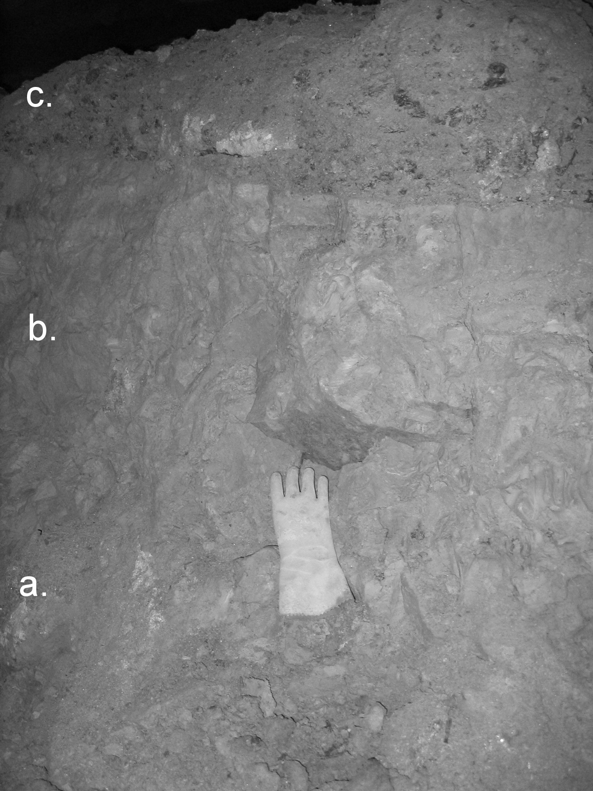

Figure 2: Profile of the clastic yellow sediments in the final part of the cave, where larger
gypsum crystals are presented. a. – sand, b. – silty-clay, c. – gravel with sand.

In the sample of sand (Fig. 2, a.) quartz and gypsum prevail, there are small amounts of mica, kaolinite, K-feldspar and chlorite in the traces.
In the sample of silty-clay (Fig. 2., b.) quartz prevails, there are small amounts of gypsum, kaolinite, mica, smectite and chlorite in the traces.

Gypsum crystals
In the cave gypsum is presented in different forms. Most common are gypsum crusts and “flowers” with crystals to 2 cm long. Crystals in Some of gypsum flowers surround the pyroclastic clasts of breccia and jut out of the wall. Some of the crystals form big clusters on the wall. Gypsum grows also from fissures, covers the cave walls like ice crust. We call it “gypsum ice”, because of its transparency. It is thin crust of small crystals deposited all over the wall. But important are big gypsum crystal from the cave sediments. There are needles and big subhedral gypsum crystals. Large individual crystals can grow because sediment around them is soft and plastic.
Subhedral crystals from the sandy sediment are to 15 cm long (Fig.3), they look like eroded crystals (Hill & Forti, 1986), but they are not eroded. Individual crystal is not fully developed, because during its growing, crystal had not have enough energy to push aside the confining particles of the sediment. Some of them have them form twin crystals in the shape of swallow-tail. Needles are usually shorter, but they can be to 10 cm long.

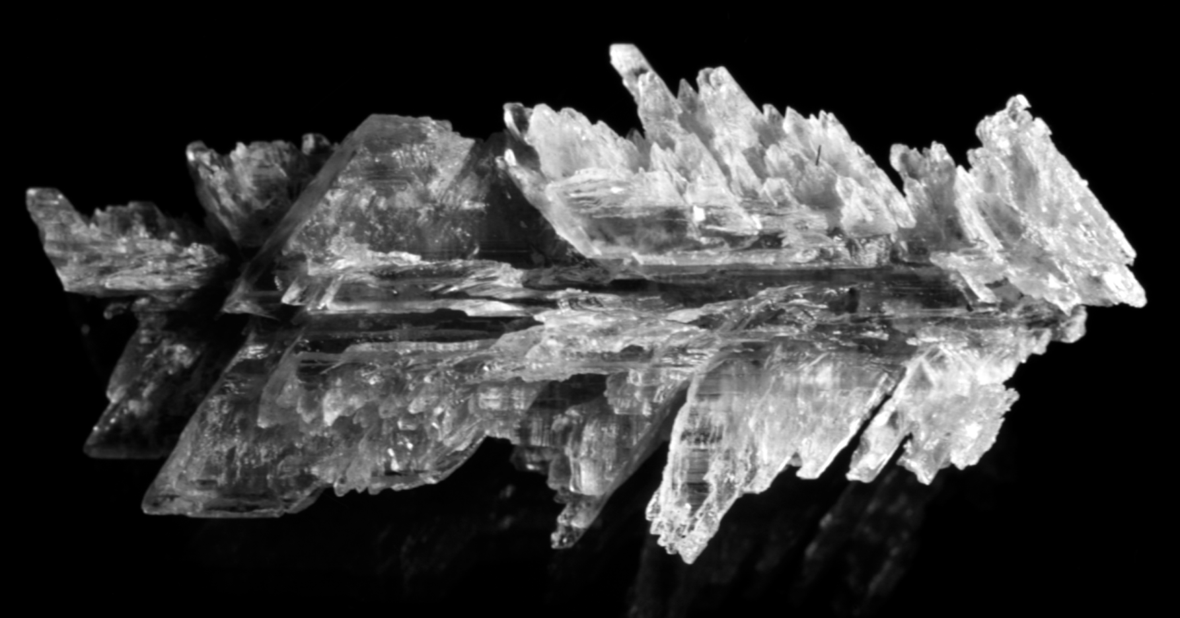
Figure 3: Subhedral crystals are poorly developed crystals of gypsum, formed in sandy silt. This particular crystal is 15 cm long.

Origin of sulphate ion
In both samples there is no evidence of pyrite, marcasite or limonite, which can be the source of the sulphate for gypsum deposition. That means, that the origin of sulphate ions is from somewhere else, perhaps from the sulphate ore bodies (pyrite, galena), which are developed in the wider area on the contact between limestone and quartz keratophyre (Germovšek, 1953).
The genesis of large crystals is due to water, rich with sulphate ions, seeping through the sediments. Deposition occurs when the water in sediments is over-saturated; that usually happens during evaporation.
For the presence of the gypsum in the cave sediments is important that a new coming water is over-saturated by sulphate ions in other way all gypsum will be dissolved in it.

References
Buser, S., 1977: Basic geological map, 1: 100000, Sheet Celje.Federal Geological Survey, Beograd.
Germovšek, C., 1953: Kremenov keratofir pri Veliki Pirešici. Geologija 1, 135-168, Ljubljana.
Hill, C.A. & Forti, P., 1986: Cave minerals of the world. p. 121., National speleologica society, Huntsville.
Hill, C.A & Forti, P., 1997: Cave minerals of the worl. Second Edition, 187-193, National speleologica society, Huntsville.
Mihevc, A.,1992: Sadra v Tajni jami in jami Kubik. Acta Carsologica, 21, 175-183, Ljubljana.
Naraglav, D., 1976: Zapisnik terenskih ogledov 1971- 1976. Cave Register IZRK ZRC SAZU and JZS.
Pruner, P., Zupan Hajna, N., Mihevc, A., Bosák, P., Man, O., Schnabl, P. Šlechta, S., 2005: Palaeomagnetic research of cave sediments in Slovenia in 2004. 13th International Karstological School “Classical karst”, Karst in various rocks. Guide-booklet for the excursions and abstracts of presentations. Karst Research Institute ZRC SAZU, 35-36, , Postojna.

