Recent research into Vjetrenica cave (Bosnia-Herzegovina) and the current view of the cave regarding its candidature for the World Heritage List

Ivo Lučić¹, Darko Bakšić², Jasminko Mulaomerović³, Roman Ozimec⁴.

Vjetrenica is the largest and most interesting cave in Bosnia and Herzegovina, developed in the deeply marked Karst of the southern Dinarid massif, in the final part of the course of the canyon river Trebišnjica. It has been the subject of research and exploration throughout history. It was proclaimed to be a natural monument in 1950, the first in Bosnia and Herzegovina. After this proclamation, modern exploration followed to draw up plans to make it accessible for tourists. In 1964 a tourist path was opened and electric lighting set up over about 1050 m of the cave, a motel was opened and tourist guides began work. In 1991 war broke out in Bosnia and Herzegovina. Vjetrenica was one of the first places to be affected by the war, all its tourist installations and all the buildings were destroyed, and even the Institute for the Protection of Cultural and Natural Heritage in Sarajevo, where documents on Vjetrenica were destroyed by fire. Over the past five years, after a ten-year break caused by the war in Bosnia and Herzegovina, research into Vjetrenica has been going on, and this has resulted in some important new discoveries related to the picture of the cave. A new speleological plan of Vjetrenica has been made, which has corrected some earlier erroneously defined situations, and this formed the basis for a monograph entitled “Vjetrenica, a glimpse into the Earth’s soul” which covered, systematized and presented all the knowledge about Vjetrenica available at that time. This particularly relates to information about fauna, where Vjetrenica is the second in the world in terms of biodiversity. After the monograph the speleological research continued and comprehensive bio-speleological research launched including drawing up an inventory of habitats and fauna, and the recently introduced all year round ecological monitoring. All these events concerning Vjetrenica have been accompanied by enviable publicity in Bosnia and Herzegovina, where there is a need and desire for perspective and more positive news. The basic tourist program has been restored and the idea born of entering Vjetrenica as a candidate for the World Heritage List, and this has been done. Efforts are now being made to gain public support for the building of an institution which would work on this idea in an organized manner, and also the idea of setting up a multi-functional center for Karst, which would organize research, education, tourist activities and environmental protection.

¹ Speleological Society Vjetrenica – Popovo polje, 88370 Ravno, Bosnia & Herzegovina, ivo@vjetrenica.com; ² Speleological Section of University Mountaineering Club Velebit, Radićeva 23, 10000 Zagreb, Hrvatska, baksic@sumfak.hr; ³ Speleological Society Speleo-Dodo, Branilca Sarajeva 30 71000 Sarajevo, Bosnia & Herzegovina jasminko_mulaomerovic@hotmail.com ⁴ Croatian Biospeleological Society, Demetrova 1, 10000 Zagreb, Hrvatska, roman.ozimec@zg.htnet.hr.

Vjetrenica is the biggest, the most famous and the most explored cave in Bosnia-Herzegovina. It is situated around the middle of the western edge of Popovo Polje, some 12 km from the Adriatic Sea.

«Wind» and the local tradition

Vjetrenica got its name thanks to the fascination of the poeple with a strong «wind» blowing from cave during the warm season, and with somewhat weaker «wind» blowing into the cave in the winter (vjetrenica = wind cave). Scientists and adventurors were equally fascinated. Here are some examples of visitors' impressions of the «wind»: «The noise is louder than a thousand steam machines» (Ayala 1850); or: «Compared to the hurricane blowing from the cave, the northern wind called bura is but a spring breeze». (Riedel 1888). What the local people thought of the «wind» can be seen from the traditional legends with all sorts of fairies and other creatures supposedly living in the cave. During history, the nobles took the cave over from the fairies. They built a summer residence on its entrance and used the «wind» as a unique cooling system. Anybody who spent a hot summer day in Herzegovina Karst can confirm the importance of the invention. This is the feeling that has eventually started to attract a completely new kind of visitors – tourists.

The history of exploration

The first known scientific work about Vjetrenica dealt with its unique air circulation. It is Historia naturalis by Pliny the Elder, in 77 AD (Plinio Secondo 1884). In his work he mentions a cave in Dalmatia, which could be Vjetrenica. This theory is supported by one of the most famous renaissance biologists Ulisse Aldrovandi from Bologna: on the margins of a letter by the duke of Ston (Dubrovnik seaside) Jakov Sorkočević, (written somewhere between 1580 and 1584), he added the Pliny reference (Grmek, Balabanić 2000). At the same time, the duke of Dubrovnik and philosopher Nikola Gučetić in his On Aristotle's meteors (1584) mentions a cave with a strong wind in Popovo polje. This reference is the starting point for the scientific cave exploration in Bosnia-Herzegovian and Croatia.

In 1888 the first modern study of wind was conducted: Austrian engineer Riedel wanted to create a wind-propelled mill. Two years later Hristifor Mihajlović, a monk from the nearby monastery drew the first ground-plan of the cave. Since then, six speleological drawings of Vjetrenica are known have been made.

In the first quarter of the 20th Century the first comprehensive modern research was conducted to discover the Vjetrenica we know today: Czech geographer, biologist and archaeologist Karel Absolon was the first to explore every part of Vjetrenica between 1912th and 1914 th (Aboslon 1916), later to be measured, described and explained by Mihajlo Radovanović (1929), co-worker of Jovan Cvijić.

Absolon was especially interested in subterranean fauna: he visited Vjetrenica 27 times and found as many as 47 organisms there. In the nearby Bjelušica he found as many as 51 organisms! (Pretner 1976). His work marked the beginning of a wave of modern biological explorations throughout the 20th Century, the most successful being the research of Stanko Karaman in the thirties and early fifties. Also, the work of a series of Slovene researchers must be mentioned, Egon Pretner and Boris Sket among many others (Lučić 2003). Sket has explored, documented and described Vjetrenica in biospeleological terms, his most recent work was published in a 2003 monograph. Early second half of the 20th Century saw some paleontological exploration in Vjetrenica: bones of some 10 species of prehistoric animals were found, including a complete skeleton of a leopard (Panthera pardus) (Malez & Pepeonik 1969), the only such find in the area and scientifically the most interesting.

Karst in the Trebišnjica region

Vjetrenica developed in the deeply marked Karst of the southern Dinarid massif, in the final part of the course of the river Trebišnjica, once the longest underground stream in Europe. The Karst here is made of some 5 km thick blocks of carbonate layers. According to the basic geological map of the Popovo polje area (Čičić, 2003) it was created in Jurassic and Lower Cretaceous limestone layers with interbeded dolomite. In some parts of Popovo polje, limestone is 99 percent calcite. The rocks are exposed to heavy geodynamics: annually they move some 2 cm northwards, which causes change in their compactness, told Croatian geologist Eduard Prelogović. Drainage basin goes alomost from the highest peak in Bosnia-Herzegovina, Maglić (2386 m) on the eastern border of the country, to the Adriatic Sea, to the South. That is why this area is 45 times bigger than Popovo polje (Vlahinić 2004), with Vjetrenica on its edge. If one adds 2500 mm of rain annually, one gets ideal situation for the development of Karst.

Picture 1. Hydrogeologic map of the Trebišnjica river-basin, (Took from «Vjetrenica – pogled u dušu zemlje»)
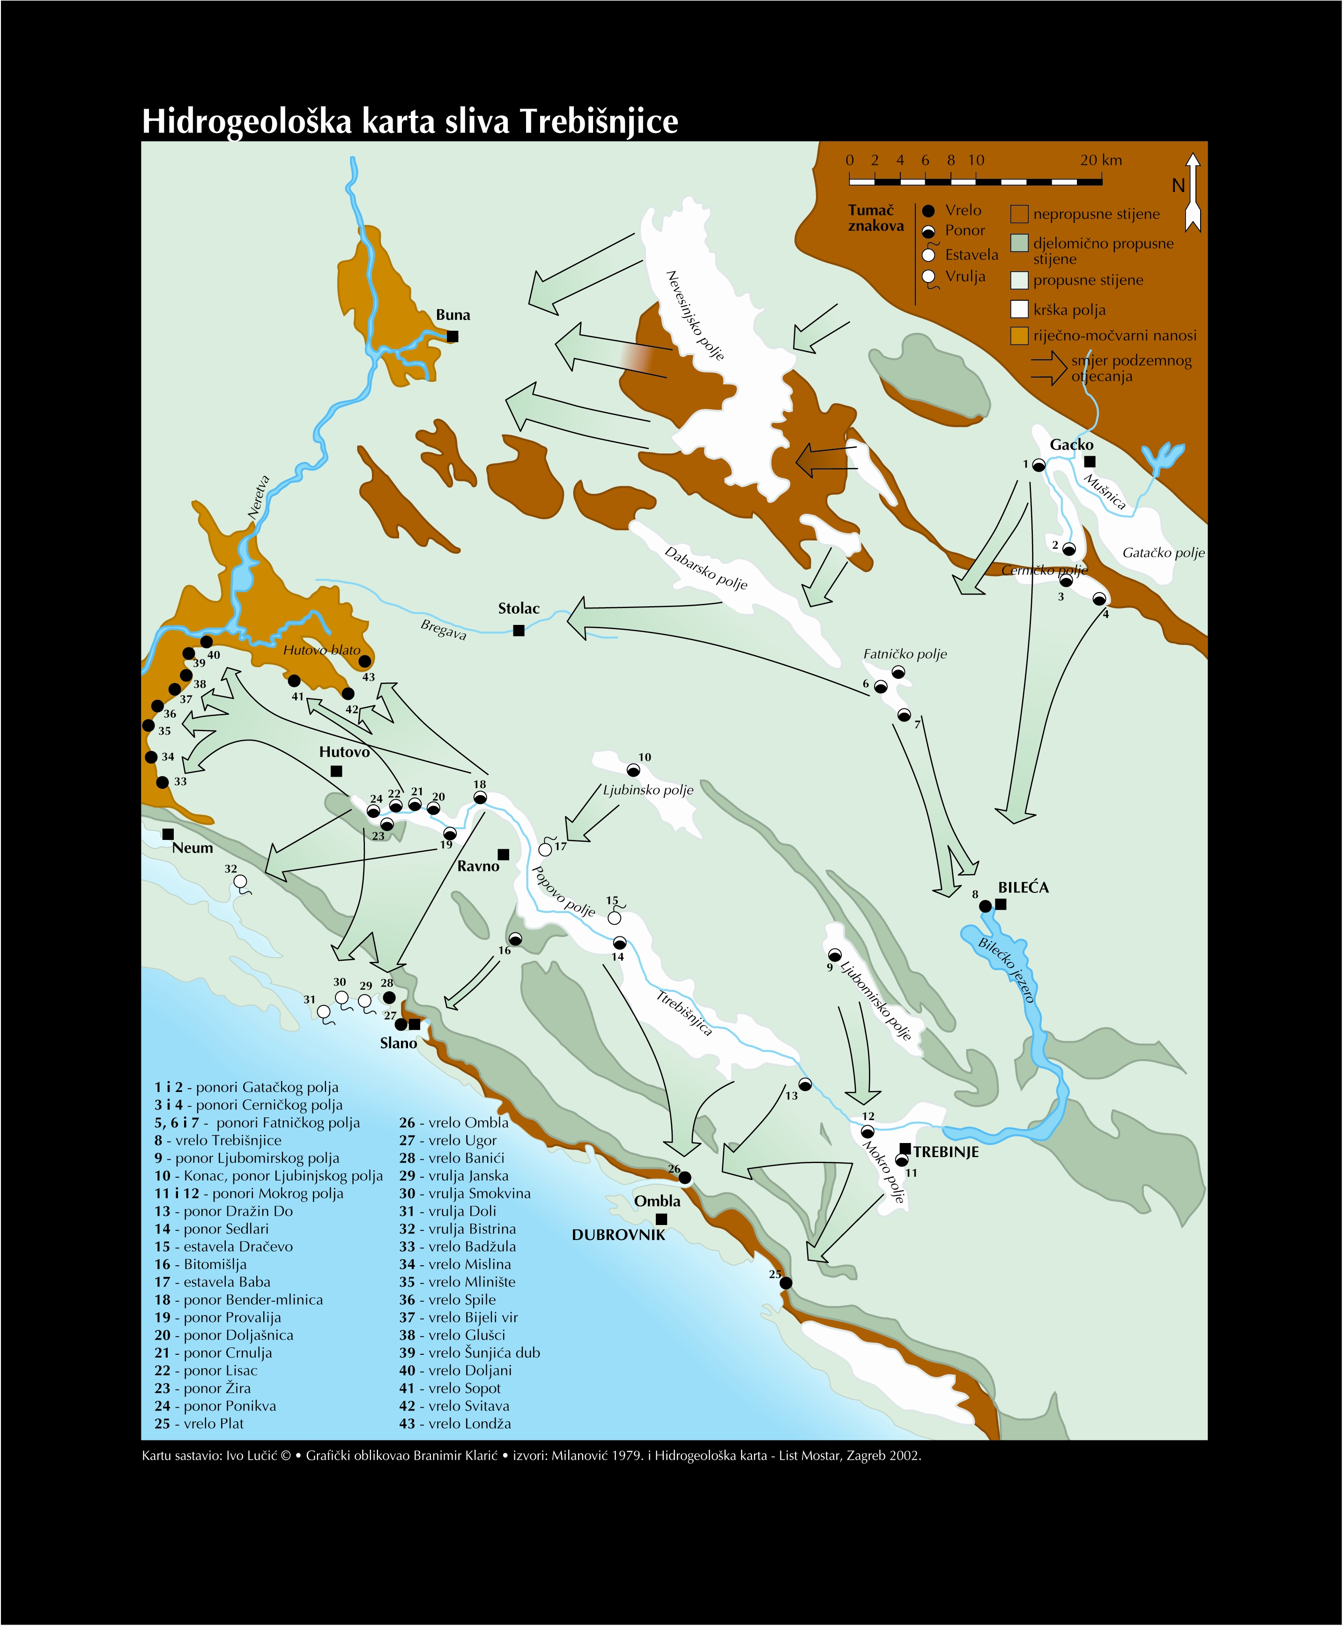

Explanation of colours/signs on map:
Brown – impermeable rock
Blue – semi-permeable rock
Light-blue – permeable rock
White – Karst valley
Yellow-brown – river and marsh alluvium
Arrow – direction of subterranean drainage
Ponor - swallet
Vrelo - spring
Estavela – estavelle
Vrulja – submarine spring
Note: Vjetrenica is near Nr. 16

Vjetrenica and modern hydrology

Experts think that the tectonics and specific hydrology of Popovo polje had the main role in forming this cave. Geomorphologists think that Vjetrenica used to serve as a drain for the water flowing from Popovo polje towards the Adriatic (Radovanović 1929) (Cvijić 1950). Subsequent carstification towards the edge of Popovo polje created a series of ponors with several hundred of kilometers of underground channels that lead to a series of springs and wells in the lower part of Neretva area and in Dubrovnik area on the Adriatic Coast, where they emerge as springs and submarine springs. Further carstification along Trebišnjica river created more than 500 small and big ponors and estavellas (Milovanović 1979) which today mostly take the water towards Ombla near Dubrovnik. During this period the side channels of Vjetrenica were formed by dripping of surface water, while Vjetrenica in this period was a spring, bringing water to Popovo polje. (Milojević 1938).

Speleological survey

In recent speleological research conducted in summer of 2002, 2003 and 2004. by Speleological Section of University Mountaineering Society Velebit from Zagreb and Speleological Section of the Mosor Mountaineering Society from Split, a new map of Vjetrenica was drawn up. It is a detailed map, scale 1: 500. As for the ground-plan, the length of the cave is 6141 m, while the polygon length is 6384 m. New measuring showed that the total length is much shorter than 7503 m mentioned by Radovanović (1929). As there is no sufficient data on Radovanović, it is difficult to comparatively analyse the results, but based on a comparison of the ground-plans it seems that no channels have been missed out.
Recent speleological research has shown that Gornji Absolonov kanal and Duboka dvorana are connected. The exact location of the Velški kanal has been defined, while the newly explored Ravanjski kanal has been added to the map. The new map shows a different position of Donji Absolonov kanals with regards to Donja Vjetrenica: Donja Vjetrenica seems to go in the same direction as Donji Absolonov kanal. These two channels create a single hydrological entity: water probably goes from there to Lukavac. The lengths of individul channels have been measured. (Table 1 and Picture 2).

Table 1. Channel lengths in Vjetrenica

Picture 2. Map of Vjetrenica: channel numbers refer to numbers in Table 1

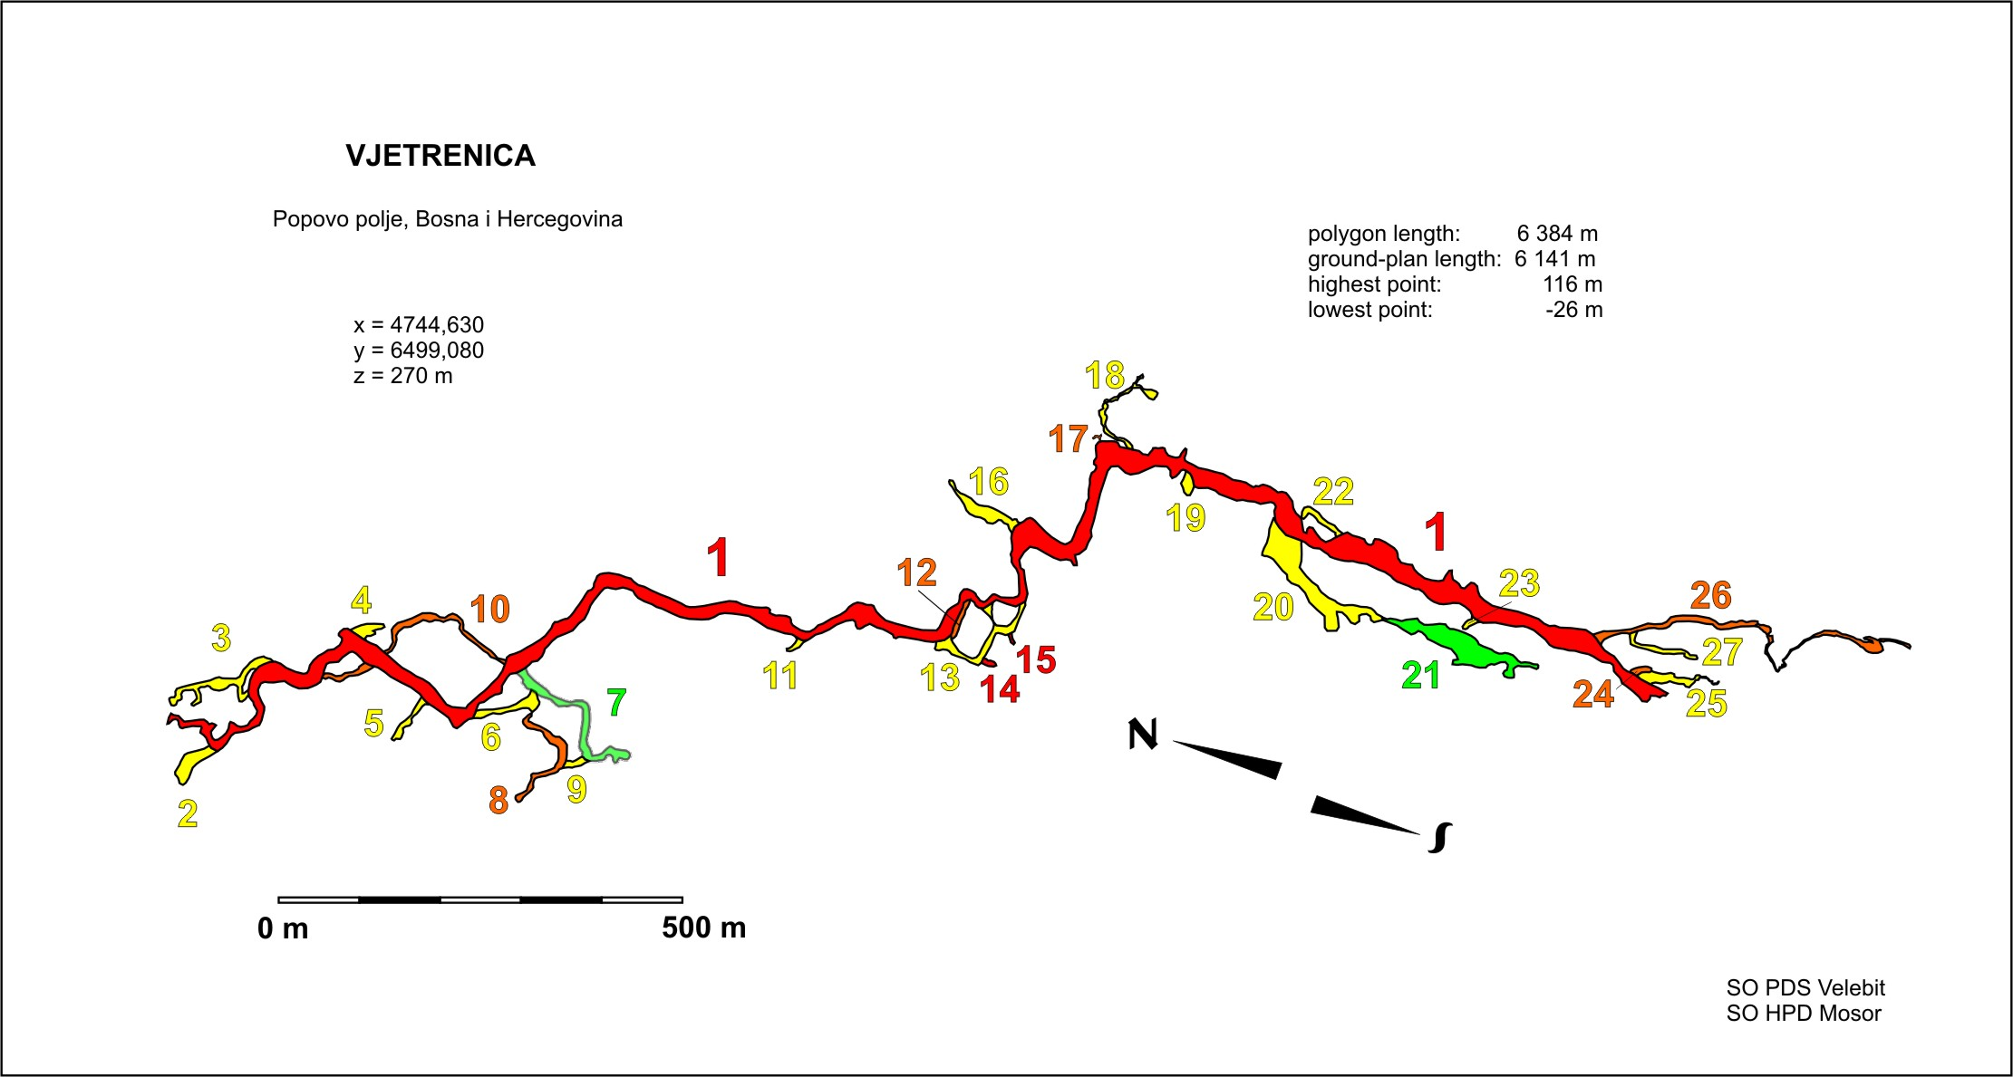
Morphology of Vjetrenica

In hydrological terms, Vjetrenica has three main parts.
One: the stretch from the entrance to the Četvrti pjati (1460 m from the entrance), from there the watercourse is northbound, goes to the Popovo polje. This part of the cave, some 1000 m from the entrance has a siphon during winter.
Two: From Četvrti pjati to Bijeli Saljev where the watercourse goes underground. The watercourse is South-Westbound, the direction opposite the Popovo Polje.
Three: Ravanjski kanal from which the watercourse is Nort-Westbound, toward Popovo Polje. It creates an underground stream underneath the blocks of rock in the Main channel, after which the watercourse makes a sharp turn so it is impossible to tell whether it keeps or changes its direction.
Četvrti pjati is an underground watershed: the watercourse from there is northbound or southbound. It is still unclear whether the watercourse from the Ravanjski channel changes direction once it sinks. The complex situation should be explored further.

The cave was formed on the cracks stretching in NW-SE and N-S directions. The general direction of the cave from the entrance to its furthermost point in Ravanjski kanal is S-SE (azimuth 157°). Average incline is 1.2° with the cave going up: in the horizontal distance of 2153 m it goes 45.5 m up. But if we look at the Main channel (Glavni kanal) and its furthermost point, in relation to the entrance, then there is a slight downfall, the incline is – 0,3°.

Picture 3. The Main channel (Glavni kanal) of Vjetrenica – some 800 m from the main entrance, photo by Ana Opalić
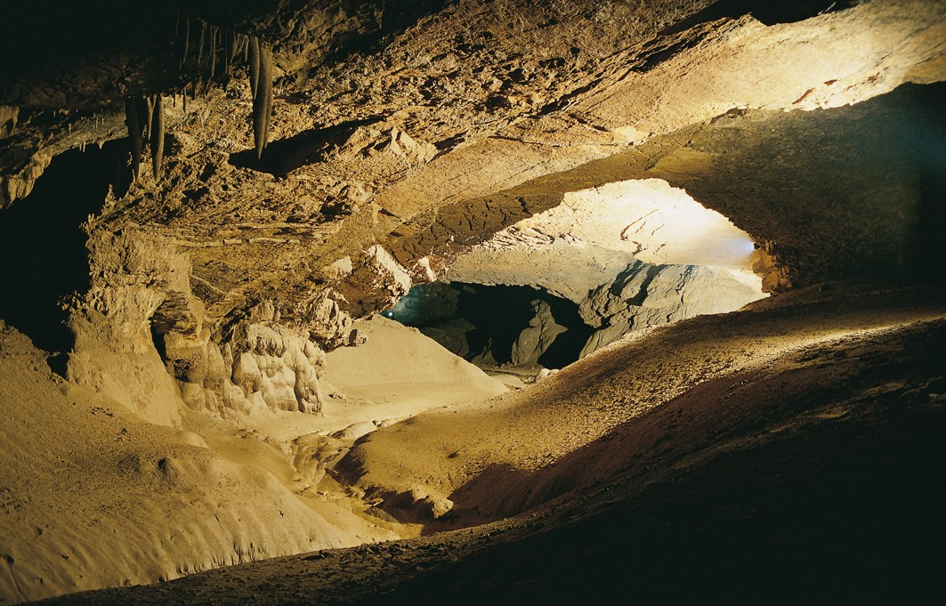

Vjetrenica is easily described as a horizontal speleological object with channels in three levels. The lowest, and hydrologically active level consists of Donja Vjetrenica, Donji and Gornji Absolonov kanal and Radovanovićev kanal. The middle level consists of Glavni kanal with side channels, stretching from the main entrance to Duboko jezero, while the third and highest level consists of Požovo brdo, Visoki zasigani kanal, Velški kanal and the southernmost parts of Ravanjski kanal. The lowest point is in Donja Vjetrenica, 26 metres below the entrance level, while the highest point is in Visoki zasigani kanal, 116 metres above the entrance level.

Majority of the channels in Vjetrenica has a lot of speleothems of various shapes, which contribute to a unique visual experience. There are flowstones, stalactites, stalagmites, curtains and sinter pools. In the oldest and highest parts of the cave one can find even some aragonite formations and crystals.

In autumn and in winter, when the temperature of the atmosphere is lower than in the cave, the air is sucked into the cave, until the temporary siphon closes. When that happens, there is no circulation of air any more. This could mean that there are higher entrances or cracks below the temporary siphon, which in turn could mean that the cave itself is bigger than we now think The current of air at the entrance measured in August ranged form 5.1 to 9.8 m/s, average speed being 6.1 to 8.5 m/s. The strongest current was measured in the afternoon (at 14.00 hrs) with the biggest difference between temperatures in the cave (11.4 °C) and outside (29.7 °C).

Biospeleological research

Several inventories of fauna have been made so far (Wolf 1934-1937; Buturović 1951; Pretner 1963; and Mikšić 1979). According to Culver and Sket (2000), Vjetrenica with its 60 cave-limited species is the second such cave in the world, rivalled only by Postojna-Planina Cave System in Slovenia, which has 84 such species. The most comprehensive inventory of fauna and habitats of Vjetrenica and the nearby Bjelušica cave and Lukavac spring, the three being parts of a single system, has been published rather recently (Sket 2003). This study found 110 species in the system, 76 troglobionts, 36 of them terrestrial and 40 aquatic.

In August 2004 comprehensive biospeleological research was launched, including microclimate and environmental measuring nad drawing up an inventory of subterranean fauna. The research was conducted by Croatian Biospeleological Society from Zagreb. Scientists such as Gordan Karaman and Božana Karaman from Podgorica also participated in the exploration, while Boris Sket from Ljubljana supervised it all.

First analysis of the recently gathered material and comparison with the most comprehensive list of fauna in this cave system (Sket 2003) showed 17 new taxa, including seven positively and three most likely troglobionts. Three species are probably troglophils and four are trogloxene.

Picture 4. The beetle Hadesia vasiceki in its locus typicus, photo by Darko Bakšić
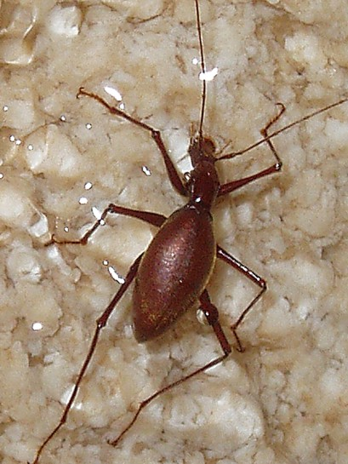
The most up-to-date inventory of fauna in Vjetrenica, Bjelušica and Lukavac has 128 species, including 85 troglobionts and possible troglobionts. Among them, there are 45 terrestrial troglobionts, and 40 aquatic stigobionts. More than nine species have been found in Vjetrenica alone, among them two monotypes - snail Zavalia vjetrenicae i mysid shrimp Troglomysis vjetrenicensis. (Sket 2003). The fauna of Vjetrenica includes also the only European subterranean vertebrate čovječja ribica (Proteus anguinus), the only cave clam Congeria kusceri, the only cave serpulid worm Marifugia cavatiaca, etc. A rich ecological diversity within the cave includes some very unusual habitats, most especially the cave hygropetric which harbors high specialized coleopterans species, Hadesia vasiceki and Nauticiella stygivaga (Leptodiranae), as well as Niphargus (Amphipoda) Typhlogammarus mrazeki. (Sket 2003). The most numerous are the crabs, especially Amphipoda, ten species altogether, (including eight Niphargus spp.), and also insects (11 species of Coleoptera), snails, etc. Vjetrenica is the locus typicus for as many as 32 troglobiontic species.

As of summer 2005, Vjetrenica will have an all-year-round environmental monitoring. Further research will positively come out with new species for the experts to study

Usage of Vjetrenica

It seems that Vjetrenica was used as a winter and summer shelter but nobody used it for living, the reason being the narrow entrance and strong wind preventing people form entering the cave. Also, one should not forget the very strong psychological effect of the wind. But the local people lived with Vjetrenica, hence the local word «pjat» (Italian for plate) for series of a sinter pools, or «čejrek» (Turkish for a quarter of dried mutton) for series of a small curtains, etc.

The beginning of the protection of Vjetrenica started around 1900, when the metal gate was first made. The same gate, slightly modified in early '60s, is still there (Ržehak 1965). Legal protection of the cave started in 1914, when the authorities issued the first Rule regarding the protection of the cave, and it was proclaimed a natural monument in 1950.

First attempts to make it accessible for tourists were made at the end of 19th Century, by monk Hristifor Mihajlović who, around 1890 managed to draw interest from scientific circles and who, by some sources, expanded the main entrance to the cave. Local etnologist, writer and politician Ljubo Mićević created a 1250 m long path to Veliko jezero (Ržehak 1965). By the end of 1950s Vjetrenica was for the most part ready for the tourist project realised in 1964: a tourist path was opened and electric lighting set up over 1045 m of the cave, a motel was opened and tourist guides began work. According to available information, Vjetrenica attracted some ten thousand visitors annually.

A new picture of Karst

In 1991 war broke out in Bosnia and Herzegovina. Vjetrenica was one of the first places to be affected by the war, all its tourist installations and all the buildings were destroyed (Lučić 2001), and even the Institute for the Protection of Cultural and Natural Heritage in Sarajevo, where documents on Vjetrenica were kept was destroyed by fire. Over the past five years, after a ten-year break caused by the war in Bosnia and Herzegovina, research into Vjetrenica has been going on, and this has resulted in some important new discoveries related to the picture of the cave. Monograph entitled “Vjetrenica, a glimpse into the soul of the Earth” covered, systematized and presented all the knowledge about Vjetrenica available at that time.

Speleological Society Vjetrenica – Popovo polje has renewed the pre-war tourist programme, but flashlights are used at the moment, instead of electrical lighting. The B-H Academy made iniciative to candidate Vjetrenica for the World Heritage List. The idea has got public support and publicity unprecedented in B-H terms when environmental issues are concerned.

What next?

Caving associations together with international experts are trying to establish modern standards for the management of Vjetrenica and other unique Karst phenomena of Bosnia-Herzegovina. A multifunctional Centre for Karst should be established, with fourfold function: research, education, tourist and protection of the environment. The idea was first heard in the summer of 2004 when Speleological Society Vjetrenica – Popovo polje, together with Ravno Municipality and the Ministry of the environment of the Herzegovina-Neretva County applied for technical cooperation, as announced by the government of Japan. Several months later the initiative was endorsed by SIBIOS, noting that future development must pay special attention to the subterreanean fauna. We expect the similar support by UIS.

«SIBIOS enthusiastically endorses the candidacy of Vjetrenica in Bosnia-Herzegovina for the World Heritage list». This is the beginning of their statement which further on describes Vjetrenica as a «remarkable subterranean hydrogeological system, worthy of all of the superlatives one can muster». It stresses the importance of its biodiversity, calling it the very centre of the centre of endemisms, with a large number of cave species.

In order to protect the cave, the Speleological Society Vjetrenica – Popovo polje will be very careful in future dealing with Vjetrenica. Contact was made with the IUCN Task force for Karst and caves, and very soon work in Vjetrenica cave lighting will continue. Neil Kell from Australia describes his lighting approach as one using »as little light as possible for two reasons: firstly, to conserve the cave ecosystem, and, secondly, to reinforce the reality that it is a cave environment where darkness is the natural state».

Conclusion

Data gathered from both previous and recent research show that Vjetrenica is unique in spleological, biological, paleontological, cultural and others terms. That is why it should be included in the World Heritage list: it is not only important for Bosnia-Herzegovina and the countries of Dinaric Karst, but is also universally important for further research and protection of most interesting subrettanean habitats. Also, its tourist and educational importance is noted.

References

Absolon, K. 1916. Z vyskumnych cest po kraceh Balkana. O Vjetrenici a jaskynich med Zatonem. Zlata Praha, Ročnik XXXIII, 51, Praha, str. 609–612.
Ayala, A. 1850. Izvješće članovima Centralnog savjeta za propagandu vjere u Lionu i Parizu 31. prosinca 1850. u Zorić, D. 1989.: Način života u istočnoj Hercegovini sredinom XIX stoljeća. Studia Etnologica, I, Zagreb, str. 114.
Buturović, A., 1951: Bibliografski podaci o pećinama i pećinskoj fauni u Bosni i Hercegovini, God. Biol. Inst., Sarajevo, 4/1:95-114,
Culver & Sket 2000. Hotspots of Subterranean Biodiversity in Caves and Wells. Journal of Cave and Karst Studies 62(1):11-17.
Cvijić, J., 1950: Stare otoke Popova polja i hidrografske zone u karstu, Glasnik srpskog geografskog društva, XXX, 1, Beograd, str 3-10
Čičić, S., 2003: Geološka karta šireg područja Popovog polja (Geological Map of Popovo polje – wider area), U: Lučić I.: Vjetrenica - pogled u dušu zemlje, Zagreb, str 104-107.
Grmek, M. D. & Balabanić, J. 2000, O ribama i školjkašima dubrovačkog kraja. Korespondencija Sorkočević –Aldrovandi, Dubrovnik – Bologna: 1580–1584. Dom i svijet, Zagreb, str. 125–129.
Lučić, I., 2001: U novi ciklus osvajanja mraka, Oslobođenje 19.1.2001. Sarajevo, str.10.
Lučić, I., 2003: Vjetrenica - pogled u dušu zemlje, Zagreb – Ravno, 322 str
Malez, M. I Pepeonik, Z. 1969. Entdeckung des ganzen skelettes eines fossilen leoparden in der Vjetrenica – Höhle auf dem Popovo polje (Herzegowina). Bulletin scientifique, section A – Tome 14, No. 5–6, str .
Mikšić, S., 1979. O Značaju faune pećine Vjetrenice. Naš krš V, 6, Sarajevo, str 80-82.
Milanović, P. 1979. Hidrologija karsta i metode istraživanja. HE Trebišnjica, Trebinje, str. 302.
Milojević, M. S., 1938: Pitanje o hidrografskoj funkciji pećine Vjetrenice (Popovo polje), Pojavi i problemi krša, Posebna izdanja SANU, 123, Beograd, st.r 160
Plinio S. 1884. Della storia naturale di C. Plinio Secondo, "Historiarum mundi lib. II, Venezia, str. 245–247.
Pretner, E., 1963: Kako zaštititi pećinsku faunu Vjetrenice kod Zavale, 3. Jug. Speleo. Kongres:169-174, Sarajevo
Pretner, E. 1976. Geschichte der Biospeläologischen forshungen in Bosnien, Herzegowina und angrenzenden gebieten. GZM N.S. 16, Sarajevo, 243–253.
Radovanović, M., 1929: Pećina Vjetrenica u Hercegovini, morfološko-hidrološka studija, Spomenik Srpske kraljevske akademije LXVIII, prvi razred, 15, Beograd
Riedel, J. 1888. Eine Ventarole in der Hercegovina. "Mitthelungen der Section für Höhlenkunde", B. N. 2, str. 13–16.
Ržehak, V 1965. Konzervatorski radovi u pećini Vjetrenici u Zavali. Naše starine, X, Sarajevo, str. 217–230.
Sket, B., 2003: Životinjski svijet Vjetrenice, In: Lučić, I., Vjetrenica - pogled u dušu zemlje, 149-202, Zagreb-Ravno
Vlahinić M. 2004. Poljoprivredno-melioracijska i agrohidrološka monografija Popova polja. - Sarajevo : Akademija nauka i umjetnosti Bosne i Hercegovine. (Djela ; knj. 78 ; knj. 6)- 294 str.
Wolf, B., 1934-1937: Animalum Cavernarum Catalogus, 2:1-616

