NATURAL AND ARTIFICIAL AIR IONIZATION IN UNDERGROUND SPACES – AN ENVIRONMENTAL FACTOR WITH THERAPEUTIC POTENTIAL

Dr.phys. ENACHE Liviu^{1,2}, Chem. FILIPESCU C.³, Dr.b, Ph.D.SIMIONCA Iu. (Ghe)^{1,2} Dr.Biol.BOTEA SIMONA³, Biochem.HOTETEU M.¹, Dr.med. KISS Ja.¹, Dr.chem. PETEC CĂLIN Ghe¹, Chem. ROGOJAN Rodica¹.

¹ National Institute of Recovery, Physical Medicine and Balneoclimatology, Bucharest, Str. Sf. Dumitru, nr. 2, sect. 3, Romania;
² Romanian Permanent Commission of Speleotherapy, Bucharest;
³ “Victor Babes” National Institute of Research and Development in Pathology and Biomedical Sciences, Bucharest, Splaiul Independentei nr. 99 – 101, sect. 5, Romania;

ABSTRACT

The paper makes a review on the aspects regarding the characteristics, the action, the effects, and the importance of the electric climate – the natural and artificial air ionization – on living organisms. The underground spaces, represented by caves and mines (salt mines, particularly), present some physical characteristics that could be valorized for the treatment of some specific diseases – one of the main speleotherapy purposes.

The paper presents data regarding the natural and artificial air ionization characteristics in some salt mines and caves from Romania, some of them with therapeutic destination.

Keywords: air ionization, salt mines, speleotherapy.

1. INTRODUCTION

The environmental situated nearby the soil, there where the majority of living organisms live, is characterized through many characteristics out of which some are of physical-chemical nature and others of biological nature. All these factors are in a closed interdependence and fulfill some specific roles. Any quantitative and qualitative modification of environment characteristics, over some limits, evidences its presence at the level of one living organism as different shapes.

From physical factors of aerial environment, in frame of electric atmosphere for beautiful weather, an important role is given to natural ionization of the air. This aero-electric parameter presents many valences as a consequence of the influence and direct and indirect effects on living world, favorable or unfavorable, depending on the intensity, exposing period, or its characteristic features.

The first remarks regarding the existence of aerial gaseous ions were made since 30’s of past century, the researches were taking again and elaborated then after 50’s by different collectives, that put into evidence the existing relation between the content of small ions from air and pollution of respective atmosphere, and also the fact that almost daily lack of a sufficient quantity of small negative ions of oxygen in work and rest places is a cause of appearance of one unavoidable disorder, often severe, of health state.
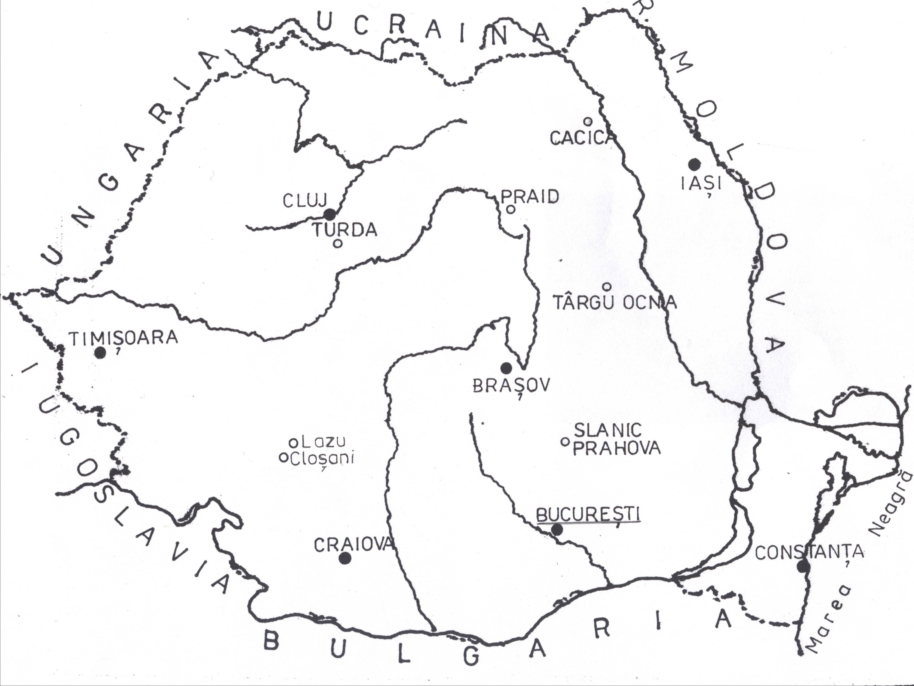
A significant number of researches confirm the existence of connection between this electric parameter of the air and a series of biologic effects shown on different stages of organization of living world, from cellular level up of that of organism.

Figure 1 – Location of salt mines and caves on Romanian territory.

The researches achieved in the last decades in Poland, Austria, Ukraine, Slovenia, Slovakia and others, but also in Romania, regarding the physical-chemical characteristics of caves and salt mines microclimate point out the fact that this may carry on favorable effects on organisms and recommend it for its valorization in the treatment of some diseases (speleotherapy).

The features of air ionization from these underground precincts, together with microclimate ones, contribute at defining and completion knowledge of the specific physical conditions of these in order to be used for therapeutic purposes [1, 3, 6].

The paper proposes to present the results regarding some characteristics of underground environment (temperature, humidity, pressure difference, air ionization and others) from some salt mines and caves from Romania (figure 1) in order to use them in balneo- and speleotherapeutic purposes [4, 5, 11, 12].

2. THEORETICAL ASPECTS REGARDING THE NATURAL AND ARTIFICAL IONIZATION OF THE AIR.

Air ionization consists of existence in surrounding atmosphere of different types of ions, gaseous mainly, as shape of some molecules electric loaded (positive and negative), of different dimensions and movement speeds (mobility), that which make possible ions classification in more categories [2, 7, 8].

Ions existence is the result of interaction between the physical factors, generators of aerial ions, on one hand and on the other hand of air molecules. Generators factors for troposphere air are represented of radioactive elements from soil and air, and also of cosmic and solar radiation that trough corpuscular radiations (α, β) and electromagnetic (γ, roentgen) released directly or indirectly, assure the energy necessary to neutral molecules of gases and water vapors from atmosphere [9, 10].

Ionization phenomenon of these molecules is complex and is achieved in more successive stages, at its final different categories of aero-ions may be generated.

In initial stage, primary ions are produced, for example the oxygen ones.

If the electrons have sufficient kinetic energy, then others category of ions may appear.

Following to these reactions in atmosphere may appear aerial ions as follow: H⁺( H₂O), (H₃O)⁺ (H₂O), O²⁻( H₂O)_{n}, OH⁻( H₂O)_{n} and others.

From secondary ionizing agents, the processes of water fragmenting present especially importance (breaking in micro-particles, spraying through fine jets of water, breaking of the pellicles of air bubbles from water surface, evaporation process, breaking of ice crystals through collision and others), processes and physical phenomenon known in meteorology.

Between the action of generator factors and those which lead at ions recombination (destroying) a balance is established, reflected sometimes in existence of one regime of air ionization and in considered place. In the table 1 some values of negative ions concentrations registered in different places, are presented.

Table 1 – Negative ions concentration (c) in different places.

Place | c (ions/cm³)
Nearby a cascade | 50 000
At mountain | 4 500 – 8 000
In some balneal resorts | 3 000 – 4 000
After lightning | 1 500 – 2 500
Outside the town | 500 – 1 000
In town | < 500
Modern typical office | 350
Closed vehicle in movement | 200

Except natural ionization, through different types of generators apparatus, ions concentrations of both polarities (in limited spaces) that may attain high values, arriving at a few millions ions/cm³ may be obtained.

3. MATERIALS AND METHOD

In order to appreciate local specific characteristics an important role revenue to knowledge of microclimatic conditions from these underground precincts. Microclimatic determinations inside salt mines were achieved with Assmann psyhrometer (temperature and relative humidity of air) mechanical anemometers with buckets and pallets (air speed) and with an aneroid barometer (difference of atmospheric pressure because of level difference ∆h in comparison with entry in salt mine). Thermal comfort appreciation through °TEE determination (temperature equivalent effective) was made in accordance with corresponding nomographic calculation method.

For the determinations regarding air ionization in the salt mines and caves from Romania the classic method was used (electrometric). The measurements made at Slănic Prahova, Cacica and Târgu Ocna salt mines and also in Lazu, Cloşani and No.2 caves (the remarks were made in the National Institute of Recovery, Physical Medicine and Bioclimatology, Bucharest) were achieved with aid of one ions register of Ebert type, based on the discharging principle of one electric condenser, provided with a bifilar electrometer, Leybold type, without auxiliary field, connected with a suction air device, with a volume flow corresponding to measured ions category.

The remarks followed stability of small negative and positive ions concentrations (more important as therapeutic aspect) and were made through incidental measurements in different seasons of the year.

4. RESULTS

Cacica salt mine (old salt mine) from Suceava County, is located in a region with hills with a bio-climate preponderant sedative. In frame of the salt mine some applications climato-medical are carried out.

The microclimatic remarks developed in the course of time in the above-mentioned salt mines, and also in three caves (Mehedinti county) from Romania are summarized in the table 2.

Table 2 – Microclimatic data regarding some salt mines from Romania

Salt mine/ Cave  (∆h, in m) | Air temperature (°C) | Relative humidity of air (%) | Air speed (m/s) | Pressure difference in comparison with outside  (mmHg) | Thermal comfort (°TEE) | Measurements period
Cacica (-38;-58) | 9,5 -10,0  10,2-10,4 | 54-55  76 | <0,1  <0,1 | +7 ÷+8  +5 | 9,5  9,5 | III,1979  VIII, 1999
Slănic Prahova (-210) | 11,6-12,8  10,0-1,6 | 61-75  50-51 | <0,1  <0,1 | +18÷+20  +18 | 12,0-12,5  7,9-11,2 | V,IX,1972  XII, 2004
Târgu Ocna (-15) | 11,7-12,4  9,0 | 67-74  74-75 | <0,1  0,2-0,3 | <+1  <+1 | 11,5  10-12 | VI, 1972  XI, 1993
Praid (-100) | 15,6  15,2-15,4  15,4-15,8 | 59  70-72  70-72 | 0,07  0,47  0,26-0,50 | +12  +8÷+9  +8÷+9 | 13,5  14,3-14,4  14,5-14,6 | 1980  X,1989  VI, 1990
Turda (-60) | 7,2-10,5  9,5-11,2 | 60-76  72-80 | 0,0-0,4  <0,5 | +1÷+2  (superior level)  +5÷+6  (Rudolf room) | 7,1-10,4  9,1-11,0 | III, 1989  VII, 1989
Lazu | 8,9  12,0  7,9 | 93  90  92 | 0  0  0 | -  -  - | -  -  - | IX,X,1983  VIII,1984  VII,1985
Cloşani | 11,5 | 95 | 0 | - | - | VII,1985
Nr.2 | 17,0 | 72 | 0 | - | - | VII,1985

The air ionization determinations (in the area of underground lake) achieved with preliminary character, indicate big values (the biggest in ratio with the others underground locations) of ions concentrations: n₊ = 1500 ions/cm³, n₋ = 1300 ions/cm³, k = 1,15. The continuation of aero-ionization measurements is imposed.

Measurements of air natural ionization are presented in table 3.

Slănic Prahova salt mine (“Unirea” salt mine) is found in the resort with same name situated on Slănic river valley, at about 45 km North of Ploieşti, at an altitude comprises between 380 and 430 m. The locality is characterized by a hills climate, with small annually amplitudes of main meteorological parameters.

The salt mine for some therapeutic activities is situated at 210 m depth, in frame of some large rooms with a trapezoidal profile (height of 60 m), with walls having smooth surfaces.

The remarks regarding air ionization from the salt mine put into evidence the fact that the values of ions concentrations, although constant, are relatively small and they were modified in time. Thus, positive ions that were presented concentrations over 350 ions/cm³ after measurements from 1972, were decreased at almost half in 2004 and those of negative ions were diminished in a small measure. The lowest concentrations were remarked in the point “Hospital” in comparison with the others measurement points (aeration well, elevator). It was also stated the fact that, in the remarks from 2004, air ionization was preponderant negative, aspect sustained by single-polarity coefficient, of which size was presented a sub-unitary value.

Târgu Ocna salt mine is situated in the area of Oriental Sub-Carpathians, at an altitude of about 280-400 m, on Meadow Trotuş (at confluence with Slănic river), at about 14 km of Oneşti city. Under climatic aspect the locality is situated at limits between clime of hills and that of middle mountains.

The spaces destined for speleotherapy have the shape of a series of precincts with dimensions of 8x8x12m³ with unfinished walls (with rough aspect).

The air ionization determinations put into evidence a modification (decreasing) in time of the concentrations for small ions both positive and negative. The measurements from 1972 (the most complete) shown that air ionization from salt mine is comparable with that from surface, with values of 600-800 negative ions/cm³, 450-700 positive ions/cm³ respectively, the ratio between positive and negative ionization is maintained especially constant, at about 1,12, the data presenting a very small spreading.

Praid salt mine (old salt mine) is situated in the locality with same name from Târnava Mică valley, at an altitude of 500-550 m and located in a large depression surrounded of hills with middle heights (600-750m). The local geographical conditions determine a continental moderate climate of large mountain depression, with relative cold summers and cold winters.

Table 3 – Natural ionization of air from some salt mines and caves from Romania

Locality | n₊  _{(cm}⁻³) | n₋  _{(cm}⁻³) | n  _{(cm}⁻³) | k | Period
Cacica (Suceava county) | 1500 | 1300 | 2800 | 1,15 | VIII,1999
Slănic Prahova (Prahova county) | 350-450  120-250 | 275-340  180-270 | 650-750  300-520 | ~ 1,3  0,5-0,9 | V,IX,1972  XII,2004
Târgu Ocna  (Bacau county) | 600-800  250-400 | 450-700  220-330 | 1050-1500  470-730 | 1,12-1,48  1,00-1,25 | VI,1972  XI,1993
Praid (Harghita county) | - | - | 413-610 | 1,14-1,53 | X,1989;VI,1990
Turda (Cluj county) | - | - | 450-850 | 1,0-1,5 | II,VII,1989
Lazu (Mehedinţi county) | 370  450 | 410  490 | 780  920 | 0,89  0,92 | IX, X,1983  VII,1985
Cloşani (Mehedinţi county) | 570 | 530 | 1100 | 1,07 | VII,1985
Nr.2 (Mehedinţi county) | 245 | 245 | 590 | 1,00 | VII,1985

Air ionization in different points (entry, central area at intersection, sanitary point) indicates moderate values of total concentrations of ions (positive and negative) comprised between 413-610 ions/cm³ and a coefficient of single-polarity (k) contained between 1,14 and 1,53. Higher concentrations were stated at salt mine entry and the lowest in treatment area.

Turda salt mine is situated in west of Transilvania Depression, with reduced altitude (335 m), characterized by a moderate continental climate, with steppe character, of hills.

Natural total aero-ionization varies between 450-850 ions/cm³, being maxim in the upper area of Rudolf room, at aeration hole 2 and minimum at soil level from Rudolf room. The ratio of single-polarity varies between 1,0 and 1,5, that which prove positive ions predomination.

Air ionization determinations from the three caves indicate values relative average of ions concentrations, comparable with some areas situated in free atmosphere, unpolluted. Smaller values remarked in Lazu caves (season 1983) in comparison with the measurements are because increased humidity of air (93 %).

In some salt mines (Tg. Ocna, Sl. Prahova) studies were also achieved with artificial aeroionization, in therapeutic aims.

5. CONCLUSIONS AND RECOMMENDATIONS

1. The salt mines from Romania are appreciated as relative cold (10-12°C) with low speeds of air currents (absence of air currents or speeds much below 0,5 m/s), depending on aeration system of salt mine, with relative moderate humidities (60-70 %), higher humidities of air are registered in the three researched caves. Air pressure inside these precincts varies depending on the outside pressure and of level difference in comparison with the surface.

2. The microclimate is, generally, characterized by a big constancy or a very low variation both inside space and in time of meteorological parameters such as the temperature, pressure difference depending on outside and air movement.

3. Air ionization for every salt mine is distinguished through a very small spreading of the concentration values remarkable smaller than at surface.

4. Differences are stated between the values of ions concentrations between different salt mines, especially as consequence of salt mine operation mode. Smaller values of ionization may be owe both to low content of radioactive elements of salt rock and operation mode and also of final processing of these precincts walls. There where the walls are presented with irregular aspect of surfaces (Tg.Ocna and Cacica salt mines) ions concentrations are higher than in the precincts with walls with smooth surfaces (Slănic Prahova salt mine). Crystals breaking is accompanied of generation of electric load, which arrive then in inside air through evaporation, because of the sharp edges and corners of salt crystals.

5. Continuation of aero-ionization measurements is imposed for measurements completion, data updating and their corroboration with determinations of spatial load, saline aerosols.

REFERENCES

1. Breton J. and Breton M. (1994), Phénomènes ioniques atmospheriques, micropollution et climats: des lois physiques á leur application, Climat et Santé, G.D.R., 102, CNRS, 11, p. 55 – 74.
2. Breton J., Breton V. and Le Goff Y. (1998), Atmospheric ionisation patterns at 4 m above ground level in correlation to meteorological events, Journal of Geophysical Research, 103, p. 1837 – 1846.
3. Buckalew L.W. and Rizzuto A. (1984), Negative air ion effects on human performance and physiological condition, Aviation, space and environmental medicine, 55, 8, p. 731 – 734.
4. Charry L. (1984), Biological effetc of small ions: a review of findings and methods, Environmental Research, 34, p. 351 – 389.
5. Enache L., Voiculescu Camelia (1978), Aspecte ale ionizării aerului în staţiuni balneoclimatice de pe litoralul românesc al Mării Negre, Lucrări ştiinţifice, seria E, XX – XXI, Îmbunătăţiri funciare, I.A.N.B., Bucureşti, p. 13 – 18.
6. Enache L. (1999), Ionizarea aerului şi efectele sale biologice, Sănătatea plantelor, nr. 16 (9), Bucureşti, p. 34.
7. Enache L. (2004), Biofizică, Vol.1, Editura didactică şi pedagogică S.A., Bucureşti.
8. Gates D.M. (1980), Biophysical Ecology, Springer – Verlag, New-York.
9. Huertas M.L., Fontan J., Gonzales J. (1978), Evolution times of tropospheric negative ions, Atmospheric Environment, vol.12, p. 2351 – 2362.
10. Sulman F.G., Levy D., Pfeifer Y., Superstine E. and Tal E. (1974), Air ionmetry of hot, dry desert winds (sharav) and treatment with air ions of weather sensitive subjects, Int. J. Biometeor., 18, p. 313 – 318.
11. Teodoreanu Elena, Dacos – Swoboda Mariana, Ardeleanu Camelia, Enache L. (1984), Bioclima staţiunilor balneoclimatice din România, Ed. Sport – Turism, Bucureşti.
12. Terman M.and Terman J.S. (1995), Treatment of seasonal affective disorder with high-output negative ionizer, Journal of Alternative and Complementary Medicine, 1, p. 87 – 92.

