IMPROVING KARST SUBSURFACE CARTOGRAPHY USING GEOPHYSICS

Jeremy A. Tallent*
Josh Brewer
Patricia Kambesis
Leigh Ann Croft
Nicholas C. Crawford
Center for Cave and Karst Studies
Applied Research and Technology Program of Distinction
Western Kentucky University
Bowling Green, Kentucky, USA

ABSTRACT

All cave survey data inherently have errors due to factors including, but not limited to: inaccurate cave survey data due to conditions inside the cave, inaccuracies associated with compass and tape measurement techniques, survey instrument calibration errors, and errors related to magnetic fields. In locales where urban planning and construction are conducted upon karst landscapes, it becomes important to know the exact location of caves, cave roof collapses, regolith voids, bedrock crevices and other potential sites for sinkhole collapses. Therefore, subsurface survey errors must be detected and corrected before the subsurface data can be correlated with the surface cartography. This paper will demonstrate how geophysical data including microgravity and electrical resistivity data, cave radio-location technology, geo-referenced geologic and topographic quads, and cave survey data can be correlated using GIS software to produce a highly accurate subsurface-to-surface cartographic representation of an area.

INTRODUCTION

A few decades ago, the ethics behind caving began to change, the number of cavers increased, virgin passage became scarce, and more people began to think about cave preservation, cultural resources, and the consequences of building upon karst landscapes. In these times cave cartography became an encouraged activity among caver groups, thus producing tangible data about the caves they explored. Now in the most recent years, cave cartography has experienced a paradigm shift just as it did decades ago, due to GIS and other technological advances. Multiple forms of data including geophysical data can now be combined using GIS (Geographical Information Systems) technologies to produce levels of accuracy in representations of subsurface cartography that are greater than ever before. This is done by collecting various forms of geophysical data that are directly related (geo-referenced) to a cave map or other subsurface cartographic representation. This geophysical data along with the cave cartography and geologic and topographic data are combined into a GIS for this high level of accuracy. To further demonstrate this, the paper will examine two case studies conducted by the authors and other staff at the Center for Cave and Karst Studies (CCKS), Western Kentucky University, where these techniques were used.

GEOPHYSICS, GEOPHYSICAL EQUIPMENT, AND SOFTWARE UTILIZED

Before the research is examined, some background information needs to be discussed. The following sections review topics that are inclusive to this research. These topics are reviewed in the following headings:

- Geophysical Equipment and Data:
  - Microgravity - This geophysical technique is conducted using a microgravity meter, specifically in this case, a Scintrex Autograv CG-3M Automated Microgravity Meter. This gravity meter detects changes in subsurface density, measured in microGals. It allows non-evasive detection of voids due to the low-gravity signature they exhibit, relative to the surrounding area. A properly located void or cave will have the look of an inverted bell curve on the X-axis of the data, if a perpendicular traverse is placed directly over the entire cave passage.
  - Electrical Resistivity - Electrical resistivity is another non-evasive geophysical technique that can indicate a void or cave presence. The particular electrical resistivity meter used in this study is an AGI Sting and Swift R1. This method also uses perpendicular traverses, just as microgravity does. Subsurface features like air-filled voids, etc, will typically show up as an area of high resistivity, surrounded by areas of low resistivity.

  - Cave Radio - Unlike the previously discussed geophysical techniques, Cave radiolocation techniques require access to the cave to perform. The cave radio used by the CCKS was created by Brian Pease, and uses very low frequency 1-3 kHz electromagnetic waves to operate. The principle behind cave radiolocation is simple. A cave radiolocation transmitter located within a cave is leveled (for proper broadcasting) and its position noted relative to the nearest survey station within the cave (Figure 1). The transmitter is activated, causing an emission of very low frequency waves in an arching manner out from the transmitter. These waves are dispersed in 360 degrees, but as shown in Figure 2, the only location on the surface where a null zone occurs (location where the waves do not reach) is directly above the transmitter. The term ground zero is used to describe the exact surface location above the transmission site. By using a receiving antenna, the null zone is determined through triangulation on the surface, thus creating a point on the surface that can be documented and have its GPS coordinates recorded. Given that the null zone on the surface is directly above the subsurface transmission point, this provides a surface to subsurface correlation point.

- Software Used:
  - ESRI ArcGIS 9.0 – ArcGIS is computer software that allows the input of multiple forms of data into a geo-referenced database for analysis and comparison. There are other versions of GIS software available, but this version is most widely used. Data can be entered in as a point, line, or polygon. The data are entered into the system while maintaining its contextual data, and GPS coordinates.
  - Adobe Illustrator 10 and Cave Illustrator – Illustrator is a digital drawing/drafting program that is used to compose (electronically draw) cave maps. Cave Illustrator is a special plug-in for Adobe Illustrator created by Jim Olsen and is freely available for download online. Cave Illustrator works in tandem with Compass Cave plot and creates the ability to import a cave's lineplot and station data into Adobe Illustrator.
  - Compass Cave Plot, and CaveX – These programs are used to create a digital version of the lineplot created by the sketch artist. This digital lineplot is then used to compare with the data recorded in the cave and errors are looked for. The lineplot created can now be exported into multiple forms, including shapefiles. This new shapefile addition is available through CaveX (a lineplot viewer) also freely available via the internet.

CAVE SURVEY AND SURVEY ERROR

Cave cartography is the science of creating paper or digital representations of a subsurface void or cave. This is conducted via a set of processes. First, a lineplot of the cave is created. A lineplot is a two dimensional line that demonstrates the azumuthal change in a cave passage. This is called the plan view (bird's eye view). This lineplot is created by setting up a series of points that extend from within the cave, to its entrance. Each of these points are linked to the other points by recording the horizontal and vertical change of each point relative to the next and previous stations. These horizontal and vertical changes are measured using a compass, clinometer, and fiberglass tape measure (Figure 3). Each station has a direct line of sight to the previous station. As has been discussed before, these plots, and measurements are never perfect due to human error and other factors. These errors can be detected and eliminated through the use of the techniques demonstrated in the following case studies. | 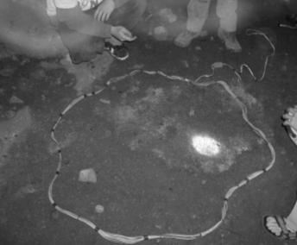Figure 1: Cave Radio Transmitter.

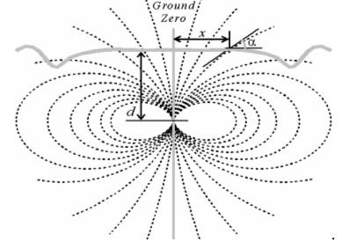 | 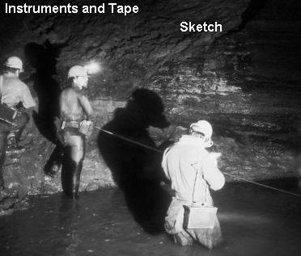
Figure 2: Electromagnetic waves emitted by the cave radio transmitter from within the cave. Gibson, (2002) | Figure 3. Cave surveying in Coldwater Cave (2005).
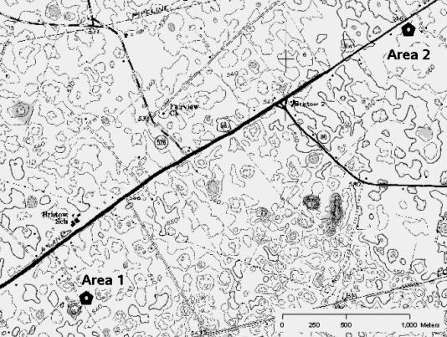 | 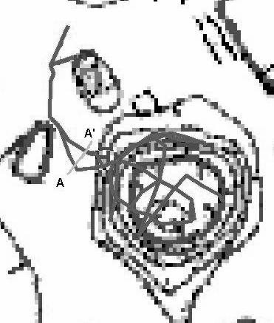
Figure 4: Map showing Case Study 1 and Case Study 2. | Figure 5: Lineplot of cave in Case Study One, note the perpendicular microgravity traverse (A-A’).

CASE STUDIES

Case study locale information: Both study locales are within close proximity of each other, and are related to the same industrial area, specifically the Kentucky Trimodal Transpark (Figure 4). Both case studies were also conducted by the CCKS. The following geologic and topographic information can be attributed to both case studies. Both caves are located in the Horse Cave Member of the Mississippian (Lower Carboniferous) Ste. Genevieve Limestone below an extremely fossiliferous silicified reef limestone bed called the Lost River Chert and directly above the Corydon Chert Member of the Mississippian St. Louis Limestone. The topography of the area can be described as a low-relief sinkhole plain, the Bristow Plain.

CASE STUDY ONE
Selection of a monitoring well location for the Kentucky Trimodal Transpark
A monitoring well is to be placed downstream of the Kentucky Trimodal Transpark to monitor water quality from this new industrial park. After reviewing the karst hydrology of the area, a cave (Grant-Palmore Cave) was found that is downstream of the Transpark. Given these facts, this cave was selected as one which could be used for a monitoring well location.

Description of Study area
A general description of Grant-Palmore Cave is as follows: The entrance to the cave is marked by a 200 meter wide collapse sinkhole, with the entrance to the cave at the bottom right (Figure 5). The passage continues to curve to the right around the perimeter of the sinkhole for about 150 meters. In this first portion, many layers of very large breakdown are present. The breakdown has a vertical extent of 15-20 meters at some points. At the bottom of the breakdown is a chert layer where a stream flows during most times. This stream is a tributary to the trunk cave stream that flows through the Graham Springs Groundwater Drainage Basin to discharge at Graham Springs. Continuing further in the cave, the passage moves beyond the boundaries of the massive sinkhole and the cave structure changes. In this structurally different portion of the cave, no breakdown is present and the floor has very large sinuous mud dunes. The fore-mentioned water flows out of discontinuous chert layers on the wall and flows downstream until it reaches either a deep pool at the termination of the cave or flows downward through small openings in the lower, continuous chert layer that serves as a basement rock for the cave. The water level of the deep hole fluctuates but it is typically never lower than 15 meters in water depth. Excellent examples of chert are numerous throughout the lower portions of the cave. Dye traces by the CCKS have revealed that the deep pool is connected to the large trunk cave stream that flows to Graham Springs. The cave has a current length of 320 meters.

Method used in determining subsurface cartographic accuracy
A monitoring well is to be drilled into the deep pool for systematic water sample collection and testing. Therefore, an accurate correlation of the location of the pool on the subsurface map with that of a surface topographic map was necessary. This required a highly accurate subsurface map so that it can be used to drill into the pool chamber. This goal was achieved using the following processes:
- Survey teams drafted a map of the cave. This was conducted in the fashion described in the previous paragraph about cave survey (+ - 2 degrees accuracy using Suunto instruments).
- The cave map was then digitized (drawn digitally using the program Adobe Illustrator) and its survey data was entered into Compass, cave plotting software. Compass created a lineplot that corresponded exactly with the survey measurements taken in the cave. This Compass generated lineplot was then used as reference when comparing other data such as survey data or geophysics.
- Cave survey data, the Compass generated lineplot data, and digital topographic quads were next geo-referenced into ArcGIS. Compass cave editor and CaveX viewer have the ability to export objects and lineplots as shapefiles, loadable into ESRI's ArcGIS 9.0.
- Geophysics was used to test the accuracy of the cave map, in this case, a microgravity analysis. A microgravity traverse was performed on the surface. This was done by locating the area on the surface directly above the large chamber which contains the mud dunes. This area was located by referring to the GIS map. The GIS allows the comparison of the cave map in respect to the topography of the area, and provided the exact GPS coordinates of the subsurface features, in this case the mud dune chamber. A perpendicular traverse was setup to intersect the center of this chamber ( Figure 5).
- Microgravity analysis was performed. The microgravity readings indicate that the perpendicular traverse may have been terminated while still above this large chamber. This data indicates that the survey may be in error. An error of 3.5-5 meters was anticipated.
- Cave radio was used next. With these conflicting reports, cave radio broadcasts were conducted near the edge of the pool chamber and in the dune chamber. These subsurface broadcast points were documented in survey notes and their positions relative to other survey stations were noted. As described before, these subsurface broadcast points can be interpolated on the surface using a triangulating antenna. The cave radio, not only provided the latitude and longitude for the broadcast site, but also the depth. Three different broadcasts were conducted on different days and their locations marked on the surface.
- Highly accurate GPS technology was used to record the exact GPS coordinates of the different broadcasts points.
- This lat-long data taken from the GPS was then entered into the GIS. This was done through the usage of the input X/Y data command in ArcGIS.
- The data was analyzed in the GIS.

RESULTS OF CASE STUDY ONE

The original cave map was slightly in error causing a 3 meter discrepancy. The cave radio broadcasts and the microgravity data both indicate this discrepancy. Later, resurvey was conducted and found one of the stations readings to be in error, possibly causing this discrepancy. The cave radio locations were used to make minor adjustments to the cave map so that it accurately indicates its true position relative to the ground surface.

CASE STUDY TWO
Protection of prehistoric and historic cultural resources and archaeological sites near a
proposed building location at the Kentucky Trimodal Transpark

A cave was discovered during the excavation for a part of the storm water runoff treatment system near the proposed location for the Kentucky Technological College building presently being constructed at the Transpark. The cave was surveyed by the CCKS to determine its extent and proximity to the proposed building location. Until the recent discovery of this cave, its existence had not been known, and it is thought that its entrance collapsed or was filled in around 100 years ago.

Description of Study Area
The cave was accessible (now resealed to preserve the Native American burial sites, and petroglyphs inside) via an artificial entrance that was created during the construction of a storm sewer for the job site. This entrance consisted of a five meter drop from the surface into the cave. The cave continues in both directions, approximately north and south, and has multiple leads, all of which terminate in breakdown. The research indicates that these breakdown termination points sometimes correspond with sinkholes on the surface. The cave is shallow, and typically is 0.5-2 meters in height, though in some areas standing is possible. In some areas the ceiling reaches 4 meters in height. The cave never plunges below 10-12 meters in depth because all passages are above a continuous chert layer located around 10-12 meters below the surface. This is the Corydon Member of the St. Louis Limestone. The cave has a total length of around three-forths of a kilometer. The cave seems to be very inactive hydrologically. Even during rain events, very little water enters the cave. It appears that during the hydrologically active period of this cave, water drained to the center portion, which is the deepest, where it then descended toward the water table (over 30-40 meters below) though a small opening in the chert layer. Unfortunately, this opening through the confining chert layer is much too small for human entry.

During the course of surveying the cave by the CCKS, multiple cultural artifacts and archaeological resources were found. These included, but where not limited to, multiple petroglyphs (Figure 6), cane charcoal fragments, wood charcoal fragments, cultural artifacts from circa 1890, candle writings, and two intentional human burial sites. The Kentucky State Archaeologist, and the director of Anthropology and Archaeology at the University of Kentucky were contacted by the client, the Intermodal Transportation Authority (ITA) and hired to conduct an investigation of these archaeological findings.

Preliminary findings show that humans entered the cave at two distinct times in the past: most recently, around the late 1800's when the wood charcoal and candle writings were produced and around 2000-3000 BCE when the cane charcoal, geometric petroglyphs, and the human burials were placed in the cave. At the time of the writing of this research, carbon dating results were not yet completed, and these ages of the archaeological sites are estimated by the preliminary results of the archaeological investigation.

Method used in determining subsurface cartographic accuracy
The techniques used for this study area do not vary much from those used in the previous example (Case Study One) except for a couple of exceptions. Electrical resistivity data was analyzed and inserted into the GIS instead of microgravity, and more cave radio points were collected. This is due to a few factors:
- The cave length is greater in Study Area Two.
- Study Area Two has multiple objects of interest that must be accurately located in relation to the rest of the cave survey, namely the archaeological sites.
- This cave is not as deep as the cave in Study Area One.

These differences resulted in a greater reliance on cave radio data in this study than that in Study Area One. Cave radio points (surface to subsurface correlation points) were placed in areas where they would provide the best accuracy for both, archaeological and cultural artifact location data, and provide accurate data for the entire cave. In other words, by placing the cave radio in areas near the extremities of the cave as opposed to the center of the cave, one can better gauge the accuracy of the entire cave map because a greater percentage of the cave is in close proximity to a cave radiolocation transmission site.

RESULTS OF CASE STUDY TWO

The cave discussed in this study is approximately three-forths of a kilometer long, much longer than Grant-Palmore Cave, the cave previously discussed in Case Study One. Therefore multiple cave radiolocations (and other surface to subsurface correlation points, [i.e. entry site GPS data]) were used in testing the accuracy of the cave survey. Also, the proximity of the archaeological resources and sites was taken into account. Logically, the closer in proximity to a radio-location broadcast point, the greater the accuracy of the sketch for that area. The broadcast points were selected to provide adequate coverage of the extremities of the cave, while also still being in close proximity to the petroglyphs and burial sites. Initially, before corrective measurements were made, the survey had an error of 3-4 meters. After GIS techniques were used, this error was reduced by more than two hundred percent. These results were then transferred into a computer file format that the site engineers could utilize and import into CAD for better planning. This allowed for better protection of the cave archaeological sites and cultural artifacts.

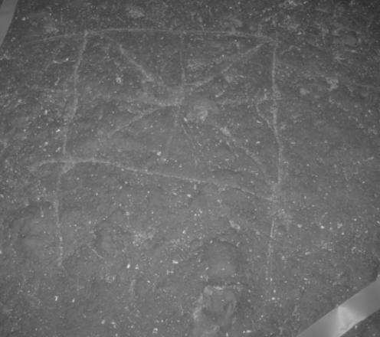 | 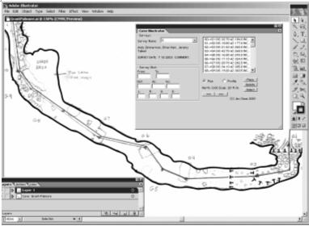
Figure 6: Petroglyphs from Case Study Two. Circa 2500 BCE | Figure 7: Adobe Illustrator showing the drafting of Grant-Palmore Cave.

CONCLUSION

The techniques discussed in this paper increase the accuracy of subsurface cartography to levels that were not possible before. This level of accuracy is helping to improve and increase the usefulness of the GIS data as well. No longer are cave maps only the interest of the cave enthusiasts. Now, since GIS data is easily searchable, and transferable, multiple disciplines of scientific research are able to use cave cartography. Contextual data describing attributes of objects and features found in the caves can now be included in the GIS. These sciences include, but are certainly not limited to; paleontology, archaeology, geology, hydrology, and engineering, just to name a few. As technology continues to advance, it is hoped that more disciplines will continue to utilize GIS and subsurface cartography.

REFERENCES
Crawford, N.C. (2003). Site Evaluation and Design Assistance for the Proposed Kentucky Trimodal Transpark, Final Report, Center for Cave and Karst Studies, Western Kentucky University, Bowling Green, Kentucky 42101, USA

Gibson, D. (2002). Radiolocation for Cave Surveying. Http://www.caves.org.uk/radio/radioloc_for_cave.html

Author Unknown, (2005). The Coldwater Cave Project. http://www.caves.org/project/coldwater/

Author Unknown. (2005). Cavers Digest http://www.caversdigest.com/new_page_1.htm

Pease, B. (2005). Thru-the-Earth Radio Location and other Stuff. http://radiolocation.tripod.com/

