SOIL AND GYPSUM CAVES MICROBIAL COMMUNITIES OF KARSTOGENIC LANDSCAPES OF ARCHANGELSK REGION (RUSSIA)

Semikolennykh A.A.¹, Ivanova A.E.², Dobrovolskaja T.G.², Gorlenko M.V.²

¹ – Russian Geographical Society, Academy of Science
² – Soil Science Faculty, Moscow Lomonosov’s University

ABSTRACT
The structure and functional specifics of microbial communities and fungi from cave deposits and near-by surface soils have been studied in caves of the Archangelsk Region of Northern European Russia. The caves are all undergoing the active process of modern karst development. Cave microbial communities were overall quite similar to those from surface soil horizons located over the caves, with some substantial structural differences, including: replacement of dominant species and the appearance of new, rare species; the prevailing growth of oligotrophic and psychrotolerant forms; and the changes in kinetic growth parameters of microbial populations.

INTRODUCTION
Karstogenic landscapes are widely spread around the world and are characterized by high contrast of ecological niches. A special position among them belongs to cave habitats that have various degrees of connection with the surface. There is a constant influx of matter and energy from terrestrial biotopes to the caves undergoing the active process of modern karst development. Various microorganisms also get here from surface with the help of air streams, infiltration waters and flood karst waters. In the new environmental conditions the introduced microbial pool may undergo substantial changes. However, it is not known, which features and properties of microbiocenoses that grow in surface environments are inherited by the microbial communities that form in the cave habitats.

THE SITE AND SAMPLES COLLECTION
The caves involved in this study are located at the site of “Pinezhsky” State Natural Reserve and special natural reserve “Golubinsky” near settlement Pinega in Archangelsk region (64°32’ north latitude, 43°15’ east longitude) in the northern taiga (boreal forest) natural subzone. At this site there are specific karstogenic and typical glacial landscapes. The caves lay in gypsum and anhydrites 4 to 50 meters deep from the surface and have the following attributes [Structure and dynamic…, 2000]: stable average annual atmospheric temperatures 1–4° C; temperatures of ground waters 0,1–10° C; annual spring floods; sulfate-calcium mineralization of waters ranging from 0,4 g/l during flood period to 2,5 g/l during low-flow period; oligotrophic conditions (the content of biophilic elements in gypsum is much lower than in cover loams. Loose deposits in caves were represented mainly by moraine clays eroded by surface waters. Several samples of cave deposits and surface soils were collected in August 1998 for microbiological analysis. The following samples were considered as taken from rich habitats:
1) SLA – the soil litter of “albeluvisol” soil (Note: Here and below soil types are named according WRB Soil Classification [WRB, 1988]), (typical eluvial-illuvial forest soil in northern humid climate), located above a cave, which was developed in draining position on a smooth slope;
2) SLL – the soil litter of “gypsiric leptosol” soil (organic accumulating soil on hard gypsum bedrock), developed on single gypsum residual hills;
3) SLCave – the fragment of soil litter removed from the surface into a cave by spring flood waters.
The following samples were considered as taken from barren habitats:
4) MIA – the mineral illuvial horizon of “albeluvisol” soil (typical eluvial-illuvial forest soil in northern humid climate), located above the cave, which was developed in draining position on a smooth slope;
5) GPL – the gypsum powder of “gypsiric leptosol” soil (organic accumulating soil on hard gypsum bedrock), developed on single gypsum residual hills;
6) MDCave – the mineral sediment on the cave floor which is flooded not yearly.

METHODS OF ANALYSIS
Field assessments of esterase activity (Index of vital biomass). Determination of vital biomass index in field conditions was based on the intensity of fluorescein diacetate (FDA) (achromatic form) hydrolysis to fluorescein (green coloring) by a complex of esterase enzymes of microbial cells in vivo. It is known from previously published reports [Ingham & Klein, 1982] that intensity of FDA hydrolysis has strong positive correlation with the amount of biomass of active microorganisms, which allows to perform indirect estimation of biomass in samples of natural substrates. One gram of fresh soil or deposits was used for analysis (three replications taken). The specimen was immersed in 50 ml of phosphate buffer (pH – 6.47) and then was shaken manually for 10 minutes. After that 1 ml of 0.001 % aqueous solution of fluorescein diacetate was added to the obtained homogenate. The specimen was put into a warm place (20° C – 25° C) for 2 hours. After that exposition, 10 ml of colored solution was filtrated into a calibrated test tube and compared to the scale of standards under illumination with wavelength of 480 nm. Ten-point relative scale of standards for hydrolysis intensity was utilized for result estimation. Score of 10 corresponded to 100% transformation of fluorescein diacetate into fluorescein (resulting concentration of fluorescein 0.0002 mg/ml). Score of “0” corresponded to the absence of fluorescein diacetate destruction for the incubation period mentioned.
Cellulose decomposition tests. The test of cellulose decomposition was carried out using the application method with cotton strips [Jones & Mollison, 1948]. The method involved complete placement of preliminary dried, weighted and sterilized cotton strips into soil or cave deposits. After completion of exposure time (2–8 weeks) the cotton strips were taken out, washed, dried and weighted. Percentage of mass loss was measured.
Characteristics of bacterial communities. Biodiversity and structure of bacterial community of soil horizons and cave deposits were studied by culturing 1:100–1:10,000 dilutions of soil suspension on solid. Two weight specimens of each sample were taken. The cultures were incubated for 10 days. Bacteria were studied on glucose-peptone-yeast agar at temperatures of 28° C and 5° C. There were three replications of Petri dishes with cultures used. Genus identification of bacteria was performed [Bergey's manual…, 1997] using morphological, cytochemical (Gram stain) and physiological-biochemical signs (test for oxidase and catalase).
Characteristics of fungal communities. Biodiversity and structure of micromycetes community of soil horizons and cave deposits were studied by culturing dilutions of soil suspension on solid medium. Dilution 1:100 was used for micromycetes culturing. Five weight specimens of each sample were taken. Microscopic fungi were grown on Czapek agar and Water agar at temperatures of 25° C, 15° C and 5°C. In all cases for each weight specimen we performed replication three times. The cultures were incubated for 10 days, after which the pure cultures were counted and isolated for genus and species taxonomic identification of fungi. Identification was performed using the keys [References are abridged]. Biodiversity and structure of micromycetes communities and the quantitative ratio of species was characterized using the following indices: a) frequency of occurrence (percentage ratio of samples/replications, in which the given species were found, among all the investigated samples/replications); b) relative abundance (percentage ratio of the colonies of the given species to the total number of fungal colonies for every replication, and subsequent calculation of the mean value for the sample among all replications); c) assessment of rank distribution of species abundance [May, 1975]; d) assessment of species diversity according to Shannon’s diversity index, based on the values of species occurrence [Megarran, 1983].
Determination of temperature optimum for cultures initially cultivated at different temperatures. For model experiment of temperature adaptation determination an elementary bacterial association isolated by “diminishing streak” technique from one of the colonies from MDCave sample after primary inoculation at +28° C was used. Association was stable (did not split into components by terminal dilution with further inoculation on glucose-peptone-yeast agar) and included two components: Myxococcales spp. and Aquaspirillum sp. The elementary association was reinoculated into Petri dishes at +5° C and +28° C to get biomass of “mesophilic” and “psychrophilic” lines. After accumulation of biomass in the new temperature conditions the temperature range of growth was determined by reinoculation into several Petri dishes, incubated at different temperatures. Capability for growth at different temperatures was studied.
Multisubstrate testing for investigation of functional structure of microbial communities. Method of multisubstrate testing (MST) was utilized to analyse functional patterns of natural microbial communities using spectrum analysis of consumed monosubstrates. A special microtitre plate, which included 47 test substrates, was used for implementation of MST. Weight specimens of 2 gram were taken from samples at field moisture for the test. Each weight specimen was mixed with 100 ml of Serenson’s phosphate buffer (pH = 6.5). Vital dyes were added to the obtained centrifugate:
1) in the first series of tests, an aliquot of centrifugate was mixed with solution of TTB (concentration 3 g/l) in 10:1 ratio (final concentration of the dye — 0.27 mg/ml), as an indicator activity dehydrogenase enzymes;
2) in the second series of tests, FDA (fluorescein diacetate) was used as an indicator of esterase vital activity. The FDA solution was added to the centrifugate until final dye concentration of 0.0001% (0.001 mg/ml).
The obtained sample was thoroughly mixed and 0.2 ml of it was placed into each cell of plate using multi-channel butcher. The plates were incubated in thermostat at +28° C. Optical density of the cells was measured by photometry at 1st, 2nd and 3rd days of incubation. Measurements were performed at wavelength of 510 nm for TTB-containing plates and at wavelength of 480 nm for FDA-containing plates. The data obtained were categorized using algorithms of cluster analysis by means of SPSS 10.0 software. Numerical data of the device (optic densities of solutions at 510 nm and 480 nm minus control sample values) were used as index values of growth energy. Simple summation method was used for the device readings from all cells of the plate. It was called “community performance” and was used for demonstration of global intensity of metabolism.

RESULTS AND DISCUSSION
Results of cellulose decomposition tests. The table below shows the results of 8-week experiment measuring the intensity of decomposition of cotton strips exposed in soil and cave environmental conditions. The cellulose in “cave environment” decomposes significantly slower when compared to soil environment. This is likely to be associated with predominance of copiotrophes (Aquaspirillum) in the psychrotolerant pool of microorganisms in cave clays, while hydrolytic bacteria - cellulose decomposers - are passive at low positive temperatures, although maintaining vitality.
Index of vital biomass in samples of soil and cave habitats. The results of field assessment of vital biomass index using method of FDA hydrolysis are presented in the table. Despite of high diversity of vital biomass indices for different soil types, existing in different environmental conditions, one cannot say that cave deposits contain substantially less biomass of microorganisms. Rich organic cave deposits have values of vital biomass index which are very comparable to many soil litters. Mineral deposits of caves have values of the index, typical for moderately barren soil horizons. Meanwhile, the process of FDA hydrolysis by microorganisms in different samples varies substantially. Figure shows kinetic graphs of this process for some of the samples. It demonstrates that in the samples from habitats experiencing constant influence of low temperatures the FDA hydrolysis begins with delay and has a lesser activation energy (tangent to the curve at the initial stage) (Fig).
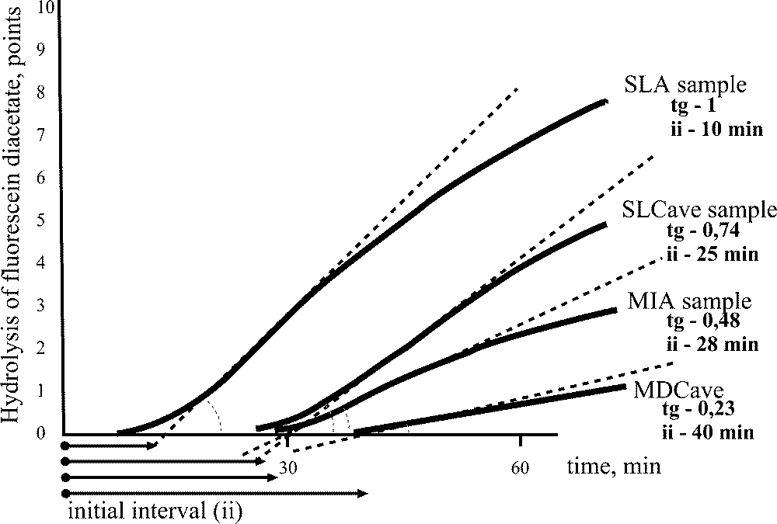

Samples |  |  | Index of “vital biomass”.  0-10 Points | %_{m}, cellulose utilization  (the mass loss during 8 weeks)
Soils | Albeluvisol soil under the Cave | Upper horizon of soil litter | 9 | 30
Soils | Albeluvisol soil under the Cave | Lower horizon of soil litter | 10 | 30
Soils | Albeluvisol soil under the Cave | Eluvial (Albic) horizon, mineral | 3 | 3
Soils | Albeluvisol soil under the Cave | Illuvial (Argic) horizon, mineral | 4 | 3
Soils | Albeluvisol soil under the Cave | Horizon transitional into morine, mineral | 1 | 3
Soils | Gypsiric leptosol soil near the Cave | Soil litter (like dry peat) | 8 | 12
Soils | Gypsiric leptosol soil near the Cave | Gypsum powder | 4 | 3
Soils | Histosol soil at the bottom of karst sink-hole near the Cave | Organic illuvial horizon | 10 | 18
Soils | Histosol soil at the bottom of karst sink-hole near the Cave | Clay deposit with organic illuviation | 6 | Traces
Soils | Regosol soil at the slope near the Cave | Soil litter | 8 | 28
Soils | Regosol soil at the slope near the Cave | Horizon transitional into morine, mineral | 3 | 8
Caves | Soil litter on the ceiling of the Cave |  | 7 | No data
Caves | Plant remains at the distance from 100 m from the entrance |  | 9 | Traces
Caves | Clay deposit in the middle part of the Cave |  | 2 | Traces
Caves | Clay deposit at the distance from 200 m from the entrance |  | 3 | Traces
Caves | Clay deposit in the far part of the Cave |  | 2 | Traces

Taxonomic structure of saprotrophic bacterial communities in soil and cave habitats. Features noted for bacterial communities of litters and illuvial horizons of surface soils (SLA, MIA samples) were similar to the typical characteristics of most soils of taiga region. For these soils, dominating microorganisms of the litters are cellulose-decomposing bacteria of Myxococcales order and Cellulomonas, as well as typical pedobionts of mineral horizons, such as Arthrobacter. In the bacterial community of gypsiric leptosol significant percentage is occupied by representatives of Actinomycetales order: 17% in SLL and 31% in GPL. This soil also has maximum abundance of Myxococcales and Bacillus compared to albeluvisol. In the bacterial community of SLCave there were found the same groups of microorganisms as in SLA, with domination of Myxococcales. The structure of bacterial communities of these biotopes differed in the ratio of bacteria of Cellulomonas genus and Aquaspirillum genus: 10:1 in the albeluvisol and 1:10 in cave habitats respectively. The domination of Aquaspirillum, which are typical hydrobionts, in SLCave is associated either with their influx with spring flood waters, or with constantly high humidity of cave atmosphere. Usually, Cellulomonas are isolated in high numbers from forest litter in autumn periods, when the process of mineralization of seasonal abscission of leaves begins. That is exactly what we observed in the analysis of SLA sample, which was taken in the beginning of autumn. Considering that material of SLCave sample got into the cave in the spring with spring flood waters, but was taken for tests in Autumn, there weren’t found Cellulomonas genus bacteria. This appears to indicate some indirect evidence of absence or great suppression of seasonal dynamics in caves when compared to terrestrial habitats. Bacterial communities of MDCave have similar features to MIA bacterial communities. The dominant position in these communities is occupied by bacteria of Arthrobacter genus and Aquaspirillum genus.
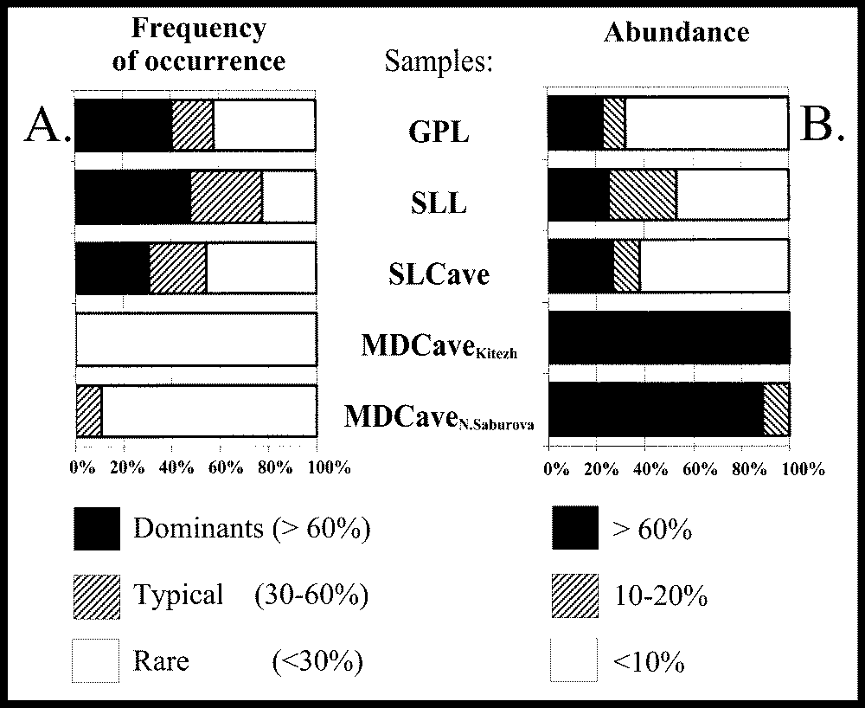
Biodiversity and structure of microscopic fungi communities in soil and cave habitats. The communities of microscopic fungi isolated from samples of organic horizons of surface soils and caves were significantly richer in terms of species diversity than fungal communities of mineral horizons of the same habitats (Look the table below). Micromycetes communities of soil horizons and SLCave sample had pronounced structure, which included two to three dominating in occurrence and in relative abundance species, several typical and frequent species, and several sporadic species. However, the percentage of low-abundant species exceeded one half. At low temperatures the percentage of rare, low-abundant species with relative abundance values less than 10% increases. The communities of micromycetes isolated from cave spring flood clay had low species diversity and the lowest values of Shannon’s diversity index (Table). Structure of fungal communities of these cave deposits was different from typical soil habitats and even from mineral soil horizon: there were only rare species of micromycetes that had at the same time high abundance (Fig.). Appearance of these species in the inoculate was random and did not depend on the cultivation conditions (temperature and nutrient medium). High values of relative abundance were observed in all the fungal species isolated from this sample. These values exceeded 10% and usually were 50% to 100%. Therefore, the patterns of species distribution may be described by a model of community composed of several discretely distributed (i.e. rare, with low spatial occurrence) and absolutely prevailing in number (i.e. abundant) species, and at the same time rare and not numerous (i.e. not abundant) species are completely absent in the community. The prevalence of rare but abundant species of fungi together with their “dotted”, random pattern of isolation is caused by barrenness and discreteness of organic substrates existing in cave clays, which is a specific feature of the given habitat.

Species | Soil habitats |  | Cave habitats
Species | (GPL) | (SLL) | (SLCave) | (MDCave, Cave 1) | (MDCave, Cave 2)
Acremonium charticola (Lundau) W. Gams | ХХХ | Х | Х
Acremonium kiliense Grutz | Х |  | Х | Х
Acremonium sp. |  |  | ХХ |  | Х
Artrobotrys artrobotryoides (Berl.) Lindau |  | Х | ХХ
Aspergillus niger van Tieghem | Х |  |  |  | Х
Aspergillus wentii Wehmer | Х
Chaetomium globosum Kunze ex Steud. |  |  | ХХ |  | Х
Chrysosporium merdarium (Link ex Grev.) Carm. |  |  |  | Х
Cladosporium cladosporioides (Fres.) de Vries | Х | Х | ХХ
GeomycesChrysosporium pannorum (Link) Hughes |  | ХХ | ХХХ | Х | Х
Mucor hiemalis Wehmer |  | ХХ | Х
Oidiodendron tennuissimum (Peck) Hughes | ХХХ |  | Х
Penicillium aurantiogriseum Dierckx |  |  | Х |  | Х
Penicillium canescens Sopp |  | Х |  |  | Х
Penicillium chrysogenum Thom |  |  | Х
Penicillium crustosum Thom | Х | Х | Х | Х | Х
Penicillium decumbens Thom | Х | ХХХ |  |  | Х
Penicillium expansum Link ex Gray |  | Х
Penicillium funiculosum Thom | Х | Х | Х | Х | Х
Penicillium janczewskii Zaleski |  | ХХ |  |  | Х
Penicillium janthinellum Biourge |  | ХХХ
Penicillium minioluteum Dierckx |  |  |  | Х
Penicillium oxalicum Currie & Thom | Х
Penicillium roquefortii Thom | Х
Penicillium rugulosum Thom | Х | Х
Penicillium spinulosum Thom |  | ХХ
Penicillium thomii Maire |  | ХХХ
Phialophora cinerescens (Wollenw.) van Beyma |  |  | ХХ
Rhizopus oryzae Went & Prinsen Geerligs | Х
Sterile dark-colored mycelium |  |  | Х | Х
Sterile light-colored mycelium |  | Х |  | Х
Trichoderma viride Pers. ex Gray |  | ХХХ
Verticillium lecanii (Zimm.) Viegas | ХХ
Shannon’s diversity index | 1,99 | 2,45 | 2,27 | 1,93 | 2,06
Evenness | 0,75 | 0,86 | 0,84 | 0,95 | 0,94
Species frequency of occurrence: X – rare (< 30%); ХХ - typical (30-60%); ХХХ – dominant (> 60%).

The massive growth of one predominant population (one species) within such discretely distributed substrate-containing areas is possible in the absence of interspecific competition in the circumstances of disruption or termination of continuous progression of fungal succession which takes place in the process of decomposition of organic substrates. This indicates global unsaturation of cave fungal communities. The species composition of micromycetes communities of cave deposits has hereditary similarity to the communities of surface soil horizons. For instance, in the community of micromycetes in a soil litter fragment, brought into a cave by spring flood, there were many fungi species isolated, which were also found in a soil litter taken from daylight surface (Table above). These were fungi that grow in the seasonal abscission of leaves, decaying plant remains and tree remains: Mucor hiemalis, Geomyces pannorum, Cladosporium cladosporioides, and nematophagous fungus Arthrobotrys arthrobotryoides. At the same time, the data on species structure show that when soil litter is moved from surface into cave habitats, which are different in physical, climatic, and trophic parameters, substantial and rapid restructuring of fungal community occurs, and species that were dominant in surface habitats are forced out of the community by fungi that are more adapted to the new conditions.
Differential significance of temperatures and organic matter supply for studying of structural and functional features of communities. Population numbers of bacteria in the communities of soil litters were 2–4 orders of magnitude higher, than in mineral horizons, and were equal to 10⁷ to 10⁹ CFU/g (Table below). Incubation at different temperatures allowed to reveal substantial differences in mesophilic and psychrotolerant bacteria groups ratio in biotopes of daylight surface and cave biotopes. The percentage of psychrotolerant pool of bacteria in MDCave was 20%. At the same time the numbers of bacteria, grown at 5° C and at 28° C, were within the same range of magnitude. In MIA sample the pattern was opposite: percentage of psychrotolerant pool of bacteria was only 0.05%, and numbers of bacteria grown at 5° C were two orders of magnitude less than numbers of those grown at 28° C. Analysis of bacterial communities grown at 5° C demonstrated that the spectrum of bacteria taxons was significantly narrowed when compared to the spectrum obtained at 28° C. At 5° C the vast majority of colonies isolated from mineral substrates was represented by bacteria of Arthrobacter genus and Aquaspirillum genus, while there were no representatives of other genus found. Analysis of litters showed much lesser influence of factor of the temperature on psychrotolerant pool of bacteria.

 |  | Samples
 |  | Albeluvisol soil (typical forest soil in humid climate) |  | Gypsiric leptosol (primitive soil on gypsum rocks)) |  | The Cave
 |  | Soil litter  (SLA) | Illuvial mineral horizon  (MIA) | Soil litter  (SLL) | Gypsum powder  (GPL) | Soil litter  (SLCave) | Clay deposit  (MDCave)
Quantity of colony forming units/ 1 gram of dry sample | 28°C | 3,92  х 10⁹ | 6,10  х 10⁷ | 1,30  х 10⁸ | 2,00  х 10⁶ | 1,14  х 10⁹ | 1,58  х 10⁵
Quantity of colony forming units/ 1 gram of dry sample | 5°C | 1,35  х 10⁷ | 0,31  х 10⁵ | ^{No data} | ^{No data} | 0,68  х 10⁷ | 0,37  х 10⁵
The ratio of psychrotolerant to mesophillic pools, % |  | 0,34 | 0,05 | ^{No data} | ^{No data} | 0,60 | 23,42

In the studying of influence of soil and cave habitats on microscopic fungi communities we utilized different cultivation conditions for their isolation: barren and rich mineral mediums (Water agar, Czapek agar); low (5° C, 15 C) and standard for soil microbiological analysis (25° C) temperatures. Substrate limitation (growing of micromycetes on poor medium — Water agar) caused reducing of total numbers of fungal colonies isolated from the study samples. Also substrate limitation determined the structure of communities, their composition and percentage of infrequent species in fungal community. For instance, isolation of fungal cultures from rich in organic matter litters on Water agar resulted in the increase of percentage of infrequent and scarce (low abundant) species by 15–20%. And, on the contrary, cultivation of fungi from oligotrophic soil mineral horizon on Water agar resulted in community composition with several highly abundant fungal species, while the percentage of low-abundant species was significantly lower than obtained when grown on rich medium. Isolation of fungi from cave clay deposits on Czapek agar resulted in abundant growth of sterile mycelium, which inhibited growth of any other fungi. The factor of temperature also played a significant role, as it determined global diversity of species in isolated communities of micromycetes. In fungal communities of oligotrophic habitats (e.g. cave clays and mineral soil horizon) the increase of cultivation temperature from 5° C to 15° C and 25° C resulted in the increased number of species isolated. And vice versa, in fungal communities from surface and cave litters that had lots of organic substrates the increase of diversity of species was noted when reducing temperature from 25° C to 15° C and 5° C. Apparently the shift of thermal range of growth into less typical zone for these substrates activates the reserve microbial pool and initiates development of resting fungal forms, which are present in the given substrates. Increase in the diversity of species of fungal communities occurred as a result of greater percentage of low-abundant species which grew from 30–50% to 75–90%.
The data of complex analysis of multisubstrate tests results. Using FDA as a metabolism indicator, the reduction of incubation temperature resulted in predictable decrease of all calculated indexes: Shannon’s index, amount of substrate consumed and value of “community metabolic performance”. Notably, the decrease in the indices depended on the initial values. It may appear to be the evidence that organisms with prevailing r-strategy (hydrolytics) — which are presumably determined in FDA assessment — are equally depressed at low temperatures in both soil and cave habitats.
In the TTB-analysis relatively high values of diversity index and evenness in cave clay sample (MDCave) when compared with other oligotrophic samples are worth attention. However, the amount of substrates consumed and community performance for that sample did not exceed the corresponding values for MIA and GPL. SLCave and SLA samples taken in winter season featured relatively higher values of evenness and community performance. It is likely to be caused by activation of community in mesophilic conditions of incubation after being exposed to cold environmental conditions. Most probably that the response of community is just a single-event reaction.
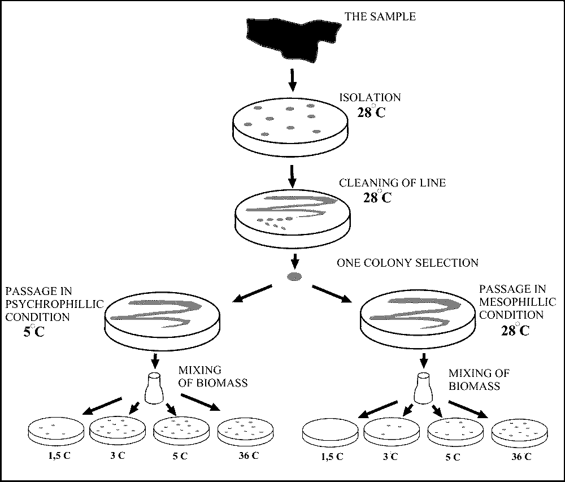
To address the assessment of rapidness and grade of temperature adaptation response we performed a series of experiments with elementary association (refer to “Methods of analysis” section). The results showed differences in the growth capabilities of cell association pool at low temperatures depending on the previous temperature of cultivation. For instance, if the initial cultivation temperature was +5° C, then the range of temperatures in further reinoculation was widened towards lower temperatures: + 1.5° C and +3.5° C. If the association was initially cultivated at +28° C, further it wasn’t capable to grow at temperatures lower than +5° C during the same period of time. For temperatures higher than incubation temperature of previous culturing there were no similar patterns observed. For instance, at +36° C the cultures cultivated earlier both at +5° C and at +28° C grew with similar intensity. The patterns observed and the experiment conditions are demonstrated at Figure 6. Most likely those rapid changes in the ecology of microorganisms are associated with predominant propagation of adapted psychrotolerant cellular pool which exists inside a population of a single genus. It is evident that bacteria multiplication at low positive temperatures causes the appearance of modification changeability or divergence of elementary association components (micropopulations), which occurs later in sequential cell generations. Determination of temporal stability of this feature was not included in the objectives of the present study.

CONCLUSIONS
In conclusion, based on the presented data we can emphasize the following specific features of structure and functioning of microbial communities in environmental conditions of caves undergoing active process of modern karst development and closely connected with daylight surface:
- In caves undergoing active karst development we observed basic diversity of zonal soil microorganisms in vital state presented in numbers that are comparable to the terrestrial habitats.
- The main features of microbial communities of cave habitats were caused by influence of environmental factors and adaptation of microorganisms to the specific climate of cave environment. It was manifested by inhibition of hydrolytic organisms growth (which nevertheless preserved vitality), predominance of psychrotolerant and oligotrophic forms, discrete development of mono-species populations resulted from the absence of significant natural competition for nutrients.

REFERENCES
- Bergey’s manual for identification of bacteria. (1997). 8th edit. “Myr” Press. Moscow. (in Russian). 799 pp.
- Ingham E.R. & Klein D.A. (1982). Relationship between flourescein diacetate-stained hyphae and oxygen utilization, glucose utilization, and biomass of submerged fungal batch cultures. Appl. Envirin. Microbiology. 44 (2). P. 363-370
- Jones P. and Mollison J. (1948). J. Gen. Microbiol. 2:54-69.
- May R.M. (1975). Patterns of species abundance and diversity. In: Ecology and Evolution of Communities (eds. M.L.Cody & J.M.Diamond), Harvard Univ. Press, Cambridge, MA.
- The structure and dynamic of natural components of Pinezhsky Reservation. Biodiversity and geodiversity in karst areas. (2000). Edit. By Puchnina L.B., Goryachkin S.V. 207 pp. Arkhangelsk Press. (in Russian)
- World Reference Base for Soil Resources (WRB), 1998. Rome. FAO/UNESCO.

