The reasons for high biodiversity in karst landscapes IN THE NORTHERN TAIGA

Goryachkin S.¹, Glazov M.¹, Puchnina, L.², Rykov A.A.², Rykova S.Yu.², Semikolennykh A.¹ (contact author), Shavrina E.², Spiridonova I.¹, Tuyukina T.¹, Zakharchenko J.²

¹ Institute of Geography, Moscow, Russia
² Pinezhsky Natural Reservation, Russia
Pervomaiskaya str., 94-133. Moscow, 105203. RUSSIA. E-mail: aasemik@list.ru

ABSTRACT: The character of landscapes can be greatly influenced by underlying soluble rocks and related karst processes. This phenomenon has been studied within an area situated 200 km east and north-east of Arkhangelsk, where karstified material influences taiga & forest-tundra landscapes. The taiga zone in the Russian European North is a territory with predominant swamped glacial plains. Such landscapes are formed in cold & humid climates combined with poor drainage. However, there is another type of landscape that has developed over gypsum & limestone rocks covered by a thin layer of moraine or outcropping to the surface. Here, instead of typical spruce woods, there are low-productive larch woods, natural meadows, and open woodlands with plant species atypical of northern habitats. Bogs occur rarely, but so-called "disappearing" lakes, caves, and other karst forms are common. This is a type of a landscape, where geodiversity and biodiversity are strongly interconnected, where biotic and abiotic components develop together. The dynamic processes involved in such landscapes were monitored on 2 sites using a three-dimensional approach. Thus, the characteristics of environment (i.e. temperature, moisture, concentration of nutrients in soil solution, etc.) and life indices (i.e. microbiological activity, bird occurrence and frequency, plant community characteristics, etc.) were measured together with their principal quantitative & qualitative differences in conditions of karst & moraine landscapes. Karst areas in northern taiga can shelter some relict arctic-alpine species within sink-holes and support specific oligotrophic plants growing on rock outcrops; karst areas in tundra provide for the development of forest vegetation. In other words, karst processes & topographical features are able to support more sophisticated landscape structures and ecological systems due to the diversity of habitats. The impact model may be represented as follows: "rocks dissolution → dissected relief → intense drainage, contrasting temperatures & nutrition sources → impact on organisms". The existence of local karst areas also contributes to the wider system biodiversity within a whole region.

INTRODUCTION. Observations of the dynamic processes in soils and landscapes allow for the formulation of a complex spatial-temporal structural and functional conception of the biosphere and its components. As such studies require a special stationary-based methodology very few works in this field have been conducted within different natural zones (e.g. [Regulatory role…, 2002]). Our research was conducted in the northern taiga (northeastern part of Belomorsko-kuloiskoe Plateau, Arkhangelsk region, Russia) (Fig.1). The post-glacial landscape typical of this territory is complicated by the presence of karst areas; hence we focused our attention on the differences between karst and moraine landscapes. A significant part of our research was carried out within the Natural State Reserve “Pinezhsky”, where the highest diversity of landscapes can be observed.
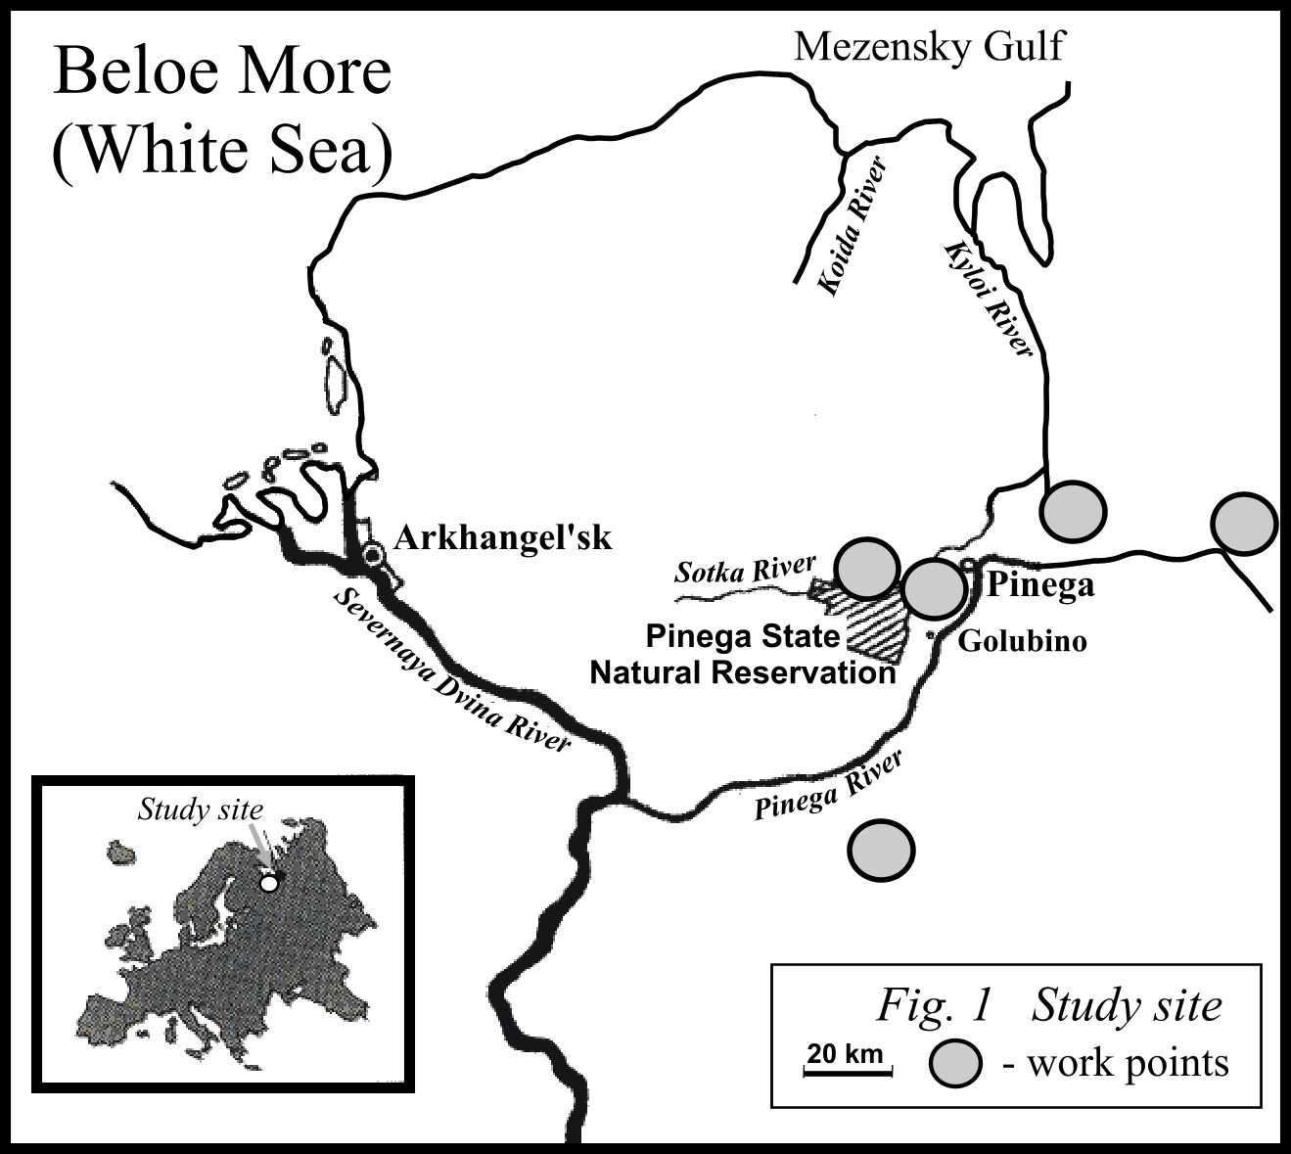
STUDY OBJECTS. The study was conducted in the northeast of European Russia, in the interfluve between the Mezen and North Dvina rivers. The study area is characterized by a temperate humid climate with the mean annual temperature 0.2⁰C, mean temperature of January -13.8⁰C, and mean temperature of June +15.4⁰C. The sum of temperatures >10^{о} is 1100^{о}; the annual precipitation is 652 mm with its maximum in summer.

Bedrocks are formed of Paleozoic sulfate, calcareous, and terrigenous sediments. They are overlain by Quaternary moraine clays and loams. Karst processes developed in positions, where the thickness of moraine cover is less than 10 m. Soluble rocks are represented by Early Permian lagoon sediments (gypsum and anhydrite) about 40-70 m thick. The density (frequency) of karst forms is from 100 to 1500 units per 1 sq. km. Karst forms are sinkholes, "organ pipes", karst ditches (ravines, gorges, gullies), and residual hills.

Typical woods in the northern taiga are formed mostly of conifers (Picea abies, Picea obovata, Larex sibirica, Pinus sylvestris). Pine-birch-spruce forests with a ground cover of shrubs and green mosses predominate within post-glacial (non-karst) areas. Their typical soils are Gleyi-Histic Albeluvisols (gleyzation caused by ground water), Stagni-Abruptic Albeluvisols (in loamy moraine with abrupt lithological contact) and Histosols (Note: Here and below soil types are named according WRB Soil Classification [WRB, 1988]).

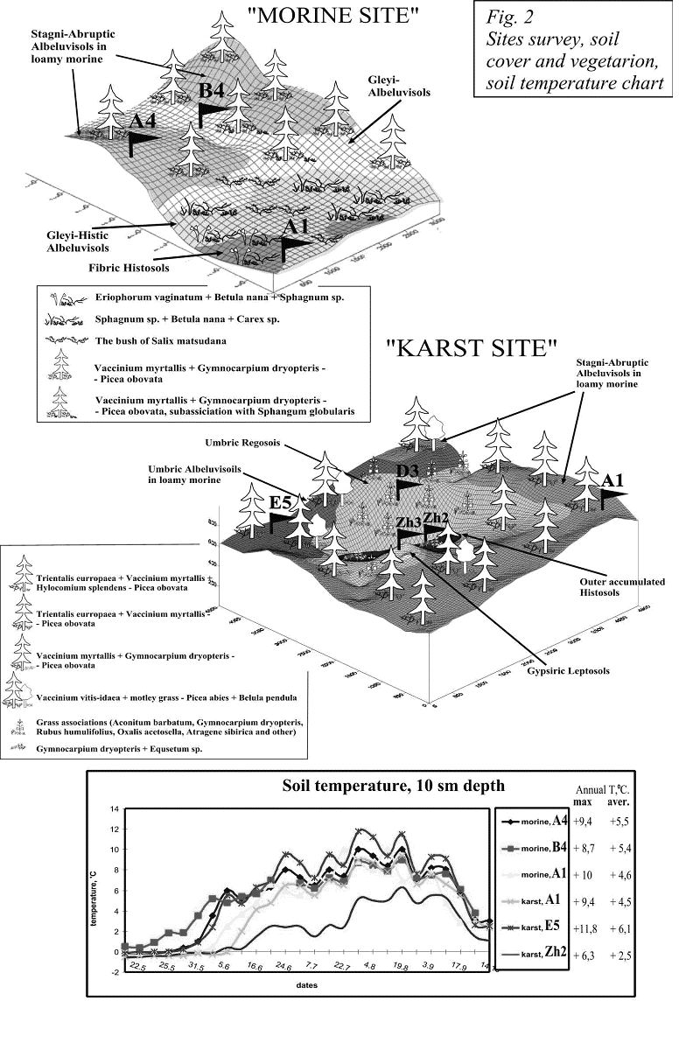
Karst landscapes are more complicated. There are some atypical plant species, such as relic arctic-alpine ones: Arctous alpina, Dryas octopetala, Pinguicula alpine; boreal Siberian: Atragene sibirica, Diplazium sibirica; nemoral: Stellaria nemoralus, Paeonia anomata; endemic: Gypsophyla uralensis subsp. pinegensis, Thymus talievii and others. The structure of soil cover is related to the geomorphological structure. Gentle slopes and watersheds between single sinkholes are covered by moraine deposits from 10 cm to several meters in thickness, where Haplic Podzols and Stagni-Abruptic Albeluvisols are formed. The bottoms of large sinkholes are filled by coarse organic deposits that are several meters in thickness (Outer accumulated Histosols). The specific soil type – Gypsiric Leptosol (formed in hard gypsum and having the metamorphic horizon) is formed on gypsum outcrops on residual hills and slopes.

MONITORING OF THE KEY SITES
Monitoring of ecosystem dynamics was performed on two key sites in karst and moraine areas that represented the diversity of topographical features, vegetation, and soils. The key sites are located on the right bank of the Pinega River within the fenced-off area of the State Natural Reserve “Pinezhsky”. The "moraine site" has an area of about 1200 sq. m. (30x40 m), and the "karst site" – 1800 sq.m (40x45 m) (Look the Fig. 2). The following initial works were carried out: topographic survey (measuring relative heights), plant and soil descriptions, soil and groundwater sampling, and taking samples of leaves and shoots for chemical analysis. The plant and soil descriptions and soil and groundwater sampling were done at 5 meter intervals over the study site areas. The monitoring included measuring air and soil temperatures and soil moisture, phenological observations, setting traps for cursorial insects, experiments for measuring the rate of decomposition of cotton strips, taking soil samples for inoculation of microbiological media in the laboratory, and some other tests. Monitoring points were located at the main elements of the key sites. Three points were monitored on the "moraine site": point A4 – gentle hill, local watershed; point B4 – small depression; point A1 – bog. Five points were monitored on the "karst site": point A1 – gentle hill, local watershed; point D3 – steep slope to sinkhole; point E5 – gentle slope, low hill; point Zh2 – bottom of sinkhole; point Zh3 – top of residual hill. Chemical analyses included bulk chemical composition analysis, agrochemical analysis (NPK), and X-ray analysis of microelements (Cr, Ni, Cu, Zn, As, Br, Pb, Rb, Sr) in soil and plant samples.

The comparison of the temperature condition during a year shows that karst site has more contrast changes in temperatures in the different soils distributed within the site. The same regularity was found for moisture condition in soils. The diversity of hydro-thermic conditions reflects on development of plants that is illustrated by some phonological data (look at table below).

Species | Phase
Species | Phase | “morine”, A4 | “morine”, A1 | “karst”, E5 | “karst”, Zh2
Vaccinium myrtallus | Spreading of leaves | 29 May | 29 May | 28 May | -
Vaccinium myrtallus | Mass florescence | 13 June | 20 June | 12 June | -
Vaccinium myrtallus | Drupe bletting | 5 August | 1 August | 1 August | -
Picea obovata | Growth of sprouts | 13 June | - | 13 June | -
Betula pendula | Spreading of leaves | 27 May | - | 29 May | -
Oxalis acetosella | Beginning of vegetation | - | - | 29 May | 6 June
Oxalis acetosella | Beginning of florescence | - | - | 5 June | 13 June
Oxalis acetosella | Mass florescence | - | - | 13 June | 20 June
Orobus vernus | Beginning of vegetation | - | - | 25 May | 6 June
Orobus vernus | Budding | - | - | 28 May | 13 June
Geranium sylvaticum | Mass florescence | 2 July | - | 4 July | 25 July
Aconutum barbatum | Mass florescence | - | - | 16 July | 25 July

As a result of observations on the dynamics of microorganisms, we have revealed the following:

1. The total number of microorganisms increases from spring to autumn; although the relative proportions of phenological groups change. The proteolytic group decreases in number during the autumn season, and at the same time we observe an explosion-like growth of the number of cellulolytic organisms. The number of bacteria in litters during the growing season is a bit higher on the moraine site, however in autumn the moraine site has mostly lower values than the karst site. The number of fungi in litter layers on the moraine site is higher, in autumn as well.

2. The distribution of microorganisms within the soil profile is somewhat different. In Albeluvisols of the moraine site, there is a rapid, but smooth decrease in the number of microorganisms with transition from the litter to mineral horizons. In the well-drained Podzol of the karst site, that transition is rather abrupt. Slope soils tend to exhibit a smooth decrease in microorganism numbers in their transitional horizons, which accounts for a high biological activity within a whole soil profile.

4. The cellulase activity in poorly developed soils, i.e., Leptosols formed in hard gypsum on slopes, doesn't show significant seasonal fluctuations, remaining constant during a whole growing season. The cellulase activity in Podzols increases nearer autumn. Podzols have a curious tendency for significantly changing the proportion of utilized substrates in the litter and mineral horizons towards the end of the growing season. A prominent relative growth of the cellulase activity in the mineral horizons can be connected either with the "retarded" development of microorganisms in these horizons in comparison with that in litters (possibly because the former warm up more slowly in the spring), or

with the conditional deficiency of moisture in litters during the dry period in the middle of summer. The influence of temperature can be clearly illustrated by the example of soil occurring in the bottom of the sinkhole (point Zh2) which is the "coldest" one among all monitored soils and gets warm only by the middle of summer.

5. In the north taiga soils, coloured forms of Myxobacteria are predominant in the bacterial community of litters, and the genus Arthrobacter and Spirillum with bacilli-like cells prevail in the mineral horizons.

6. A general tendency in all studied soils is an increase in the total number accompanied by a decrease in the biodiversity of bacteria from summer to autumn.

7. The assessment of the biological diversity using the Shannon’s index has revealed the following:
- the biological diversity in summer is generally higher than that in spring;
- Leptosols formed in hard gypsum have the highest diversity of micromycetes;
- Histosol formed on oligotrophic bog shows the lowest increase in biodiversity during summer.

We compared data on soil regimes over two years, 1996 and 1997, which had very different climatic conditions. The summer of 1996 was characterized by abundant precipitation and relatively low temperatures. In contrast the summer of 1997 was dry and hot. The some results are presented in the table below.

In litters of Albeluvisols on the moraine site, optimization of the water-temperature regime accompanied by an increase in the cellulase activity was observed in 1997. But, in the mineral horizons of those soils, the biological activity little varied between 1996 and 1997. The biological characteristics of Stagni-Abruptic Albeluvisols formed in automorphic position on the karst site remained almost unchanged; though the limiting factor in 1996 was probably heat deficiency, followed by moisture deficiency in 1997. However Podzol on the gentle slope on the karst site demonstrated an important increase in the activity indices, especially, in the mineral horizons. Since its moisture was similar in 1996 and 1997, the difference should be explained, apparently, by an increased warming of its whole profile in 1997.

OLIGOTROPHIC KARSTIFIED OPEN WOODLANDS

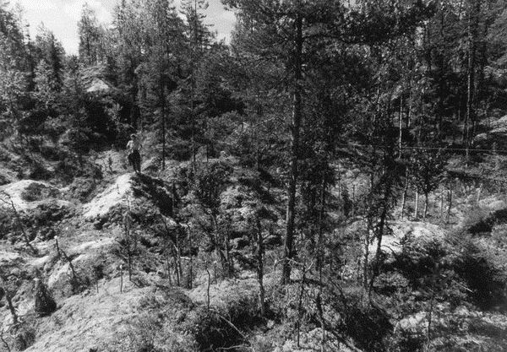
Within the study area, there are specific landscapes that we term "oligotrophic karstified open woodlands"(Fig). They are characterized by a total projective cover (percent of ground surface overgrown by grass-shrub vegetation) of only 20%. The ground cover is formed mostly by various lichens of genus Cladina, and less abundantly by the moss species Pleurozium schreberi. These open woodlands are characterized by a dissected topography with karst forms and the predominance of specific soils formed in hard gypsum (Leptosols and Regosols) and lichen communities. The soil and vegetation patterns are very heterogeneous because of the karst topography. Highly oligotrophic lichen communities on gypsum soils on residual hills occur next to moss communities on Histosols within sinkholes. Such a contrast results from a wide difference (15ºC) between the soil temperatures on the hill top and at the sinkhole bottom. However the warmest ecotope is characterized by the most oligotrophic vegetation and the lowest microbial activity.

On the basis of our results of measuring the diameter and height of trees and the data [Molchanov, 1971] on mass proportions of dry and live wood of main tree species in the northern taiga, we estimated the mass of above-ground parts of trees in this community. The mass of live above-ground wood equals to 14.8 ton of dry phytomass per hectare, which is 8-10 times as low as that in typical taiga communities (green moss spruce forest on Albeluvisol and pine forest on Podzol).

Plants that are capable of occupying bare hard gypsum are characterised by a peculiar chemical composition: Festuca ovina – oligotrophic plant with a wide ecological amplitude, and Gypsophila uralensis Less. Subsp penegensis - gypsophilic plant. As distinct from most other plants of karstified open woodlands, Festuca ovina doesn't concentrate Ca, Sr and S: their concentrations in the above-ground part of this plant in karst and moraine landscapes are similar. At the same time, Gypsophila uralensis Less. Subsp is distinguished among all other plants of karstified open woodlands as a supreme accumulator of calcium (6.38 % of dry weight), sulphur (0.74%), and copper (13 mg/kg) with the total ash content of 15.24 %.

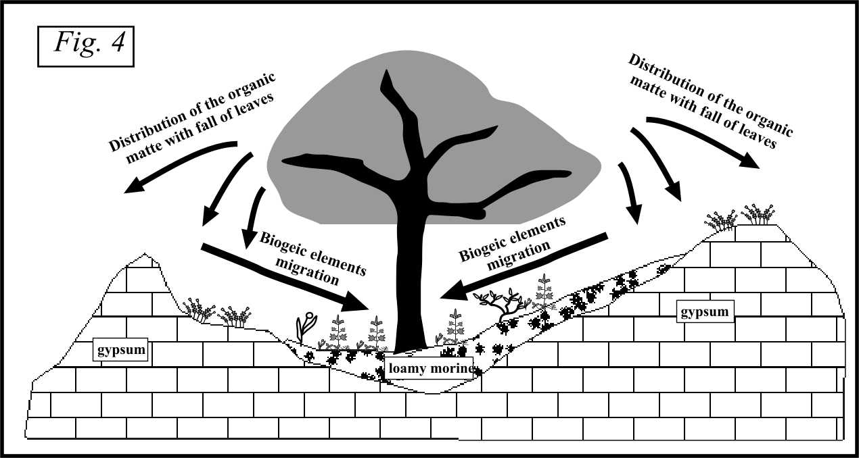
Processes of erosion and accumulation of moraine material in depressions account for a specific spotted pattern of the vegetation cover. Trees and shrubs grow only in depressions, whereas residual hills and steep slopes are occupied by lichens and grasses. Our observations on the colonization of bare rock surfaces and sod formation allow us to suggest that the relationship between the vegetation and the degree of topography dissection is even greater. Trees obtain mineral nutrients from silicate moraine deposits accumulated within karst depressions. The fall-off (leaves, needles, etc.) from the trees is distributed over a wide area including the tops of residual hills. Since the litter accumulates in a sufficient amount, it allows for growth of vascular plants on hard gypsum, where their growth would normally seem impossible. Due to this mechanism, the projective cover (percent of surface overgrown by vegetation) can grow in a certain period of time up to 50% and more, thus forming patches of sodded karst. The cycle of biogenic elements is shown in the figure 4.

Comparing the values of microbiological activity in similar gypsum soils formed within an open patch and under the tree canopy also revealed some functional differences that have no manifestation in the structure of these soil profiles. It was found that the samples of mineral soil horizons contain the same general quantity of bacteria (2,04 x 10⁶ and 2,75 x 10⁶ colony forming units per a gram of a dry soil). However, there were certain differences in the composition of bacterial associations. We found more actinomycetes and coryne-like organisms in the mineral soil horizons within the bare patch (as compared to the wood patch): 31% versus 5.6% for actinomycetes, and 27% vs. 10% for coryne-like organisms. The proportion of gram-negative organisms in soil under the trees was found to be higher than that in soils of the bare area: 80.4% vs. 20%.

We also studied the rates of cellulose destruction (by application of paper filters) in these soils. The cellulose destruction in the soil litter under trees (that consists mainly of green mosses) is faster than in the soil litter of the bare patch (that consists of green mosses and lichens): 40% vs. 29% per month. However, such rates in mineral horizons are approximately the same: about 4-5% per month.

NATURE OBSERVATIONS AND STUDIES OF THE NATURAL CHRONICLE

General observations on the flora and fauna distribution over moraine and karst landscapes in the Natural State Reserve “Pinezhsky” revealed that karst influences biological diversity as follows:

Karst landscapes increase the biodiversity of vascular plants. 80% of plant species occurring on the reserve are found within such landscapes, whereas glacial landscapes can support only 20% of species. This is associated with the appearance and continuous growth of rare and relict species and also with an increase in the proportion of secondary forests as part of the total vegetation cover of karst landscapes.

For the bryoflora of karst areas, the total number of species reaches 127 (as compared to 107 in glacial landscapes). The share of sphagnum species is slightly less.

For the lichenoflora, the number of species that grow on bare rocks is doubled. The total number of lichen species is 43. The share of epiphytic lichens also extends up to 72 species (as compared to 64 in glacial landscapes), which is connected with the appearance of open woodlands and better supply of sunlight.

Fishes increase their biomass in karst lakes with their high concentration of salts. Most likely, this is due to the increase in the biomass of crustaceans Amphipoda in calcium-rich karst lakes; the presence of calcium facilitates the growth of their chitin cover. In karst landscapes one can find species typically occurring in foothills: Thymallus thymallus, Phoxinus phoxinus, Cottus gobio

Amphibians and reptiles increase their numbers in karst areas due to the appearance of meadow communities and secondary forests.

Birds are influenced by karst in two ways. Firstly, the number of species living in water-bog habitats is decreased. Secondly, the total frequency of bird occurrence is higher in karst areas, together with the appearance of specific alpine species (Motacilla cinerea, Mergus merganser, Cinclus cinclus).

Small mammals. Mice-like rodents increase in numbers within meadow phytocenoses. Some species totally disappear in karst areas (Castor fiber, Ondatra Zibetica, Sciurus vulgaris), while others significantly increase in number due to a richer supply of their specific food sources or shelters (Eutamias sibiricus, Lutra lutra, Musteia erminea, Vespertilio nilssonii). Certain species are not specifically influenced by karst (Lutreola vision, Lepus timigus, Mustela martes).

Large mammals. Moose increase in numbers in karst areas due to a better nutrition base (meadows and smaller trees). Bear (Ursus arctos) prefer karst areas, because of the ease of finding shelter (although dens are rarely be found in caves, bears often make their dens among fallen trees and branches in large karst depressions). The frequency of foxes (Vulpes vulpes) decreases in karst landscapes. The influence of karst on large predators (Canis lupus, Lynx lynx, Gulo gulo) has not been revealed.

CONCLUSION
Thus, the wide spectrum of temperature and moisture conditions in karst areas accounts for the close co-existence of species of soils, plants and animals that are typical for both colder and warmer regions. The appearance of new, atypical regimes of soil functioning affects soil microorganisms, plants and, consequently, cursorial animals that choose their food base and place for resting and nesting. Intense development of karst processes result in the formation of landscapes atypical of the north taiga – oligotrophic karstified open woodlands, where however, biodiversity does not increase due to the nutrient deficiency of soils.

LITERATURE

REFERENCE
- The regulatory role of soil in functioning of taiga ecosystems. Edited by G.Dobrovolsky. Moscow, 2002. “Nauka” Press. (in Russian)
- World Reference Base for Soil Resources (WRB), 1998. Rome. FAO/UNESCO.
- Molchanov A.A. The productivity of the organic matter in forests of different zones. Moscow, “Nauka” Press/ 1971.

RELATED PUBLICATIONS
      - The structure and dynamic of natural components of Pinezhsky reservation. Collective of authors. (2000) Arkhangelsk, 2000. 268 pages. (in Russian)
      - Goryachkin S.V., E.I.Gurkalo, V.N.Malkov, L.V.Puchnina, A.A.Semikolennykh, I.A.Spiridonova, T.Y.Tuyukina, E.V.Shavrina. (2000). Phenomenon, structure and genesis of landscapes of northern taiga karst open woodlands and features of their soil cover”. Transactions of XI Congress of Russian Geographic Society. Arkhangelsk, 2000. vol.6, p. 23-24. (in Russian)
      - Goryachkin S.V., L.V.Puchnina, A.M.Rykov, S.Y.Rykova, A.V.Sivkov, E.V.Shavrina (2000). Biogeographical characteristics of natural complex of Pinega reserve (Arkhangelsk region). // Natural and historical-cultural heritage of North-West of Russia”. Petrozavodsk. 2000pp. 79-126. (in Russian).
      - Gorlenko M.V., Semikolennykh A.A. The characteristics of functional state of soil microbocoenisises in moraine and karst landscapes of Arkhangelsk region. Bull. of Moscow State Univ., series 17 (Soil science), № 2. 1998. Pages 50-52
- Lessovaya S.N., Dmitricheva L.E., Goryachkin S.V., Vodyanitsky Y.N., Gagarina E.I., Semikolennykh A.A., Shelemina A.N., Tuyukina T.Y. Soil-ecology conditions of unique taiga landscapes. 2001. (in English). http://soilinst.msu.ru/pub_01/text_paper.htm
- Semikolennykh A., Ivanova A., Dobrovolskaya T. Microbial communities of the northern taiga // “Pochvovedenie”, 2004. Number 1, pages 23-35 (in Russian). The mirror in the Eurasian soil science journal (in English)

