Contribution to the cave origin by mechanical weathering in temperate zone

Ludovit Gaál
Slovak Cave Administration, 031 01 Liptovsky Mikulas, Hodzova 11, Slovakia, e-mail: gaal@ssj.sk

Abstract
There are several examples of caves originated by mechanical weathering in various rocks of the Western Carpathians (andesite, basalt, rhyolite and their tuffs, limestones) described in this paper. The mechanical weathering is a physical breakup or disintegration of rocks without changes in their composition. It consists mainly of washing up, temperature oscillations (solar warmth), frost wedging, eolic processes. Cooperation of more components at the same time generally occurs in natural conditions. The mechanical weathering moves forward in appropriate structural and/or lithological environment (fault, gravitational crevice, joint, layer intercalation, xenolits, tree molds and others). Loose rocks are the most prone to the mechanical weathering (sandstone, aleurite, conglomerate, tuffs etc.).

Key words: pseudokarst caves, mechanical weathering, washing up, temperature oscillations, frost wedging.

Caves originated by mechanical weathering – without chemical dissolution – are not frequent in nature and do not reach larger dimensions. Weathering phenomena originated by the frost wedging and other cryogenic processes occur more frequently in northern and periglacial zone, high mountains (Holler & Holler 1989, Sjoberg 1989) and as Pleistocene remains in temperate zone (Demek 1989).

Several small caves, which originated by mechanical weathering, occur in temperate zone of the Central Europe. This process is caused by following exogenous forces:
1. Washing up: raindrops (0.004-8.0 mm of size) infiltrate through fissures (lithoclases, diaclases), joints, interlayer sheets and pores of rocks and carry along the smallest particles into the deeper zone. This process is considerable in humid areas. In Central Europe the annual average rainfall is 170-600 mm in continental zone and up to 2,000 mm in mountains and Atlantic zone. The plant cover can delay the infiltration and decrease the washing up. Larger washing up process is known as suffusion (piping, tunneling – Liszkowski 1995, Halliday 2004, sapping, tunnel erosion - Bryan & Jones 1997).
2. Temperature oscillations: outer part of rocks is warmed more than the inner one. A stress is generated between them and exfoliation happens. Daily temperature oscillations in summer in temperate zone range between 40-60 °C and are extended to the depth of 0.25-0.6 m. Exfoliation and disintegration happen due to different warming of dark and light minerals (dark minerals increase more their volume than the light ones, some minerals are enlarged only in certain directions). In basic rocks the sonnenbrandt (exfoliation in small rounded forms due to sunshine) is typical.
3. Frost wedging: the frozen water – ice – expands its volume down to -22 ºC (1 cm³ of water produces 1.0908 cm³ of ice) and, under condition of bottle effect and filling up of all pores with water, it pushes out the surrounding particles of rock. The greatest effect is in rough, schistose, bedded and vesicular rocks, mainly by repeated processes. The depth of the frozen part of rock is 0.4 – 0.9 m in the temperate zone. Frost wedging is effective only in caves entrances in this climate (several caves are known in limestone in the West Carpathians - Mitter 1983)
4. Wind erosion: it was stronger in the temperate zone in the cold periods of Pleistocene, when strong winds in lowlands took along many soft clasts.
5. Spreading forces of tree roots: cracks in rock can start by the growth of tree roots, which press the surrounding rock with power of 10-15 kg/cm².
6. Crystallization of salts: several salts can spread the surrounding rock; it may have the same effect as frost wedging in cracks.

Particles of rocks loosed by this processes will be fallen down and exfoliated by the gravitation power. However, the majority of the upper mentioned processes generally occur simultaneously in nature. Therefore the classification of weathering caves by the mechanic processes is questionable.
The exogenous powers work in nature conditions generally along sheets of predisposition, i.e. mainly faults, crevices, layers, schistosities, joints, as well as in consequence of different hardness of rocks and weathering of xenolits. The optimal rocks for mechanical weathering are loose, not much coherent for example as conglomerate, sandstone, claystone, loess, tuffs and so on. However, in appropriate conditions the weathering processes take place also in solid rocks.

The weathering processes proceed the most frequently along the tectonic fissures or gravitational crevices. Some caves of this type occur in Permian-Mesozoic sandstone of Saint-Cross (Świętokrzyskie) Mts. in Poland. Their development consists in widening of vertical fissures by subsurface water with contribution of mechanical weathering and gravitational collapsing (Urban & Kasza 1994). Similar way of origin has several caves of the Czech Cretaceaus region, mainly around Broumov (Vítek 1979, Kopecký 1982) and in the upper Triassic sandstones near Bayreuth in Germany (Striebel 1994). Small underground tunnels are known in gneiss of Ždárske vrchy in Czech Republic (Kirchner 1989).

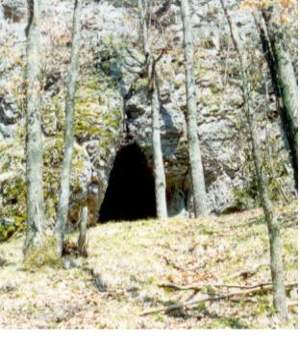
Fig. 1: The Delta Cave originated by washing up and frost wedging along a gravitational crack in Štiavnické vrchy (Slovakia).
Photo: M. Solár

Two small caves occur in the Štiavnické vrchy Mts. in Slovakia (Delta 10,7 m and Buková diera 5,1 m), which originated by washing up and frost wedging along a gravitational crack in relatively weathered rhyolite.
Weathering processes often operate along the bedding plane or stratum intercalations. One example of a bedding cave is the 5 m long cave Jaskyňa v Budinskej skale in the Ostrôžky Mts. in Slovakia, that originated by frost wedging and washing up along the tuff intercalation in andesite.

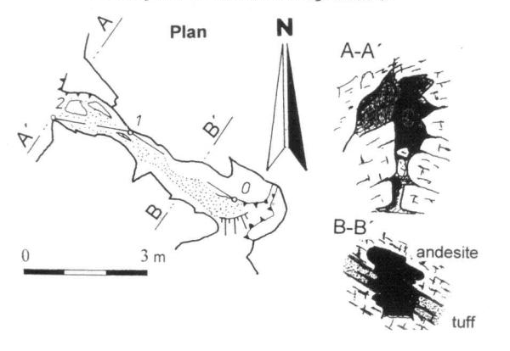
Fig. 2. The Jaskyňa v Budinskej skale Cave. Compiled by L. Gaál.

The other nice example is the Komoniecki Cave in the Beskid Maly in Poland created between sandstone and conglomerate (Waga 1990). Many bedding plane caves occur in sandstones of Czech Cretaceaus region (caves in Klokočská skála - Vítek 1987, in Broumov region – Kopecký 1982, caves in marlite – Vítek 1977), Elbsandsteingebirge (“schichthöhlen“ - Börner 1989) and Zittauer Gebirge in Germany (Bothe & Winkelhöfer 1989) but also in Paleogene sediments near Sokolov in Czech Republic (Cikánka cave – Kukla 1950).

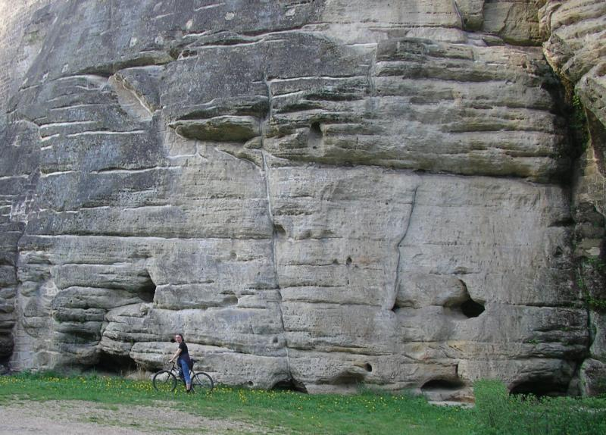
Fig. 3. Small underground spaces along the bedding plane in sandstone in Český ráj (Czech Republic).
Photo: L. Iždinský.

Weathering processes can proceed along a joint plane in volcanic rocks. Very interesting weathering cave of this type occurs in the Cerová vrchovina Mts. near Fiľakovo in Slovakia. The 4.5 m long Belinská jaskyňa is developed on the plane of columnar jointing of Pliocene basalt by the weathering of sonnenbrandt type by temperature oscillations (Gaál 1996).

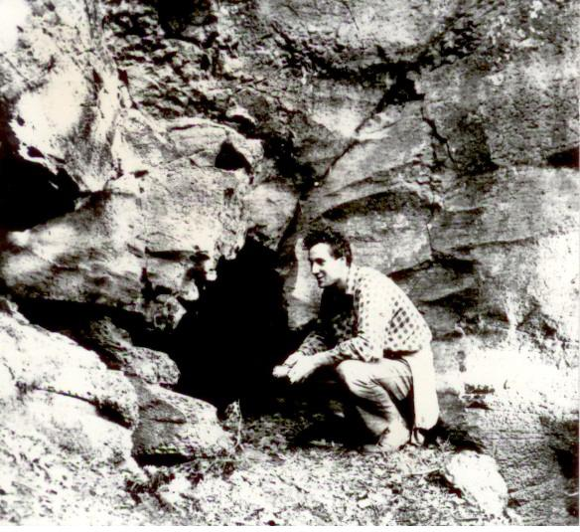
Fig.4: The Belinská jaskyňa Cave in Cerová vrchovina (Slovakia).
Photo: L. Gaál

Underground cavities can originate also by selective weathering in rocks with different hardness and resistance. The cave Abčina with 12 m of length in Poľana Mts. in Slovakia originated by dropping out of andesite blocks from loose tuffit. Later, it was enlarged by eolic and frost processes.

The event of washing up of sandstone xenolith in basalt neck is known in Salgótarján in the Northern Hungary (Baglyas-kö cave - the opinion of fumarole origin of this cave is known as well – Ozoray 1960). Probably unknown object was washed out in the case of andesite cave Jánošíkova skrýša in Ostrôžky Mts. in Slovakia (Gaál 1996). Arched shape of jointing of andesite and its exfoliation signalized the existence of this object.

Special types of the selective weathering caves are the tree mold caves. In temperate zone they originate by washing up or decay processes of trees usually covered by the volcanoclastic material. The trees were deposited by periodical flows on the volcanic slopes or by debris flows, mud flows as lahar sediments. The first type is represented by caves with the length of about 5-10 m in Miocene volcanoclastic rocks of the Central Slovakia (Jaskyňa pod Jaseným vrchom, Trpasličia jaskyňa, Jaskyňa v tufoch, and Voňačka).

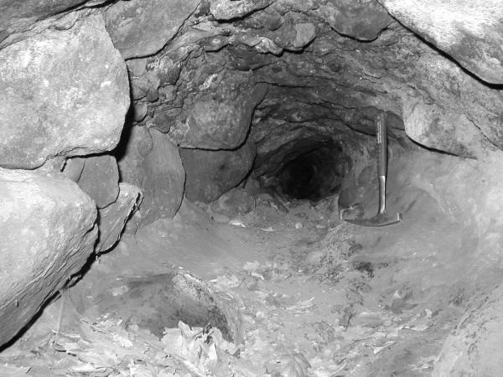
Fig. 5. Underground tube of the Trpasličia jaskyňa tree mold cave in Slovakia.
Photo: P. Bella.

Mučínska jaskyňa in the Southern Slovakia originated by weathering of totally carbonified tree. The little cave Jaskyňa v maare in the Southern Slovak Basin lies in lapilli tuffs of maar crater´s wall. The trees near the crater were probably pulled down by strong volcanic explosions, thrown to the air and their remains (trunks) were consecutively covered with another layer of lapilli tuffs (Gaál, Tachihara & Urata 2004).
The nice example of the tree mold cave in lahar occurs in Doupovské vrchy in Czech Republic. The tree mold cave is a compound of 7 trees with the length of 18 m found there among the ca 15 caves named Jeskyně škřítku.

References
Bothe, M. & Winkelhöfer, R. (1989): Petrographische und Morphologische verhältnisse im Zittauer Gebirge/DDR – beitrag zur genese von sandsteinhöhlen. 2. Sympozium o pseudokrasu. Sborník ref. Praha, 21-25.
Börner, F. (1989): Sandsteinkarsterscheinungen im Elbsandsteingebirge DDR. 2. Sympozium o pseudokrasu. Sborník ref. Praha, 49-55.
Bryan, R. B. & Jones, J. A. A. (1997). The significance of soil piping processes: inventory and prospect. Geomorphology, 20, 3 – 4, 209 – 218.
Cílek, V. (1997). Sufozní podzemní systém ve sprašové rokli v Zeměchách u Kralup. Speleo, 25, 19 – 23.
Demek, J. (1989): Periglacial processes in karst regions. Proceed. of 10th Int. Conger. of Speleology, Budapest, 732-733.
Gaál, Ľ. (1996): Nové jaskyne v bazaltoch Slovenska s dôrazom na ich prírodovedecký a kultúrno-historický význam. In (M. Lalkovič ed.): Kras a jaskyne, Zborník ref., Liptovský Mikuláš, 57-62.
Gaál, Ľ., Tachihara, H. & Urata, K. (2004): Hot and cold way of origin of the tree mold caves. In (Gaál ed.): Proceedings of the 8th Int. Symp. On Pseudokarst. Teplý Vrch (Slovakia). Žilina, 14-21.
Halliday, W. R. (2004). Piping caves and badlands pseudokarst. In Gunn, J. (ed.): Encyclopedia of Caves and Karst Sciences. Fitzroy Dearbon, New York – London, 589 – 593.
Holler, C. & Holler, M. (1989): North Carolina granitic caves: valuable speleological resources. Proceed. of 10th Int. Conger. of Speleology, Budapest, 140-141.
Kirchner, K. (1989): Tvary zvětrávání a odnosu hornin v CHKO Žďárske vrchy. 2. symposium o pseudokrasu. Sborník referátů. Praha, 12-15.
Kopecký, J. (1982): Pseudokrasové jeskyně v kvádrových pískovcích Broumovské vrchoviny. Symposium o pseudokrasu v ČSSR. Janovičky u Broumova.27-29.
Kukla, J. (1950): Pseudokrasové jeskyně u Loktu na Sokolovsku. Československý kras 3, Brno, 274-278.
Mitter, P. (1983): Frost features in the karst region of the West Carpathian Mountain. Permafrost, Proceed. Of the 4th Int. Conf., Fairbanks – Alaska. Washington, 861-865.
Ozoray Gy. (1960): Nemkarsztos üregek genetikája magyarországi példák alapján. Karszt és Barlangkut. Táj., Budapest, 4-15.
Sjoberg, R. (1989): Weathering studies on Pseudokarst-Caves along the Northern Swedish coast. Proceed. of 10th Int. Conger. of Speleology, Budapest, 290-293.
Liszkowski, J. (1995). On the mechanisms and kinematics of drift dolines formation. Acta carsologica, 24, 333 – 345.
Striebel, Th. (1994): Zur genese der sandsteinhöhlen in der umgebung von Bayreuth/Oberfranken (Bayern, Deutschland). 5th Pseudokarst sympozium with international participation Szczyrk 1994 Proceedings. Bielsko-Biała. 17-19.
Urban, J. & Kasza, A. (1994): Inwentaryzacja jaskiň I schronisk skalnych w piaskowcach mezozoicznych regionu Świętokrzyskiego (Polska Środkowa) – wstępne podsumowanie wyników. 5th Pseudokarst sympozium with international participation Szczyrk 1994 Proceedings. Bielsko-Biała. 13-16.
Vítek, J. (1977): Vývoj skalních a jeskynních forem ve slínovcích východní části České křídové pánve. Sborn. Československé společ. Zeměpisné 82, 4, Praha, 279-292.
Vítek, J. (1979): Pseudokrasové tvary v kvádrových pískovcích severovýchodních Čech. Rozpravy ČSAV, mat.-přír. 89, 4, Praha
Vítek, J. (1987): Pseudokrasové tvary v pískovcích Klokočských skál. Československý kras 38, Praha, 71-85.
Waga, J. M. (1990): Origin and age of Komoniecki Cave in the Beskid Maly mountains. 4th Pseudokarst symposium, Proceedings, Praha, 132-133.

