CAVE DEVELOPMENT IN SE SPAIN DURING UPPER PLEISTOCENE UNDER PERIGLACIAL CONDITIONS
González-Ramón⁽¹⁾, A.; Andreo, B⁽²⁾, Ruiz-Bustos, A.⁽³⁾ and Richards, D. A. ⁽⁴⁾
- Instituto Geológico y Minero de España. Urb. Alcázar del Genil, 4. Edif. Zulema bajo, Granada, Spain. E-mail: antonio.gonzález@igme.es
- Departamento de Geología. Facultad de Ciencias. Universidad de Málaga, Spain. E-mail: andreo@uma.es
- Instituto Andaluz de Ciencias de la Tierra (CSIC). Facultad de Ciencias. Universidad de Granada, Spain. E-mail: aruizb@ugr.es
- School of Geographical Sciences, University of Bristol, Bristol, BS8 1SS, UK (david.richards@bristol.ac.uk)

ABSTRACT

Cucú Cave is a small cavity, 30 m long, 1600 m above sea level in the southern slope of Sierra de María (N Almería province, Spain), an area where the present precipitation occurs partially as snow. A sedimentary sequence 9 m thick, including fossils, fills the cave. The sediment characteristics allow us to consider the prevailing climatic conditions, and also the age and evolution of the genesis of the cavity. The lithological sequence is dominated by clast supported detrital sediments without evidence of alluvial transport. These sediments were formed by gelifraction under periglacial conditions. The micromammal fossil species are of Upper Pleistocene age and the mammal biocenogram also indicates that cold conditions prevailed at the time of deposition, between 140 and 70 ka. Sedimentological and biostratigraphical evidence within the cave indicates, during the Upper Pleistocene, increasing dimensions of the karst cavity previously created by solution. The detrital sequence is covered by a flowstone which evolved during a period of warmer, wetter conditions and provides a minimum U-Th isochron age of 40 ± 7 ka for the timing of periglacial action.

INTRODUCTION

Climatic change has been much debated in the scientific world in recent decades. Many studies of climatic and hydrological variations have been made using carbonate deposits, particularly speleothems, because they are less affected by postdepositional processes than are superficial sediments. Speleothems can be dated precisely by means of the U/Th decay series and consequently they can contribute to our knowledge of paleoclimatic and paleohydrologic events in continental areas (Schwarcz, 1986). Geochemical studies can be performed with a very high time resolution from stable isotopes such as δ¹⁸O and δ¹³C, which respectively may reflect paleotemperature and vegetation (Gascoyne, 1992), and trace elements like Mg and Sr, which are indicators of paleohydrology (Fairchild et al., 2001). Nevertheless, the analysis of paleontological remains and the detrital sediments filling the cavities can also be used for paleoclimatic investigations (Ruiz Bustos, 1995, 1996, 1999).

The main aim of this work is to show the interest and the complementarity of geological, paleontological and geochronological methods to find out more about paleoclimatic conditions, taking into account the preliminary results obtained in El Cucú cave. This cave is located in SE Spain, in the northern part of Almería province, in the region of Andalusia. The cave is situated within the Natural Park known as Sierra de María-Los Vélez, in the southern slopes of El Cabezo mountain (which rises to 1948 m a.s.l.), at an altitude of 1600 m a.s.l. (Fig. 1).
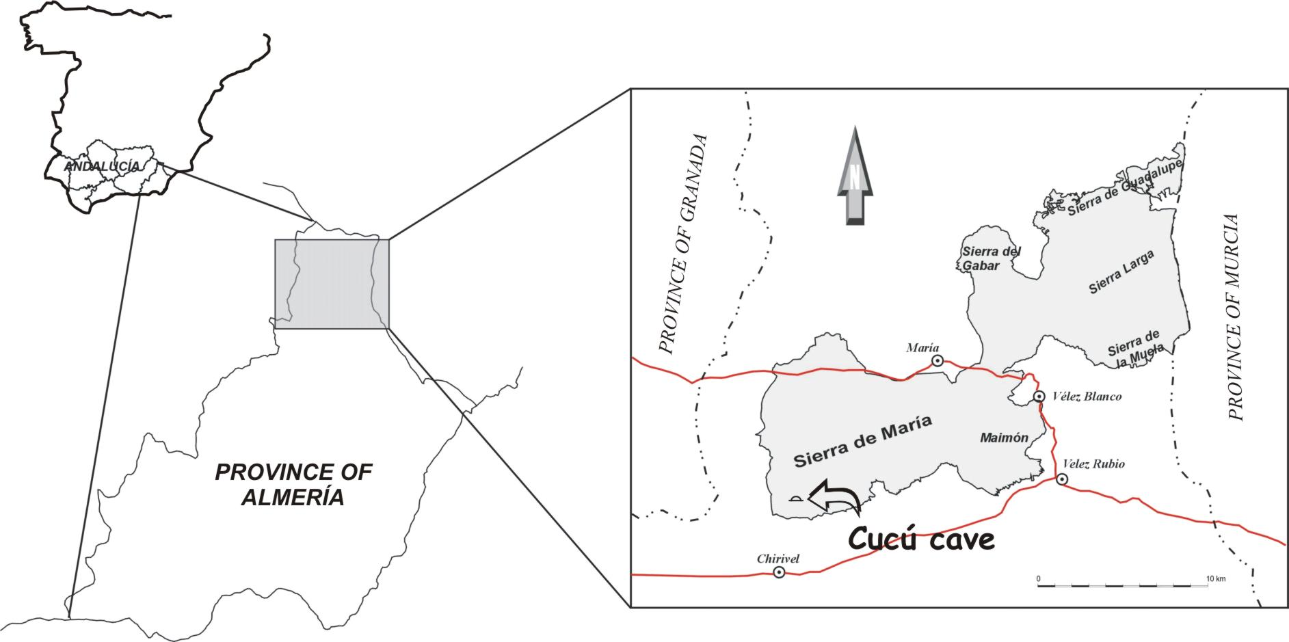

Figure 1. Geographic situation of El Cucú cave. Extension of the Sierra María-Los Vélez Natural Park shown in grey.
From the geological standpoint, the cave evolved in Jurassic limestones in the Inner Subbetic domain of the External Zone of the Betic Cordillera (Andreo, 1990). These limestones are severely deformed by fold structures that were subsequently affected by faulting.

The cavity is some 30 m long, has a very large mouth and a principal chamber that has frequently been used as a shelter for cattle (Fig. 2). At the far end of the cave is a second, smaller chamber, where a group of gours have evolved, thanks to the existence of a small spring that only drains water during particularly wet winters. The cave was explored and mapped in 2001 by the Velez Association of Speleologists (González-Ramón, 2002; González-Ramón, et al. 2002).

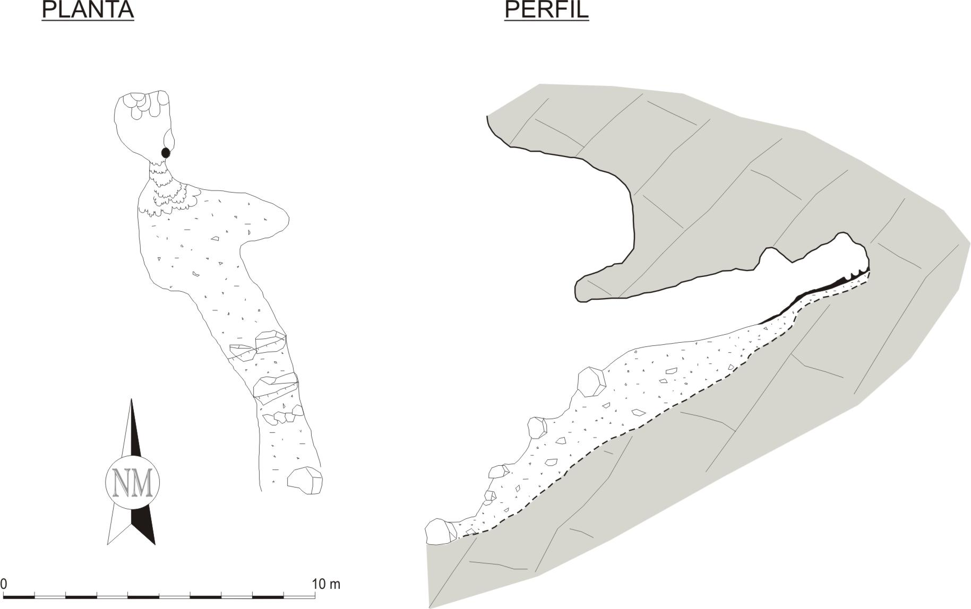

Figure 2. Topographic sketch of El Cucú cave (after Velez Association Speleologists).

DESCRIPTION OF THE SEDIMENTARY FILLING

The photograph in Figure 3 illustrates the study area, together with an explicatory sketch showing the points that were sampled for the paleontological study.
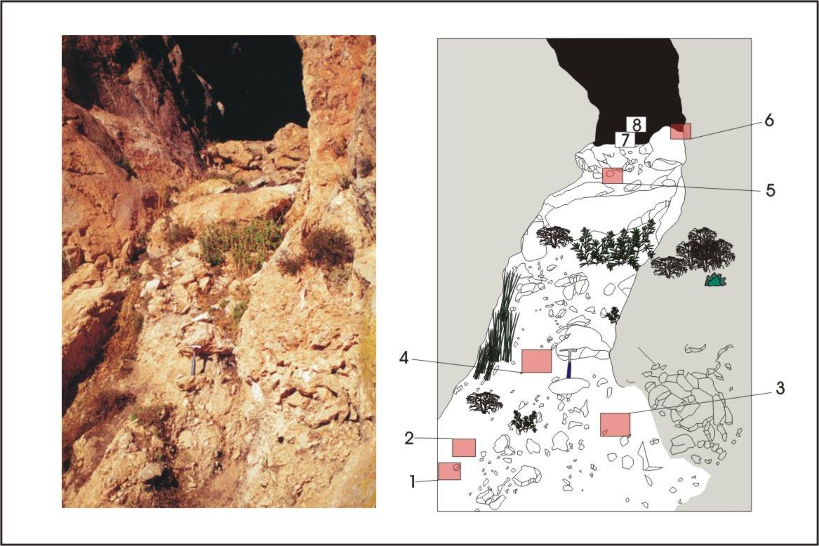

Figure 3. Photograph of the study area and explicatory sketch showing the location of the points sampled.

At the cave entrance there is a filling some 9 m thick, the stratigraphic column of which is shown in Fig. 4. The filling is basically made up of angular, unrounded clasts, with dimensions ranging from sand-grain size to large blocks several metres across. The sediments are mainly clast supported, because the matrix is scarce and of a silty nature. Although no clear stratification can be observed, it is possible to distinguish levels with coarsely-ordered granulometries, and even coarse upward sequences. There is a calcite flowstone above the latter sediments.

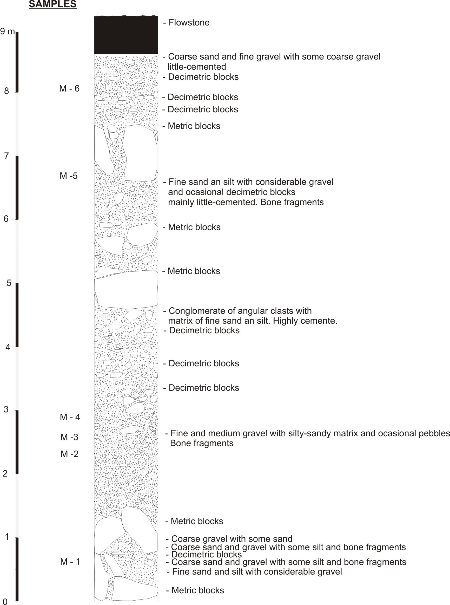

Figure 4. Stratigraphic column of the filling at El Cucú cave.

The cave developed following one of the faults created by the escarpments of Sierra del Cabezo. This fracture presents as fault rock the remains of Cretaceous marls, several metres thick, which constitute a discontinuity in the permeability of the Jurassic limestones and favour the presence of the perched drainage at the rear of the cave. The existence of this flow, during periods of cold climate, must have favoured the cryoclastic action which gradually caused the fissure to widen. This widening led to instabilities that provoked rockfalls from the roof and enlarged the cave.

DATING OF THE CAVE FILLING

The remains of micromammal species found in some of these levels must have been seized and carried there by birds of prey nesting within the cave. The following inventory has been made of the fauna contained in samples obtained from the sedimentary infilling: Apodemus sylvaticus; Microtus nivalis; Microtus arvalis arvalis; Mimomys (Villanyia) savini; Neomys sp. Crocidura ?; Oricyolagus sp.; Lepus sp.; Capra pirenaica; Aves; Lacerta sp; Bufo sp.; Salmo sp. From the evidence of this fauna content, the filling of El Cucú cave dates from the upper Pleistocene, biozone Mp-20, intrazone SI-20-3 (Ruiz Bustos, 1995, 1996, 1999) with an age of 140-70 ka.

The flowstone covering the detric filling was dated at the Laboratory of Geochronology of the University of Bristol, and a U-Th isochron age of 40 ± 7 ka was estimated.

PALEOCLIMATIC CONSIDERATIONS

According to the above-mentioned results, the cave was partially created by the solution or karstification of Jurassic limestone, probably during the middle Pleistocene. The features of the detrital filling (supported clast and angular shapes of the heterometric pebbles) are in agreement with a periglacial origin. Thus the cavity created by solution was subsequently enlarged by gelifraction and by occasional rockfalls from the cave roof.

The fauna encountered in the sequence is also indicative of very cold conditions in southern Spain. The filling of El Cucú cave occurred at a moment of intense cold in the region, as is evidenced in other karstic cavities in Andalusia (Ruiz Bustos, 1995, 1996, 1999). Taking into account that the sedimentation coincided with the moment of lowest temperatures in the region, the most probable age of a large proportion of the sedimentary register is 80 ± 5 ka.

Since about 40 ± 7 ka, periglacial climatic conditions have become less significant, as shown by the fact that it was during this period that the flowstone covering the whole of the detritic filling was deposited, and because since then there has been no deposition of detritic fillings similar to those described above.

REFERENCES

Andreo B. 1990. El Subbético Interno de las Sierras de María y del Maimón (Provincia de Almería). Bachelor Thesis University of Granada, 108 pp.

Fairchild I.J., Baker A.., Borsato A., Frisia S., Hinton R.W., McDermott F., Tooth A.F. 2001. Annual to sub-annual resolution of multiple trace-element trends in speleothems. Journal of the Geological Society of London 158: 831-841.

Gascoyne M. 1992. Paleoclimate determination from cave deposits. Quaternary Science Review 11: 609-632.

González-Ramón A. 2002. Consideraciones sobre el desarrollo kárstico en el Parque Natural de la Sierra de María-Los Vélez (provincia de Almería). In: Karst and Environment (F. Carrasco, J.J. Durán and B. Andreo –eds-), 337-345. Fundación Cueva de Nerja, Nerja (Málaga, Spain)

González Ramón A., López Ramón M.I., Carra López, J.C. y Pérez Martínez P. 2002. Resultados de la catalogación de cavidades kársticas en el parque natural Sierra de María-Los Vélez. Revista Velezana 21:142-148.

Ruiz Bustos A. 1995. Analysis of enamel-line length as a morphometric parameter and its application to Quaternary arvicolids. Lethaia, 28: 361-369.

Ruiz Bustos A.1996. Parameterization of the distribution of arvicolid tooth enamel. Acta zoológica cracoviensia, 39(1): 435-446.

Ruiz Bustos A. and Riquelme J.A. 1999. Análisis sistemático y ecológico de los roedores del Pleistoceno superior procedentes de la Cueva de las Ventanas (Granada, España). 277-288. In: The scientific study of karstic cavities as a contribution to geological knowledge (B. Andreo, F. Carrasco and J.J. Durán –eds-), 277-288. Patronato de la Cueva de Nerja, Nerja (Málaga, Spain).

Schwarcz H.P., 1986. Geochronology and isotope geochemistry of speleothems. In: Handbook of Environmental Isotope Geochemistry (P. Fritz and J.C. Fontes –eds-), Vol 2, The Terrestrial Environment, 271-303.

