INFILTRATION IN THE DOLOMITIC KARSTIC SYSTEM OF NERJA CAVE (SOUTHERN SPAIN)

B. Andreo⁽¹⁾, C. Liñán⁽²⁾, F. Carrasco⁽¹⁾, C. Batiot⁽³⁾ C. Emblanche⁽⁴⁾ and J.J. Durán⁽⁵⁾

(1) Departamento de Geología. Facultad de Ciencias. Universidad de Málaga, E-29071 Málaga (Spain). andreo@uma.es, fcarrasco@uma.es
(2) Instituto de Investigación Cueva de Nerja. Carretera de Maro s/n, E-29787 Nerja, Málaga (Spain). cbaena@cuevanerja.com

(3) Laboratoire HydroSciences, UMII Maison des Sciences de l’Eau, Place Eugène Bataillon – CC MSE, F-34095 Montpellier Cedex 5, France
(4) Departamento de Hidrogeología. Universidad de Avignon, F-84000 Avignon (France). christophe.emblanch@univ-avignon.fr
(5) Dirección de Hidrogeología y Aguas Subterráneas. Instituto Geológico y Minero de España, E-28003 Madrid. (Spain). jj.duran@igme.es

ABSTRACT

Hydrogeological studies have been carried out within Nerja Cave since 1991 to characterise the dripwater within the cavity, both chemically and isotopically, and to determine the hydrodynamic functioning of the unsaturated zone of the aquifer in which it lies. Analysis of the natural responses (hydrodynamic, hydrochemical and isotopic) observed at a representative drip point in the cave to variations in the volume of precipitation reveals the existence of two types of infiltration through the marbles overlying the cavity, and enables us to establish the mean residence time of the infiltration water in the unsaturated zone of the aquifer.

INTRODUCTION

Nerja Cave is in the province of Malaga (Andalusia, southern Spain), some 5 km east of the coastal resort of Nerja (Fig. 1). It has three entrances, two natural and one artificial, and was opened for tourist visits in 1960 (one year after its discovery). Since then, it has received an average of 500,000 visitors per year. The cavity contains an almost uninterrupted 25,000 year-long archaeological sequence, together with important groups of Palaeolithic and post-Palaeolithic cave paintings.

The cave, with a volume of approximately 300,000 m³, has a practically horizontal development, lying between 123 and 191 m a.s.l. (SEM, 1985). It is divided into two sectors: one is open for tourist visits (the Tourist Galleries) and occupies about a third of the total volume of the cavity; the other area (High Galleries and New Galleries), occupying the remaining two thirds of the total volume, is closed to tourists and is only occasionally visited, by researchers and small groups of speleotourists. The general orientation of the main galleries is N35ºE in the tourist zone and N-S in the rest of the cavity (Sanz de Galdeano, 1993).

Outside the cave, the air temperature varies between 8.1ºC (January) and 27.8ºC (August), with a mean annual value of 17.3ºC. The mean precipitation in the area is 490 mm/year (Andreo and Carrasco, 1993a), although it is irregularly distributed over the year, with a well-defined wet season during the months of November to January, and a dry season during the summer.

From a geological viewpoint (Fig. 1), the cave lies within rocks belonging to the Alpujarride Complex of the Betic Cordillera (Andreo et al., 1993). The stratigraphic series of this Unit is made up of a Palaeozoic lower metapelitic succession and of an overlying carbonate sequence, constituted of dolomitic marbles (in which the cave developed) of Middle Trassic age toward the bottom and calcareous marbles of Upper Triassic age toward the top. These marbles, which are permeable as a result of fracturing and karstification, form part of the Sierra Almijara carbonate aquifer.

Today, the cave is situated in the unsaturated zone of the aquifer, several metres above the piezometric level (Fig. 1), as a consequence of the tectonic lifting of the region during the Pliocene and the Quaternary. The thickness of the marbles above the cavity is highly variable: from 4 to 50 m in the area open to tourism, and exceeding 90 m in the non-visitable area. Rainfall infiltrates through fissures and fractures in the marbles, and drips from the roof of the cave.

The objective of the present study is to describe how infiltration takes place in the unsaturated epikarst zone of the Nerja cave system, on the basis of the results obtained from over a decade of investigation.

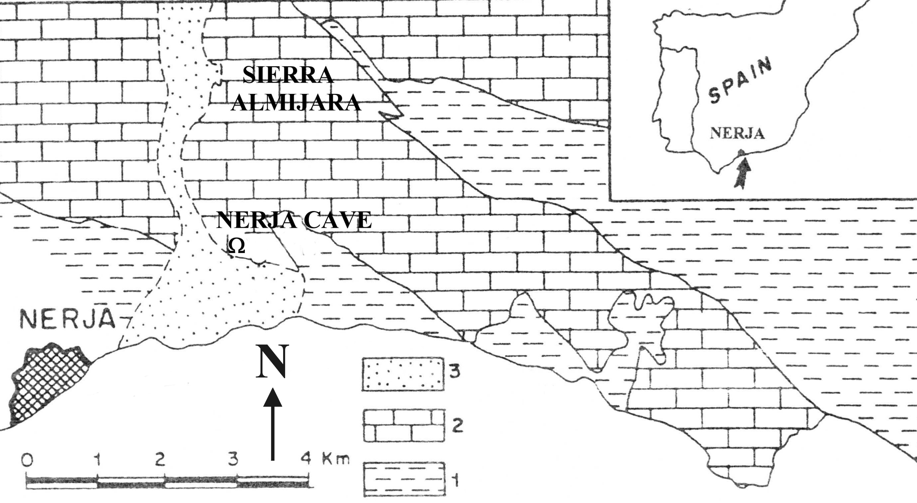
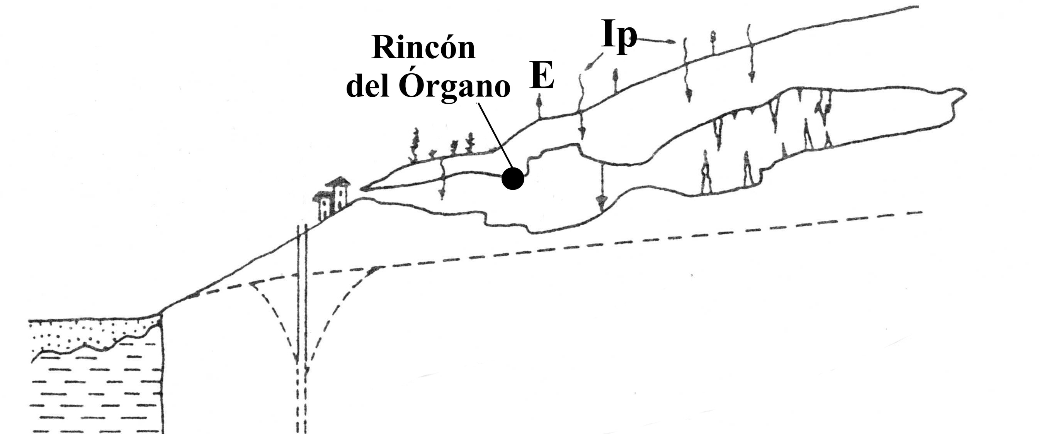

Fig. 1. Location of Nerja Cave and hydrogeological cross-section (not to scale). Key: 1- metapelites; 2- marbles; 3- Pliocene and Quaternary deposits; E- evapotranspiration; Ip- infiltration of rainwater

METHODOLOGY

From 1991 to the present day, a systematic study has been made of the hydrodynamics, the hydrochemistry (principal components), the isotopic content (δ¹⁸O and δ²H) and the physical-chemical characteristics (pH, temperature and electrical conductivity) of the water obtained both outside the cave (rainwater recorded at the weather station) and within it (dripwater). Daily records have been kept of the volume of precipitation above the cave, measured by the pluviometer at the weather station, and the volume of dripwater within the cavity.

Until March 1993, the control network was made up of 10 points where dripwater was monitored. After this data had been analysed (Andreo and Carrasco 1993b; Carrasco and Andreo 1993; Carrasco et al. 1995, 1996), the monitoring was restricted to a single dripwater point in the Cataclysm Chamber, known as the Rincón del Órgano drip point, which was considered to be representative. Sampling periodicity has varied over the years; it was performed monthly from 1991 until December 1993, fortnightly from January 1994 to October 1995, and then weekly from November 1995 to date. The Total Organic Carbon content of the dripwater collected at this point was recorded from April 2000 to August 2001.

Hydrodynamic of the unsaturated zone

The dripwater flow within the cavity is, in general, very low, at around 10-100 m³/year under average pluviometric conditions. At the Rincón del Órgano drip point, the mean dripwater flow is 90 cm³/day. The temporal evolution of the dripwater flow at this point is wave-shaped, with maximum values during the summer and minimum ones in the winter (Fig. 2). The fissures and fractures in the dolomitic marbles above the cave present only a slight aperture (or width) and, moreover, are partially filled in by clays or carbonates, which means rainwater must infiltrate very slowly through the marbles.

The temporal evolution of the volume of dripwater, with respect to the local pluviometry (Fig. 2A), reflects the existence of two modes of infiltration through the epikarst and through the unsaturated zone (Carrasco et al., 1996, Liñán et al., 1999): one is a slow infiltration, that is predominant throughout the year, and the other is a rapid infiltration that occurs only occasionally. Taking into account the annual distribution of precipitation, the overall evolution of the volume of dripwater, with maximum values in summer/autumn and minimum values in winter/spring, means that rainwater circulates slowly through the aquifer, from its entry until its appearance at the drip points within the cavity. Only during periods of significant recharge, in magnitude or in intensity (for example, in the early months of 1997), is there evidence of rapid infiltration, visible as a marked, rapid increase in the volume of dripwater within the cavity. The magnitude of the latter depends on the quantity of the recharge and on that of the water stored in the epikarst of the cave, before the precipitation occurred. Rapid infiltration takes place in response to high levels of precipitation that produce a faster circulation of water through preferential diaclases.

Fig. 2. Temporal evolution of the volume of dripwater flow at Rincón del Órgano, plotted against precipitation (A) and autocorrelograms of the data series for dripwater flow and rainfall (B).

The correlatory and spectral analysis of the daily precipitation and dripwater data, corresponding to 5 hydrological years, reveal the inertial behaviour of the unsaturated zone and the strong modulating force of the input signal recorded (Andreo et al., 2002). The correlogram of the dripwater flow displays a slope flattens more slowly with respect to that of the rainfall (Fig. 2B), there is a marked memory effect (about six months), the regulation period is high (85 days), the spectral band is narrow, with a cutoff frequency of 0.10 (10 days) and the entry-exit lag, for events of annual periodicity, is around 6 months. The quantity of water stored in the epikarst before precipitation occurs plays a very important role in the hydrodynamic functioning of the system; the latter factor has been observed to be less inertial during a wet year than during a dry one. Only in periods of high levels of recharge (in magnitude or in intensity) is there a considerable, rapid increase in the volume of dripwater within the cave. The magnitude of this variation depends on the previous hydrodynamic state of the unsaturated zone above the cave, that is, on the greater or lesser quantity of water stored before the precipitation occurred.

Both rainfall and dripwater sporadically present a very high content of K⁺ (up to 49 mg/l in rainfall and up to 92 mg/l in dripwater) and of Cl⁻ (up to 61 mg/l in rainfall and up to 139 mg/l in dripwater). By making use of the K⁺ content as a tracer it has been calculated that the transit time, from the rain falling onto the surface until the dripwater appearing within the cavity, is approximately 2 to 8 months (Fig. 3), depending on the quantity and intensity of recorded precipitation before, during and after the K⁺-rich rainfall, and also on the path this water follows through the fissures of the marbles (Carrasco et al., 1996, Liñán et al., 1999, Andreo et al., 2002b).

Fig. 3. Entry and exit flows of K⁺

The values of δ¹⁸O in the dripwater are lower during the summer and autumn months, and higher during the winter and spring. Comparison of the entry and exit flows of δ¹⁸O reveal the existence of a slow circulation through the unsaturated epikarst zone (with a duration of some 8 months) together with a faster circulation presenting a transit time of 1-3 months (Andreo et al. 2002b; Liñán et al. 2002).

Fig. 4. Entry and exit flows of δ¹⁸O. 1- Slow flow; 2- Fast flow

The temporal evolution of the Total Organic Carbon (TOC) content of the dripwater reveals a seasonal variation, with maximum values during the summer and minima during the winter (Fig. 5). The organic matter content in the soil lying above the cavity is higher during the summer because this is when the vegetable matter that falls onto the soil accumulates and decomposes, as part of an adaptation mechanism to the dry conditions prevailing at this time of the year. The rain that falls during the subsequent months of autumn and winter washes the soil and carries this organic matter into the aquifer, and thus into the dripwater that appears in the summer (Batiot et al., 2003). This again illustrates the existence of a seasonal lag between rain falling and its exit through the dripwater points within the cave. The water drained by the drip point contains minimal levels of TOC because the latter is mineralised and because this water falls and infiltrates during the winter and spring, when the organic matter content of the soil is low, the decomposed organic matter having been washed previously by the rain falling in autumn and winter.

Fig. 5. Temporal evolution of the Total Organic Carbon content of the dripwater registered at Rincón del Órgano, and of the precipitation recorded at the Nerja Cave weather station.

Hydrochemistry of the unsaturated zone

Within the cave there are two main types of water: that which is obtained in the area closest to the entrance, and the samples taken in the rest of the cavity (Andreo et al., 1993a and b). The first type, with a bicarbonated-sulphated calcic-magnesic facies and presenting an average level of electrical conductivity of 1150 μS/cm, has a P_{CO2} of 0.43% (0.43 x 10⁻² atm). This water is obtained from a nearby borehole and is used to irrigate the garden, after which it seeps into the cave. The second type has a magnesic-calcic bicarbonated facies and a mean electrical conductivity of 468 μS/cm. It is clearly of meteoric origin, as evidenced by its chemical and isotopic composition (Liñán et al., 1999). In general, the mean P_{CO2} is 0.15% -0.15 x 10⁻² atm- (Carrasco et al., 1998), which is higher than atmospheric values and, moreover, is higher in summer than in winter (Fig. 6). The water inside the cave is supersaturated in calcite throughout the year, and so produces deposits of calcium carbonate.

On an annual scale, the chemical composition of the meteoric dripwater is mainly influenced by the Ca²⁺ and Alkalinity (TAC) content and, to a lesser degree, by the K⁺ and Cl⁻ content (Fig. 6). In turn, the Alkalinity and the Ca²⁺ and Mg²⁺ contents influence the degree of saturation of calcite and dolomite in the dripwater.

The electrical conductivity of the dripwater increases in summer, when the volume of dripwater is greater, when the water is less supersaturated, has a lower Mg²⁺/Ca²⁺ ratio and a higher Ca²⁺ and TAC content, and presents higher P_{CO2} values. The electrical conductivity decreases progressively during the autumn, coinciding with the progressive reduction in the dripwater flow. These seasonal variations in the electrical conductivity of the dripwater are related to the degree of saturation in calcite and dolomite which, in turn, is related to the P_{CO2} of the dripwater; in winter, the water is more supersaturated in calcite and dolomite, there is a greater precipitation of calcium carbonate, the Mg²⁺/Ca²⁺ ratio increases, and so the electrical conductivity decreases. In summer, the water is less supersaturated in calcite and dolomite, there is less precipitation of calcium carbonate, the Mg²⁺/Ca²⁺ ratio decreases and the electrical conductivity increases.

Fig. 6. Temporal evolution of the electrical conductivity, the chemical composition and the parameters of the calcium-carbonic system of the dripwater at Rincón del Órgano.

CONCLUSIONS

The hydrogeological studies carried out in Nerja Cave have enabled us to characterise the hydrodynamic functioning of the unsaturated zone of the aquifer in which it lies. Analysis of the natural responses (hydrodynamic, hydrochemical and isotopic) at one of the drip points in the cavity, with respect to variations in precipitation, reveals the existence of two types of infiltration through the epikarst and the unsaturated zone: one is slow, and predominates throughout the year, while the other is rapid (or, rather, less slow) and only occurs sporadically, when recharge levels are very important in magnitude or in intensity.

The residence time of the rainwater in the epikarst and in the unsaturated zone, until its appearance at the drip points in the cave, is 2-8 months (“rapid” and slow infiltration, respectively), as calculated from the hydrogram obtained at the drip point, from the results of correlatory and spectral analysis, from the time lag between entry and exit flows of K⁺ and δ¹⁸O and from the temporal evolution of the TOC content.

The chemical composition of the dripwater is mainly determined by the Ca²⁺ and TAC content, and to a lesser degree by the K⁺ and Cl⁻ content. There are seasonal differences in the electrical conductivity of the dripwater, which are related to differences in the degree of saturation in calcite and dolomite, and therefore in the P_{CO2} of the dripwater. When the latter is low, the water is more supersaturated, there is a greater precipitation of calcium carbonate and the electrical conductivity of the dripwater decreases; when the P_{CO2} is higher, the water is less supersaturated, the precipitation of calcium carbonate is reduced and the electrical conductivity of the dripwater is higher.

ACKNOWLEDGEMENTS
To the Nerja Cave Foundation for the financial assistance. This work is a contribution to the Spanish-French Integrated Action HF02-158, to the Research Group RNM-308 of the Junta de Andalucía and to the projects REN2002-1797/HID of the DGI and IGCP-513 of UNESCO.

REFERENCES
Andreo B. and Carrasco F. (1993a): Estudio hidrogeológico del entorno de la Cueva de Nerja. In: Carrasco F. (ed) Geología de la Cueva de Nerja. Trabajos sobre la Cueva de Nerja, 3: 163-187.
Andreo, B. and Carrasco, F. (1993b): Estudio geoquímico de las aguas de infiltración de la Cueva de Nerja. In: Geología de la Cueva de Nerja (F. Carrasco, ed.). Trabajos sobre la Cueva de Nerja, 3: 299-328.
Andreo, B., Carrasco, F. and Sanz de Galdeano C. (1993): Geología de la Cueva de Nerja. Trabajos sobre la Cueva de Nerja (Carrasco F., ed.), 3: 25-50.
Andreo, B. Liñán, C. Carrasco, F. and Vadillo, I. (2002a): Funcionamiento hidrodinámico del epikarst de la Cueva de Nerja (Málaga), Geogaceta, 31: 7-10.
Andreo, B., Carrasco, F., Liñán, C. and Vadillo I. (2002b): Epigenic CO₂ controlling the drip water chemistry and speleotheme growth in a Mediterranean karst area (Nerja Cave, southern Spain). In: Y. Daoxian, Z. Cheng (eds.), Karst processes and the carbon cycle, pp. 51-64.
C. Batiot, C. Liñán, B. Andreo, C. Emblanch, F. Carrasco and B. Blavoux (2003). “Use of TOC as tracer of diffuse infiltration in a dolomitic karstic system: the Nerja Cave (Andalusia, southern Spain)”. Geophysical Research Letters, 30(22): 2179.
Liñán, C., Carrasco, F., Andreo, B., Jiménez de Cisneros C. and Caballero E. (2002). Caracterización isotópica de las aguas de goteo de la Cueva de Nerja y de su entorno hidrogeológico (Málaga, Sur de España). In: F. Carrasco, J.J. Durán y B. Andreo (eds.) Karst and Environment, 243-249.
Carrasco F., Durán J.J., Andreo B., Liñán C. and Vadillo I. (1998): Consideraciones sobre el karst de Nerja. In: Durán J.J. and López Martínez J. (eds) Karst en Andalucía, 173-181. ITGE, Madrid.
Carrasco, F. and Andreo, B., 1993: Características de las aguas de infiltración de la Cueva de Nerja (Málaga). Geogaceta, 14: 9-12.
Carrasco, F., Andreo, B., Benavente, J. and Vadillo, I. (1995): Chemistry of the Nerja Cave system (Andalusia, Spain). Cave and Karst Science, 21 (2): 27-32.
Carrasco, F., Andreo, B., Liñán, C. and Vadillo, I. (1996): Consideraciones sobre el funcionamiento hidrogeológico del entorno de la Cueva de Nerja (provincia de Málaga). Jornadas sobre Recursos Hídricos en regiones kársticas, Vitoria, 249-263.
Liñán C., Andreo B., Carrasco F. and Vadillo I. (1999): Hidrodinámica e hidroquímica de las aguas de goteo de la Cueva de Nerja. In: Andreo B., Carrasco F. and Durán J.J (eds) Contribución del estudio científico de las cavidades kársticas al conocimiento geológico, 393-402.
Sanz de Galdeano C. (1993): La fracturación en el entorno de la Cueva de Nerja. In: Carrasco F. (ed), Geología de la Cueva de Nerja. Trabajos sobre la Cueva de Nerja, 3: 95-114.
SEM. (1985): La Cueva de Nerja. Sociedad grupo de espeleólogos granadinos, 87 pp.

