Activities of Czech and Slovak cavers in Riviera Maya, Mexico
Zdenek Motycka, Czech Speleological Society

Several expeditions of Czech and Slovak Speleological Society to the Mexican semiisland Yucatan were proceeded in last two years in cooperation with UNAM – The Mexican National University and QRSS – Quintana Roo Speleological Survey. The area of the activities of expeditions is known as a Riviera Maya. Besides as a result of geoological and climatic conditions it is a unique area with large underwater cave systems.
The expeditions worked in the surroundings of the towns Tulum and Chemuil. First exploration briought discovery of new pasages in cenote Cangrejo, where total 1328m has been discovered and documentated up to now. The most important discovery was in cenote Joolis. The entrance was found in 2002 and 167m of corridors have been known. During first exploration another 180m long continuation was discovered and surveid. The following dives brought the discovery of huge, several hundred meter long tunnel “Esperanza.” Within the first week more than 1000m of new corridors were discovered, while the second week brought the discovery of a new cenote, called Tatich. Totally 2405m of new passages was discovered, documentated and joined them with other 3 neighbour cenotes – Polo, Hoyt a Chu-much-cho. So the system long 3587m arose.
Later, two new cenotes were found, 600m far from the end of the known parts of Joolis and 200m far from the end of the another cave called Ich – Kin. In the first of them, called Nai-Bosch due to the black walls, huge tunnel 200m long was found. It leads directly to Ich-Kin. The second cenote brought a big surprise. Near the wall of the spread corridor old Mayan ceramic pot was found. Then the cavers discovered dry cavern with the small island in the middle of lake with the ruins of the stone wall nearby and connected to the cave. All these discoveries were documented.
Also other cenote called Zebra was found. Huge tunnel 30m wide and 200 m long was found during first exploration. This tunnel leads to another big cenote. Tottaly 1819m was explored and documentated.
Near Tulum new cenote Dos Locos was found, explored and surveid 493m of new passages there.
Totally 6860m of new corrridors was discovered and surveied by Czech and Slovak cavers in Riviera Maya up to now.
The important part of the expeditions was also the soil taking and and catching up of the troglobytes animals for the research of UNAM.

Bibliography:

1) MOTYCKA Zdenek. Expedition report - Yucatan 2003, SPELEOFORUM 2003, Czech Speleological Society 2003

2) MOTYCKA Zdenek. Expedition report - Yucatan 2004, SPELEOFORUM 2005, Czech Speleological Society 2005

3) List of Long Underwater Caves in Quintana Roo Mexico (online)
Quintana Roo Speleological Survey (cit.2004-09-15)
URL: <http:// http://www.caves.org/project/qrss/qrss.htm

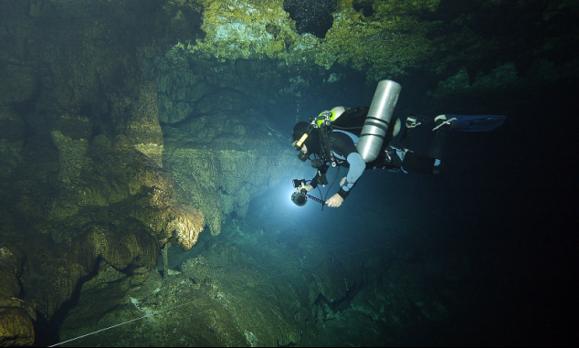

Fig.1 The cenote Nai Bosh, Riviera Maya, Mexico. Photo by: Radek Husak

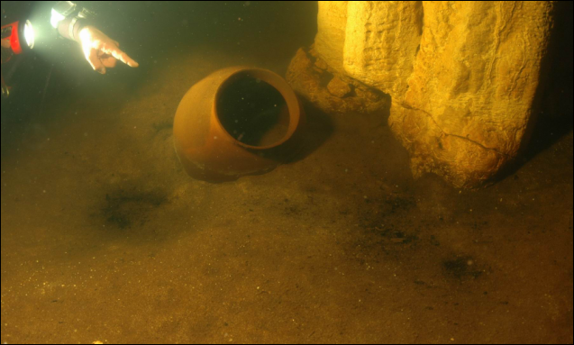

Fig. 2 Old, Mayan ceramic pot found in the cave Chac Ha, Riviera Maya, Mexico. Photo by: Radek Husak

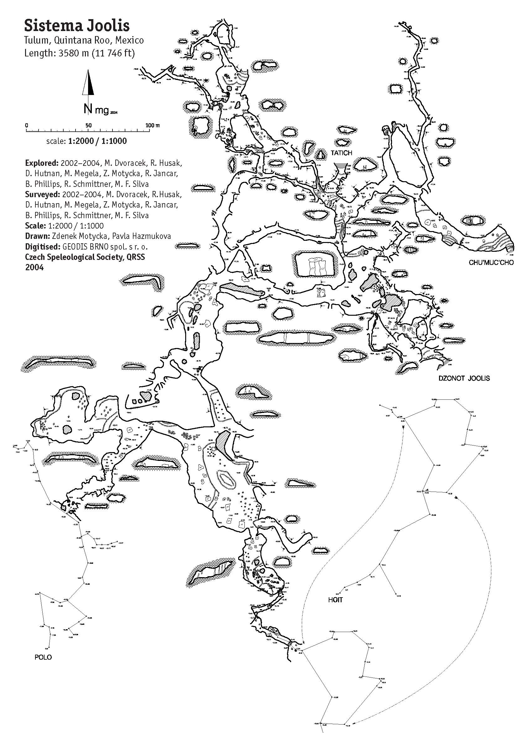

Fig. 3 Map of Sistema Joolis, Riviera Maya, Mexico

