Phenomenon of the underwater caves of Riviera Maya, Mexico

Zdenek Motycka, Czech Speleological Society

Riviera Maya is a part of eastern coast of Mexican semiisland Yucatan by the Caribbean, in state of Quintana Roo.
The area of carbonates is about 190000 km2. They are esentially pure, deposited from Paleocen till Pliocen. Uplift of penninsula in Pleistocene predisposed karst platform to dynamics speleogenesis. Oft rains penetrated through the porous surface and created the shallow systems that leaded the water to the sea. In the next period there was another drop of the sea level and it caused the erosion broadened existing caves while eroding deeper passages. In the meantime the process of secondary karstification and collapsing of thin cave ceilings was running through and the cenotes occurred. 18000 years ago the sea started to rise to the contemporary level and these caves were flooded.
Today the surface is absolutely flat, covered with a jungle. There are no rivers, only lagunas and cenotes. Lagunas are big lakes, while cenotes can be small, often hidden behind the rocks. At the seaseide there are calets where the fresh water flows to the ocean. Thanks to its attractive location it also became a favourite tourist destination.
The cenotes and caves are the really unique ecosystem. Hundrets species of animals were described in last century.
The first bigger system Nohoch Nach Chich was discovered in 1986 by the team of Mike Madden. It was the beginning of the invasion of divers and many other cenotes and kilometrs of corridors were discovered. At the present there are more then 140 cave systems where 580km of underwater cave corridors were discovered. System Ox Bel Ha is the longest cave system in the world with 134km of corridors. The exploration of cenotes continues up to now by many projects. One of them in second longest underwater cave system of the world called Sac Aktun. The Members of SAET (Sak Aktun exploration team) leaded by Robert Schmittner and Steave Boegards establisth that this system is now 77 183 m long.
In 1990 The Quintana Roo Speleological Survey was establish by Jim Coke to collect all dates about caves in Riviera Maya.

 | Cave Name | Length in Meters | Depth in Meters | No. of Cenotes in System | Explored | Last up date
 |  |  |  |  | By | Last up date
1 | Sistema Ox Bel Ha | 134048 | -33.5 | 87 | Devos/LeMaillot | 01/2005
2 | Sistema Sac Actun | 77183 | -25.0 | 61 | SAET | 05/2005
3 | Nohoch Nah Chich | 63073 | -71.6 | 34 (?) | M. Madden | 05/2005
4 | Sistema Dos Ojos | 56671 | -119.1 | 24 | Jasper/Turgeon | 08/2001
5 | Sistema Naranjal | 21525 | -34.7 | 8 | B. Phillips | 09/2004
6 | Sistema Ponderosa | 15019 | -16.5 | 18 | S. Gerrard | 02/2000
7 | Sist. Yaxchen East | 13090 | -16.5 | 29 | K./G. Walten | 10/2003
8 | Sistema Chac-Mol | 9193 | -28.3 | 9 | A. Matthes | 01/2000
9 | Cueva Quebrada | 9000 | -10.7 | 5 (?) | S. Ormeroid | 1993
10 | Sistema Zapote | 7697 | -27.4 | 3 | R. Weijski-Wol. | 02/2005
11 | Sistema Camilo | 7397 | -19.5 | 4 | Cambrian Fnd. | 04/2004
12 | Sistema Xel-Ha Norte | 6652 | -13.4 | 4 | Bogaerts/Phillips | 09/2004
13 | Cueva Aerolito | 6100 | -27.4 | 3 (?) | S. Ormeroid | 1993
14 | Sistema Toh Ha | 5818 | -10.4 | 3 | Berni/Sieff | 03/2005
15 | Sistema Actun Chen | 5435 | -25.0 | 9 | Birnbach/LeMaillot | 01/2001
16 | Sistema Taj Mahal | 5361 | -24.4 | 8 | Carnahan/Phillips | 04/2004
17 | Sistema Actun Koh | 5156 | -16.5 | 5 | F. Devos | 01/2001
18 | Sistema Tortuga | 4900 | -27.4 | 2 | R. Weijski-Wol. | 12/2004
19 | Sistema Tux Kupaxa | 4777 | -14.6 | 5 | Schnittger/Phillips | 05/2005
20 | Dzonot Took | 4736 | -16.5 | 5 | Lins/Matthes | 08/2000
21 | Sistema Burrodromo | 3962 | -14.3 | 2 | W. Skiles | 09/1988
22 | Cenote Chan-hol | 3938 | -11.6 | 1 | K. Davidsson | 05/2005
23 | Sistema K'oox Baal | 3838 | -17.7 | 7 | Labarthe/Phillips | 04/2005
24 | Sistema Dos Pisos | 3704 | -25.9 | 3 | Dotchon/Schmittner | 08/2003
25 | Sistema Joolis | 3636 | -20.1 | 5 | Czech Speleo. Soc. | 05/2005
26 | Sistema Dos Pies | 3516 | -13.1 | 5 | F. Devos | 01/2001
27 | Sistema Ich Tunich | 3343 | -15.8 | 6 | Schmittner/Dovland | 04/2003
28 | Sistema Sac Be Ha | 3303 | -11.3 | 3 | Berni/Sieff | 05/2005
29 | Sistema Crustacea | 3163 | -18.9 | 2 | Meacham/Madden | 01/2003
30 | Sistema Minotauro | 3118 | -14.6 | 5 | Birnbach/LeMaillot | 01/2001
Fig. 1 List of longest caves in Riviera Maya, Quintana Roo, Mexico

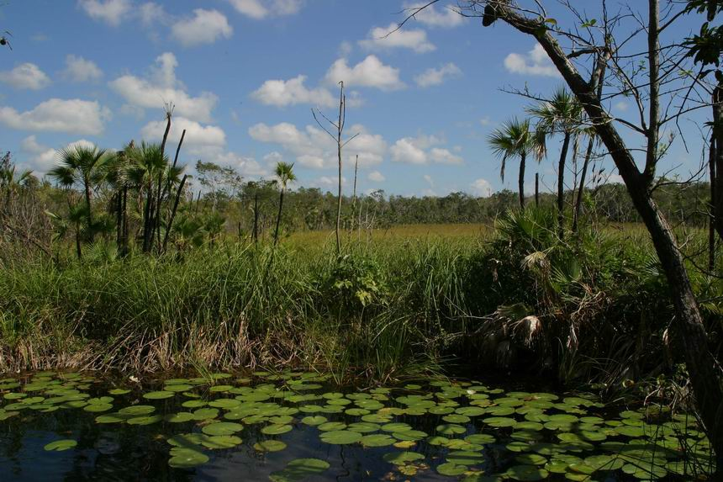
Fig. 2 Wiew on a Riviera Maya surface, covered with jungle. Photo by: Zdenek Motycka

Bibliography:

1) GERRARD, Steve. The Cenotes of the Riviera Maya. 1.print Tallahasssee, USA Rose Printing Inc., January 2000.
ISBN 0-9677412-0-3

2) A Condensed History of Biospeleology in Yucatan. ( online )
Quintana Roo Speleological Survey (cit.2004-09-15)
URL: <http:// http://www.caves.org/project/qrss/qrss.htm

3) A Condensed Geological Chronicle of the Yucatan Platform. ( online )
Quintana Roo Speleological Survey (cit.2004-09-15)
URL: <http:// http://www.caves.org/project/qrss/qrss.htm

4) List of Long Underwater Caves in Quintana Roo Mexico (online)
Quintana Roo Speleological Survey (cit.2004-09-15)
URL: <http:// http://www.caves.org/project/qrss/qrss.htm

