Cueva Charles Brewer (Chimantá)
Cueva Ojos de Cristal (Roraima)
the greatest quartzite caves of the world (table-mountains, Venezuela)

Branislav Šmída¹ – Marek Audy² – Hernán Biord³ – Federico Mayoral⁴
¹Slovak speleological society (SSS), Hodžova 11, 031 01 Liptovský Mikuláš, Slovakia; sandia@nextra.sk;
²Czech speleological society (ČSS), Tyršova 332, 679 06 Jedovnice, Bohemia; audy@speleo.cz;
³Grupo Espeleológico de la Sociedad Venezolana de Ciencias Naturales (SVCN), Calle Cumacho con Arichuna El Marqués, Caracas, Venezuela; svcn@cantv.net;
⁴Miami or Caracas, Venezuela; fmayoralp@cantv.net

Abstract: This contribution-article discusses about quite new discoveries (2002–2004) of the most extensive quartzite caves of the world by leading cavers and scientists from Venezuela, Slovakia and Czech, who in 2004 created common numerous international South American-Middle European working team, specialized in the research of the subterrain portion of plateaus of Venezuela (so called tepuy). Because of the limited possibility of the length of this article does not allow the authors to write broader about the latest findings and explorations of the spaces, already longer than 13 km (on the massifs Chimantá and Roraima), so fresh and diversified, that it would take (and it will) whole compendia, we will struggle in the next lines to point only to the most substantial part for now, what touches to the history of the discoveries about the morphology of the quartzite caves discovered by us and to mention expressively couple of curiosities around it. People who are interested in this specific, however exceptionally valuable knowledge of the problem, can find more in already published articles in world speleo-magazines (as Spelunca, NSS News, Descent, Regards, Speleofórum, Journal of Sydney Speleological Society and so on), or in the monographs already published, or being prepared by us.

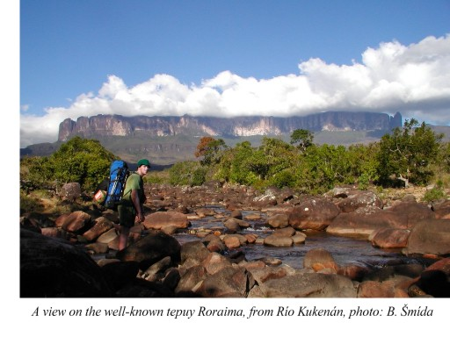
INTRODUCTION
The modern speleological research in the area of Venezuela's tepuy is of very young data. Great progress to the knowledge about this fascinating table-mountains was provided by the photographic pictures from the air and by the possibility to use a helicopter. The expeditions there however remain relatively expensive and difficult in logistics: plateaus, like Cerro Duida, Marahuaca, or the very Chimantá, are deeply inside the country, and they are isolated from the surrounding impenetrable jungle and from the savannas by vertical (or overhanging) walls of hundreds of meters. Expeditions to here therefore are still not numerous.
The first such known legendary action was performed to known Cerro Autana, by the well-known researchist Charles Brewer-Carías. In mountain climbing way he got to the wall about 150 m under the top, he found in this marvelous, about one kilometer high tower, caves and tunnels of the same name, already in 1971, crossing the massif in the length of 653 m (Brewer-Carías, 1976a). Basically it was the discovery of the first quartzite cave, additionally with evident fluvial modeling. In 1974 then, the also by him, in the cooperation with the scientists from SVCN, the giant abyss at the plateau Sarisariñama was the first time explored, known as Sima Mayor, with the depth -314 m and with monstrous oval mouth, 350 m in diameter, which had the internal volume 18 million cubic meters (Brewer-Carías, 1976b). Other remarkable discovery at this area was performed at the plateau Auyantepui: the dimensional abyss Sima Aonda (-383 m) was explored by the Venezuelian cavers from SVE (Galán, 1983). At the same massif, later (1992–1996), the Italian cavers from the association La Venta (for example Bernabei et al., 1994), were exploring here the system in quartzite Sima Auyantepui Noroeste (2950 m/-370 m) which was not long ago the biggest one, or other dimensional collapses, crevices and collectors (Sima Churun and so on).
By this article we would like to introduce to you, at least briefly, the last important period of the speleological research in the area of tepuy (or of the Lost World, how it was poetically named in the famous novel by Sir A. C. Doyle, 1912). Since 2002 we discovered at the mountains Roraima and Chimantá the greatest quartzite caves of the world, which are immensely interesting, not only by the parameters of the length, or of the volume, but also for it's unique genesis, spectacular fillings of biogenic origin, or by the endemic fauna.

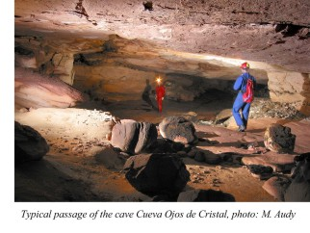
CUEVA OJOS DE CRISTAL
During short tourist visit of the famous plateau Roraima (40 km²), at the borders of Venezuela, Brazil and Guayana, on 4th February 2002, Marek Audy and Zoltán Ágh, by the logical disappearing of water (but otherwise in fact accidentally) found the entrance to the subhorizontal inflow cave. Because they were also excellent cavers, they entered to it's trace, in the length of about the first 300 m, where they found smaller waterfalls and quite dimensional passages with an underground river. For the further exploration of the underground they were not ready in the time. The had just basic headlamps and no mapping tools (Audy, Šmída, 2003).
Because it seemed that the cave could continue, they organized a serious speleological expedition to there one year later. During the expedition in the days 8th–15th January 2003, we explored here in the group of five: M. Audy, B. Šmída, E. Kapucian, M. Griflík and L. Vlček (members of SSS and ČSS, Slovak speleological society and Czech speleological society) not only the cave named as Cueva Ojos de Cristal (in Slovak or in Czech Kryštálové oči, in English Crystal eyes), in precise scaled map (scale 1:500) the length 2410 m, but also other new caves, with the total length of underground discoveries 3,7 km (Audy, Šmída, 2003; Šmída et al., 2003; Šmída, 2004; Vlček, 2004).
During the next expedition in the days from 20th to 28th February 2005, we continued in the speleological exploration of this area, already in the cooperation with the speleologists from SVCN (Grupo espeleológico de la Sociedad Venezolana de Ciencias Naturales). The system Cueva Ojos de Cristal is formed by the three evident main lines: Mischel, Cueva del Hotel Guácharos, and the first known Ojos de Cristal, which were connected into one complex with the length of 3164 m and with the elevation -48 m (Šmída, 2005).
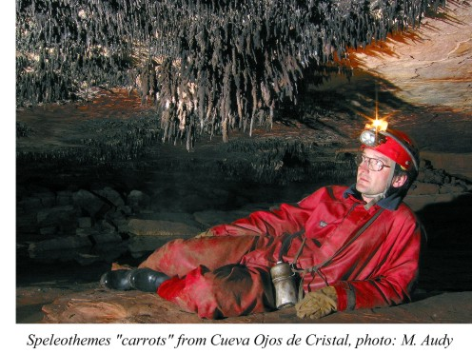
Their main passages are 4–7 m wide and 2–3 m high in average. Locally however they reach the width 15–20 m, and maximum 10–12 m of height. The greatest known space is Sala con catarata (40 x 20–25 m). The inflow rivers flow through the branches Ojos and Mischel, at the circumstances when the passages are comfortable for the exploration (during relatively dry season January–March), with water flow 0,5–3 l/sec. (In the time of rain, the flow can increase to tens of l/sec.) Only slight increase of the water flow during raining will cause flooding of wide and relatively very low passages, which are not available for crawling then at the ends of the branches, which are, though relatively wide, but they are just 0,5 m high in the profile. Cueva del Hotel Guácharos is the one with the higher position, originally surely the older branch of the hollow basin depression (100 x 180 m), where as if blind end of the valley is in fact the main entrance to the branch Ojos. The passages of the system are connected by some mutually parallel passages which are smaller in dimensions, they are separated from each other often only by narrow rocky barriers and connected to the labyrinth. Their direction is much subhorizontal, as if little bit oblique, but otherwise almost without remarkable steps (the highest is about 4 m high, the other steps are about up to 0,5 m high) – the average cadence in the straightened cut is only about 2–3 %. The cave tunnels go subparallel with the surface, not deep below the surface (20–30 m). The passages have mostly quite flat rocky floor, with micro-cuts, deepening, or somewhere with turbulent hollows (diameter up to 40 cm) and with swirl holes (so called "ojos de cristal"), which were engraved by quartz pebbles (originally crystals of pure quartz brought from the surface) – the name of the cave is by this phenomenon. The passages are otherwise mostly without sediments, somewhere there are rocky bridges, or fallen pieces of ceiling (by the plate separation or the separation of ashlar shapes). In the fossil levels, or in the wider passages it is evident side "plastic" separation of the lengthy quartzite plates. The passages are generally significantly wider than high, commonly in the ratio of the width to the height 4:1 (somewhere it is at the edge of being available, and the ratio is 40–60:1!!). The speleothemes are rare, however if they are present, they have often lovely shapes, they are directed by relatively strong drafts: no once they are concentrated nests of dark very solid stalactites in the shape of spiky carrots up to 0,5 m long. Some speleothemes appeared here by the decay of moulds or by unique decomposition and lithological hardening of some down from the little birds of Zonotrichia genus.
The cave was created by the secondary corrosion of the layers, which are the least resistant of the almost 98 % ortho-quartzite (mainly at interlayer discontinuities, and on the planes of hiatus), which is caused by the sophisticated enrichment of the water in organic materials, coming from the products of metabolism and from the decay of special endemic flora at the surface (for example also carnivorous plants). The repeating inflows of the water, during enormous rain seasons (the most of the year), apply significantly at the removal of the material from the block areas.
The cave has five entrances discovered till today, 3 of them are standard and 2 are in the form of remodeled vertical crevices (the deeper of them is about 100 m long and -18 m deep).
The discovery of the cave is unambiguous and undoubtable, because we did not find any traces of human activity inside Cueva Ojos de Cristal neither in 2002 (what was possible to verify also in the fossil passages, where there are very creep untouched little crusts developing thousands of years). The entrance to Cueva del Hotel Guácharos was known to the local indians Pemons, however even they did not enter to the tract deeper than the first 100 m, where we found their pictogram – further the sandy floor of the passages was untouched and the rocky floor was quite clean (Audy, Šmída, 2003; Šmída et al., 2003).

CUEVA DE LOS PEMONES
AND ANOTHER DISCOVERIES IN THE KARST AT RORAIMA
The cave Cueva Ojos de Cristal likely has some genetic and hydrological connection with the next interesting cave in the close area named as Cueva de los Pemones (for the tribute of already mentioned indians – Pemons). These locations were not connected in the time of our research in February 2005, by physical personal passing through them.
One of the entrances to this second biggest system at Roraima, called as Pokemon 2, we had known already in 2003, it had been found by the duo B. Šmída and L. Vlček, on 14th January 2003 (Šmída et al., 2003). Other potential entrances to this genetic subsystem we also partially explored in 2003 (Cueva de Gilberto, Cueva Asfixiadora). The location, which was visited by the cavers from Oxford(?) just before us (not by very clean and ethical way, using our knowledge), we mapped precisely in the days from 20th to 28th February 2005, in the scale 1:500, while we discovered here some great extent of passages not visited by anyone and ever (again by the not existing footprints) and also some crevice entrances, mainly in the South-East ascending tract.
The passages of the main line Cueva de los Pemones, descending in the direction to the West, are 10 m wide in average, somewhere however even 15 or 20 m (or even more). Their height is also 2–3 m. The connection of the crossings and passages here also forms locally almost chaotic labyrinth of disorientation (mainly in the middle part of the cave). The main passage of the system is more compact, in the middle part (analogically as in Ojos de Cristal) with oval, also with ashlar shapes, and also with deeper lake pools, which must be passed around, by the several meters higher situated fossil parallel passages. (There are nice hollow pits in them.) There are also some collapsed little domes here. The biggest of the spaces is the lengthy passage-like hall, the dimensions are about 20 x 30 m and the height is 8–9 m. Two of the entrances are formed by about 100 m long collapsible crevices, about 25 m deep. Further similar, but little bit more shallow crevices (covered by high-mountain jungle) create the entrances to the South-ascending branch of the system.
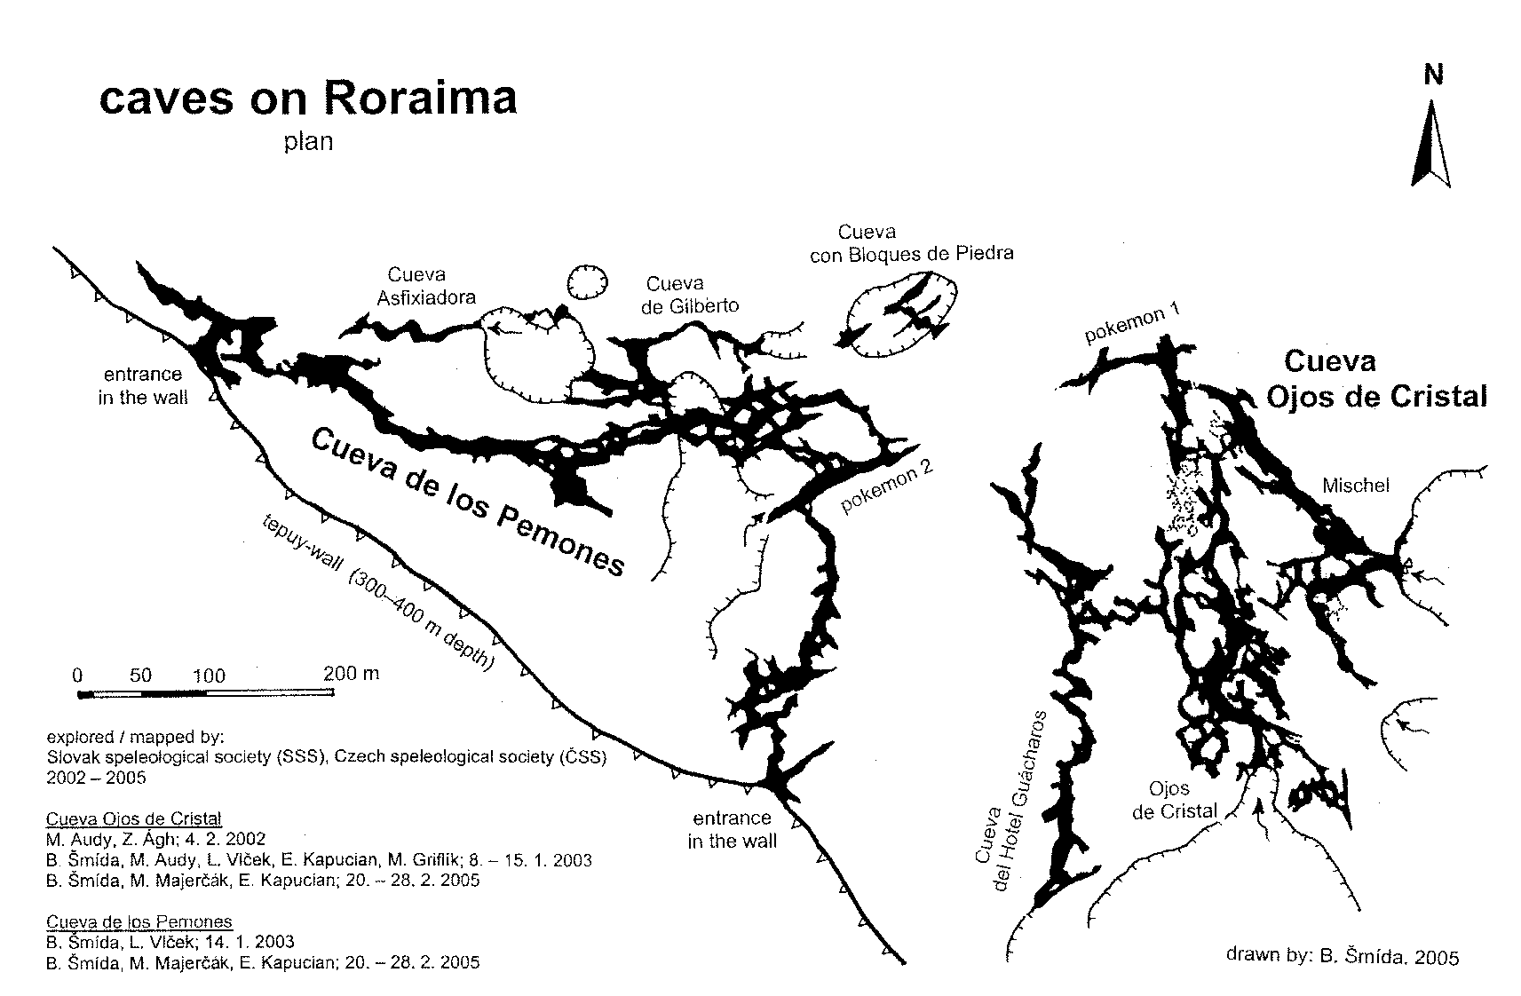
In the cave several smaller inflows connect together in the shape of delta, to one concentrated little river, with the minimal flow about 30–100 l/sec. (In the monsoon season, or at intensive rain, the flow can increase at least to several hundreds l/sec.) This river disappears in the cave in the floor with collapsed boulders, only some 80 meters from the vertical wall of the plateau. The most probably it feeds some strong spring at the heel of this wall, called by the indians Tuná Deutá, which is approximately 350–400 m lower (at the beginning of the access ramp to Roraima). The way to this remarkably vertical hydrological system unfortunately was not found yet.
Cueva de los Pemones has the mapped length of 2070 m for now (200 m of less significant branches and spurs are drawn only for the orientation for now). The elevation of the cave is -73 m (Šmída, 2005).
All the remarkable genetic system of the caves at Roraima has 13 known entrances for now (in the altitudes around 2600 m above the sea level): two of them are heading directly to 300–400 m high wall at the South edge of Roraima, about 30–50 m below the top plateau. (They were found by the exploration from inside and they are beautiful places, with impressive view from some kind of amphitheaters, with special flora.) The other 8 entrances are collapse crevices remodeled by the water (relatively direct, or only slightly curving), which are up to 25 m deep, from 1 to 3–5 m wide, and even more than 100 m long. Because they are by their characteristics different from the others and from the common "not cave creating" crevices at Roraima, we use for them not genetic term, so called pokemon (Šmída et al., 2003). These are oriented roughly in the directions WSW–ENE, and if they did not collapse to the underground totally there are higher longer halls created under them in the caves, with the falls of with the surface water in the form of dispersed drops falling down.
The length of the common genetic system of the caves Cueva Ojos de Cristal and Cueva de los Pemones, which could be later connected into one location, is 5,3 km now. At the close area of the plateau (roughly 500 x 1000 m) there is not impossible even to discover other less visible sub-branches and labyrinths, after the precise mapping of the branches maybe another kilometer of the length could be reached. Even the connection with the other close locations here is possible, for example with the cave Cueva de Gilberto (505 m long for now), Cueva Asfixiadora (125 m), Cueva Fragmento Marginal (78 m), or Cueva con Bloques de Piedra 2 (75 m). Beside these, we discovered bigger number of another caves at Roraima, 80–150 m long for now. Already in 2003 we explored some of the huge crevices, for example Grieta de Diablitos Volantes (-120 m), where some numerous colony of the blind birds live "guácharos" (Steatornis caripensis), or Cueva con Puente (-80 m).

CUEVA CHARLES BREWER – THE GREATEST QUARTZITE CAVE OF THE WORLD
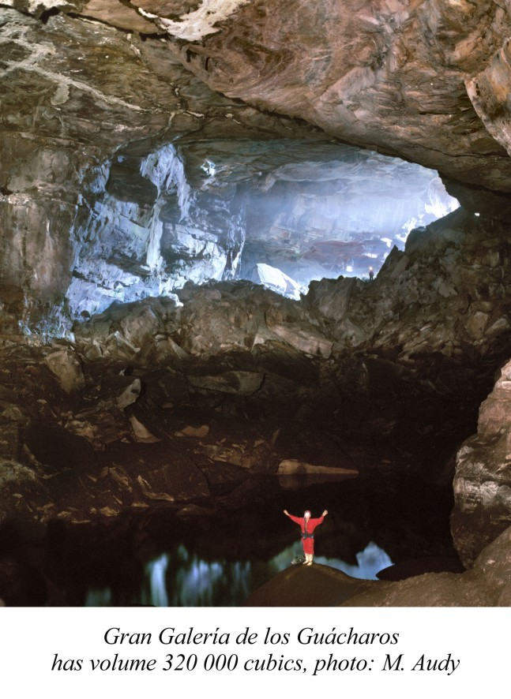
The entrance to this unique, directly monstrous quartzite cave by its dimensions, was observed by it's discoverer, Mr. Charles Brewer-Carías, the best expert on the research of tepuy in Venezuela (he performed about 150 expeditions here!), for the first time on 11th January 2002, during the flight above one of the plateau of the dismantled massif of Chimantá (1470 km²). After the analysis of the flight photographs by stereoscope and after another position determining flight, then they finally entered on 27th February 2004, together with a group of 11 friends, as the first humans in the history at all, to a giant cave, and then (on 28th February) they passed approximately the first two kilometers, where they were stopped, as they were not prepared for such dimensions of the cave, the 40 m long and relatively deeper lake (Lago Chayo) stopped them in further proceeding. In the group under the leadership of Ch. Brewer-Carías, there were: Ch. Brewer-Capriles, F. Mayoral, A. Tovar, L. A. Carnicero, F. Tamayo, A. Chumaceiro, E. Wallis, A. Chacón, C. Barrio, R. Guerrero and F. Delascio.
The next already very well organized and unusually successful action was performed here not much later, in the days from 28th May to 2nd June 2004, while at this action when Cueva Charles Brewer completly mapped in the length of 4482 m and with the altitude difference 110 m (Šmída et al., 2004, 2005a, b, f), again under the leadership of Ch. Brewer-Carías also participated: Ch. Brewer-Capriles, F. Mayoral, L. A. Carnicero, J. Brewer, photographer M. Audy and B. Šmída.
For now the latest, this time very numerous, 25 member multi-disciplinary Venezuela, Slovak, Czech natural-science and speleological expedition was performed to this area (again under the leadership of Ch. Brewer-Carías and B. Šmída) relatively not long ago, in the days from 6th–17th February 2005. Also this was exceptionally successful and we are just processing now the wide results, knowledge and the samples obtained.
Cueva Charles Brewer is a spring in fact, with the entrance that has enormous dimensions (30 x 120 m!) in some kind of amphitheater valley. The main branch of the cave is up to 50 m wide, already at the beginning. However in spite of that (from the reason of barrier of huge blocks being at the entrance) in the time of strong rains during few hours a lake can appear here up to 200 m long, 7–8 m deep, which is like half-siphon (or a real siphon?). The entrance to the cave is closed then, and it is better to be outside in the time... At the time of absolutely dry weather at least 300 l/sec. flows through the cave, otherwise however commonly 500–800 l/s. We suppose that at the sudden inflows of water the capacity of the river floor can take much more (maybe up to 20–30 m³ sec.!!), the traces of corrosion at the walls from water, and the first speleothemes preserved and growing (also in wide passages!) show, that the level is even 8–10 m above the basic flow level. Because of the huge dams formed by the fallen blocks, surely big and deep lakes are created along the whole cave passage in that time.
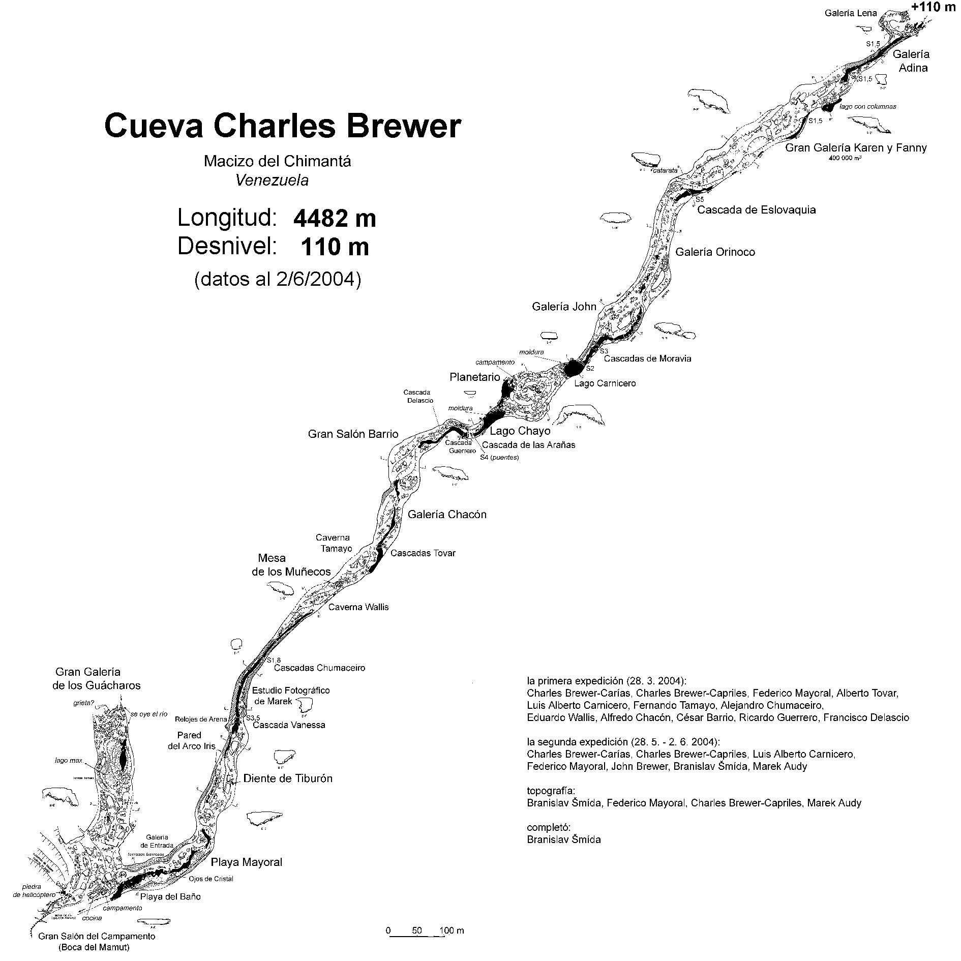
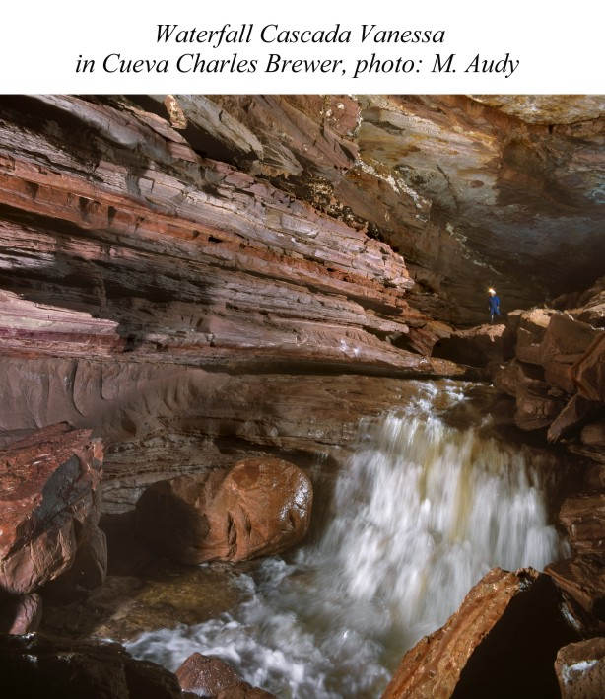
In the cave two types of galleries appear and they repeat relatively regularly: 1. dome-like (width 40–100 m! height is 10–40 m, with huge asymmetrical debris areas; they are hard to pass, the walk through the cave to the end and back with some light equipment can take several hours), 2. canyon-like (width 10–15 m, height 15–20 m, which have the river flow in the whole width; therefore these are dangerous places during sudden water inflows). There are some super-dome widening areas, with the volume commonly more than 50 000 m³, and more places with above 100 000 m³ (for example enormous oval hollow Planetario, 90 x 150 m). The biggest space of the cave is 355 m long, and up to 70 m wide portion of the passage Gran Galería Karen y Fanny, with the calculated volume of about 400 000 m³. It is the biggest natural underground space in Venezuela, and the biggest underground quartzite chamber in the world. (For the comparison even the smallest passage profile in Cueva Charles Brewer reaches 5 x 15 m!)
There are turbulent waterfalls in the cave (the highest, Cascada de Eslovaquía, is 5 m high), and all the forms of the underground quartzite corrosion which are possible to imagine (mantels, lake dishes and cave "pokemons", rock bridges, selectively separated columns, "ojos de cristal", lateral flood floors), as well as various fillings (for example sandy beaches). There is a unique diversity of the speleothemes: Champignons, Muňecos (Puppets), Carrots, Guácimos... (Brewer-Carías, 2005, in press). This classification and typology has it's reason, because each of the mentioned types was created in a different way. For example, the big hard white balls (diameter up to 15–30 cm), in the form as if "mushrooms" or "footballs" are created as alive(!) accumulations of Cyanobacteria (Aubrecht et al., 2005, in press), creating in aphotic conditions big wall colonies (after the lithological hardening of their growth layers opal stromatolith appears). Another researcher (Marcano et al., 2005, in press) has found other autotroph and undescribed symbiotical organisms... Other speleothemes of coral shapes appear as a result of drafts, with heavy aerosol and at the same time there are places with culmination of the organic material by spiders building their webs everywhere.
Also the initial proto-channels of the cave Cueva Charles Brewer were created at interlayer and hiatus predisposition (for example the old beach scallop surfaces) of the quartzite sandstones. These could be created at least from the Cretaceous period, so it is a very old cave. So, it is in fact accidental connection of two big hydrological drainage areas and at the crossing point the enormous entry collapse appeared. The cave passages of Cueva Charles Brewer are about 100–150 m below the surface. Their basis is created by much silicate containing ortho-quartzite mass, and the widening of the passages to 40–50 m appeared at the somehow rhythmical position of the more soluble silicates with belts, which is about 10–12 m thick. The enlargement of the passages to the height then appeared after the lateral widening, and by the consequent collapse of the ceilings (or better said by the side breaking of the huge masses of the rock) and by the attacks of the water at the turbulent water conditions, to the displaced fragments (Šmída et al., 2004, 2005a, b, c, d, e, f).
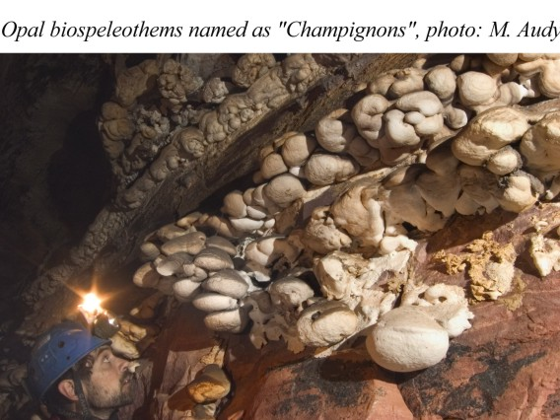
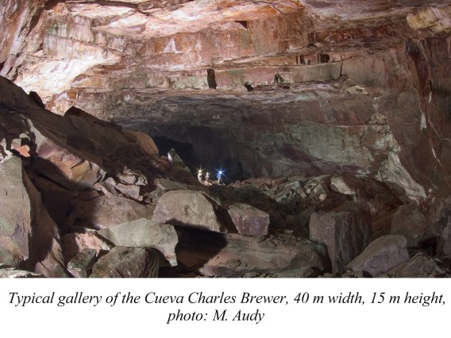
In this exceptionally valuable cave, the discovery of which can be compared to the discovery of the highest waterfall of the world, Salto Angel, we performed during the last expedition intensive scientific research – making geological profiles of the walls, connected with taking and analyzing samples, hydro-geochemical studies, climatological observations and analysis of the air, watching the hydrological regime, we performed also detailed mapping (the mapping of the cave and drawing the map was in the scale 1:1000), we created morpho-genetic model of the development of the cave, we picked up rich cave fauna: the giant up to 8–12 cm long scorpions of Broteochactas genus, which are relatively abundant here, and everywhere in the cave(!), troglobionte bugs, big cave crickets Hydrolutos, probably new species of cave leech, Isopoda and so on. The results of this expertise and very complex research are just being processed now, but they will be published soon.
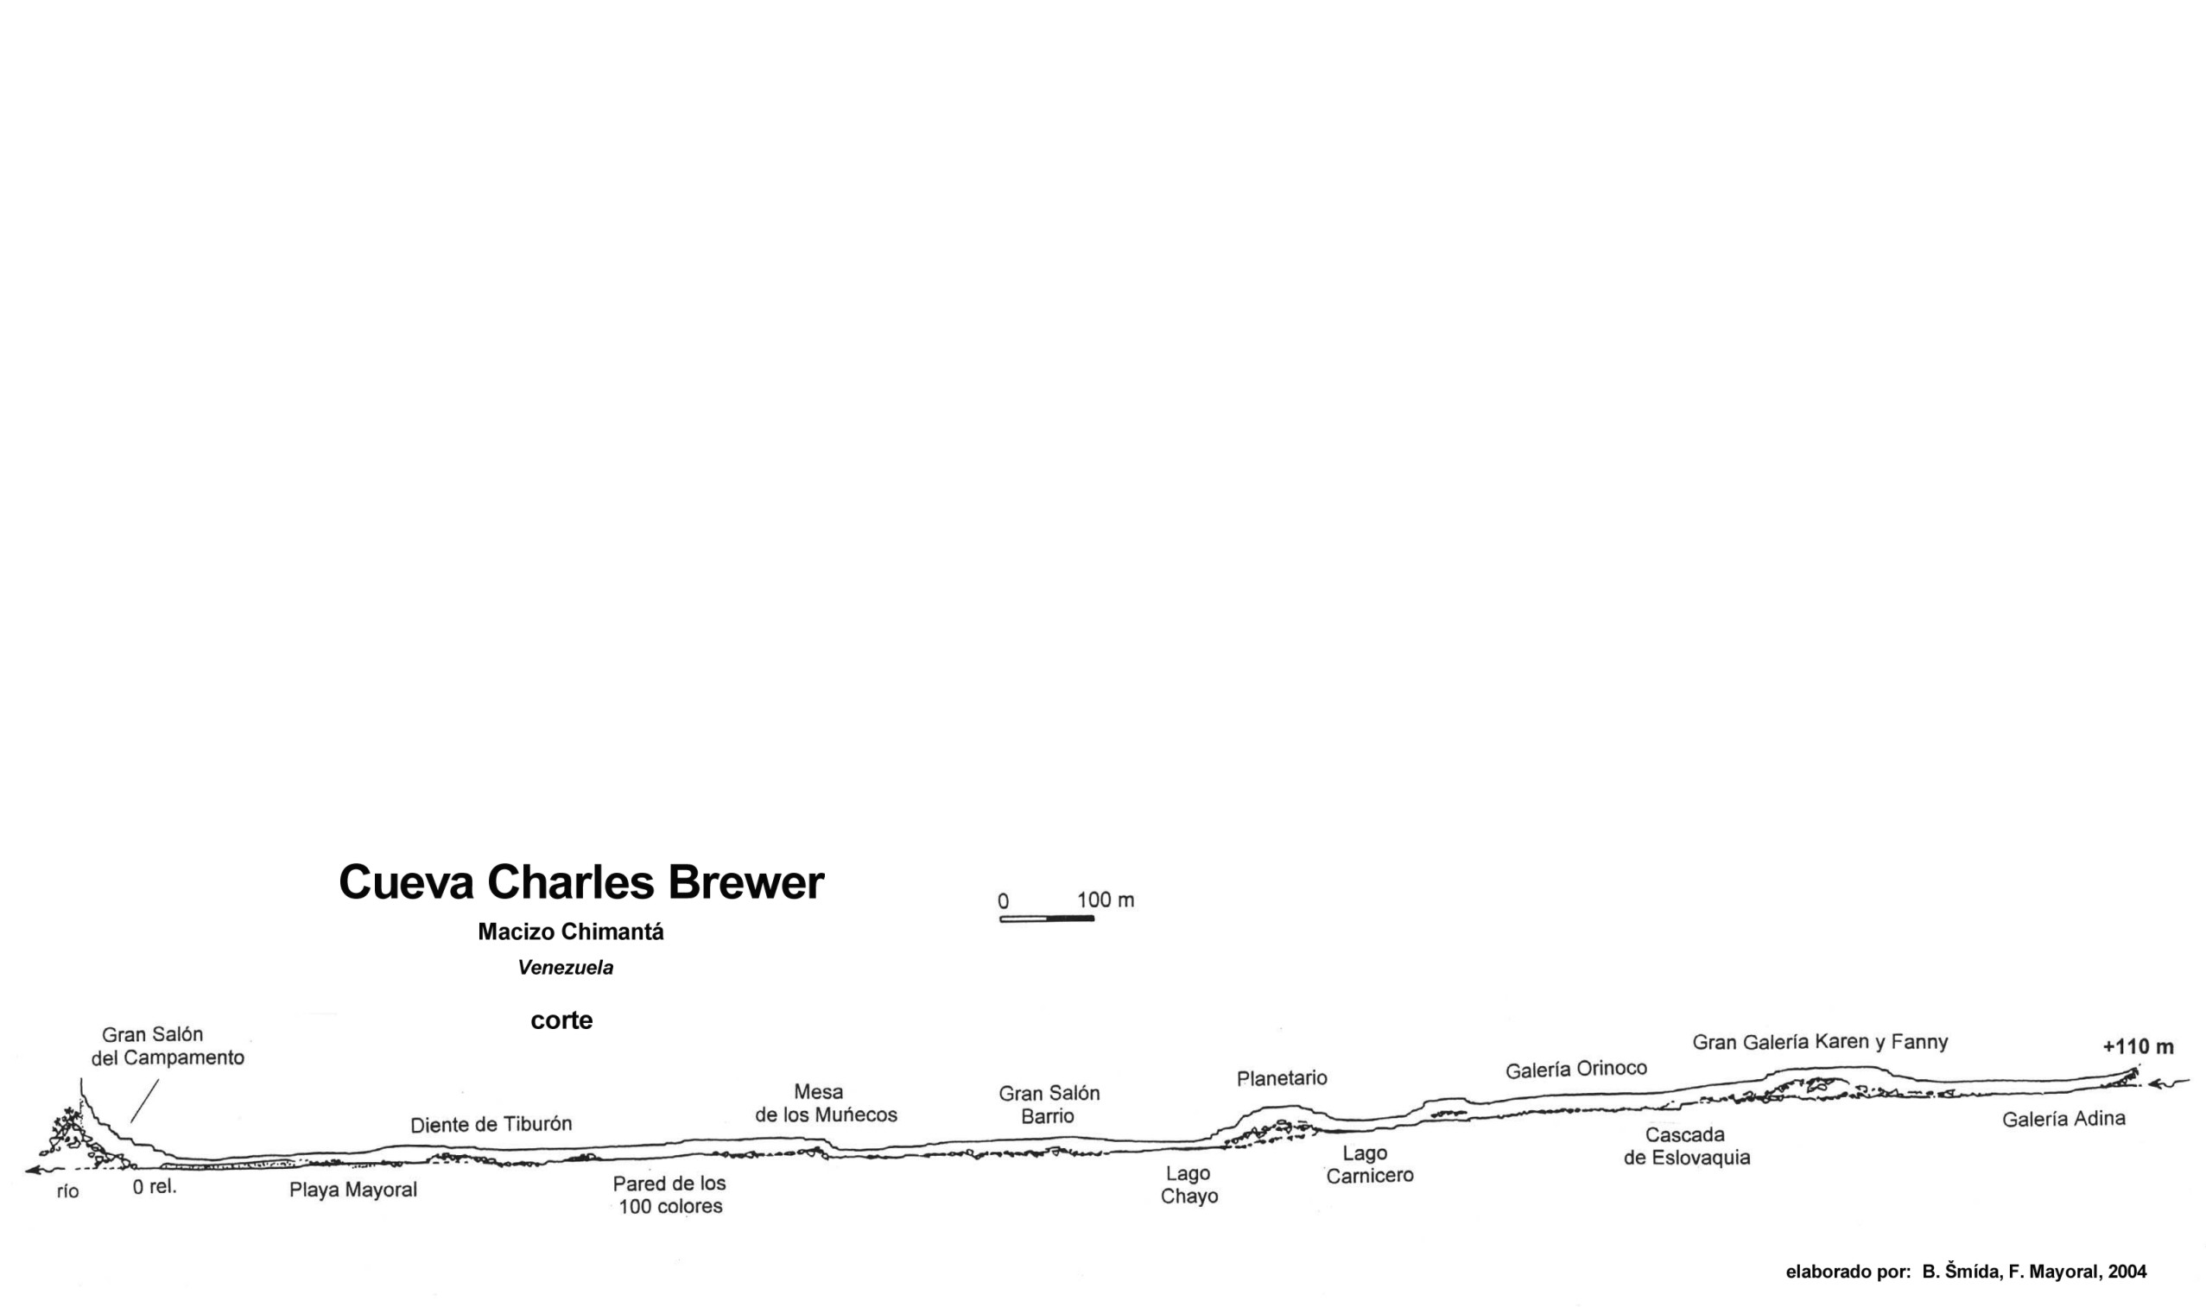
ANOTHER NEWLY DISCOVERED CAVES OF THE MASSIF OF CHIMANTÁ
During our common expedition in February 2005 (all the authors of this article participated in it) at the plateau Chimantá, we explored also further big caves, which might have some connection with the hydrological system of Cueva Charles Brewer:
1. Cueva del Diablo (Devil's cave). This cave complex is created by the central abyss-like collapse (80 x 200 m), -80 m deep, from which some robust tunnel passages lead to all directions. To the North, approximately 500 m long fossil gallery, with average profile 30–40 x 15 m, ending by dome-like cavity, with 80 m in diameter, 60 m high, reactivated by the river at the South, giant corridors, 50 x 20 m in profile, at one place almost 80 m wide. There are up to 3 m long(!), very massive stalactites, built by organic material, "mouldy and bacterial" speleothemes, or fossil "mushrooms". The system is 2,3 km long for now.
2. Cueva del Cañon Verde (Green canyon). From the enormous collapse, -80 m deep, there was explored dimensional tunnel-like gallery to one direction, 800 m long, and locally up to 30 m wide. We did not explore the continuation to the opposite side yet. The lower end of the gallery is closing by the peripheral area to Cueva del Diablo.
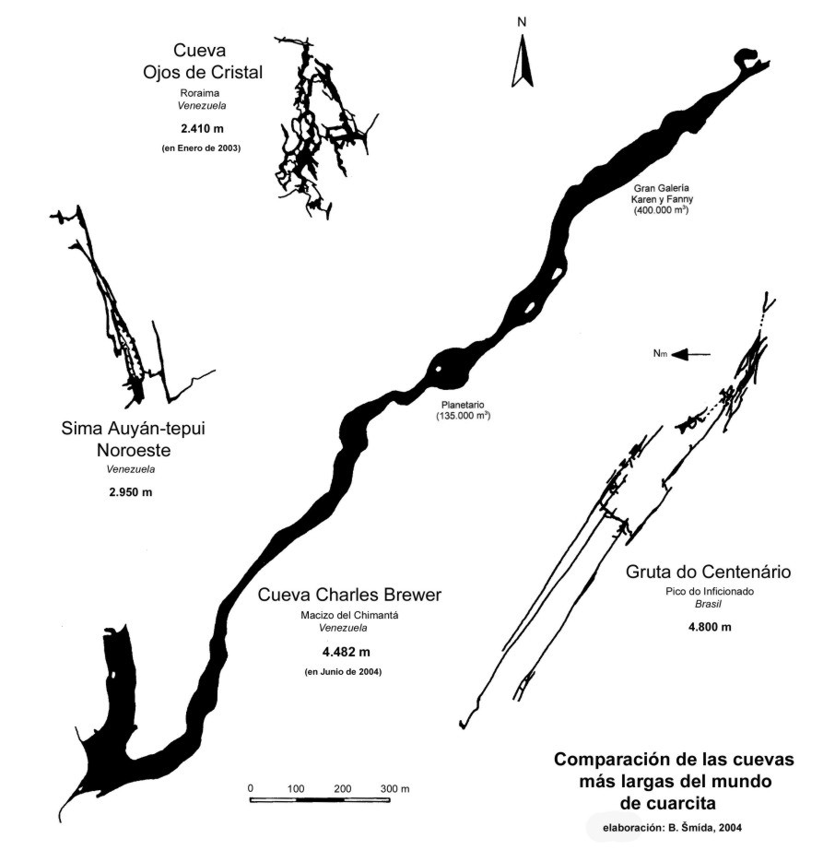
3. Sima Noreste (North-East abyss). It's enormous lengthy collapse-crevasse (so called grieta) has the dimensions 400 x 60 m and the explored depth is -130 m for now. There was evident a deep continuation here, at least to -170 m. Still the hypothetical basis was not found, where the source of the main river floor of the branch of Cueva Charles Brewer could be expected.

THE PERSPECTIVES
By our discoveries at the plateaus Chimantá and Roraima the view on the style of karst creation in the quartzite and on the underground potential of similar massifs of table-mountains is changed principally.
The cave Cueva Charles Brewer was prolonged to 4732 m by some short progress against the flow at the end of the main gallery, as well as by finding of the continuation through the collapsible end of Gran Galería de los Guácharos connected with the surface.
But in the potential underground hydrological drained area of Cueva Charles Brewer it was explored by us altogether more than 8 km of the cave passages, crevices and abysses (Šmída et al., 2005). By connecting them, which is really supposed, plus by the discoveries and explorations of the new caves, which have entrances (and mainly some access to them) that we already know, it will appear unprecedentedly and for long time the biggest known karst system in quartzite. It depends on the next expeditions how fast we will get to it, and we are already planning them.

BIBLIOGRAPHY
AUBRECHT, R. – BREWER-CARÍAS, Ch. – ŠMÍDA, B. – AUDY, M. – KOVÁČIK, Ľ. (2005): Peculiar speleothems in the world’s largest sandstone cave Cueva Charles Brewer, Chimantá Tepui, Venezuela (in press).
AUDY, M. – ŠMÍDA, B. (2003): Krystalové oči (československá výprava do křemencového krasu venezuelské Guyany). Speleofórum, 22, Česká speleologická společnost, Praha, 60–63.
AUDY, M. – ŠMÍDA, B. (2005a): Největší kvarcitová jeskyně světa Cueva Charles Brewer. Speleofórum, 24, Česká speleologická společnost, Praha, 58–62.
AUDY, M. – ŠMÍDA, B. (2005b): Jeskyně Charles Brewer. Mamutí jeskyně v kvarcitech Guyanské vysočiny. Vesmír, 84 (135), 1, Praha, 20–29.
BREWER-CARÍAS, Ch. (1976a): Las Cuevas del Autana. Natura, 58, Sociedad de Ciencias Naturales „La Salle“, Caracas, 33–48.
BREWER-CARÍAS, Ch. (1976b): Las Simas de Sarisariñama. Boletín SVCN, 132–133, Sociedad Venezolana de Ciencias Naturales, Caracas, 549–623.
BREWER-CARÍAS, Ch. (2005): Las espeleotemas de la Cueva Charles Brewer (in press).
GALÁN, C. (1983): Expedición a la Sima Aonda. Boletín SVE, 20, Sociedad Venezolana de Espeleología, Caracas, 99–103.
BERNABEI, T. et al. (1994): La spedizione Tepuy 93 (Auyantepuy, Bolivar, Venezuela). Progressione, 30, Trieste, 1–120.
MARCANO, V. – BREWER-CARÍAS, Ch. – CEDEÑO, C. (2005): Exobiological significance of silica biostructures forming opal stromatolite in light-independant environments (in press).
ŠMÍDA, B. (2004): Kvarcitové jaskyne stolovej hory Roraima (Venezuela). Výskum, využívanie a ochrana jaskýň, 4, Liptovský Mikuláš, 63–68.
ŠMÍDA, B. (2005): Chimantá 2005, Roraima 2005, krátke oficiálne komuniké. Spravodaj SSS, 36, 1, Slovenská speleologická spoločnosť, Liptovský Mikuláš, 47–49.
ŠMÍDA, B. – AUDY, M. – VLČEK, L. (2003): Expedícia Roraima, Venezuela, január 2003 – Cueva Ojos de Cristal (Kryštálové oči). Spravodaj SSS, 34, 2 (special issue – monograph), Slovenská speleologická spoločnosť, Liptovský Mikuláš, 1–192.
ŠMÍDA, B. – AUDY, M. – MAYORAL, F. – CARNICERO, L. A. (2004): Expedícia Chimantá 2004, alebo objavovanie Cueva Charles Brewer – najväčšej kvarcitovej jaskyne sveta. Spravodaj SSS, 35, 2, Slovenská speleologická spoločnosť, Liptovský Mikuláš, 3–14.
ŠMÍDA, B. – AUDY, M. – MAYORAL, F. (2005a): Cueva Charles Brewer – la plus importante grotte du monde creusée dans les quartzites (massif du Chimantá, Venezuela). Spelunca, 97, Paris, 27–35.
ŠMÍDA, B. – AUDY, M. – MAYORAL, F. (2005b): Cueva Charles Brewer: Largest quartzite cave in the world. NSS News, 63, 1, National Speleological Society, 13–14, 31.
ŠMÍDA, B. – AUDY, M. – MAYORAL, F. (2005c): Into the Lost World. Descent, 183, Abergavenny, 36–38.
ŠMÍDA, B. – AUDY, M. – MAYORAL, F. (2005d): Cueva Charles Brewer. Regards, 58, 9–12.
ŠMÍDA, B. – AUDY, M. – MAYORAL, F. (2005e): Cueva Charles Brewer. The largest quartzite cave in the world (Chimanta massif, Venezuela). Journal of the SSS, 49, 1, Sydney Speleological Society, Sydney, 3–12.
ŠMÍDA, B. – BREWER-CARÍAS, Ch. – AUDY, M. (2005f): Cueva Charles Brewer – najväčšia kvarcitová jaskyňa sveta. Speleoexpedície do masívu Chimantá (Venezuela) v roku 2004. Spravodaj SSS, 36, 5 (special issue, monograph), Slovenská speleologická spoločnosť, Liptovský Mikuláš (in press).
VLČEK, L. (2004): Horizontal quartzite-karst caves in Venezuela – one of the newest geomorphological discoveries. Proceedings of the 8th International Symposium on Pseudokarst, Teplý vrch–Slovakia, 57–61.

http://audy.speleo.cz/Chimanta
http://audy.speleo.cz/Roraima

