Lukina jama-Manual II (-1392 m), Slovačka jama (-1320 m), Meduza (-707 m)
and the share of the Slovak cavers at discovering some of the deepest abysses
of the world and of underground super verticals in Velebit (Croatia)
in the years 1990-2004

Branislav Šmída
Slovak speleological society (SSS), Hodžova 11, 031 01 Liptovský Mikuláš, Slovakia;
sandia@nextra.sk

Abstract: Directly along the beautiful Jadran riviera there is more than 150 km long mountain area of Velebit, of which not an extensive territory at the North, the limestone wildness, where there are huge holokarst mega-depressions and karst pits, it became in incredibly short time literally a world term in discovering more than thousand meters deep caves, mainly with immensely deep shafts and verticals. What is less known, and what is necessary to emphasize, is that on the exploration results of this area is considerable, if not the substantial share of young members of Slovak speleological society (SSS), who started with the systematic works, basically as the first ones (since 1990) and since then they performed 14 expeditions to here, in fact with fantastic results. By this contribution we would like to introduce to you the objective history of the first discovering of the deepest caves in Croatia, the systems Lukina jama-Manual II (-1392 m) and Slovačka jama (-1320 m), which belong also to the deepest of the world, and also the look at the discovery of the abyss Meduza (-707 m), with it's giant underground shaft, at least 450 m deep, which is the second deepest underground shaft of the world.

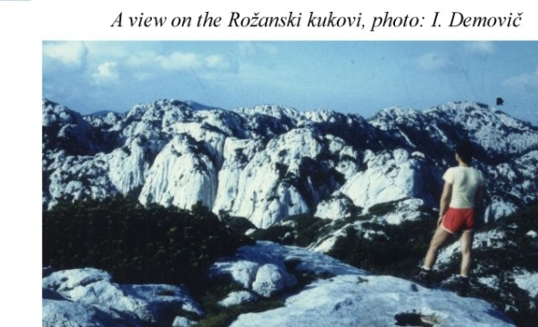
ROŽANSKI AND HAJDUČKI KUKOVI
Velebit culminates with it's height at the south, with the point Vaganski vrh (1757 m). But also in the northern wildly dismantled limestone zone of this mountain area, the peaks reach relative heights from the sea level more than 1650 m. (The highest peak here is Gromovača, 1676 m.) This amplitude is at the same time the possible potential of the altitude difference of the not so long ago discovered, more than 1 km deep, and to all that immensely vertical cave systems: significant part of the massif is build by Jurassic limestones and by carbonate Paleogene cover (Jelar-breccias), it is drained by huge springs in the sea under the sea level (so called vrulje).
The central part of the northern Velebit, not an extensive territory (18 km2), where two partial massifs Rožanski kukovi and Hajdučki kukovi, seem to be the most perspective from the speleological view. Their most characteristic feature are huge depressions (it could be said collapse areas), commonly with the depth over 100 m and with the diameter more than 200 m. In the massif of Rožanski kukovi there is about 60 of such huge mega-depressions. They are ended by extensive block areas at the bottoms, in the areas of significant thermal inversion there is snow cumulated during the whole year. The interior of the depressions is often complete holokarst, it is hardly penetrable, often with vertical walls between the levels. The external edges of the depressions are covered by spruces or by impenetrable scrub. The individual depressions are separated from each other by cone-like peaks, walls, rock towers, or by compact cones (kuk, toranj), while 50 of them is higher than 1600 m. From the microforms there are groovy scarps here, often perfectly created.
The carbonate bedrock in this area is strongly damaged by the tectonics. The most often vertical faults are evident directed NNE-SSW. Just on these ones the intensive corrosion took place (and is going on), there was created enormous number of slots, cracks and abysses, from which there is explored maybe more than 250 today. The overwhelming majority of them is relatively not deep, couple of tens meters, ended by icy or snowy enclosures. But few of them belong not only to the deepest in the country, but also to the deepest all over the world. For these abyss cave systems the deep, relatively homogenous but mainly direct shafts and verticals are typical, which are close to each other, often separated from each other only by narrow rock barriers and by windows, or connected with each other by curving meanders. There are also huge domes in the abysses. The underground shafts are mostly without calcite decoration, but almost always in the zone which is close to the surface (100–200 m) they are very strongly filled with ice (icicles, monoliths), and therefore they are also really dangerous. The exploration is also limited by the season: in the top summer, when theoretically no rains can be expected, eventually in the winter, however in the winter there appears the problem with the access to the area.
The abysses and the systems in the northern Velebit are of significant alpine character, with low temperature (from minus to maximum 3–4 °C). The exploration of the deepest of them required connection of bigger teams of experienced cavers and speleoalpinists, as well the exploration demanded establishing remote underground camps.
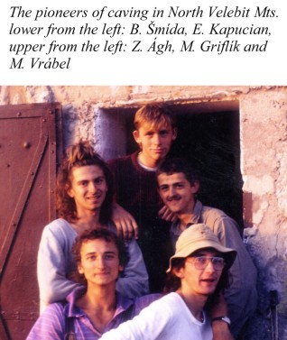
THE FIRST EXPEDITION OF SLOVAK CAVERS
TO VELEBIT IN 1990
Slovak cavers were present at the territory of Rožanski and Hajdučki kukovi since 1990. Until then it was almost completely unexplored area. Though the entrances to some deep abysses are visible literally from the tourist paths(!), nobody neither visited them, nor explored them. The only explorative activities until this time were only short journeys of the cavers from the Croatian speleological club "Ursus spelaeus" who in 1980 and 1981, in the area of the peak Crikvena (1641 m), explored several abysses, the deepest of them (Crikvena 1) to -120 m (Ostojić, 1999). Beside this the huge collapse area of the cave Varnjača was known here for a long time (after our explorations in 1996 it was explored up to the depth -120 m) and the tiny abyss filled with ice next to the road, called by the local meteorologist from the Zavižan station, Vukušić jama.
Our first 12 days of actions from 4th to 15th August 1990 where participated (it could be said the pioneers of the discovery of this worldly known speleological terrain): Branislav Šmída (the head of the actions), Zoltán Ágh, Erik Kapucian, Marcel Griflík, Mário Vrábel and Igor Poláček (our average age was only 19 years in that time!), brought in that time mainly introduction knowledge and unexpected perspectives (Šmída, 1991): in the massif Rožanski kukovi we did recognizant actions to already known abysses around Crikvena, but we did discover also new ones, from them the deepest for now became the abysses Platňa (-96 m) and in the huge 150 m deep depression Jerković dolac, directly on the opposite side from the little cottage Rossijeva koliba, there was Punoleda uniquely filled with ice (-157 m; in the year 2001 we did recognizant action here after more than 10 years). During one day of this pioneer expedition on 9th august 1990, we in a group of five visited also the virginal territory of Hajdučki kukovi, while by the descent from it's logical peak (in 1650 m) we got into the terrain (B. Šmída and M. Griflík) some 150 m from the entrance to today's system Lukina jama. Of course we did not even anticipate it in the time...

LUKINA JAMA-MANUAL II (-1392 m)
The massif Hajdučki kukovi was before our first visit in 1990, in spite of the incredible possibilities absolutely untouched by the speleological means. In addition, what is paradox, one of the first entrances which we localized here, was the lower entrance to the tenth deepest cave today...
It was 28th September 1992, when we during the second expedition of Slovak explorers to Velebit, the group of five: Zoltán Ágh, Stanislav Gajdošík, Marcel Griflík, Erik Kapucian and Branislav Šmída, started from the hollow basin Lomska duliba, basically "blindly" during intensive rain, to NE slopes of the massif, and here, in the oblique step-like area scratched by scraps, in the altitude 1438 m, we found huge crevice well, where the thrown stones fell without hearing the sound... and where we could see at least 80 m into the depth. On 29th September for the first time E. Kapucian abseiled into this shaft. On 30th September he repeated the abseil together with J. Meluš and with S. Gajdošík and they proceeded up to -145 m. As the autumn rain season was culminating, we determined the further exploration again to 2nd October (Z. Ágh, S. Gajdošík, B. Šmída and E. Kapucian), when we reached the depth -240 m, pendulating to side snowy meander. Under us a never ending abyss appeared, at least 200 m deep... however after exploring the abyss we did not continue exploration at this action. Strong rains ejected us from the mountains, with flowing dangerous waterfalls underground carrying pieces of broken ice. This fact discouraged us. Neither the last abseil on 5th October 1992 (E. Kapucian, Z. Ágh, S. Gajdošík) was not more successful – the explorers were caught in the depth -230 m by such an intensive sudden stormy inflow, that they barely climbed out of the abyss... (Šmída, 1993, 1996).
We informed the local cavers from the club Željezničar, on the way back through the city of Zagreb, about finding the perspective abyss, which we assigned technically as SO.1 and we named it as Manual (or Manuál). These cavers came here during the next summer in July and August 1993, then they organized national expedition, where about 60 cavers from many Croatian clubs participated. Because the abyss Manual continued quite freely and at the same time immensely vertically, the depth -1355 m was reached very quickly by the help of two bivaks in -748 m and in -958 m (in huge dome 50 x 100 m).
We learnt about this action and about the unbelievable progress in fact accidentally, just at our passing through Zagreb in the autumn 1993, when we planned to continue in Velebit in the started explorations. It was a real surprise for us... The abyss Manual was at the same time renamed by the Croatian cavers to Lukina jama, by O. Lukić, who died in war.
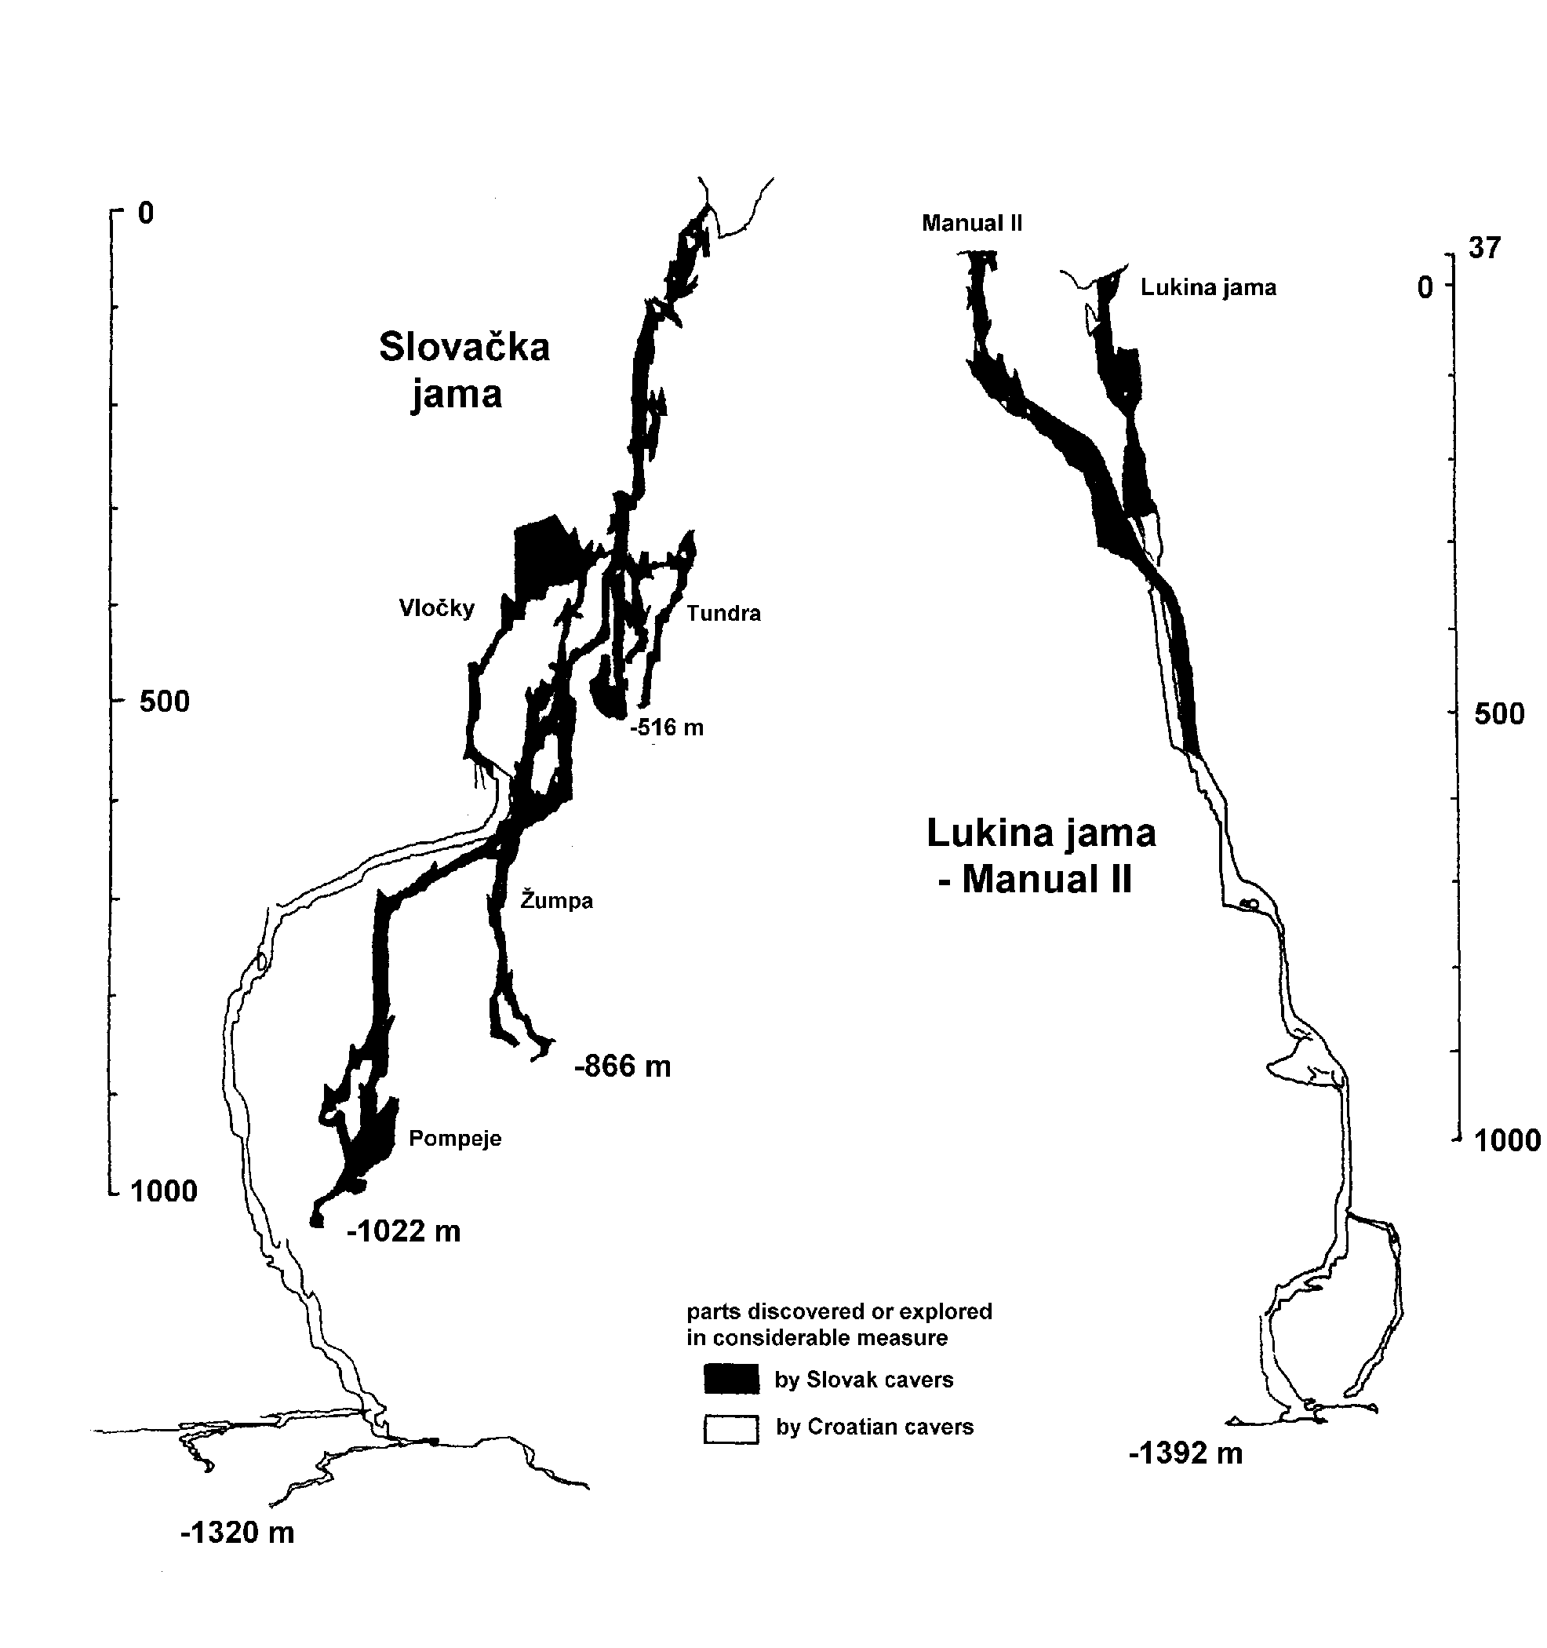
However it could be said that our Slovak team managed to make an excellent tricky success just at the expedition in the next summer 1994. By the entrance which we had known from two years ago (it was discovered by Erik Kapucian and by Branislav Šmída, on 4th October 1992), in the altitude 1475 m and about 120 m from Manual (Lukina jama) to SE, and we had assigned is as SO.2, we managed to deepen the system, in fact by the higher branch, the common system got deeper up to -1387 m! As the first ones abseiled to this location, named for certain symbolic as Manual II, on 23rd July 1994 Z. Ágh and M. Griflík, they reached the depth -190 m. After 5 days of exploration we then managed to lower at the end of 160 m deep Monzúnová šachta (Monsoon shaft), up to the depth -582 m, where on 27th July 1995 the trio Z. Ágh, M. Griflík and D. Kotlarčík found the connection to the shafts of Lukina jama (Šmída, 1994a, b, c, d).
(Next to this we would like to emphasize that though the Croatian cavers sometimes call the branch Manual II also as Trojama, it is not correct, neither ethical, because none of them, during the first explorations, and in fact neither till now, did visit the cave, neither passed through it. It should be thus used the correct name and also by us fully accepted name of the common system: Lukina jama-Manual II.)
During the same expedition in 1994 we helped to Croatian cavers also at the exploration of the branch of Lukina jama itself, by the work progress (transport of the material for diving) by the lower entrance to the system, 1355 m deep, up to the lakes and siphons at the bottom (1st–3rd August 1994, the group of five: Z. Ágh, E. Kapucian, M. Griflík, B. Šmída and J. Vykoupil). After the diving of T. Barišić and Z. Stipetić the system Lukina jama-Manual II became -1392 m deep (Jalžić et al., 1994).
SLOVAČKA JAMA (-1320 m)
The entrance to the second cave in Velebit, which is more than one kilometer deep, discovered by Slovaks, we found on 28th July 1995, by the duo Branislav Šmída and Marcel Griflík. The entrance is positioned in the altitude 1520 m, not far from the cone elevation Mali kuk (1565 m), the relative altitude is about 250m from the meadowy hollow basin Veliki Lubenovac, where the basic camps of all the expeditions were since 1995, while exploring in the close area. The entrance is little bit untypical for the Velebit conditions: it lays in the side wall of the depression and it's introductory, not big collapsible zone, did not tell the appearance (except the strong pulsating draft) that this could be once some exceptionally deep system... On the 29th July the same duo, B. Šmída and M. Griflík, removed from the entrance squeeze (Fučák) couple of boulders and abseiled to compact vertical Pokojná (P55). The cave led freely only to -96 m in the time. On it's bottom there were however two narrow branches with evident draft and pizolits. At first we decided to dig in the higher branch (with the help of an ascender as a shovel), but after pulling out big blocks from the meander of the lower well Grepová (P11), finally at the third day of the exploration (30th July), the lower narrow allowed some progression (participants of the probing: Z. Ágh, M. Mišík, K. Kýška a M. Griflík). The spaces then misled us incorrectly down, to the blind meander and even the exploration of the window in the hall above was not successful... Just on 31st July 1995 the group in the composition: E. Kapucian, M. Mišík, K. Kýška and B. Šmída, widened another narrow passage above S5, and E. Kapucian and B. Šmída pushed themselves through ascending edges of the meander, to the position above the huge 194 m deep well (Cez celú zem, Through the Whole Earth). The preliminary bottom of the cave, in the depth -516 m, was reached then by the duo E. Kapucian and J. Vykoupil, on the 2nd August 2005. At the mapping of the lower giant well of the location, named Poseidon (direct vertical P213) on the 4th August B. Šmída noticed an important window, which he estimated as a perspective one for the further exploration. The new deep cave was named to the credit of our explorers as – Slovakia (Šmída, 1996, 1997a).
One year later as the Croatian cavers recommended to us to change the original name of the location to the new one – Slovačka jama (what we accepted), we organized another very progressive expedition to the cave. The mixed team was formed from 14 Slovak an 7 Croatian explorers (who performed 78 / 13 abseils altogether). The breakpoint was already the third day of the expedition, the 22nd July 1996, when J. Vykoupil and Z. Ágh did traverse to the window mentioned before, and they discovered there some whole maze (Koridor) of big domes and more abyss branches. We then based an underground camp, in the depth -360 m, from where the pairs of the researchers started every day to the two sub-branches (so called Črevo-Intestine and the branch of Kankula). Though in the branch of Kankula, where the two brothers J. Kankula and M. Kankula widened the narrow little window, with the help of a drill and bullets (Vločky), our explorers stopped above in fact free continuation, above the great meander with an echo (the deepest point about -600 m, J. Vykoupil and M. Sova), they did not abseil deeper, because we needed to support our team in the neighboring branch. In the other branch, after some days, we managed to pass through lengthy and pretentious narrows (Šaleny meander, Crazy meander) and we managed to abseil under the next enormous vertical, Patkov skok (P170), on the 3rd August 1996, up to the depth -1000 m (D. Kotlarčík, J. Vykoupil, B. Šmída and M. Sova), where a huge oblique dome Pompeje was discovered (Šmída, 1997a, b, c; Bakšić, Šmída, 1999).
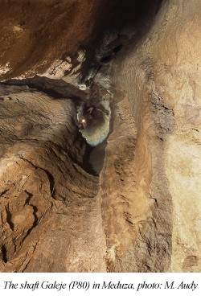
On our expedition in 1998, the Croatian cavers continued in the exploration of the branch of Kankula, where they managed to abseil from -600 m to -1268 m. We, as the Slovak team deepened the branch Črevo to -1022 m (J. Stankovič, J. Kankula, B. Šmída and M. Griflík), while the second remote bivouac was placed in the depth -1000 m, and we explored also the side shafts around the first camp, where we reached -504 m in the branch Tundra (Bakšić et al., 1999).
We concentrated our efforts during our last expedition till the next time, which was allowed to us to perform in 1999, to the branches of Hermanova studňa (reached depth -530 m) and Žumpa, the continuation of which was found directly under the bivouac I. by M. Sova. (Originally it was "the place where we left the remains of our metabolism..." at the bivouac I.) Here we reached the depth -850 m (on 4th August, P. Medzihradský, M. Griflík), and -866 m (5th August, J. Ondruška, B. Šmída). In this branch there is another great shaft created, 156 m deep Adriána (Šmída, 1999).
Slovačka jama has the total depth -1320 m today, which was reached by the cavers from Zagreb in the summer 2002, at the bottom of the Kankula branch. It is necessary only to remind that thanks to the endurance, high enthusiasm at the widening of the rock narrows, finding the decisive points and generally to the whole effort of the Slovak explorers, who discovered about two thirds from today's extent of the location, which is more than 5,5 km(!), and that because of that, Slovačka jama today still belongs to the twenty deepest abysses of the world... It's name is thus absolutely truthful and for us it is the best, fully deserved reward.
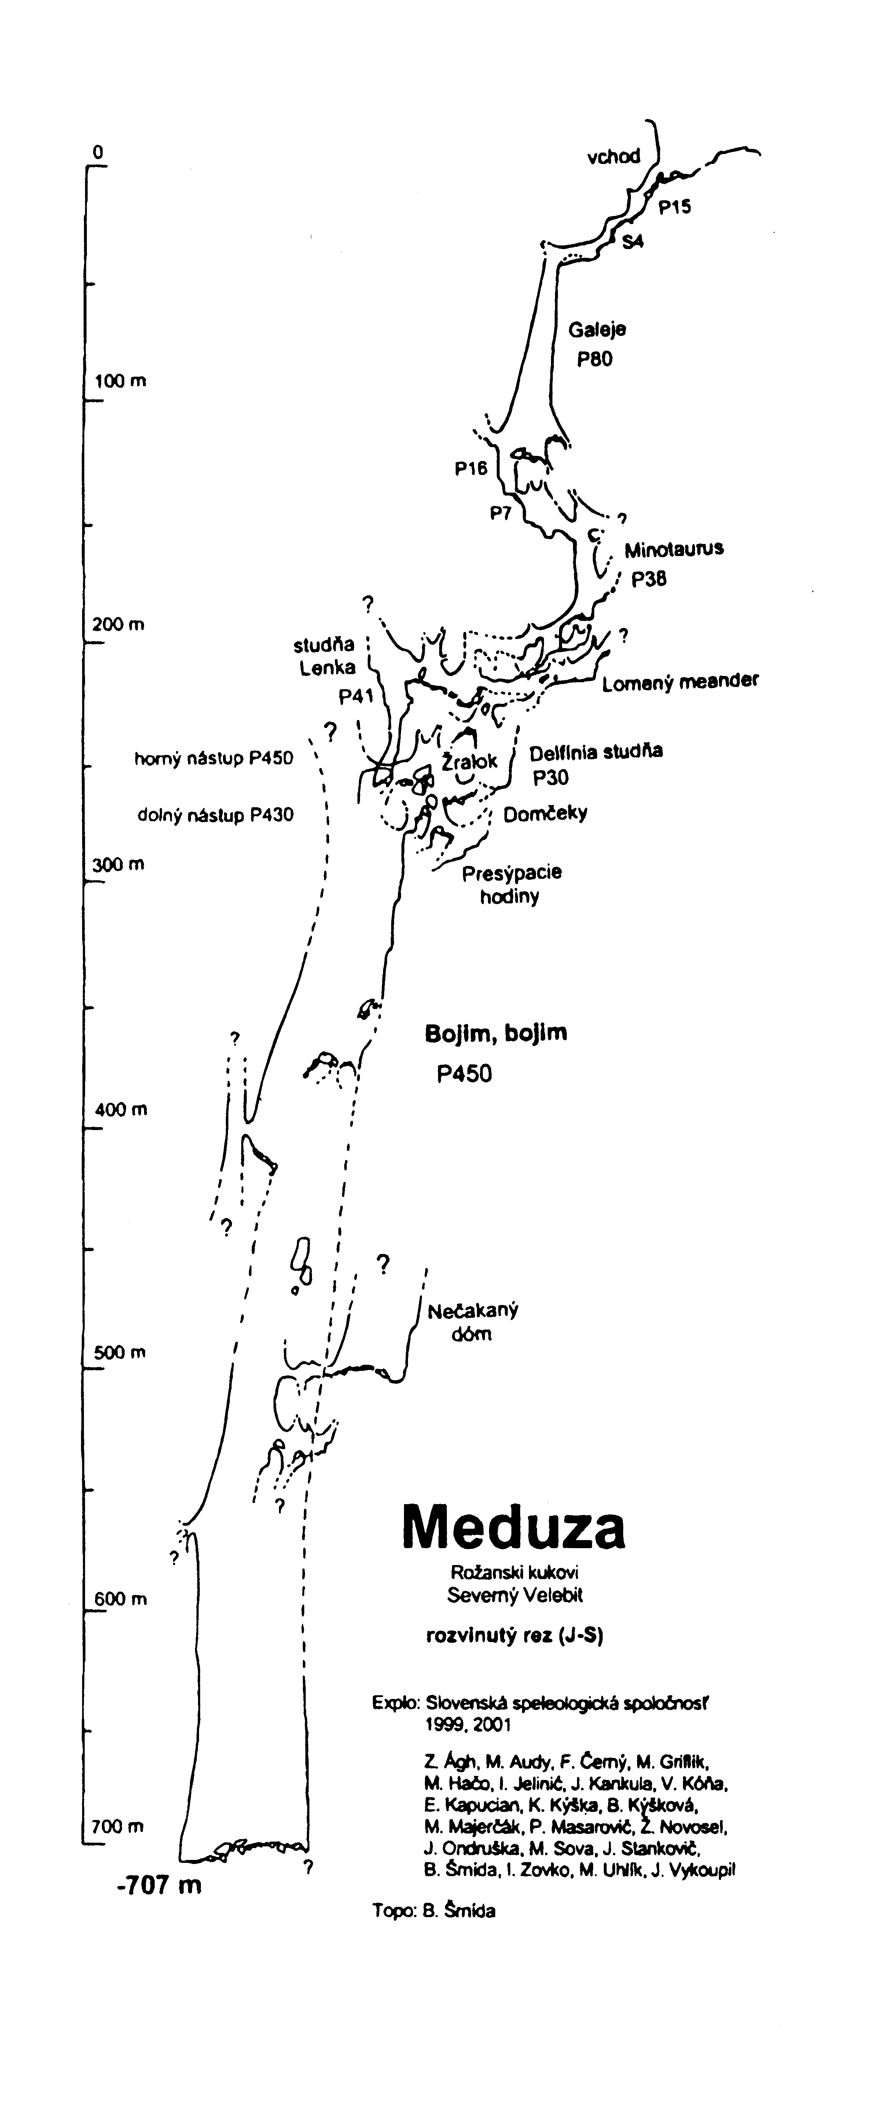
MEDUZA (-707m)
This cave, today the 4th deepest cave of Croatia, was also discovered, the first time climbed and in fact completely explored, almost exclusively by Slovak cavers. The entrance to Meduza (by the way quite resembling to the entrance of Slovačka jama) we found on 28th July 1999 by the duo Branislav Šmída and Jozef Ondruška. The entrance is situated at Rožanski kukovi, couple tens of meters from the touristic path Premužićeva staza, in the side of not a deep depression, in the altitude 1580 m. The first abseil to the broken entry little shaft of Meduza, to the depth about -30 m, was performed by M. Griflík during the same expedition. The progress was blocked there by a squeeze, from which however some intensive draft blew.
During the next pretentious winter expedition we widened this squeeze with the help of a drill and bullets in the days 16th–17th January 2001, in the composition: J. Stankovič, V. Kóňa, M. Griflík, B. Šmída, E. Kapucian and Z. Ágh (all six from Slovak speleological society), while B. Šmída abseiled further through dimensional shaft (P80), where at it's bottom, after short raking among blocks, he got to position where he was above another smaller step (P7) in the depth -145 m, where the cave evidently continued by the hall-like widening and by the black crevice.
During the next summer, during the complex expedition we continued in the detailed survey of the abyss Meduza (as the original work name we used at first also the name "The second"). On 7th August 2001 B. Šmída and K. Kýška abseiled to -200 m. The first one managed to pendulate at the bottom of the impenetrably narrow shaft to a window and he managed to climb from there through some pretentious squeezes to the beginning of some meander with long echo... The next progress was performed on 8th August by the Moravian photographer M. Audy, who continued alone through the narrows to the labyrinth of passages and lower areas behind the Žralok meander, up to depression collapse halls (Domčeky, Houses) in -260 m. F. Černý with K . Kýška on 9th August found in the narrow of the bottom of these halls the entry to a very deep well... On 10th August this, really immensely deep, and somewhere really big-profile (up to 15–20 m) well was passed through for the first time by J. Ondruška and by P. Masarovič, who used about 300 m of ropes in it, but in spite of that they did not barely see any bottom... The abyss was called for it's enormous dimensions as "Bojim, bojim", or I am afraid, I am afraid (Šmída, 2002a, b).
The bottom of this monstrous shaft (in the profile up to 15 x 50 m!), which is also the definitive bottom of the abyss Meduza in the depth -707 m, was reached the first time by B. Šmída and by K. Kýška, on 11th August 2001.
During this actions we performed also the making of a remote bivak at the bottom of the abyss: M. Griflík, J. Ondruška and M. Uhlík, who tried to probe in the debris of the bottom, but without any success, and on 15th August B. Šmída with P. Masarovič pendulated to the windows which were positioned somewhere in the depth under -500 m. These windows were later explored by M. Sova, again with the assistance of P. Masarovič (16th August), when the bottom of the parallel well Nečakaný dóm was found. In the same day B. Šmída and F. Černý found the higher entrance to the well Bojim, bojim.
Croatian cavers with the assistance of the French cavers re-explored the abyss Meduza in the year 2003. However without progress further to the depth, neither in other aspects this numerous action to the abyss Meduza, reportedly of 59 members, did not bring any remarkable progress. (The participants reportedly did not even find the upper entrance to P450 Bojim, bojim.)
The shaft Bojim, bojim (P450) is today the second deepest direct vertical inside a cave in the world. (In the time of the discovery it was even the first one.) The deeper one is only the shaft so called Divka Gromovnica (P513), which was found in the abyss Jama Velebita (-580 m), accidentally just in the neighboring massif Crikvena, by the cavers from Zagreb in 2003.
However! Above the upper entrance to the well Bojim, bojim (the lower has the vertical P430 deep) there is a high chimney (in fact a shaft, just aiming upwards...), where it is possible to illuminate it at least further 30 m to plus...

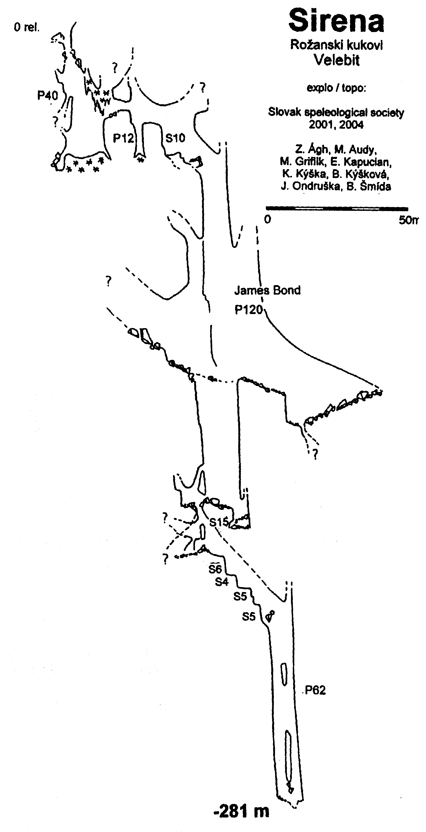
SIRENA (-281 m)
Also the entrance to Sriena this was discovered by Slovak cavers. It was 13th August 2001 when B. Šmída climbed through one of the depressions of Rožanski kukovi and he got to some kind of valley where there was cold air flowing out of there and where some more alive moss grew. (By this moss the work name of the location was "Moss slope"). The first exploration was done here by B. Kýšková and K. Kýška, they abseiled only to about -30 m. More serious exploration of this location again by the team composed almost exclusively from Slovak cavers (Z. Ágh, M. Griflík, E. Kapucian, J. Ondruška, B. Šmída, plus the Moravian caver M. Audy) was performed during the next pretentious expedition in the days 5th–8th January 2004. The bottom of this abyss was reached in the depth
-281 m by J. Ondruška, on the 7th August (Šmída, Audy, 2004).

LEDENA JAMA (S.U.K.)
U LOMSKOJ DULIBI (-536 m)
In 1992 we found at the bottom of the hollow basin of Lomska duliba also extensive cave depression (50 x 60m). This abyss was preliminarily explored before us, longer time ago, however only into the depth of -62 m where the progress was blocked by the icy filling. However we found holes and passes in this icy cone melted after time by the draft and so on the 6th October 1992 the trio Z. Ágh, I. Ághová and E. Kapucian abseiled even deeper, to about -90 m, to the place where there was a huge deep well with an unknown depth... This 180 m deep shaft, somewhere over 20 m wide in profile, was penetrated by the duo Z. Ágh, M. Griflík (on expedition 1993). There is a huge dome down there, 50 x 80 m, with the ceiling impossible to illuminate, and at it's end there was a series of smaller wells, where we reached the depth -432 m, during this action, after three abseils, on the 18th September by the group of four M. Griflík, Z. Ágh, L. Plučinský and B. Šmída (Jalžić et al.,1994). The abyss was re-explored later by cavers from Karlovac, who in 1996 penetrated through the bottom narrow to another well (P63) and they introduced the final depth -536 m (Jelinić, 2001).

OTHER REMARKABLE RESULTS OF SLOVAK CAVERS IN VELEBIT
Another important location, which was discovered and explored by Slovak cavers at Rožanski kukovi (partial massif Vratarski kuk, 1676 m), is also the abyss Xantipa, -323 m deep (Šmída, 1994a). It's unusualy great entry, in the form of giant mega-depression with the outer diameter almost 300 m and depth 150 m was found on 23rd July 1994 by Ján Vykoupil and Branislav Šmída. The abyss in which there is the well 210 m deep, dangerously covered with ice, was explored by us in 1994 and in 1995. Another interesting abyss named Marianna (-250 m) was found by Erik Kapucian and by Croatian female caver Sanja Cirić. In the year 1996 the brothers J. and M. Kankula widened some narrows here, and so they made available the pass to the 210 m deep shaft, which had the diameter almost 30 m at the bottom. The bottom was reached on 23rd July 1996 (B. Šmída, J. Kankula). The other relatively deeper abysses in the reservation Rožanski and Hajdučki kukovi, which were discovered by Slovak cavers, and which we did not mention yet are: in the year 1992 – Pavúčia (-112 m); 1993 – Brutál (-108 m), Dvojvchodová (-102 m); 1994 – Uhu (-111 m); 1995 – Obor (-124 m), Hnedá (-101 m), Pri dvoch smrekoch (-100 m).
Until today Slovak cavers, members of the Slovak speleological society from more clubs (mainly however from the Speleoclub of the University of Comenius Bratislava) explored about 150 caves and abysses in the northern Velebit (which is at least half of the total number!!, if not more than half of the number of all the know localities here...). These results were published in the complete monograph (Šmída et al., 1999) as well as in ten articles, in Slovak, Croatian, Czech, French, or English speleo-magazines, from which only the most important are mentioned here (in chronological order):

BIBLIOGRAPHY
ŠMÍDA, B. (1991): Velebit ’90. Speleofórum, 10, Česká speleologická společnost, Brno, 47–48.
ŠMÍDA, B. – ÁGH, Z. (1993): Velebit ’92. Speleofórum, 12 (April 1993), Česká speleologická společnost, 51–52.
ŠMÍDA, B. (1994a): Les résultats des spéléologues slovaques. In: Božić, V.: Lukina jama – les plus profond gouffre de Croatie. Spelunca, 58, Fédération francaise de spéléologie, Paris, 16–20.
ŠMÍDA, B. (1994b): Croatia – Velebit 94. The caving scene. International Caver Magazine, 12, Swindon, 38–39.
ŠMÍDA, B. (1994c): Expedícia VELEBIT ’94. Summary of results of Slovak speleological exploration activities in the northern Velebit Mts. (Croatia). The research expedition Velebit ’94. Spravodaj SSS, 25, 3, Slovenská speleologická spoločnosť, Liptovský Mikuláš, 4–5.
ŠMÍDA, B. (1994d): Manual II ili Trojama. Xantipa. Velebiten, 16, Speleološki odsjek PDS Velebit, Zagreb, 22–24.
JALŽIĆ, B. – LACKOVIĆ, D. – ŠMÍDA, B. (1994): Lomska duliba ’93. Speleolog, 40/41, Speleološki odsjek HPD Željezničar, Zagreb, 5–16.
ŠMÍDA, B. (1996): Tragom tisućica u Hrvatskoj: Kako je bila otkrivena Lukina jama. Kako je bila otkrivena i istražena jama Manual II. Slovačka jama. Velebiten, 24, Speleološki odsjek PDS Velebit, Zagreb,1–14.
ŠMÍDA, B. (1997a): Slovačka jama. Un nouveau -1000 m du karst méditerranéen. Spelunca, 67, Fédération francaise de spéléologie, Paris, 40–44.
ŠMÍDA, B. (1997b): Second deepest cave in the Balkans – Slovačka jama (Croatia). International Caver Magazine, 20, Swindon, 27–31.
ŠMÍDA, B. (1997c): Slovačka jama (-1000 m), druhá najhlbšia priepasť Balkánu. Speleofórum, 16 (April 1997), Česká speleologická společnost, Praha, 45–47.
ŠMÍDA, B. (1999): Expedícia Slovačka jama ’99. Spravodaj SSS, 30, 4, Slovenská speleologická spoločnosť, Liptovský Mikuláš, 40–55.
ŠMÍDA, B. et al. (1999): Velebit. Reportáž z objavovania hlbokých priepastí Chorvátska v rokoch 1990–98. Slovenská speleologická spoločnosť, Liptovský Mikuláš, 1–116.
BAKŠIĆ, D. – JALŽIĆ, B. – ŠMÍDA, B. – LACKOVIĆ, D. (1999): Slovačka jama. Speleolog, 44/45, Speleološki odsjek HPD Željezničar, Zagreb, 3–12.
BAKŠIĆ, D. – ŠMÍDA, B. (1999): Kako su nastali nazivi u Slovačkoj jami. Velebiten, 30, Speleološki odsjek PDS Velebit, Zagreb, 36–38.
ŠMÍDA, B. (2002a): Velebit 2001 – o objave najhlbšej vnútrojaskynnej vertikály sveta Bojim, bojim v priepasti Medúza (-707 m). Speleofórum, 21 (April 2002), Česká speleologická společnost, Praha, 49–50.
ŠMÍDA, B. (2002b): Expedícia Velebit 2001. Spravodaj SSS, 33, 1, Slovenská speleologická spoločnosť, Liptovský Mikuláš, 21–29.
ŠMÍDA. B. – AUDY, M. (2004): Velebit 2004 – nová priepasť Siréna (-281 m). Speleofórum, 23 (April 2004), Česká speleologická společnost, Praha, 52–54.

THE DEEPEST ABYSSES OF ROŽANSKI AND HAJDUČKI KUKOVI

 |  | Depth | The first year of discovery
1. | Lukina jama-Manual II * | 1392 m | SSS (1992)
2. | Slovačka jama * | 1320 m | SSS (1995)
3. | Meduza * | 707 m | SSS (1999)
4. | Jama Velebita | 580 m | SOV (2003)
5. | Patkov gušt | 553 m | SOV (1997)
6. | Ledena jama S.U.K. * | 536 m | SOŽ (?)
7. | Olimp | 531 m | SDK (1998)
8. | Lubuška jama | 521 m | SBŻ (2000)
9. | Xantipa * | 323 m | SSS (1994)
10. | Sirena * | 281 m | SSS (2001)
11. | Marianna * | 250 m | SSS (1995)

* – abyss discovered or explored in considerable measure by Slovak cavers

SSS – Slovak speleological society (Slovakia), SOV – Speleološki odsjek PDS Velebit (Croatia), SDK – Speleološko društvo Karlovac (Croatia), SOŽ – Speleološki odsjek HPD Željezničar, SBŻ – Speleoklub „Bobry“ Żagań (Poland)

