ABOUT THE SEISMIC STABILITY OF ANCIENT ENGINEERING CONSTRUCTIONS

Samvel M. Shahinyan

Armenian Speleological Center,
61 Rostomi Str., Yerevan, Armenia
Tel: (374 10) 550986
E-mail: speleo@arminco.com
URL: www.speleo.am

Abstract
In their analyses scientists, examining the consequences of Spitak earthquake, arrived at various conclusions concerning different questions. But they were unanimous on one point. The general quality of engineer works didn’t meet the security requirements of Armenian seismic zone.

But the problem is more serious. In town-planning and different engineering works the geological, seismic, hydro-geological, petrographical structure, the peculiarities of landscape and geomorphological structure of the area were not taken into consideration.

In the given report the author brings up several examples of underground constructions, built from 300-3000 years ago and in spite of the destructive earthquakes preserved till our days. Some of the examples are the Orgov tunnel, II BC, the Ashtarak and Shirak stone-door caves, built 700-3000 years ago, the multi-piece underground settlement in Spitak coming from Middle Ages, the cave settlements of Ani and Akhourian, built 800-1500 years ago, in VII BC built water channel of king Argishti, up to these days irrigating the gardens of Dalma.

The reason of seismic stability and longevity of the ancient constructions was the profound knowledge of nature and its correct use by the builders and the settlers.

The destructive earthquake of Spitak (1988, Spitak, Armenia, 25 000 victims) almost razed to the ground the cities of Spitak and Gyumri. It took 15 years to cover the damage caused in numerous settlements, but the psychological stress people suffered at times still makes itself felt.
The whole process of origination of modern man in the Armenian Highland was accompanied by active geotectonic processes – earthquakes, volcanoes and etc. These geological phenomena as ecological factors have influenced the formation of local population’s mode of life, way of thinking and relations with the surrounding environment.
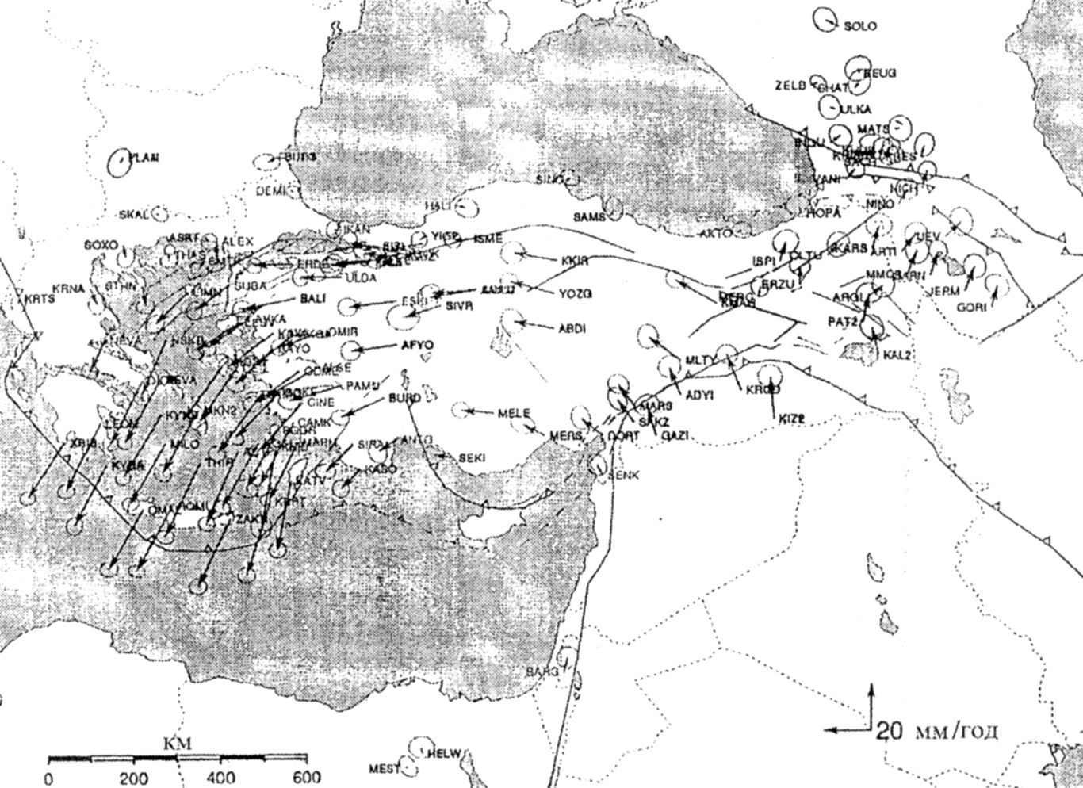
Thr horisontal deformation of surface (GPS). 1991-2002 (reilinger et al,1997)
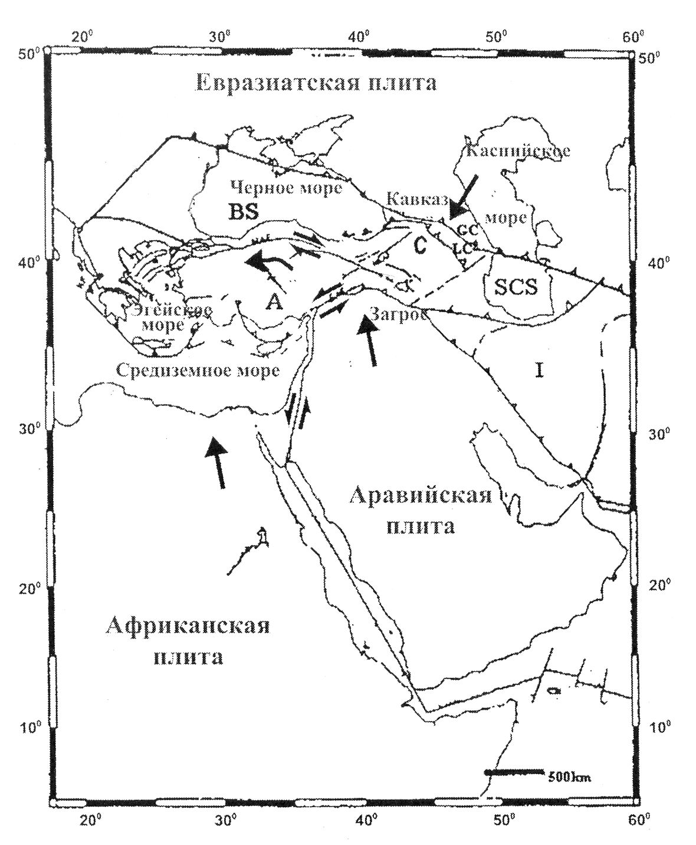
The Caucasus, African-Arabic and Eurasian blacks. Tektonic stability situation.

Pleistocene and Oligocene earthquakes have been common phenomena in the Armenian Highland, which however have played a great role in the fate of the people. The capital cities of Armenia were often moved not because they were invaded by the enemy, but mostly because the natural phenomena made life impossible. Thus for instance in 200 B.C. as a consequence of a destructive earthquake river Araks changed its course, bringing about unbearable conditions for health and the capital city moved from Armavir to Yervandashat. In I B.C. as a consequence of tectonic processes a huge gap opened on the way to Nakhijevan, causing the draining of Ararat lake water, creating arid landscape around Yervandashat and the capital city of Armenia was again moved to Artashat. These geological processes were also mentioned in Strobe’s work “Geography”. In 330-338 A.D. again caused by an earthquake, river Metsamor changes its course and the whole area of Artashat bogs up. They were obliged to once again move the capital city – this time to Dvin. However this area too was in an active seismic zone; in only 42 years from 851-893 there had been 5 destructive earthquakes, during one of which in 893 Garni earthquake there were 120 thousand victims, which makes 5% population of Armenia today. The capital city is then moved to Ani, which however after the 1064 earthquake loses its forts, is captured and destroyed by Turks.
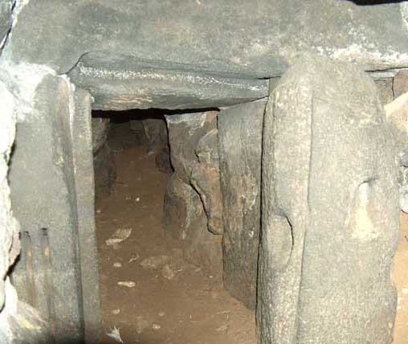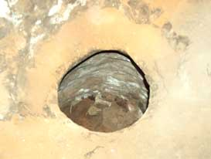
The details of stone door cave.300 B.C. Aragatsotn region

Volcanoes also have been the constant companions in Armenian history. Here are the periods of several volcano eruptions (acc. to A. Kazanchyan) Porak – coordinates (40⁰01¹, 45⁰47¹) the end of V millennium, 780 B.C., Ararat – coordinates (39⁰42¹, 44⁰18¹) middle of XXX millennium, I-IV cc., 1783, 1840, Zschook (35⁰44¹, 46⁰01¹), middle of IV millennium, Vayots mount (39⁰48¹, 45⁰30¹) and Smbatasar (38⁰37¹, 42⁰13¹) 1441 and etc.
Naturally, one who had lived over 10 000 years in such an active geotectonic zone should be able to prevent the destructive influence of earthquakes and volcanoes. We have explored and taken measurements of numerous anthropogenic caves and tunnels, which were built by taking into account the conditions of the surroundings. These caves are valued not only from engineering point of view, but also from archeological point of view, as they were built from 800-4000 years ago. As to compare we will mention that none of the faces and tunnels dug in 1900-1930 is good for usage today, and the Arpa –Sevan 45-km-long tunnel put in 1960’s has been completely repaired 3 times in 400 years.
Stone-Door Caves.
In Armenia these caves are spread in the region of Aragatsotn, in the surroundings of Saghmosavank, Dzorap, Avan, Agarak, Kosh and Ujan villages, also in Shirak region and in the territory of historic Ani. These caves were built in the I millennium B.C. till XVc.; already in XVIIc the historians mention that these type of buildings were no longer built (Artemi from Ararat, S.M. Shahinyan). These are caves that were dug in volcanic rock layers and at first (I-II millennium B.C.) most likely served as mausoleums and parish places, while later (from the middle of I millennium B.C. till XVc.) as storages for keeping food. Some caves are designed for hiding for a long period.
Subterranean Tunnels
Such tunnels come across in the area of almost all Bronze Age fortresses and sanctuaries, however, only very few of them have preserved today. We will present two of them. One is the Anberd secret flee way that lost its military significance in XIIc, the other is the 2-km-long secret tunnel going to the gorge from a Bronze Age Cyclopean fortress.
Anberd tunnel was first explored by Pyatrovski and Ajan, then by Tokarski and at last in 1986, 2002 by the expedition of Armenian Speleological Center. Only 110m of Anberd tunnel were explored, the other two tunnels were little examined. These tunnels were built two-storied. The architectural scheme reminds of a Dolmen building. The cover is from relatively regular 1.5-2.0 m long-slabs, while the sides are from huge rock pieces.
The Orgov Tunnel is an exceptional construction. This was built in the clay layer between two lava layers. The builders must have known very well the surrounding environment and the geology of this mountainous area. This is why despite the building being over 3000 years old, it’s over 80 m long section has wonderfully preserved up to our days.
Having observed these constructions we think that it would be right for the engineers to examine today the experience of our forefathers and apply it in construction today. A thing that should solve some seismic security problems.

Bibliography
- Abich G.V. ‘Volcan de Tondourek“ Ibid VII, St. Petersburg, 1867, p. 34
- Aslanyan A.T. “The Regional Geology of Armenia’, “Haypethrat”, 1958, Yerevan, p 430 (in Russian)
- Balasanyan S., Nazaryan S., Amirbekyan V., ‘Seismic Protection and its Organization” , “Eldorado 2005”, Gyumri, Armenia, p. 437
- Hovhannes Draskhanakettsi, “History of Armenia”, “State University”, 1996, Yerevan, p 397
(in Armenian)
- Memoirs of the Life of Artemi of Wagarschapat , near mount Ararat in Armenia, from the original Armenian written by himself, London, 1822, p. 136.
- Moses Kaghankatvetsi, “History of Aghvan Land”, “Hayastan”, 1969, Yerevan, p 321 (in Armenian)
- Movses Khorenatsi, “History of Armenia”, “Hayastan” 1990, Yerevan, p 320 (in Armenian)
- Oswald F.F., “Treatise on the Geology of Armenia” , London, 1907
- Shahinyan S. M., “About the Seismic Stability of Ancient Engineering Constructions in Aragatsotn Region”, the V Congress of ASG, 2005, Yerevan
- Shahinyan S.M. Cave Dwellings with Stone Doors”, UIS X Congress, 1989, Budapest
- Stepanos Orbelyan, “History of Syunik”, “Sovetakan Grogh”, 1986, Yerevan, p 616 (in Armenian)

