The Discovery of VII-XII cc Underground Churches and Settlements in Qasharagh by the 2002-2003 Expedition of ASC

Samvel M. Shahinyan

Armenian Speleological Center,
61 Rostomi Str., Yerevan, Armenia
Tel: (374 10) 550986
E-mail: speleo@arminco.com
URL: www.speleo.am

Abstract
The ASC expedition of 2002-2003 discovered and marked five rock-hollowed churches, four rock-hollowed protective complexes, over thirty dwelling complexes in Qashatagh (former Lachin). Here of significant importance are the monastic complexes of Qron and Hochants, of which evidence the Armenian Medieval historian Stepanos Orbelian (XII c) and the VII c cuneiform cave.
The inscriptions coming from the assumed Roussa II king of Van kingdom and the Medieval rock-hollowed Hochants and Qronk churches are of great archeological importance, as here is situated the I c Tsiternavank, the most ancient famous Christian church of Armenia.
The Temple of Hochants
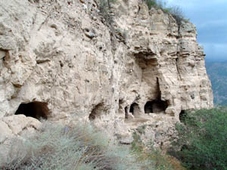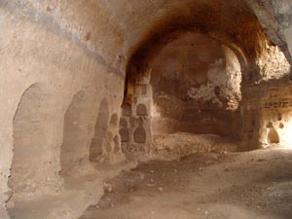

The temple of Hochants is situated near village Hochants, 20km towards northeast from Goris. Two big halls have preserved from the big church complex, evidenced by the medieval Armenian historians, among them Hovhannes Draskhanakertsi, Movses Kaghankatvetsi, Stepanos Orbelyan, etc. The temple has had two more halls, of which only ruins have preserved. There are numerous pilgrimages around the temple, different settlements and buildings of civilian significance. At first the temple was two-story, but later, in the XII century it was remodeled into a one-story big construction.
The inside of the church is typical to the XI-XIV cc Armenian churches, (for comparison see Geghard, Kobayr monasteries).

The cave was discovered on July 23, 2002. It is situated 18km towards south from Berdzor, on the left bank of the river (near the settlement called “Stroyka”). On the right side of the cave entry there are relief inscriptions, one of which is from Van kingdom period, 720BC, cuneiforms, and the inscriptions reminding of some letters are thought by some scientists as Aghvan letters. As a consequence of many battles from Karabagh war, the cave has suffered greatly. During the 90 years of exploring the caves of Armenia, there have been but few caves discovered with inscriptions. Caves containing non-Armenian inscriptions do not exceed 10. According to the studies it may be supposed that; 1. The cave has been a small mausoleum, VIII c B.C., 2. Next to the cuneiform inscriptions new letters were inscribed, 3. During the Christianity period, the altar of the above picture was dug, 4. in XII-XIVcc the rest of the territory was dug.
The holicave of Kingdom of Biaina (720 B.C.)
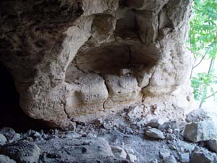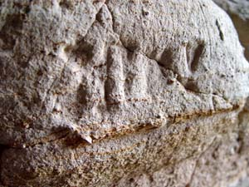

The Church of Qashatagh
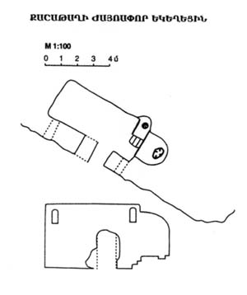
This small, but very beautiful church is dug into sediment hard rocks. In the geological layers there is much carbonates. The church was dug in one attempt, the builders had the plan in their mind and closely followed it. The area selected for the construction is isolated and unique. The church was dug in separate rock pieces, taking into account the peculiarities of the surroundings and of the landscape. Towards southwest, on the bank of the river there are dug halls, traces evidencing that here once has been a religious place. It joins the church harmoniously, making a unique ensemble.
In 1994 the Armenian Speleological Center expedition with Samvel Karapetyan in the head have carried out different works on the cave.

The Temple Krunk (from Tsakhkaberd)

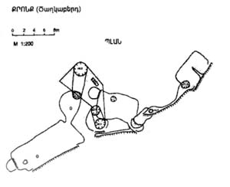

This rock-dug complex is situated on the right bank of Hakari river, 2 km towards south-west from Tsaghkaberd village. Over the rock-walls open numerous cave openings, of which are worth mentioning the inhabitable cave complex and the small rock-dug church on the slopes of the opposite rock. With a high roof and correct geometrical synthesis, the church was built with an excellent knowledge of the area. It seems like the church was built in one attempt with a detailed plan from the beginning. Every single detail on the church evidences that the person who ordered it was someone in power and was far-sighted.

Bigliography
- Hovhannes Draskhanakettsi, “History of Armenia”, “State University”, 1996, Yerevan, p 397
(in Armenian)
- Moses Kaghankatvetsi, “History of Aghvan Land”, “Hayastan”, 1969, Yerevan, p 321 (in Armenian)
- Movses Khorenatsi, “History of Armenia”, “Hayastan” 1990, Yerevan, p 320 (in Armenian)
- Stepanos Orbelyan, “History of Syunik”, “Sovetakan Grogh”, 1986, Yerevan, p 616 (in Armenian)
- S. Shahinyan, New Archeological Evidences from Kashatagh, Handes Amsorya, 1-12, 2002, Mkhitaryan Press, Vienna, 2002
- S. Shahinyan, The Caves of Hochats River Basin, Hayatsk Yerevanits, # 11, November 2002, Yerevan, p. 25 (in Armenian)
- S. Shahinyan, The Cave Pilgrimages and Settlements of Kashatagh, Hayats Yerevanits, # 10, October 2002, Yerevan, p. 21 (in Armenian)

