Cave Man of XXI c

Samvel M. Shahinyan

Hasmik Ghazaryan

Armenian Speleological Center,
61 Rostomi Str., Yerevan, Armenia
Tel: (374 10) 550986, (374 91) 378842
E-mail: speleo@arminco.com, hasmik_no1@rambler.ru
URL: www.speleo.am

Abstract

The last cave-dwellers of Armenia moved to regular houses in 1961. Though recently an interesting phenomenon is observed. At least 40 cases are known when people, who have houses with all the modern conveniences, return to cave life again. In fact, some of them dig large, comfortable and multifunctional constructions according to their taste and intentions.
The resident of Arinj village Levon Varazdat Arakelyan started digging potatoes and cabbage in his cellar for protecting from cold and forgetting about the primary intention, continued digging.
With no modern digging or punching instruments, using only chisel, pick and hammer, today he has already dug 7 rooms, 26m deep, with 500m² total surface, which are connected to each other by tunnels and staircases. In fact, the central big hall is 12m high and is built in the form of a church.
It’s noteworthy that this latter day miner has secondary education and has never dealt with engineering sciences; he doesn’t know geology, geophysics, mining, topography, geodesy, etc.
Nevertheless, this has not hindered the corridor labyrinth to connect to the rooms to millimeter’s exactness.
Levon Arakelyan insists that his activities are conditioned by communicating with the Holy Spirit and he is sure that till the end of his life he will have dug 100 rooms.
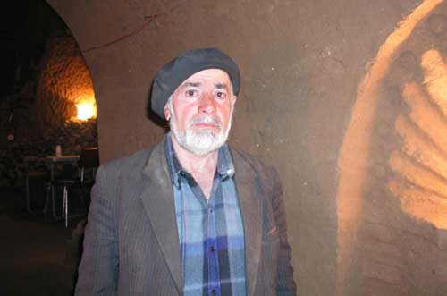

In 1985 Levon Arakelyan, as he himself states, had a dream saying that he had to dig a cave. This was the strange beginning to latest cave-building.
After that Levon Arakelyan, without any electric or mechanical machines, using only chisel and hammer started digging rooms. Even if he wanted to, he couldn’t have used electricity, as at that period there was no electricity in Armenia; Armenia was occupied.

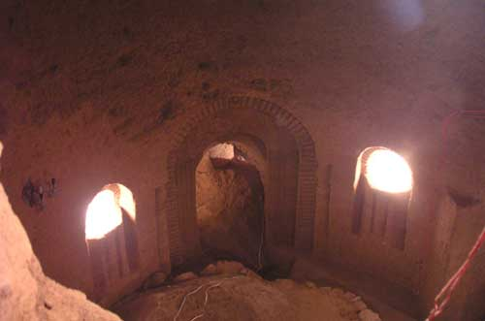
The biggest hall that he has dug is 10m high and 15m diameter at the basis. The big hall is dug in three layers.
The top layer Q₄ holocene volcano-sediments, the middle layer Q₁ (pleistocene) clay, that have marine origination, and the lower layer conglomerate of clay sediments.

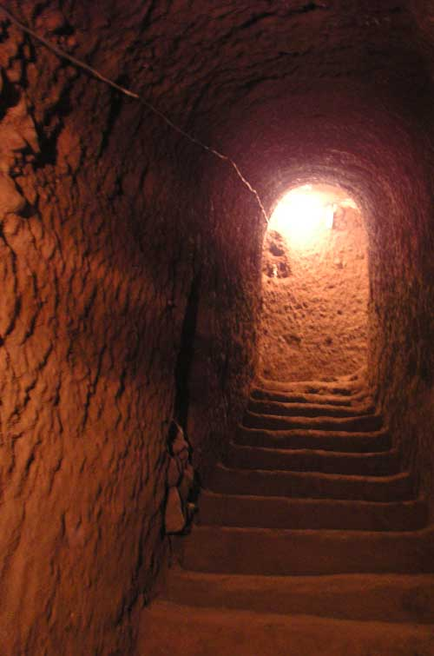
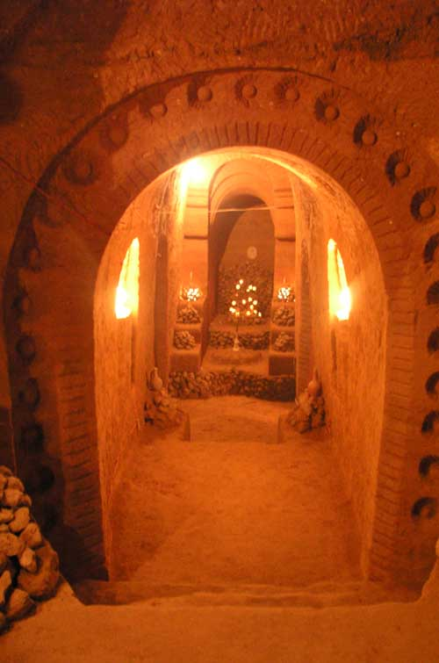

The staircase goes down 27m deep, where the temperature is never higher than 9⁰ C. The corridors lead to over 10 different rooms. The length of the corridors is over 200m. All this was dug by one person in the period of 20 years without using any techniques. It has now become a sightseeing place as for the locals, so for the foreigners to come and admire the amazing cave work. In 2005 Levon Arakelyan was awarded with the title of a deserved cave-expeditors.

