Experimental research using
Thermography
To locate heat signatures from caves

Jim Thompson and Murray Marvin

Jim Thompson Murray Marvin

1 Jim Thompson Way 621 S.W. Alder Street Suite 200
Blackwell, MO 63626 USA Portland, Oregon 97205 USA
disasterjim@aol.com murray@murraymarvin.com
(800) 839-6789 (800) 247-5404

Abstract

Thermal differences between cave entrances and the surrounding landscape have long been known. Cavers traditionally ridge walked in cave-likely temperate regions in cold mid-winter with a falling barometer in order to visually detect ‘fog-plumes’ of escaping subterranean air from crevices in order to locate caves. We are experimenting with a high-technology solution to this cave detection method by applying infrared thermography, a useful tool in fire detection, human body location and other building examination remote sensing to the surface of the earth. Early trials during the spring of 2005 with a Therma CAMTM B20 HSV infrared (IR) camera, even under foliage-filled and warm atmospheric conditions, produced promising results in initial trials in New Mexico, Missouri and West Virginia. Further research is underway at Fisher Cave, Franklin County, Missouri.

This research began by documenting temperatures of cave openings and surrounding substrates. Atmospheric, ambient conditions (temperature, relative humidity, specific humidity and dew point) were recorded inside the cave, at the entrance and at intervals up to 183 meters. Normal images were contrasted with thermograms that showed full temperature gradients of the openings. At 118 meters, the opening could no longer be seen with the naked eye. The thermograms showed distinct images of cave openings. Trials continued to 388 meters. In excess of 300 meters, thermograms showed the distinct cave opening of Fisher Cave. At 388 meters, the thermograms showed signatures that could be that of a cave entrance. The initial results indicate that individual cave entrances have separate and unique temperature gradients. Thus, individual cave thermograms are a “fingerprint” or signature of that cave. Thermograms can be used to isolate and identify caves entrances from surrounding terrain. Once standardized procedures are established, thermograms may become an important tool for cave location and exploration.

Introduction

Thermography is a type of infrared imaging. Thermographic cameras detect radiation in the infrared range of the electromagnetic spectrum and produce images of that radiation. Since infrared radiation is emitted by all objects at ambient temperature, thermography makes it possible to "see" ones environment with or without visible illumination. The amount of radiation emitted by an object increases with temperature.Thermography allows visualization of variations in temperature. With a thermographic camera warm objects stand out well against cooler backgrounds.
Thermographic technology has advanced considerably in the last few years. Current uses include building-energy audits, building diagnosis, medical applications, fire detection, military night vision, computer heat scans, industry, surveillance and other utilitarian uses where heat production and dissipation are a factor. We hypothesize this technology can be used under the correct conditions to locate potential caves by taking thermograms of land masses such as hillsides and valleys while looking for heat signature changes in the images which would reveal cave openings, swallets, seeps and other karst features.
Overview of Theoretic Thermography. ³
There are three methods by which heat flows from one object to another—radiation, convection and conduction. IR viewers are concerned with radiation effects, but the others cannot be neglected. In radiation, electromagnetic energy is actually emitted by an object or gas. ²
Heat measurement devices are either contact or non-contact devices. Infrared Imagers observe and measure heat without being in contact with the source and rely largely on radiation. The infrared camera used in this experiment generates a digital false-color image of the view being examined using IR sensors in the place of normal visual-range detectors. Thermography makes use of the infrared spectral band. At short-wavelength end the boundary lies at the limit of visual perception, in the deep red. At the long-wavelength end it merges with the microwave radio wavelengths. The unit relationship between the different wavelength measurements is: 10 000 Å = 1 000 nm = 1 µ= 1 µm.

The Infrared Spectrum
Every animate or inanimate body that exists emits infrared energy from its surface. This energy is emitted in the form of electromagnetic waves that travel with the velocity of light through a vacuum, air, or any other conductive medium. Whenever waves fall on another body, which is not transparent to the eye, they are observed and their energy is reconverted into heat. The difference between a cold or hot body is the level at which it both emits and absorbs energy. If the body absorbs more energy than it radiates, it can be considered cold. If the body tends to emit more energy than it absorbs, it is considered hot. The state of being hot or cold is a dynamic state. If a body is allowed to equilibrate with its surroundings, the emission and absorption will become equal and the body will be neither hot nor cold.

Measurement Principles

All materials above absolute zero emit infrared energy. Infrared radiation is part of the electromagnetic spectrum and occupies frequencies between visible light and radio waves. The infrared part of the spectrum spans wavelengths from 0.7 micrometers to 1000 micrometers (microns). Within this wave band, only frequencies of 0.7 microns to 20 microns are used for practical, everyday temperature measurement.
Though IR radiation is not visible to the human eye, it is helpful to imagine it as being visible when dealing with the principles of measurement and when considering applications. In many respects, IR and visible light are similar. IR energy travels in straight lines from the source and can be reflected and absorbed by material surfaces in its path. In the case of most solid objects that are opaque to the human eye, part of the IR energy striking the object's surface will be absorbed and part will be reflected. Of the energy absorbed by the object, a portion will be re-emitted and part will be reflected internally. This also applies to materials that are transparent to the eye, such as glass, gases and thin, clear plastics, but some of their IR energy will also pass through the object. These phenomena contribute to what is referred to as the emissivity of the object or material.
Materials that do not reflect or transmit any IR energy are know as “blackbodies” and are not known to exist naturally. However, for the purpose of theoretical calculation, a true blackbody is given a value of 1.0. The closest approximation to a blackbody emissivity of 1.0, which can be achieved in real life is an IR opaque, spherical cavity with a small tubular entry. The inner surface of such a sphere will have an emissivity of 0.998.
Different materials and gases have different emissivities, and emit IR at different intensities for a given temperature.

Theoretical Basis for IR Temperature Measurement

Thermography (infrared thermal scans) uses specially designed infrared video or still cameras to make images (called thermograms) that show surface heat variations.
The formulas upon which infrared temperature measurement is based are old, established and well proven. Theoretic physical laws invoked by thermography include:
- Planck's Equation: Describes the relationship between spectral emissivity, temperature and radiant energy.
W_{λb} = $\frac{2π{\text{hc}}^{3}}{λ^{5}\left(e^{\text{hc}{λk}^{T}}−1\right)}x$ 10⁻⁶ $\left[\text{Watt}m^{2}μm\right]$ (Eq. 1)

where: W_{λb} is the blackbody spectral radiant emittance at wavelength λ, c is the speed of light, h is Planck’s constant, k is Boltzmann’s constant, T is the absolute temperature (K) of a blackbody and λ is the wavelength in μm.
- Stephan Boltzmann Law: The hotter an object becomes the more infrared energy it emits.
W_{b} = σT⁴ [Watt/m²] (Eq. 2)

where the total radiant emittance is integrated from λ = 0 to λ=∞.
- Wien's Displacement Law: The wavelength at which the maximum amount of energy is emitted becomes shorter as the temperature increases.

λ_{max} = $\frac{\text{2898}}{T}\left[μm\right]$ (Eq. 3)
- Kirchoff's Law: When an object is at thermal equilibrium, the amount of absorption will equal the amount of emission.

α = ε (Eq. 4)

The theoretic functioning of the thermographic camera is best explained by the following diagram²:
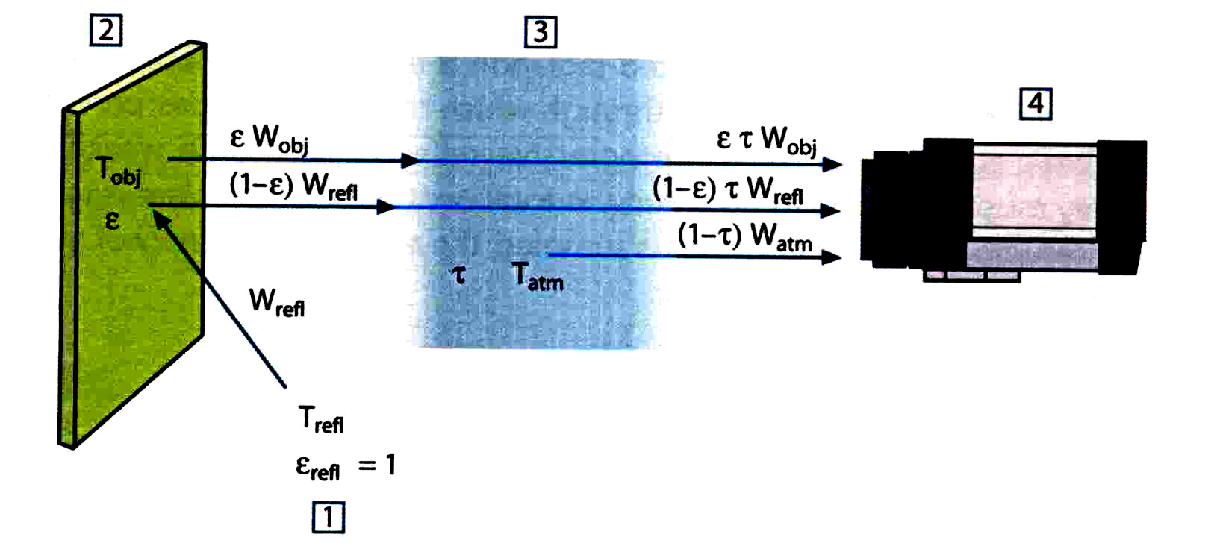
Figure 1. Schematic showing a generic thermographic imaging situation. 1: Surroundings; 2: Object; 3: Atmosphere; 4: Camera.

Assume that received radiation power W from a blackbody source of temperature T_{sourrce} on short distance
Generates a camera output signal U_{source} that is proportional to the power output (power linear camera). We can then write Equation 5:
U_{obj} = $\frac{1}{εΤ}$U_{vol} – $\frac{1−ε}{ε}U$_{refl} - $\frac{1−T}{εΤ}U$_{atm} (Eq. 5)

Where the operator has to supply values for object emittance $ε$, relative humidity, T_{atm}, object distance (D_{obj}), the effective temperature of the object surroundings, or the reflected ambient temperature T_{refl} and the temperature of the atmosphere T_{atm}. ²

Speleology and Thermography
The natural meteorological conditions of temperate latitude caves make infrared thermographic investigation possible. Differences in temperature and humidity make cave entrances discrete from the surface, and visible to thermography. As the inside of the cave maintains a constant temperature and the outside ambient temperature fluctuates with the seasons the cave entrance temperatures are normally different then outside conditions. It is this premise that directs this research. Moore and Sullivan put this most succinctly:
“The air in most caves is nearly saturated with water vapor – in other words, the relative humidity is close to 100 percent. This is so because seeping water moistens the ceilings, wall, and floor and that the air must pass by as it moves slowly through the cave. The constant temperature of the inner part of the cave permits this high humidity to be maintained indefinitely.
Near the entrances to caves, however the humidity may be lower, partly because the outside humidity is usually lower, and partly because the cave temperature differs from the outside temperature.
In the summer, warm air entering a cool cave soon becomes saturated without absorbing water from the cave walls. In the winter the air becomes warmer as it enters the cave, and for a short distance its relative humidity falls.”⁴
Research assumptions:
- Cave entrance substrate temperatures are normally different from other outside substrate temperatures. The air blowing from a cave or into a cave is at a different temperature and humidity level than the outside ambient temperature and humidity.
- Cave humidity alters moisture on cave entrance substrates compared to other surface substrates.
- An infrared camera measures and images the emitted infrared radiation from an object. Since radiation is a function of object surface temperature it is possible for the camera to calculate and display this temperature.
- Cave entrances can have their surface temperatures displayed by thermo imaging infrared camera.
Trial Location

Fisher Cave is a lantern-toured show cave located in Meramec State Park, Franklin County, Missouri, USA. The cave entrance is approximately 3 m high by 11 m wide, gated, and easily accessible. This wide mouthed cave entrance allows ample atmospheric exchange. The cave entrance is at a slightly oblique angle to its containing bluff, making it ‘vanish’ visually within a short distance, despite proximity to a parking lot. These factors selected it as our experimental site. One set of thermogram/normal photos is included from the mouth of Carlsbad Caverns for comparison.

Materials

The camera used for this research is the Therma CAMTM B20 HSV, which is the most sophisticated of the infrared-thermographic image cameras made by the FLIR Company. A steady tripod was necessary to get accurate signatures.

Nikon D1X Camera and lenses.

Delmhorst HT 3000 A Thermo Hygrometer & Dickson TH 550 Thermo Hygrometer to measure temperature, humidity and dew point at cave entrances and distances from the entrance.

Data Log Recorders (HOBO brand: timed temp, dew point, relative and specific humidity at prescribed intervals and distances from the entrance.)

Fluke 52 II Thermometer and Thermocoupler to measure temperature readings of the substrates at cave entrances and stream water temperatures.

Methods

Radiation measured by the IR camera not only depends on the temperature of the object but is also a function of emissivity. Radiation also originates from the surroundings and is reflected by the object. Radiation from the object and the reflected radiation will also be altered by atmospheric adsorption. We consulted C. Warren Campbell on our methods. ¹

To measure temperature accurately, one must compensate for the effects of different radiation sources. This is done electronically and automatically by camera. The following parameters must be supplied for the camera:

- The emissivity of the object
- The reflected temperature
- The distance between the object and the camera
- The relative humidity

These parameters were established for the IR camera with the use of handheld thermo hygrometers at the cave entrances. Data loggers were then set up to ensure accurate monitoring during the thermography, and to provide data for the FLIR camera manufacturer, which is in process of establishing standard emissivity tables for limestone based on this research.

Results

Measurements at the entrances of known caves for temperature, relative humidity and dew point were taken at different distances from the entrance for the caves and locations. The data were used to calibrate the B20 HSV. A tripod was required for steady images as the B20 HSV does not have a fast “shutter speed.”

On May 11, 2005 with a cloudy sky and recent light rain, Fisher Cave had a entrance temperature of 16.4 C (61.6 F) with Relative Humidity (RH) of 66.8%, Dew Point (DP) 10 C (50.2 F) with a substrate at entrance temperature of 19.2 C(66.5F). Ambient conditions at 15.2 m (50 ft.) from the entrance-were 15. 6C (60.1 F), RH of 62.4% DP C (46.2 F). At 182.9 meters from the entrance (600 ft.): Temperature 26.4 C (79.5 F) RH 20 DP (68 F)

At 118 meters, the opening could no longer be seen with the naked eye. The thermograms showed distinct images of cave openings. Trials continued to 388 meters. In excess of 300 meters, thermograms showed the distinct cave opening of Fisher Cave. At 388 meters, the thermograms showed signatures that could be that of a cave entrance

Thus, individual cave thermograms are a “fingerprint” or signature of that cave. Thermograms can be used to isolate and identify caves entrances from surrounding terrain. We found taking the thermograms was easier if the remote control was removed from the camera and used to adjust the setting and take the shots, as it helped reduced camera shake. The resulting thermograms and corresponding visual images are reproduced in Appendix I.

We found we will need to compensate for the following conditions in future trials: a) Shooting thermograms through tree foliage will pick up reflective signatures off the leaves. b) Shadows on hills do not show the same temp gradient as actual cave openings. c) Images without a tripod are susceptible to camera shake thereby altering the image result.

Analysis of the Results

We believe thermography shows great promise as a cave entrance location method. Thermograms will expedite field work in locating cave sites, especially in temperate climates, where the mean annual temperature (and therefore the temperature of the cave air) is stable but local surface atmospheric conditions reflect wide seasonal variation. The ability of a thermogram to penetrate vegetative cover (once we learn to norm for reflective signatures) may turn ridge walking into a year round activity, not one confined to late fall through early spring. Thermographic imaging may be useful in recording cave entrance meteorological data as it relates to monitoring trogloxene and troglophile species.

Conclusion

Thermography can be applied when seeking unknown caves by photographing larger land mass areas such as hillsides and aerial perspectives. This paper documents fundamental field research done to demonstrate this technology is a viable tool to assist scientists in finding caves and other karst features. As this technology and its field use improves, so will its efficiency. As an ongoing project our fieldwork is establishing baseline standards for professional use.

Acknowledgements

Thanks are due to the following people for technical assistance and advice:

Scott Fee, President National Speleological Society (NSS), Gordon Birkhimer, Executive Vice President NSS,

Dr. Malcolm Field, US Environmental Protection Agency; Dr. Barbara am Ende; Dr. Warren Campbell, CCKS, Western Kentucky University; Azar Louth; Dan Jarvis; John Frocot and David Doerhoff, FLIR Systems Inc.- USA; Per Fostvedt - Infrared Systems Inc.; Jim Holland, Rest Con Environmental; Dave Bunnell, Editor, NSS News: Gregory (Tex) Yokum – who first taught us to look for caves “breathing ” fog plumes in winter. Special thanks go to Jo Schaper, Associate Editor, Missouri Speleology, for editing and formatting assistance.

The field assistance of these people is gratefully acknowledged:
Dr. Barbara am Ende, Gordon Birkhimer, Aaron McLean, George Gates, Zachary Harrison, Bryan McAllister, Tony Schmitt, Bill Runyon, Scott Watson, Justin Blankenship, Jane Fisher and my daughter Christina Ann Thompson.

Grateful Appreciation to the L. Ron Hubbard Foundation for their support of this research.

References

1) Campbell, C. Warren. “Application of Thermography to Karst Hydrology.” Journal of Cave and Karst
Studies. 58 (3); 163-167.
2) FLIR Systems Handbook for the “Therma CAMTM B20 HSV Camera”.
3) Sierra Pacific Innovations. http://www.x20.org/thermal 2005
4) Sullivan, G. N. and G.W. Moore. Speleology: The Study of Caves. Cave Books, St. Louis, MO 1978, 150 p.

Appendix I – Sample photo/thermogram pairs showing cave detection abilities of the technique.

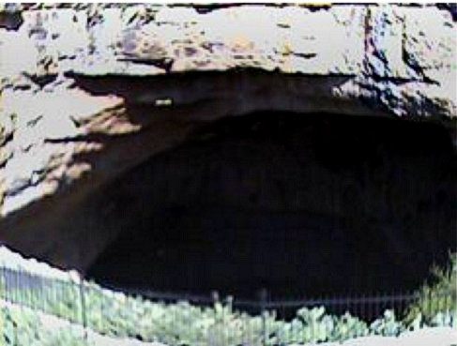  Carlsbad Caverns, New Mexico  +/-75 ft +/-22.9 m | 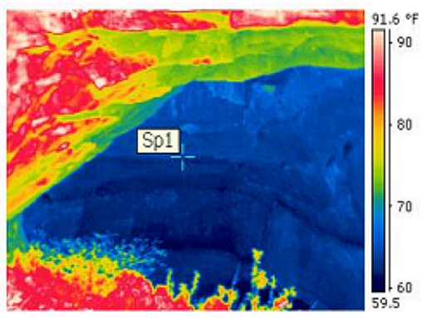  Carlsbad Caverns, New Mexico  +/-75 ft +/-22.9 m
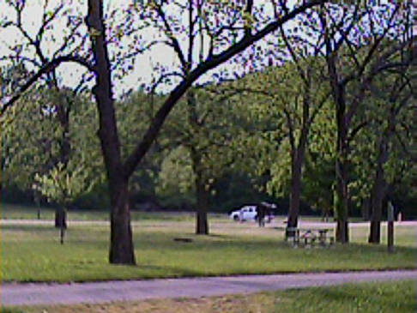  Fisher Cave Meramec S.P., Missouri  600 ft 182.9 m | 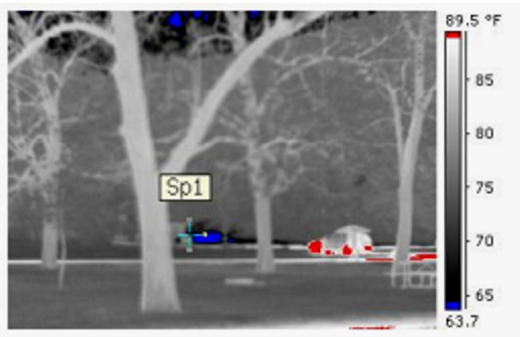  Fisher Cave Meramec S.P., Missouri  600 ft 182.9 m
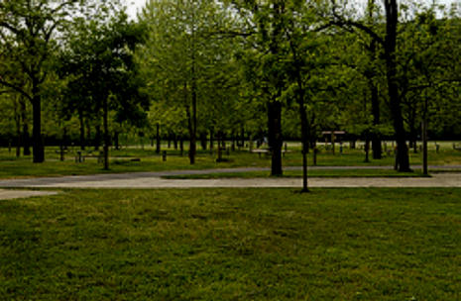  Fisher Cave Meramec S.P., Missouri  1,000 ft 304.8 m | 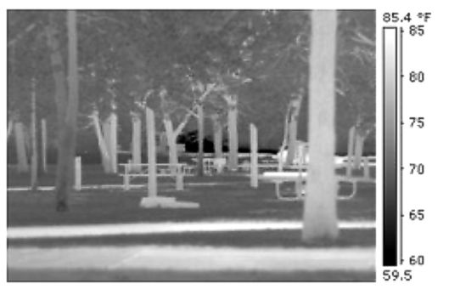  Fisher Cave Meramec S.P., Missouri  1,000 ft 304.8 m

