Predrag Djurović
Dragan Milovanović
Nebojša Vasić

Silicate pseudo-speleothem in Gradašnica Cave (Mt.Miroč, Eastern Serbia)

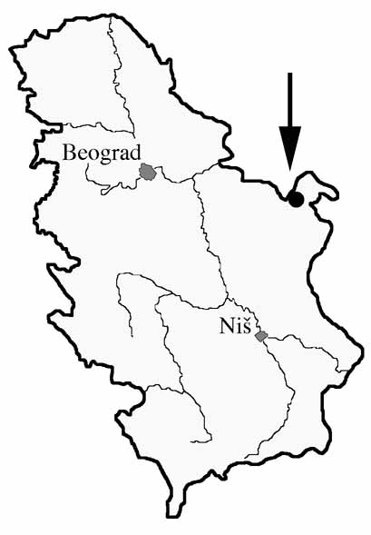
Introduction

Gradašnica Cave is situated in Eastern Serbia, on the western slopes of Mt.Miroč, which is a part of Carpatho-Balkan mountain belt (Fig. 1). The cave is located on the left side of the valley of Velika Gradašnica River, which feeds directly into the Danube River. The entrance to the cave is situated in a wide natural amphitheatre, 15 m above the riverbed of the Velika Gradašnica. The area is a part of the Djerdap (Iron Gates) National Park. Total length of the cave is 529 m (Djurović, P. Ed., 1998).
The cave is formed in Lower Cretaceous limestones, defined as micrites or biomicrites, consisting of microcrystalline and recrystallized calcite, with the occurrences of fossils and stylolites. Thickness of beds varies from several tens of centimetres to more than one metre, when the limestones may be defined as massive.

Fig. 1 – Location of the Gradašnica Cave
Geological setting of western slope of Mt. Miroč
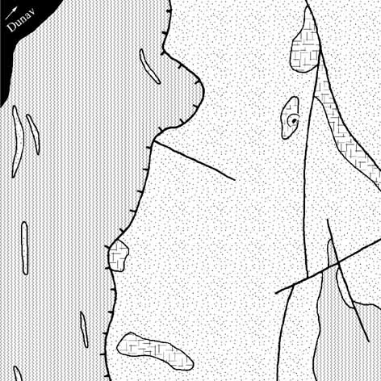
According to the accepted tectonic division of the Carpatho-Balkanides of Eastern Serbia, Mt.Miroč is a separate unit. The whole area of the mountain can be structurally defined as a horst-anticlinorium. Western part of Miroč tectonic unit, where the cave is situated, is characterized with folding and faulting tectonics, resulting in anti-forms and sin-forms, isoclinal folds and several major fault structures (Miroč and Urovica faults). Gradašnica Cave is situated close to the point of intersection of these two faults (Fig. 2). Stratigraphically, in this part of Miroč tectonic unit, Jurassic and Lower Cretaceous sediments are distinguished. Further to the west, they are overlaid by the Getic tectonic unit, consisting of Proterozoic plagioclase gneisses. In this area, Jurassic is exposed as a narrow belt along the Miroč fault, as well as in small tectonic-erosional windows. Gradašnica Cave is situated exactly in one of those windows, where Upper Jurassic limestones are exposed (Fig.2). Lithological column of Upper Jurassic (Malmian) sediments is represented by carbonate rocks, starting with bedded dark-gray and gray arenaceous limestones, changing upwards to white massive highly karstified, sometimes dolomitized limestones. The column of Malmian carbonate rocks has gradual transitions both to Dogger and Lower Cretaceous rocks (Marković, V. & Danilova, A., 1973).

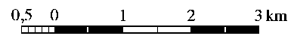
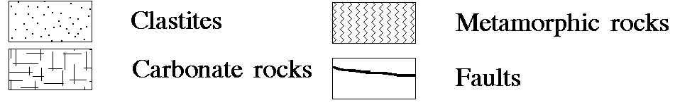
Fig. 2 – Schematic geological outline of a part of Velika Gradašnica drainage area

Morphological and hydrological characteristics of the cave

Gradašnica Cave is a permanent outflow cave of dendritic pattern, consisting of the main, hydrologically active passage, and several lateral confluent passages that are out of hydrological function (Fig.3).
By its shape and size, the entrance part varies from the rest of the cave. It has a form of natural rocky amphitheatre, with the diametre of about 70 m and height exceeding 30 m. In the eastern part of the amphitheatre there is a river terrace cut by the cave stream in accumulated clastic material. Its height ranges from 1,5 to 2 m. Parts of big limestone blocks protrude from clayey-sandy material. These blocks, as well as the whole entrance part are the result of cave ceiling collapse, which led to retreat of cave entrance and formation of the great amphitheatre.
The Main passage starts from the entrance, stretches towards north and then sharply turns towards west. It represents a morphological unit that connects all the passages of the cave, and has various morphological and hydrological characteristics. In the entrance part, it has huge dimensions – width of about 30 m, and height about 15 m. The floor is rather flat, covered with clayey-sandy fluvial sediments. There is a permanent cave stream that emerges downstream from the sharp bend of the Main passage. In the stream-bed, the intensive precipitation of calcium-carbonate contributes to forming of small tufa dams along the whole course. On the walls, there are calcite flowstones and draperies 3 to 5 m wide and up to 10 m high. Widely opened entrance enables the penetration of cold air, which, during winter time, leads to freezing of films of water seeping over flowstone and draperies. Consequently, calcium-carbonate precipitation has stopped. Micro-climate conditions have considerably changed since the period of flowstone and draperies formation, so nowadays they are being destroyed by frost erosion. Therefore, their dimensions are much smaller than before. Sub-zero winter temperatures reach almost to the sharp bend of the Main passage.
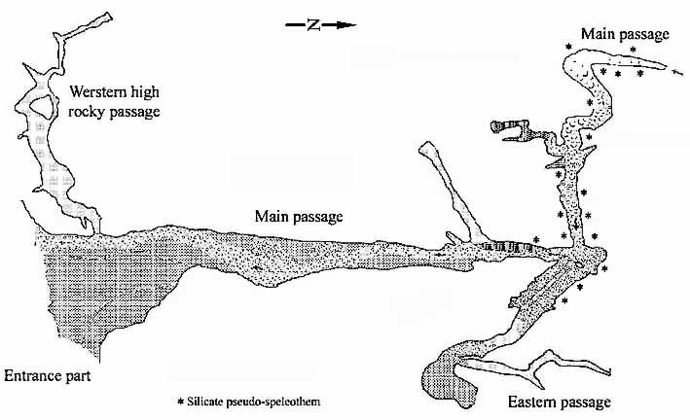

Fig. 3 - Plan of the Gradašnica Cave

In the second part of the cave, after the sharp bend, the Main passage has different morphological, hydrological and sedimentological characteristics. The passage is much narrower (2 to 3 m), while the height decreases until it reaches impassable dimensions. This part of the Main passage is periodically active, only after snowmelt or heavy rains. On the cave floor, there are deep rimstone dams filled with fluvial gravel. Two types of dams, differing in age, may be distinguished. Older rimstone dams are bigger in size and eroded by the stream. Younger dams are smaller, fitted into the older ones, and partially filled with fluvial gravel. Their formation is still active, during short period of hydrological activity of the passage. Such morphological and sedimentological characteristics point to considerable changes of cave stream regime, after stopping of its incision into the limestone bedrock. Intensive and long-lasting process of calcium carbonate precipitation, when the older rimstone dams were formed, switched to the process of increased fluvial accumulation of gravel and sand. Subsequently, the travertine accumulation process started, when younger and smaller rimstone dams were formed. In the next phase, they were filled with fluvial gravel and sand as well. Present accumulation of mechanical river sediments or growth rates of calcium-carbonate in the river bed cannot be measured due to the short period of existence of the stream. By comparison of stream characteristics in the lower part of the Main passage, it can be concluded that present accumulation in the upper part of the Main passage is also related to calcium-carbonate deposition.
Upstream from the sharp bend, the walls and ceiling of the Main passage are rocky, with very small quantities of calcium-carbonate, in forms of thin coatings, small soda-straws and stalactites. Apart from those, wide accumulations of spongy material have been noticed. By shape and structure, this material considerably differs from normal, calcite speleothem. That spongy and crumbly mass protrudes from the carbonate bedrock for up to about 10 cm. It spreads either in a form of several metres long belts, or in separate, isolated patches. The material covers continual surfaces of up to several square metres. Hollows within the mass are of irregular shape, several centimetres in size. In the direction of carbonate bedrock, the hollows contain carbonate fragments.
In the most upstream parts, walls and ceiling are covered with forms that morphologically resemble flowstone, but also erosional forms made by whirlpool erosion of the stream. By their dark brown colour, they substantially differ from the surrounding gray-white features – limestone bedrock and travertine accumulations. These forms are often covered with travertine coating, several milimetres thick, which often masks their real distribution. At the places where travertine coating is missing, one can notice their compact, glassy structure. At the cross-sections of this material, its striped to wavy-laminar fabric is visible.
By optical examinations, it was determined that both materials contain dominantly silicate materials – chalcedony and, to a smaller extent, quartz.
Eastern passage joins the Main passage close to the sharp bend. It is not in the active phase of formation, which is obvious from the relative height of its floor, 3 m higher than the Main passage floor. The floor is, except in the first part, covered with thick sandy-clayey sediments, in which remnants of Ursus Spelaeus have been found. The walls are rocky, without carbonate speleothem. Only in the first part of the passage, on the northern wall, there is spongy silicate material identical to the one in the Main passage. The mass is present as a horizontal belt 1 to 1.5 m wide and several metres long.
Western high rocky passage joins the Main passage in the entrance part of the cave. It is characterized by relatively small width and considerable height. Cave floor and walls are without chemical or mechanical sediments. By morphological and sedimentological characteristics, this part differs completely from other passages of the Gradašnica Cave.

Petrology of silicate material

By its macroscopic and microscopic characteristics, spongy silicate material was primarily a silicate cement that cemented the limestone fragments (Fig.5). Limestone fragments are of mm or cm dimensions. Their shapes are irregular, but the roundness is quite high, so at first sight they resemble real pebbles. These fragments, by their sedimentological characteristics, are micritic and alochemomicritic varieties (presence of association of pelagic microorganisms, with prominent radiolaria skeletons replaced by calcite). Pore space between such grains and fragments is filled with fine-grained chalcedony and quartz pigmented by Fe oxides and hydroxides. Sporadically, in such cement mass there are small rhombohedral crystals, which by appearance resemble siderite (dolomite and ankerite cannot be excluded either). Structural characteristics of the cement point to its multi-phase character. It is manifested as various grain size of chalcedony and quartz, and as various degree of pigmentation by Fe oxides and hydroxides, which give striped to wavy-laminar appearance to the cement. The first phase of cementation is growth of coarser-crystalline chalcedony on the fragment surfaces. These zones are of sub-milimetric dimensions. The next phase is deposition of finely-crystalline Si cement, which was filling the largest part of the pore space. Depending on the character of solution (smaller or greater Fe input), the cement with smaller or greater Fe-mineral content was deposited, which gave it striped to wavy-laminar appearance.
Spongy silicate material, which is present on the walls and ceiling of the cave passage, was formed by dissolution of limestone fragments and grains, as less stable in comparison to silicate cement. Therefore the morphology of hollows responds to the shape of limestone fragments.
Silicate material of striped to wavy-laminar structure is composed of chalcedony and quartz as well. Different extent of dark-red colouring is a consequence of various Fe mineral content. Poliphase deposition is even more prominent than in the case of spongy material. The phases are characterized with various size of chalcedony and quartz grains, from micro- to coarse-crystalline. Phases with coarse-crystalline grains are mostly of quartz. Certain phases are characterized with the presence of Fe minerals in large regular cubic forms, which could point to primarily sulphide mineralization. In these silicate rocks, coarse-grained siderite rhombohedres are present. Regarding this material, it must be stressed that there are two generations of fissures, filled with chalcedony and quartz.

Genesis of silicate pseudo-speleothem

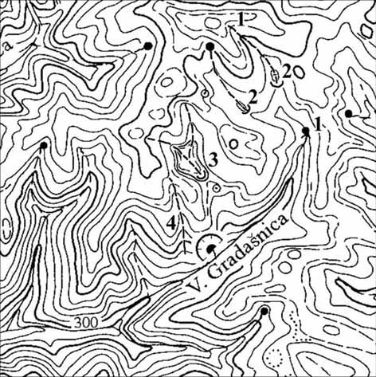
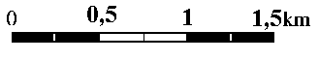
In the wider spring area of the river Velika Gradašnica, which is composed of limestones, there is an active karstification process resulting in development of certain karst surface forms (Fig.4). Karstification process has caused lowering of the permanent spring from 520 m to 420 m a.s.l. (Fig. 4/Nº1). From that elevation, to the mouth at 70 m a.s.l, the river Velika Gradašnica has cut a steep river bed with numerous smaller steps. One of the spring confluents, as well as all right tributaries to the Gradašnica Cave (Fig. 4/Nº2,3,4), have been transformed from surface to underground river courses. These tributaries are of periodic character; their springs are in clastic rocks, but they sink soon after reaching limestones. Karstification process, except for the tributary that is closest to the Gradašnica Cave, is only at the early stage. This can be concluded from the size of dolines in which the mentioned streams sink, as well as lack of blind valleys. Regarding the confluent closest to the Gradašnica Cave (Fig. 4/Nº3), the situation is different. At the place of joining of its two spring confluents, a small irregularly-shaped uvala has been formed. Downstream from the uvala, there is a remaining dry valley, the bottom of which is about 15 m higher than the uvala bottom. In the dry valley, all the way to its mouth to the river Velika Gradašnica, there are neither stream nor springs. It is obvious that here the karst process was more intense and lasted longer. By analyzing the passage directions in the Gradašnica Cave, the uvala gains importance for understanding of speleogenesis. General direction of the cave is northwards (towards the uvala), except the Western high rocky passage, which stretches westwards. Analyzing the immediate surroundings of the Gradašnica Cave, another short dry karst valley has been noticed (Fig. 4/Nº4). It passes close to the entrance to the cave, from the west side. The morphological relation between the Western high rocky passage and this dry valley is obvious.
Fig. 4 – Orographic relations in a part of the Velika Gradašnica drainage basin

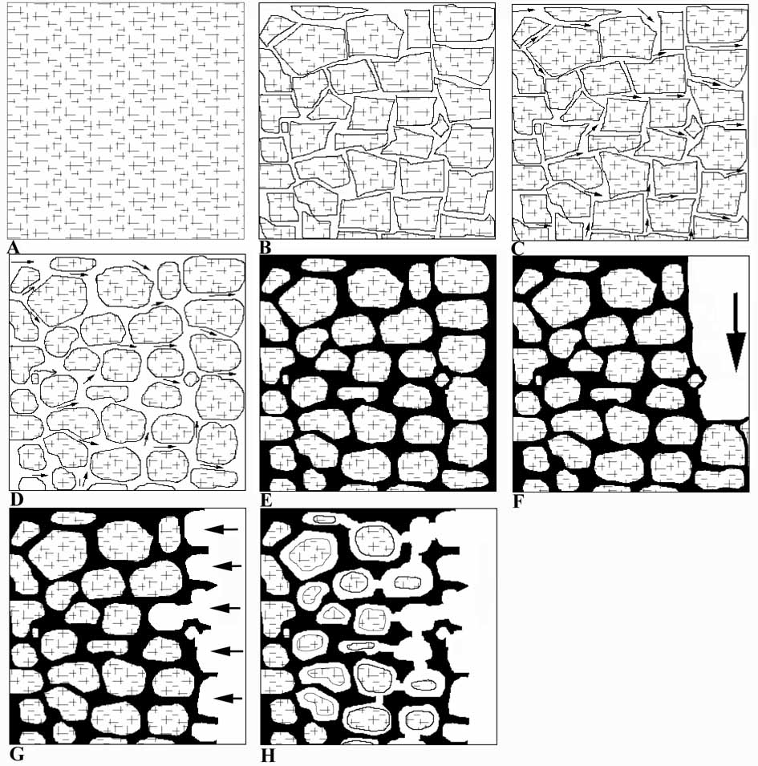
Geological settings of these two valleys, their hydrological characteristics and evolution have directly influenced the speleogenesis of the Gradašnica Cave.
Fig. 5 – Scheme of silicate pseudo-speleothem development

Silicate features that were studied in the Gradašnica Cave are (by appearance, way and time of genesis) substantially different from seemingly similar features (chert layers and nodules in limestones). Silicate material was formed in specific geological conditions, and in subsequent speleogenetic processes it gained its present form. Therefore it is distinguished as speleothem feature. This is a complex form, whose evolution had certain phases. Taking into account that it was not formed in the same way as the usual, calcite speleothem, it was added a prefix – pseudo. Furthermore, as it is not of carbonate composition, it was finally determined as ‘silicate pseudo-speleothem’.
The issue of genesis of silicate pseudo-speleothem is primarily a petrological problem, but it is speleological as well. In the Gradašnica Cave, two groups of silicate pseudo-speleothem were distinguished: spongy and striped-wavy-laminar. Regarding the spongy silicate pseudo-speleothem, it is undoubtable that the carbonate bedrock was formed first (Fig.5/A). In the process of tectogenesis, it was fissured (Fig.5/B), and water solutions from greater depths had started to seep through the voids (Fig.5/C). These solutions carried silica and cemented the voids and hollows in the carbonate mass through which they were flowing and seeping. Besides, they contributed to partial dissolution of carbonate mass, thus making carbonate fragments that were rounded in situ (Fig.5/D). On several limestone fragments, the processes of metasomatic replacement of carbonate by silica were noticed. This phase finished by filling the fissures in carbonates with silicate material (Fig.5/E). Much later, in these limestones the process of speleogenesis has started. Waters that formed the surface drainage system started to sink and flow through limestones along tectonically guided directions, forming the cave passages. During that process, the underground flow has cut also through the limestones whose fissures and voids had been previously filled with silicate material. Fluvial erosion is strong enough to erode both limestones and silicate material within them. Therefore, at the level of the river bed and immediately above it, there is no spongy silicate pseudo-speleothem (Fig.5/F). Only after cessation of fluvial erosion, the process of limestone dissolution starts. Chemical erosion is stronger in limestones than in silicates, so the limestone bedrock is faster eroded (Fig.5/G). Limestone within the silicate material become completely or partially dissolved, and the hollows with or without limestone fragments remain (Fig.5/H).
Presence of rhombohedres of high Fe-carbonates, preserved cubic forms of other Fe minerals, fissure systems filled with chalcedony and quartz in case of striped and wavy-laminar silicate pseudo-speleothem are also the arguments pointing that the primary rock system is related to the fault zone.
During the Paleogene, this part of Eastern Serbia was mainland. In that time, strong tectonic movements took place, caused by Laramian and Pyrenean folding phase. These phases reflected to the folding of Mesozoic rocks, faulting combined with igneous intrusions and certain mineralization. Rock system in which the Gradašnica Cave is developed was formed during the mentioned tectonic phases. Silicate pseudo-speleothem was formed much later, during karstification of limestones and the speleogenetic process, most probably during various phases of the Pleistocene (Filipović, I. et all, 1978).

References

1. Djurović P. (Ed.) (1998): Speleological Atlas of Serbia, SANU, "Jovan Cvijić" Geographical Institute, Special Issues Nº 52, Belgrade, 216-217
2. Marković V., Danilova A. (1973): Jura i kreda na Miroču i Velikom Grebenu i novi pogledi na tektonici ovih planina (Severoistočna Srbija), Glasnik prirodnjačkog muzeja, Ser. A., Knj. 28, Beograd, 131-142
3. Filipović I., Marković B., Pavlović Z., Rodin V., Marković O. (1978): Osnovna geološka karta 1:100.000, Tumač za list "Gornji Milanovac", L 34-137, Beograd, 61-62

