ABOUT PROCESSES GOVERNING SPELEOGENESIS IN THE ROCKS

By Claude MOURET
La Tamanie, F-87380 Magnac-Bourg
claude.mouret@wanadoo.fr

Résumé

La plupart des roches peuvent recéler des grottes, qu'elles soient sédimentaires, ignées ou métamorphiques. Toutefois, la taille et le développement de ces grottes varient beaucoup d'un type de roche à l'autre. Nous présentons ici les trois facteurs principaux de creusement spéléogénétique, d'une façon générale: dissolution/ corrosion, altération géochimique et désagrégation des grains/ érosion. La spéléogenèse nécessite l'export des matériaux pour que le vide apparaisse et se développe: en solution, par entraînement des grains par l'eau ou par effet mécanique gravitaire. Dans la quasi totalité des cas, la présence de l'eau est nécessaire à quelque degré, pour la destruction de la roche, l'export ou les deux. Même les effets gravitaires et ceux du vent sont accentués, sinon largement préparés, par la présence d'eau.
De nombreux facteurs géologiques interviennent, outre ceux tectoniques et hydrogéologiques bien connus, comme les alternances de bancs de résistance contrastée, les émersions interrompant momentanément la sédimentation, la diagenèse classique et les effets hydrothermaux lors des phases d'enfouissement.

Abstract

Most of rocks may host caves, whatever they are sedimentary, igneous or even metamorphic. However, the size and overall length of caves largely differ from a type of rock to an other. We comment here three main factors of rock destruction, which are dissolution/corrosion, geochemical weathering and grain disintegration/erosion. Rock export is necessary and it occurs as mineral solutions, grain transport by water or gravity action.
Many geological factors also play a role, in addition to the well known tectonic and hydrogeological ones, such as alternations of beds, or intervals, of contrasted resistance, aerial exposures during short interruptions of sedimentation (during relative sea level falls), classical diagenesis or deep burial effects.

Most of the rocks (sedimentary, igneous and metamorphic) may host caves, but related passage developments vary significantly. In a given rock, the number, size and location of the caves depend on rock nature and fabric, and on the geological, geomorphologic and climatic settings.

Water is nearly always necessary to speleogenesis, even with regard to a number of gravity-driven processes. Even the wind, under arid conditions, cannot fully exert its action if the rock has not previously or sub-contemporaneously been weakened by some weathering-related and capillary phenomena.

- Rock destruction and rock export

Both destruction and export are necessary to cave formation. Rock destruction mainly includes rock dissolution and corrosion, geochemical weathering and erosion-grain disintegration.
Export by water and/ or gravity processes (sliding, solifluction, fall, undermining…) may enhance or in a few cases slow down rock destruction, depending on climate and morphology. Wind plays a role in carrying arenas or other kinds of particles and small grains away from small caves.

1.1. Rock destruction

Rock dissolution/ corrosion by acidic water (whatever acidity originates from CO₂ dissolution in the soil, organic acids, bacteria action, volcanic gases, oil-related or hydrothermal solutions), is active at a significant scale on a limited number of rocks:
- carbonates, with significant differences from limestone to dolomite, siderite, etc.,
- metamorphic carbonates, such as marble and cipolino,
- evaporites, which are highly soluble.
- largely calcite-cemented sandstones and conglomerates with non-carbonate grains or elements.
Nevertheless, corrosion by organic acids also occurs, but at a very limited scale, with siliceous minerals such as quartz and especially feldspars.
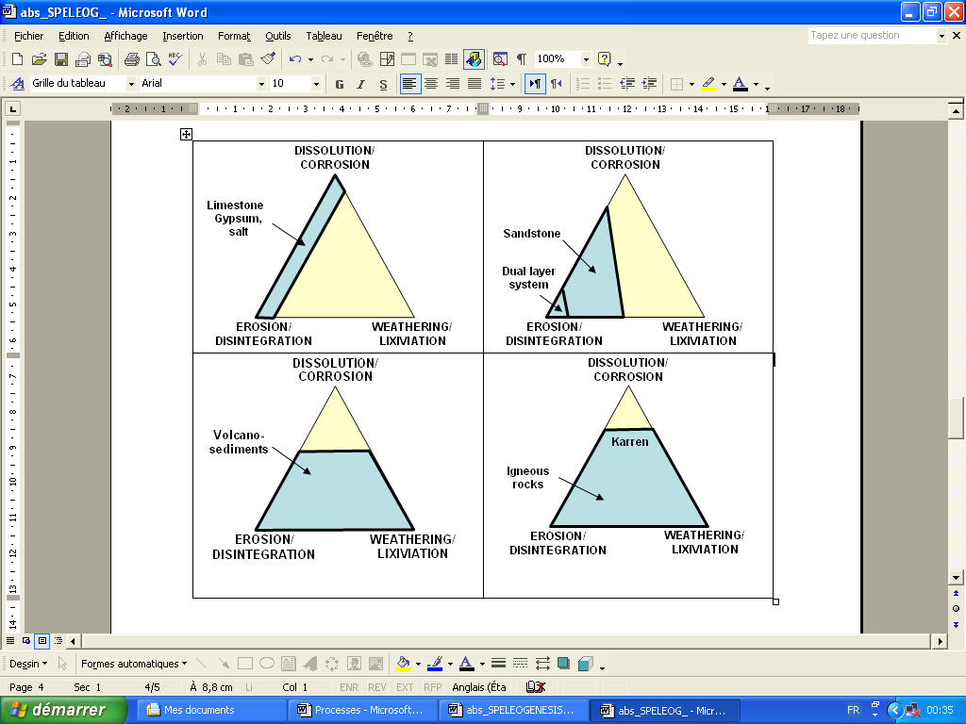
Fig. 1: Rock destruction factors in speleogenesis
Dolostone

Geochemical weathering includes a minor amount of pure dissolution, and mainly a lixiviation/ geochemical transformation of weaker minerals in non carbonate, non evaporitic, rocks which can be sedimentary (sandstone, conglomerate), metamorphic (micaschist, gneiss…), igneous, either crystallised at depth (granite, diorite, syenite, gabbro, pegmatite, etc.) or volcanic (basalt, andesite, dacite, rhyolite, etc.). As weathering depends on water availability, it depends on climate and on seasonal effects as well as regional morphology. Rainy paleoclimates have played an important role in arid regions, where rock weathering was more developed a few millennia ago. Weathering is facilitated where rock drainage is poor, as in flat and low lands, while aprons, plateau edges or pitons are not so weathered.
Usually, feldspars (and certain rock fragments in sandstones and conglomerates) are the weak components of the rocks (sandstones, igneous rocks, volcanic and metamorphic rocks), together with ferro-magnesian minerals. Dissolution and weathering may lead to a neoformation of clay minerals (the nature of which depends on drainage conditions). Geochemical weathering interacts with mechanical rock weakening. Acidic solutions penetrate the rock better where grain contacts are loosened and where microfracturing occurs. There is always a balance between the opening of small discontinuities in the rock and weathering, because water must penetrate the rock but it must also remain in it a sufficient time for chemical reactions are effective.
Salt migration in the rock commonly creates mechanical exfoliation which results in cave enlargement, specially near the outside. Capillary effects needs only a minor quantity of water and largely weaken the rock, preparing the ground for rock disintegration and exfoliation.
Bacteria may exert an additional destructive action through corrosion or more complex interactions with the host rock.

Rock disintegration concerns crystals or grains. It depends on the nature of rock, on the size of the crystals (for instance, dacites often have large crystals of biotite, hornblende, pyroxene, and in this case disintegrate much more than basalts or rhyolites) and on the pattern they form with other minerals. It facilitates water penetration into the rock and so may have a direct impact on weathering. Too small-grained rocks usually do not show significant grain disintegration. Thermal action (alternations of cold and hot temperatures, frost...) is able to enlarge already existing voids (for instance in some granite caves). Rock overburden generates shelters in rocks like siltstones and shales interbedded below massive sandstones, by creating lateral mechanical breaking.

Erosion is directly linked to grain disintegration. Freed crystals or grains can be easily carried away, provided there is available space for that (connected fenestrae, conduits, open fractures, open stratification surfaces, outside slope, etc.). Erosion probably occurs in karst conduits to a higher extent than it is usually thought. In underground passages following river sinks, transportation of solid particles by water may erode cave walls and the fine-sized particles liberated in this way are subsequently more easily dissolved. Near the outlets, erosion (if conditions for it are encountered) may be enhanced by the stronger current possibly generated by the setting: eroded particles are easily exported. The water breakthrough and specially the cave breakthrough between sink points and outlets lead to a well developed passage association able to generate long cave systems.
Rock massifs existing as topographic highs can be affected by gravity deformation leading to deep open cracks within them, which form sometimes long cave systems.

1.2. Rock export

Rock export is mainly ensured by mineral solution and/or particle transportation. Dissolution is predominant in carbonates and evaporites. Grain disintegration and particle export is dominant in sandstones. Weathering and capillary effects dominate in metamorphic and igneous rocks and liberate particles which can be exported by water and gravity over a commonly short distance (before it is reworked and exported over a long distance). Small caves in grained rocks form more easily along fractures, where grains can be exported by water and/or gravity-related export.
At a large scale, geometric setting plays a large role in grain export, specially if it is associated with a favorable geological pattern: for instance, strata surfaces in a sandstone gently sloping towards the local hydraulic base level is a good setting for this. Rock export first occurs in the downstream part of a cave under formation and associated grain disintegration progressively moves more and more toward the upstream. In Western Borneo, such an export is the major reason why caves have formed in silici-clastic beds below basaltic andesites.

2. Other factors of cave formation

Many factors play a role with respect to cave formation, but we would like to review here some factors which have been less studied. They are presented, for sedimentary rocks, from early sedimentation time to diagenesis and late deformation time and, for other rocks, mainly under the aspect of lithological contrasts.

Beds succession may enhance speleogenesis, whenever a harder, thicker, more resistant bed (or interval) overlies a less resistant one. For instance, roofs of large chambers or large passages may be made up of the thicker beds of a thickening up carbonate sedimentary sequence, or made up of a more cemented carbonate lithology or of a different carbonate (siderite beds interbedded with limestone series for example).
In non carbonate environments, caves often form because there is a stronger bed above easily erodible rocks. It is the case in volcanic and volcano-sedimentary environments (basalt above sandstone or above sandstone-shale alternations, welded breccias above sandy volcano-sediments...), in sedimentary silici-clastic settings (cemented thick coarse-grained sandstone above less cemented, thinner, finer-grained one), in laterite profiles (caves formed below an iron crust), etc.
Speleogenesis also occurs where a formation concentrates water towards peculiar points or areas of weaker strata, as does a poorly porous, fractured, sandstone above a fractured carbonate. Harder beds also play a role as the substratum of horizontal flows along their non fissured or faulted parts. Water is forced to follow them until it meets a fracture or a sedimentary or diagenetic wedge which allows it to go deeper into the rock massif, according to the hydraulic gradient.

Longer periods of temporary exposure during relative sea level falls (which are temporarily interrupting sedimentation in areas with a higher elevation) are more prone to initial cave development, because they allow slow processes to take place in a significant way. Once the secondary voids, including caves, have developed, they are usually sufficiently preserved (if their fill is not too highly cemented during deep burial) to influence subsequent karstification and speleogenesis. Therefore, depositional sequence boundaries are prone to subsequent karst development.

Diagenesis of sedimentary rocks is a very important factor: in carbonates, karstification and speleogenesis are completely different when the degree of rock cementing and the amount of porosity vary. Poorly cemented, porous, limestones with a low mechanical resistance lead to smaller caves and a dual porosity system (matrix + karst) with complex mutual relations. Hard, tight, highly cemented limestones bear longer caves, sometimes very long, with large passages and chambers; they show more contrasted, much steeper, outside morphology.

Dissolution and/ or rock alteration under deep burial conditions are probably more common than it is presently thought, not only in carbonates but also in sandstones, for instance, despite it is much more subtle to spot.

Cave filling may slow down or stop cave enlargement. It may be generated by changes in the conditions of cave evolution, local or more regional, and even by relative sea level fluctuations.
Many karsts are subsequently onlapped by marine formations and their passages are filled with sediments to a variable extent. Larger parts are likely to collapse with burial, and collapse is more developed in rock with no strong mechanic resistance.
Cave fills may be allochtonous or simply autochthonous (e.g. exfoliation sheets in granite caves) and may slow down cave formation whenever they decrease export.

Obviously, tectonic conditions play a classically known role and the hydraulic conditions as well. It is not here our purpose to be exhaustive, but we wish to draw attention on some less known factors which are conditioning speleogenesis. We also wish to highlight, if necessary, the extraordinary variety of rocks and rock formations in which caves can form.

_____________

