A Tale of Looting of Paleontological Cave Resources or International Commerce

David A. HUBBARD, Jr.
Virginia Speleological Survey, 40 Woodlake Dr., Charlottesville, VA 22901 USA; e-mail: david.hubbard@dmme.virginia.gov

Abstract
The looting of archaeological and paleontological resources has long been a problem in caves. An informal surveillance of Internet sales of archaeological and paleontological items from caves in USA evolved into an eleven-month international survey over the year 2002. This paper summarizes a survey of 430 Internet auctions of 356 paleontological items from the caves of Austria, Canada, “Europe”, “Eastern Europe”, France, Germany, Italy, Netherlands, Poland, Romania, Russia, and USA. The majority of the fossils were from Romanian (42%) and Russian (31%) caves and overwhelmingly were of Ursus spelaeus (98.6 %). The other items were a Crocuta crocuta spelaea (hyena) jaw, Crocuta crocuta spelaea (hyena) skull, Panthera leo spelaea (lion) sacrum, Mammut americanum (mastodon) patella, and a Procyon lotor (raccoon) skull. Ursus spelaeus elements included teeth, jaws, articulated paws, skulls, vertebrae, phalanges, claws, articulated skeletons, humeri, ulnae, bacula, a tibia, an ankle element, and a pelvis fragment. Cave bear remains are common mega-fauna fossils in the caves of Europe. Certainly, some of these items were legally obtained. Contrary to one dealer’s claim that “fossil cave bear material is ALWAYS LEGAL!!!,” undoubtedly, many of these specimens were taken illegally. The concern is that commercial harvesting of mega-faunal remains probably occurs without the study or documentation of context and associations and archaeological, paleontological, and sedimentological resources are destroyed.

Introduction
Humans have exploited caves throughout history. Significant records of extinct paleo-fauna, paleo- and prehistoric human, and historic human are known from cave sites. Such sites document presence, but more importantly, forensic elements convey information about the nature of an occurrence and cultural as well as individual patterns of human cave use. Many initial discoveries of spelean faunal records are made by curious and observant cave visitors not formally trained in the disciplines of physical anthropology or paleontology. Private collectors long have competed for a share of the known specimens. The looting of Native American (American Indian) sites in U.S.A. caves historically has eclipsed those examined by scientific methods, but paleontological sites in U.S.A. caves have been more closely balanced between advocational and scientific exploitation. Perhaps the most significant period of commercial exploitation of vertebrate cave fossils worldwide followed the publication of Jean Auel’s book The Clan of the Cave Bear in 1980. Auel’s Cave Bear Clan novel series has spurred an unprecedented interest in the cave bear and an extensive market has developed for cave bear remains. Although cave bear remains are relative common in many eastern- and western European caves, their wholesale acquisition has imperiled fossil cave deposits as well as associated archaeological deposits and the stratigraphic integrity of sediments in which they occur. International markets can be difficult to appraise, but it was thought that Internet sales are one source of information by which the degree of exploitation might be scaled.

This study was initiated after a purported Pleistocene-age raccoon skull, from a Missouri cave, was offered on an Internet auction. It is probable that the taking of this skull was in violation of the Missouri Cave Resources Act.

Methods and Results
Vertebrate remains from cave sites offered on an Internet auction site were recorded for an eleven-month period over 2002. A total of 430 auctions of 356 cave vertebrate items were reported as from Austria, Canada, “Europe,” “Eastern Europe,” France, Germany, Italy, Netherlands, Poland, Romania, Russia, and U.S.A. (Missouri and Florida). The majority of the fossils were from Romanian (42%) and Russian (31%) caves and overwhelmingly were of Ursus spelaeus (98.6 %). The other remains were a Crocuta crocuta spelaea (hyena) jaw, Crocuta crocuta spelaea (hyena) skull, Panthera leo spelaea (lion) sacrum, Mammut americanum (mastodon) patella, and a Procyon lotor (raccoon) skull. Ursus spelaeus elements included teeth (130 lots: 37% of items), jaws (91: 26%), articulated paws (42: 12%), skulls (22: 6%), vertebrae (20: 5%), phalanges (15: 4%), claws (15: 4%), articulated skeletons (6), humeri (3), ulnae (2), bacula (2), tibia, ankle element, and a pelvis fragment. Items sold included a skull for $3500, paw for $270, jaw for $135, canine for $134, and the only skeleton that sold - for $2900 in U.S. currency. Of the 356 lots, 274 were successfully sold for a total of $28,415.70 in U.S. dollars.

Legal and Ethical Issues
Long, long, long ago, humankind as did other animals, utilized many cave sites and took what they could use from caves as well as most other places they visited. Evidence of a prehistoric collection from a cave is preserved in the Grotte de Foissac in France. Off from the commercial trail, in a dry rimstone pool is a site where a prehistoric human shattered the skull of a cave lion to extract the canine teeth. We still are using caves and worldwide have seen to it that our caves and their resources are protected for enjoyment and study.

The legality of removing fossil non-human remains from cave sites is relatively simple and based on the laws in place in the jurisdiction where the cave is located and if the cave owner permission was granted. The caves of Romania and Russia are owned by their governments. Seventy-three percent of the parcels reported in this study were identified as from Romanian and Russian caves. Legislation in Romania, since 2001, specifically protects cave resources and prohibits their removal. The claim of one of the internet cave bear fossil merchant that “fossil cave bear material is ALWAYS LEGAL!!!,” is untrue.

In 2001, American cave historian Dean Snider (personal communication, May 2005) visited some Romanian caves in the Bihor Mountains. In one of the caves he visited, he observed the disturbed remains of Ursus spelaeus, which had been excavated (Figure). Examination of this photograph reveals that Dean posed in an excavation, the disturbed fossil bear bones were discarded on the spoil pile adjacent to the excavation. This is not a scientifically excavated site, but evidence of looting, probably for skulls and jaws. Nor are carpals, metacarpals, or phalanges visible, but these small bones - that comprise the paws, could easily be overlooked.

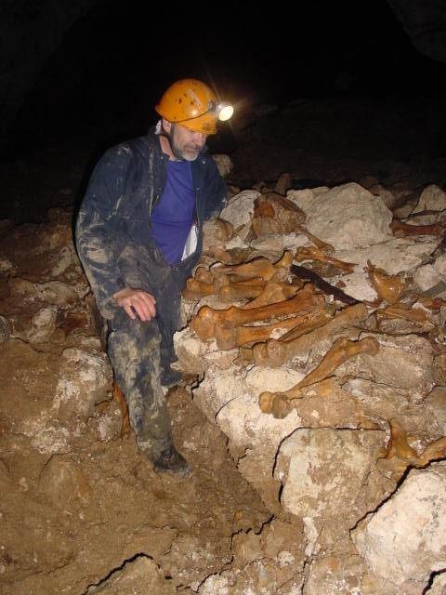

Discussion and Conclusions
It is doubtful that the efforts of the individuals commercially excavating Ursus spelaeus remains are using scientific methods and documenting the context and associations of the deposits they are exploiting. One must assume that this glimpse of the international market for non-human vertebrate remains from caves is but a small fraction of the actual market. The enforcement of cave protection acts, where they occur, is difficult and where successful it is usually through the aid of local cavers, who may observe the activities or evidence of looters. The commercial exploitation of spelean fossil deposits is likely to continue. The major concern of this paper is not that there appears to be a large market demand for the relatively abundant remains of the Ursus spelaeus, but that the fulfillment of that demand has imperiled fossil cave deposits as well as associated archaeological resources and the stratigraphic integrity of the sedimentary deposits in which they occur.

Acknowledgements
Special thanks to Dean Snider, for his information and permission to use his image of a cave in the Bihor Mountains of Romania. Thanks to Dr. Oana Moldovan, of the Institute of Speleology in Cluj, Romania for information about the caves and cave protection in Romania. Thanks to Fred Grady of the Smithsonian Institution in Washington, D.C., for his suggestions and comments.
Figure. Dean Snider posing in a looters excavation adjacent to the jumble of disturbed cave bear remains in an cave in the Bihor Mountains of Romania.

