PRELIMINARY DATA RECORDED BY A MONITORING STATION TO SUDY THE HYPOGEAN CLIMATE IN A ICE CAVE: THE LO LC 1650 ICE CAVE “ABISSO SUL MARGINE DELL’ALTO BREGAI” (GRIGNA SETTENTRIONALE, LECCO – ITALY)

Turri S.¹, Citterio M.¹, Bini A.¹, Maggi V.², Favaron M.³, Fraternali D.³, Alberici A.³, Borghi S.⁴, Colombo M.⁴, Gottardi R.⁴, Zappalà D.⁴

¹ Earth Sciences Dept. "Ardito Desio", University of Milano. Via Mangiagalli 34, 20133 Milano. Italy. E-mail: stefano.turri@unimi.it
² Environmental and Territorial Sciences Dept., University of Milano – Bicocca. P.zza della Scienza 1, 20121 Milano. Italy.
³ S.T. Servizi Teritorio S.r.l. Via Garibaldi, 21, 20092 Cinisello Balsamo. Italy
⁴ Osservatorio Meteorologico di Milano Duomo, Piazza del Duomo 21, 20121 Milano. Italy

Abstract
In November 2004, to study the hypogean climatic conditions a monitoring station is installed at the LO LC 1650 ice cave. The ice cave is locate at Moncodeno, Grigna Settentrionale (Lecco). The climatic study of ice caves is one aspect of a wider multidisciplinary project. The climatic studies are supported by glaciological studies, aimed to understand the factors controlling the conservation, ablation of ice deposits in caves. The monitoring system is composed of a meteorological station to record epigean data and two hypogean stations. The meteorological station collects solar radiation, air temperature, humidity, wind direction and velocity. The two hypogean stations collect air temperature and humidity in many points of the cave, rock temperature at different depths and ice temperature. Hypogean air direction and velocity are measured by an ultrasonic anemometer. Some preliminary data after the first short period of measurement are presented here.

Introduction
Studies of ice caves is attracting more researchers in the last few years (e.g., Racoviţă & Onac, 2000; Perroux , 2001; Borreguero & Pahud, 2001; Turri et al., 2003; Piasecki et al., 2004; Strug et al., 2004; Luetscher & Jeannin, 2004; Borsato et al., 2004; Mavlyudov & Kadebskaya, 2004; Szczuciński & Rachlewicz, 2004). Since 1999 studies of glaciology and climatology are conducted in some ice caves of Moncodeno (Grigna Settentrionale, Northern Italy). A preliminary and small data logger network was installed in 2000 both in the hypogean and the epogean environments (Turri et al., 2004). The earlier temperature data collected were so interesting that successive monitoring systems project were setup to measure epigean meteorological parameters and various hypogean parameters.

Geographic background
The Moncodeno site is nearly rectangular amphitheatre occupying an area of less than 2 km² at the northern flank of mount Grigna. This karst forming high mountain zone has developed a high density of caves that appear on the surface as depressions (dolinas) and shafts. Due to the high altitude and the high quantity of snow precipitation, during the cold seasons thick deposits of ice are preserved for long time in some of the caves. The studied cave for this task is LO LC 1650 “Abisso sul margine dell’Alto Bregai”, where its entrance is located at 2030 m, forming a shaft of 30 m in diameter (Fig.1A). The shaft is connected with an ice deposit that is recharged directly by meteoric snow. The cave meanders downwards (Fig. 1B) leading to a wide and 50 metres deep shaft that is also capped by ice, which is the focal point of this study (Fig. 1C). Therefore, this ice deposit is not directly connected with the meteoric ice, but should have descended following a tunnel that was formed by the circulating hypogean air and the tunnel terminates in a 25 metres deep shaft located at a lower level (Fig.1D). The later shaft is bounded by an ice and detritic deposits (Fig. 1E).

Monitoring system
There are clear relations between epigean and hypogean temperatures. In each cave the significant variations are related to seasonal variations, depending on the snow cover of the entrances. Moreover, the internal parts of a cave could show constant or seasonal variations irrespective of other hypogean environmental conditions where communication is controlled by the morphological development of the cave and dynamics of the ice and snow deposits. In addition to the effects of the particular conditions of a cave, temperature data indicate that the circulating air, which is the principal media of heat exchange between the internal and external parts, is variably influenced by the highly complex structure of the karstic system. In here, we propose a simple schematic model to show the internal – external climatic relation by understanding their working systems.
Considering the complexity of the study, the unique way to resolve the set of unknown variables is to install various sensors in different stations all along the internal morphology of the hypogean cave. This will allow to collect necessary data to understand and establish the hypogean microclimatic conditions.

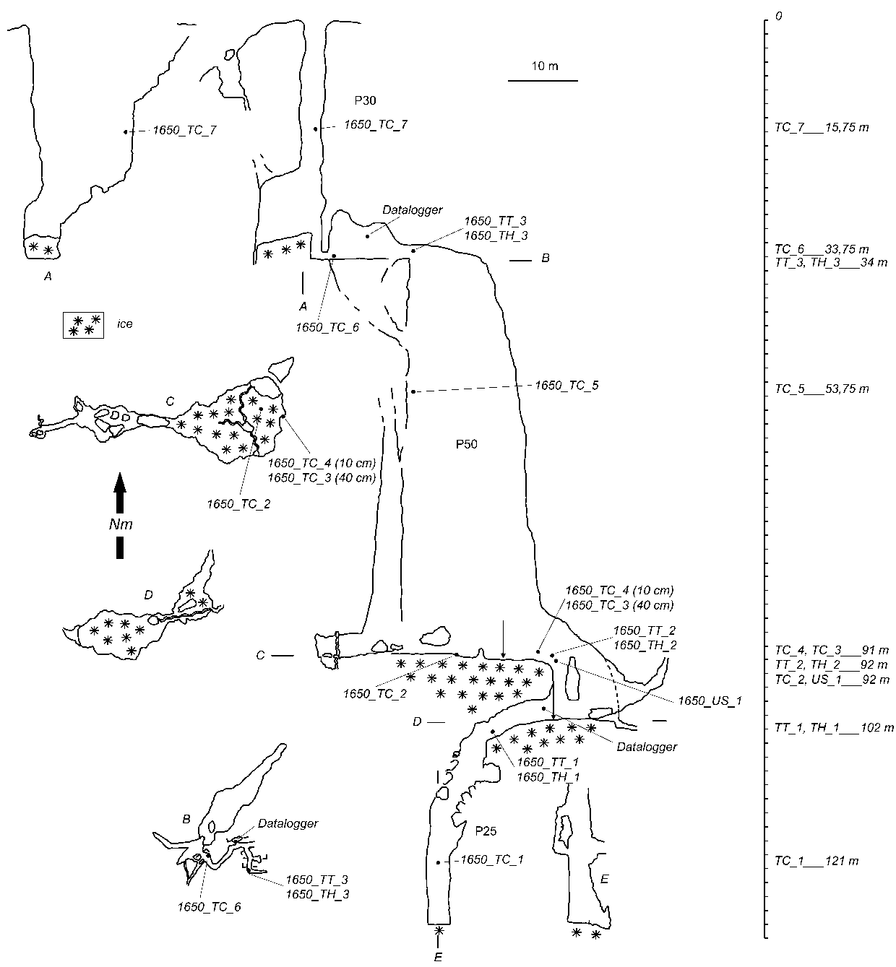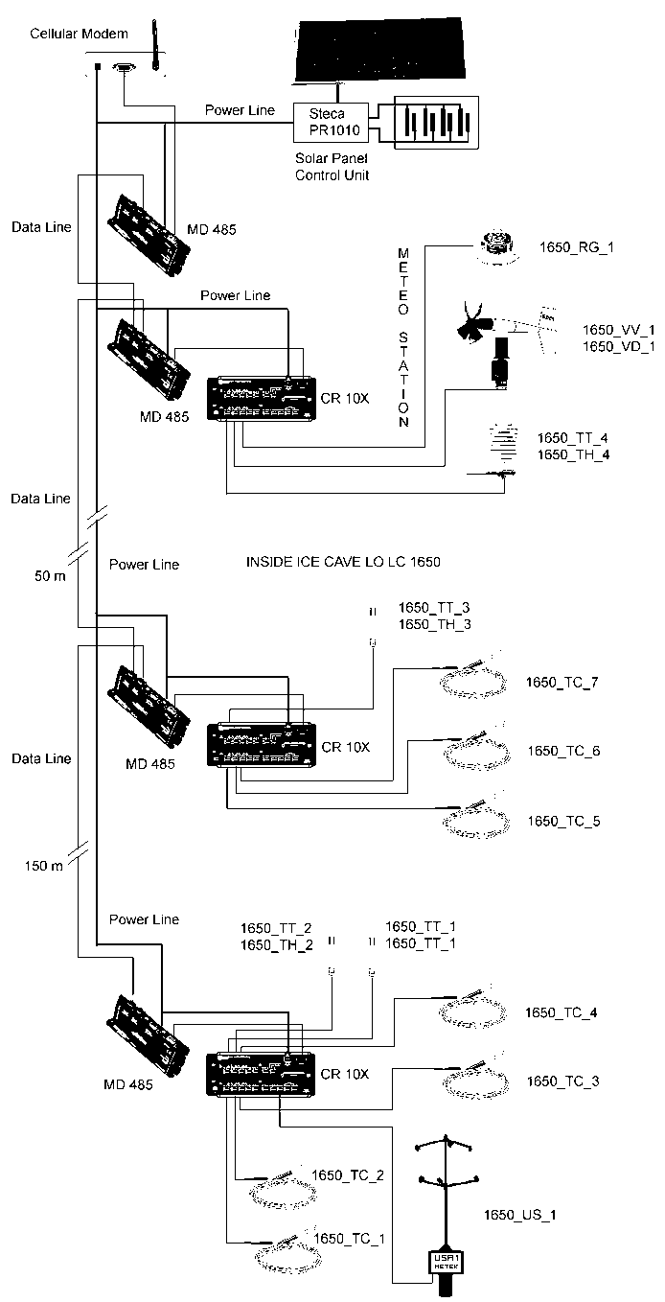
Fig.1 – Map of the LO LC 1650 cave. A) The 30 m deep shaft at the entrance of the cave. B) Meandering tunnel. C) Top of the ice deposit. D) Map of tunnel of the ice deposit. E) The 25 m. deep shaft. Locations of the monitoring system sensors that are described in the text are indicated with their relative depth. On the right side the monitoring system plan is sketched.
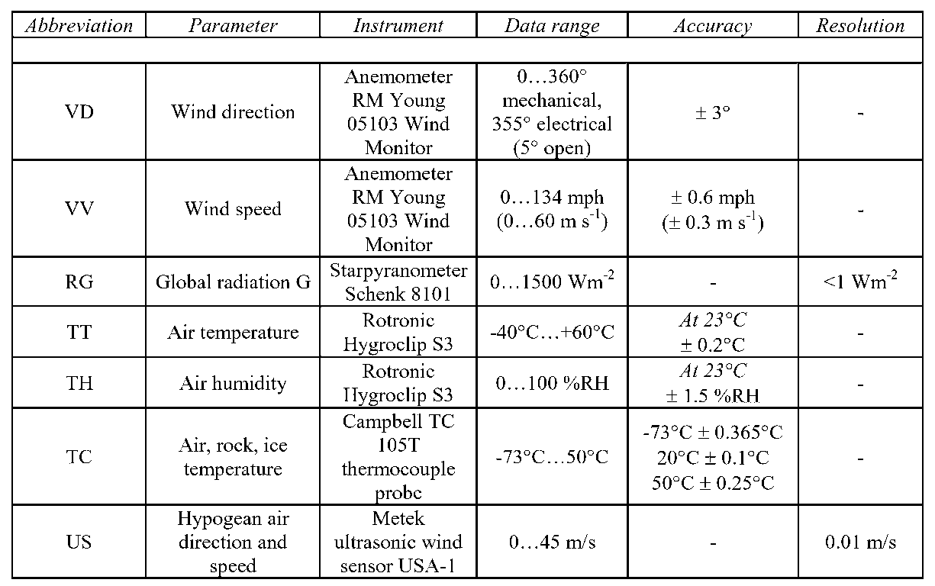

Fig.2 – Table that shows symbols utilized to identify the monitoring stations with some of their technical characteristics.

To compare the hypogean with the epogean climatic conditions, a meteorological stations is installed near the entrance of LO LC 1650, at an altitude of 2030 m.
Installation of the meteorological station has permitted to measure;
- the air temperature and humidity with the Rotronic Hygroclip S3 termohygrometer,
- global solar radiation with a Schenk 8101 global radiometer,
- wind direction and velocity with an RM anemometer. Measured data are collected by a data logger Campbell CR10X 2M.
The monitoring system sensors in the internal part of the cave are systematically distributed to establish a network so that a complete data could be collected from the surface to the depth of 121 m. The acquired data are registered by two data loggers Campbell CR10 2M, located at the meandering tunnel, –31 m. and the tunnel deposit at –99 m (Fig.1). Air temperature is measured at 7 positions with 4 Campbell TC 105T thermocouples and 3 Rotronic Hygroclip S3 thermohygrometres that measures also air humidity. Rock temperature is measured by 2 Campbell TC 105T thermocouples inserted in to the rock at a depth of 10 cm and 40 cm. Temperature of the ice deposit is measured with one Campbell TC 105T thermocouple that is fixed at the surface of the deposit. Wind direction and velocity are measured using the Metek USA-1 ultrasonic anemometer.
A general map of the LO LC 1650 cave is shown on Figure 1, with the locations of the installed instruments, both in vertical section and planar view. The main aim of the distribution of these instruments is to measure the microclimatic conditions at various parts of the cave and to identify their respective climatic variation with the external climatic changes. Sensors network around the ice deposit is quite dense, hence climatic conditions that preserve the ice deposit could be better monitored. The thermocouple installed in the rock measures the thermal gradients of the rocks near the ice deposit. This permits to evaluate quantitatively the events that are manifested and to identify the major agents that affect the ice deposit The principal role of the thermocouple that is installed on the surface of the ice deposit is to control the periods of ablation, conservation and accumulation
of the ice deposit. Abbreviated words and letters representing the installed measurement stations are listed together with some of their technical characteristics in the table of Figure 2.

Initial data collected during the first cold season
In this preliminary phase, we limit our study to the analysis of the air temperature, air humidity, rock temperature and surface of the ice deposit temperature. Diagrams in Figures 3a through 3f show the air temperature variation registered at various hypogean stations (TC_7, TC_6, TC_5, TT_2, TT_1 e TC_1) in comparison to the meteorological station (TT4). Plots of the two curves in comparison have different scales to show clearly the hypogean trend. Scales on the right side of the graph correspond to the hypogean and on the left side to the epigean temperatures.

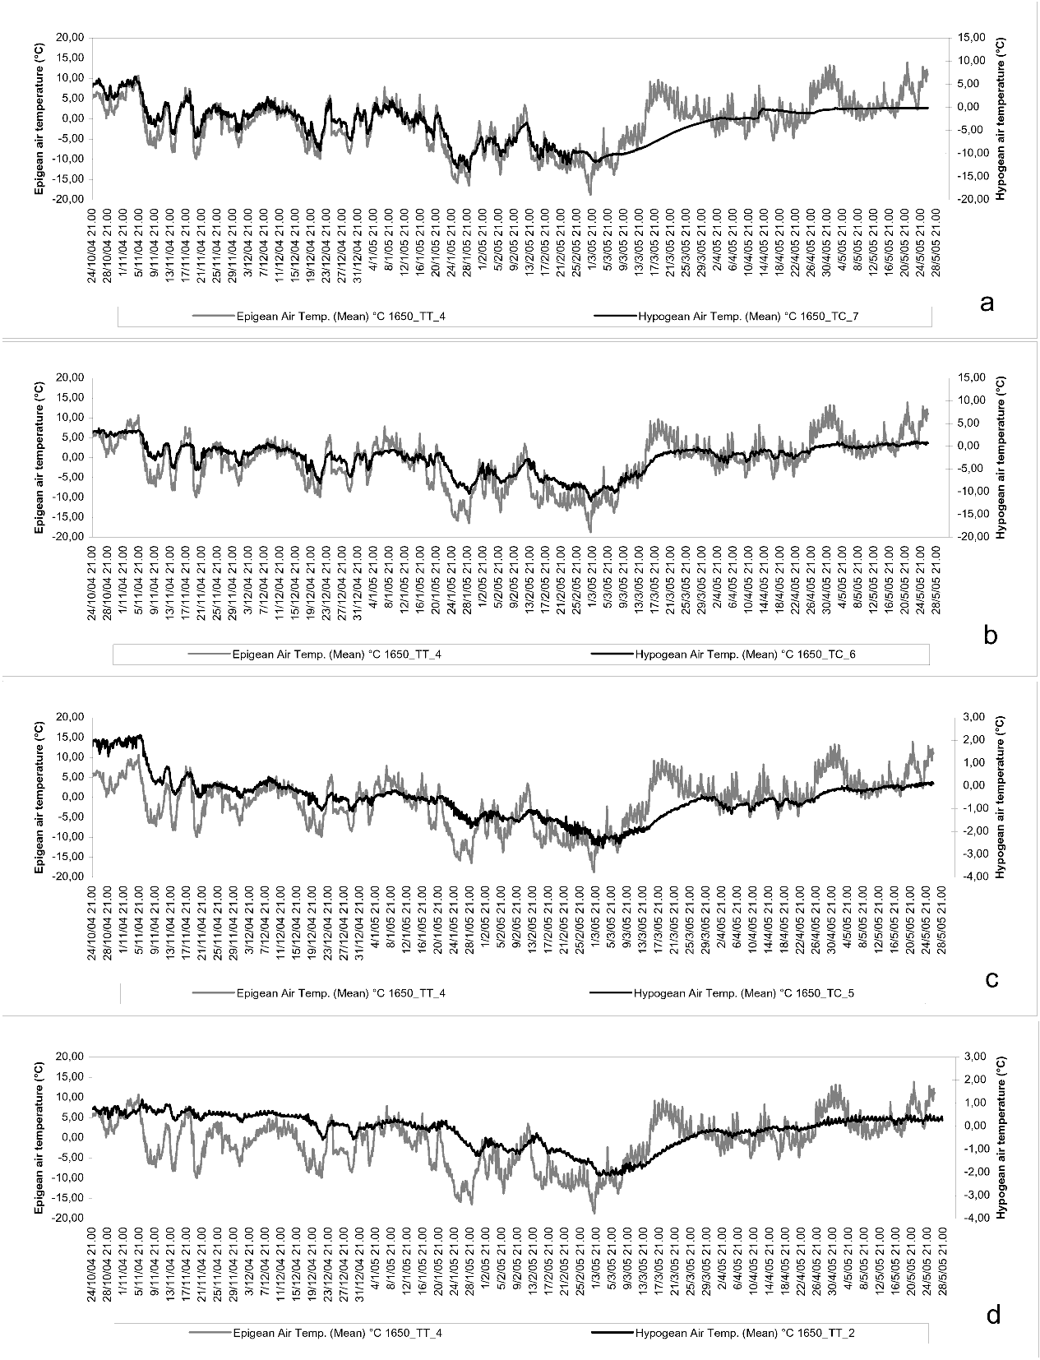
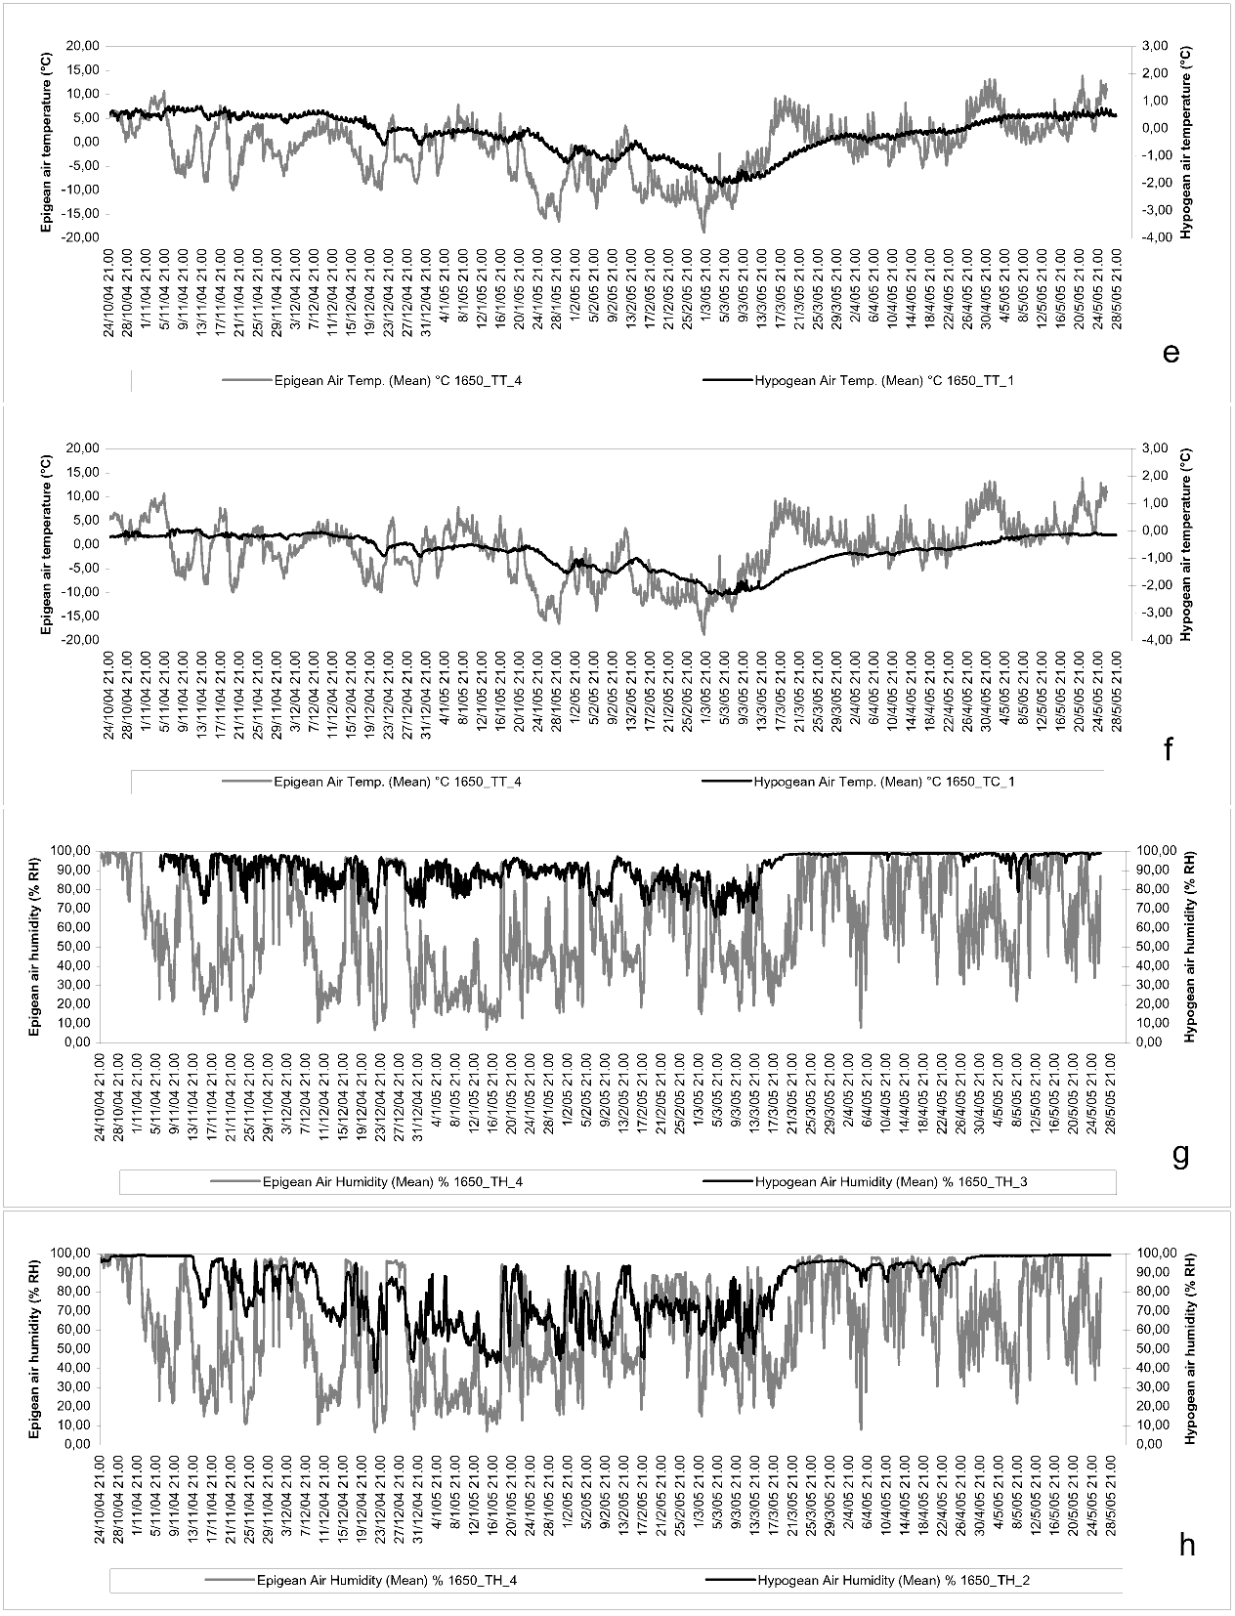
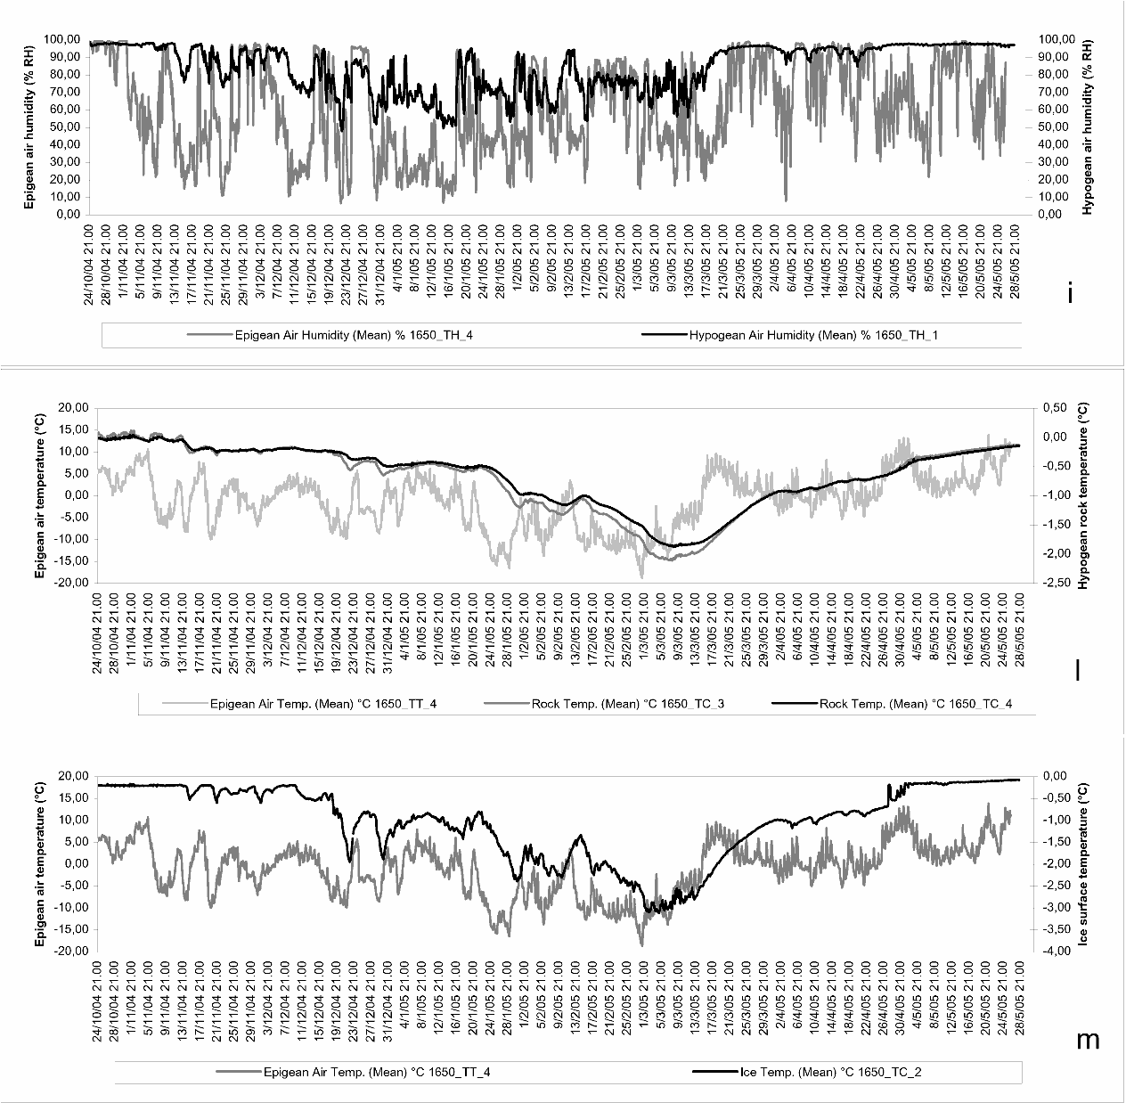

Fig.3 – Initial temperature and humidity data collected during the first cold season.
It can be noted that graphs of 3a and 3b have the same scale that is utilized in the epigean temperature plot. In fact, at TC_7 and TC_6 stations, that are located at 15.75 m and 33.75 m down from the entrance, were significantly affected by the epigean temperature, as it can be observed from the intensity and the time overlap. Hypogean temperature variations should be attentively observed during the end of a cold season when the epigean temperatures start to rise. The mild increase of the hypogean temperature should be related to the water of the melting ice that enter in to the cave, in fact the tendency is to equilibrate at about 0°C.

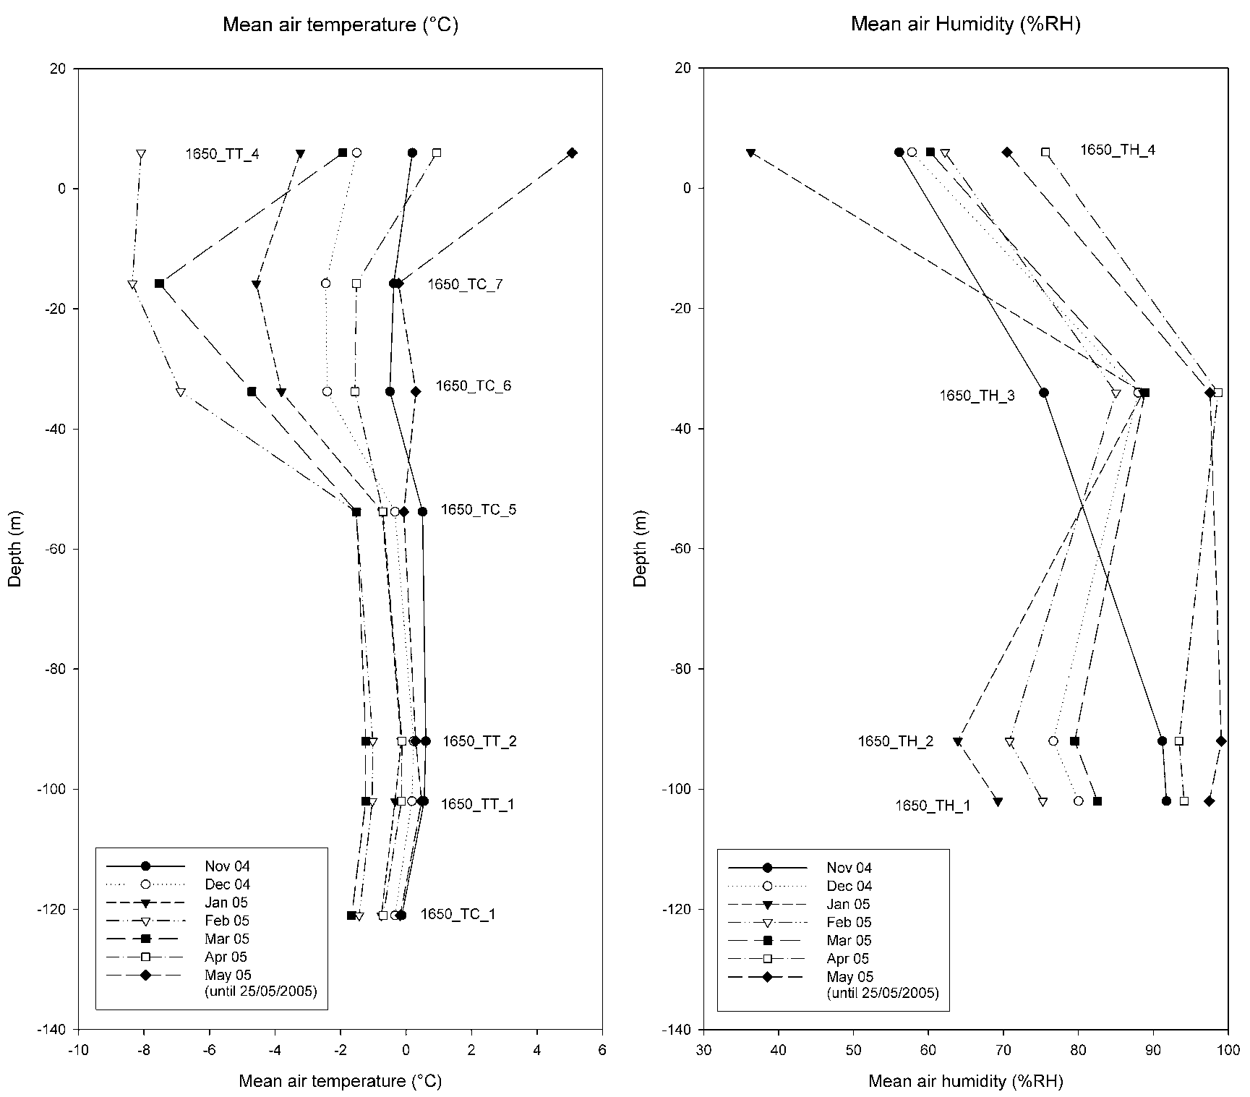

Fig.4 – Air temperatures and humidity trends in vertical profiles. Each line represents average temperature, monthly mean humidity value with increase of depth of various stations.

Station TC_5 is located at a depth of 53.75 m, within the 50 m deep shaft after the meandering tunnel shown in Figure 1. Trend of the temperature shows these environmental variations and hence the reference scale is also changed (Fig. 3c). Epigean “cold” temperatures could be still sensed, although there are some delay. The slightly increasing trend of the hypogean temperature at the end of the cold season is appreciable.
Temperature variations registered at the station of TT_2, located at a depth of 92 m near the ice deposit, are shown in Figure 3. “Cold” epigean events can be still observed although the effects are more delayed. Temperature increase during the cold season are less marked as compared to that of TC_5 station, this is due the presence a nearby ice deposit. On Figures 3e and 3f, plots of TT_1 and TC_1 are shown, that are located under the ice deposit at a depth of 102 m and 121 m respectively. On these plots it can be only effects of only the important “cold” epigean events can be observed, and delays of some days are again appreciated in this case. The first thermal profiles are shown in Figure 4, that were measured during the cold season. Plots represent mean monthly temperature in respect to the depth of the cave. The first points of every plot at the depth of 6 m. belong to the mean temperatures of epigean station. Each station shows different thermal characteristics with depth and variable environmental conditions. In fact along the meandering tunnel, as shown on Figure 3, effects of the epigean temperatures are reflected both in their intensity and temporal overlap. The shaft of 50 m depth reacts differently to the epigean events, that is, intensity decrease and major delay of “cold” impulses. At the base of the shaft, the ice deposit has created a new environment that is conditioned by the ice itself. Hence below the level of the ice deposit, the monthly mean data show a zone with a different trend. Profile of the month of March is particularly interesting. The mean epigean temperature shows a moderate increase indicating the beginning of the end of the cold season. Where as the mean monthly temperature at the station of TC_1 at a depth of 121 m, shows the lowest mean temperature of the season.
Diagrams of Figures 3g, 3h, and 3i show the relative humidity trend registered at the stations of TH_3, TH_2 and TH_1 at the depths of 34 m, 92 m, and 102 m, respectively. All the plots are made in comparison to the meteorological station (TH_4). Evaluating the 3 diagrams, it can be noted that, like during the cold season, the relative hypogean humidity is also affected by the epigean humidity. In fact, during the end of the cold season values increase due to the percolating water into the cave melting from the surface ice. The low relative humidity value registered at the stations of TH_1 and TH_2 as compared to that of TH_3, are indicators of sublimation condition that take place near the ice deposit by either the direct contact of the ice itself or the cave wall near the ice deposit.
The above situation could be better observed in Figure 4, where diagrams show the vertical profile trends of the air humidity. Each plot represents the mean monthly air humidity in relation to the depth of various stations.
In Figure 3l rock temperatures at depths of 10 and 40 cm are plotted against the epigean temperature variations. As it can be noted from the diagram, during the “cold” events the rock is affected by the air temperature at least in the first 40 cm. Studies are on progress to evaluate the rates of delay, considering the above mentioned stations and the nearest station TT_2.
The variation diagram of Figure 3m shows the temperature fluctuations on the surface of the ice deposit. This trend is compared to the epigean temperature variations. This station is particularly interesting since it may indicate the periods of ablation of the ice deposit. We have limited data of the cold season, but some indications are obtained. The deposit has suffered from many “cold” events with delayed manifestations (typical of its environment). A mild increase towards the end of the cold season, different from the other heating trends registered during the cold season, may indicate a progressive melting of the surface ice and percolation in to the ice cave deposit. The short interruptions of this trend may create favourable condition for the formation of new ice.

Acknowledgements
We thank IMONT (ex INRM) “Istituto Nazionale della Montagna” and the “Comunità Montana” of Valsassina, Valvarrone, Val d’Esino and Riviera that partially financed the research.

References
Borreguero M. & Pahud A., 2001 – Mesures de température dans la grotte des Pingouins, (Saviése, VS), premiers résultats. Cavernes, 2-2001, 7-17

Borsato A., Miorandi R. & Onelio F., 2004 – Age and evolution of two cave ice deposits in the Brenta Dolomites (Italian Alps). In: Citterio M. & Turri S. (ed.) Volume of abstracts of the 1st International Workshop on Ice Caves, Căpuş, Romania, 29th February - 3rd March 2004, p. 14

Luetscher M. & Jeannin P.-Y., 2004 – What heat flux must be considered at the base of an ice cave ? In: Citterio M. & Turri S. (ed.) Volume of abstracts of the 1st International Workshop on Ice Caves, Căpuş, Romania, 29th February - 3rd March 2004, p. 21.

Mavlyudov B. R. & Kadebskaya O. I., 2004 – About degradation of glaciation in Kungur cave and possible ways of its restoration. In: Citterio M. & Turri S. (ed.) Volume of abstracts of the 1st International Workshop on Ice Caves, Căpuş, Romania, 29th February - 3rd March 2004, p. 23.

Perroux A.-S., 2001 – Etude du fonctionnement d’une cavitè englacée durant un cycle climatique. Karstologia n°37 – 1/2001, 41-46

Piasecki J., Zelinka J., Pflitsch A. & Sawiński T., 2004 – Structure of air flow in the upper parts of the Dobšinská ice cave. In: Bella P. (ed.) Výskum, využívanie a ochrana jaskýň, 4. vedecká konferencia s medzinárodnou účasťou, 5-8 októbra 2003, Tále, 113-124

Racoviţă G. & Onac B., 2000 – Scărişoara Glacier Cave; Monographic study. Editura Carpatica, Cluj Napoca, Romania. 139 pag.

Strug K., Piasecki J., Sawiński T. & Zelinka J., 2004 – The ice crystals deposit in the Dobšinská ice cave. In: Bella P. (ed.) Výskum, využívanie a ochrana jaskýň, 4. vedecká konferencia s medzinárodnou účasťou, 5-8 októbra 2003, Tále, 125-133.

Szczuciński W. & Rachlewicz G., 2004 – Seasonal, annual and decadal ice mass balance changes in Jaskinia Ladowa w Ciemniaku (ice cave in Ciemniak, Tatry, Poland). In: Citterio M. & Turri S. (ed.) Volume of abstracts of the 1st International Workshop on Ice Caves, Căpuş, Romania, 29th February - 3rd March 2004, p. 27.

Turri S., Citterio M., Bini A., Maggi V., Udisti R. & Stenni B., 2003 – Etude glaciologique et climatologique des cavités glacées du Moncodeno. (Grigna septentrionale, province de Lecco, Lombardie). Karstologia n°42 – 2/2003. 37-44

Turri S., Citterio M., Bini A. & Maggi V. 2004 in press - Preliminary analyses of the avaible hypogean and epigean temperature recordings in Moncodeno (Grigna Settentrionale, Lecco, Italy). Theoretical and Applied Karstology (Special Issue on Ice Caves) n. 17.

