THE FORMATIONS OF THE GRUTAS DEL PALMITO
(Bustamante, Nuevo León, Mexico)
PRELIMINARY RESULTS

Paolo Forti, Univ. Bologna, Via Zamboni 67, I-40127 Bologna, Italy
Arrigo A. Cigna, UIS-SSI, Fraz. Tuffo, I-14023 COCCONATO (Asti), Italy

Abstract
The formations found in the "Grutas del Palmito" confirm the existence of different climatic situations occurred in the cave. Among the more common formations this cave is characterised by a number of rimstone pools, sometimes very large. In some of them big cave pearls (up to more than 10 cm diameter) are found. Physical chemical analysis of the material of the rimstone pools show a very fast deposition rate with the presence of thermal water.

Key words: Palmito, formations, rimstone, cave pearls speleogenesis.

INTRODUCTION
The cave environment can be divided into three parts (Fig. 1 and 2):
1 - First part, already used as a show cave: Salon de Baile (about 150 m)
2 - Middle part: from Paso de la Muerte to Grandes Desniveles (about 160 m)
3 - Last part: Salon de los Gigantes, Catedral, Cueva de Nieve, etc.

Fig. 1 - Location of the "Grutas del Palmito"

The first part is peculiar for many rimstone pools, often rather large, in addition to stalactites, stalagmites and column. In some rimstone pools there are big cave pearls (up to 10 cm in diameter). In the second part, close to the western side (on the right when entering) there is a room of some ten of square metres with very nice helictites rather well preserved.
In the last part many columns are found, some of them fallen down in the past and, successively, other stalagmites grew on them.

From the point of view of formations, this cave has an exceptional abundance of cave powder (Hill & Forti 1997), which is the main constituent of the rimstone pools and is also found in some rocks, being probably the remnants of ancient pools. For this reason some small samples were taken to study their composition and possibly define their origin. In this note, after the geological and climatological characteristics of the cave have been summarised, the samples of cave powder are described with reference to their morphology and mineralogy, and eventually a genetical interpretation is reported.

GEOLOGY
Grutas del Palmito (also called Grutas de Bustamante) formed in the Cupido Limestone, which was deposited 115 million years ago as sediment on the bottom of a shallow sea. Other sediments were deposited on the limestone, until about 60 million years ago when geologic forces pushed up the rocks to form the Sierra Madre Oriental. Successively such rocks have slowly been eroded to expose the limestone and to cut the Bustamante Valley over 500 m deep.

PHYSICAL FEATURES OF THE CAVE
This cave probably developed under hydrothermal conditions since there is evidence of gypsum in some formations. On the other hand, thermal waters have been observed in the area (Ojo del agua, with a temperature above 26°C, source S. Lorenzo with a temperature around 25° C, with the outside temperature around 13°C).

Important cycles of deposition and corrosion may be observed in the cave; concerning both the formations and the rock. In addition, close to the entrance, many stalactites have an evident bent toward the entrance itself, due to an air flow entering the cave when such stalactites developed. For this reason the cave had another entrance at a lower altitude, which later was closed by the growth of formation or collapse.
Fig. 2 - Map of "Grutas de Bustamante" ("Grutas del Palmito")

Since the present entrance was the "warm entrance" of the karst system, the airflow entered during the Summer time. Therefore this fact agrees with the season of the faster development of the stalactites which occurred during the Summer, a rainy time in this region. Presently very weak air flow were detected (below 1 cm/s) at the entrance, sometimes directed inside and outside the cave. Such a flow may be due either to a "barometric cave" (i.e. the air moves inside or outside according the change of the atmospheric pressure outside) or to a chimney effect with a lower entrance is due to small fractures or the porosity itself of the rock. The phenomenon of the acoustic resonance was excluded because the time interval between the change of direction (inflow or outflow) of the air was too long with respect to the intervals (some minutes) due to this phenomenon.

A series of thermometric measurements inside the cave resulted in a uniform air temperature around 19.5°C all over the cave, sometimes with local changes around one tenth of Celsius degree. Such uniformity also in the vicinity of the entrance is a proof of a rather stable equilibrium of the cave from the energy balance point of view. Therefore the presence of visitors and the lighting system should not alter such equilibrium.

EXPERIMENTAL
Three samples have been collected in the cave (Fig. 3):

1 - From the remnant of a ridge in the middle of the main flat chamber.
2 - From the ridge of the rimstone pool in the same chamber, towards West.
3 - From a whitish rock towards the "Paso de la Muerte"

These samples are quite similar and normally consist of small aggregates of euedral crystal of calcite (Fig. 4), even if larger isolated calcite crystals have been rarely observed (Fig. 5). Under a higher enlargement it is possible to see that many vertices of the crystals in samples 1 and 2 have a "skeleton" structure (Fig. 6) with many triangular cavities suggesting an extremely fast growth without the possibility of keeping a euedral structure. In sample 3 such structures if not absent are much rarer.In sample 3, unlike the previous ones, a thin crust is observed. Such a crust, characterised by dry up fractures, covers many calcite crystals (Fig. 7). In addition this crust supported biogenic activities as confirmed by filaments (Fig. 8) and complex structures (Fig. 9) having an evident bacterial origin. X-ray analysis confirmed that samples 1 and 2 are composed exclusively by calcite, while in sample 3 also traces of gypsum were found.

Fig. 3 - Sampling points

DISCUSSION
The experimental results show that the cave powder samples 1 and 2 are quite identical and therefore also their origin should have been the same. Sample 3, on account of the presence of larger crystals, of gypsum traces and organic material, and the absence of "skeleton" structures, implies an evolution different from those of the previous samples. The purity, size and imperfection of the crystals of samples 1 and 2 support the hypothesis of a growth by a fast deposition due to a fast release of CO₂ in the atmosphere from water with a relative high concentration of CO₂, probably of thermal origin. The precipitation was due to physical chemical processes only, which justifies the purity of the deposited calcite.

The evolution of sample 3 should have been slower and more complex. Larger sizes of the crystals, together with the absence of "skeleton" structures support the hypothesis of a slow deposition under a low supersaturation. Accordingly the processes of crystal growth (bi-dimensional) were more frequent than the processes of formation of new nuclei (three-dimensional). Therefore this cave powder was formed probably for evaporation than for the diffusion of CO₂. The presence of a thin crust with traces of gypsum above many calcite crystals shows that, after the deposition of calcite, the evolution continued for a short time under different conditions. In fact, the calcite (also if in small amounts) was solved and re-deposited as gypsum.

Some biogenic process, as supported by the presence of hyphae and globules forms this crust, and the consequent deposition of gypsum probably implies that such reactions could have developed within the cycle of sulphur (Forti, 1989). Thus, the environmental conditions of the evolution of the cave powder should have been in a aerial environment with the powder slightly wet by condensation water and the presence of small amounts of organic material. Then some micro-organisms could develop ad produce a small amount of sulphuric acid, which corroded the calcite and covered it partially with a thin crust having some gypsum inside.

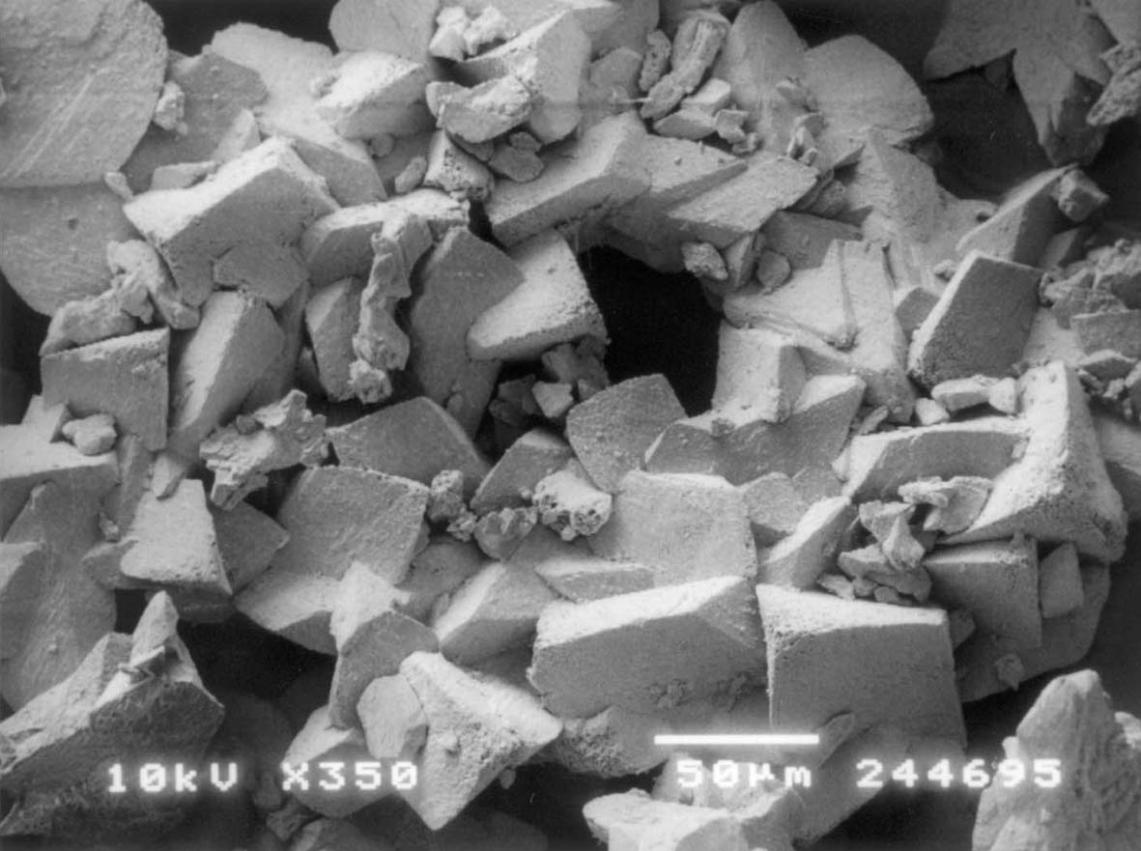
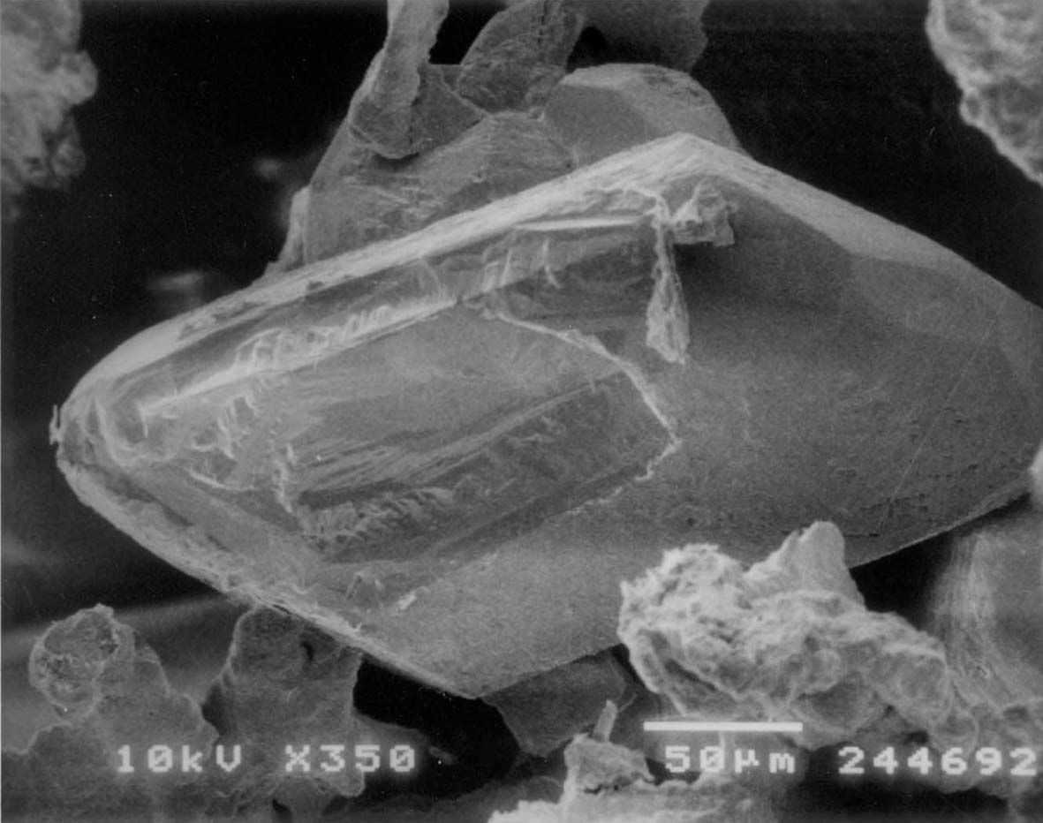
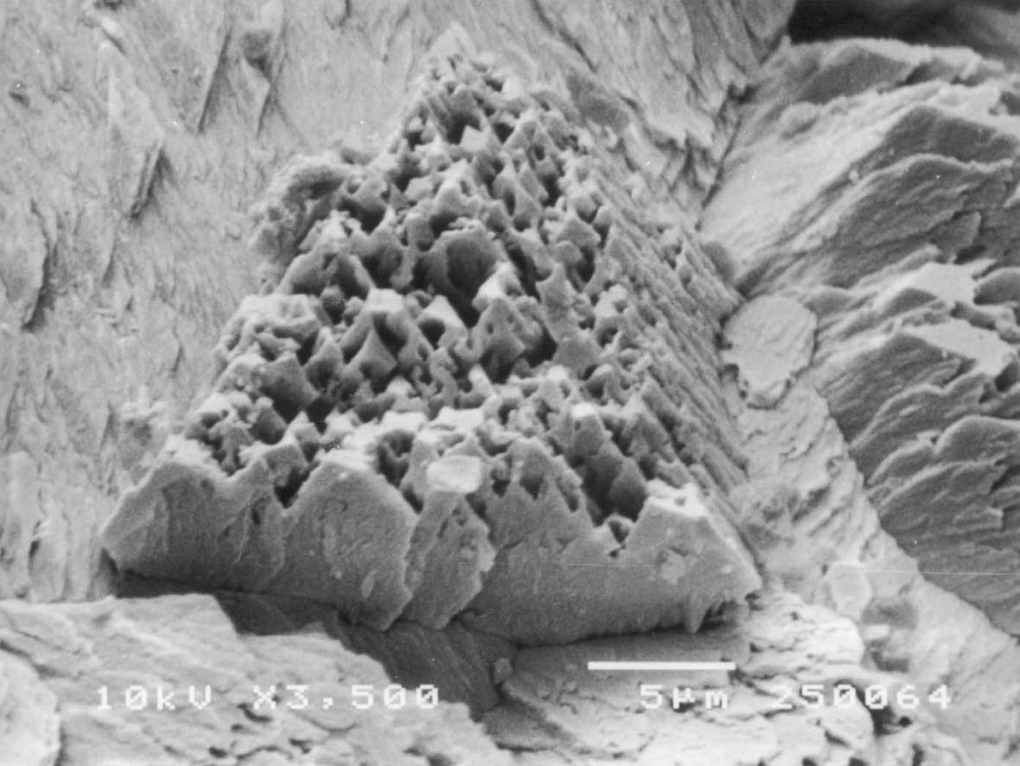
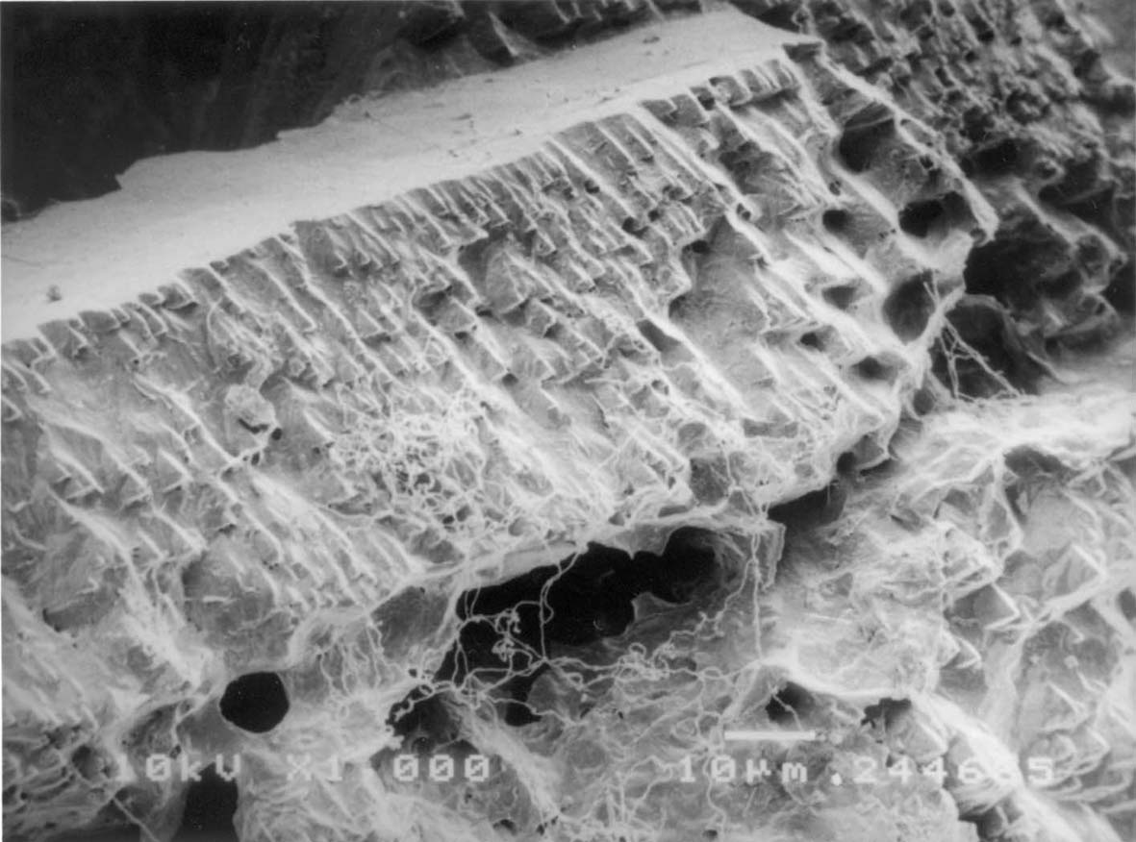
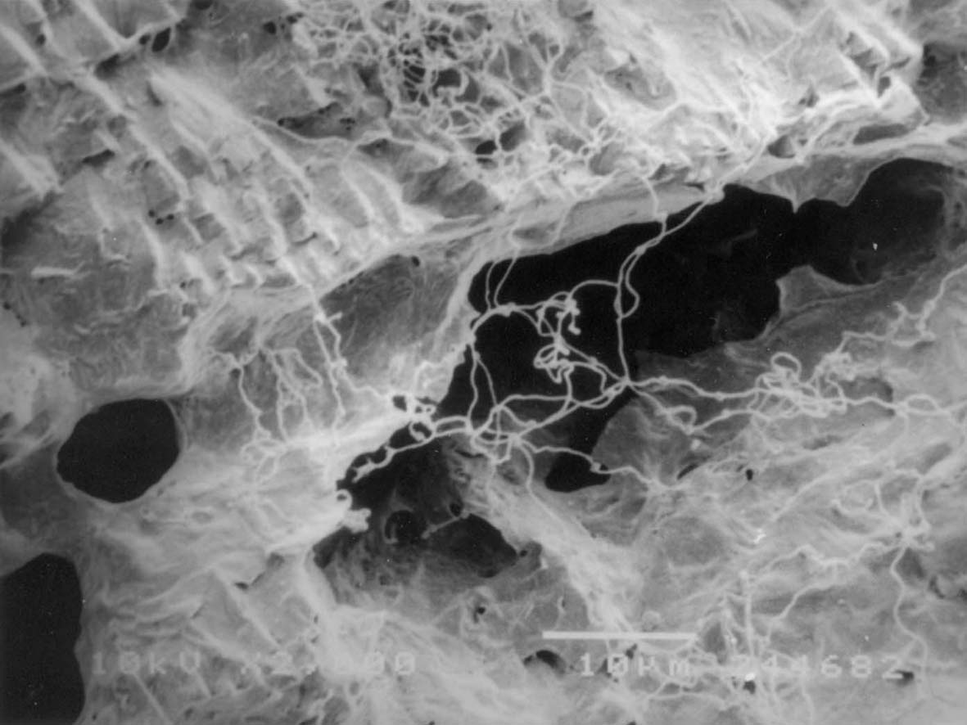
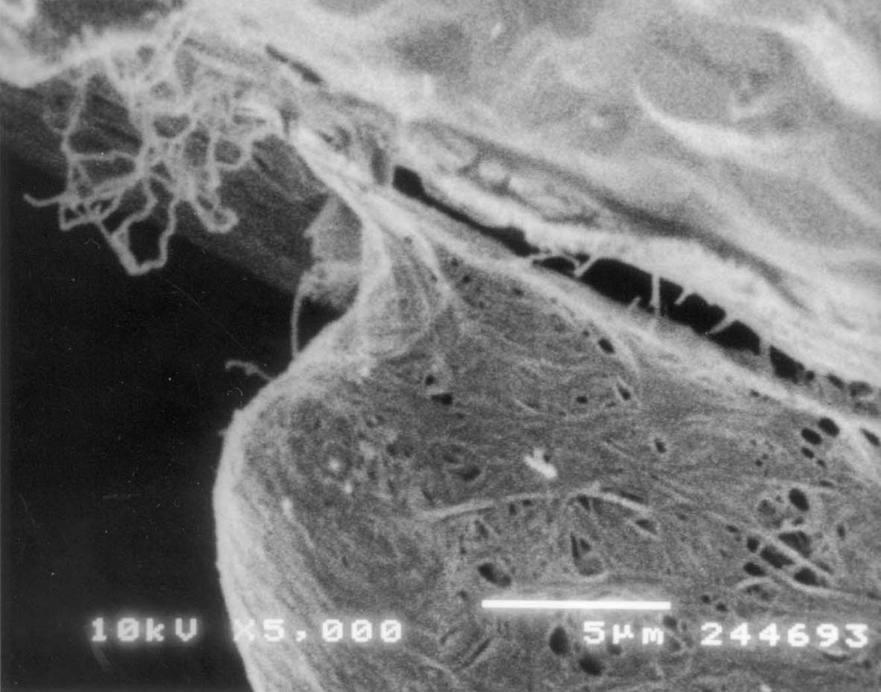
Fig. 4 - SEM image of a characteristic calcite aggregate from sample 1

Fig. 5 - SEM image of a “gigantic” calcite crystal from sample 3

Fig. 7 – SEM image of an aggregate of calcite crystals of sample 3 partially covered by a thin fractured crust

Fig. 6- SEM image of a vertex of a crystal characterized by holes induced by insufficient crystallisation energy
Fig. 8 - SEM image of filaments growing over the crust covering calcite crystals of sample 3

Fig. 9 – SEM image of a “biogenic nest" in sample 3

CONCLUSION
The first results of the investigations here reported support the hydrothermal origin of the cave, with a good agreement with the cave morphology. The existence of hydrothermal sources in the vicinity confirms this evidence. The cave itself shows a number of different conditions, which probably followed one after the other. In fact, successive conditions of deposition and corrosion can be observed on many formations, particularly in the part of the cave closer to the entrance.

Further researches both on the hydrothermal sources of the region and cave formations will provide more details on the processes here described.

ACKNOWLEDGEMENTS
The authors are very grateful to Orion Knox for his support and particularly for having supplied the map of the cave.

REFERENCES
Forti P. 1989 - The role of sulfide-sulfate reactions in speleogenesis. Proc. 10t^{h} Int. Spel Congr., Budapest, 1: 71-73

Hill C.A. & Forti P. 1997 - Cave minerals of the world. Natl. Spel. Soc., Huntsville: 1- 464.

