THE CLIMATE OF KARTCHNER CAVERNS (Arizona, USA)

Arrigo A. Cigna, SSI-UIS, Fraz. Tuffo, I-14023 COCCONATO, Italy
Rickard S. Tomey, III, Kartchner Caverns State Park, PO Box 1849, Benson, Arizona, 85602, USA
Ginger Nolan, Kartchner Caverns State Park, PO Box 1849, Benson, Arizona, 85602, USA

Abstract
Kartchner Caverns is a recently developed show cave in the southwestern United States. One tour opened to the public in November 1999 and another opened in 2003. These openings followed over 11 years of work carried out by the Arizona State Parks. Monitoring of the cave began prior to development and has extended to the present. In this monitoring, some changes in temperature and humidity have been detected. Comparison of the changes at Kartchner Caverns with some undeveloped caves in the vicinity suggests that much of the change seen at Kartchner can be attributed to regional changes in climate; however, development and tourism is also a factor.

Introduction
The climate of Kartchner Caverns was already the subject of a paper (Cigna, 2001) where the propagation of the seasonal heat wave from outside was evaluated for different sections of the cave. The delay grouped mainly around two-three months and extended in one case to about 8 months. In addition, predevelopment data on the cave microclimate has been reported (Buecher, 1999).

Because development and exhibition of caves may cause significant changes in the microclimate, the cave temperature and humidity has been monitored from before development through the present. The long-term monitoring has occurred at approximately 11 environmental monitoring stations throughout the cave (Figure 1). The series of temperature and relative humidity measurements, which extends for some stations from mid-1988, shows either a positive and negative trend, depending on the station. The most extreme example of the climatic changes at Kartchner was noted in the Lower Throne station (Figure 2). This could suggest an effect due to the development of the show cave in spite of the great care paid to avoid, as much as possible, any disturbance. Therefore more detailed studies were carried on to investigate the cause of such climatic changes (Toomey, 2002; 2003).

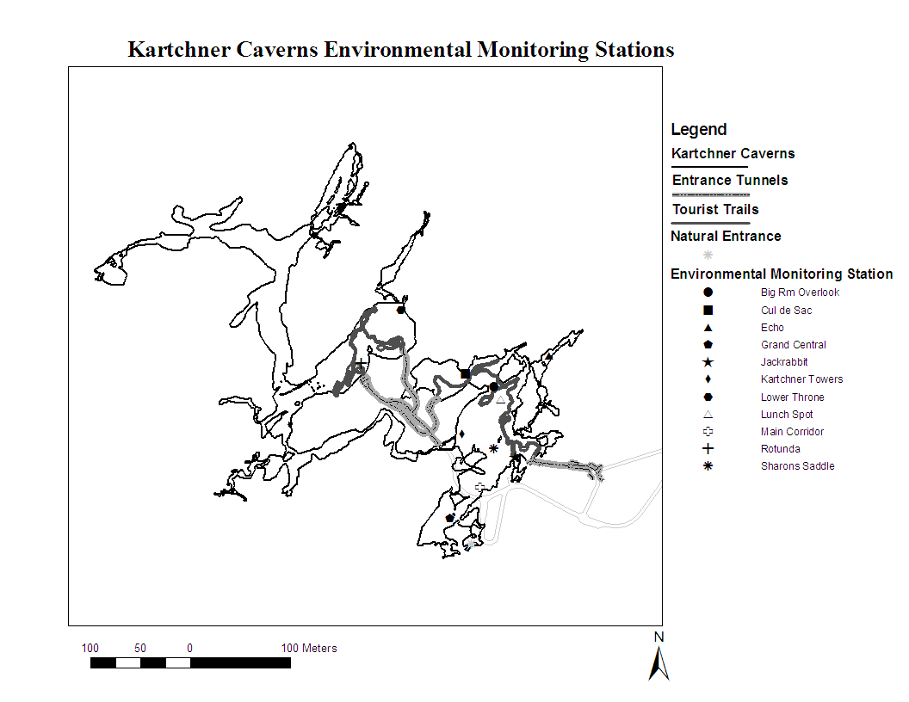
Fig. 1 - Map of Kartchner Caverns showing the natural entrance, the excavated tour tunnels, tour trails, and the location of the environmental monitoring stations discussed in this paper.
Fig. 2 – Temperature and relative humidity measurements and trends from the Lower Throne environmental monitoring station. The point symbols show individual measurements. The black (relative humidity) and gray (temperature) lines show five measurement moving averages of the individual readings to show the general trends more clearly and to reduce data noise. This station shows the most extreme change of the stations at Kartchner cavers.

Relationship between outside and inside climate
A first indication of a possible influence of a natural change was detected by a comparison between the Palmer Drought Severity Index for the southeastern area of Arizona. This index is a climatological parameter that uses rainfall, temperature, and soil moisture to express the moisture state of an area. When this index was compared to the most extreme changes noted in the cave, notable similarities were observed in the records. These similarities suggested an influence of the outside climatic variation on the cave environment (Toomey, 2002).

To further examine the possibility that changes observed at Kartchner relate to regionally observed changes, the quarterly to semi-annual measurements of temperatures and relative humidity in four caves in the Coronado National Forest near Kartchner Caverns were considered. The four caves are Whetstone Cake Cave #1, Whetstone Cake Cave #2, SP Cave, and Cave Mine Cave. They are all located in Cochise County relatively near Kartchner Caverns (Figure 3). Whetstone Cake Cave #1 and #2 are small caves (100-150 m long) with relatively large entrances in the Whetstone Mountains above Kartchner Caverns State Park. They are not very good analogues to Kartchner Caverns, because their small size and large entrances result in large seasonal differences in temperature. However, they do provide data from undeveloped caves that are near the park. Cave Mine Cave and especially SP Cave are much better analogues for Kartchner Caverns. They are each relatively extensive caves with somewhat restricted entrances. They are each located in the Huachuca Mountains near Sierra Vista. The characteristics of these caves are here summarized:

Whetstone Cake Cave #1
Elevation ~1800 meters
Length ~100 meters
Depth ~10 meters
Large entrance
The measurements are taken in the variable temperature zone near to the entrance

Whetstone Cake Cave #2
Elevation ~1800 meters
Length <50 meters
Depth <10 meters
Large entrance
The measurements are taken in the variable temperature zone near to the entranc
SP Cave
Cave Mine Cave
Elevation ~1900 meters
Length ~300 meters
Depth ~20 meters
The measurements are taken in the large room just off the fairly large mine entrance

Cave Mine Cave
Elevation ~1850 meters
Length ~600 meters
Depth ~25 meters
Entrance small (less than 1 square meter)
The measurements are taken tens of meters back from entrance in the stable
temperature zone.

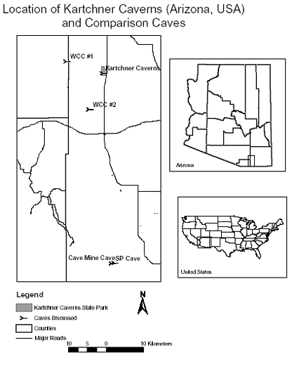
Fig. 3 - Simple map of the region around Kartchner Caverns including other caves discussed in this paper.

An initial comparison between the values of temperature and relative humidity obtained in these caves and the corresponding ones in the Kartchner Caverns (Toomey, 2003) showed some similarities which indicated that certain climatic changes in Kartchner Caverns might be attributed to regional changes in surface climate. In order to investigate more accurately the role played by natural and human factors, a quantitative evaluation of the data obtained in the wild caves was performed. In particular the linear best fit of the results available for these caves was calculated. In Table 1 and 2 the coefficient "a" of the best fit linear equation for temperature and relative humidity values are reported. Such a coefficient is a measure of the variation of temperature or relative humidity through time.

A systematic trend is quite evident, with an increase of the air temperature and a corresponding decrease of the relative humidity. Average values of "a" were also calculated. Similar evaluations were carried on for some stations in Kartchner Caverns by taking into account the values obtained roughly in the same time interval (Tables 3 and 4). The trends of the climatic variations from a surface station, in the wild caves and in Kartchner Caverns is also similar from a quantitative point of view, confirming that the general trend observed in Kartchner Caverns is mainly due to a natural cause.

Table 1 - Best fit of the air temperature values obtained outside and in the wild caves.
Station | Period | T=ax+c  "a"
Outside | January 1991 - July 2004 | 0.0007
SP Cave | November 1991 - September 2004 | 0.0003
Cave Mine Cave | July 1991 - September 2004 | 0.0002
Whetstone Cave 1 | July 1991 - February 2002 | 0.0005
Whetstone Cave 2 | July 1991 - February 2002 | 0.0007
Average±1 sigma |  | 0.00048±0.00020

Table 2 - Best fit of the relative humidity values obtained in the wild caves.
Cave | Period | RH=ax+c  "a"
SP Cave | November 1991 - September 2004 | - 0.0005
Cave Mine Cave | July 1991 - September 2004 | - 0.0009
Average±1 sigma |  | - 0.0007±0.0002
Fig. 2 - Lunch Spot: linear best fit of temperature measurements
Fig. 3 - Lunch Spot: linear best fit of relative humidity measurements

In order to evaluate the delay of the propagation of the seasonal heat wave from outside into the wild caves a sinusoidal best fit equation was calculated. Unfortunately on account of the very few values for each season, only indicative values were obtained, these suggest a delay ranging between 0 to 2 months with respect to outside. Such values compare favorably with most of those obtained in Kartchner Caverns (Cigna, 2001) and reported in Table 5.

Table 3 - Best fit of the air temperature values obtained in Kartchner Caverns.
Station | Period | T=ax+c  "a"
Big Room | January 17, 1991 - April 9, 2004 | 0.0003
Cul de Sac | January 17, 1991 - January 13, 2003 | 0.0003
Echo Passage | January 17, 1991 - January 13, 2003 | 0.0001
Grand Central | January 17, 1991 - July 5, 2004 | 0.0002
Jack Rabbit | June 6, 1994 - August 9, 2004 | 0.0005
Kartchner Towers | January 17, 1991 - April 4, 2004 | 0.0003
Lower Throne | January 15, 1991 - August 6, 2004 | 0.0007
Lunch Spot | September 8, 1992 - May 3, 2004 | 0.0004
Main Corridor | January 17, 1991 - July 5, 2004 | 0.0003
Rotunda | January 15, 1991 - August 9, 2004 | 0.0009
Sharon Saddle | January 17, 1991 - July 19, 2004 | 0.0003
Average±1 sigma |  | 0.00039±0.00022

Table 4 - Best fit of the relative humidity values obtained in Kartchner Caverns.
Station | Period | RH=ax+c  "a"
Big Room | January 17, 1991 - April 9, 2004 | - 0.0003
Cul de Sac | January 17, 1991 - January 13, 2003 | - 0.0002
Echo Passage | January 17, 1991 - January 13, 2003 | - 0.0001
Grand Central | January 17, 1991 - July 5, 2004 | - 0.0008
Jack Rabbit | June 6, 1994 - August 9, 2004 | - 0.0007
Kartchner Towers | January 17, 1991 - April 4, 2004 | - 0.00005
Lower Throne | January 15, 1991 - August 6, 2004 | - 0.0005
Lunch Spot | September 8, 1992 - May 3, 2004 | - 0.0004
Main Corridor | January 17, 1991 - July 5, 2004 | - 0.0002
Rotunda | January 15, 1991 - August 9, 2004 | - 0.0004
Sharon Saddle | January 17, 1991 - July 19, 2004 | - 0.0003
Average±1 sigma |  | - 0.00036±0.00024

Fig. 4 - Lower Throne: polynomial best fit of the 3rd order

The result of the investigations reported above indicates that the development work performed within the Kartchner Caverns, as well their opening to visitors, played a very minor role in the variation of the climatic parameters inside the cave. However in some stations of the Kartchner Caverns, e.g. Lower Throne and Rotunda, a polynomial best fit of the 3rd order is preferable to a linear one, with a correlation ratio R² around 0.9 instead of a R² around 0.7 obtained with the linear best fit.

Fig. 5 - Rotunda: polynomial best fit of the 3rd order

This result, combined with characteristics of these stations, may be local effect due to heat released by visitors and by the electric plant. Because the Rotunda station results also exhibit the minimum delay (1 month) in the propagation of the heat wave from outside, they could infer the existence of some possible connection with outside through unknown passages.

Because development and tourist activities contribute some component of the warming, there may be steps that can be taken to mitigate this portion of the climate change. Using more efficient lamps and reducing time that such lamps are switched on may contribute to a decrease of the human impact. These steps are being taken incrementally at Kartchner and the results are being examined to see if they improve the situation.

Table 5 - Delay of the propagation of the seasonal heat wave from
outside in some stations of the Kartchner Caverns (Cigna, 2001).
Station | Date of max | Delay (days)
Outside | 1-Aug | 0
Rotunda | 5-Sep | 35
Cul-de-Sac | 30-Sep | 60
Main Corridor | 30-Sep | 60
Grand Central | 30-Sep | 60
Lower Throne | 30-Sep | 60
Big Room Overlook | 30-Sep | 60
Kartchner Towers | 16-Oct | 76
Jack Rabbit | 22-Oct | 82
Sharon's Saddle | 15-Nov | 105
Echo Pass. (Start) | 28-Mar | 238

Acknowledgements
The authors are grateful to Jerry Trout, USDA-Forest Service, who kindly provided temperature and humidity data on caves from the Coronado National Forest. We would also like to thank the Cave Unit staff at Kartchner Caverns who made most of the measurements at the environmental monitoring stations.

References
Buecher R.H., 1999 - Microclimate study of Kartchner Caverns, Arizona. Journal of Cave and Karst Studies. 61(2): 108-120.

Cigna A.A., 2001 - Evaluation of the tourist impact in the Kartchner Caverns (Arizona, USA). Proc. 13th Int. Congr. of Speleology, Brasilia July 15-22, 2001, Speleo Brazil 2001, 2: 188-192

Toomey R.S., III, 2003 - Kartchner Caverns 2001-2002 Cave Resources Manager Annual Report. Arizona State Parks.

Toomey R.S., III, 2003 - Kartchner Caverns 2003 Environmental and Research Report. Arizona State Parks.

