Chemical and stable isotopes profiles along two cores from the snow deposit in
the Lo Lc 1607 ice cave (Grigna Settentrionale, Italian Alps)

Citterio M.¹, Turri S.¹, Bini A.¹, Maggi V.², Stenni B.³ & Udisti R.⁴

¹ Dipartimento di Scienze della Terra "Ardito Desio", Università di Milano, via Mangiagalli 34, I-20133 Milano, Italy.
² DISAT - Dipartimento di Scienze dell’Ambiente e del Territorio, Università di Milano Bicocca, p.za della Scienza 1, I-20126 Milano, Italy.
³ Dipartimento di Scienze Geologiche, Ambientali e Marine, Università di Trieste, via E. Weiss 2, 34127 Trieste, Italy.
⁴ Dipartimento di Chimica Analitica, Università di Firenze, via della Lastruccia 3, Polo Scientifico, 50019 Sesto Fiorentino, Italy.

Corresponding author: michele.citterio@unimi.it

Abstract
Two snow cores from the Lo Lc 1607 “Crepaccio superiore in media Val Laghetto” ice cave were analyzed for their chemical and stable isotopes composition. The cave, located at an altitude of 1948 m a.s.l., contains a snow deposit fed by windblown snow showing a yearly thickness variability of some metres in connection with winter snow availability.
We compare data from the two snow cores data and discuss the characteristics and significance of the observed enriched levels. A distinctive pattern characteristic of the ablating top snow surface is described, with particular attention to the behaviour of those ions typical of the carbonatic environment (Ca²⁺, Mg²⁺) when compared to the other ions. These results can be useful in developing a method for detection of buried ablation surfaces in cave snow cores. A first simple attempt to derive such a method is proposed.

Introduction
The entrance to thr Lo Lc 1607 "Crepaccio superiore in media Val Laghetto" ice and snow cave is located at an altitude of 1948 m. a.s.l. on the northern slope of Grigna Settentrionale (Central Italian Alps), in the Moncodeno high altitude karst area (Fig. 1). Surface morphology of the area is dominated by dolines, bare rock surfaces and karren. Buried karst surface landforms testify of a time when the very poor present soil cover was more abundant. Field work started in 1999 and developed from a general survey of a selection of the many caves known to host ice deposits to the coring of two snow cores year 2000. Further work on cave ice in the area is summarized in Citterio et al. (in press); since autumn 2004 at a nearby ice cave a large microclimatic system is collecting data both from the epigean and the hypogean environments down to a depth of 100 m.

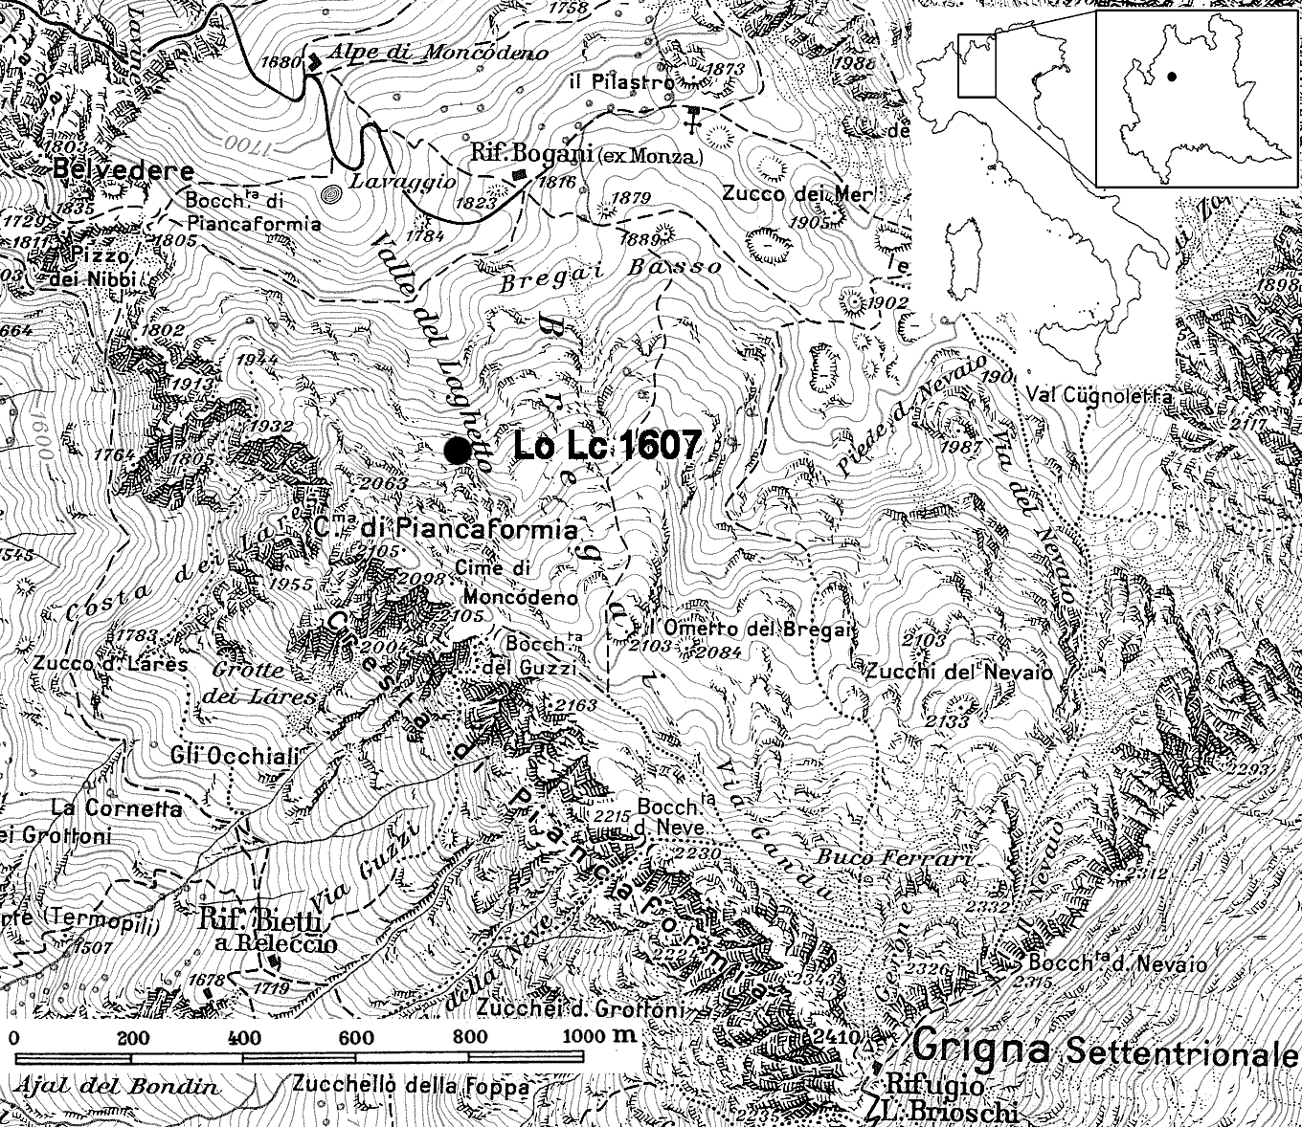

Figure 1 – Map of the Moncodeno area; the black dot marks the location of the Lo Lc 1607 cave.

Figure 2 – Plan and vertical cross maps of the Lo Lc 1607 cave (simplified and updated from Bini & Pellegrini, 1998).

The Lo Lc 1607 is a small cave in the infiltration zone of a karstic system decapitated by glacial exaration (Bini & Pellegrini, 1998). The cave has been surveyed in the past decades and the presence of perennial ice and snow deposits is reported since the first surveys (published many years later by Bini & Pellegrini, 1998), which also show a now obstructed down-going passage in the ice . The present setting of the cave is shown in Fig. 2: the snow deposit at the bottom of the entrance doline has an unknown depth and is directly and abundantly fed by snowfalls. Following to the entrance of the cave and the steep debris slope is another snow deposit where accumulation is due to windblown snow. In summer 1999 the deposit featured a statigraphy composed of more than one hundred layers over a total thickness of about 2.5 metres. These layers were bounded by irregular undulated surfaces produced by refreezing of a usually millimetric wet snow level. The proximity to the cave entrance allows for the relatively wide temperature oscillation needed for the development of such features. The thickness of this deposit showed a rapid variability: the few metres observed during summer 1999 were found to have reduced to less than one metre when the cores have been drilled in summer 2000. Nevertheless, the two short cores allowed precise sampling and high quality samples for chemical and isotopical analyses. At the time of drilling the snow deposit was undergoing a strong ablation phase also promoted by sparse dripping from the cave roof.
The interest for ice and snow deposits in caves is mostly connected with the attempt to use them as sources of past environmental data, both for the last years or tens of years (in the case of deposits near to the cave entrance) and for the last centuries or even thousands of years (at deeper and more stable ice deposits). Dating by various techniques at some ice caves have already confirmed the existence of cave ice deposits reaching these ages (Şerban et al., 1967; Achleitner, 1995; Citterio et al., 2005). Nevertheless, for a snow or ice cave deposit to be a viable source of information about the past, it has not only to represent a long time interval with good resolution, but its stratigraphy also has to be clearly defined. Most importantly, melting episodes resulting in stratigraphic gaps have to be readily recognizable someway. Direct observation of vertical exposures on the sides of the deposits are not always available or even reliable, and the advantages of working on ice and snow cores back in a cold room calls for the development of practical methods for detecting ablation surfaces buried by successive accumulation events. What makes this an even more challenging issue is the present lack of a crystallographic and textural evolutio model of snow in cave environments. Due to the different thermal regimes of ice caves with respect to epigean snow covers, the well known sequence of recrystallization stages involved in metamorphism of snow into firn can be expected not to be immediately portable to hypogean snow evolution (Perşoiu, pers. comm.). Similarly, snow composition profiles available from the nivological and glaciological literature may not be directly compared with findings from cave environment.

Matherials and methods
Many technical details are involved both in field and laboratory operations on ice cores. The Environmental Sciences Department (DISAT) at the University of Milano Bicocca is active in leading ice drilling projects in Antarctica and the Alps; building on this expertise, research assets and resources we cored a total of four cores in the Moncodeno area (Italy), and a fifth one in the Padiş area (Romania) in cooperation with the Cluj section of the Speleology Institute “E. Racoviţă” of the Romanian Academy of Sciences. For the Lo Lc 1607 snow core, the same conventional lightweight corer used in all of the other caves was selected. The drill head is an aluminium ring bearing three hard metal alloy knives of selectable shape and geometry. The stainless steel corer barrel has an internal diameter of 10 cm, it is 1 m long and it can accept up to 60 or 70 cm of ice in every single run. Its external helicoidal trail drives the ice chips to the upper part where two windows let them enter and collect in a chamber. Rotation is provided by a 220 V, 1.5 kW low rpm electric engine and the operator both supplies the thrust force and contrasts the torque manually; a heavy duty power line was used to connect to a 2.5 kW power unit located near the entrance of the cave. The core was drilled from the top surface of the snow deposit down to the coarse rock debris found at the bottom of the snow deposit. The cold transport from the coring place was a two steps process: first, the cores were immediately closed in plastic bags, hauled to the surface inside sections of rigid PVC pipe to protect them from handling shocks, and placed in insulated boxes cooled by solid CO₂; at the end of the coring operations the boxes were taken downvalley with the help of two mules and finally to cold storage by car. Once in the cold room of the University of Milano Bicocca the cores were cut with a band saw and 5 cm thick continuous samples were cut for chemistry, stable oxygen isotopes, pollen content and insoluble particles analyses. This sampling procedure of the core, which produces a virtually continuous record of equal, regular, prismatic subsamples under controlled conditions, is impossible to be reliably carried out in the field.
The chemical analyses have been carried out by ionic chromatography on melted and 0.45 μm filtered samples at the Analytical Chemistry Dept., University of Firenze; the oxygen isotopes analyses have been performed at the Geological, Environmental and Marine Sciences Dept., University of Trieste.

Results
Chemical profiles (Fig. 3) show a pattern consistently present in both the cores and for any of the measured ionic species: the topmost 5 cm high sample is always more enriched than the sample immediately below it, usually by three to five times. The strong enrichment of the topmost sample can be clearly observed in every plot. A strong peak in the Ca²⁺ content and a lower one for Mg²⁺, typical ions of the carbonatic environment, can be observed both in the 1650-1 and in the 1650-2 cores at a depth of 35 cm and 20 cm respectively. No significant enrichment in any other ion has been found at these same depths. Cave samples show lower values than samples from an old snow patch sampled in the cave area in June, 2001 (Tab. 1) with the exception of Ca²⁺ and Mg²⁺, which are more abundant in the cave samples.

 | Na⁺ | NH₄⁺ | K⁺ | Mg²⁺ | Ca²⁺ | Cl⁻ | NO₃⁻ | SO₄²⁻
 | ppb | ppb | ppb | ppb | ppb | ppb | ppb | ppb
1607-1 core, average | 48 | 17 | 35 | 65 | 844 | 72 | 27 | 71
1607-2 core, average | 24 | 12 | 12 | 32 | 550 | 57 | 20 | 43
snow patch, val Laghetto, June 2001 | 85 | 259 | 30 | 24 | 445 | 258 | 970 | 505
Colle del Lys Glacier, summer average | 49 | 206 | 31 | 21 | 243 | 111 | 437 | 505
Colle del Lys Glacier, winter average | 27 | 35 | 19 | 9 | 86 | 68 | 149 | 245
Colle del Lys Glacier, year average | 36 | 108 | 24 | 14 | 152 | 86 | 272 | 855

Table 1 - Major ions average content in the two snow cores (5 cm high continuous samples), in samples from a nearby epigean old snow patch and in the Colle del Lys core (this last data set is from Radice, 2000).

When considering as a rough reference the averaged data from an Alpine glacier high altitude coring (Colle del Lys Glacier core, representing the 1971 to 1997 snow accumulation), where seasonality has been found to be particularly strong in NH₄⁺, NO₃⁻ and SO₄²⁻ contents (Radice, 2000), it can be seen that these same ionic species show the largest differences between cave and epigean old snow patch data. The chemical profiles follow similar trends in the two cores (Fig. 3) but, despite having been cored in two very near locations (less than one metre apart from each other) the 1607-1 core has a higher ionic content. The correlation coefficient matrixes for both cores are similar and Tab. 2 shows the correlation coefficient matrix for the 1607-1 core.

 | Na⁺ | NH₄⁺ | K⁺ | Mg²⁺ | Ca²⁺ | Cl⁻ | NO₃⁻ | SO₄²⁻
Na⁺ | - | 0,99 | 0,99 | 0,84 | 0,15 | 1,00 | 0,81 | 0,99
NH₄⁺ | 0,99 | - | 0,99 | 0,84 | 0,15 | 0,99 | 0,82 | 0,99
K⁺ | 0,99 | 0,99 | - | 0,86 | 0,19 | 0,99 | 0,80 | 0,99
Mg²⁺ | 0,84 | 0,84 | 0,86 | - | 0,64 | 0,86 | 0,77 | 0,88
Ca²⁺ | 0,15 | 0,15 | 0,19 | 0,64 | - | 0,18 | 0,30 | 0,22
Cl⁻ | 1,00 | 0,99 | 0,99 | 0,86 | 0,18 | - | 0,81 | 1,00
NO₃⁻ | 0,81 | 0,82 | 0,80 | 0,77 | 0,30 | 0,81 | - | 0,85
SO₄²⁻ | 0,99 | 0,99 | 0,99 | 0,88 | 0,22 | 1,00 | 0,85 | -

Table 2 – Correlation coefficients matrix for the 1607-1 core data.
Figure 3 – Major ions content profiles along the two snow cores (5 cm high continuous samples). The strong enrichment of the topmost sample can be clearly observed in every plot. Very strong peaks in the contents of Ca²⁺ and Mg²⁺, typical of the carbonatic environment, can be observed at a certain depth in both the cores, while the other ions consistently feature a fairly constant content, without showing any enrichment at that same depth (see the text for a discussion of this patterns). Concentrations in ppb, depths in cm.

Figure 4 – δ¹⁸O profiles expressed in ‰ units for the 1650-1 (to the right) and the 1650-2 (to the left) cores.

As can be seen from Tab. 2, while in general the correlation coefficients are quite high, the correlation coefficients of Ca⁺ is very low with any other ionic species except Mg²⁺.
δ¹⁸O values are remarkably constant along the core length(fig. 4), with average values of -6.0 and -6.1 ‰ in the two cores. The chemical and oxygen stable isotopes plots with depth show no correlation, being the constant δ¹⁸O values does not reflecting neither the generalized ionic enrichment at the top of the core, nor the deeper Ca²⁺ peak described above.

Discussion and conclusion
The main focus of our discussion will deal with the different nature of the two levels of comparatively higher ionic content which have been found in the two snow cores from the LO LC 1607 ice cave. Further discussion may deal with the lower content in most ionic species (notably in the industry-related species such as SO₄²⁻) with respect to the Colle del Lys core, despite the fact that the latter is from a site located at much higher an altitude, but this falls beyond the main purpose of this paper, which is to investigate the feasibility of detecting stratigraphic discontinuities in the snow deposit. The fundamental difference between the two enriched levels, which are found one at the very top of the core and the other at the depths of 35 and 20 cm in the 1607-1 and 1607-2 cores respectively, is the enrichment in all ionic species opposed to the enrichment in Ca²⁺ (and to a lesser extent, of Mg²⁺) only. The common feature of both levels is the complete absence of any corresponding signal in the oxygen stable isotopes ratio data. In order to interpret the evidences found, it is necessary to take into account the setting of the investigated snow deposit, and its consequences on the accumulation, possible contamination and ablation of the deposit. The coring location is a few metres inside the cave and is not reachable neither by free falling snow nor by avalanching snow because of the peculiar internal topography of the selected cave. Accumulation is thus represented by windblown snow only, the strong winds being also responsible for the presence in the cave of leaves from the broadleaf forest a few hundred metres of altitude lower. This accumulation process can also be expected to mix to some extent the snow before it enters the cave, thus smoothing the chemical and isotopical differences of the various snowfalls. Dusts are also likely to be blown into the cave by the strong winds. The deep Ca²⁺ and Mg²⁺ enriched levels are clearly related to contributions from the carbonatic environment, either under the form of aerosols due to water dripping and enriched in these ionic species typical of the carbonatic environment or to the presence of light windblown layers of carbonatic dust of local origin or finally to other means of contamination of the snow deposit by rock derived content. It is also likely that this process is acting slowly in nature, so that the Ca²⁺ peak will only develop during a temporary accumulation stop. The different depths at which this level is found in the two cores is an effect of the different thickness of the snow deposit in the two coring sites and it is interesting to observe that, when measured with reference to the bottom of the core, they it is found at 10-15 cm in both of the cores. This last note actually supports the described genetic model of the deep enriched layer, since it is more likely that a roughly regular surface was produced by windblown snow accumulation instead than by ablation. In facts, the ablation surface at the time of coring was quite undulated and irregular.
As for the enriched surface level, we must exclude any process leading both to isotopic fractionation or allowing for the preferential accumulation of certain ions at the top of the deposit. Warm season ablation in the cave can be considered as dominated by melting, being the humid, cold and solar radiation shielded cave environment not favourable to significant evaporation and sublimation processes. During the ablation season, as was the case at the time of coring, the snow deposit is melting and the surface of the snow gets enriched in ionic content without undergoing any significant isotopic fractionation; this may be accompanied by some amount of percolation through the first millimetres and centimetres of snow by the slightly enriched meltwaters. During the frequent cloudy weather some small and isotopically undetectable amount of condensation on the snow surface may also take place from the humid air entering the cave, but the dominant phenomenon seems to be acting concentrating in the top surface the ionic content already present in the melting snow, since the ratio between different ions remains roughly constant.
Unfortunately the short length of the two cores prevented from fully investigating the occurrence and characteristics of a series of many high concentration layers, but it is obvious that a new accumulation event would have buried the surface level here described and a new surface level would have started getting enriched during the following ablation phase.
These observations makes for the main conclusions of this work: it seems possible to detect from chemical and isotopical profiles the occurrence of missing gaps (marked by peaks in the content of every ion and constant δ¹⁸O values) or even of stopped accumulation (marked by Ca²⁺ and Mg²⁺ peaks only and constant δ¹⁸O values). Further work on this and other similar cave deposits is needed in order to confirm the reliability and convenience of this method and to refine the suggested models for the development of the enriched levels.

Acknowledgments
We wish to thank Marco Filipazzi for the assistance with operations in the field and in the cold lab.

References
Achleitner A., 1995 - Zum Alter des Höleneises in der Eisgruben-Eishöhle im Sarstein (Oberösterreich). Die Höhle, 46 (1), 1-5.

Bini A. & Pellegrini A. (1998) – Il carsismo del Moncodeno. Geologia Insubrica, 3 (2), 296 pp.

Citterio M., Turri S., Bini A., Maggi V., Perşoiu A. & Rajka G. (2005) – Cave ice coring in the Geţarul Focul Viu (Romania): techniques, preliminary observations on core stratigraphy and radiocarbon ages setting a new record for this cave. 9th Alpine Glaciological Meeting, Milano, 24 - 25 February 2005.

Citterio M., Turri S., Bini A., Maggi V., Pelfini M., Pini R., Ravazzi C., Santilli M., Stenni B. & Udisti R. (2004, in press) – Multidisciplinary approach to the study of the Lo Lc 1650 “Abisso sul Margine dell’Alto Bregai” ice cave (Lecco, Italy). Theoretical and Applied Karstology (Special Issue on Ice Caves), 17.

Kern Z., Fórizs I., Kázmér M., Nagy B., Szántó Zs. Gál A. (2004) - Late Holocene environmental changes at Geţarul de la Focul Viu (Bihor Mts., Romania) studied by various methods. In: Citterio M. & Turri S. (eds.) 2004 - Volume of Abstracts of the 1st International Workshop on Ice Caves (IWIC-I), Căpuş, Romania, 1st-3rd March 2004, p. 20

Radice P. (2000) – Misure glaciochimiche sulla carota del Colle del Lys (Monte Rosa) e loro significato ambientale. Tesi di Laurea in Scienze Ambientali, Università di Milano Bicocca.

Şerban M., Blaga L., Chifu A. and Ciobotaru T. (1967) - Contribuţii la stratigrafia depozitelor de gheaţa din Gheţarul de la Scărişoara, Lucr. Inst. Speol. «E. Racoviţă», 6, 107-140.

