Some New Speleological Research of Caverns in route of the Highways in Croatian Karst

Prof.dr.sc. Mladen Garašić, dipl.ing.geol.^{1,2}
mgarasic@public.srce.hr

¹University of Zagreb, Faculty of Civil Engineering, HR-10000 Zagreb, KaČićeva 26, Croatia
²Croatian Sopeleological Federation, HR-10000 Zagreb, Nova Ves 66, Croatia

While building highways in karst regions of Croatia during the last fifteen years, over 767 caverns (speleological objects without natural entrance) were discovered and thoroughly explored. Research were carried out sistematically on sections of roads, highways, cuttings, tunnels, bridge foundations, viaducts, etc. while building Zagreb-Rijeka highway, Zagreb-Split Highway, Ypsilon of Istria semi-highway, Rijeka-Rupa highway, Zagreb-Zadar semi-highway, Rijeka by-pass, etc. Until June, 30th 2005, over 9000 caves and pits were discovered in Croatia.
Research goals were geotechnical solutions of cavern improvement, treated accordingly to engineering geological and hydrogeological parameters obtained by thorough speleological research, measuring, surveying and filming. Using geostasistical methods combined with computer programs, interesting data concerning groupations of certain speleological objects were obtained (lithostratigraphical indicators and speleogenesis type, hydrogeological parameters in relation to tectonic and lithostratigraphical factors, their relation towards topographic position, morphometric parameters in relation towards overbeds above caverns, etc.). Aditionally, average lengths and depths of speleological objects in certain areas (different from earlier data got by treatment of known speleological objects with entrances on the surface of the terrain) were also noted. Explanation for this is that laws of «inner» speleogenesis rule in the caverns, and the influence of sudden changes on terrain surface affects them slower. Speleological objects with surface entrances have faster and more intense development of speleogenesis. Caverns can be in «initial» or «fossil» phase of speleogenesis, but those processes are slower. Caverns (in their morphometric parameters) are in big percentage larger than objects in those areas with surface entrances. Explanation for this is that many of the objects with surface access are already in «fossil» or «older main» karstification phase in the moment of their self-destruction. Caverns with more than 100 meters of rock overbeds (except in Jelar beds and limestones of Liass) are no different than speleological objects with natural entrances situated on the road level in that area. Some of the caverns were later connected with speleological objects known earlier. Detailed measurements of natural radioactivity were also carried out. Radioactivity in caverns was almoust negligible, while in nearly all other objects it had much bigger intensity. Highest dose of radioactivity is brought into speleological objects by every visitor when entering from the terrain surface. Some of those caverns ask for special attention because of their dimensions (length, depth, width, highth) or seconday sediments (speleothems).
There were 688 (89,71%) vertical (of 767 fully researched caverns), and 79 (10,29%) horizontal speleological objects (features). No combined or complexed objects were noted. Partial explanation for slight change in general picture of vertical : horizontal : complexed relation (V:H:C=78:21:1) is that built sections mostly go through outer and middle area in Dinaric karst.
Average depth was 34,50 meters (more than average for 9000 other speleological objects known so far in Croatia- except Min/max peaks). Average length was 52 meters (no peaks). Deepest pits was 196 meters, longest cave 1137 meters. (Garašić, 2004.) Large cavern was the one in «Sveti Rok» tunnel (left tube), on stationage of tunnel km 200+525, where 1137 meters of surveyed cave channels, with vertical altitude difference of 147 m, was speleologically researched and surveyed. Throughout long-lasting research of about fifty caverns in «Sveti Rok» tunnel, several kilometers of profiles and plans (appearing in certain pattern) were surveyed with precission. Speleogenesis of caverns is directly linked with litostratigraphical, hydrogeological and tectonic predispositions on every location in tunnel. Speleological objects are mostly vertical (shafts, pits), kneelike morphological type, with hydrogeological function of spring (permanets or semipermanent). Only one true exeption is the cavern o stationage km200+525, with explored big cave chamber of 148m x 53m x 62 meters. Some objects are even deeper (they are connected to the surface - bats were found). Caverns in «Mala Kapela» tunnel (left tube, Lika side) presented a problem for building improvement several times, because of their posotion and morphlogy.
In Rijeka-Karlovac (Zagreb) highway area, there are all three speleogenesis phases. General relation between «main» and «fossil» phase of karstification is different in particular parts of highway, and totally, it equals 3:1 (exactly 3,11:1). In inner karst area (area from Karlovac to Bosiljevo) situation is completely different. Here the relation between «main» and «fossil» phase of speleogenesis equals 1:7 (exactly 1:6,89), which indicates that most caverns are filled with cave in material, calcite or in most cases with high plastic clays, color red to brown-red. In center karst karstic area (Bosiljevo to Fužine), highway goes through area where speleogenesis in relation «main» : «fossil» phase equals 2:1 (exactly 2,36:1) to 3:1 (3,05:1). (Garašić&all, 2003a, 2003b). In outer karst areas (Fužine to Rijeka area), relation equals 4:1 (4,20:1). All known and researched objects on this route and all the ones nearby were taken into consideration while calculating relations of particular speleogenesis phases. (Garašić, 2002.)
Studiing genesis of speleological objects in Croatian karst on great number of examples, it was concluded that they are situated immediately next to fault planes - paraclase. Cavers and speleologists used different technics to explore some of the speleological objects with natural entrances on the surface, and that was the end of research. Research of numerous caverns (speleological objects without natural entrance on the surface) discovered while building highways, bridges, tunnels, viaducts, etc. have made possible paraclase zone research. It was found that speleological objects always come in several groups per fault, depending on type of rocks, intensity of karstification, neotectonic activity, etc.
Corelation of measuring absolute movements (neotectinic activity) showed that most of speleological objects on the same fault (or fault zone) by a vertical arrangement in case of neotectonic raising and lesser deviation of neotectonic force direction in relation to predisposed fault are relevant to speleogenesis. Faults on which horizontal continuation of caverns are created, are usually in the area of neotectonic dipping off or change of neotectonic forces direction in relation to prdisposed fault.
There were examples of calculating probability of vertical or horizontal cavern continuation in advance, and documenting the real situation in field later. Method could assume the way in which many speleological objects in Croatian karst spread out. Comparing neotectonic (today) direction and intensity of movements, speleological objects within rocks of same type could be compared with relatively large punctuality. Along with comparison of their karstification intensity, the data would corelatively be very indicative. In some caverns karstification intensity are being measured and compared. Influence of seizmic waves on them in relation to continually measured neotectonic movements are also being observed.
In Zagreb-Split highway (without «Bosiljevo 2» road cross) section to «Pirovac» road cross, situation is different, as is in Istra, Rijeka by-pass, etc.

Figures: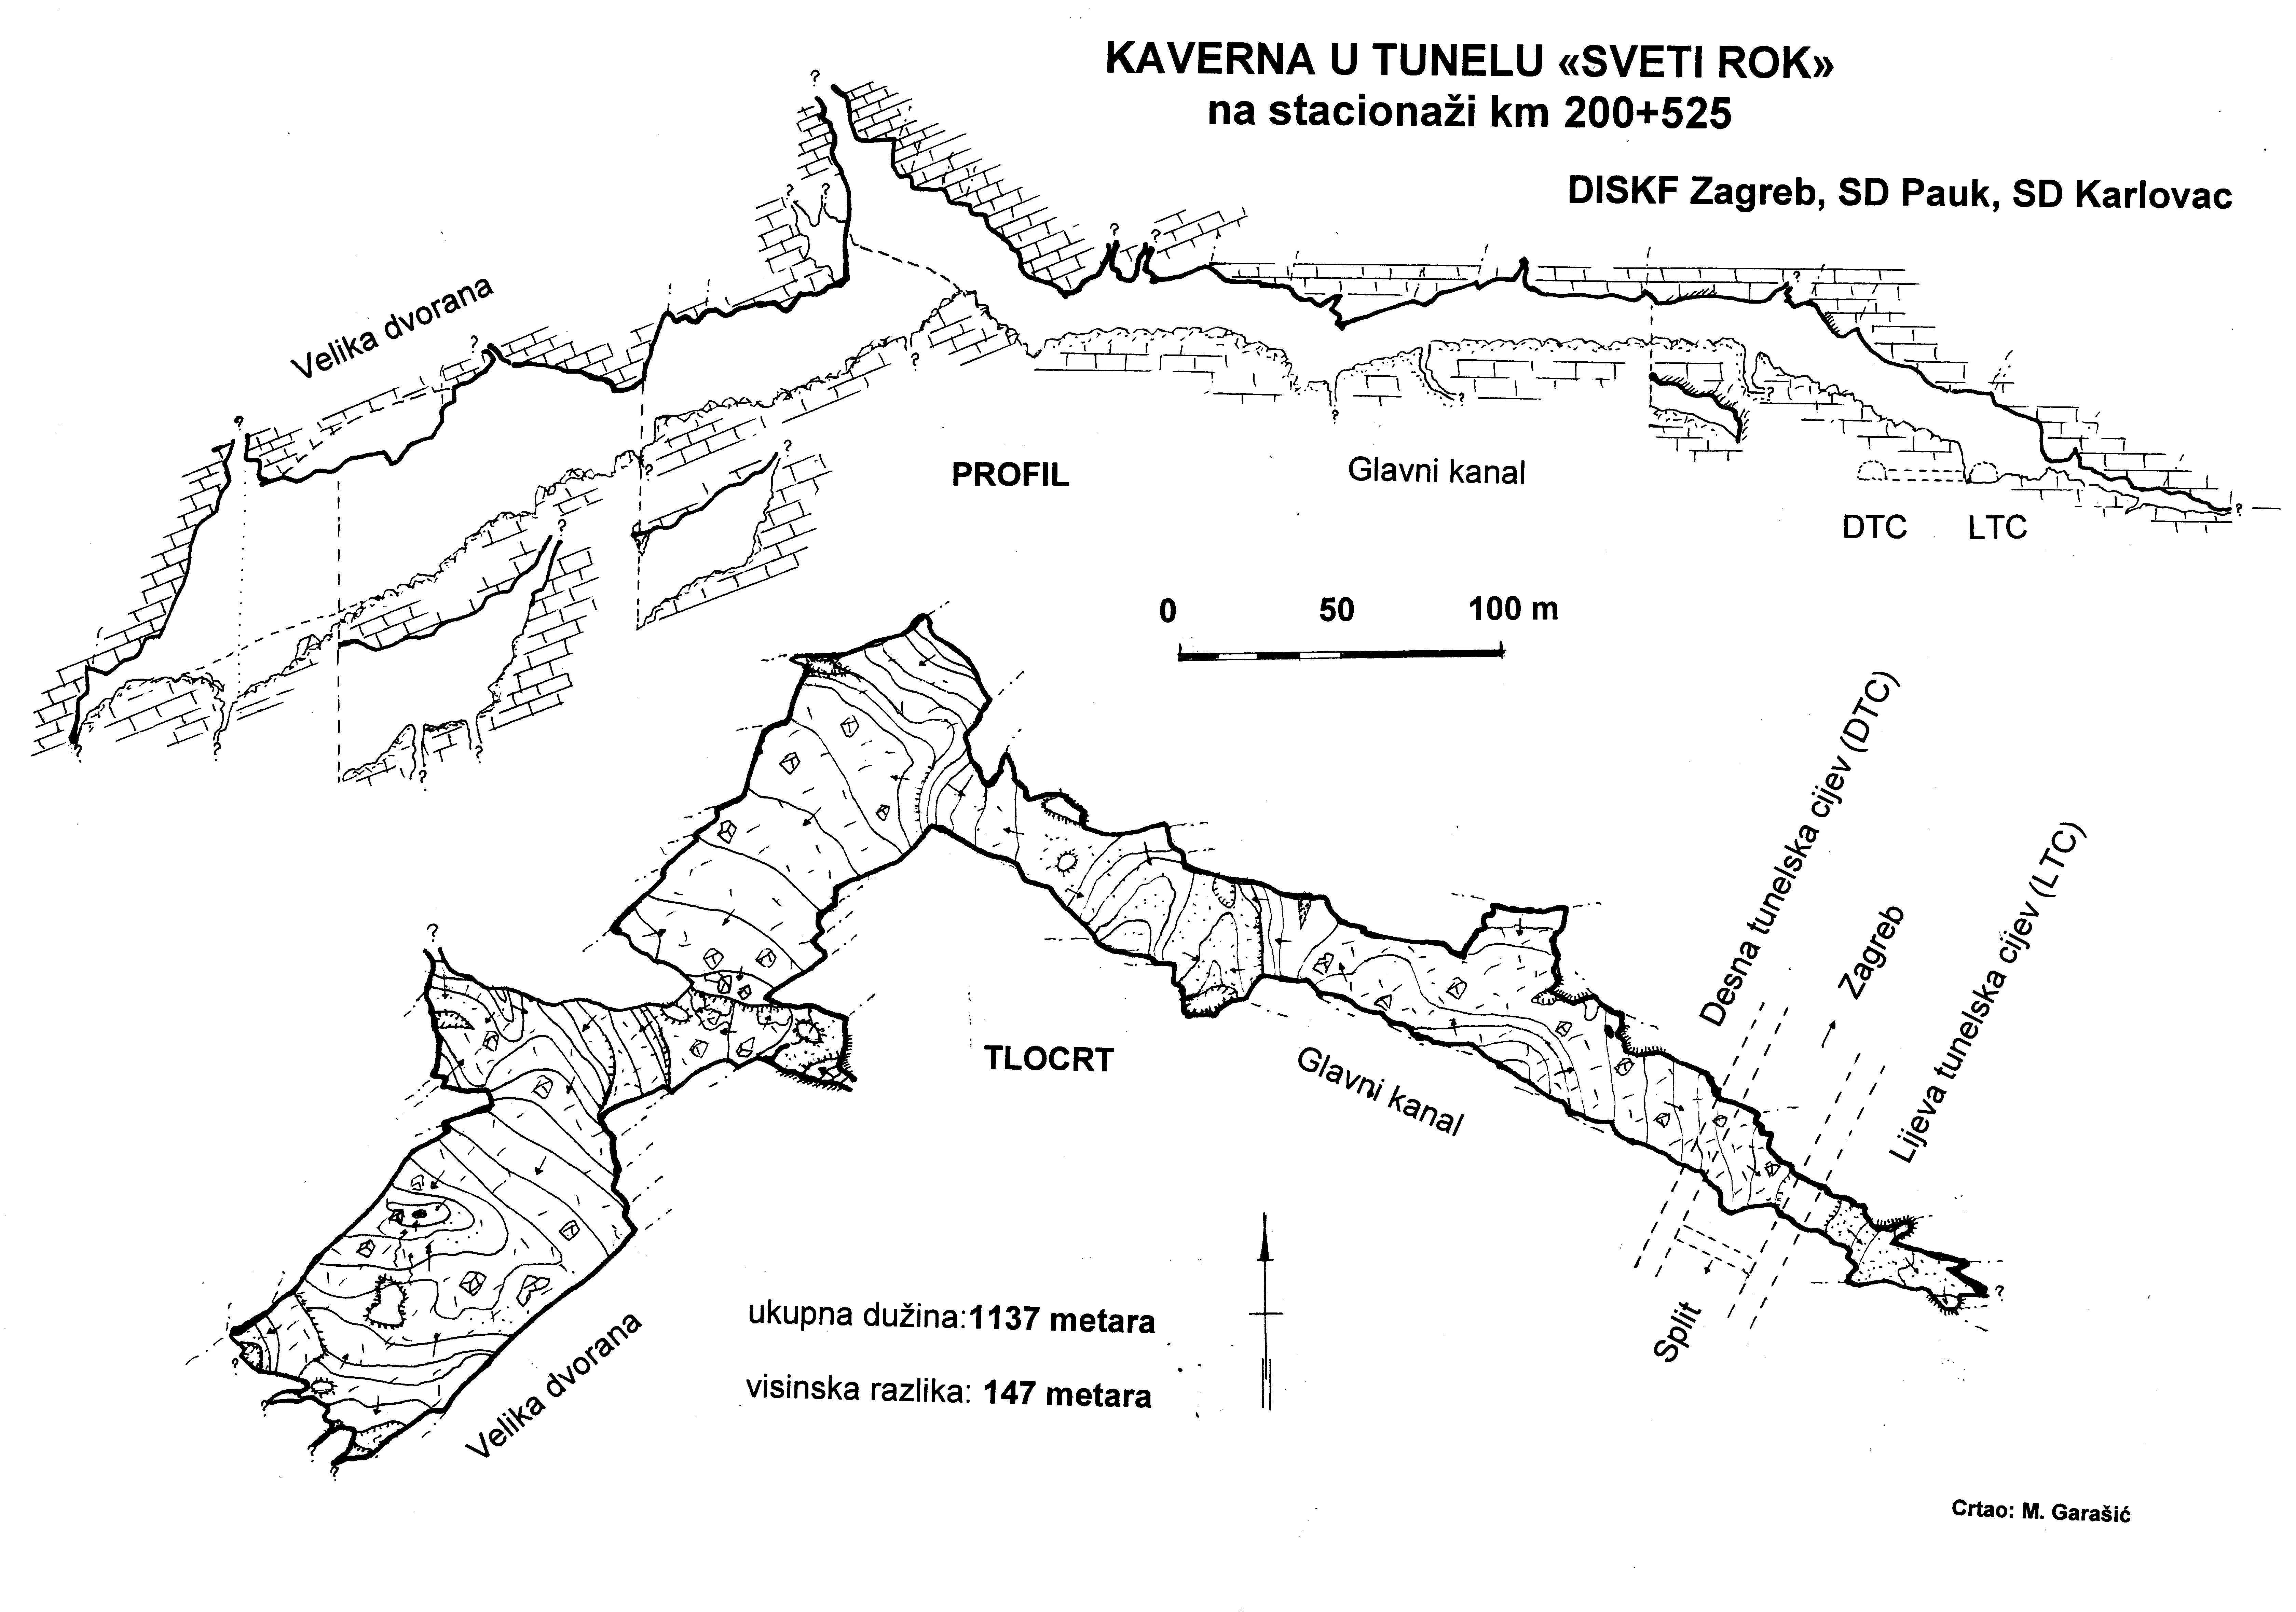Photo 1. - Special kinds of Speleothems in Cavern in tunnel “St. Rok” on km 200+525

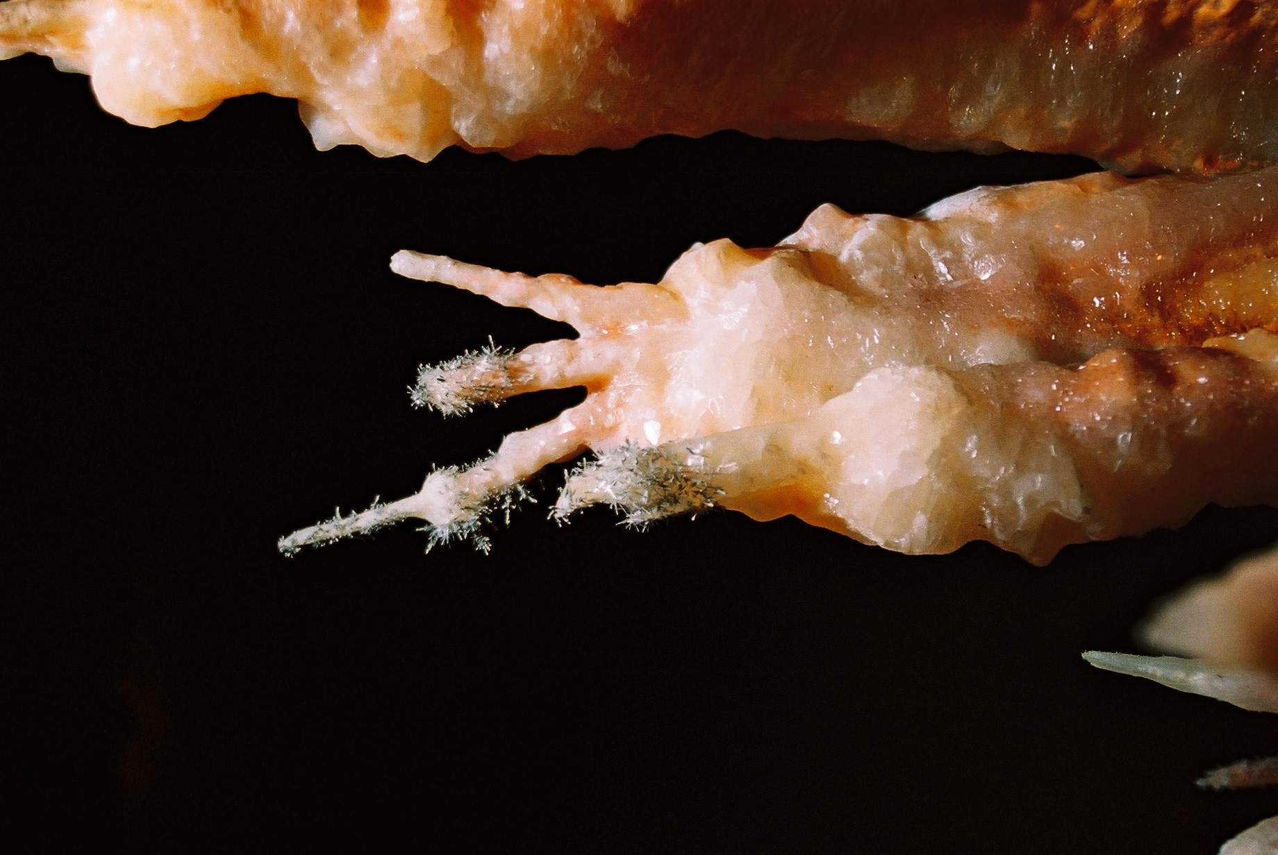Photo 2.- Large and big cave channels in cavern “St.Rok” on highway Zagreb-Split

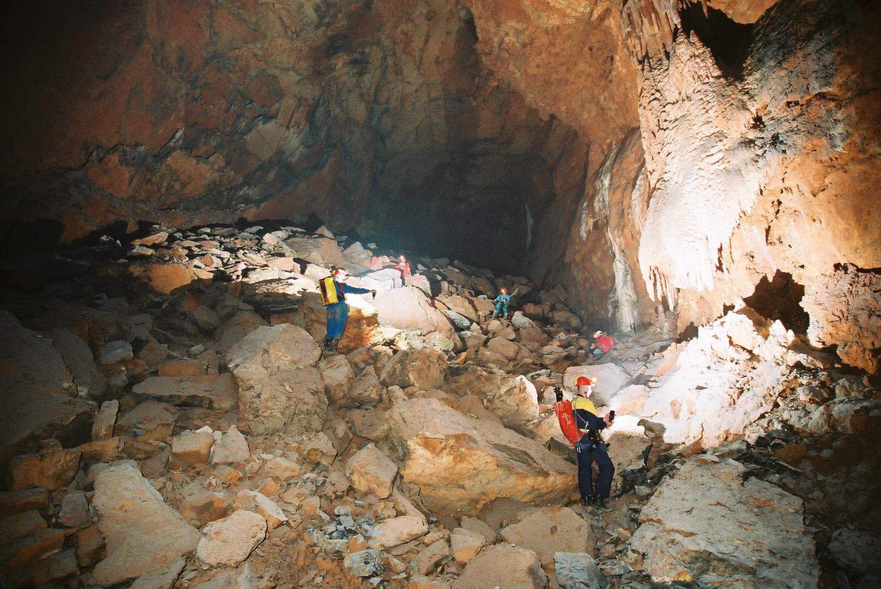Fig 3. – Survey of one of the caverns in tunnel of “St. Rok” in Velebit mountain on highway Zagreb – Split in Croatian Dinaric Karst area

Literature:

GARAŠIĆ, M. (2002): Speleološke pojave u tunelu “Sveti Rok”. Ceste i mostovi, vol. 48, br.1-2, str.11-20, Zagreb.
GARAŠIĆ, M. & VIVODA, B. (2003a): Speleološke pojave (kaverne) u trasi autoceste Zagreb-Rijeka. Ceste i mostovi, vol.49, br.5-6, str.104-111, Zagreb.
GARAŠIĆ, M. , VIVODA, B. & KARLOVAC, Z. (2003b): Geološke značajke tunela “Rožman brdo”.Ceste i mostovi, vol.49, br.11-12, str. 58-66. Zagreb.
GARAŠIĆ, M. (2004): Istraživanje kaverni u tunelu “Sveti Rok”. Speleozin, vol. 12, br.17, str.21-27, Karlovac.

