Open air and in caves rock carvings at the gorge of Aggitis at the prefecture of Serres
L. I. Chatzilazaridis ∗

Rock carvings have been discovered in four spots at the gorge of Aggitis river (which is a tributary to the Strymon river) The gorge is a natural monument of unparalleled beauty. It holds interesting fields for research for geologists – paleontologists, archeologists, speleologists and other scientists.
The first spot is located near the village Symboli at Serres, at about 200 metres south of the tributary of the Angitis river, the water which drains from the plain of Fillipi and the blue water river. It is an open air marble surface 4 by 3,5 metres on which more than 25 depictions of riders, deer and animal figures can be seen.
The second spot is the floor of a small cave which is the southernmost of a cluster of caves at about 1300 metres to the south of the cave of Alistrati and 100 metres above the riverbed at the east side of the gorge. At about 150 metres to the north of these caves on the same eastern bank of the gorge there is a long natural bridge. The access to the three caves and to the natural bridge is possible from the village of Nea Mpafra and through a shorter way from the village of Krinida in the prefecture of Serres. A part of the floor of the southern cave is like a balcony which overlooks the abyss of the gorge. It consists of an irregular, horizontal surface, ellipsoid in shape. Its largest dimensions are 6m x 3m. On this surface there is a total of 60 depictions of animals and deer carved in a threadlike manner.
The third spot is “Alistrati 1”. It lies about 1000 metres to the southwest of the cave of Alistrati, which can be reached from the village of Alistrati.It is situated towards the downflow of Aggitis on the left of the railway line, at the first level of the edge of the gorge at a height of 90 metres. On the opposite side of the gorge one can see the large impressive natural bridge of Aggitis. This spot is a marble horizontal surface under a towering rock shelter. It is round in shape with a diameter of 3 metres. Around it the soil is dug by gold miners or treasure hunters. On this surface there are about 60 carvings which undoubtedly were carved at different periods. They depict deer and other animals hunters and warriors and other non defined lines.
The fourth spot is “Alistrati 2”. It lies on the same side and at the same level as “Alistrati 1”, around 100 metres before the latter. Individual etchings can be seen but less in number than the ones at “Alistrati 2”.
The dimensions of the etchings vary between 5 – 40 cms. Carvings and etchings are a characteristic feature of humans. It is suggested that the dating of this rock art should be from the Neolithic age to the Copper age.

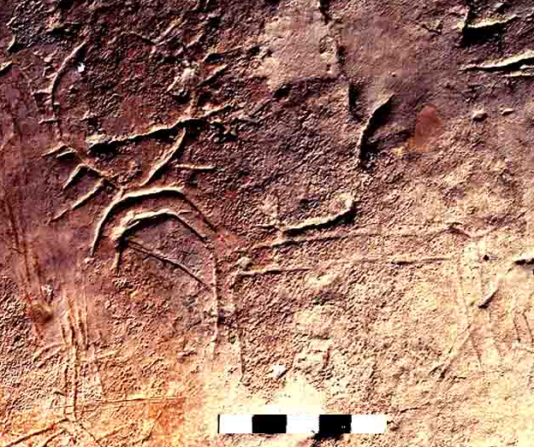
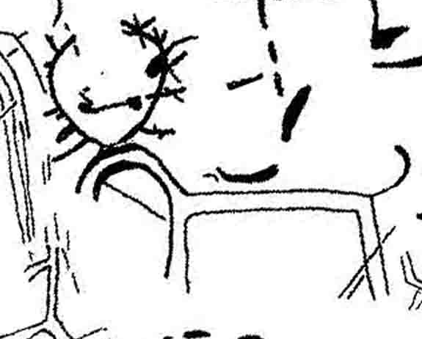

An impressive deer etched on the floor of the cave and its outline

 Ph.D at the Aristotle University of Thessaloniki - Geologist , State School Advisor for Physics

