A GLOBAL DENUDATIONAL MODEL OF CAVE DEVELOPMENT

Augusto S. Auler
CPMTC – Instituto de Geociências, Universidade Federal de Minas Gerais. Av. Antonio Carlos, 6627, Belo Horizonte - MG - 31270-901, Brazil

Peter L. Smart
School of Geographical Sciences, University of Bristol, Bristol, BS8 1SS, England

ABSTRACT

A significant number of caves in the stable cratonic area of eastern Brazil display well-developed “primary” paragenetic features (i.e. features generated during cave phreatic development and not during later sedimentation processes) that indicate that paragenesis was a dominant process of speleogenesis. However, a survey of cave geomorphological studies elsewhere in the world indicate that paragenesis is usually considered to be a relatively minor speleogenetic process, syngenesis being considered as the “normal” type of phreatic cave development.

Paragenesis in eastern Brazil is favoured by a combination of geomorphic and hydrological conditions such as: (i). high rates of pedogenesis under tropical conditions yield thick soil sequences that commonly mantle the karst. Thus, nearly all karst areas contain abundant soil cover that can be eroded towards phreatic conduits; (ii). low elevation terrain and thus very low hydraulic gradients that prevent fine grained sediment to be removed from phreatic cave passages during conduit development; (iii) low denudation rates / uplift rates and thus low water table lowering rates. Any evolving conduit will stay for a prolonged time under phreatic conditions before interception (due to both upward paragenetic ceiling migration and water table lowering) by the water table. Paragenesis may also benefit from deeper initial flow routes.

We propose a model in which, given sediment availability, paragenetic development will be the dominant mode of speleogenesis in tectonically stable areas under slow denudation / uplift rates. Central Brazil and areas of Africa, Australia and parts of Europe are prime candidates for paragenetic caves. Paragenetic caves will tend to be rare or absent in bare karst terrains in tectonically active areas such as in high mountain karst areas in Europe.

1. INTRODUCTION

A survey of caves in several Brazilian karst areas, but mostly in the Lagoa Santa, Caatinga and Iraquara areas (Fig. 1), has demonstrated that the majority of caves display features previously recognised as due to paragenetic processes such as:

1. Presence of pendants (Bretz, 1942; Renault, 1968). 2. Presence of anastomoses or half tubes (Bretz, 1942; Renault, 1968). 3. Presence of parasitic wall tubes (Lauritzen and Lauritsen, 1995). 4. Presence of wall grooves (Farrant, 1995). 5. Lack of guiding fracture or bedding plane at ceiling level (Pasini, 1967). 6. Lack of a precursor phreatic tube on the ceiling (Lauritzen and Lauritsen, 1995; Farrant, 1995). 7. Downstream propagation of meanders (Ewers, 1985). 8. Phreatic canyon or triangular passage cross section (Farrant, 1995). 9. Active paragenetic passages in the phreatic zone (Worthington, 1991).

Observations in several karst areas in eastern Brazil have allowed the recognition of the following additional distinctive features of paragenesis:

10. Lack of scallops. The velocity required for scallop length to match passage sinuosity (and thus become indistinguishable) is too slow to allow for sediment removal and should therefore favour paragenesis if there is sediment availability.

11. Meander junctions at ceiling level occur through an ascending meander. This feature demonstrates that water flow was occurring mostly at ceiling level at time of junction.

12. Anastomotic canyons are the predominant type of cave pattern. In low dip situations this should be the prevalent type of paragenetic cave pattern. Variable passage cross section due to changes in sediment volume can keep several passages simultaneously competitive.

13. General absence of joint fed speleothems. When compared with vadose caves, paragenetic caves may exhibit less speleothems due to the general absence of vertical joints at ceiling level. Furthermore, the overall volume of a paragenetic passage spends more time in the phreatic zone and under sediment cover than a typical vadose cave, restricting the chance of speleothem precipitation by water percolating through joints.

The caves located along the stable cratonic area of east central Brazil have shown similar styles of cave development, despite major differences in lithology, hydrology and present climate. Paragenetic processes are evident in the majority of caves examined. It will be proposed that the mode of conduit development after initiation is controlled by large-scale denudation rates which are dependent on the tectonic setting.

2. CONTROLS ON PARAGENETIC DEVELOPMENT

2.1. Sediment availability

The first requisite for paragenesis is the availability of sediment for transport into the cave system. In eastern Brazil, bare bedrock floors are extremely rare, nearly all caves having their floor covered by sediment deposits usually of unknown thickness. There has been no worldwide survey on the frequency and extent of soil cover in karst areas, but covered karst predominates in most of the karst areas in the Americas, especially in eastern United States, northern Mexico, Central America and some islands of the Caribbean such as Cuba, and most of South America. Soil cover predominates in many karst areas of Europe, such as in England, parts of France and Italy, and in most of tropical Asia sites. It seems apparent that sediment derived from the soil is commonly available in most karst areas of the world. Possible exceptions to this situation would be very pure limestones in barren karst areas with very limited sediment supply such as in some alpine settings, mixing zone karst areas, or hypogenic settings where deep flow is not surface derived.

2.2. Depth of conduit initiation

Deep initial flow routes will enable a given conduit to have the necessary vertical amplitude for paragenetic upward ceiling migration. The depth at which a cave will originate below the water table has been subject to considerable debate in the past on conceptual grounds (see review in White, 1988) but even recently few quantitative advances have been made. Folding and faulting may promote deeper ground water routes (Palmer, 1987). For the sake of simplicity, a homogeneous carbonate aquifer, without significant folding or faulting and without impermeable beds that can cause confined and artesian aquifers will be assumed. This is the common situation in eastern Brazil cratonic carbonate areas.

Although there is a number of ways of determining depth of present or past ground water circulation such as water temperature in spring outlets (Worthington and Ford, 1995) or empirical relationships that equate catchment length and dip of the strata (Worthington, 2001) few direct observations have been made. Borehole logging and packer testing frequently show the presence of dissolution openings at depths up to 3000 m (Ford and Williams, 1989), often with capacity for water circulation. Direct observation of flooded passages by cave divers worldwide confirm the common existence of deep flow routes in carbonate systems, to depths well in excess of 100 m below the water table (Farr, 1991). The vertical range of a paragenetic passage provides an alternative method of determining minimum flow depth of cave passages. This is represented by the elevation difference between the bedrock floor of the passage and the ceiling. Considering that some water table lowering must have occurred since the beginning of the paragenetic development, this parameter provides a minimum depth of initiation below the water table. Vertical paragenetic amplitudes up to 50 m have been reported in the literature (Renault, 1968). At Lapa Doce cave in the Iraquara Karst, the vertical paragenetic range is 11 m as measured at several sites with an ultrasonic tape. In the Lagoa Santa Karst, it may exceed 15 m in some caves. According to Worthington (2001) depth of ground water flow in unconfined aquifers is related to D = 0,18 (L sin θ)^{0,79} where D is the mean depth of flow in metres below the water table, θ is the dip of the carbonate strata and L is the flow path length in metres. In much of eastern Brazil, low dip (up to 10°) and long flow paths (up to 20 km in a straight line) would translate in depths up to 110 m, but commonly below 50 m, a value that is in general accordance with cave diving reports for the area.

2.3. Rates of upward paragenetic evolution

After breakthrough has been achieved, provided the water table remains above the passage during the period of enlargement, there will be two alternatives for further development of a flooded conduit. In a situation where there is no supply of sediment, or where water velocities are too high to allow for sediment deposition, a phreatic tube will develop. Such a tube will grow indefinitely until modified by breakdown or drained by water table lowering. Given the existence of flooded passages at great depths (in excess of 100 m) we should expect the common occurrence of very large phreatic tubes. Although White (1988) and Worthington (1991) have acknowledged the existence of phreatic tubes > 40 m in diameter, such very large passages appear to be more the exception than the rule. The second style of development is through paragenesis. Cave divers have commonly reported that phreatic caves normally have a sediment mantled floor (Worthington, 1991). It thus appears that sediment filled passages are at least as common than sediment-free phreatic tubes.

Ground water flow velocities decrease with lower hydraulic gradients. In the subdued relief of eastern Brazil low hydraulic gradients should be expected, resulting in very low conduit velocities, below the threshold for sediment transport. Considering the nearly global availability of sediment in karst systems, the ubiquitous existence of input points linking sediment sources to underground passages, and the slow water flow velocities in subsurface conduits, paragenesis should be a common mode of cave evolution in the phreatic zone.

During paragenesis, the floor of a phreatic passage is armoured by sediment. Dissolution, if it occurs, is unlikely to be significant at the sediment-bedrock interface because it will be limited by replacement of reactant and evacuation of products. The sole sections of bedrock available for conduit enlargement are the upper walls and ceiling. The cave will then evolve upwards towards the water table. Rates of upward conduit migration are an important component in determining the magnitude of vertical paragenetic range, the rate of loop elimination, and possibly the development of flat water table roofs. There has been no previous study of this problem. However, if a paragenetic passage is considered to be a half tube with a sediment floor, the relation of Palmer (1991) can be applied:

S = 31.56 Q (C- C₀) / pLρ_{r} ; where: S is the rate of paragenetic upward migration; Q is discharge of water through the passage; C is the solute concentration (C₀ = C at upstream end of passage); p is the wetted perimeter; L is the passage length and ρ_{r} is the rock density

Dreybrodt (1990) has estimated average rates of 100 m/Ma for conduit bedrock removal after breakthrough, but variations of an order of magnitude on either side are possible. Taking into consideration discharges measured at the Lagoa Santa Karst (Auler, 1994) and estimated discharges for springs in the Iraquara Karst, a range between 0.05 - 2 m³/s appears reasonable. Length of underground flow paths should be in the range 1 - 20 km, resulting in Q/L ratios below 20 cm²/s. Following Palmer (1991) these values would represent enlargement rates in the range of 1000 m/Ma. Typical maximum enlargement rates for karst systems averages about 100-1000 m/Ma (Palmer, 1991).

2.4. Water table lowering rates in karst regions

The end of the phreatic regime in a cave system happens when the water table reaches the top of the passage, and dissolution becomes concentrated on the floor. It is thus important to quantify the rates of water table lowering, because these will determine the amount of time available for paragenesis. Water table lowering will be considered as a relative measure in relation to a fixed point in the bedrock (or a cave system within the bedrock). This is because tectonic uplift can rapidly change relative water table positions within the bedrock, while the water table elevation relative to a outside datum (such as sea level) could remain virtually unchanged.

Long-term regional denudation rates in cratonic or low relief areas are reported in Table 1 while denudation rates based on fluvial incision rates in karst are given in Table 2. It is assumed that surface lowering rates are compatible with water table lowering rates. Furthermore, fluvial downcutting rates, together with other techniques of punctual measurements, are assumed to provide reasonable approximation of regional scale water table lowering rates.

The data demonstrate that denudation rates in cratonic or low relief areas are typically in the range 1 - 50 m/Ma, with several areas (mainly in the best studied sites in the plains of Australia) having values below 10 m/Ma. These data demonstrates that denudation rates in stable tectonic settings can be an order of magnitude lower than in mountainous or in tectonically active regions.

3. A DENUDATIONAL MODEL OF CAVE EVOLUTION

It has been demonstrated that conduits commonly carry sediment deposits. It has also been shown that ground water velocities, especially in low relief areas with low hydraulic gradients, may fall below the threshold of sediment transport. Under such conditions, the minimum requirements for the initiation of paragenetic development should be present in many if not most karst settings. Two further variables should be taken into account. Because paragenetic passages evolve upwards towards the water table, there should be enough vertical amplitude for a passage to develop, i.e., the deeper the passage is, the more “room” for upward paragenetic development there will be. Areas with steeply dipping carbonate should in theory be more favourable for paragenetic development. However, a major control affecting this opportunity for upward development is the rates of water table lowering. The rate is very slow in eastern Brazil permitting an extended period for paragenesis, despite the shallow dip of the carbonate which limits depth of paragenetic development.

Water table lowering rates in mountainous or tectonically active areas are an order of magnitude higher than in stable cratonic settings. In the latter regions, caves would tend to remain for a much longer time in the phreatic zone. It has also been demonstrated that upward paragenetic migration rates should be at least an order of magnitude higher than water table lowering rates in tectonically stable, low relief areas, but should match these rates in mountainous settings. Fig. 2 illustrates these relationships. For any given initial conduit depth, the time available for upward paragenetic migration would be greatly increased in karst areas with low water table lowering rates. On the other hand in areas with very fast water table lowering rates, such as mountain ranges, the cave passage could be intercepted by the water table before significant paragenetic development had occurred.

From this denudational model of cave development, paragenetic caves should predominate where water table lowering rates are slow, such as in cratonic settings or in low relief continental interiors. Prime candidates are the ancient tablelands of interior South America, Africa and Australia. At the other extreme, areas with very high denudation rates, such as mountain ranges or areas with active tectonics, should show predominantly vadose passages and little paragenetic development. Many karst areas, however, fall between these extremes, and could display both paragenetic and syngenetic development styles, depending on initial flow depth, sediment availability and local geomorphic factors.

The above model, developed at a regional scale of cave systems, is also applicable to individual passages in caves. It has been suggested by Palmer (1991), Worthington (1991), Dreybrodt (1990) and others, that cave passages can play the role of local base levels for tributary conduits, in the same way that major rivers do for large cave systems. It is thus possible that a tributary can evolve paragenetically towards a vadose trunk passage. This is supported by the observation of paragenetic passages within otherwise predominantly vadose caves, such as in Gruta do Padre, Brazil, Ogof Draenen, Wales, among others.

4. REFERENCES

Atkinson, T.C.; Rowe, P.J. 1992. Applications of dating to denudation chronology and landscape evolution. In Uranium Series Disequilibrium. Applications to Earth, Marine and Environmental Sciences (Ivanovich, M.; Harmon, R.S. ed.). Clarendon Press, p. 669-703.

Auler, A.S. 1994. Hydrogeological and hydrochemical characterization of the Matozinhos-Pedro Leopoldo karst. MSc Thesis, Western Kentucky University.

Auler, A.S. 1999. Karst evolution and palaeoclimate in eastern Brazil. PhD Thesis, University of Bristol.

Bretz, J.H. 1942. Vadose and phreatic features of limestone cavernas. Journal of Geology 50: 675-811.

Dreybrodt, W. 1990. The role of dissolution kinetics in the development of karst aquifers in limestone: a model simulation of karst evolution. Journal of Geology 98: 639-655.

Ewers, R.O. 1985. Patterns of cavern development along the Cumberland Escarpment. In Caves and Karst of Kentucky (P.H. Dougherty ed.). Kentucky Geological Survey Special Publication 12: 63-77.

Farr, M. 1991. The darkness beckons. Cave Books.

Farrant, A.R. 1995. Long-term Quaternary chronologies from cave deposits. PhD Thesis, University of Bristol.

Ford, D.C.; Williams, P.W. 1989. Karst geomorphology and hydrology. Unwin Hyman, London.

Lauritzen, S.E.; Lauritsen, A. 1995. Differential diagnosis of paragenetic and vadose canyons. Cave and Karst Science 21: 55-59.

Palmer, A.N. 1987. Cave levels and their interpretation. National Speleological Society Bulletin 49: 50-66.

Palmer, A.N. 1991. Origin and morphology of limestone caves. Geological Society of America Bulletin 103: 1-21.

Pasini, G. 1967. Nota preliminare sul ruolo speleogenetico dell’erosione “antigravitativa”. Le Grotte d’Italia 4: 297-322.

Renault, P. 1968. Contribution a l’etude des actions mécaniques et sédimentologiques dans la spéléogenèse. Annales de Spéléologie 23: 529-596.

White, W.B. 1988. Geomorphology and hydrology of karst terrains. Oxford University Press, Oxford.

Worthington, S.R.H. 1991. Karst hydrology of the Canadian Rocky Mountains. PhD thesis, McMaster University.

Worthington, S.R.H. 2001. Depth of conduit flow in unconfined carbonate aquifers. Geology 29: 335-338.

Worthington, S.R.H.; Ford, D.C. 1995. High sulfate concentrations in limestone springs: an important factor in conduit initiation? Environmental Geology 25: 9-15.

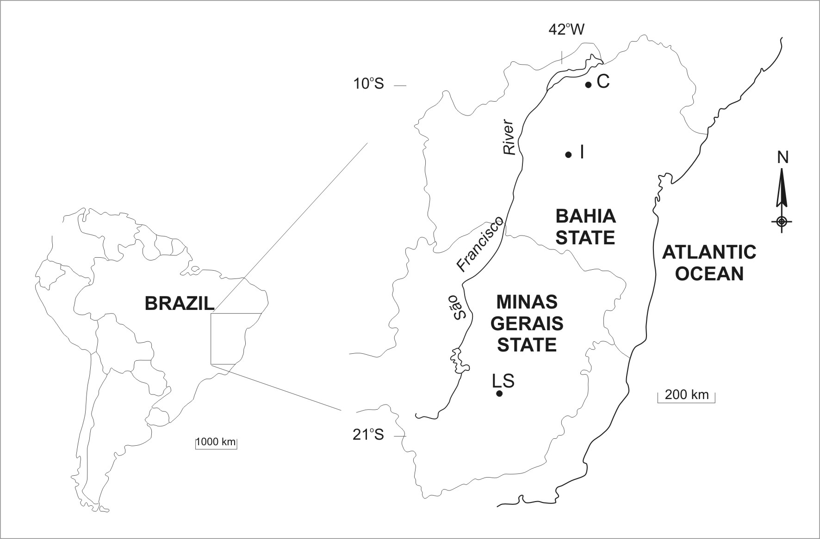

Figure 1. Location of study area. LS – Lagoa Santa Karst; I – Iraquara Karst; C – Caatinga Karst.

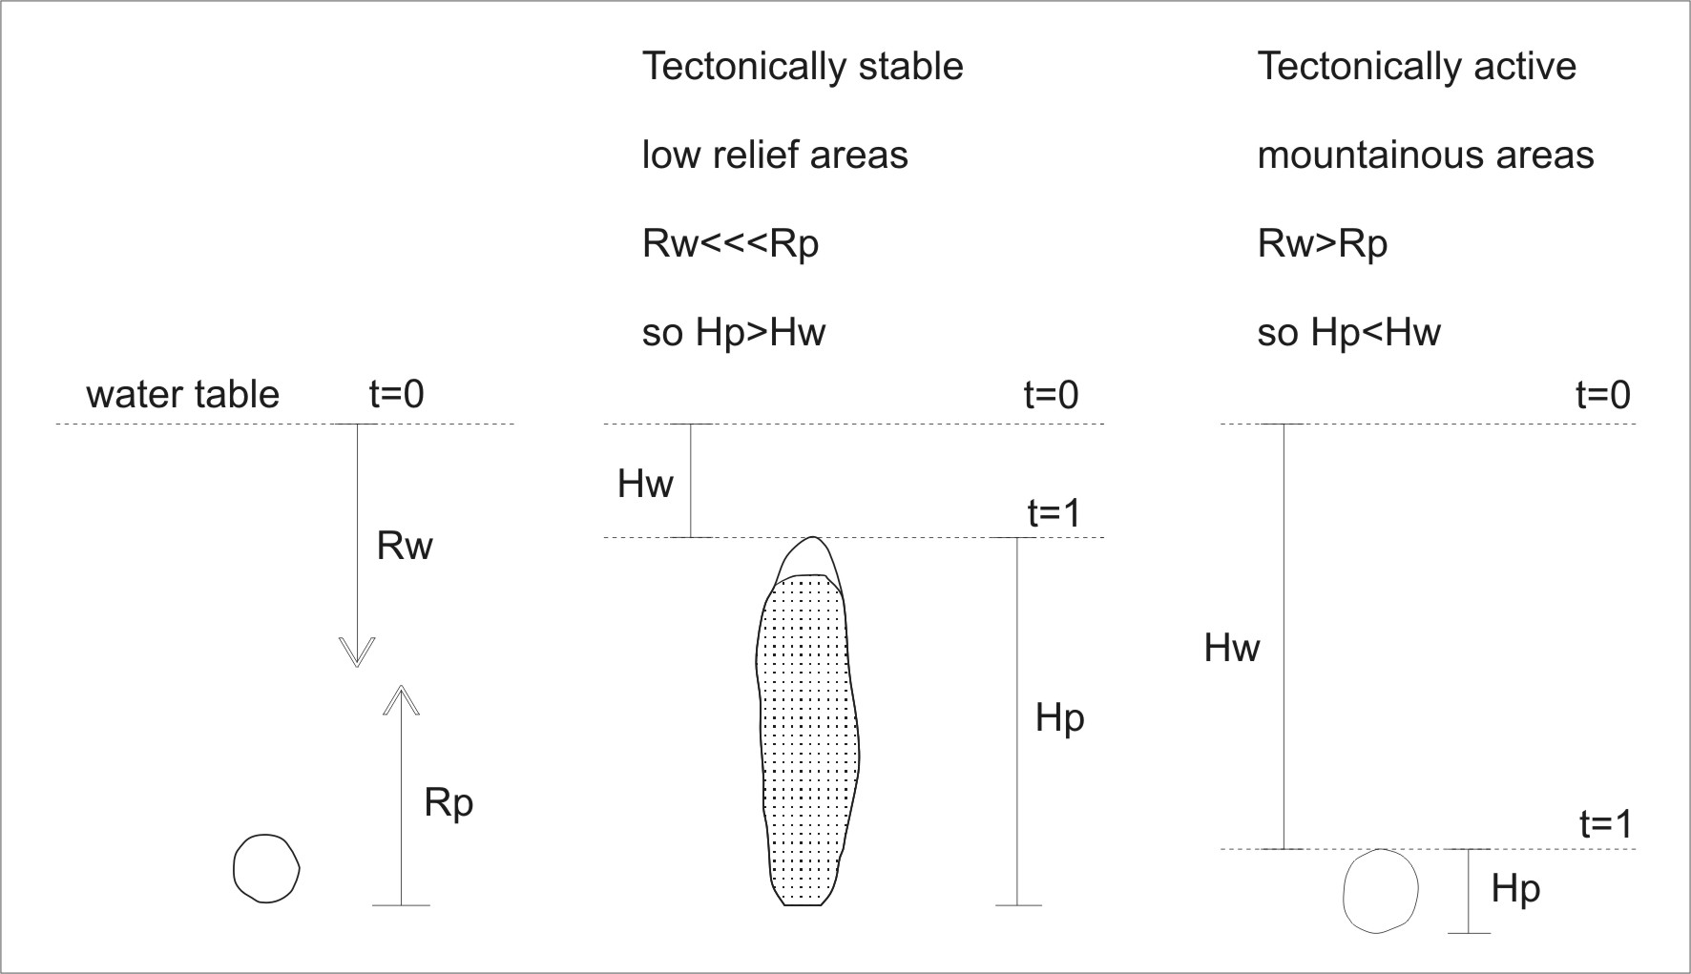

Figure 2. Model of cave development in relation to water table lowering rates. Rw = Rate of water table lowering; Rp = Rate of paragenetic upward migration; Hw = Amount of water table lowering between t=0 and t=1; Hp = Paragenetic vertical range.

Location | Method | Rate m/Ma
West Australian Craton | Geomorphological criteria | 0.1-0.2
Southeastern Australia | Incision rates | 1-10
Guyana Craton | Fluvial geochemistry | 10
West African Craton | Cosmogenic | 3-8
Mount Roraima, Guyana Craton | Cosmogenic | 1
Southeastern Australia, Yilgarn | Weathering rates | 1-2
Africa, Lake Chad | Fluvial geochemistry | 8
SE Australia, Snowy River | AFTA | 15-18
Southeastern Brazil, Paraná | AFTA | 8
Guaporé Craton, Brazil | AFTA | 15-50
Interior São Francisco Craton | AFTA | 20-40
Interior São Francisco Craton | AFTA | 18
Global average rate |  | 43
Mountainous areas/highlands |  | 500

Table 1. Denudation rates for cratonic and low relief interior settings. Estimates extrapolated over diverse timescales. This list is by no means a complete list. AFTA – Apatite fission track analysis. References in Auler (1999 p. 26).

Location | Rate (m/Ma)
Cueva del Agua, Spain  Nahanni River, Canada  Green River, Kentucky  Matchlight Cave, Tasmania  Exit Cave, Tasmania  Yorkshire Dales, England  Elwy Valley, Wales  Creswell Crags, England  Perlait River, Malaysia  Cheddar Gorge, England  Crowsnest Pass, Canada  Bearjaw Cave, Canada  Castleguard Cave, Canada  Arige Valley, France  Manifold Valley, England  Derwent Gorge, England  Mammoth Cave, USA  Cheat River, USA  Buchan Karst, Australia  East Fork Obey River, USA  Wee Jasper, Australia  Greenbrier River, USA  Santana Cave, Brazil  Wyandotte Cave, USA  Clearwater Cave, Malaysia | c. 300  < 800  70-90  < 100-200  < 60  120 / > 50 / < 200  120  65  8  190 / 60 / 200  115-130  290-510  50-130  120-210  55  < 190  40  56-63  3-4  < 20  26  46  42  60  190

Table 2. Compilation of fluvial downcutting rates in karst terrains. Adapted from Atkinson and Rowe (1992) and Farrant (1995). See references in Auler (1999 p.37).

