PERSPECTIVE OF DEVELOPMENT OF MARONIA CAVE AND THE SURROUNDING AREA
(THRACE, GREECE)

S. Pavlides¹, I. Chatzigogas², E. Tsoukala¹, A. Chatzopoulou¹, A. Vasileiadou¹, V. Melfos¹.

1. Department of Geology, and 2. Department of Architecture, Aristotle University, GR-54124 Thessaloniki

Abstract: Protection and development plans of Maronia Cave are proposed. The speleological and architectural studies suggest part of the cave to be used for tourist visits, in association with a modern undermine building - museum of natural sciences and environmental studies. Suggestions extend to surrounding area (geotopes, flora, archaeological paths etc).

Maronia cave is located at Rhodope Prefecture, western Thrace, close to the homonym village (2 km NW) and the archaeological site as well. It is formed in a relatively thin formation of Nummulitic limestones of Middle Eocene age on top of schists. The decoration of the cave presents a great variability. Some of the speleothems are rare and impressive. The Cave and the district of SE Rhodope Prefecture have also a great archaeological interest, while it is related with the significant archaeological sites as old as 3,500 yr, which are spread around the whole region (Ismara mountain), making the area a huge open-air museum.

Our proposed master plan for the development of the cave and the architectural study suggest part of the cave (northern chambers) to be used for tourist visits, in association (cut and cover tunnel) with a modern undermine building - museum of natural sciences and environmental studies (Fig.1,2). Suggestions extend to surrounding area (geotopes, flora, archaeological paths etc) with a tower (Café, observatory) as a symbol of the cave and reference point.

The development of the Maronia Cave anticipates giving an alternative approach to the visitors in comparison with other developed caves in Greece. Visitors will have the opportunity to learn about the geology, paleontology, archaeology and the flora of the cave and the surrounding area. They could observe the fauna of the cave (in situ). Cameras situated in chambers of the cave, will make possible to see bats as they hibernate or breed as well as spectacular speleothems. Some of the endemic invertebrates of the cave could be observed in terrariums (Paragamian et al. 2004).

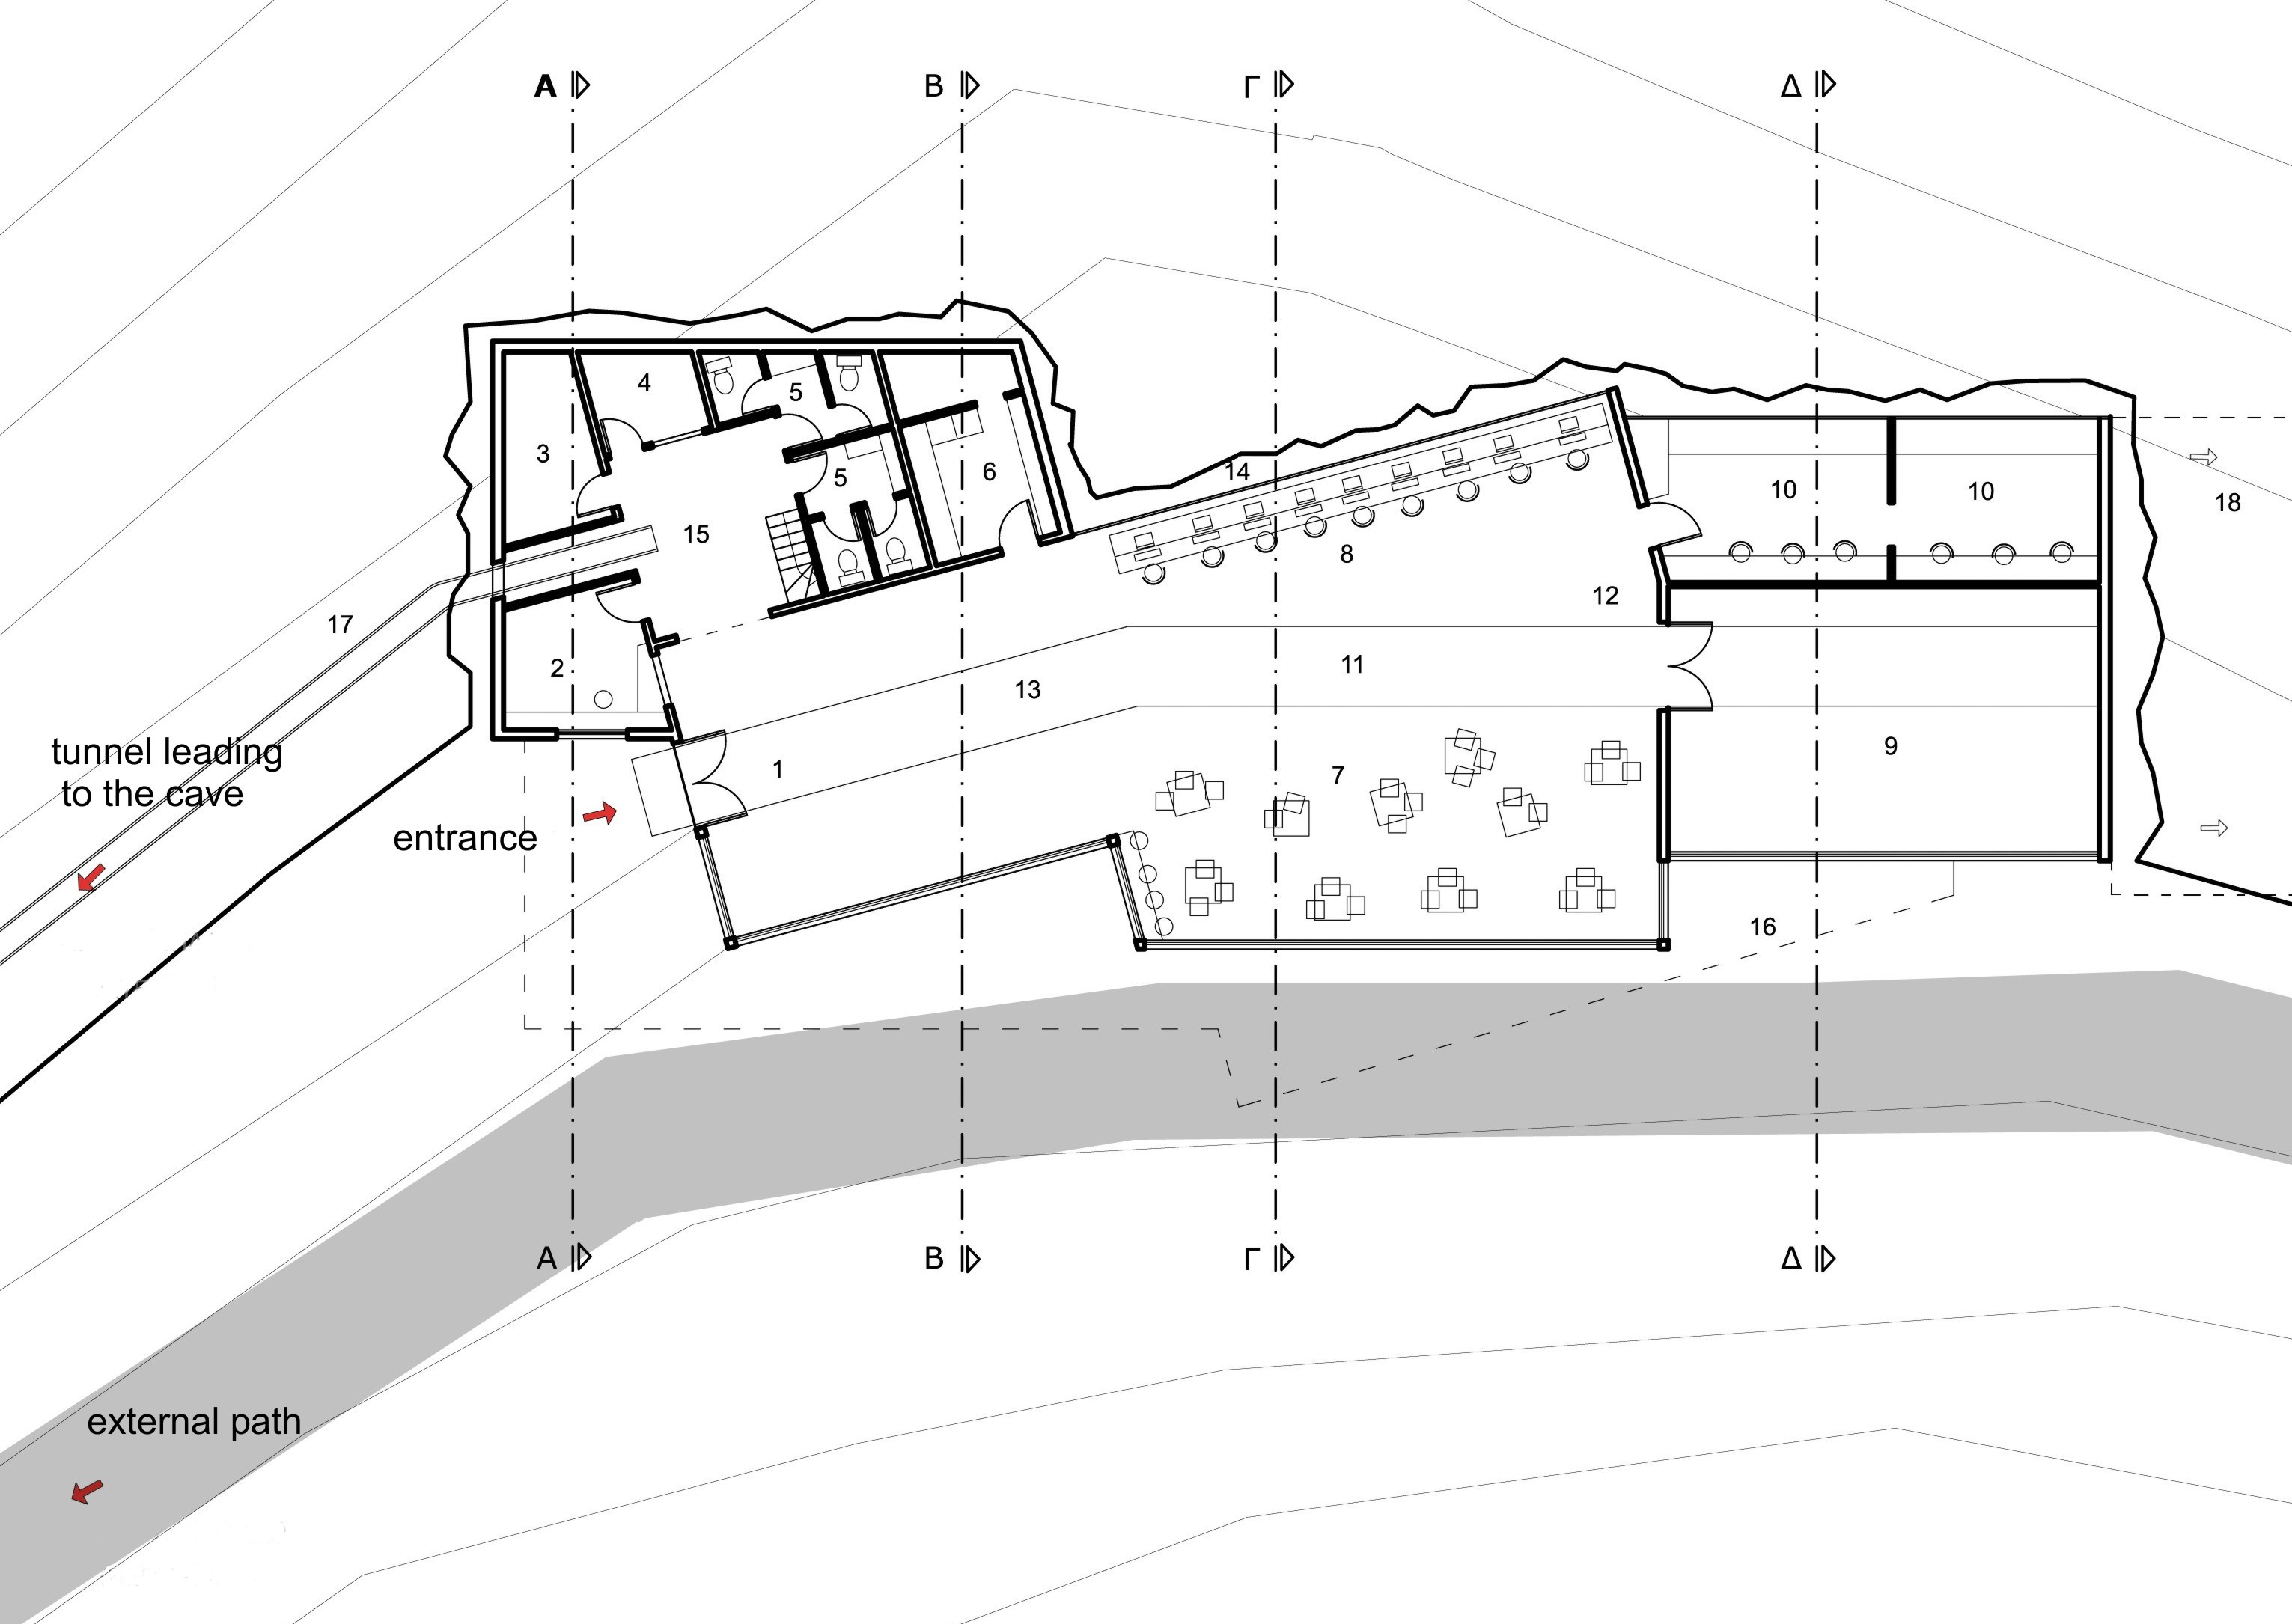
Figure 1. View of the ground plan of an undermine building - museum of natural sciences and environmental studies that communicates with the cave through a subterranean tunnel. The external path is also shown.
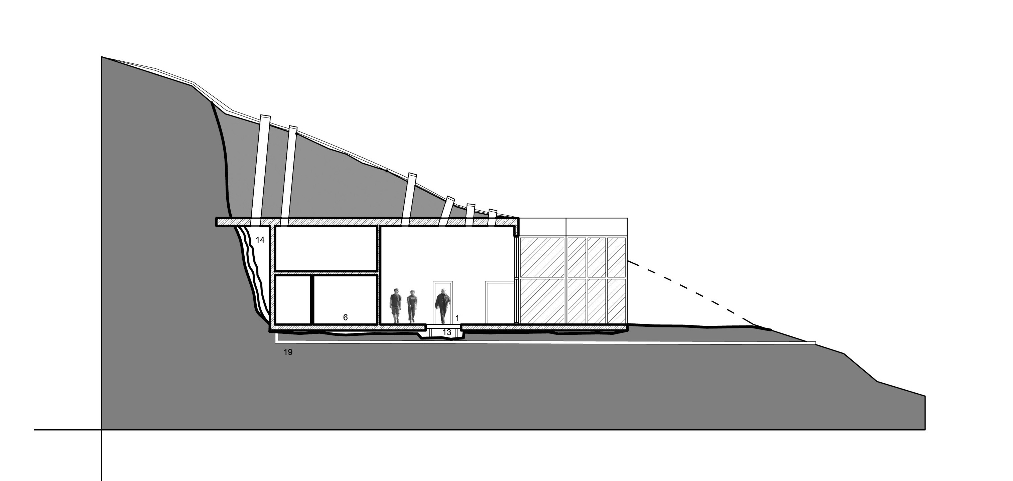
Figure 2. Vertical section of the undermine building. Part of the building will be constructed in the bedrock (nummulitic limestone) while the eastern side will be covered with glass. The building will be illuminated by natural light for the ceiling.

The building will be underground so that it will not fail the surrounding landscape. It is suggested that the visitors can only access the northern part of the cave through a subterranean tunnel (Fig.3), due to the presence of large number of bats on the southern part. Along the touristic path all the impressive speleothems will be illuminated. The intended path outside the cave will have marked locations where visitors can observe the cohesive bone breccia, calcite crystals and the main tectonic fault on the hill were the cave is situated.
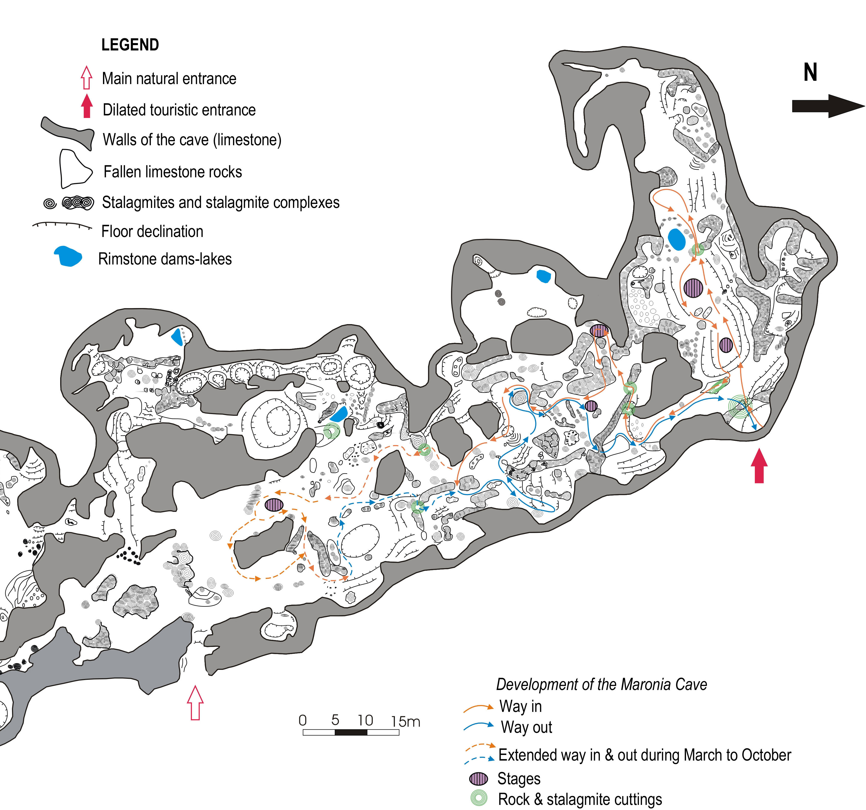

Figure 3. Drawing of the ground plan of the northern part of Maronia Cave based on the plan of A. (Petrochilou 1985). Arrows show the intended way in and out for the development of the cave. Location of the stages and rock and stalagmite cuttings are also marked.
ACKNOWLEDGEMENTS: Since the beginning of the speleological research, to the Maronia project, have been participated: O. Koukousioura, G. Lazaridis, M. Vaxevanopoulos (geologists), R. Pappa, Ch. Pennos (students of geology), S. Zachariadis (archaeologist) & Dr. F. López-Gonzáles (palaeontologist). K. Ataktidis and B. Makridis (speleologists) were leading the speleological research. We thank them all for their contribution.
The Municipality of Maronia, the Prefecture of Rhodope and the Region of Eastern Macedonia and Thrace financed the Maronia project. We are grateful to the authorities that supported this research.

References

PETROCHILOU, A., 1985. Caves of Greece. p. 160, Athens.
PARAGAMIAN, Κ., NIKOLOUDAKIS, I., PAPADATOU, E. & SFAKIANAKI, E, 2004. Research project: Biological-Environmental Study of the Maronia Cave. Analysis - Proposals. Institute of Speleological Research in Greece, p. 176 (unpublished rapport in Greek).

