THE MARONIA CAVE IN THE NUMMULITIC LIMESTONE (THRACE, GREECE).
GEOLOGY & PALEONTOLOGY

S. Pavlides¹, E. Tsoukala¹, A. Chatzipetros¹, A. Chatzopoulou¹, V. Melfos¹, A. Vasileiadou¹,
G. Lazarides¹, M. Vaxevanopoulos¹.

1. Department of Geology, Aristotle University, GR-54124 Thessaloniki (pavlides@geo.auth.gr)

ABSTRACT: The Maronia Cave (Thrace, Greece) is a cavern with great geological, palaeontological and archaeological interest. The tectonics, morphology and the speleothems of the cave are being described. In the present study the invertebrate and vertebrate remains are presented.

Geological structure of Maronia cave

Maronia cave is located at the Koufoplati hill (2 km NW of the Maronia village) and is developed in a relatively thin layer of eroded Nummulitic limestones of Middle Eocene age (Kouris 1980, Papadopoulos 1982). These Nummulitic limestones have been unconformably deposited on top of the underlying greenschists of Makri and Drymos-Melia Units (Circum Rhodope geotectonic zone), and are spread over a wide area, covering today the top of the region hills. Limestones are slightly inclined towards the west and contain several species of fossilized Foraminifera, Algae, corals, sea urchins, bivalves and Bryozoa. A basal clastic series partly defines the contact between limestones and greenschists. It comprises mainly of conglomerate and sandstone. It is considered to be the regression series marking the beginning of limestone deposition. The greenschists of the Makri and Drymos-Melia Units are a complex of Jurassic – Lower Cretaceous metavolcanic rocks (lavas and tuffs) of low metamorphic grade. The Mesozoic metamorphic rocks and the Eocene limestones are intruded by Oligocene volcanic rocks, which are represented mainly by altered andesites alternating with bedded and partly unbedded tuffs (Melfos 1995).

The cave is formed along two main tectonic lines (faults): the primary one is trending NW – SE and forms the main cave chambers, while the secondary one is trending ENE – WSW and forms the secondary chambers. These lines are in good agreement with surface microtectonic analysis. Two main sets of joints are observed: the primary one (D1) is striking S20ºE to S30ºE and comprises of long (>10 m) and quite sparsely (ca. 0.5 m) developed joints, while the secondary one (D2) is striking N60ºE and comprises of shorter joints. The coincidence in strike between the two main joint systems, the cave chamber orientation and the tectonic lines of the near area, lead to the conclusion that the cave was formed along three main tectonic zones. Surface water circulation has played an important role during the speleogenesis procedure (fig.1).

Figure 1. Stereographic projection (lower hemisphere) of faults and joints (density diagram) showing the two main directions NW-SE and ENE-WSW.
The Maronia Cave presents a total passage length of approximately 2000 metres and expands 10000 square metres. There are two natural entrances to the cave, both on the eastern slope of the Koufoplati hill. Most of the floor surface is covered with calc-crust flowstone. The southern part of the cave comprises large chambers. It has great biological interest due to the presence of 11 different species of bats and 31 species of invertebrates. 1/3 of this fauna consists of endemic species (Paragamian 2004). This can be interpreted by the early cracking of the Eocenic Nummulitic limestone cover that resulted isolated cave faunas. The southern part of Maronia Cave shows remarkable diversity of speleothems. The most spectacular forms are the shields, (e.g. Hill & Forti 1997), such the huge shield (diameter 2m)(Photo 1), which was observed in one of the deepest rooms of the cave.

The northern part of the cave is rather small. The two entrances control the microclimate of this part of the cave. Temperature and humidity are not stable throughout the year. This effects the bat populations regarding moving and hibernating. Curtains and enormous columns create mazy paths. The scarlet hue of the speleothems is dashing (Photo 2). The solution process of percolating water is intense only in few areas. Chambers of the northern part are relatively dry and the speleothems are under corrosion. The stalactites of the ceiling of some chambers have been collapsed ( e.g. Klimchouk et al. 2000).

The decoration of the cave presents a great variability. Some of the speleothems are rare and impressive. Among them, there are stalactites that are shorter than the stalagmites almost in all cases, columns, draperies, helictites (Photo 3), conulites, flowstones, gours, pool spars, cave pearls and corrals, and shields or discs as well. Mushroom-like (Photo 4) and curved stalagmites and the discs are the most characteristic features of the Maronia cave. The stalactites and stalagmites follow the tectonic lines of the cave. In some chambers, mainly in the southern part of the cave, chemical corrosion caused great damage to the speleothems. This may be due to the affection of the CO₂ released from the guano of the bats that covers most of the floor of the cave. In certain places small lakes have been formed and small potholes as well.

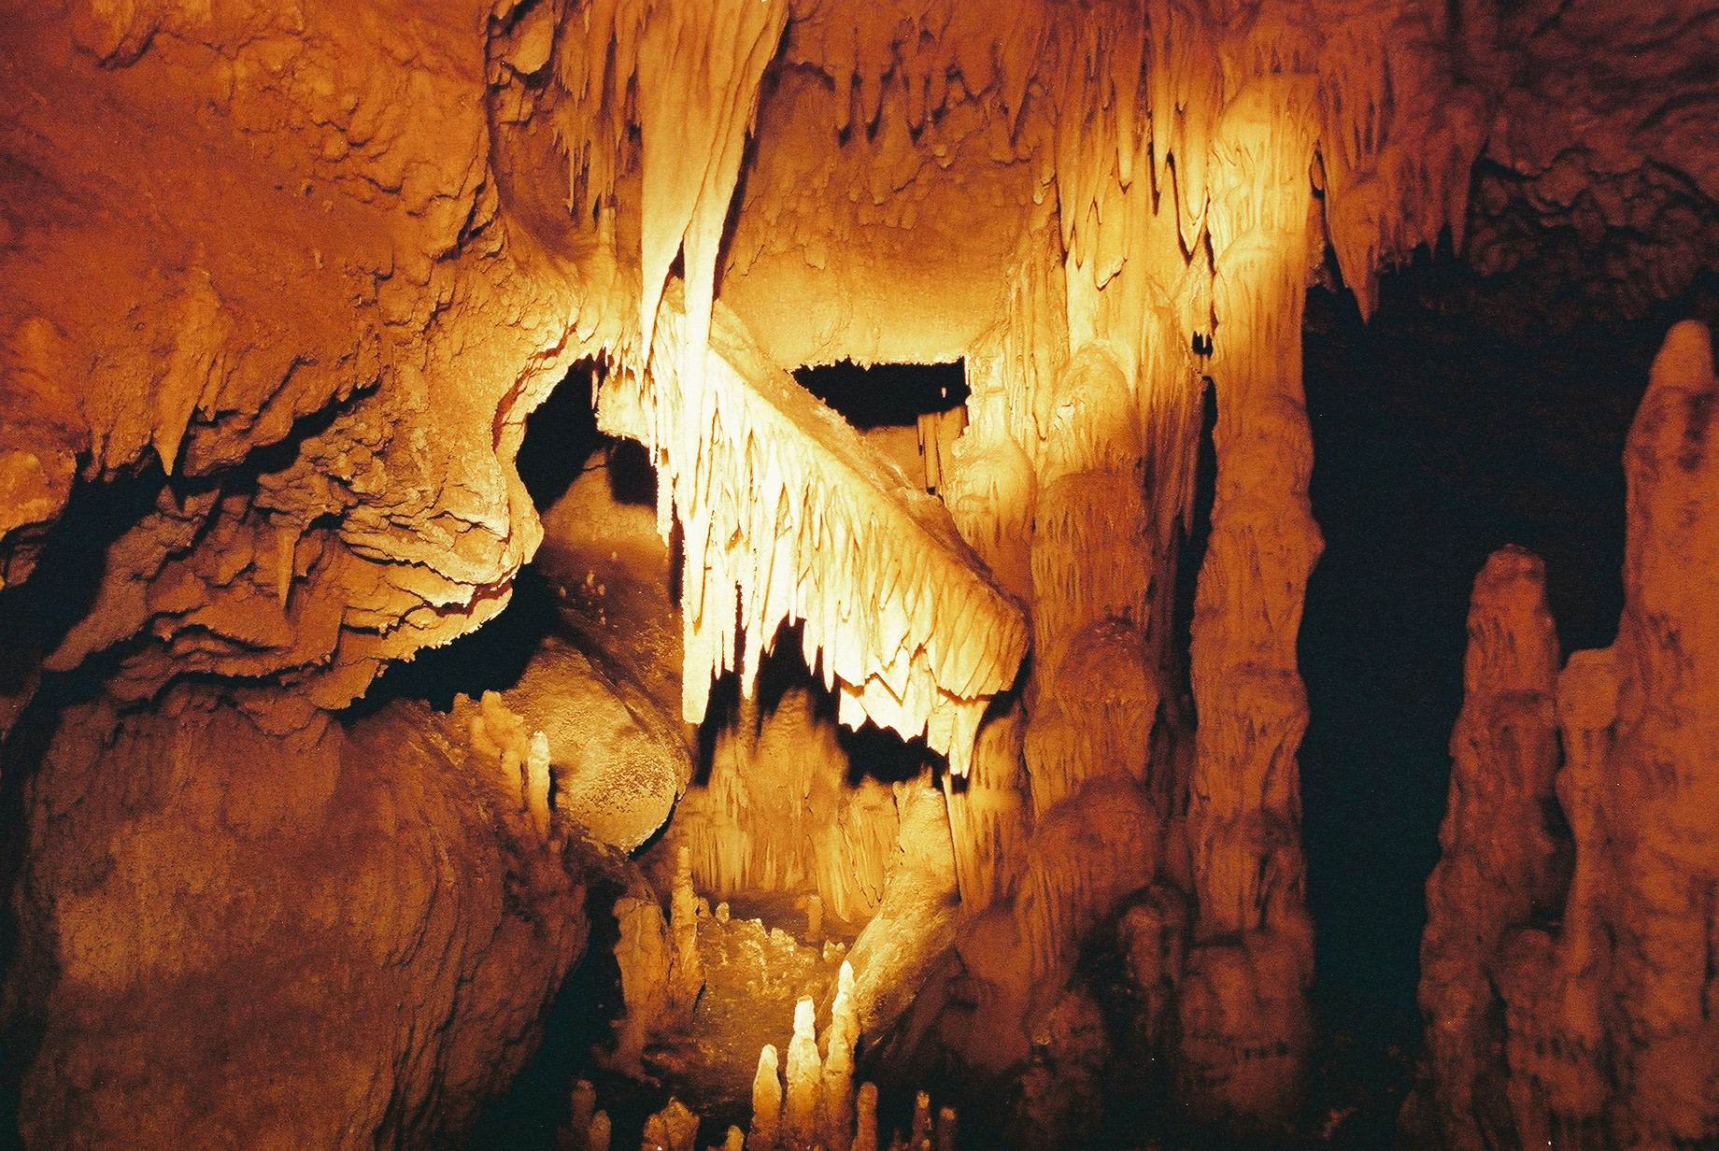 | 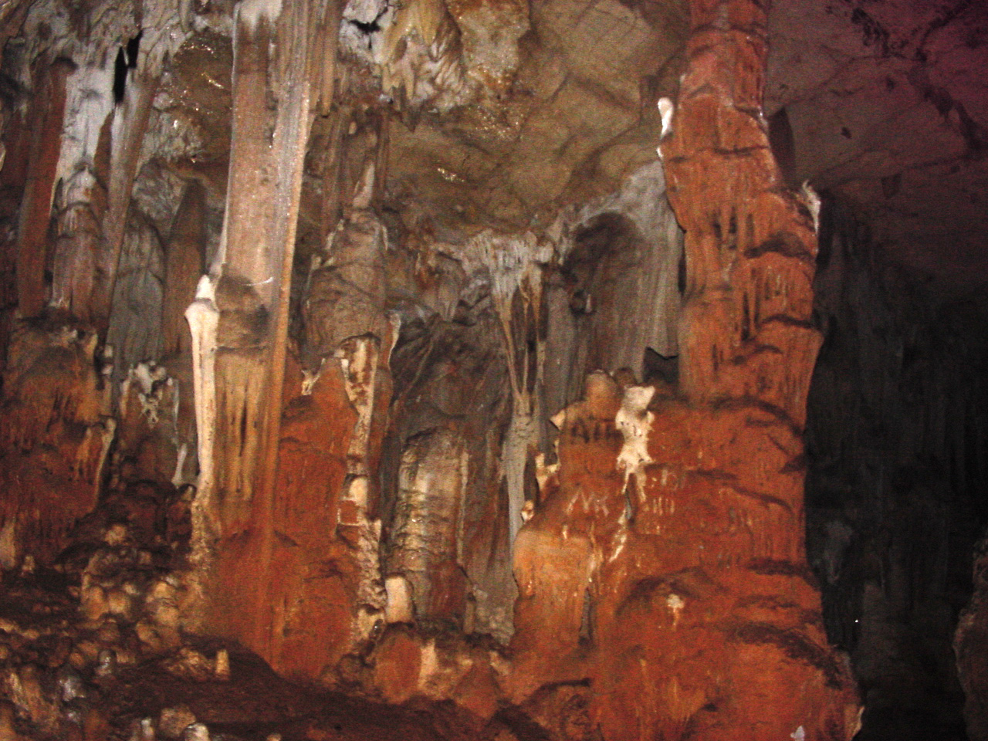
Photo 1. Shield of diameter 2m. The most characteristic form of speleothems of the Maronia Cave. | Photo 2. Spectacular red columns due to iron oxide.

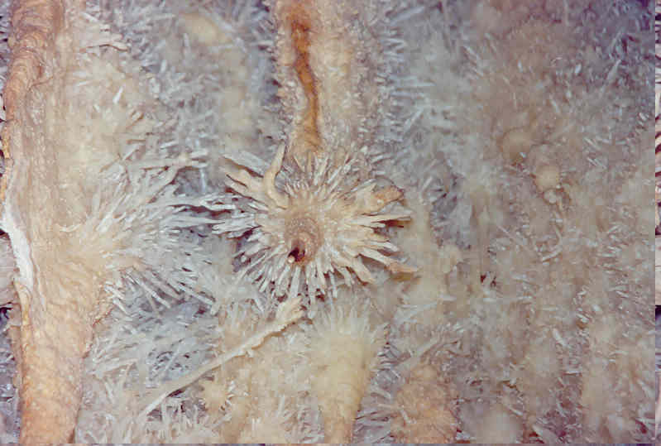 | 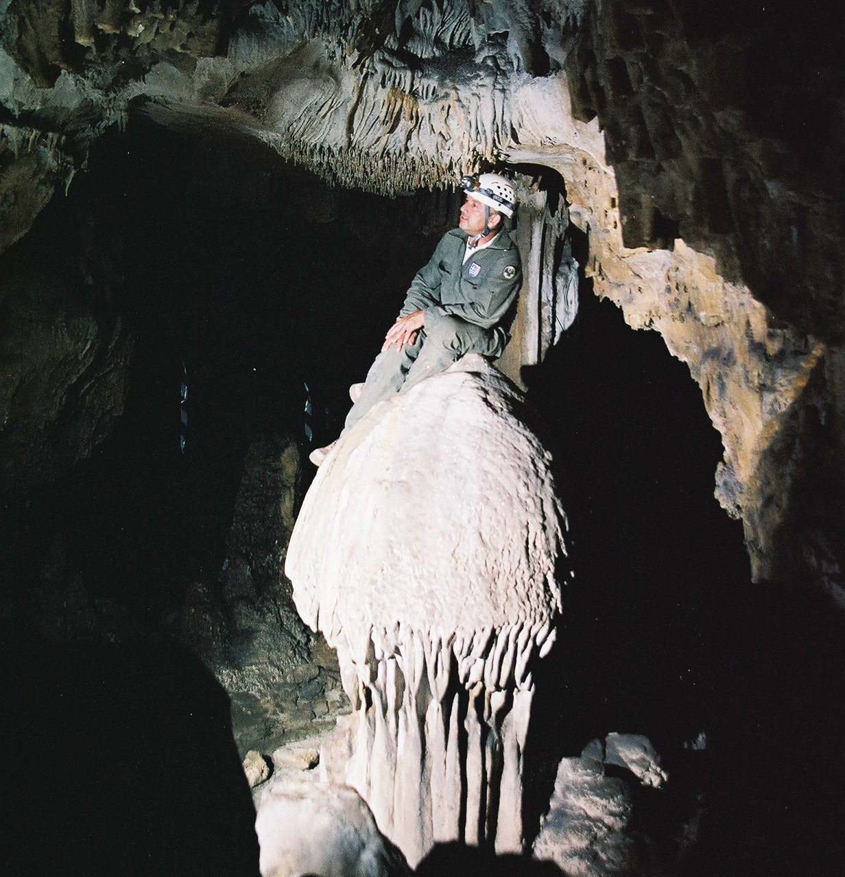
Photo 3. Helictites | Photo 4. Huge mushroom-like stalagmite

Palaeontological findings

The paleontology of the cave presents great interest. There are invertebrates in the limestone of the cave surroundings including sea urchins, giant ostreas, hexacoralls, lamellibranchia (mainly Pectenidae and Cardiidae), and foraminifers (mainly nummulites) (Photo 5) of Eocene age. The nummulites characterized the Intertidal and Neritic environment. They are also of great stratigraphical importance since they are index fossils of Eocene (Dermitzakis & Georgiades-Dikeoulia 1986).

Next to the entrance of the cave, in a small recess of the bedrock, a cohesive bone breccia (Photo 6) is being preserved. The initial examination gave interesting results (Bartsiokas 2000). Of the vertebrates found in the breccia from the additional material, the fossilized bones and teeth can be attributed to Crocuta crocuta spelaea (Photo 7), Coelodonta antiquitatis, Elephantidae? bos primigenius, Equus caballus, Dama dama of the Late Pleistocene age.

Further more, recent bones have been observed on the floor of the cave. These can be attributed to Capra/Ovis, Equus caballus, Sus scrofa scrofa, Homo sapiens, Martes martes, Canis familiaris. Small mammals were also identified: Leporidae, Chiroptera, Erinaceus sp. Crocidura sp., Apodemus mystacinus, A. sylvaticus, Rattus rattus, Microtus arvalis and M. agrestis. Few remains confer to small reptiles and birds. Many of these bones have been covered by stalagmite.

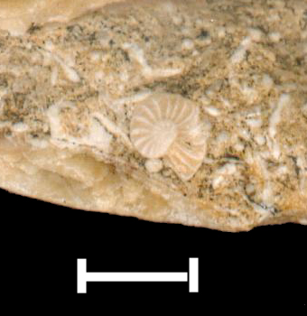 | 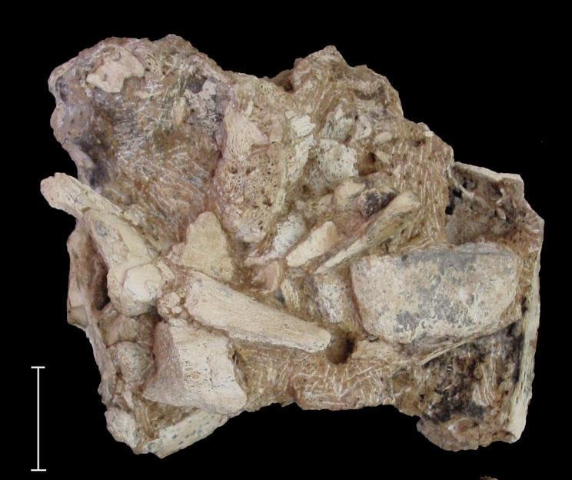 | 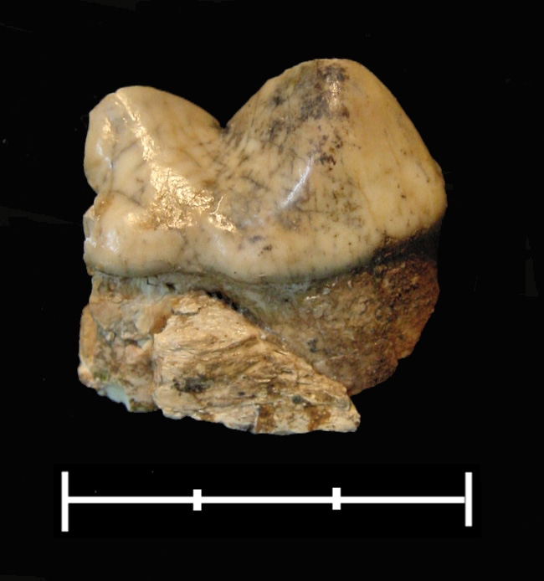
Photo 5. Detail of a nummulite.  Scale 1cm | Photo 6. Part of the cohesive bone breccia.  Scale 5cm | Photo 7. First molar of Crocuta crocuta spelaea. Scale 3cm

Archaeological Importance

The Maronia Cave has a great archaeological interest. Excavations have shown that the cave was inhabited in the Neolithic and Bronze Age, while in the Archaic and Byzantine periods it was a place of refuge in times of hardship or a place of worship (Petrochilou 1985; Bakirtzis &Triantaphyllos 1988). In traditional tales it has been identified with the cave of the Homeric hero Plyphemus, the Cyclops who was blinded by Odysseus, after intoxicating him with the Maron's wine. The cultural importance of the cave is related with the significant archaeological sites, which are spread around the whole region. Maronia was a considerable trade and cultural centre in Northern Aegean Sea, for more than 2.500 years and many monuments and buildings are still preserved, making the area a huge open-air museum. Ismara inhabited by the Thracian Cicones is documented by the acropolis, the city walls with a gate and a sanctuary (Photo 8). In the neighbouring Maronia the colonisers from Chios constructed the city walls, a theatre, sanctuaries, houses with mosaics and a harbour, all still preserved today.

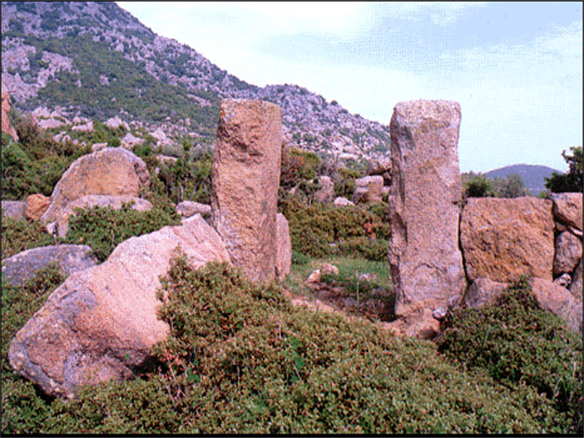 Photo 8.A gate and the city walls of ancient Ismara inhabited by the Thracian Cicones.

ACKNOWLEDGEMENTS: Since the beginning of the speleological research, to the Maronia project, have been participated: O. Koukousioura (geologist), R. Pappa, Ch. Pennos (students of geology), S. Zachariadis (archaeologist) & Dr. F. López-Gonzáles (paleontologist). K. Ataktidis and B. Makridis (speleologists) were helping the speleological research. We thank them all for their contribution. The authors are deeply grateful to Assist. Prof. G. Syrides for determinations on the invertebrates.
The Municipality of Maronia, the Prefecture of Rhodope and the Region of Eastern Macedonia and Thrace financed the Maronia project. We are grateful to the authorities that supported this research.

References

BAKIRTZIS C, TRIANTAPHYLLOS D (1988) Thrace. Cultural Foundation ETBA, Athens, pp 80.
BARTSIOKAS, A., 2000. The myth of Cyclops Polyphemus and the paleontological reality in the Cave of Cyclops, Maronia, Greece. –18th International Congress of Zoology, Athens (28/8-2/9/2000)
DERMITZAKIS, M.D. & GEORGIADES-DIKEOULIA, E., 1986. Introduction to the Marine Micropaleontology, Part A, p. 720, Athens.
HILL, C. & FORTI, P., 1997. "Cave Minerals of the World". 2nd edition, National Speleological Society. Huntsville, Alabama, USA.
KLIMCHOUK, B. A., FORD, C. D. & PALMER, N. A. 2000. Speleogenesis. Evolution of karst aquifers. Wolfwang Deybrodt Editors, Huntsville, Alabama, U.S.A. 2000, p 526.
KOURIS, Ch., 1980. Geologic map of Greece, Mesi-Xylagani sheet, scale 1:50.000. Inst Geol Miner. Expl, Athens
MELFOS, B., 1995. PhD Thesis, Aristotle University of Thessaloniki, School of Geology, p. 289 (in Greek)
PAPADOPOULOS, P., 1982. Geologic map of Greece, Maronia sheet, scale 1:50.000. Inst Geol Miner Expl, Athens, Greece
PARAGAMIAN, Κ., 2004. Research project: Biological-Environmental Study of the Maronia Cave. Part A. Institute of Speleological Research in Greece, p. 112.
PETROCHILOU, A., 1985. Caves of Greece. p. 160, Athens.

