Modification of cave entrances in Norway by marine action

Trevor Faulkner

Limestone Research Group, University of Huddersfield, Queensgate, Huddersfield, HD1 3DH, UK
tfaulkne@globalnet.co.uk

Abstract
Several karst caves in north central Norway lie below the (Weichselian) deglaciation marine limit, which is the highest level reached by the sea during the Younger Dryas and Holocene melting and the associated isostatic uplift. Except for mainly vadose caves of Holocene age, such caves commonly exhibit wide, relatively low, sub-horizontal, tapering, rocky entrances that are larger than internal passages. Such morphology appears diagnostic of erosion by waves and sea ice at a time of falling sea level and confirms the prior existence of the cave passage. However, several Norwegian non-carbonate sea caves and a few karst caves have entrances that are taller and much larger, but lie well above the deglaciation marine limit. It is suggested that these cave entrances were primarily enlarged when the sea approached a glaciation marine limit, perhaps at the start of the Weichselian and / or an earlier glaciation. The different morphology can be explained by enlargement at a time of rising sea level, when the coastline experienced isostatic depression before being covered by ice. In the case of karst caves, these large entrances may indicate that continuing smaller internal passages were in existence before the end of the Eemian interglacial.

Introduction
Large sea caves along the coast of Norway are well known (e.g. St.Pierre and St.Pierre, 1980; St.Pierre, 1988). Most of these caves are in non-carbonate rocks and many appear to be of pre-Holocene age, because they are commonly situated well above the highest post-glacial local shoreline (Sjöberg, 1988) and / or because they contain deposits dated to various stages in the Weichselian glaciation, as in some sea caves in southern Norway (Larsen et al., 1987; Larsen and Mangerud, 1989; Valen et al., 1995; Valen et al., 1996). As part of a wider study of speleogenesis in glaciated Caledonide metacarbonate rocks (Faulkner, 2005), the author compared karst caves near the coast of north central Norway with variations in local sea level and the extent of ice cover during the onset and decay of the Weichselian and earlier glaciations. This paper deduces some relationships between sea level and the formation and modification of caves in both metacarbonate and non-carbonate rocks.

Sea level curves and marine limits
The Late Weichselian deglaciation of Norway was illustrated in an ice margin recession map by Andersen and Karlsen (1986). With the removal of the ice burden, Fennoscandia rebounded isostatically at a very fast rate initially, with the elevation increasing inland. The tilting shorelines were raised progressively, with the oldest and highest raised shorelines showing the greatest tilt, as Møller (1989) showed in a 3D model of Holocene relative sea level changes for northern Norway and as presented in land uplift maps for Norway by Sørensen et al. (1987). Their isolines smooth out scanty observations and uncertain datings, generating local isobases that are remarkably linear and parallel. The uplift always outpaced rising sea level at all parts of the indented north central Norway coast.

The elevation that the sea reached along the coastal fjords and valleys is called the deglaciation marine limit in this paper. It depended on the recession of the ice margin and on the isobase of the location and it varied from c. 125m at 12000¹⁴Ca BP at coastal islands at the 100m Younger Dryas (YD) isobase to 133m at 9080 at the 200m YD isobase in Vefsndal, the farthest east that the sea penetrated in the Holocene. The YD isobase sea level curves in Figure 1 are based on similar ones for Trondheim by Svendsen and Mangerud (1987, Fig. 12) and show (e.g.) that all points on and underneath the surface at the 150m YD isobase below a present 150m altitude were inundated by the sea at the start of the Holocene at 10000¹⁴Ca BP, providing that the ice had melted by then at that location.

At the onset of each glaciation, valley glaciers and mountain icesheets progressively extended towards the sea. The icesheet grew to a considerable thickness, and at the end of the Eemian interglacial “depression extended ahead of the ice margin” (Lundqvist, 1986, p288). Hence, the sea encroached significantly inland before its surface froze permanently and there must be another limit, not previously explicitly recognised in the literature, that equals the elevation that the sea reached up each valley before freezing (or before falling eustatically relative to the land) during a transgressive glaciation phase, which is called the glaciation marine limit in this paper.

Information from the last glaciation phase and from the glaciation and deglaciation of previous stadials and glacials is much more difficult to obtain, because stratigraphical and dating evidence is commonly altered or destroyed by the glaciation process. Hence, the geometry of the glaciation marine limit is presently unknown. However, from the evidence of Mid Weichselian marine-influenced deposits at high elevations, e.g. sediments dated from 35–24ka at 260m near Hattfjelldal in north central Norway (Olsen et al., 2001), it is clear that this interstadial marine limit was 120m above the equivalent local (210m YD isobase) deglaciation marine limit (although the sea did not quite reach this point during deglaciation). This isobase may mark the eastward limit of any Weichselian marine impact in this area because there are no eastern caves and few carbonate outcrops below 260m in altitude. It is also probable from the survival of Mid Weichselian fine grained sediments and Early Weichselian speleothems dated to 80±9ka in the elevated sea cave Skjonghelleren in southern Norway (Larsen and Mangerud, 1989) that that cave was not inundated again by the sea after these depositions, and that it formed at a high sea level even earlier in the Weichselian or before. This suggests that the maximum Weichselian marine limit occurred relatively soon after the start of the Weichselian glaciation. With no evidence to the contrary, it is concluded that this also applied in north central Norway, so that the extra 120m above the deglacial marine limit reported near Hattfjelldal is a conservative value to use for the local glaciation marine limit. Mangerud (1991) and Fredin (2002) also reported that several coastal caves in southern Norway, which are well above the deglaciation marine limit, were submerged after the Eemian, because of rapid isostatic depression caused by the YD-sized Herning glaciation in the Early Weichselian.

The order in which some relevant karst caves in north central Norway were submerged by the sea during the Weichselian deglaciation is presented in Table 1, with estimates of their emergence timescales. This uses data from the sea level curves in Figure 1 and the timings of the west to east recession of the ice margin.

Formation of sea caves and littoral caves in limestone
A few karst caves lie along the coastal strandflat, commonly at altitudes below c. 25m. Many of these short ‘coastal’ caves show little karstic dissolution, but appear to be littoral caves formed by previous wave action with no continuing passage. They include three of the four relict Brønnøysund Football Pitch Caves, Vistnesoddgrotta and possibly Tarmaunbotngrottene. Their low elevations mean that they were under >100m of sea water at the start of the Holocene; hence, they were not much affected by wedging by YD sea ice. Instead, they were exposed near sea level for ≥1000a during a late phase of the Holocene isostatic rebound. The above-mentioned caves face NE or NW, suggesting that their formation was facilitated by the presence of late Holocene winter sea ice. Two ‘coastal’ caves appear to be karst caves modified by marine action: Brønnøysund Football Pitch Cave B shows clear signs of the surface erosion of a phreatic tubular passage and Langfjordgrotta is a resurgence cave partly explored by diving that has a relatively large entrance. These caves were presumably already developed phreatically as part of subglacial waterways during the Weichselian deglaciation (Faulkner, 2005). The previous presence of the sea at both coastal and marine-influenced karst caves is sporadically demonstrated by the occurrence of holes bored by marine molluscs in the walls and ceilings of entrance areas. More rarely, marine deposits are also found in the caves (e.g. Hoel, 1906).

Enlargement of cave entrances that are below the deglaciation marine limit
Karst caves that lie below the deglaciation marine limit and above the strandflat were also inundated by the sea at the end of the Younger Dryas, before being raised isostatically to their present altitudes of 30–167m. Many exhibit wide, relatively low, sub-horizontal, tapering, rocky entrances that seem disproportionately large when compared with the dimensions of internal passages. This group of caves includes: Green Gorge Cave, Marble Arch, Klausmarkgrotta, Klausmark Resurgence Cave (all at Klausmark), Hubruhola, Aunholet, Skånvikgrotta, Tourist Cave, Svartdalgrotta (lower entrance), Evening Cave (H5), Hate Cave (H8), Laveste Langskjellighattengrotta, Jenshola, Risehula 1 and 2, several caves at the Arch Cave complex, Mølnvatngrotta (Forest Entrance), Aunhattenhule 1–3, Nedre Landegrotta, Kalkdalgrotta, Gårdsfjellgrotta, Møllebekkgrotta 1 and 2, plus Remnant Cave and, possibly, Fjellbrygga. Beyond the entrance areas, most of these caves contain obviously dissolutional karstic passages. Many function, or have functioned, as resurgences.

Only caves that contain relict phreatic passages appear to have entrances enlarged by marine action, although some similar caves that are below the deglaciation marine limit do not have significantly enlarged entrances, including Neptune’s Cave, Barnacle Cave and Draugenshullet. The reason may be that the entrances are shafts or they were in protected locations or they did not form until after elevation above the sea. Attached barnacles in these three caves (Faulkner, 2005) prove that at least their internal passages existed prior to emergence. The direct evidence of entrance enlargement from individual caves agrees with the greater mean cross-sections of caves with relict phreatic passages if they lie below the deglaciation marine limit (Faulkner, 2005) and shows that such caves were already in existence before marine inundation at the start of the Holocene, as do non-laminated deposits of coarse dry sand reported only in the relict phreatic passages of Søvikgrotta, Nordlysgrotta, Marimyntgrotta, Neptune’s Cave and Aunhattenhullet 2 (which suggest marine ingress into cave entrances that mainly face east, when they coincided with beach levels).

Marine cave entrances at altitudes above 80m experienced a very rapid elevation through sea level in the Preboreal, so that they typically rose 10m in only c. 100a (Figure 1). Lower entrances rose above sea level later, and rose more slowly during emergence. In contrast to the lower littoral caves discussed above, the only definite littoral cave recorded in limestone above the strandflat is the single chamber Bordvikgrotta, at an altitude of 40m. Several features at the Arch Cave complex, at the relatively low altitude of 60m, may also be littoral caves. It thus appears that, at altitudes higher than 40–60m, the uplift was so fast that there was insufficient time for the sea and ice to form new, presently inland, littoral caves in limestone before they were elevated above wave height.

The extent of the enlargement of pre-existing entrances has a weak relationship with altitude and the duration of submersion. Thus, five entrances to caves with phreatic passages not obviously enlarged were submerged for a maximum of c. 150 years (although others are exceptions) and enlarged entrances were commonly submerged for many hundreds or thousands of years. Thus, it seems that pre-existing cave entrances were more likely to be enlarged by wave action supplemented by wedging by winter sea ice if they passed slowly through the tidal range after long submersion, with an overall preferred orientation of northwest. The enlargement was probably contemporary with the production of elevated marine terraces (e.g. Andersen et al., 1982, p44). Large sea caves also formed in non-carbonate rocks above the strandflat (e.g. Sjöberg, 1988). Marmorhølet on the island of Dønna, in predominantly non-carbonate rocks (despite its internal calcite deposits), is probably a short sea cave created early during deglaciation.

No cave that is clearly mainly vadose appears to have an enlarged entrance (Table 1). Thus, it is likely that such caves that lie below the deglaciation marine limit (and, by extension, those above it) did not exist in their present form at the time of their elevation above sea level. This observation is partly supported by the absence of reports of sand deposits in such caves. It is concluded that the ‘mainly vadose’ caves primarily developed within the Holocene.

Enlargement of cave entrances that are above the deglaciation marine limit
Table 1 lists five caves that are anomalous in a deglaciation context. From their locations, YD isobases and the time of passing of the ice margin, it appears that the entrances to Bollhauggrotta, Øyåskjeleren (Photo 1), Øyfjellgrotta, Lilleelvgrotta and Geitklauvgrotta were already too high to be reached by the sea when they were deglaciated. The first four caves have entrances that appear enlarged by marine action, to the same criteria. The entrance to Geitklauvgrotta (which is upstream to Lilleelvgrotta) is not at all enlarged internally, being a phreatic passage some 1m high by 2m wide. However, there appears to be an unroofed section of cave between this entrance and the end of the upstream Øvre Geitklauvgrotta. The thin roof may have been removed by glacial movement or by the action of the sea and sea ice, or by a combination. If marine action has modified these caves, and it is difficult to envisage any other agency to account for the enlarged entrances to Øyåskjeleren and Øyfjellgrotta, then it seems very likely that this occurred when the marine limit was higher than the last deglaciation marine limit. This leads to the possibility that these entrances were enlarged during the onset of one or more glaciation phases or during a Mid Weichselian interstadial, and were well-enough protected during subsequent glaciation for the enlarged parts to have survived. The five cave entrance floors are at altitudes from 100–150m at YD isobases from 140–170m and are well below the possible maximum Weichselian marine limit discussed earlier. In contrast to many enlarged entrances below the deglaciation marine limit, all five above that limit are on eastern slopes (although the Bollhauggrotta and Øyåskjeleren entrances face west), but this may not be significant with a small sample. There are no other apparently marine-enlarged cave entrance floors above an altitude of 167m, so that the absence of similarly-styled entrances above the maximum Weichselian marine limit provides supporting evidence for entrance enlargement of phreatic passages below marine limits by sea ice and wave action.

Cave entrances modified during the onset of glaciation were enlarged at a time of rising sea level, in contrast to those enlarged during the falling sea level of a deglaciation phase. When a sea level that is falling encounters a cave entrance, that part of the entrance that remains submerged is protected. Hence, the vertical scale of enlargement is related to the tidal range and wave height: ~5–10m (Figure 2a). In fact, the entrances enlarged during deglaciation listed in Table 1 are rarely >5m high (although they may extend to a width of 10–20m). However, when a rising sea level encounters a cave entrance, a vulnerable roof may remain under attack from the time that the wave height reaches it, until the time when the sea either freezes at its maximum level, or starts to fall relative to the land at a glaciation marine limit (Figure 2b). 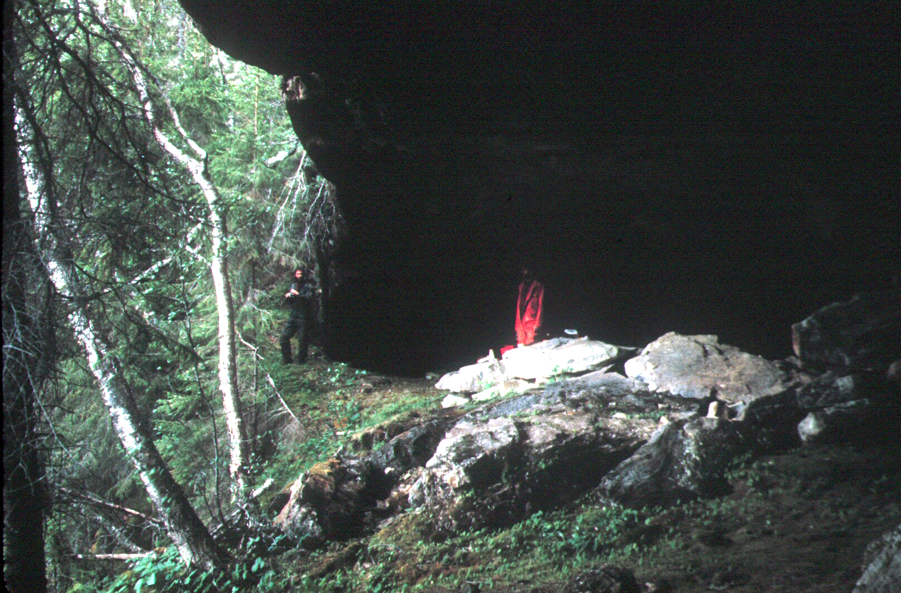Photo 1 Upper cliff entrance to Øyåskjeleren
At an altitude of 100m, this entrance was probably
enlarged by the wave and ice action of a rising sea
level

Although the roof collapse rate may be overtaken by the rising sea level and the local isostatic depression

there is clearly potential for cave entrances to be enlarged vertically by marine action much more during a glaciation phase than during a deglaciation phase.

The only karst cave in north central Norway that has an entrance taller than that of the exceptionally tall inland Grønndalsgrotta (16m) is Øyfjellgrotta, whose lower (main) entrance is up to 30m high and c. 15m wide (Heap, 1968) and is well above the deglaciation marine limit. This evidence supports the upward stoping of cave entrances by marine and winter ice activity as a mechanism for entrance enlargement during a glaciation phase. The marine invasion of Øyfjellgrotta is also supported by a statement by Smart (1984, p173): “exotic boulders of (up to 6m) size have been carried in and effectively blocked the system”, and by his mention of sand-sized sediments. Sand deposits in Sirijordgrotta (Valen et al., 1997; entrances not enlarged and not listed in Table 1) and Øyfjellgrotta, both on eastern slopes below the glaciation marine limit, may have been brought in by the sea at the onset of glaciation, although fluvial or glacio-fluvial deposition remain as possibilities. Above the marine limits, only three caves appear to have large sand deposits, which were presumably deposited by glacio-fluvial processes.
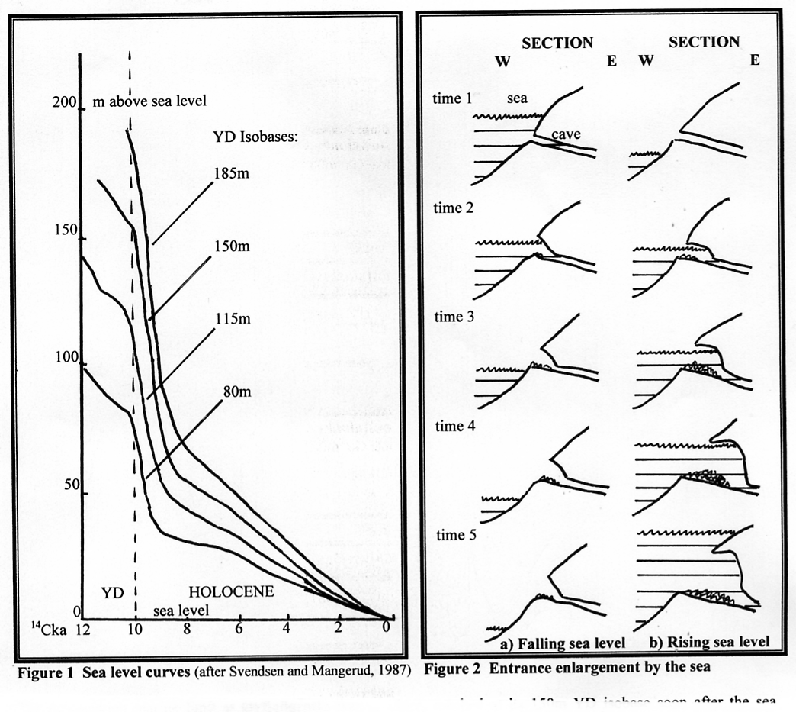

The deglaciation marine limit at Øyfjellgrotta was c. 125m, reached at its 150m YD isobase soon after the sea encroached south of Mosjøen at 9300 ¹⁴Ca BP (Andersen et al., 1981). This is some 45m below the 170m level of its main entrance roof, confirming that the enlargement above its floor at 140m must have occurred prior to the final deglaciation. This extra minimum 45m of maximum marine limit is well within the extra 120m discussed earlier so that it seems likely that the interstadial or Early Weichselian sea rise overtook the upward stoping of the Øyfjellgrotta entrance, so that the whole cave became submerged.

The upward stoping mechanism also explains the existence of the very large sea caves in non-carbonate rocks along the north central Norway coast that are positioned above local deglaciation marine limits (Sjöberg, 1988, Table 2). For example, Torghatt-hullet and Monshola (at YD isobases of 115 and 120m) are shown as having entrance floors at 138 and 147m, and roof altitudes as high as 160m. At c. 11500 and 10700¹⁴Ca BP, when the YD ice margin passed them, the sea level was at an elevation of c. 135m for both these caves (Figure 1). Because this level is below the entrance level of each cave, and 25m below roof levels, it seems very unlikely that wave action could have formed them during the final Weichselian deglaciation. On the other hand, if they were formed or enlarged during the onset of the Weichselian glaciation, or during the various interstadials, their maximum roof heights of 160m could define the minimum glaciation or interstadial marine limit applicable to their isobase. Subsequently, these, and other sea caves above the deglaciation marine limit, may have changed little in size, being protected by their west-facing aspect beneath a west-moving icesheet. Torghatt-hullet could also have been partly enlarged by deglacial meltwater flows at the end of the Weichselian, because it is a through-cave.

By comparing the height of the local deglaciation marine limit with the cave roof altitudes given by Sjöberg (1988, Table 2), his list of 33 caves can be divided into three classes: those formed only during deglaciation, those formed during glaciation and / or interstadials, and those similarly formed but subsequently enlarged during deglaciation. For the second two classes, the difference between the roof height and the deglaciation marine limit ranges up to 70m, suggesting that an earlier marine limit was ≥70m higher than the deglaciation marine limit for these coastal caves, which is within the extra 120m discussed earlier. It seems likely that this explanation for the formation of sea caves in north central Norway also applies in northern Norway (e.g. Møller, 1985) and in southern Norway (Introduction).
Table 1 Marine inundation of metacarbonate caves during the Weichselian deglaciation
Time  of  inun.  ¹⁴Ca  BP | Local YD iso-base  m | Cave(s) | Alt.  m | Time of final  emer-gence  ¹⁴CaBP | Appr.  time  sub-merged  ¹⁴Ca | Entrance  faces | Notes 1. MV: mainly vadose cave  2. Enlarged entrances are suggestive of wave action  3. Sea / littoral caves are commonly non-dissolutional
12000 | 90 | Marmorhølet | 113 | 11500 | 500 | N | Sea cave, formed in non-carbonate
10700 | 100 | Søvikgrotta | 64 | 9000 | 1700 | SW | Slightly enlarged relict entrance. Sand.
10700 | 110 | Football pitch caves | 25 | 4800 | 5900 | NE | 1 of 4 is a dissolutional hybrid
10700 | 110 | Vistnesoddgrotta | 10 | 2000 | 8700 | NE | Short littoral cave
10700 | 130 | Klausmark caves | 120–160 | 10000 | 0–700 | S,E,E,S | 4 enlarged entrances, one at 160m
10300 | 120 | Hubruhola | 119 | 10000 | 300 | N | Enlarged entrance
10300 | 120 | Langkilagrotta | 40 | 6800 | 3500
10300 | 135 | Aunholet | 60 | 8300 | 2000 | N | Enlarged entrance
10300 | 140 | Holåsen caves HO1–5 | 110–135 | 10000 | 300 | (shafts) | Not enlarged: all MV
10300 | 140 | Bordvikgrotta | 40 | 6500 | 3800 | NW | Single chamber littoral cave
10300 | 140 | Nordlysgrotta | 155 | 10200 | 100 | NE | Sand banks below entrance pitch
10300 | 140 | Marimyntgrotta | 155 | 10200 | 100 | SW | Relict entrance. Sand
10300 | 140 | Skånvikgrotta | 77 | 9000 | 1300 | S | Enlarged entrance
10210 | 145 | Tourist Cave | 150 | 10010 | 200 | N | Enlarged sink entrance
10210 | 145 | Svartdalgrotta | 180–127 | 9700 | 510 | NE | Enlarged lower entrance only
10210 | 145 | Neptune’s Cave | 126 | 9260 | 950 | E+shafts | Not enlarged. Barnacles. Sand
10210 | 145 | Barnacle Cave | 142 | 9900 | 310 | N | Not enlarged. Barnacles
10210 | 145 | Draugenshullet | 137 | 9600 | 610 | N | Not enlarged. Barnacles
10210 | 145 | Hestfjell H1–4, H6 | 90–115 | 9500 | 710 | NW | Not enlarged: all MV
10210 | 145 | Hestfjell caves H5,H8 | 110, 135 | 9700 | 510 | NW | Enlarged sink entrances.
10100 | 155 | Tarmaunbotngr. 1–3 | 5–20 | 1000 | 9100 | NW | Tectonic and littoral caves
10100 | 155 | L. Langskjellighattengr | 167 | 10000 | 100 | W | Entrances possibly enlarged
10100 | 155 | Langfjordgrotta | 10 | 1500 | 8600 | NW | Coastal karst sumped resurgence cave
10100 | 160 | Jenshola | 145 | 9800 | 300 | NW | Entrance possibly enlarged. Not MV?
10050 | 140 | Trondjordhula | 5 | 1000 | 9050 | S | Coastal resurgence cave. MV
10050 | 140 | Risehula 1 and 2 | 50, 53 | 7800 | 2250 | S | Enlarged relict entrances.
10050 | 155 | Arch Caves R6–R16 | 60–70 | 7500 | 2550 | vary | Enlarged ents., except 3 MV caves
10050 | 155 | Mølnvatngrotta | 140 | 9800 | 250 | SW | Enlarged relict Forest Entrance
10050 | 155 | 5 caves at Saus | 21–63 | 4000 | 6050 |  | 3 are MV. Not enlarged
10050 | 160 | Aunhattenhule 1–4 | 105–135 | 9500 | 550 | NW | Enlarged relict ents. to A1–A3. Sand
9900 | 140 | Sildgarngrotta | 120 | 9800 | 100
9900 | 140 | Splintågrotta | 135 | 9900 | 0 | E | Not enlarged resurgence entrance
9900 | 140 | Kumragrotta | 62 | 8500 | 1400 |  | Truncation of entrances
9900 | 170 | Svartdalsholet | 160 | 9850 | 50 | NW+SE | Sea just reached this cave. Not enlarged?
9900 | 170 | Ø. & N. Landegrotta | 80, 95 | 8600 | 1300 | S | Enlarged entrance to lower cave
9800 | 140 | Bollhauggrotta | 150 | 10100 | -300 | W | Enlarged sink entrance
9800 | 140 | Hestdalgrotta | 100 | 9500 | 300
9800 | 140 | Through Cave | 100 | 9500 | 300
9800 | 170 | Kalkdalgrotta | 50 | 7000 | 2800 | NE | Slightly enlarged relict entrance
9600 | 140 | Gjeitvikgrotta | 70 | 8900 | 700 | W | Not enlarged
9600 | 140 | Berntvikgrotta | 40 | 7200 | 2400
9550 | 140 | Høgligrotta | 100 | 9400 | 150 | S | Not enlarged
9500 | 150 | Gårdsfjellgrotta | 56 | 7800 | 1700 | E | Enlarged relict entrance
9300 | 150 | Øyåskjeleren et al. | 100 | 9500 | -200 | NW | Enlarged main relict entrance
9300 | 150 | Øyfjellgrotta | 180–140 | 9900 | -600 | SE | Enlarged lower relict ent. Sand
9300 | 170 | N. Laksfors Rising | 55 | 7200 | 2100 | E | Not enlarged sump entrance (=MV)
9300 | 170 | Møllebekkgrotta 1–3 | 90–79 | 8600 | 700 | NW,W | Enlarged entrances at M1 and M2
9300 | 170 | Geitklauvgrotta | 148 | 9800 | -500 | S | Unroofed cave outside
9300 | 170 | Lilleelvgrotta | 150 | 9800 | -500 | N | Enlarged entrance
9300 | 170 | Remnant Cave | 93 | 9000 | 300 | E | Cave wall removed
9300 | 170 | Fjellbrygga | 110 | 9300 | 0 | NW | Sea just reached huge 20m long arch
9300 | 180 | Farewell Cave | 130 | 9300 | 0 |  | Sea just reached cave
Shading indicates that the cave is above the deglaciation marine limit
Conclusions
This paper shows that at relatively low attitudes below the deglacial marine limit, when there was late and slow emergence above a falling sea level during deglaciation:
- ‘new’ littoral caves could form in limestone and in other rocks, giving a late Holocene genesis
- existing karst phreatic entrances could enlarge, with heights ≤5m, suggesting origins prior to the Holocene
- the absence of enlarged entrances to ‘mainly vadose’ caves suggests that few existed prior to the Holocene.
At higher altitudes between the deglacial and glacial marine limit, when there was late and slow submergence below a rising sea level during glaciation:
- very large sea caves could form in non-carbonate rocks (and probably in limestone, but none are known)
- existing karst phreatic entrances could enlarge greatly, with heights ≤30m, suggesting origins prior to the end of the Eemian interglacial.
These conclusions probably also apply to northern Norway. The map by Sørensen et al. (1987) shows that the YD isostatic uplifts at various karst areas vary from 110–180m. Thus, caves below these altitudes potentially have entrances enlarged by marine action during deglaciation. The two huge tapering (commonly dry) entrances of Okshola and Kristihola at c. 160m altitude have almost certainly been enlarged by marine activity. Their entrances were probably above the reach of storm levels when the sea invaded after the start of the Holocene, because the local YD isobase is at c. 145m. However, both are good candidates for enlargement upwards by a rising sea level at the end of the Eemian, as is the c. 10m high Resakjelen entrance to Setergrotta in Røvassdal, at an altitude of 100m and a YD isobase of 150m, which probably enlarged further during deglaciation.

This paper has used published data about marine limits and YD isobases to review influences on speleogenesis and entrance modification. It may also be possible to invert this process and estimate maximum and deglaciation marine limits and relevant isobases more accurately, by a more complete study of both sea cave entrance environments and modified karst cave entrances.

References
Andersen, BG and Karlsen, M. 1986. Glacial chronology – recession of the ice margin. 1:5000000.
Nasjonalatlas for Norge. Kartblad 2.3.4. Statens kartverk.
Andersen, BG, Bøen, F, Nydal, R, Rasmussen, A and Vallevik, PN. 1981. Radiocarbon dates of marginal
moraines in Nordland, N. Norway. Geografiska Annaler 63A (3–4) 155–160.
Andersen, BG, Bøen, F, Rasmussen, A, Rokoengen, K and Vallevik, PN. 1982. The Tjøtta glacial event in
southern Nordland, North Norway. Norsk Geologisk Tidsskrift 62 (1) 39–49.
Fredin, O. 2002. Glacial inception and quaternary mountain glaciations in Fennoscandia.
Quaternary International 95/96 99–112.
Faulkner, T. 2005. Cave inception and development in Caledonide metacarbonate rocks. Unpublished PhD thesis.
University of Huddersfield.
Heap, D. 1968. Norway Report for 1967. Kendal Caving Club Journal 3 11–16.
Hoel, A. 1906. Den marine graense ved Velfjorden. Christiana Videnskaps-Selskabs Forhandlinger (4) 1–15.
Larsen, E and Mangerud, J. 1989. Marine caves: on-off signals for glaciations. Quaternary International 3 / 4 13–19.
Larsen, E, Gulliksen, S, Lauritzen, S-E, Lie, R, Løvlie, R and Mangerud, J. 1987. Cave stratigraphy in western
Norway; multiple Weichselian glaciations and interstadial vertebrate fauna. Boreas 16, 267–292.
Lundqvist, J. 1986. Late Weichselian glaciation and deglaciation in Scandinavia.
Quaternary Science Reviews 5 269–292.
Mangerud, J. 1991. The Last Ice Age in Scandinavia. Striae. 34 15–30.
Møller, JJ. 1985. Coastal caves and their relation to early postglacial shore levels in Lofoten and Vesterålen, north
Norway. Norges Geologiske Undersøkelse Bulletin 400 51–65.
Møller, JJ. 1989. Geometric simulation and mapping of Holocene Relative Sea-Level Changes in northern
Norway. Journal of Coastal Research 5 (3) 403–417.
Olsen, L, Sveian, H and Bergstrøm, B. 2001. Rapid adjustments of the western part of the Scandinavian Ice
Sheet during the Mid and Late Weichselian - a new model. Norsk Geologisk Tidsskrift 81 93–118.
Sjöberg, R. 1988. Coastal Caves Indicating Preglacial Morphology in Norway. Cave Science 15 (3) 99–103.
Smart, CC. 1984. Overflow sedimentation in an alpine cave system. Norsk Geografisk Tidsskrift 38 (3/4) 171–175.
St.Pierre, D. 1988. A History of Cave Exploration and Study in Norway. Cave Science 15 (3) 139–144.
St.Pierre, S and St.Pierre, D. 1980. Caves of Velfjord, south Nordland, Norway, with particular reference to
Sirijordgrotten. Trans. British Cave Research Association 7 (2) 70–82.
Svendsen, JI and Mangerud, J. 1987. Late Weichselian and Holocene sea-level history for a cross-section of
western Norway. Journal of Quaternary Science 2 113–132.
Sørensen, R, Bakkelid, S and Torp, B. Land Uplift. 1987. 1:5000000. Nasjonalatlas for Norge. Statens kartverk.
Valen, V, Larsen, E and Mangerud, J. 1995. High-resolution paleomagnetic correlation of middle Weichselian
ice-dammed lake sediments in two coastal caves, western Norway. Boreas 24 141–153.
Valen, V, Mangerud, J, Larsen, E and Hufthammer, AK. 1996. Sedimentology and stratigraphy in the cave
Hamnsundhelleren, western Norway. Journal of Quaternary Science 11 (3) 185–201.
Valen, V, Lauritzen, S-E and Løvlie, R. 1997. Sedimentation in a high-latitude karst cave: Sirijordgrotta,
Nordland, Norway. Norsk Geologisk Tidsskrift 77 233–250.

