A simple growth model for allogenic pedestals in glaciated karst.

Stein-Erik Lauritzen
Department of Earth Science
University of Bergen
Allegaten 41, N-5007 bergen Norway

Stein.lauritzen@geo.uib.no

Abstract
Limestone pedestals (Karrentische) are believed to develop by differential corrosion beneath and around a protecting boulder. Here, we develop mathematical models for the size of limestone pedestals as a function of time and the properties of the perched boulder. These properties are the shortest horizontal axis of the boulder, its shape factor and the rate of condensation corrosion beneath it. Because the shielding effect will decrease with increasing pedestal height, pedestals will, over time, attain a finite, steady-state height. The time needed to aquire the steady-state height is considerable, and probably longer than the Holocene (10,000 years) for most sites. The present-day height of pedestals in a given site is dependent on up to 3 different parameters that are likely to vary within a pedestal population. Hence, the model also explains the variability observed in pedestal heights within a site. A method for estimating the total denudation by means of measurable pedestal properties was developed and tested with favorable outcome on pedestal populations at the Svartisen karst, north Norway and in north-west Spitzbergen.

Limestone Pedestals.
Limestone pedestals (Karrentische, Bögli 1960) develop underneath boulders. The perched block can either be an allogenic, non-karstic rock type (for instance, a glacial erratic in alpine karst) or it can be an in situ piece of the local limestone (autogenic). The formation of a pedestal is due to differential corrosion between the area beneath the boulder and the surrounding area, Figure 1a. The corrosion rate beneath the boulder is lower than elsewhere because the boulder acts like an umbrella and protects the limestone surface below from the action of corrosive precipitation. Pedestals are mostly found in glaciokarst settings, where the growth process was zeroed by glacial erosion when the erratics were laid down.

In the karst geomorphological literature, much attention has been given to the height of pedestals, and to their significance as measures of total denudation in bare and alpine karst settings (Ford & Williams 1989, Bögli 1961, Peterson 1982, White 1988). The average or maximum height of pedestals have been taken as equivalent to the total denudation; this is rarely the case. Here, we develop a simple mathematical model for pedestal growth, which aims at determining the total denudation of the area outside the pedestal (Lauritzen 1997). This growth model also explains the variability observed in pedestal heights.

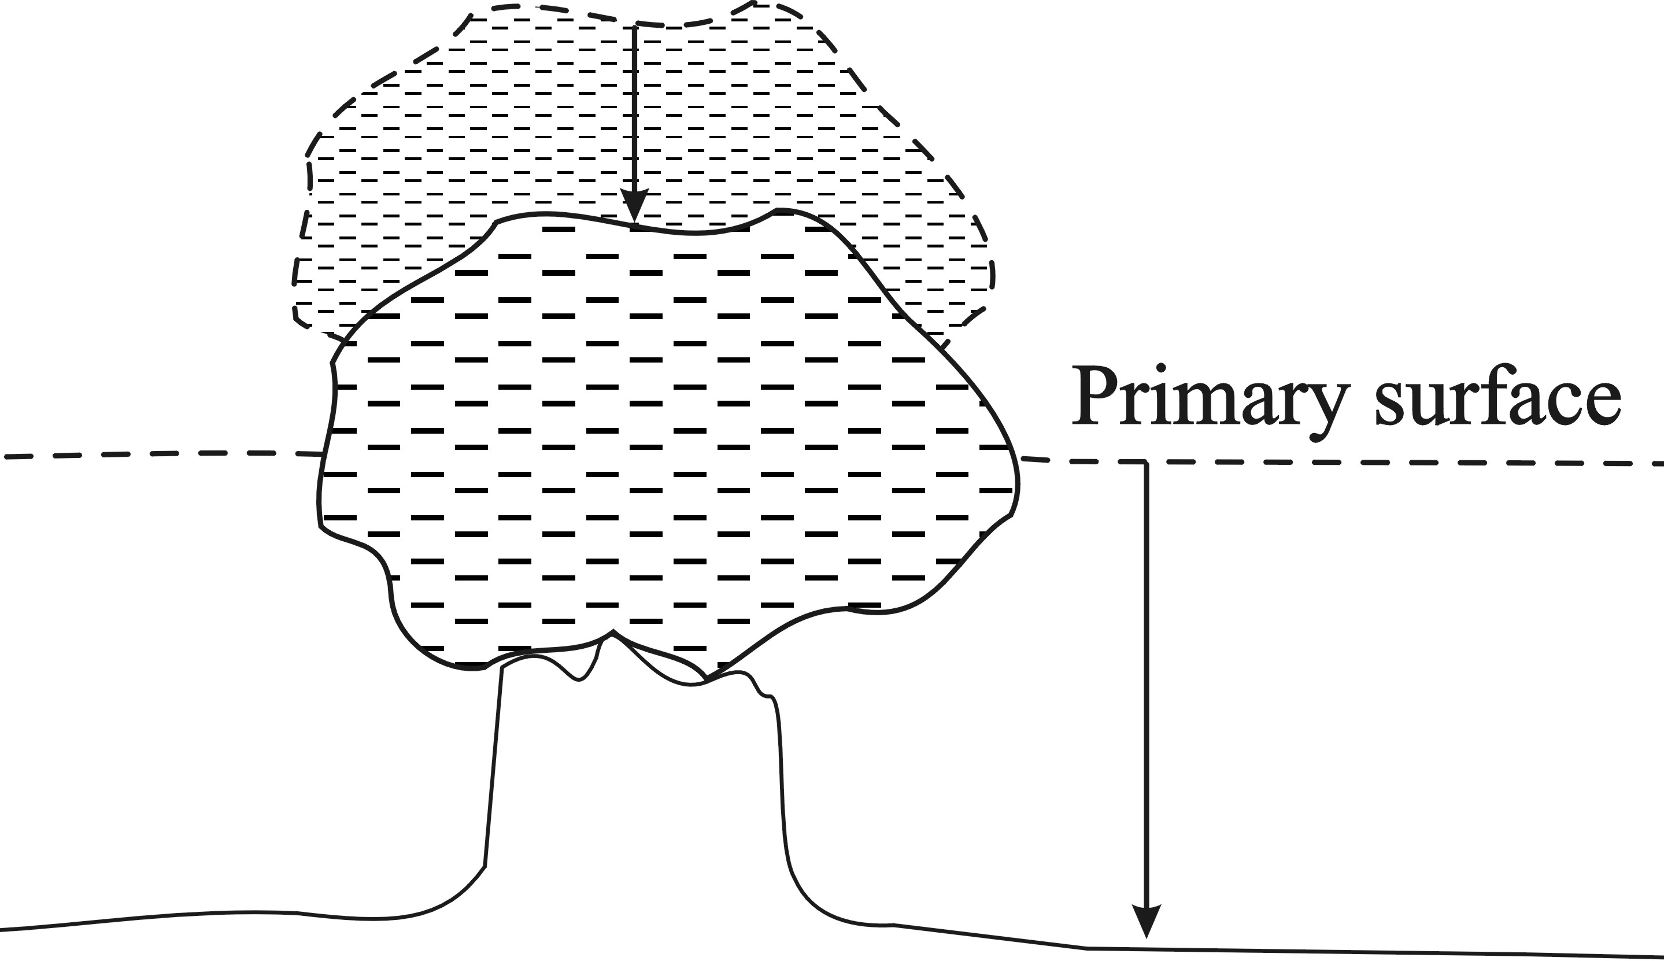 | 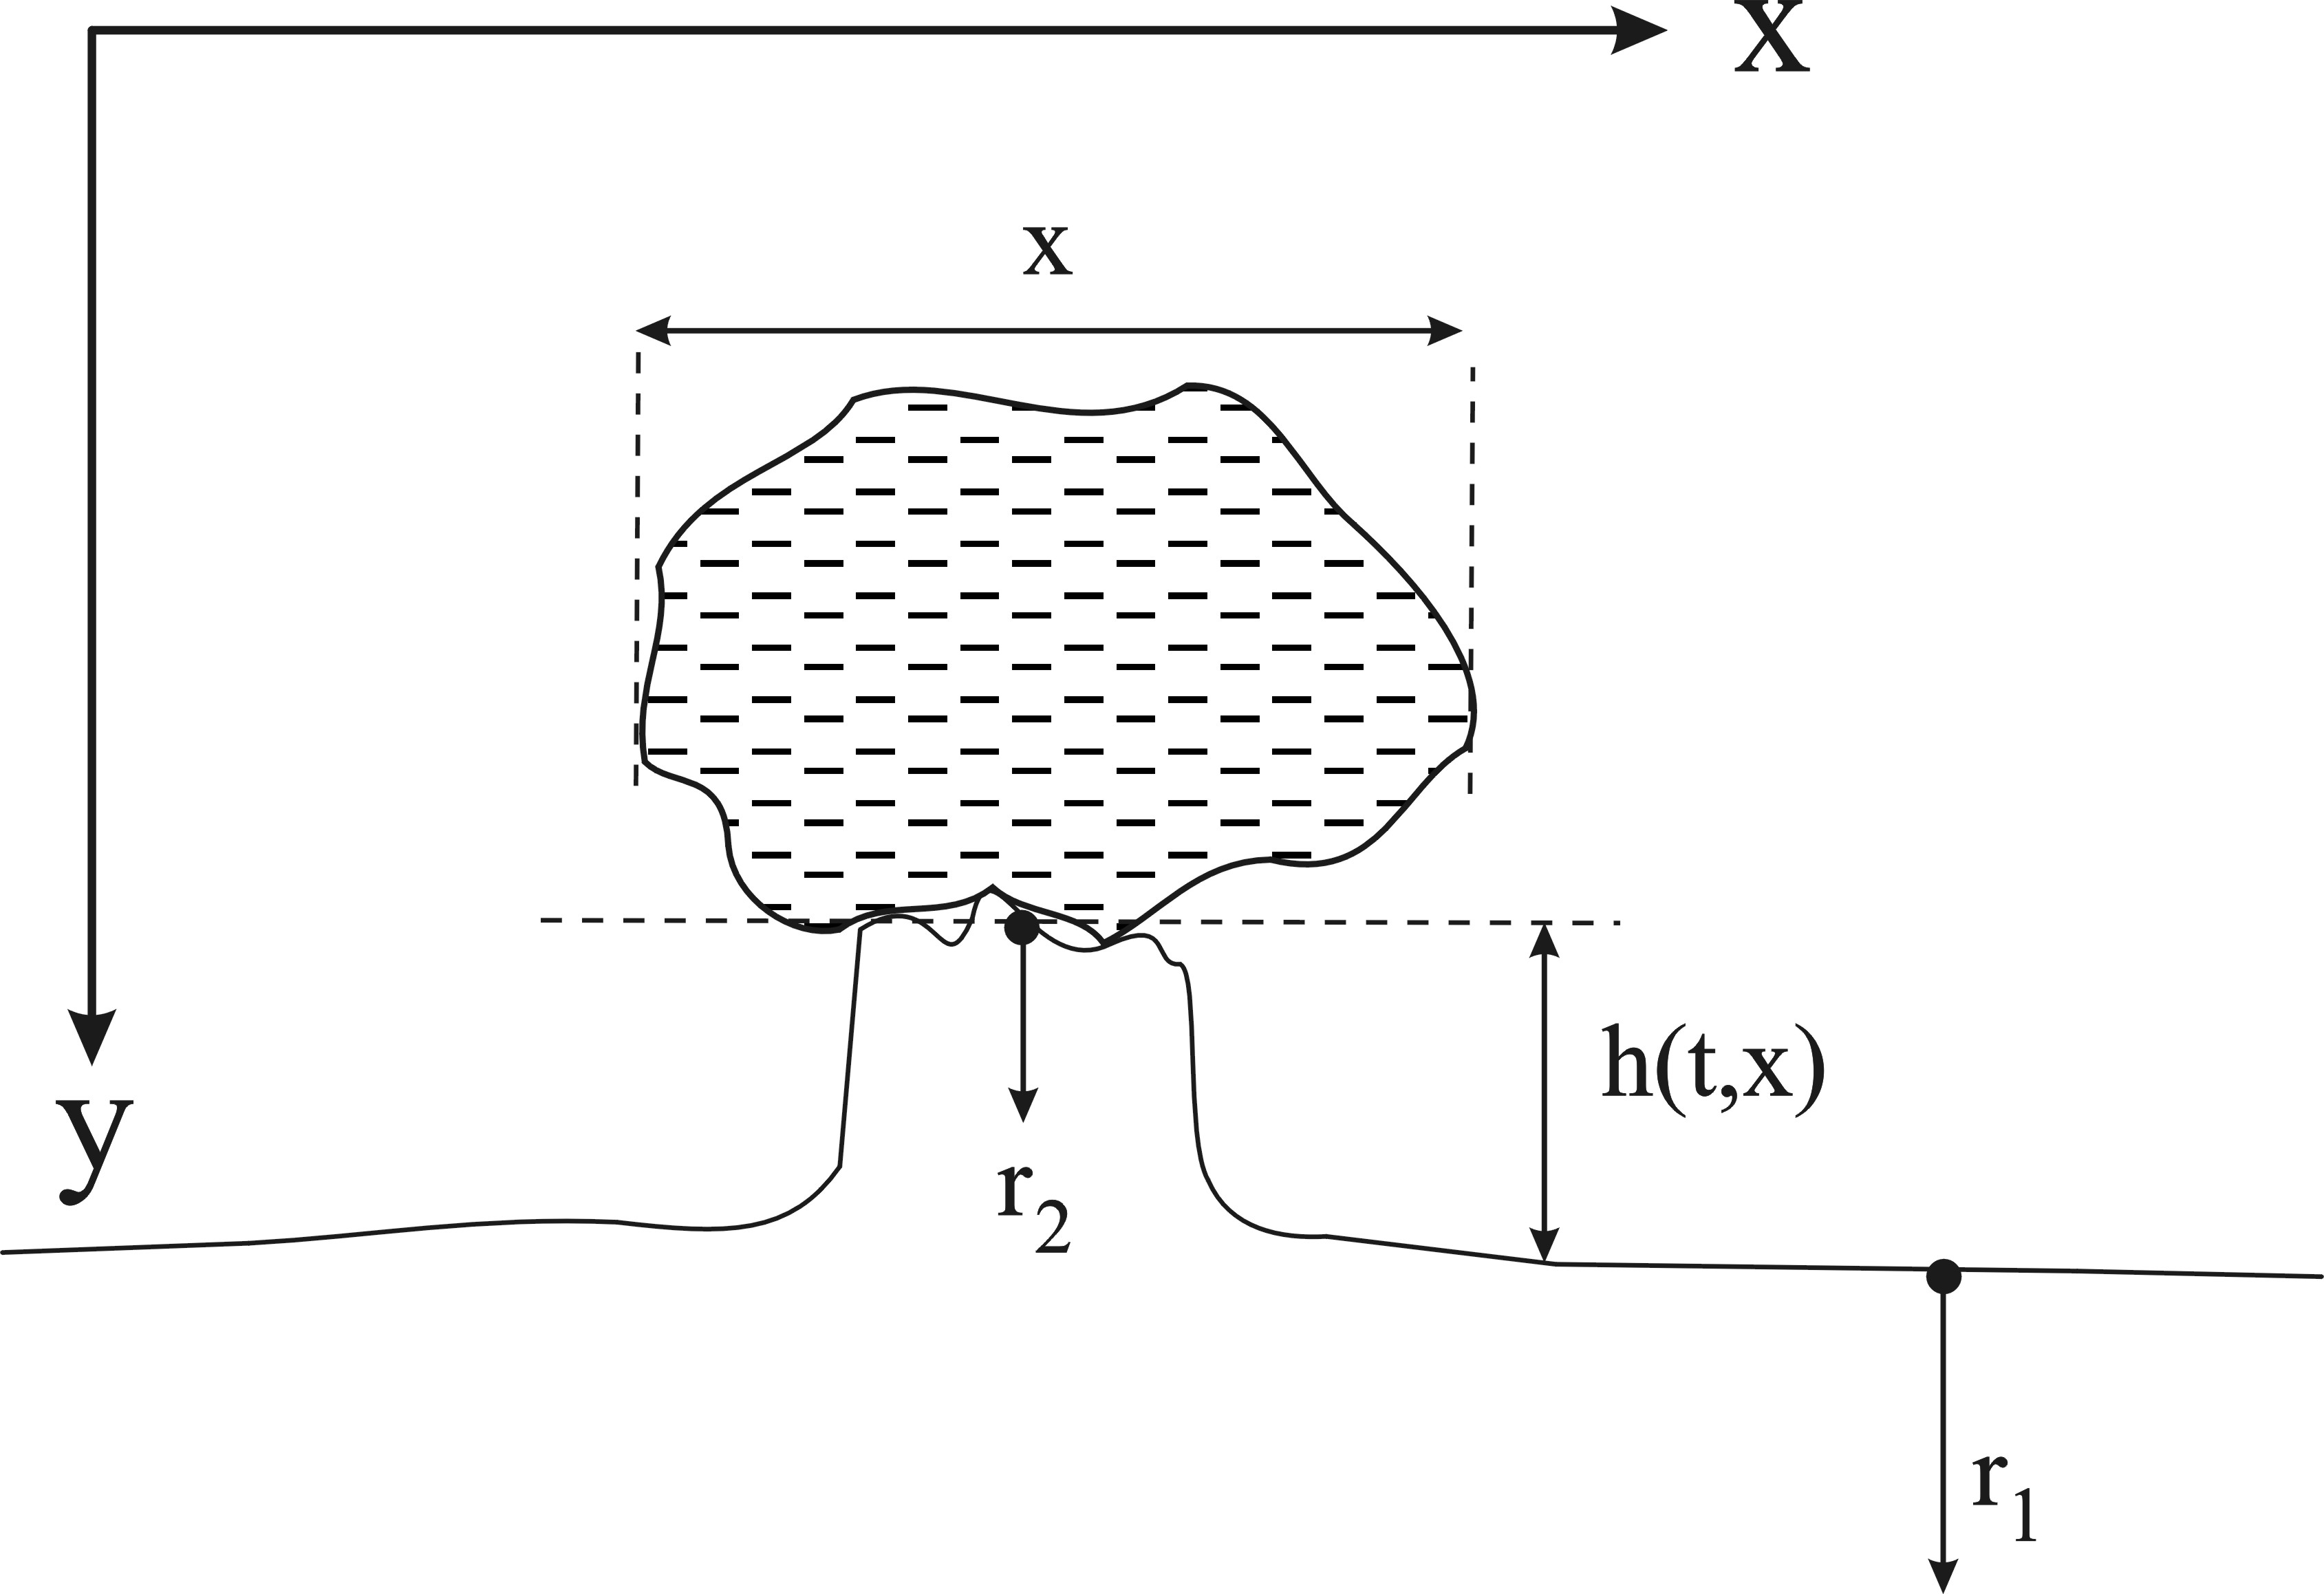
Figure 1. Left: The height of an allogenic pedestal is a function of differential corrosion benath and around the perched block. The height of any such pedestal is only a minimum measure of the total denudation at the site. Right: Coordinate system and variables used in the growth model.

Qualitative properties of pedestals
The following observations are based on alpine sites in Norway and Spitsbergen. Within the same area, pedestal heights reveal a rough positive correlation with the size of the perched boulder, although there is a considerable spread and linear models do not work (e.g. Finnesand 2002, 2003). There appears to be a lower threshold for pedestal growth, because pedestals are absent beneath small boulders.

The top surface of the pedestal, beneath the boulder, is always rugged and pitted, indicating that corrosion is going on even under the largest boulders. (The largest boulder observed by the author was more than 4 m across). This corrosion mechanism may be ascribed to condensation (ε, see below). A block resting on the ground will not only shelter against direct rainfall, but is also a locus of long-lasting, low levels of moisture. Therefore, even the highest pedestals are only a minimum measure of the total denudation around them.

Supporting evidence for various condensation and evaporation-related processes beneath the boulders is the existence of botryoidal precipitates on minor protrusions and edges, due to seasonal evaporation. This is also a common phenomenon on many other karst surfaces, like the sharp edges of rillenkarren.

It must also be kept in mind that there is some difference between the authogenic karrentische (described by Bögli 1961) and allogenic pedestals carrying a non-carbonate, glacial erratic. Only allogenic pedestals have uniquely defined initial conditions, i.e. resetting of the process at t=0. The commencement of growth is not well defined for authogenic blocks resting on its actual bedding plane parting, thus the height of the pedestal is not necessarily a precise measure of the post-glacial denudation of the site. In this case, the pedestal is the exhumed, or ‘Hodoo type’ (Lauritzen 2005).

The observed evaporational precipitates and the attenuated corrosion deduced for authogenic blocks add complexity to the problem. A growth model which include all these effects will inevitably become extremely complicated and have little but theoretical interest. A simplistic, approximate model which in some way summarize these effects is preferable. A growth model should, as a minimum, accommodate the following criteria:

- There is a minimum, or threshold size, x_{min}, for a boulder to produce a pedestal. The function describing pedestal height with respect to boulder size must not pass through the origin.
- The function must include the condensation corrosion that occurs beneath all boulders, regardless of their size.
- In order to be practically applicable, the model should be as simple as possible.

The model
The observed pedestal height is a result of two independent corrosion rates acting on the karst surface, the rate outside the boulder (r₁), and the rate underneath the boulder (r₂). r₁, is acting everywhere on the surrounding rock surface, and is identical to the surface denudation rate of the location, Figure 1. It is independent of the properties of the boulder, or even the existence of it. Beneath the erratic boulder, the surface is shielded, depending on various properties of both the boulder itself and of its surroundings.

As a first approximation we assume shielding is caused entirely by a shape effect (β), i.e. shielding increases with the 'size' of the block. This effect is controlled by the boulder's ability to keep the underlying rock surface dry from snow and rain. Hence, the shortest horizontal axis of the boulder should be a better measure of shielding than for instance, the shadow-equivalent area. We have :

$\frac{{\text{dr}}_{2}}{\text{dx}}=−{βr}_{1}\text{}\begin{matrix}\text{with} & \end{matrix}\left\{\begin{matrix}r_{2}=r_{1}+ε & x=0 \\ r_{2}=ε & x→∞\end{matrix}\right.$ (1)

with solution: $r_{2}=r_{1}e^{−βx}+ε$ (2). The differential rate, r₁ - r₂ is integrated with respect to time, and simplified to:

$h(x)=\left\{\begin{matrix}0 & ;x≤x_{\text{min}} \\ α(1−e^{−βx}) & ;x>x_{\text{min}}\end{matrix}\right.$ (3)

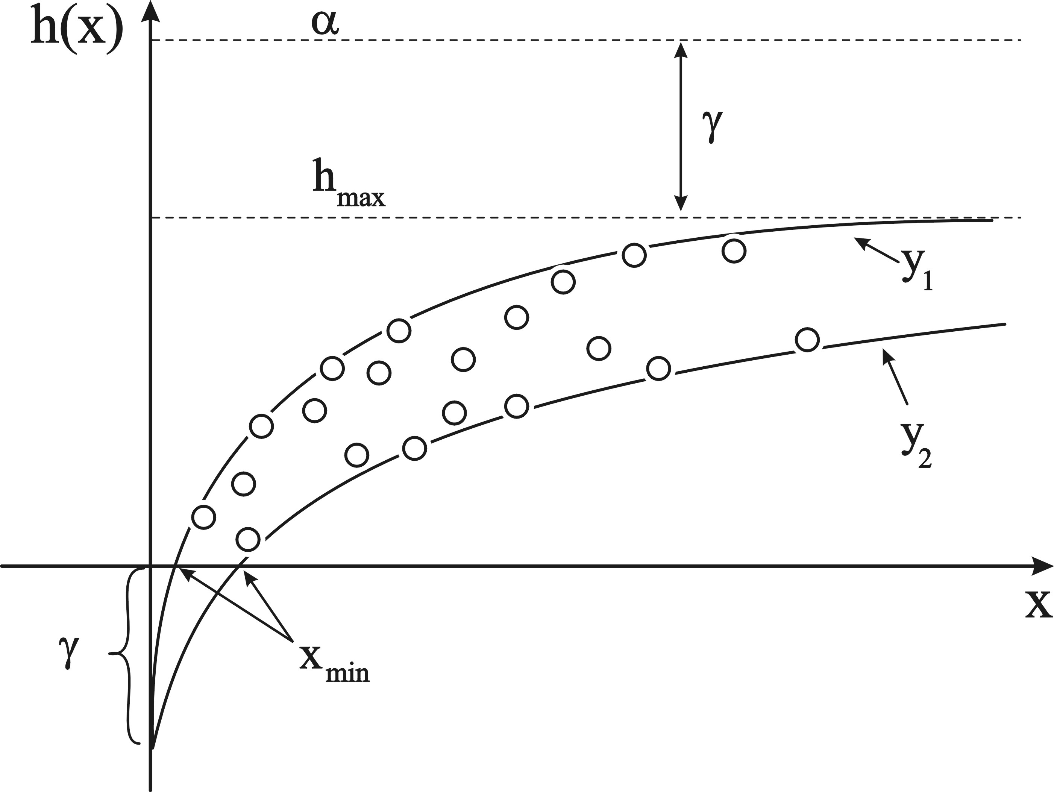
Figure 2. Pedestal growth model, eqn(3). Pedestal height as a function of boulder ‘size’ is represented by a family of functions, sharing the same α and γ, but with different β. (y₁) and lower (y₂) boundary is shown. | Figure 3. Pedestal data linearized according to eqn (5). The slope of each line is equal to the umbrella factor (β), so that this can be determined for each individual.

where h(x) is the height of a given pedestal beneath a boulder with size x, α is the total denudation far away from the pedestal, β the shielding efficiency, or ‘umbrella factor’, and finally, γ the amount of condensation corrosion acting on all surfaces, also beneath the boulder. The smallest boulder that can support a pedestal then becomes:

$x_{\text{min}}=−\frac{1}{β}\text{ln}\left[\frac{α−γ}{α}\right]$ (4)

The scatter of pedestal heights as a function of boulder size (e.g. shortest horizontal axis) can then be explained with a family of functions (eqn 3), all sharing the same α (i.e. total denudation), but having different β and γ, Figure 2.

Estimating the total denudation (α).
Given a large number of pedestals one may fit curved functions to the data set to accommodate a common α, but with various β and γ values. This may be done by trial and error on a spreadsheet or by designing proper computer algorithms. The model (eqn. 3) may be linearized to:

$\text{ln}\left[\left(α−γ\right)−h(x)\right]=−βx+\text{ln}α$ (5)

Realizing that (α - γ) = h_{max}, i.e. the maximum, asymptotic pedestal height, ln(α) may be determined by the y-intercept of straight lines (for various β) fitted to a plot of ln[h_{max}-h(x)] versus ln(x), Figure 3. h_{max}, and thereby the common y-intercept (ln(α)) for upper and lower boundary functions (Figure 2) may be determined by iteration. This was done for 4 different pedestal populations, 3 at Svartisen (at The Arctic Circle in North Norway, 67°N) and one at Blomstrand, Svalbard (78°N).

The results are shown in Table 1. Total denudation (α) is 25 – 80 % higher than the highest observed pedestal, but still in accord with independent assessment of the total post-glacial denudation for the sites. Such assessments are the maximum extent of protruding quartz veins, (extrapolated) micro-erosion meter readings, and hydrochemical denudation estimates, e.g. Lauritzen (1983, 1991). For example, for the Pikhaugene karst at Svartisen, we find that α = 200 mm, 1.7 times the highest observed pedestal h(x) = 120 mm. However, the highest observed protruding quartz vein at 220 mm in the area is in good accordance with this higher value. We may assume solutional denudation of a quartz vein as neglible in this environment and timeframe. Assuming that post-glacial denudation time is some 10 ka, this corresponds to 0.020 mm/year, in good accordance with the micro-erosion meter rate (during 14 years) of 0.018 mm/year. Hydrochemical denudation (the autogenic component) is 0.033 mm/year (Lauritzen 1991) which incorporate both exo- and endokarst solution.

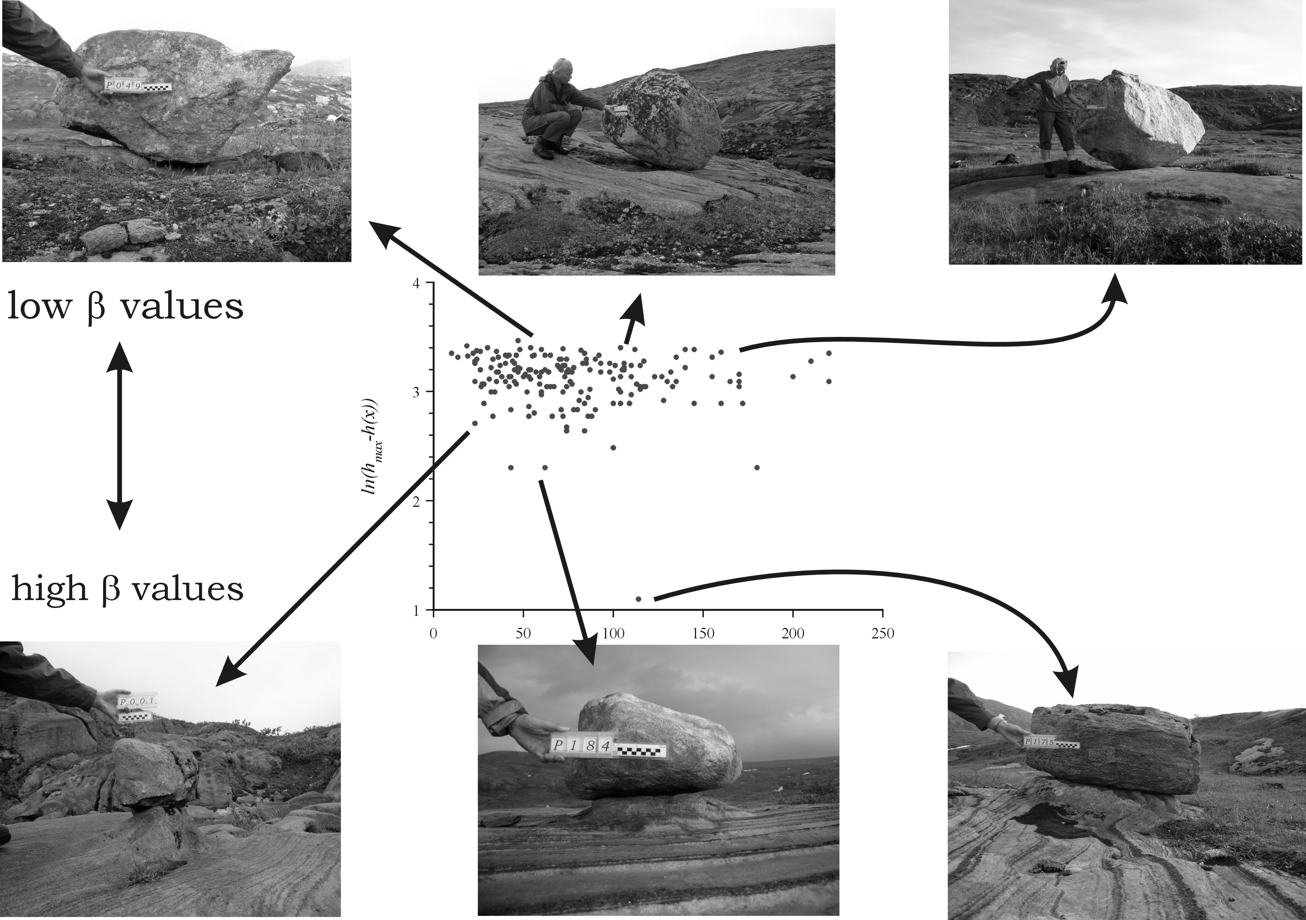
Figure 4. Identifying boulders with various β value in a linearized plot. High β blocks display pronounced drip edges or flat undersides, low β blocks have generally sloping or convex undersides, according to the concept of an ‘umbrella effect’. Data set of 185 pedestals at Glomfjell, Svartisen, north Norway

What controls the umbrella effect?
In a linearized scatterplot, we may identify families of pedestals sharing the same value of β. So far (august 2004), more than 200 pedestals have not only been measured, but also subjected to accurate photogrammetric shape analysis, GPS positioning, and evaluated in micro- and macroscale landscape context. Multivariate analysis of these data is in progress and will hopefully reveal the factors that most effectively determine the ‘umbrella effect’. This work will be presented later. However, just by evaluating photographs of pedestals that display extreme β values, it is very suggestible (or obvious) that boulders with flat or concave underside and distinct drip-edges tend to have high β values, whist boulders with convex undersides and no drip-edges have the lowest β values of them all, Figure 4.

Large pedestals.
As the pedestal grow taller, the sides of the pedestal and the underside of the boulder becomes more exposed, and we should expect the shielding effect to decrease with the aquired height of the pedestal. Given sufficient time, the ultimate fate of a pedestal is extinction, as the top surface of the pedestal may get sufficiently rounded to let the block fall off, and even a new cycle may commence. We may also conceive a steady-state condition, where r₁ = r₂. A time-dependent model for pedestal growth is:

$h(t,x)=\frac{r_{1}(1−e^{−βx})−ε}{δ}(1−e^{−δt})$ (6)

where x, β and ε are as before, and the additional parameter δ describes the inhibition of growth rate as a function of aquired height. A cartoon of a pedestal’s life cycle is depicted in Figure.5. Except for very small boulders, it is unlikely that any of the pedestals in the four study areas have attained their maximum height, suggesting that a timespan much longer than the postglacial ( > 10 kyr) is needed to see this effect.

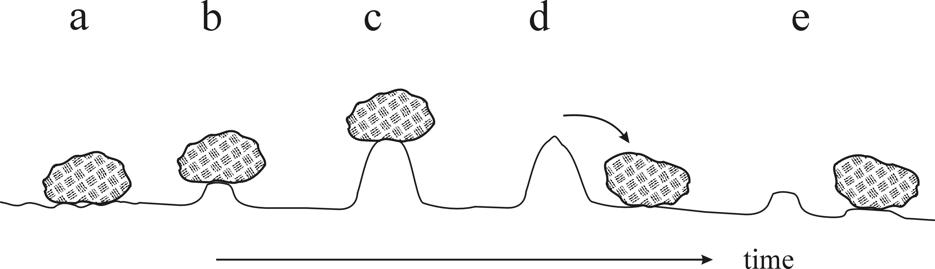
Figure 5. The life cycle of a pedestal. a) commencement of growth, the block is left on a glacially smmothed surface (t=0). b) Shielding (β) is optimal and the pedestal grows fast. c) The pedestal becomes so high that the sides are attacked , and it may reach a steady-state constant height. d) most likely, the pedestal will become rounded and the block will fall off before stage c) is reached. e) a new cycle begins while the old pedestal becomes degraded.

Table 1

Pedestal parameters for various sites (All lengths in mm.)
Location | α | Hmax | Factor¹ | γ1 | γ2 | β1 | β2
Central Glomfjell | 330 | 260 | 1.26 | 70 | 160 | 0.0033 | 0.0009
Fiskvatn | 260 | 160 | 1.62 | 90 | 140 | 0.0035 | 0.002
Pikhaug | 200 | 120 | 1.66 | 60 | 60 | 0.003 | 0.00075
Blomstrand | 65 | 36 | 1.80 | 25 | 45 | 0.07 | 0.05
¹ “Factor” is α /h_{max}.

Conclusions.
A mathematically simple growth model for allogenic pedestals has been developed. The model has three adjustable parameters, the total denudation of the site, outside the pedestal (α), its umbrella factor (β), and the condensation corrosion acting on all surfaces (γ). This allows us to determine the total, post-glacial denudation of the site from measurable properties of a pedestal population. Estimated total denudation is then some 25- 80% higher than the maximum observed pedestal height.

References.
Bögli, A. (1960) Kalklösung und Karrenbildung. Zeitschrift für Geomorphologie, Suppl. 2, pp. 4-21;
Bögli, A. (1978) Karsthydrographie und physische Speläologie Springer-Verlag, Heidelberg, 292. pp.
Finnesand, S. (Lauritzen, S.E.) (2002): Analyse av karstformer i Glomfjellområdet ved Svartisen. Cand Scient. Thesis, Department of Earth Science, Bergen University, 147 pp.
Finnesand, S. (2003) Analyse av overflateformer i Glomfjellområdet ved Svartisen. Norsk Grotteblad. (41), pp. 3-32.
Ford, D.C. & Williams, P.W. (1989) Karst geomorphology and Hydrology Unwin Hyman, London, 601 pp.
Lauritzen, S.E. (1991): Autogenic and allogenic denudation in carbonate karst by the multiple basin method: an example from Svartisen, North Norway. Earth Surface Processes and Landforms, 15, pp 157-167.
Lauritzen, S.E. (1997) A simple growth model for limestone pedestals: determination of surface karst denudation. Supplementi di Geografia Fisica e Dinamica Quaternaria, III, pp. 242-243
Lauritzen, S.E. (2005) A simple growth model for limestone pedestals. Abstract at the 18th. Kongsberg Seminar, Norway (may 3-5, 2005).
Peterson, J.A. (1982) Limestone pedestals and denudation estimates from Mt. Jaya, Irian Jaya. Australian Geographer, 15, pp. 170-173
White, W.B. (1988) Geomorphology and Hydrology of Karst Terrains Oxford; University Press, New York, 464 pp.

