The Svarthamar cave research project, Fauske, north Norway

Stein-Erik Lauritzen¹, Lene Baastad¹, Julie Bjørlien¹, Edana Fedje¹ & Per Holmlund²

¹Department of Earth Science, Bergen University, Allegaten 41, N-5007 Bergen, Norway
² Department of Physical Geography and Quaternary Geology, Stockholm University, S-106 91 Stockholm, Sweden
,

Abstract
The Svarthamar project was launched in 2003, aiming at a complete survey and speleogenetic analysis of caves within the ’Mefjell massif’. One of the caves, Svarthamarhola, is an anomalously huge cave room, the biggest in Scandinavia, containing a large ice mass which was formed since 1200 AD. Three MSc. projects (2005) were initiated in order to study cave microclimate, ice stratigraphy and speleothem stratigraphy. So far, accurate mapping of Svarthamarhola has revealed that the cave formed around a dipping anticline and that the cave has a complex history, probably originating from a set of dip tubes developed in a sheared bedding/foliation plane. The big rooms are most probably formed by a large river in the past, either as an ice-marginal overflow or maybe as a pre-glacial fluvial system. Our data logger measurements confirm very strong thermal winds through the cave and an expected dynamic behaviour in relation to external temperatures. We have also cored the upper 5 m of ice for environmental tracer analysis, which are in progress as well as a detailed study of a MIS 7 speleothem from the cave.

Introduction
Svarthamarhola in the Mefjell massif at Fauske, north Norway, is by all standards the largest natural cave room in Scandinavia. It is also a dynamic ice-cave with stratified ice dating back to about 1200 AD. The huge rooms contain loose sediments and collapse blocks in all stages of weathering, ventifacts, fossils, ice and fragile mineral deposits. We gather that subaerial weathering of marble blocks might have acted for as much as 30 kyr without major disturbance, leaving many blocks in a very fragile state. This unique and extremely fragile system is heavily over-used by both organized and causual tourism, which has led to severe degradation of the cave’s untouched atmosphere, as well as direct destruction by trampling, bonfires and vandalism. It was decided to document and study the system while it is still in a recognizable stage. First a thorough surveying of the main cave and adjacent caves were commenced, combined with photographic documentation. The main goal is to work out the speleogenesis of this anomalous room, secondly to understand the environmental information preserved in the cave. Part of this is done as MSc. Theses: Aspects of cave ventilation (L. Baastad), Ice stratigraphy and environmental tracers (J. Engelien) and MIS 7 speleothem chronostratigraphy (E. Fedje).

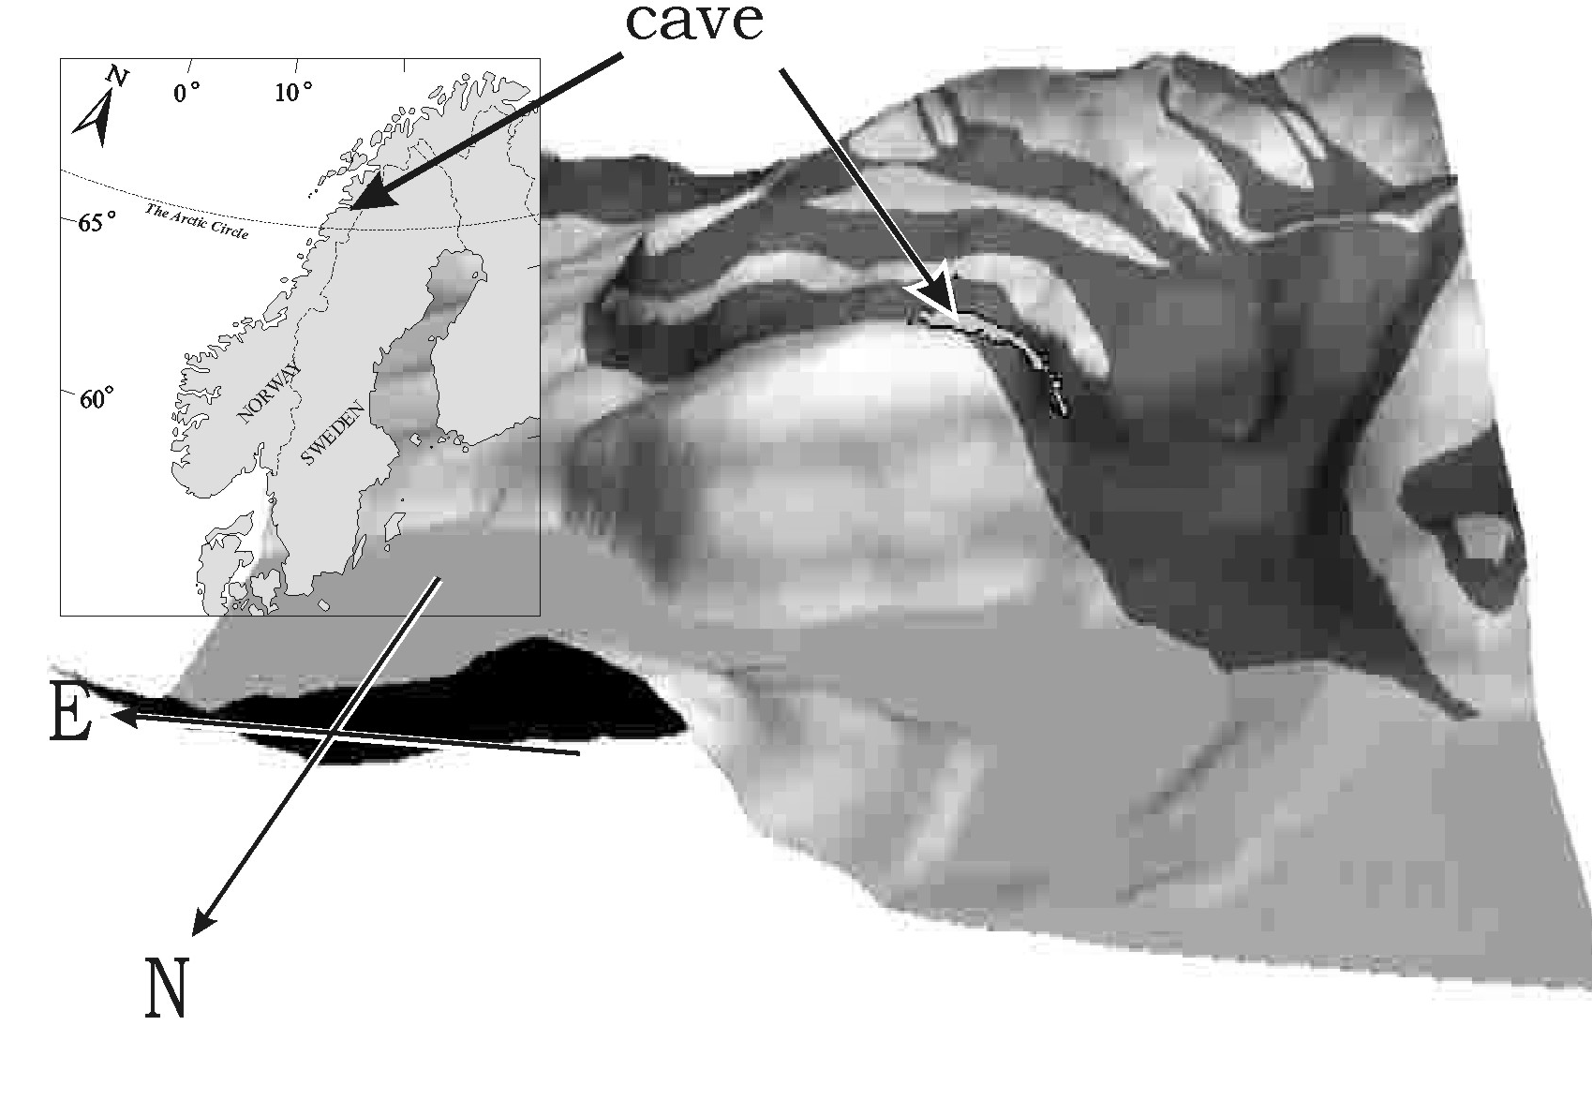 | 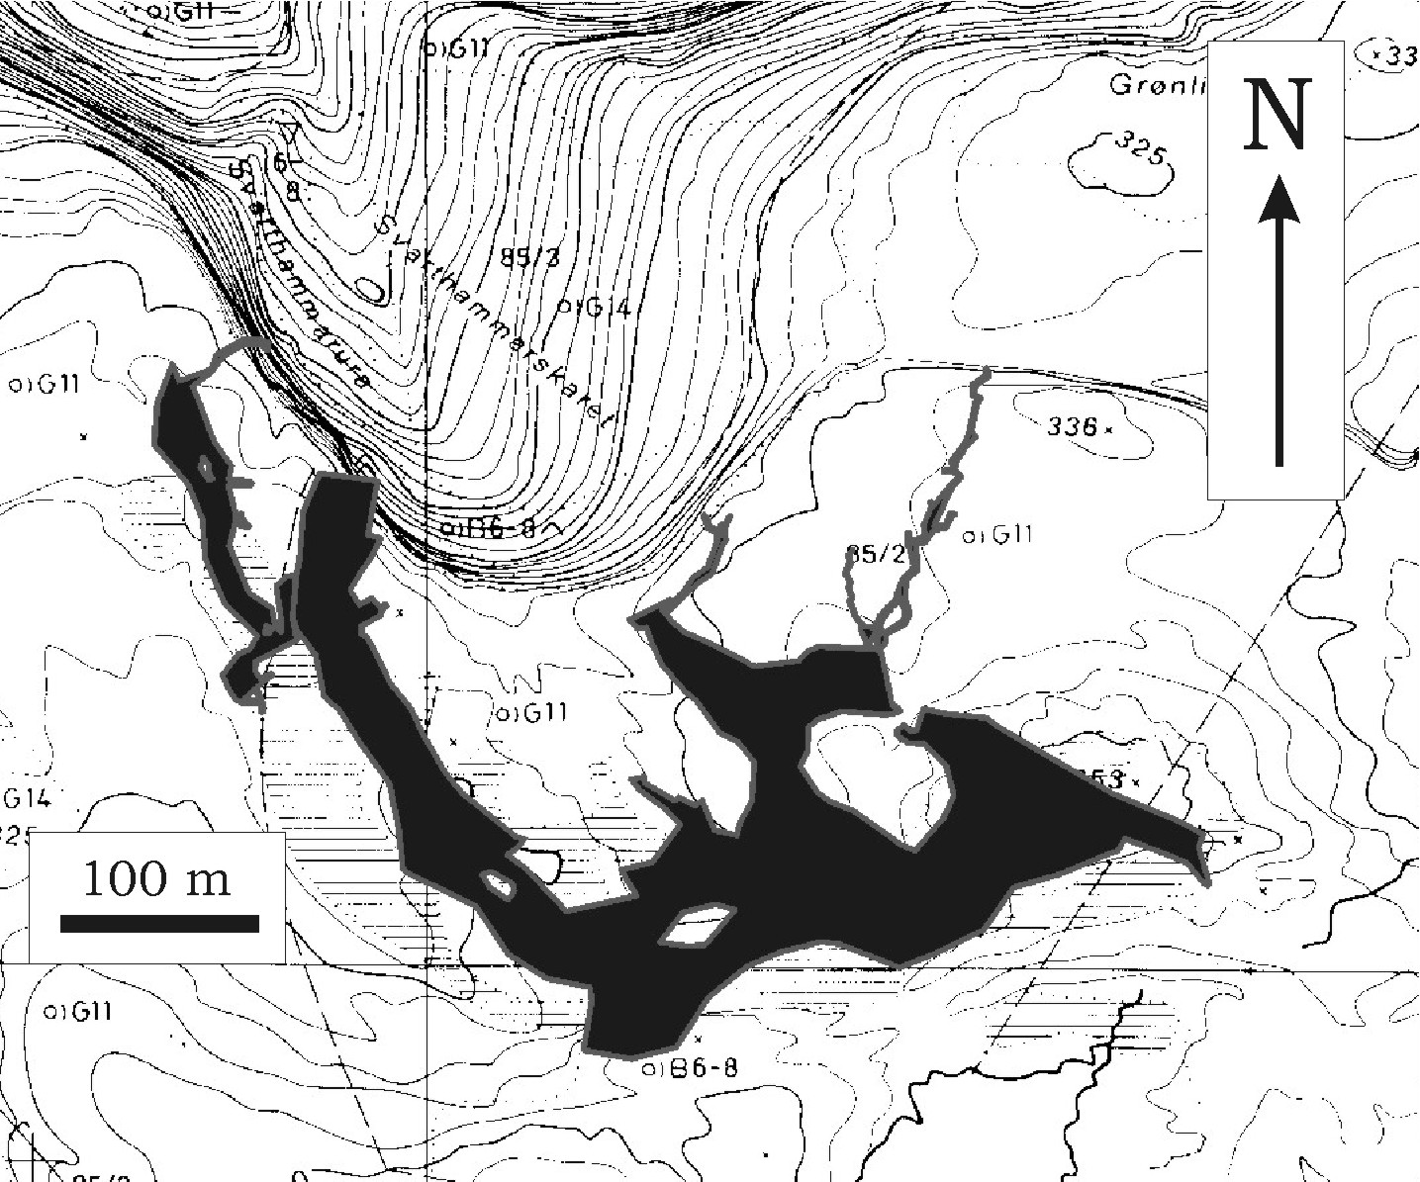
Figure 1 (left). Location of the cave in Scandinavia and in the local topography in the southern wall of the Fauske fjord. This massif is named ‘Mefjell’.
Figure 2 (right). Outline map of Svarthamarhola inserted into the local topography.

Geographic and geologic setting
The Mefjell massif is situated at the southern side of the Fauske fjord, Figure 1, with marble bands belonging to the Rognan Formation within the Fauske nappe. Carbonates are of probable Cambro-Silurian age and were metamorphosed during the Caledonian orogeny. The caves are situated on the shoulder of the main valley (fjord) where it is constricted. Just distally of this is a pre-boreal moraine, it is believed that the pre-boreal stage and this constriction are linked. The pre-Boreal events are often regarded as a result of dynamic reorganization of the ice surface, which became unstable after rapid calving inwards in the fjords. This re-organization created a push-up moraine, often located at fjord constrictions where calving would be halted.

Svarthammarhola
The cave was first reported in the late 1960’es and was surveyed shortly after (Heap 1970). Since the original map lacked vertical information, the cave was re-surveyed using photographic tripods, Suntoo instruments and a laser rangefinder. The large rooms allowed a modified triangulation technique to be used. In order to obtain accurate data from the huge cross-sections, a profile scanner was constructed from a laser rangefinder and a clinometer. In this way, an accurate survey of ceiling, walls and floor could be made. Survey data were processed on the cave survey program Grottolf (Lauritzen 2003), from which the centreline polygon could be exported to Corel Draw for adding walls and details.

Cave architecture
The laser scans clearly indicate that arced profiles, which by inspection in the cave and on photographs appear relatively smooth and rounded, are indeed irregular, reflecting geological structure, Figure 3. Cross-sections are up to 1100 m², and spalling has created dome structures in the ceiling. The cave is situated within a relatively thick marble pack, dipping south. The marble and schist pack forms a major anticline with axis dipping ca 20º S. Rotation of the centreline survey to maximum overlap yields a projection axis that is almost identical to the fold axis taken from geological maps. Hence, the southward bend in the cave outline (Figure 2) is actually a relatively horizontal stretch of passage bending around the core of a fold, Figure 4.

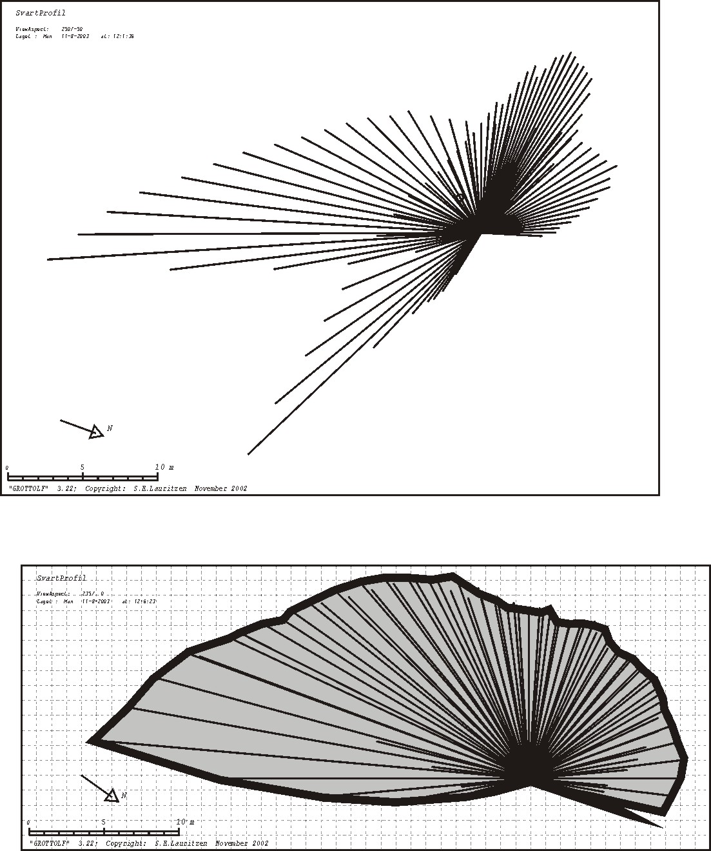 | 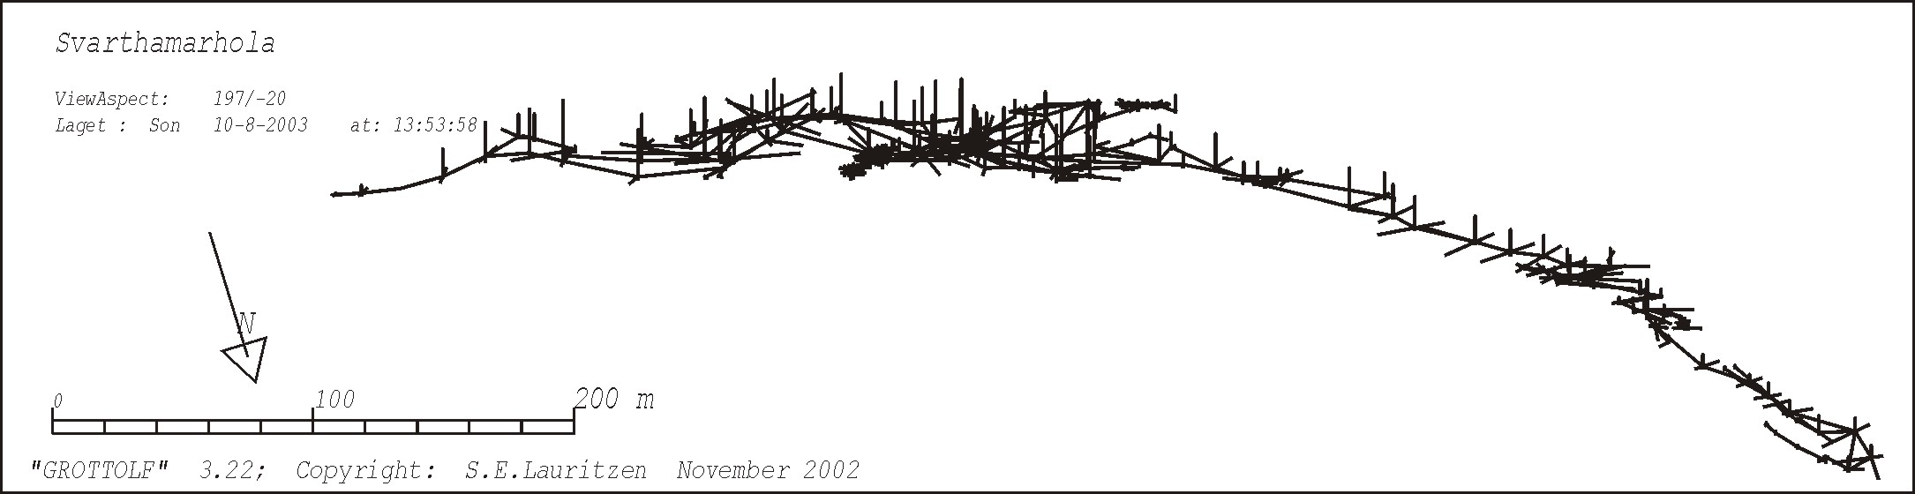
 | 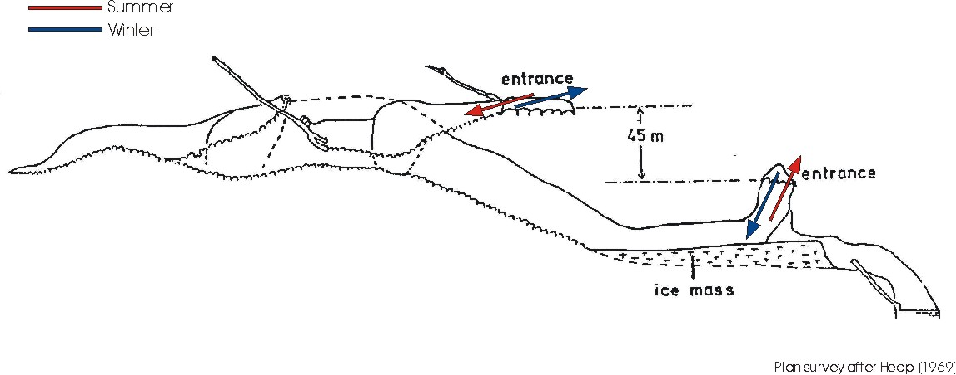
Figure 3. Cross-section made by laser scans. Two oblique planes. When rotated to overlap, the projection is parallel with the passage. | Figure 4 (top). Centerline map rotated until maximum overlap. In this case, the axis of projection is parallel with the general fold axis in the rock mass, demonstrating that the cave is indeed controlled by a major fold structure.  Figure 5 (bottom). Vertical projection of the cave, showing the two entrances with Balch-ventialtion effects.

Other caves
Several smaller caves are known in the area, and being situated within the same karst stripe, they serve to complete the speleogenetic picture of the Mefjell massif. These caves are Moengrotta (a streamsink), Svarthammargrotta and Kvithola (both fossil phreatic tubes) and tens of smaller tube fragments and unexplored entrances (Heap 1970, Lauritzen 1983, 1986).

Speleogenesis
Numerous small phreatic tubes with vadose invasion trenches penetrate from the southern hillside into the cave. Numerous small openings, either too tight to be penetrated, or choked with sediment, occur at a particular horizon in the marble. This horizon display evidence of shear movement, and was probably the target for cave initialization, or ‘inception horizon’. Since the large rooms actually have a low gradient around the fold structure, it is likely that these voids were created by vadose erosion by a sizeable river. The cave’s location closely beneath the paleic surface allude to a pre-glacial or tertiary development (i.e. Lauritzen 1990), although this hydrological requirement was fulfilled in almost every glaciation during the quaternary. Situated on the upper shoulder in the glacial fjord-valley, perched on a mica schist core in an anticline, one scenario would be ice- marginal overflow along a valley glacier at about the extent of the pre-Boreal or Younger Dryas stage, the latter is actually the ‘average’ extent during the whole Quaternary (e.g. Porter, 1989). Another, but less likely possibility is that these ‘dip tubes’ may be phreatic and vadose invasion features that targeted towards the pre- existing (large) void.

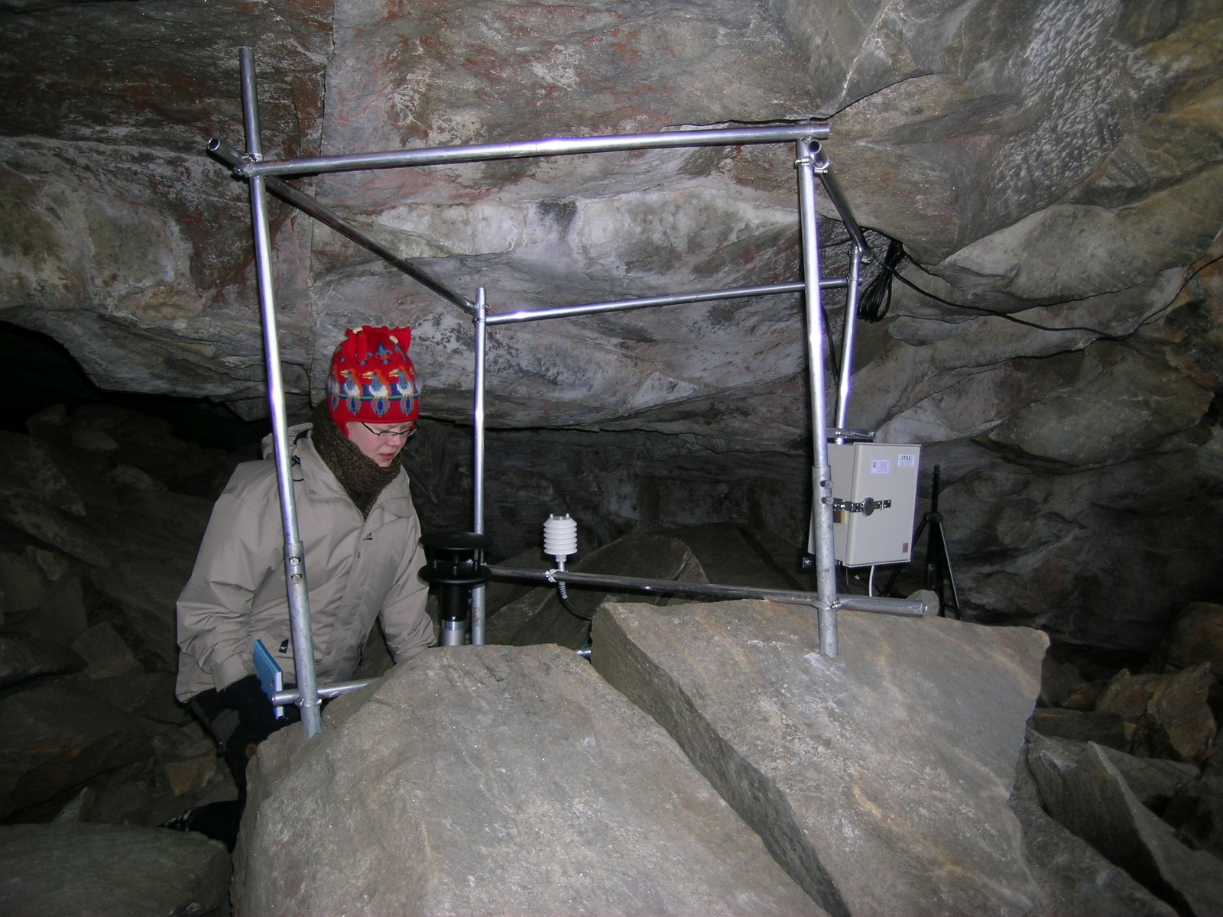
Figure 6 (left). Data Logger Station In The Upper Entrance, Logging Wind Speed, Direction, Temperature And Humidity. Photo: S.E. Lauritzen
Figure 7 (right). Breathing episode in March 200. Curves from top: air temperature (ºC), relative humidity (%), wind direction (º) and wind speed (m/sec).

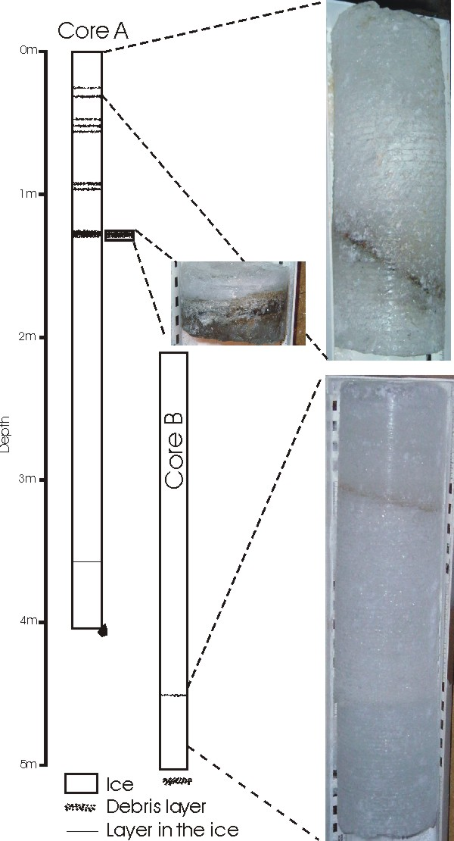 | 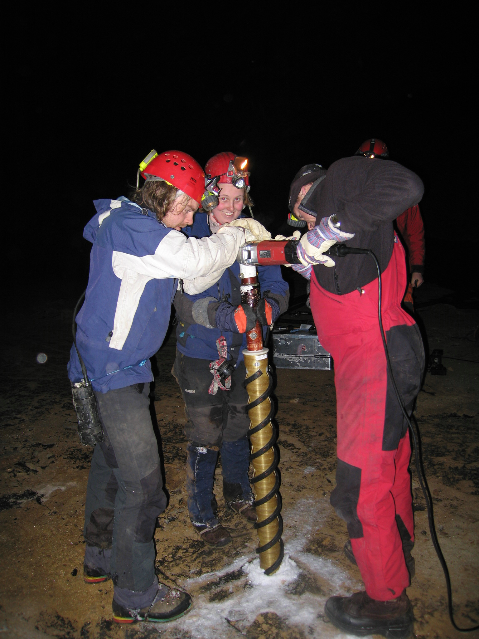
Figure 8. The 5 m deep ice core, showing dirt bands and layering. | Figure 9. Drilling the ice core. Photo: S.E. Lauritzen

Balch-ventilation of the ice cave
Having two spacious entrances at an elevation difference of 45 m, the cave supports strong Balch-ventilation, which is most probably the reason for the great ice mass that is situated at the lower entrance, Figure 5. The ice mass is abladed from the underside by (presumably) geothermal heat, creating a large ice wall at its deepest point and an ablation tunnel. Also, we think that the heat and air movements that are initiated from numerous visitors may affect the ice, which has notably shrunk during the last 30 years. This hypothesis will be tested through our monitoring program..

Cave and surface microclimate (L. Baastad)
In order to quantify air flux and enthalpy dynamics in the cave, two GSM driven, multichannel data logger stations were installed (Figure 6), together with 25 smaller loggers for humidity, air pressure and temperature at various places in the cave and on the surface. Particularly in cold periods, when surface temperature drops below the cave temperature, very strong, effluent winds are generated. Figure 7 shows one such breathing event, when surface dropped below freezing in march 2005. Assessment of volume and surface of the cave and of the ice mass, together with these physical measurements will be used in our enthalpy model of the cave.

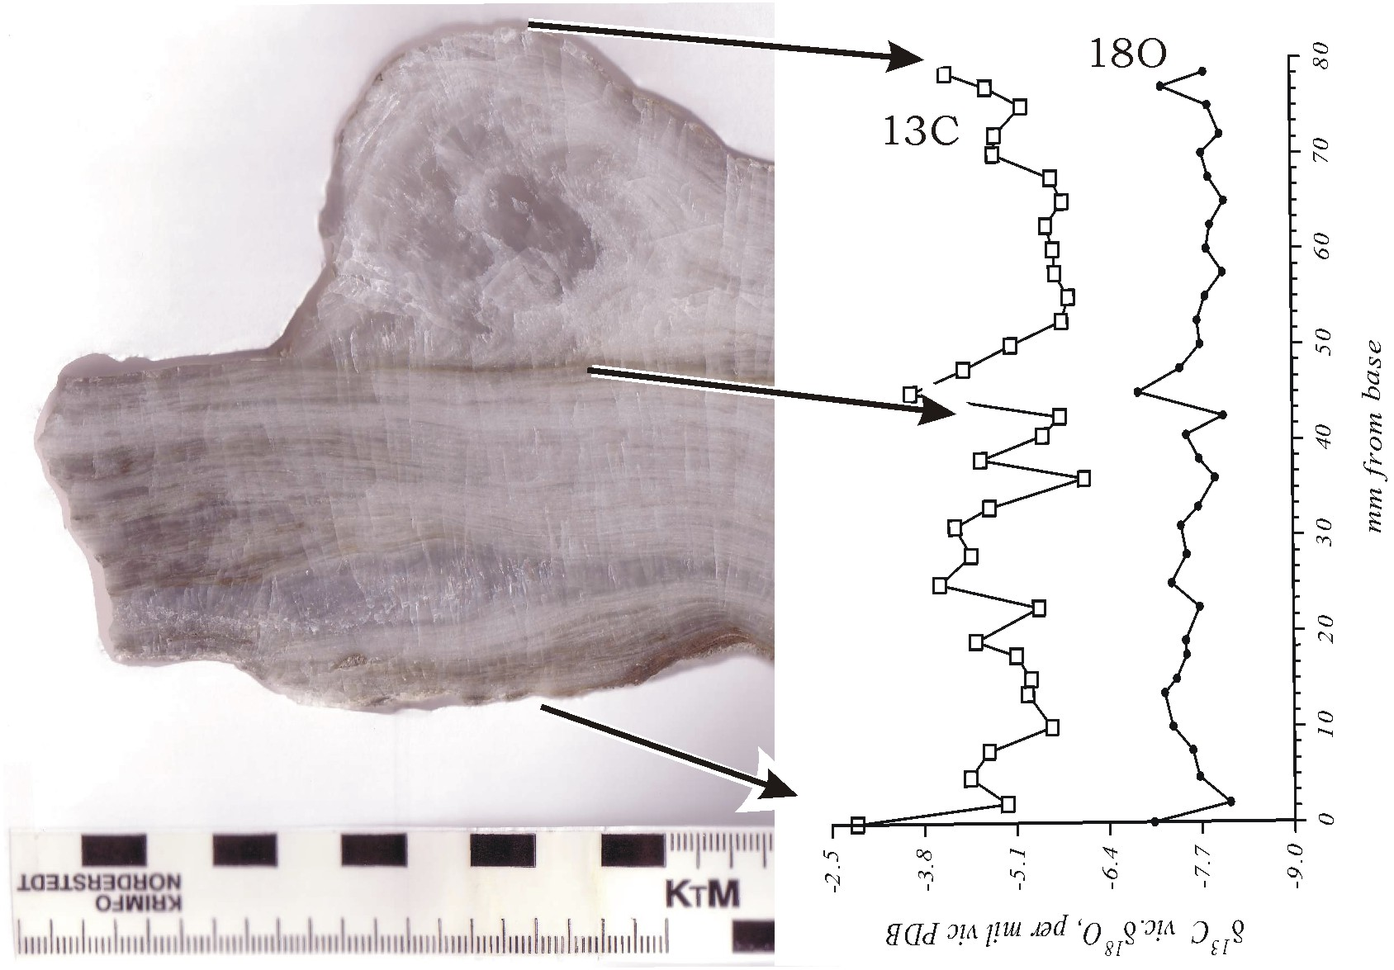
Figure 10. MIS7 speleothem with preliminary isotope record. The sample consists of a flowstone base, a dirty hiatus, and a stalagmite ongrowth. The dirty hiatus is visible isotopically in the sequence.

Ice stratigraphy (J. Bjørlien)
The ice mass is close to 20 m thick at its maximum, of which the lower 13 m is exposed in the lower ice wall and in the thermal ablation tunnel. AMS ¹⁴C dating of plant fragments suggests that the ice mass was formed after 1 200 AD and it grew first as a huge flowstone, which, - when it completely obstructed the cave- was transformed into an ice lake that froze in sequences. At least two periods of ablation occurred since it was first formed.

The upper ~ 10 m of the ice is not accessible for sampling and was cored from the top surface in march 2005, using equipment and expertise from Stockholms University. We were able to extract a 5 m continuous core before the drill hit a rock. A thermistor string was inserted into the hole before it was refilled with snow and ice fragments. The ice core contain one organic horizon and the sequence, which covers the recent history, will be used for environmental tracers, of which bomb ¹⁴C, ³H and commencement of copper smelting in the area might yield a time horizon.

Speleothem stratigraphy, MIS7? (E. Fedje)
Calcareous concretions (Höhlenkrapfen) and frost-shattered speleothems were collected for dating. In addition to previous dates from MIS 5 (Lauritzen 1996), a new specimen dated by alpha counting to 170- 200 kyr (MIS 7?) and is now subject to detailed TIMS dating and isotope stratigraphy, Figure 10. This work is in progress, and further details will be presented in the poster.

Further work
Exploration for new caves and extensions are in progress in the massif around Svarthamarhola, as well as a microgravimetric survey, searching for other sizeable voids in the vicinity. We aim at a complete isotopic and trace element profile of the ice mass of which the commencement of copper smelting in the area is an interesting target. Another target of intereset is to test the connection between surface climate and ice ablation/accumulation and to test if the heavy tourist trafficking may affect the ice mass.

Acknowledgements
Dr. Trond Ellingsen (cave owner) thanked for giving access to the cave and Fauske Municipality Administration for permitting snowscooter transport of the ice-coring equipment etc. in March 2005. Department of Earth Science, Bergen University and The Bjerknes Centre for Climate Research are thanked for support. Stockholms Universitet provided ice-coring equipment and cryo-lab fascilities. Financial support from Statoil (to Department of Earth Science, UiB) and from The Norwegian Research Council (NFR) through two projects, (NORPAST2; 155971/720) and (‘Porosity development in marble stripe karst’, 160232/V30 ).

References
Heap, D. 1970: Report of the Speleological Expedition to Arctic Norway 1970. William Hulme’s Grammar School, Manchester. 21 pp.
Lauritzen, S.E., 1983; Arctic and Alpine Karst Symposium, August 1-15, 1983, Department of Chemistry, University of Oslo.
Lauritzen, S.E. 1986: Kvithola at Fauske, northern Norway: an example of ice-contact speleogenesis. Norsk Geologisk Tidsskrift, 66 pp. 153-161
Lauritzen, S.E. 1990: Tertiary Caves in Norway: a matter of Relief and Size. Cave Science 17 (1) pp. 31-37.
Lauritzen, S.E. 1996: Karst landforms and caves of Nordland, North Norway. Guide for Excursion2, Climate Change: the Karst Record, august 5th – 16th 1996. Department of Earth Science, Bergen University. 160 pp.
Lauritzen, S.E. 2003: Kompendium I Grottekartlegging. Grottolf2 og Grottolf3.2: et turbo pascal program til grottekartlegging. Norsk Grotteblad (39), 3-54.
Porter, S.C. 1989: Some geological implications of average Quaternary glacial conditions. Quaternary Research, 32, pp. 245-261.

