Maze caves in stripe karst: Examples from Nonshauggrotta, northern Norway

Rannveig Øvrevik & Stein-Erik Lauritzen

Department of Earth Science, University of Bergen
Allégt. 41, N-5007 Bergen, Norway

Abstract
Stripe karst is stratigraphically thin outcrops of karstifiable rocks that intersect the land surface at an angle. Cave systems in stripe karst develop along the interface between the karst rock and non-karstic rock. Caves in stripe karst show the same morphological diversity as caves elsewhere. The morphological nature is a function of how various passage elements are linked together, and how they (once) transported water. Development of maze caves is interesting in the sense that mazes represent zones of extreme porosity. Their development in stripe karst makes them two dimensional and easier to model. We would like to know more about their development: what influences the selection of guiding fractures, their hydrological function and if it is possible to predict passage geometry and trend from fractures and foliation on the surface. As an example results from a thorough investigation and survey of Nonshauggrotta in northern Norway is presented. Nonshauggrotta is a phreatic network maze. Cave passages are developed along two orthogonal joint sets: one sub-vertical and the other oblique. The cave is relict with no present drainage basin. Scallop morphometry demonstrate an integrated network flow.

Introduction
Marble is the main karstic rock in Norway and it appear as stratigraphically thin outcrops that intersect the land surface at an angle, thereby producing long and narrow ‘stripes’ called stripe karst. Impermeable and insoluble rocks (mostly schists) act as aquicludes that surround and isolate the individual karst stripes. Cave systems in stripe karst tend to develop at or close to the interface between karst rock and non-karstic rock, and consequently they appear elongated and mostly two-dimensional (Lauritzen 2001). Marble has negligible primary porosity which makes speleogenesis exclusively dependent on secondary porosity i.e. fracturing.

Dependent on the dip angle of the strata, aquifers can be divided into different groups (Lauritzen 2001). In vertical strata unconfined aquifers develop. In dipping strata perched aquifers form in contact with the underlying aquiclude interface, while confined aquifers may form in contact with the overlying aquiclude. In this paper, only examples of the latter type are described.

Palmer (1975) classifies maze caves in three categories: 1) Network mazes which are characterized by fissure-like passages with lenticular cross-sections and angular intersections. 2) Anastomotic mazes typically formed by curvilinear tubes of circular or elliptical cross-sections that intersect in a braided or random pattern. 3) Spongework mazes that consist of non-tubular solution cavities arranged in a random, three-dimensional pattern. The latter type does not appear in stripe karst and are consequently not further discussed in this paper.

Maze caves develop through uniform enlargement of all available fissures under conditions of high ratios between discharge and flow distance (Palmer 1991; Kaufmann and Braun 1999). Two main mechanisms for development are described: diffuse recharge through an overlying or underlying permeable, insoluble unit; or flood water. In stripe karst with aquicludes surrounding the marble, diffuse recharge seems unlikely. Flooding from rivers appears to be the main forming mechanism in most places, but this seems not to be the case in Norway.

With respect to the presence of glacier ice, Ford (1977) points out three ice-contact hydrological conditions that generally appear in karst groundwater systems: 1) Polar based ice where karst water circulation ceases. 2) Very thick ice cover with temperate base which significantly slows down the karst water circulation or makes the water immobile. 3) Temperate ice base where karst terrain has the same relief as the glacier, which superimpose glacier hydrology upon the karst hydrology and thereby increase the hydraulic gradients in the karst. The second condition seems to prevail under the large glaciations while the third condition prevailed during glacier advances and recessions (Ford 1977). During Pleistocene glaciations karst systems in Norway probably switched between these states. This made the system to grow under high flow rates, then to fill up with silt and clay deposits before high hydraulic gradients again flushed out the system. In temperate glaciers the hydraulic gradient is determined by the glacier surface, which make the underlying topography insignificant (Lauritzen 1982). Diurnal and seasonal water table variations in glaciers may pump chemically aggressive water into all available voids, thereby creating maze forming environment. Changing environments make the caves pass through several stages of development which might give a very complex morphogenetic history.

Development of maze caves is interesting in the sense that mazes represent zones of extreme porosity. Their development in stripe karst makes them two dimensional and easier to model and we would like to know more about their development, structural settings, and hydraulic function.

Material and methods
The cave was surveyed to BCRA grade 5C. Morphology, scallop directions and sediments were recorded. Scallop analysis was done by the standard procedure of Curl (1974). Orientation of guiding fractures, foliation and marble-schist interface was measured, and these structural data were analysed statistically. Rock samples from the marble unit were analysed by “loss-of-ignition” experiments and acid insoluble residue experiments.

Results

Description of field area
Nonshauggrotta cave (66°57'N 13°58'Ø) is located in Nordland County, on the coast of Norway, just north of the Arctic Circle and the Svartisen glacier, fig. 1. Nonshauggrotta is situated 260 m a.s.l., in the top of a minor mountain ridge. The cave is formed under confined settings in the sloping interface between marble and overlying mica schist. The interface is dipping about 26° towards the South.

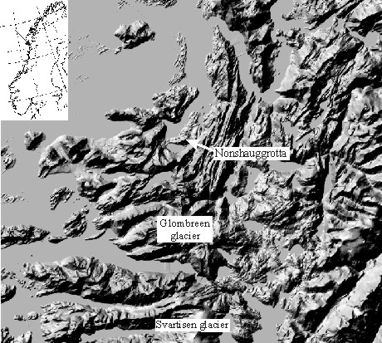 | Figure 1. Location of Nonshauggrotta in Nordland County, at the coast just north of the Arctic Circle and Svartisen glacier.

Nonshauggrotta has a total surveyed length of 1 500 m, and is 29 m deep. Morphologic parameters of the cave are summarized in table 1. Some of the parameters are ratio of the absolute cave parameter to the cave field parameter. The term cave field describes an area defined by a boundary drawn close to the cave (Klimchouk 2000). The specific volume (average cross-sectional area) of the cave is 1.4 m², which is quite small. The coefficient of karstification can be calculated both in term of area and volume. The former parameter has a value of 10.6 % while the latter is only 1.5 %. This is reasonable since the two-dimensional network consists of a quite high density of passages with small cross-sectional area. Parameters from Ukrainian gypsum maze caves are much higher probably because of higher solution rates and higher age.

Table 1. Morphological parameters of Nonshauggrotta and some other maze caves. Grønligrotta is also located in northern Norway, just south of the Arctic Circle and Svartisen glacier.
Cave | Length  m | Area  m² | Volume  m³ | Specific volume m³/m | Density of passages km/km² | Coefficient of karstification, %
 |  |  |  |  |  | in area | in volume
Nonshauggrotta | 1530 | 1490 | 2160 | 1.4 | 110 | 10.6 | 1.5
Grønligrotta | 4100 | 7500 | 9750 | 2.4 | 103 | 18.7 | 1.2
Gypsum maze caves,  Western Ukraine * |  |  |  | 3.8 | 198 | 37 | 5
* Data from Klimchouk (2000), mean values.

The cave passages form a fairly regular network, fig. 2. Cross-sections are overall phreatic tubes and rifts, only a few minor vadose canyons are developed. The cave is relict with no present drainage area. Passages are developed along two orthogonal joint sets; one sub-vertical directed north-south, the other oblique (~50°) with an east-west trending direction, dipping towards north. This is reflected in passage cross-sections which are mostly high and narrow because they are developed along a single or a few sub-parallel guiding fractures. Fracture traces as measured on the surface seem more dispersed than the guiding fractures inside the cave, even though the most pronounced set (sub-vertical with orientation north-south) is the same. The two sets of guiding fractures are oriented along strike and dip of the rock interface, fig. 3. This is a typical network maze cave (Palmer 1975).

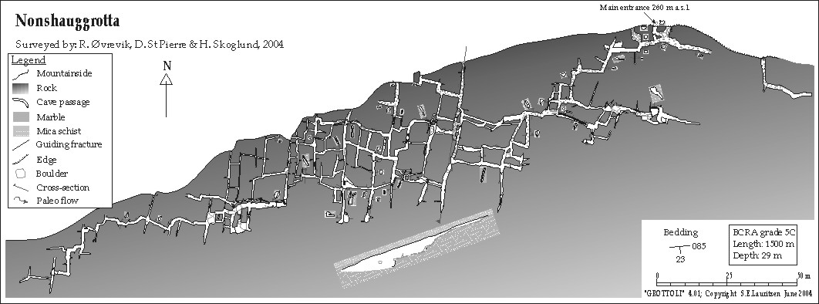
Figure 2. Map of Nonshauggrotta. The cave forms a fairly regular network. Cross-section drawings show that the cave is situated just below the marble-schist interface. The deepest part of the cave are the innermost passages to the South, these are choked by sand.

a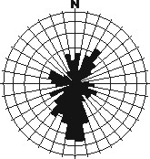 | b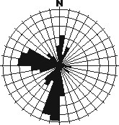 | Figure 3. a) Rose diagram of fractures measured at the surface (n = 140). There is one dominant direction towards the south (186/78) the rest is more uniform and less pronounced. b) Rose diagram of guiding fractures measured in the cave passages (n = 121). There are two dominant directions in these data: S (190/79, n = 55) and W (282/49, n = 47). The two main sets of guiding fractures are orthogonal. Each circle counts for 5 % with the outer circle as 20 %. The scale is logarithmic to make true area. c) Contour diagram of poles from fractures measured at the surface and the mean marble-schist interface as a great circle (086/26). d) Contour diagram showing guiding fracture poles and the mean marble-schist interface as a great circle. The two sets of guiding fractures seem to be almost perpendicular to the marble-schist interface.
c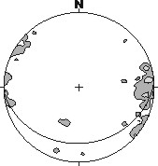 | d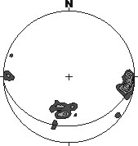
The ceiling in most passages is mica schist. The marble-schist interface is dipping away from the mountain side, which makes the innermost passages the deepest part of the cave. These are choked by silt and sand, which are the most widespread sediments in the cave. In addition, there are some marble boulders, and, in the outer parts, pebbles and cobbles mostly of mica schist.

Scallop morphometry demonstrate integrated network flow. Flow direction is consistent: towards east in the east-west trending passages and towards north in north-south trending passages, fig. 4. This indicates a hydraulic gradient towards the northeast which makes the paleo flow uphill (towards the mountain side). This indicates that the cave was an effluent network in the last active stage. Unfortunately, scallops are not very good for scallop analysis and only three analyses were made. Sauter mean of scallop length, L₃₂, was 20 cm at two sites and 32 cm at the third site. Paleo flow velocities range from 7 to 18 cm/s, while estimated discharge was between 0.02 and 0.32 m³/s, fig. 4.

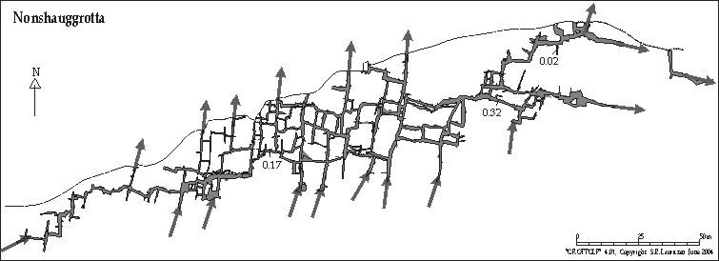
Figure 4. Paleo water flow through Nonshauggrotta as estimated from scallops-analysis. Numbers are paleo water discharge in m³/s.

The “loss-of-ignition” experiments expel carbon dioxide from the carbonate. This causes a weight loss of 44 % in pure calcite, and 48% in pure dolomite. “Loss-of-ignition” and acid insoluble residue experiments demonstrate that there are quite small variations in the composition of the marble, fig. 5. “Loss-of-ignition” in the marble varies between 34 and 43 %, while acid insoluble residues range from 0 to 21 %. “Loss-of-ignition” is inversely proportional to acid insoluble residue (r = -0.99). The marble does not seem to be purer or more homogeneous in those parts where the cave is situated. Therefore, it seems likely that there are other factors than marble composition that are guiding the speleogenesis to the upper part of the marble.

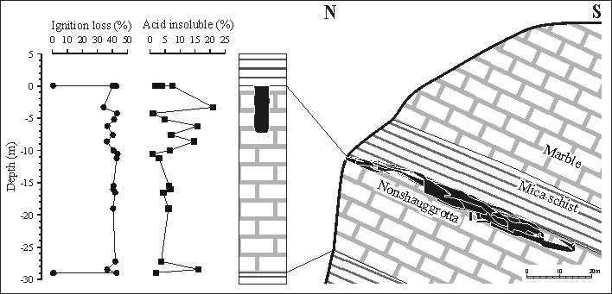

Figure 5. Left: Results from “loss-of- ignition” and acid insoluble residue experiments are shown as a function of depth below upper marble schist interface. Right: Vertical location of Nonshauggrotta. The variation in composition of the marble is small and seems to be largest in the upper part. The upper part of the marble was difficult to sample and surface weathering may be part of the reason for variation between different samples.

Substantial precipitates of gypsum and rusty weathering of the mica schist reveal that pyrite may be present in the mica schist. Drip-pits indicate that drip water from the schist is quite acidic; this may also be caused by minor extent pyrite being present in the schist. This makes it conceivable, that pyrite oxidation may have played an important role in the early stages of speleogenesis.

During the last glacial maximum, glacier movement was towards west-northwest. Younger glacier movements where topographically guided. Fjord- and valley-glaciers were dispersed from local glacier culminations at Glombreen and Svartisen glaciers, fig. 1 (Rasmussen 1981). The englacial hydraulic gradient tends to be parallel to glacier surface gradient and thus glacier movement. Because the glacier culminations were located south of Nonshaugen and high mountains (800 –1000 m a.s.l.) are located in west and northwest, it seems likely that the local glacier movement at this stage was towards northeast in the area around Nonshauggrotta. This is consistent with observations of glacial striation on the top of the ridge. This may have produced a water flow, up through the marble in Nonshaugen ridge, fig. 6. In conclusion, paleo water flow through the maze cave seems to be connected to moderate glacier distribution (with topographically guided movement) which is equivalent to Ford’s (1977) third condition. The network morphology may, thus, in part be a result of ice contact.

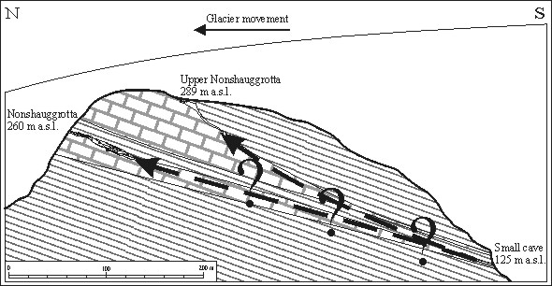

Figure 6. Glacier movement and karst water flow in relation to the cross-section of Nonshaugen ridge as imagined during the last deglaciation. In addition to Nonhauggrotta, two minor caves were surveyed: Upper Nonshauggrotta, length 230 m (BCRA grade 5C); and a small cave on the southern side of the hill, length about 27 m (BCRA grade 1A). Upper Nonshauggrotta seems to have been a phreatic riser. The small cave is almost filled up with sandy sediments and breakdown and only one passage was discovered. Same scale vertically and horizontally.

Discussion
Another maze cave in stripe karst that has been subject to thorough investigation during the last years is Grønligrotta in Rana, just south of the Arctic Circle and the Svartisen glacier (Skutlaberg 2003). Grønligrotta is 4 100 m long and 110 m deep, and situated in the valley side about 200 m above the valley bottom. It is an anastomotic maze cave with curvilinear passages and many closed loops. Grønligrotta is, as well as Nonshauggrotta, developed in gently dipping marble under confined settings just below the upper marble-schist interface. The paleo water flow was also upwards towards the mountain side, parallel with the surface gradient of a valley glacier (Skutlaberg 2003). The pattern of guiding fractures is complex in Grønligrotta. There seems to be several sub-domains with distinct guiding fractures. Skutlaberg (2003) suggest that this may be due to development under different stages.

In conclusion, we wish to emphasize some similarities between low dipping maze caves in stripe karst. First of all, they seem to have developed as part of confined aquifers. Secondly, they seem to be, at least in part, a result of ice contact. The maze morphology seem to be connected to moderate glacier distribution with topographically guided glacier movement, which correspond to the third hydrological condition described by Ford (1977). This means that the caves probably were active during glacier advances and recessions. It also seems that these mazes had an effluent function. Thirdly, jointing is an important issue, but this has been difficult to put into system and needs further examination.

References
Curl, R.L., 1974. Deducing Flow Velocity in Cave Conduits from Scallops. The NSS Bulletin, 36(2): 1-5.
Ford, D.C., 1977. Karst and glaciation in Canada, 7th Int. Speleol. Congr., Sheffield, pp. 188-189.
Kaufmann, G. and Braun, J., 1999. Karst aquifer evolution in fractured rocks. Water Resources Research, 35(11): 3223-3238.
Klimchouk, A., 2000. Speleogenesis of the great gypsum mazes in the western Ukraine. In: A. Klimchouk, D.C. Ford and A.N. Palmer (Eds.): Speleogenesis: Evolution of Karst Aquifers. National Speleological Society, Huntsville, Alabama, pp. 261-273.
Lauritzen, S.E., 1982. The paleocurrents and morphology of Pikhåggrottene, Svartisen, North Norway. Norsk Geografisk Tidsskrift, 36: 183-209.
Lauritzen, S.E., 2001. Marble stripe karst of the Scandinavian Caledonides: An end-member in the contact karst spectrum. Acta carsologica, 30(2): 47-79.
Palmer, A.N., 1975. The origin of maze caves. The NSS Bulletin, 37(3): 56-76.
Palmer, A.N., 1991. Origin and morphology of limestone caves. Geological Society of American Bulletin, 103: 1-21.
Rasmussen, A., 1981. The deglaciation of the coastal area NW of Svartisen, Northern Norway. Norges Geologiske Undersokelse, 369: 1-31.
Skutlaberg, S., 2003. Paleohydrogeologi, bruddgeometri og litostratigrafi i Grønli-Setergrottesystemet, Mo i Rana, University of Bergen, Bergen, 188 pp.

