Precise Measurement of Surveying-Sections Using Image Processing Techniques
Selçuk Canbek* Nihat Adar*
selcuk@ogu.edu.tr nadar@ogu.edu.tr

* Osmangazi University Computer Engineering Department, Eskişehir, Turkey

In this research, a method for surveying of cave, tunnel, and closed volumes is developed. In traditional methods, section height and width is estimated or measured manually. Approximated 3-D map of volume can be produced connecting those sections. In order to get more precise map, operator shall measure sections with many points that is very time consuming process. In this study, measurement process is automated by taking pictures of sections and those pictures are post processed using image processing techniques to produce precise cutting contours of measured sections. This method called Photo-Survey.
Photo-Survey uses a specially modified light source (battery operated light source with 180-degree view angle). Operator uses this lamp to illuminate the section and to obtain sharp shadow edges at measurement locations. Then, a digital photograph of illuminated section is taken. On the back of the light source, an object (circle picture) with known size is attached. These pictures are processed as following, afterwards. First, a median filter is applied to eliminate noise and reflections. In order to produce shadow contours of section, edge detection methods are used on pictures. Having shadow contours, measurement can be applied on these pictures if they satisfy two criteria. The first one is that camera should be perpendicularly positioned to sections surface. In other words, camera should be located on the normal axis of section surface. If one knows angle between section surface normal and camera, picture taken with any angle can be used for measurement. A method to find normal axis of a circle in a picture is developed. Thus, the picture can be corrected using affine transform methods using calculated angle. Second criteria, camera used in this method should be inserted far enough so that perspective distortion is negligible. However, this is not a proper restriction to follow in caves, because, we do not enough space in caves to get pictures from far away. The camera used in Photo-Survey method is calibrated and a method is devised so that its pictures can be transformed from perspective to parallel projection allowing us to take pictures closer to measured sections.
Photo-Survey method allows users to take pictures freely and fast. Next, these pictures are post processed to make measurements precisely. This lets operators to spend less time for measurement in caves or tunnels (only time to take pictures for each measured section).
Having precise cutting contours of each measured section one can produce 3-D map of volume.
1. Introduction
Cave studies are made by researchers from different disciplines. Geologists, archeologists, biologists, speleologists and others use similar research methods in cave studies. While some researchers study rocks and underground water, others only might interest intersects, flora in caves. In order for them to make research in caves, cave maps must exist. Cave maps can serve many uses in an investigation; depend upon what is being attempted. Some disciplines uses cave map to find their ways in caves, some others tries to point the location where they picked the samples. Speleologists need to know how far and deep they reached in caves. Traditional maps give rough information about shape and distances in the caves. When researchers use cave maps for volume calculation or distance measurement, map’s precision becomes important [YAMAC 03, TASKIRAN 03, ARIKAN 03, PANCARCI 03].
The standard survey technique consists of the measurement of azimuth and distance between consecutive survey stations and depth, width, and height at each station. Survey stations were established at turns in the guideline and at junctions between cave passages. Once the survey data has been collected, checked, and tabulated, the next step in the mapping process was to convert the data into a Cartesian coordinate system such that the data could be plotted and compared to other forms of spatial data. Numerous computerized cave mapping programs are available that will automatically generate cave maps. Some of the more popular programs include Compass2, Survex3, and WinKarst4. Some of the available programs are capable of three-dimensional plotting and statistical analysis of survey data [BTOPCU 05]. Most programs, however, are tailored for survey data that manually collected. In this research, we proposed a method that automates the survey data collection.
People preparing cave maps have to study with light and a few equipments because the measurement process is hard and very time-consuming work. Thus, maps prepared by these traditional methods give information about shape and rough distances in the caves and most of the details are not included (Readings taken from a navigational compass can be considered accurate to within +/- 1°; Distance measurements taken can be considered accurate up to +/- 1meter). Because of the lack of the precision, to make surface or volume calculations using traditional maps is not possible. Techniques used in traditional cave mapping methods are main cause of this precision problem. In traditional mapping methods, distance between measurement stations and direction information’s precision is important. However, precise cutting contours of the measurement section at stations have no much importance. They usually measure height and width of the section and the shape of the section contours are roughly hand drawn. Most of the time, the height of the section at stations is estimated. As a result, maps prepared using traditional methods cannot be used for precise calculations of the cave distances and volumes. A method to produce precise cutting contours of the sections, called section-cut, is proposed. Thus, precise 3-D maps of the caves can be constructed using section-cuts produced by our method.
2. Photo-Survey Method
In traditional mapping methods, section-cuts are measured using right, left, top, and bottom distances at stations and section-cut shape is hand drawn roughly on to papers (Figure 1). Since this processes handled by the person who stands at station location, most of the details are lost in these hand drawn section-cuts.
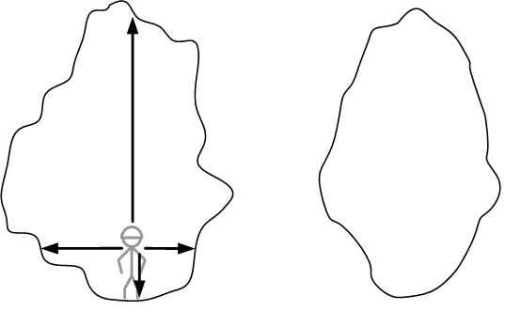
Figure 1: Traditional section-cut measurement method. Actual contour of the section and distances measured on the left. A typical hand drawn approximation of the same section on the right.
In Photo-Survey method, neither distance measurements nor hand drawing the contour of the section are needed. Only a picture of the section is taken and then post processed. These post processed pictures than can be used to make distance measurements and produce precise contour of the section (Figure 2).
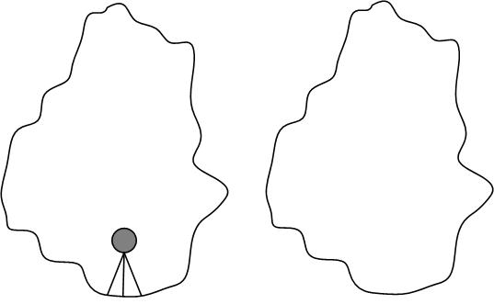
Figure 2: The Photo Survey Method. Picture of the section with light source on the left, the contour of the section after post processing on the right.
  - Material and Method
In this method, a camera for taking pictures and a point light source that lightens the half sphere are needed.
    - Camera: A digital camera with fixed lens can be used. In this study, Canon EOS 10D-photo camera with 20 mm fixed lens is being used. Cameras with zooming lenses cannot be used because lens distortions are corrected with software techniques and these techniques cannot be applied to zooming lenses. While taking pictures, camera is fixed using a standard tripod. Using higher resolution camera increases the measurement precision. Our camera’s resolution is 6.5 pixels. Its picture, taken 5 meter away from camera, can be used to calculate distances with ±5 mm tolerances.
    - Light source: The light source should be small and have high intensity in order to create sharp shadow contours. In this application, 55W halogen light bulb is used. Since light source should lighten half sphere homogenously, we inserted the light bulb into one side open cylindrical cover (Figure 3). The cylindrical cover is positioned using a tripod at stations. On the back of the cylindrical bulb cover a circle with known radius is drawn. This circle is being used as reference object in pictures.
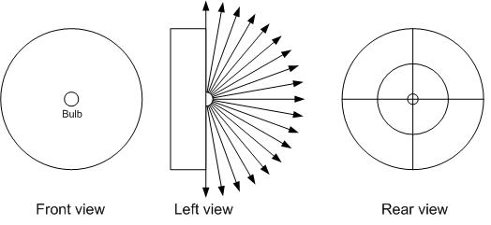
Figure 3: The front, side and rear views of the light source
  - Taking Pictures
The light source is located at station where the contour of the section is needed. Camera is positioned at some distance (distance registered for later use) so that it can get the picture of the whole section (Figure 4). Light source lightens the section away from camera.
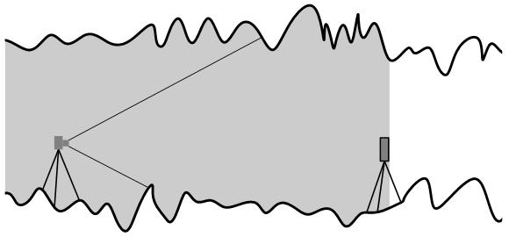
Figure 4: Taking section picture
In the picture the contours of the section is marked by shadow edges (Figure 5).
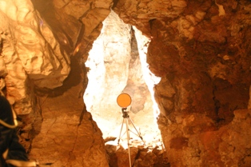
Figure 5: A sample section picture
Additionally, traditional mapping measurements, using DistPro laser range finder, are taken at every section and compared with Photo-Survey method results.
  - Post Processing
In order to use the picture, taken from survey location, it has to be post processed by image processing techniques. The post processing operations are handled at several stages as shown in Figure 6.
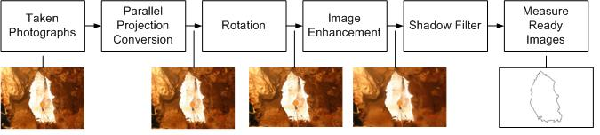
Figure 6: Post Processing Operations
    - Perspective to Parallel Conversion: The light rays of the object go through camera lenses and poses camera sensors. Camera lenses and detectors cause’s distortions near the picture frame borders. Taking picture further away from the section alleviates the distortion problem however caves are small places. Most of the time, pictures has to be taken in short distances. In addition, lenses with wide angles (24 mm) have more distortion. In order to make measurements on the pictures, this distortion has to be corrected. For this purpose, a picture of the test image (black and white 16x16-checker board picture) has taken and a correction filter is constructed by software. A correction filter for each lens has to be constructed.
    - Rotation: Another criterion to meet in order to make measurements on a picture is that the camera should be perpendicularly positioned to sections surface. However, this is not an easy task to achieve especially in caves. A method to find normal axis of a circle in a picture is developed so that camera can be positioned with any angle to section surface. After taking pictures, using circle on the back of the light source, the angle between section surface normal and camera direction is calculated. Thus, knowing the angle, the rotated picture, that is same as the picture taken with a camera that located on the normal axis of the section surface, is reproduced by affine transforms [CANBEK 04]. After rotation process, measurement on the picture using pixel counts can be achieved. The unit distance a pixel represents can be calculated by the radius of the circle drawn on the back of the light source.
    - Image Enhancement: Cave’s environmental conditions do not allow us to take picture with same quality all the time. Noise and unnecessary details should be filtered away from the picture. In this stage, a median filter is used.
    - Shadow Filter: The contour of the section is produced by shadow edges in the picture. In this stage, shadow edges are sharpened and detected to use as a contour of the section. As a result, each section picture is post processed and the precise contours of the sections are produced (Figure 7).

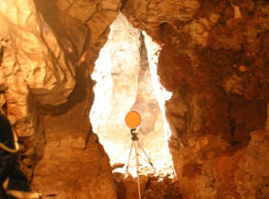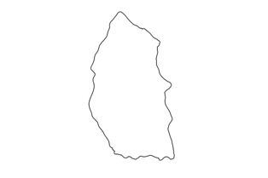
Figure 7: Section picture on the left. The contour of the section produced on the right
- Results and Discussion
Photo-Survey method allows users to take pictures freely and fast. Next, these pictures are post processed to make measurements. This lets operators spend less time and effort for measurements in caves or tunnels (only time to take pictures for each measured section). Using a standard camera and a light source, ±5 mm tolerances are easily achieved. Once the precise cutting contours of each measured section, section-cut, is collected, the next step in the 3-D mapping process is to connect section-cuts to generate three-dimensional plot of the cave. In order to produce 3-D cave maps, connecting the section-cuts of the Photo-Survey method is being studied currently. In this research, each stage of the post processing is done by different software modules. Our next goal is to produce a single software module so that image-processing phase can be handled faster.
- References
[CANBEK 04] Canbek S., Adar N., Aksoy E., “Yüzey Yönlenmelerinin Belirlenmesinde Çemberdeki Biçim Bozulmasının Kullanımı”, Havacılıkta İleri Teknolojiler ve Uygulamaları Sempozyumu, pp 537-540, 9-10 December 2004, Istanbul, Turkey.
[YAMAC 03] Yamaç M., “Biology of Caves (Biospeology)”, Conservation of the Cave Ecosystem and Cave Use in Turkey, pp 33-44, 6-7 December 2003, Antalya, Turkey.
[TASKIRAN 03] Taşkıran H., “The Importance of Caves From the Point of View of Prehistoric Archaelogy”, Conservation of the Cave Ecosystem and Cave Use in Turkey, pp 77-82, 6-7 December 2003, Antalya, Turkey.
[ARIKAN 03] Arıkan N., Evci D., Caves, “Tourism, Human and Environmental Health”, Conservation of the Cave Ecosystem and Cave Use in Turkey, pp 83-89, 6-7 December 2003, Antalya, Turkey.
[PANCARCI 03] Pancarci M., Ünlü P., “Sportive Usage of Caves”, Conservation of the Cave Ecosystem and Cave Use in Turkey, pp 103-114, 6-7 December 2003, Antalya, Turkey.
[BTOPCU 05] Büyüktopçu F., “AutoCAD ile Fotoğraflardan En Kesit ve 3 Boyutlu Görüntünün Elde Edilmesi”, speleoTURK-Karst and Cave Explorations Periodical, pp 28-34, Vol 2, 2005, Turkey.

