THE IMPACT OF ORGANIC LOAD ON GEOMICROBIAL TRANSFORMATIONS IN OLIGOTROPHIC CAVE ENVIRONMENTS.

Nicholas M. Taylor¹, Michael Kreate², Janet Bertog² and Hazel A. Barton^{1*}.

¹ Departments of Biological Sciences and ² Physics & Geology,
Northern Kentucky University, Highland Heights, KY 41099

* Corresponding author: bartonh@nku.edu and www.cavescience.com

ABSTRACT

Due to the oligotrophic nature of caves, to survive in this environment microorganisms utilize a number of different methods to fix carbon, generate energy and obtain nutrients. To asses the effect of organic load on such processes, we carried out a comparative study within Carlsbad Caverns National Park. Carlsbad Cavern is a hypogenic cave system that formed through sulfuric acid speleogenesis. The host rock comprises of the dolomitic Yates formation, with numerous secondary elements including iron, manganese, titanium, silica and other constituents of sedimentary minerals. Samples were collected from different locations based on relative organic load and were analyzed by liquid chromatography mass-spectroscopy, X-ray diffraction and scanning electron microscope with energy dispersive spectroscopy, while DNA was extracted from the bedrock for molecular phylogenetic analysis of the microbial community structure. Our result demonstrate that there is a diverse microbial population associated with the significant mineral transformation takes place in the severely nutrient deprived environment, with a breakdown of the dolomite matrix and the oxidation of Fe(II) to Fe(III) or subsequent reduction to Fe(0). At the site with observable nutrient input there is limited microbial diversity with no observable mineral transformation. Our results suggest that organic input into the cave system dramatically influences the community structure of the microorganisms found there, and the subsequent geomicrobial mineral transformations taking place. This is presumable due to the higher efficiency of obtaining carbon and energy from heterotrophic, versus chemolithotrophic, processes. Our results suggest that the relative levels of geomicrobial activity observed in geologic samples may directly relate to the amount of organic material that has entered the system.

INTRODUCTION

Due to extremely low biomass in cave environments and the difficulty in extracting DNA from chemically complex geologic samples, most culture-independent studies of microbial activity have tended to examine areas of measurable energy input (1, 2, 10, 15, 16). Despite this, in a recent study we used molecular phylogenetics to determine what, if any, microbial activity was occurring within an oligotrophic cave without measurable energy input (3). Our results suggested that a diverse microbial flora subsisted in this extremely oligotrophic environment (7, 8). Our results suggested that the microbial community within this environment subsisted by using barely perceptible carbon and energy sources; including organics entering the system through percolation, or the presence of volatile organic molecules within the atmosphere (3). The presence of phylotypes that demonstrated identity to organisms capable of carrying out iron oxidation suggested that microorganisms within the community were able to use energy sources such as reduced iron within the bedrock of the cave itself. We also detected the presence of a high proportion of nitrogen assimilating organisms. This may suggest a source of nitrogen, which along with phosphate, is a limiting nutrient in the majority of organic material percolating into cave systems (13). Such a broad phylogenetic distribution of bacterial species has been identified by other investigators in similarly oligotrophic cave environments (5).

Together, our data have led us to hypothesize that the large diversity of microorganisms found in extremely oligotrophic cave environments reflects syntrophic interactions that support community growth under such starved conditions (Figure 1). Our model suggests that due to the complex nature of organic carbon and energy sources entering the system, not one organism is capable of carrying out all the energetically favorable catabolic reactions necessary to support growth (11, 13). Rather, energetic restrictions only allow certain reactions to proceed through a close interaction with species that remove intermediates, allowing energy conservation in what would otherwise be an endothermic reaction (17). Such syntrophy has been described for anaerobic ethanol fermentation and methane oxidation (where the removal of hydrogen through syntrophic interactions is critical to energy conserving reactions) and the breakdown of complex aromatic compounds (17). Such interactions may also be a central issue in the unculturability of most microorganisms in the environment; syntrophic interactions may make many organisms recalcitrant to cultivation, where appropriate growth conditions may be dependent on specific spatial and metabolic interactions. Our previous data also suggests that such
syntrophic interactions allow the bacteria present in the environment to extract nutrients and energy from the rock on which they grow.
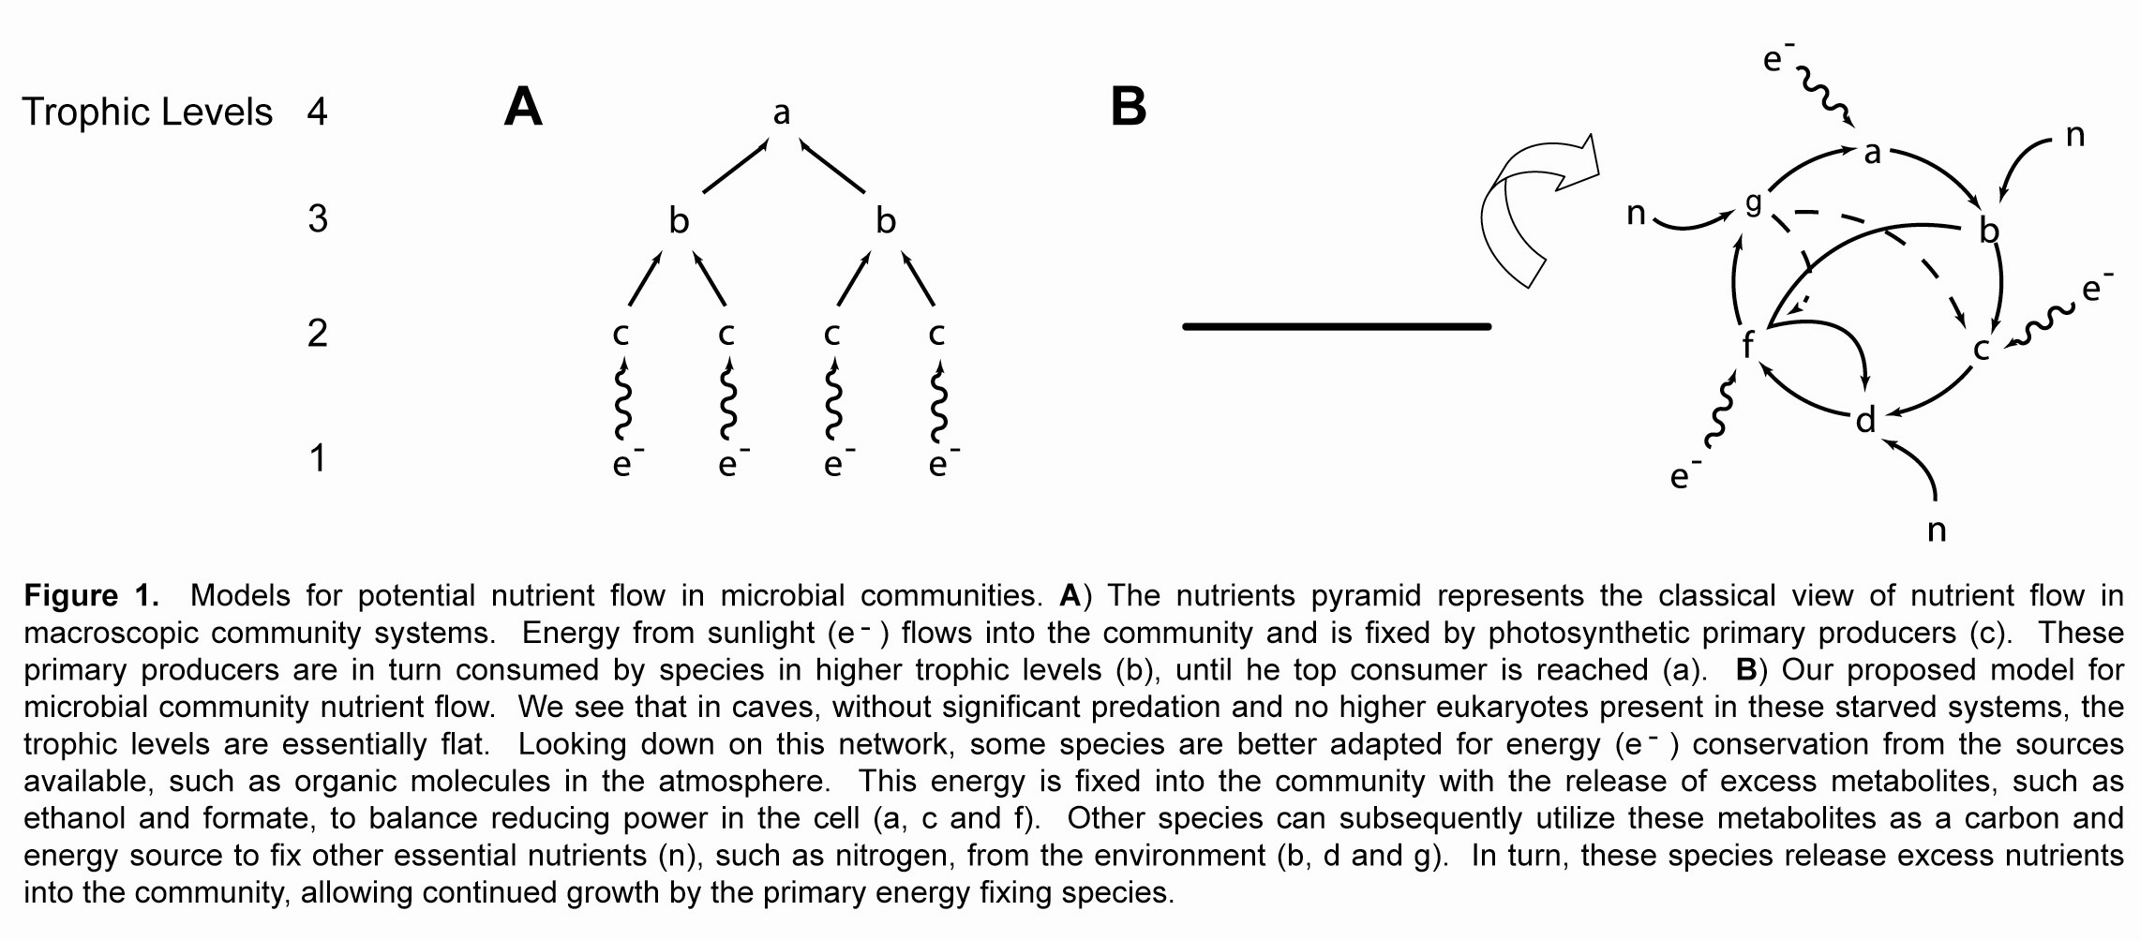
In order to address many of the questions regarding nutrient input we carried out a comparative analysis of two microbial cave communities. While the geologic nature of both environments was similar, one community was considered copiotrophic due to organics being brought directly into the system through the entry of surface waters along a geologic fault. The other community was considered oligotrophic, with no measurable organic input. We compared the different organic loads and interactions of the community with the rock matrix in order to determine whether a mineral transformation or geologic signature would indicate microbial-mineral interactions.

MATERIALS AND METHODS

Sample site and collection. Carlsbad Cavern was formed in Paleozoic reef sediments by hypogenic sulfuric acid speleogenesis, with a postulated biogenic origin. The Carlsbad cave system is dominantly within the reef complex of the Capitan Formation. The Guadalupe Rise is near the contact of the back-reef Yates Formation and the Guadalupe Formation. The relatively impermeable iron-rich, silty Yates Formation traps oxygenated groundwater and releases it into the Capitan Formation (9). The cave is located within a desert area, does not contain any surface streams and is not prone to flooding (12).

Samples for collection were identified based on a number of parameters, including the presence of water, proximity to a joint, altered bedrock or secondary mineralization. During sampling, we recorded temperature and humidity, with no significant differences between locations. Samples were collected from two different areas of Carlsbad Cavern based on the entry of surface organics into the system; WF1 is approximately 30 m from the tourist trail and is located in an area that receives a steady input of seeping surface waters; sF88, is located approximately 1 km from the tourist trail in a rarely visited area of the cave (trip reports indicate only 3 past trips to the area). The area is dry, with no indication of seeping or dripping water and has a significant corrosion residue formed on the surface of the rock. Three 5 g rock samples were collected from each location using a sterilized Dremel drill tool, one each for geology, chemistry and biology. Each sample was preserved in an appropriate manner for the subsequent tests (DNA extraction in 70% alcohol with storage at -20°C, while chemistry and geology samples were collected in gamma-irradiated clean tubes; chemical samples were stored at 4°C). Methods for DNA extraction from the carbonate rock and molecular phylogenetic analyses are described elsewhere (3, 4).

RESULTS

In order to carry out a comparative molecular phylogenetic study of microbial cave communities, we began by identifying two distinct areas in Carlsbad Cavern that had the same geology but quite different levels of available organic material from the surface, WF1 and sF88 (Figure 2). Due to a geologic fault and subsequent conduit for surface water and associated organic material seeping into the cave, WF1 is considered the energy ‘rich’ (copiotrophic) ecosystem, while sF88 is considered ‘starved’ (oligotrophic). Each environment was compared for chemical, geologic and biological activity.

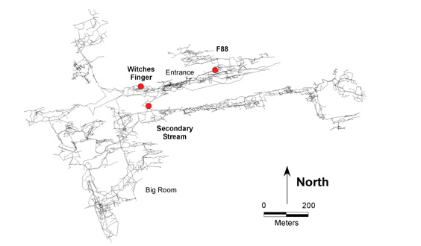

Figure 2. Map of Carlsbad Cavern. Collection sites for Witches Finger (WF1) and sF88 are indicated. The secondary stream location indicates the location of the tourist elevators and underground lunchroom.

To qualitatively compare the amount of organic material present at WF1 and sF88, 100 mg of rock sample was powdered and extracted with water and hexane and then analyzed using liquid chromatography coupled mass spectrometry (LC-MS). A qualitative analysis was carried out to make sure there was no significant difference in the type of organic material present at each location; for example, as a direct result of surface spills from any of the commercial facilities (sewage tanks, fuel tanks, etc.) above the cave. The LC-MS data (not shown) demonstrated that the type of organic material present at each location is similar; however, a significantly higher amount is found at WF1. This is in agreement with our identification of WF1 as an area receiving a larger input of surface organic material. A rudimentary analysis of the LC-MS peaks indicates that the organic material found at each location is rich in phenolic and aromatic compounds, as would be expected for organic material commonly found in soils (18).

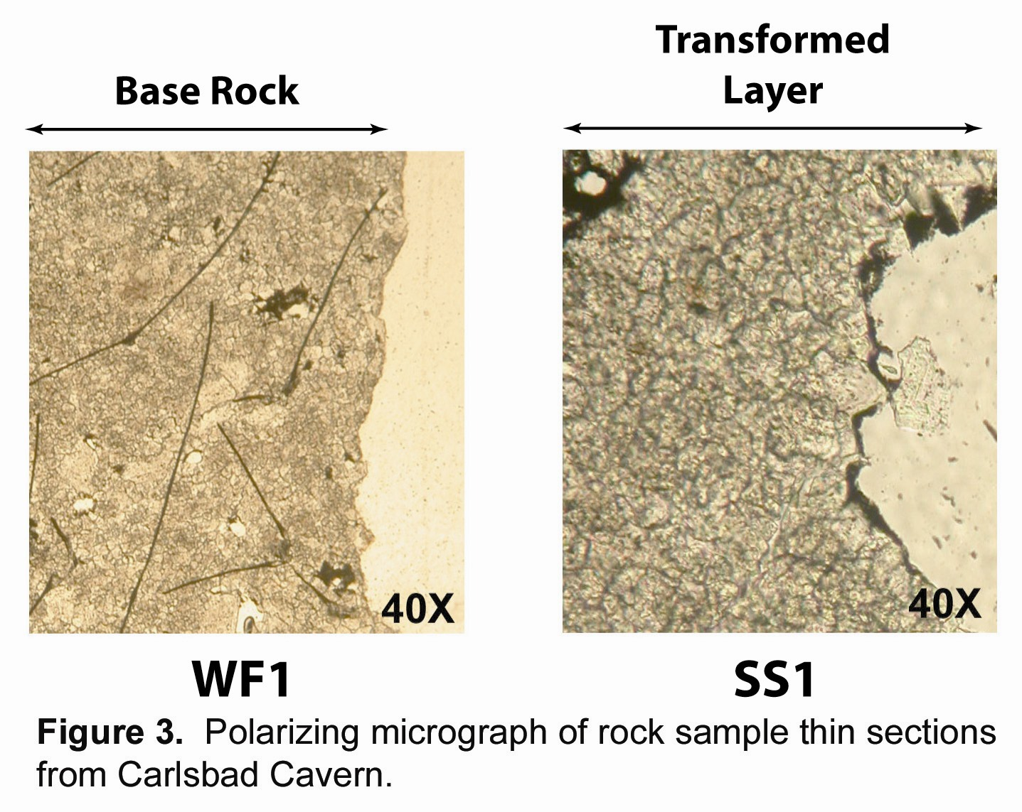
Once we had established that there was a significant difference in the organic material present at each location, we used thin-section and X-ray powder diffractrometry (XRD) analyses to examine whether there was any structural difference between these locations (Figures 3 and 4). The thin-sections demonstrated that at WF1 there is no observable change between the native structure of the rock and the surface (Figure 3). In comparison, at sF88 the rock appears to have undergone a dramatic change, with a powdering of the surface. Gross examination of the sF88 site reveals a powdery, red/pink corrosion residue that is > 1 cm thick, bearing little resemblance to the host rock structure.

While the thin section observations suggested that there were significant structural changes occurring at sF88, it is impossible to differentiate biotic versus abiotic processes without further examination. To determine what mineral changes were occurring at sF88, we carried out comparative x-ray powder diffractometry (XRD). At each location the sample collected was broken down into two components; the host (base) rock and the surface layers. The results of the XRD analysis (Figure 4) demonstrated that, in agreement with our thin-section analysis, that there were no changes in the mineral structure at WF1; however, at sF88 there appeared to be significant mineral changes. The peaks indicated that the dolomitic structure of the rock at this location was completely changed, being replaced with material that appeared to contain a large amount of iron oxides.

Despite the ability of XRD to identify structural changes within the rock, the new peaks observed at sF88 did not conclusively represent iron oxides. To determine if these new peaks were indeed iron oxides, we extracted the sF88 corrosion residue with hydrochloric acid, allowing the identification of non-dolomitic peaks through energy dispersive spectroscopy (EDS). The results (Figure 5) indicate that the majority of the insoluble particles at sF88 were indeed iron oxides, elemental iron particles or iron-rich clays. The material at WF1 was similarly extracted and subjected to EDS analysis; however, only clay particles were identified in the insoluble particulates. Such clays are a commonly found as particulate matter within the Carlsbad dolomite.
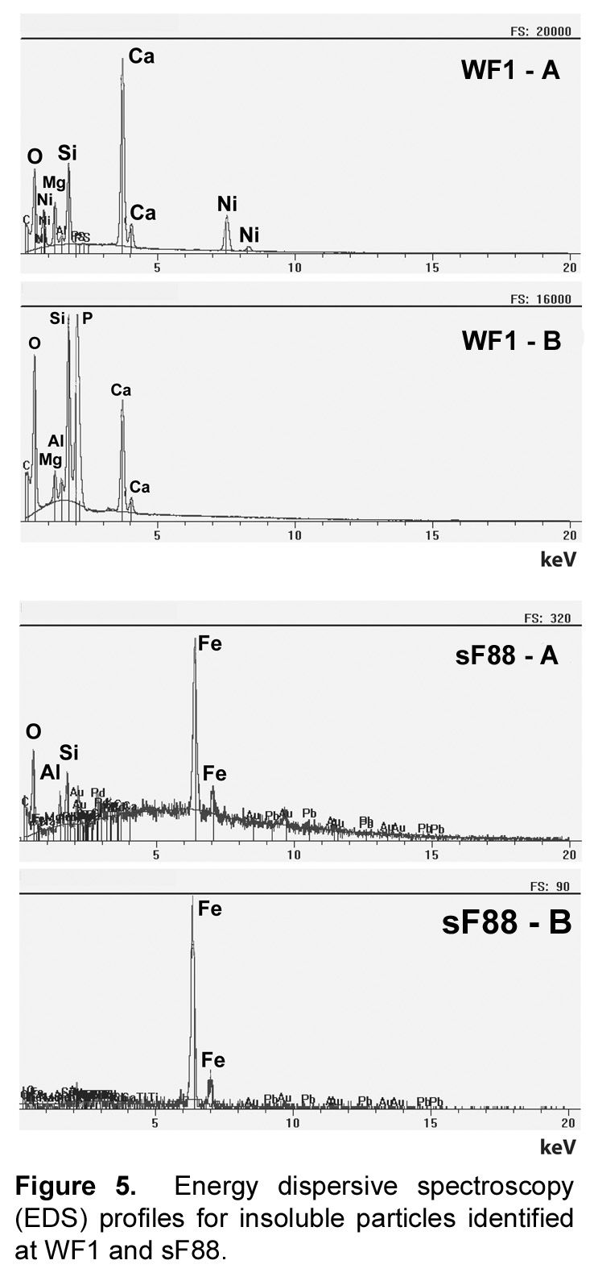
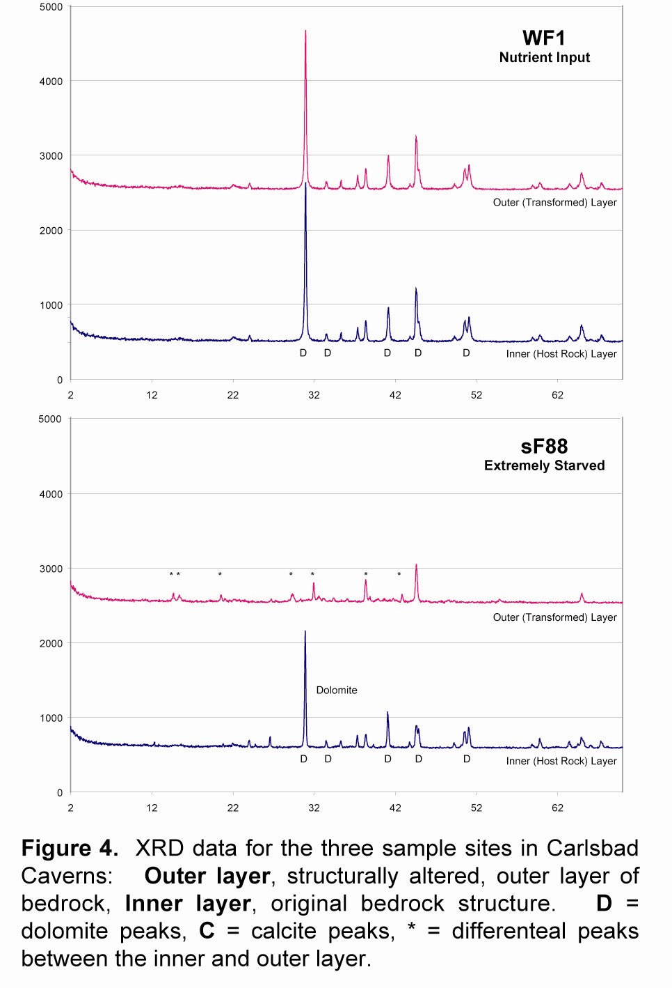

In order to determine whether the amount of organic material we observed at WF1 and sF88 affected the microbial community structure, we carried out a comparative molecular phylogenetic study. Approximately 50 ng of DNA was extracted from each location using our standard DNA extraction protocol (4). To produce 16S SSU-rDNA PCR products for cloning we used the 8F and 805R bacterial specific primer set, which provide the best PCR product for cloning at these low DNA concentrations. While this rDNA product is short (~800 bp in length), it still provides sufficient information for statistically-significant phylogenetic placement (14). Clone libraries were created for both sF88 and WF1, with 144 and 96 clones identified at these sites respectively. The clone sequences were screened by RFLP to identify unique phylotypes, which were screened against the RDP and low-biomass contaminant databases to remove chimeric and contaminating sequences (4). The remaining clone libraries contained 49 unique phylotypes for sF88 and 38 unique phylotypes for WF1. The sequences of these phylotypes were compared with the NCBI database and the closest cultivated relative was identified. The relative taxanomic distribution of bacterial divisions at each environment is shown in Figure 6.

The results of the molecular phylogenetic studies demonstrate that the copiotrophic WF1 community is dominated (84%) by members of the Actinobacteria, a broad class of high G+C, gram-positive bacteria identified in a range of environments, particularly the soil. Interestingly, within the oligotrophic sF88 community is much more diverse, including the identification of additional members from the gram-positive Clostridia/Fimucites/Bacilli group. Included within the sF88 clone library is also a much broader representation by members of the Proteobacteria, including the alpha, beta and gamma-subclasses.

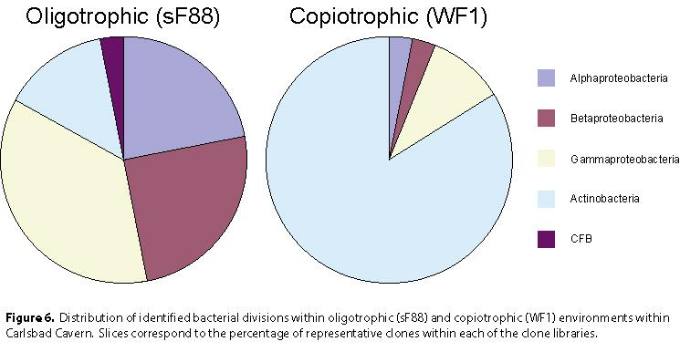

DISCUSSION

It was the aim of this study to determine what role the amount of energy entering a cave system has on microbial community structure. To do this, we compared how the organic load entering the system, presumably through the percolation of surface waters, affects the type and mechanism of energy acquisition. Our results support our hypothesis that as the system becomes more starved, there is an increase in the diversity of the microbial species found; a hypothesis which is contrary to the accepted ecological literature regarding nutrient limited conditions. In the context of the cave environment, it is interesting to note that as the amount of available organic material falls, the amount of mineralogical change observed increases, as demonstrated by thin-section microscopy and XRD. Further, our XRD and EDS analyses suggested that in the most starved environment, corrosion residues form that contain iron oxides and elemental iron. While there is a small amount of reduced iron within the dolomite bedrock, this accumulation may suggest that iron oxidation and reduction reactions are being used as a primary energy conserving mechanism.

In order to examine what metabolic activity is supporting community growth between the sF88 and WF1 sites, we examined the unique phylotypes found within each environment. The predominant phylotypes identified at WF1 are members of the Actinomycetes, which demonstrate the ability to break down and utilize complex organic molecules, as would be anticipated in an environment rich in soil detritus (6). The dominance of this copiotrophic community by one bacterial group may suggest that, indeed, in this environment with rich nutrient input, the standard rules of competitive exclusion apply (19). The structure of the microbial community at sF88 is significantly more complicated, with bacterial species that display an array of metabolic activities; these activities include atmospheric nitrogen and organic carbon fixation, methane, hydrogen and iron oxidation, the breakdown of complex organic molecules and the mobilization of inorganic phosphorous (6). The sum of all these metabolic activities is shown in Figure 7. While simplified, this metabolic web reflects our original hypothesis that syntrophic reactions may be occurring within these extremely starved environments. These metabolic relationships may allow these species to obtain energy and carbon from sources that might otherwise not provide sufficient free energy to support ATP synthesis and growth.
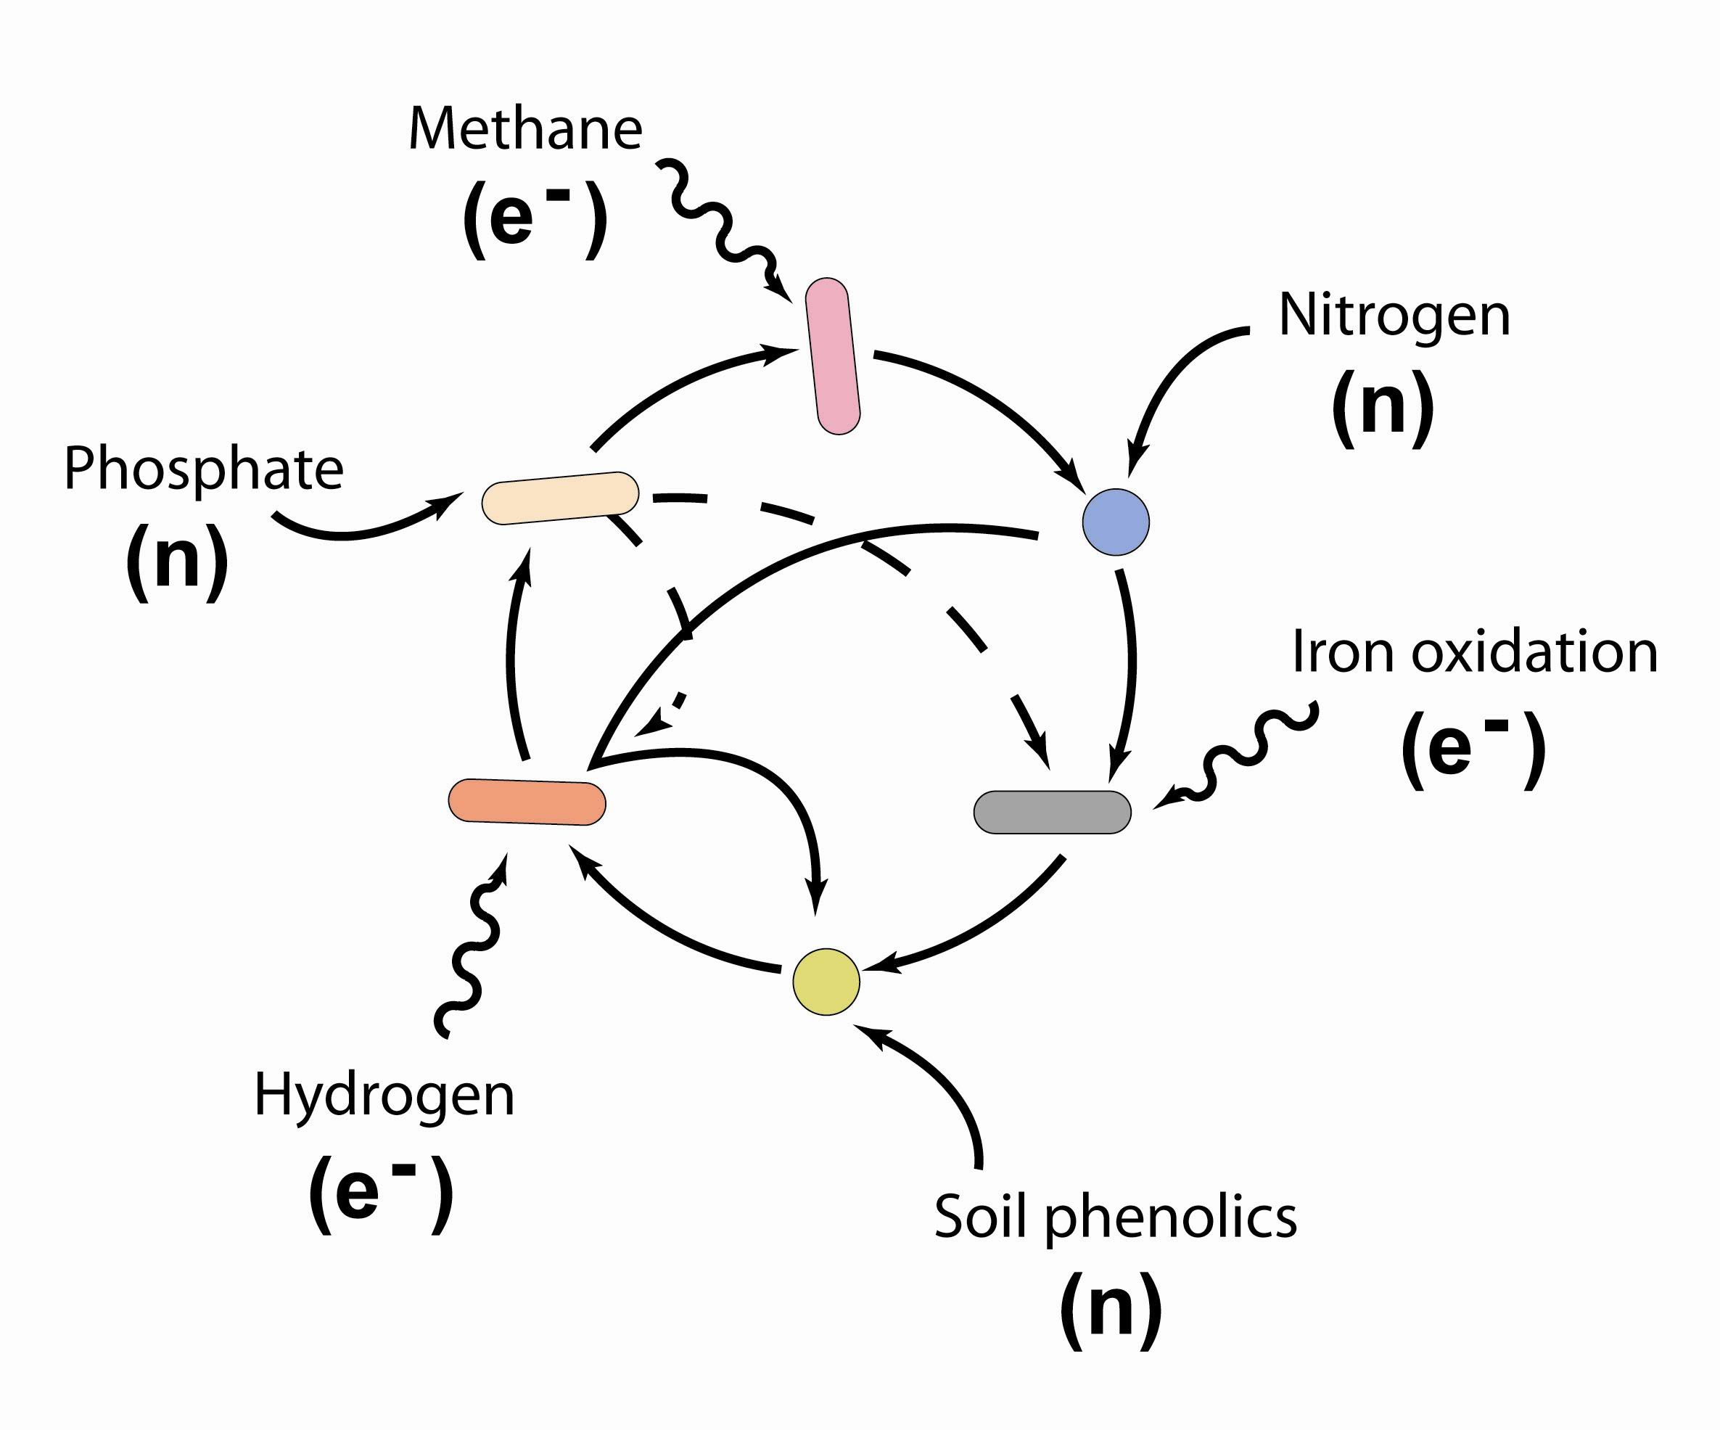

Figure 7. Metabolic structure of the microbial community identified at sF88. Presumed metabolic activity was obtained by phylogenetic comparison to the next closest cultivated species.

The initial premise of this study was to examine whether syntrophic relationships were responsible for the energy acquisition strategies observed within extremely starved cave environments. Our results, while preliminary, suggest that as the cave environment becomes increasingly starved, bacterial species are forced to rely more heavily on chemolithotrophic strategies for energy acquisition and growth. The sources of energy and nutrients for such metabolic activity appear to be available from the cave atmosphere and host rock, ultimately resulting in geomicrobial transformations through the processes of energy acquisition. Nonetheless, these results remain preliminary, and we are in the process of carrying out cultivation studies to further resolve potential mechanisms of syntrophy and energy acquisition.

ACKNOWLEDGEMENTS

The authors would like to thank the cave resource offices at Carlsbad Cavern National Park, in particular Paul Burger for his help in managing our permits and sampling trips into Carlsbad Cavern. We would also thank Brad Lubbers for his excellent technical assistance. This work was supported in part by grants from the US National Park Service, the Kentucky Academy of Science and the NSF EPSCoR program to HAB. NMT is supported by a fellowship from the NKU Department of Biological Sciences and the AAAS/Merck program.

REFERENCES

1. Angert, E. R., D. E. Northup, A.-L. Reysenbach, A. S. Peek, B. M. Goebel, and N. R. Pace. 1998. Molecular phylogenetic analysis of a bacterial community in Sulphur River, Parker Cave, Kentucky. Am. Mineralogist. 83:1583-1592.
2. Barton, H. A., and F. Luiszer. 2005. Microbial Metabolic Structure in a Sulfidic Cave Hot Spring: Potential Mechanisms of Biospeleogenesis. J. Cave Karst Stud.67:28-38.
3. Barton, H. A., M. R. Taylor, and N. R. Pace. 2004. Molecular Phylogenetic Analysis of a Bacterial Community in an Oligotrophic Cave Environment. Geomicrobiology J. 21:11-20.
4. Barton, H. A., N. Taylor, and A. Pemberton. 2005. DNA extraction from low biomass carbonate rocks: Improving yield while reducing contaminants. Journal of Molecular Methods Submitted.
5. Chelius, M. K., and J. C. Moore. 2004. Molecular Phylogenetic Analysis of Archaea and Bacteria in Wind Cave, South Dakota. Geomicrobiology J. 21:123-134.
6. Dworkin, M. 2002, posting date. The Prokaryotes: An evolving electronic resource for the microbiological community. Springer-Verlag, New York. [Online. http://link.springer-ny.com/link/service/books/10125]
7. Groth, I., and C. Saiz-Jimenez. 1999. Actinomycetes in Hypogean Environments. Geomicrobiology J. 16:1-8.
8. Groth, I., R. Vettermann, B. Schuetze, P. Schumann, and C. Saiz-Jimenez. 1999. Actinomycetes in Karstic caves of Northern Spain (Altamira and Tito Bustillo). J. Microbiol. Methods. 36:115-122.
9. Hill, C. A. 1987. Geology of Carlsbad Cavern and other caves in the Guadalupe mountains, New Mexico and Texas. NM Bureau Mines Miner. Res. Bull. 117:150 p.
10. Holmes, A. J., N. A. Tujula, M. Holley, A. Contos, J. M. James, P. Rogers, and M. R. Gillings. 2001. Phylogenetic structure of unusual aquatic microbial formations in Nullarbor Caves, Australia. Environmental Microbiology 3:256-264.
11. Juttner, F. 1984. Dynamics of the volatile organic substances associated with Cyanobacteria and Algae in a eutrophic shallow lake. App. Environ. Microbiol. 47:814-820.
12. Klimchouk, A. B., D. C. Ford, A. N. Palmer, and W. Dreybrodt. 2000. Speleogenesis: Evolution of Karstic Aquifers. National Speleological Society, Huntsville, AL.
13. Laiz, L., I. Groth, I. Gonzalez, and C. Saiz-Jimenez. 1999. Microbiological study of the dripping water in Altamira Cave (Santillana del Mar, Spain). Journal Microbiological Methods 36:129-138.
14. Nei, M., S. Kumar, and K. Takahashi. 1998. The optimization principle in phylogenetic analysis tends to give incorret topologies when the number of nucleotide or amino acids used is small. Proc. Ntl. Acad. Sci. USA 95:12390-12397.
15. Northup, D. E., and K. H. Lavoie. 2001. Geomicrobiology of Caves: A Review. Geomicrobiology J. 18:199-222.
16. Sarbu, S. M., T. C. Kane, and B. K. Kinkle. 1996. A chemoautotrophically based cave ecosystem. Science 272:1953-1955.
17. Schink, B. 2002. Synergistic interactions in the microbial world. Ant. Leeuwenhoek 81:257-261.
18. Sylvia, D. M., J. J. Fuhrmann, P. G. Hartel, and D. A. Zuberer (ed.). 1999. Principles and Applications of Soil Microbiology. Prentice Hall, Upper Saddle River, NJ.
19. Tilman, D. 1982. Resource competition and community structure. Princeton University Press, Princeton.

