Karst Hydrogeology of Lookout Mountain,
a Synclinal Mountain in the Folded Appalachian Mountains
of SouthEAST Tennessee AND Northwest georgia, USA

Brian Sakofsky* Kent Ballew and Nicholas Crawford
Center for Cave and Karst Studies
Applied Research and Technology Program of Distinction
Department of Geography and Geology
Western Kentucky University
Bowling Green, Kentucky, USA

Abstract

The primary objective of this research was to investigate the hydrogeology of Lookout Mountain, located near Chattanooga in southeast Tennessee and northwest Georgia, USA. The National Park Service (NPS) funded this research to better understand the karst groundwater flow under the Chattanooga National Military Park and how urban development in the vicinity of the park might affect the karst and groundwater quality. If a major spill of toxic material occurs on Lookout Mountain as it did in 1996 with a Colonial Pipeline oil spill, the NPS must be able to track the flow of the contaminants.

Lookout Mountain is a synclinal mountain located within the Folded Appalachian Mountains. Its stratigraphy mimics that of the nearby Cumberland Plateau. The caves tend to be oriented along the strike, and there are numerous vertical shafts where cave streams drop off resistant strata.

Dye tracing and cave exploration and mapping were used to investigate the hydrogeology. The Center for Cave and Karst Studies (CCKS) uses fieldwork and fluorimetric analysis for qualitative dye tracing. A karst hydrologeologic inventory was conducted on and around the base of Lookout Mountain, and 43 coconut charcoal dye receptors were placed in all springs, surface streams and several cave streams.

Four different dyes were injected on two separate occasions into spring-sinks in the complicated lithologic structure. The research indicates that surface streams flowing off the sandstone-capped mountain sink into the underlying limestones to create cave streams that then flow along the strike of the synclinal mountain. The cave streams have a stair-step pattern as they breach confining layers and descend through the Pennington, Bangor, and Monteagle Limestones. The deepest of these vertical shafts is Mystery Falls (the deepest vertical shaft known in Tennessee, 85.6 m). It was created by a cave stream dropping through the Hartselle Formation shale confining layer down into the Monteagle Limestone. This hydrogeologic research has identified major flow routes within the karst aquifers under Lookout Mountain.

1. Introduction

Dye tracing is a powerful tool in karst hydrogeology. Dye tracer tests combined with knowledge of the geologic structure and stratigraphy can identify the major flow routes through karst aquifers. They are, therefore, fundamental in explaining the complex nature of groundwater flow in most karst aquifers (Quinlan, 1989). Dye tracing is one of the most effective methods for determining zones of contribution, directions of groundwater flow, and quantifying residence times for water in karst aquifers where conduit flow prevails.

2. Study Area

Lookout Mountain, part of the folded Appalachian Mountain Chain, extends 134 km from the Tennessee River at Chattanooga into northwest Georgia. Lookout Creek flows northeast parallel to the mountain along its western side, and Chattanooga Creek flows northeast along the eastern side of the mountain. Both streams discharge into the Tennessee River at Chattanooga, Tennessee. The mountain lies within the folded Appalachian Mountain physiographic region near the horizontal rocks of the Cumberland Plateau to the west.

Stratigraphy within the mountain is similar to that of the Cumberland Plateau with a Pennsylvanian sandstone and shale caprock above Mississippian carbonates. Lookout Mountain is topped by Pennsylvanian period Whitwell Shale, Sewanee Conglomerate, Signal Point Shale, Warren Point Sandstone, and the Raccoon Mountain Formation (shaley sandstone). A perched aquifer exists within the Warren Point Sandstone, which makes up the majority of the top of the mountain. Groundwater from this perched sandstone aquifer and storm water runoff flow over the steep cliff sides of the Raccoon Mountain Formation confining layer onto the underlying Mississippian stratigraphy. The Mississippian Formations that outcrop along the flanks of the mountain on both sides include: the Pennington Formation (approx 120-150 m, mixed sandstones and limestones), Bangor Limestone (61-122 m), the Hartselle Formation (0-12 m, siliceous sandstones and shales), Monteagle Limestone (61-91 m), St. Louis Limestone (12-30 m), Warsaw Limestone (12-30 m), and the Fort Payne Formation (27-61 m). The Chattanooga Shale (6 m) lies at the base of the mountain below the chert beds of the Fort Payne. The strata form a shallow syncline that plunges gently to the south (Finalyson and others, 1964).

A near vertical joint set strikes N45E towards the interior of the mountain. An opposing joint set strikes N50W. The Cranmore Cove Thrust Fault flanks the west side of Lookout Mountain with the Fort Payne Formation on the hanging wall overlying the Warsaw Limestone. Extending north and south is the Chattanooga Fault, a high angle reverse fault, which extends parallel to the Cranmore Cove Fault to the north. This fault terminates on the northeastern extent of Lookout Mountain (Mies, 2005).

Crawford (1979) describes groundwater flow along the Cumberland Plateau Escarpment (Figure 1). His model proposes cavern development through a drainage system composed of vertical shafts and horizontal conduits acting together in a stair-step pattern. This schematic model indicates that allogenic streams flow off the silisiclastic caprock and invade the subsurface as they flow onto the underlying Mississippian Limestones, along the edge of the retreating escarpment. There is a similar pattern noticeable at the northern extent of Lookout Mountain.
Figure 1. Generalized cross section along the Cumberland Plateau Escarpment in Tennessee (Crawford, 1979)

3. Dye Tracing

In this ongoing study commissioned by the US National Park Service, dye tracing is being used to delineate the source areas for their undefined watersheds at Chattanooga National Military Park. A comprehensive karst hydrogeologic inventory was conducted over the entire study area to identify all karst features including springs, seeps, sinking and loosing streams, karst windows, major sinkholes, and caves. The two important springs identified during the karst hydrogeologic inventory are Skyuka and Anderson. Skyuka flows directly into Lookout Creek that then flows 8.5 km to the Tennessee River. Anderson Spring is now buried beneath riprap under Interstate Highway 24. Anderson Spring rises through the riprap directly into the Tennessee River (Nickajack Reservoir). Two significant caves also exist on the northern nose of the mountain. The stream in Mystery Falls Cave flows along the Hartselle Formation before dropping 80 m into the Monteagle Limestone. The stream in Ruby Falls Cave also flows along the top of the Hartselle before dropping approximately 24 m into the Monteagle.

Activated coconut charcoal receptors were used to adsorb the following dyes: Sodium Fluorescein, C.I. Acid Yellow 73; Eosine, C.I. Acid Red 87; Sulphorhodamine B, C.I. Acid Red 53; and Tinopal CBS-X, Fluorescent Brightening Agent 351. Each dye was injected at individual locations on two events, 13 February 2005 and 23 April 2005. Fifteen receptors were placed along the bank of the Tennessee River to catch dye rising from springs now inundated by Nickajack Reservoir. Three receptors were placed along Chattanooga and Lookout Creeks. Four receptors were placed in cave streams, and twenty-one were placed in springs. All dyes were injected on the west side of Lookout Mountain.

Receptors were changed on a weekly basis, then analyzed at the Center for Cave and Karst Studies (CCKS) dye tracer laboratory at Western Kentucky University. Smart solution (Smart and Laidlaw, 1977) was used to elute the dye from the charcoal and the elutant samples were analyzed on a Shimadzu Model RF-5301PC Synchronously Scanning Spectrofluorophotometer. Analysis on a scanning spectrofluorophotometer provides the lowest detection limits and most reliable dye analysis. Eight dyes were injected on the west side of Lookout Mountain at seven springs-sinks and at one cave stream location.

4. Dye Tracing Results

The results of the eight dye traces are presented in Figure 2. Lines indicate the suspected flow paths from each of the injection locations to resurgent springs. Injection points are represented by teardrop symbols and dye receptor location sites by round points.

Fluorescein was injected at Craven's House Spring on the Pennington Formation. Receptors picked up dye at Mystery Falls Cave stream and then at the Anderson Spring resurgence in the Tennessee River. The dye did not sink into the Pennington, but instead followed man-made structures (culverts and drainage ditches) until it sank into the Bangor Limestone and flowed along the Hartselle Formation to Mystery Falls. Sulphorhodamine B was injected into Gum Spring-Sink on the Pennington, and it flowed to Mystery Falls Cave and then to Anderson Spring. Eosine, injected in Apollo Castle Stream Swallet, also followed a similar path after dropping off the Raccoon Mountain Formation, down through the Pennington and Bangor to the Hartselle and then to Mystery Falls Cave and Anderson Spring. Tinopal CBS-X was injected at both Dogwood Spring-Sink in the Bangor and Rock Spring-Sink in the Pennington on separate occasions. Tinopal CBS-X injected at Rock Spring-Sink was first detected at Dogwood Spring-Sink. It then flowed upon the Hartselle Formation confining layer to Ruby Falls in Ruby Falls Cave, and then it was detected at Anderson Spring. Surface water sinking at Warren Point Falls Swallet was traced to Skyuka Spring using Eosine dye. This surface stream drops off the Raccoon Mountain Formation and sinks into the Pennington to then resurge at Skyuka Spring. Similarly, Sulphorhodamine B, injected into Pond Spring-Sink, was traced to Skyuka Spring. Fluorescein injected into a stream in Chambliss Cave flowed along the strike down the plunge of the Lookout Mountain Syncline to resurge at Skyuka Spring.

Water flowing from Rock Spring-Sink may travel along a N50W joint to Dogwood Spring-Sink before continuing to flow along the strike to Ruby Falls and then to a final resurgence at Anderson Spring. Resurgence in Ruby Falls instead of Mystery Falls could be due to a lower flow path in the Bangor Limestone.

Chambliss Cave Stream and the Apollo Castle Stream dye traces show the approximate drainage divide between groundwater that flows north to Anderson Spring and groundwater that flows south to Skyuka Spring. Chambliss Cave Stream flows through the Hartselle Formation instead of being diverted to flow along the strike.

Dyes injected into Chambliss Cave Stream, Warren Point Falls Swallet, and Pond Stream Swallet flowed to Skyuka Spring
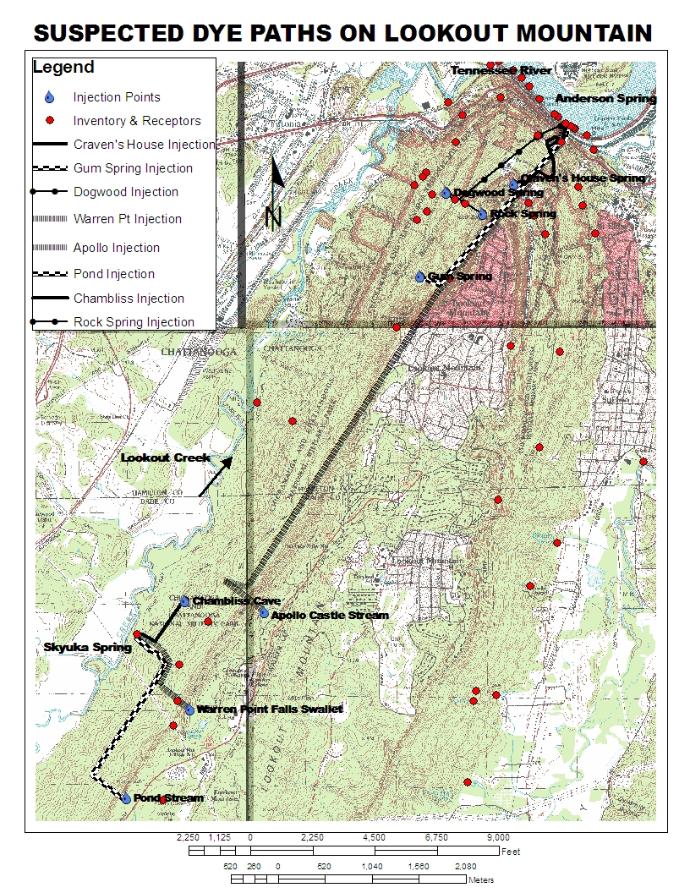
Figure 2. Lookout Mountain in northwest Georgia and southeast Tennessee showing suspected dye paths, dye injection points, major springs, major caves, and dye receptor locations. Source: Chattanooga, Fort Oglethorpe, Hooker, and Wauhatchie Topographic Quadrangles.
and then into Lookout Creek. Dyes injected at Apollo Castle Stream Swallet, Rock Spring-Sink, Dogwood Spring-Sink, Cravens House Spring-Sink, and Gum Spring-Sink flowed north along the strike, perched upon the Hartselle confining layer, to drop off at Ruby Falls or Mystery Falls to a final resurgence at Anderson Spring along the Tennessee River.

5. Discussion

The northern extent of Lookout Mountain receives an average of 138.48 cm of rainfall per year (National Weather Service, 2005). During heavy precipitation events some of this water flows down usually dry streambeds to Chattanooga or Lookout Creeks. However, much of it sinks into perched karst aquifers to then resurge at springs. After flowing off the Raccoon Mountain Formation confining layer, surface streams sink into limestone beds in the Pennington Formation, Bangor Limestone, or the Monteagle Limestone. During low flow, the entire discharge of a surface stream may sink into limestone beds within the Pennington Formation. At higher flow, it may also sink into the Bangor and Monteagle Limestones. During very heavy precipitation events, some of the stream water may reach Lookout or Chattanooga Creeks without sinking.

As discussed by Crawford (1979), not all cave streams flowing upon the Hartselle confining layer resurge as springs. Some streams breach the Hartselle and sink in back of the escarpment creating vertical shafts and underground waterfalls. These vertical shafts appear to be due to stress-relief fractures caused by the release of confining pressure near the escarpment. It appears that virtually all cave streams flowing upon the Hartselle Formation under Lookout Mountain breach the Hartselle underground creating spectacular vertical shafts and underground waterfalls, such as Mystery Falls and Ruby Falls. This may be due to an increased number of stress-relief fractures and/or faults due to the synclinal folding and thrust faulting of Lookout Mountain.

All of the dye traces indicated that surface runoff flowing down the west side of Lookout Mountain sinks into the limestones and then either flows north to Mystery or Ruby Falls and then to Anderson Spring or flows west to resurge at Skyuka Spring (Figure 2). Dye injected into Apollo Castle Stream Swallet, Gum Spring-Sink, and the Craven's House Spring-Sink sank through the Pennington Formation and Bangor Limestone until they hit the Hartselle Formation confining layer. They then flowed down the dip towards the trough of the syncline (Figure 3); towards the center of the mountain. The dyes then flowed along the strike towards Mystery Falls or Ruby Falls and then to a final resurgence at Anderson Spring. Therefore, this hydrogeologic investigation has revealed that the master conduits have formed parallel to the strike along the western side of Lookout Mountain due to the structure and stratigraphy. The hydrogeologic investigation is continuing along the eastern side of the mountain. Also, the influence of the Cranmore Cove Fault and Chattanooga Fault systems on the hydrogeology is still being investigated.
Figure 2. Hartselle Shale directing water towards trough of syncline (Source: Modified from Finlayson, 1964)

Acknowledgements. This study was funded by the National Park Service and the Center for Cave and Karst Studies, Western Kentucky University. The authors thank Dr. Jonathan Mies, Buddy Lane, and Dennis Curry for discussions on the area, and Glen Siegrest for his lodging throughout the duration of this project.

References

Crawford, N. C. (1979)”The Karst Hydrogeology of the Cumberland Plateau Escarpment of Tennessee: Subterranean Stream Invasion, Conduit Cavern Development, and Slope Retreat in the Lost Creek Cove Area, White County, Tennessee”, State of Tennessee Department of Conservation, Division of Geology. No. 44 Parts 1-4.

Finlayson, C.P., Barnes, R.H., Colvin, J.M. Jr., and Luther, E.T. (1964) “Geologic Map of the Chattanooga Quadrangle, Tennessee”.

Mies, J. (2005) Conversations with.

Quinlan, J.F. (1989) ‘Groundwater Monitoring in Karst Terrains: Recommended Protocols and Implicit Assumptions’, US Environmental Protection Agency, EPA 660/x-89/050: Las Vegas, Nevada.

National Weather Service (2005) ”Average Monthly Rainfall for Chattanooga”, http://www.rssweather.com/climate/Tennessee/Chattanooga/.

Smart, P.L. and Laidlaw, I.M.S. (1977) “An Evaluation of Some Fluorescent Dyes for Water Tracers”, Water Resources Research, 13(1): 15-33.
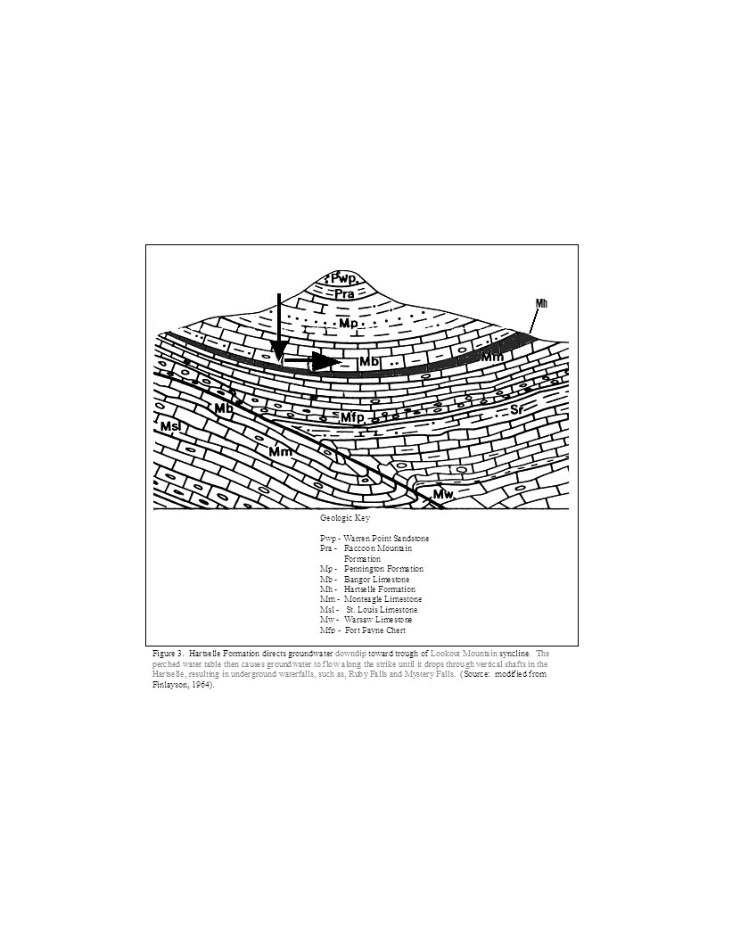
Figure 3. Hartselle Formation directs groundwater downdip toward trough of Lookout Mountain syncline. The perched water table then causes groundwater to flow along the strike until it drops through vertical shafts in the Hartselle, resulting in underground waterfalls, such as, Ruby Falls and Mystery Falls. (Source: modified from Finlayson, 1964).

Figure 3. Hartselle Formation directing groundwater toward trough of syncline (Source: modified from Finlayson, 1964).
Figure 3. Lookout Mountain in northwest Georgia and Southeast Tennessee showing suspected dye paths, dye injection points, main springs, caves, and dye receptor locations

