HOW GEOMETRIC FACTORS DETERMINE WHICH TYPE OF SPELEOTHEM WILL GROW IN A CAVE ENVIRONMENT.

CHARLES A. SELF
4 Tyne Street, Bristol, BS2 9UA, England; self@globalnet.co.uk

CAROL A. HILL
17 El Arco Drive, Albuquerque, NM 87123, USA; carolannhill@aol.com

ABSTRACT

A speleothem is a physical mineral body which can be described without regard to its chemical composition or mineral species. A stalactite, for example, can be defined purely by its morphology and internal organization. Most speleothems are mineral aggregates, formed from several (sometimes many) crystals of the same mineral species. The component crystal individuals do not simply grow together, they interact and compete for growth space and/or the supply of new material. This interaction between individuals causes a distinctive pattern of crystal boundaries to develop in the aggregate. This pattern is called texture.

Texture describes the geometric aspects of construction of an aggregate and depends mainly on the characteristic (Curie) symmetry of the medium from which crystallization occurred. The symmetry groups used in textural analysis are spherical, cylindrical and conical. For aggregates with conical symmetry, each crystal has neighbouring crystals diverging from it. The capillary film environment has conical symmetry because of the geometry of evaporation physics. In this environment, branching aggregates such as coralloid speleothems and frostwork are found.

The many different speleothem types are classified not only by their internal construction, but also according to their morphology. Morphology describes the typical physical shape of a speleothem. Stalagmites, flowstone and draperies are the same type of aggregate and may form together in the same gravitational water environment. Because of a different geometry of supply of the feeding solution, there is a difference in morphology between these texturally similar speleothems.

РЕЗЮМЕ

Спелеотем - физический объект, состояший из минералов, - может быть описан без его химического или минерального состава. Сталактит, например, можно определить морфологией и внутренней организацией. Большинство спелеотемов - минеральные агрегаты, сформированные несколькими (иногда многими) кристаллами одного и того же минерального вида. Составляющие индивидуальные кристаллы не просто растут вместе, они взаимодействуют и сражаются за пространство для своего развития и/или подачу нового материала для роста. Это взаимодействие между индивидуальными кристаллами является причиной характерной конфигурации кристаллических границ, которая развивается в агрегате. Эта конфигурация называется текстура.
Текстура определяет геометрические аспекты конструкции агрегата и зависит в основном от характеристической (Кюри) симметрии среды, в которой происходит кристаллизация. Группы симметрии, использующиеся при анализе текстуры: сферическая, цилиндрическая и коническая. Если у агрегата - коническая симметрия, у каждого кристалла есть соседние кристаллы, расходящиеся от него. Среда, создаваемая капиллярной пленкой, имеет коническую симметрию, обусловленную геометрией физического процесса испарения. В этой среде найдены такие ветвящиеся агрегаты как кораллоиды и кристаллактиты - спелеотемы.
Многочисленные различные типы спелеотемов классифицируются не только внутренней конструкцией, но также в соответствии с своей морфологией. Морфология описывает типичную физическую форму спелеотема. Сталагмиты, натеки и драпировки - один и тот же тип агрегата и могут расти вместе в одной и той же гравитационной водной среде. Различие в морфологии между этими спелеотемами подобной текстуры - результат различной геометрии подачи питающего раствора.

INTRODUCTION

A cave mineral is a secondary mineral deposit, growing in a cave, that is described by its chemistry and mineral species. Fluorite, ice and high-magnesium calcite are all cave minerals. More than 250 cave minerals have been recorded (Hill and Forti, 1997) but only three species (calcite, aragonite and gypsum) can be considered common.

A speleothem is a secondary mineral deposit, growing in a cave, that is described as a physical body. Stalagmites, pool spar and cave rafts are examples of speleothems. These speleothem terms refer only to the physical nature of the mineral deposit, so an epsomite cave flower is constructed in the same way as a gypsum cave flower. This means it is possible to disregard mineral species when studying the different speleothem types. For a detailed description of how speleothems grow, the reader is referred to Self and Hill (2003). A more concise version appears in these Proceedings (Self and Hill, “An introduction to genetic mineralogy etc.”) and in Self (2004).

So how does a single cave mineral, such as calcite, produce so many different speleothem forms? The physical description of a speleothem has two components: external shape (morphology) and internal construction. Morphology depends on how new material is supplied to the speleothem, whereas internal construction can be related to the environmental conditions of the crystallization space as a whole. The internal construction of a speleothem is therefore more informative.

Speleothems are generally not built from single crystals; gypsum (selenite) needles are the only common exception to this rule. Most speleothems are built from several (sometimes many) crystals of the same mineral species and are thus mineral aggregates. The component crystals (mineral individuals) of an aggregate do not simply grow together, they interact and compete for growth space and/or the supply of new material. Often, this competition leads to a reduction in the number of individuals constituting the aggregate, a situation called selection.

The most important selection process is geometric selection: the mineral individual whose greatest growth vector during competitive growth is best aligned for mass-transfer with the environment is the one that will continue its growth at the expense of neighbouring individuals of other orientations (Self and Maltsev, 1999; Self and Hill, 2003). Aggregates are therefore much more than similar individuals of the same mineral species, growing together simultaneously. Interaction between individuals directly affects and limits the growth of each crystal. This interaction causes a distinctive pattern of crystal boundaries to develop in the aggregate. This pattern is called texture and different aggregate types are distinguished by having different textures.

It is worth repeating here that speleothem type is not the same as aggregate type. A speleothem is described by both morphology and texture. Thus, flowstone and stalagmites are the same type of aggregate (based on texture) but are different types of speleothem.

THE CURIE UNIVERSAL SYMMETRY PRINCIPLE

There is no effect without cause (Curie, 1894). The symmetry aspects of this relationship can be expressed as: the characteristic symmetry (or the dissymmetry) of an object or medium must be found in the causes that generated that object or medium. This is known as the Curie Universal Symmetry Principle (Stepanov, 1998), and is a simplification of the 1894 original observation.

The characteristic symmetry of a phenomenon may be regarded as an ideal symmetry for that object or medium. A similar concept has been used in regular mineralogy to divide all mineral species into seven different crystal systems. It does not matter if a crystal is deformed or broken, it belongs to a particular crystal system because this is a function of the internal structure of the mineral species itself (e.g., calcite belongs to the trigonal system). The characteristic symmetry of a medium does not depend on the physical shape of the space in which it is enclosed, but is innate to the medium itself. The symmetry groups for phenomena identified by Curie include three static groups (spherical, cylindrical and conical) and a further four which involve motion (e.g., a magnetic field has the symmetry of a rotating cylinder). Only the three static groups are needed to describe the texture of mineral aggregates and the mediums from which they form.

Spherical symmetry is indicated when the texture of an aggregate displays complete disorder, since all directions from any point are equivalent. Similarly, a medium has spherical characteristic symmetry when it is isotropic. An example is phreatic deposition from a supersaturated solution. Whatever the shape of the crystallization cavity, crystal embryos (crystallites) nucleate on all available surfaces and are randomly oriented during the first stage of growth.

The distinctive feature of cylindrical symmetry is growth along one axis. This axis may change direction as the aggregate develops, but growth in other directions is severely limited. This means that each crystal has neighbouring crystals sub-parallel to it, whatever its location and orientation. The classic example is a helictite, where several crystals surround and grow parallel to the central feeding channel. (For the growth mechanism of helictites, see Self and Hill 2003).

Conical symmetry has a single axis, which is the preferred direction of aggregate growth, but some growth in other directions is allowed. Each crystal has neighbouring crystals diverging from it, whatever its orientation and location. The capillary film environment has conical symmetry because of the geometry of evaporation physics. Solvent molecules are most easily lost in the direction of the open cave, but some molecules leaving at an oblique angle to the substrate will also be lost, particularly where the substrate is convex. This allows branching aggregates such as corallites and crystallictites to grow in this environment (Figure 1).

Dissymmetry can be thought of as the set of symmetry elements which are missing. (Note: dissymmetry is not the same as assymmetry, which is a general lack of symmetry.) Unidirectional forces, such as gravitation and geometric selection, are dissymmetries which commonly affect mineral growth. If we return to the case of phreatic deposition from a supersaturated solution, which has spherical symmetry, the randomly oriented crystallites all grow at the same rate until they start competing for growth space. Geometric selection then reduces the number of individuals forming the aggregate (Figure 2) to leave a new growth front of druse crystals oriented perpendicular to the substrate (a parallel-columnar aggregate). The dissymmetry of gravitational selection therefore causes a reduction in the symmetry of the aggregate.

At the local level, a druse has cylindrical symmetry. However, druse crystals cover the walls, floor and ceiling of the crystallization space, and so point in every direction. Also the druse grows to the same thickness on all surfaces. These are surviving features of the original spherical symmetry. From this we can see that the texture of a druse has two levels of symmetry: cylindrical when examined at the local level, spherical when the whole aggregate is studied. This example shows how texture responds to environmental factors that operate at different scales, with genetic information conserved on all levels.

GEOMETRY OF SUPPLY

Texture describes the internal organization of an aggregate, but it does not control its external shape. Variations in morphology are particularly well seen in caves, where the same type of aggregate can produce speleothems of radically different appearance. The reason for this lies in variations in the geometry of the supply scheme (supply of solute and/or loss of solvent). It is important to note that this is not the same as the symmetry of supply to a crystallization space (which controls texture). These are different concepts and operate at different organizational levels in the cave environment. There are four basic supply geometries.

Bulk supply is any supply scheme that is isotropic. The essential point is that the medium itself does not impose any dissymmetry on the texture of the crystalline products. Bulk supply may be completely subaqueous (as in a phreatic or cave-pool setting), laminar or turbulent gravity flow streams (as for flowstones), bulk solutions moving slowly through a porous medium, or the bulk freezing of a melt. This supply scheme does not allow individuality in an aggregate, so the only differences that can be seen are in the size and habit of the component individuals.

Area supply is a two-dimensional feeding scheme whereby solutions spread out slowly over a crystallization surface from capillary thin films. The evaporation of capillary films is very sensitive to local air flows and to irregularities in the substrate, so considerable variation in morphology is seen among the corallites which grow in this environment. Area supply also applies to crystallization along phase boundaries, such as the growth of rafts at the air/water interface of cave pools.

Linear supply is where a solution gathers into linear streams or issues from fracture openings. Mostly, this supply scheme modifies aggregates that form by bulk or by axial supply. It always results in the appearance of dissymmetry, usually with the elimination of the rotation axis. On steep or overhanging cave walls, the bulk supply of gravitational water gathers into linear streams and flowstone converts into draperies. These two speleothem types have essentially the same texture, but their morphologies are different. Shields grow from fracture openings by linear supply, but when solution overflows from the edge of the shield, the supply scheme reverts to bulk supply and flowstone overgrows the underside of the shield. Crystalline shields can also develop from helictites when the axial supply of the capillary channel becomes blocked and solution escapes through a structural line of weakness.

Axial supply is a one-dimensional feeding scheme typified by solutions moving through the middle of a speleothem, or feeding one single growth spot. These are "point-source" solutions where growth is aligned along a single axis. The most obvious point source in caves is water dripping from the roof and landing on the floor, from which grow regular stalactites and stalagmites. Axial supply causes them to grow out into the cave void, but it is the bulk supply of solutions running down their sides which thickens them. Stalactites and stalagmites are thus essentially the same type of aggregate as flowstone, but with a different supply scheme. If the linear supply to a drapery ends at a drip point, a stalactite will grow from this place. Another type of axial supply is solution seeping along the central canal of a helictite, which causes it to grow outwards from the substrate.

In the subaerial environment of caves, there may be differences in the supply scheme to different parts of a single speleothem. For example, in a cave with a strong airflow, the bulk supply of solution on one side of a stalactite may evaporate and become a capillary thin film. Corallites may start to grow on this side, while the rest of the stalactite continues to develop normally (Figure 3). Large stalagmites may find that drip water does not flow evenly down their sides, but gathers into rivulets giving locally enhanced growth rates. These minor variations in the supply scheme are responsible for the great variations in morphology that we see in some speleothems.

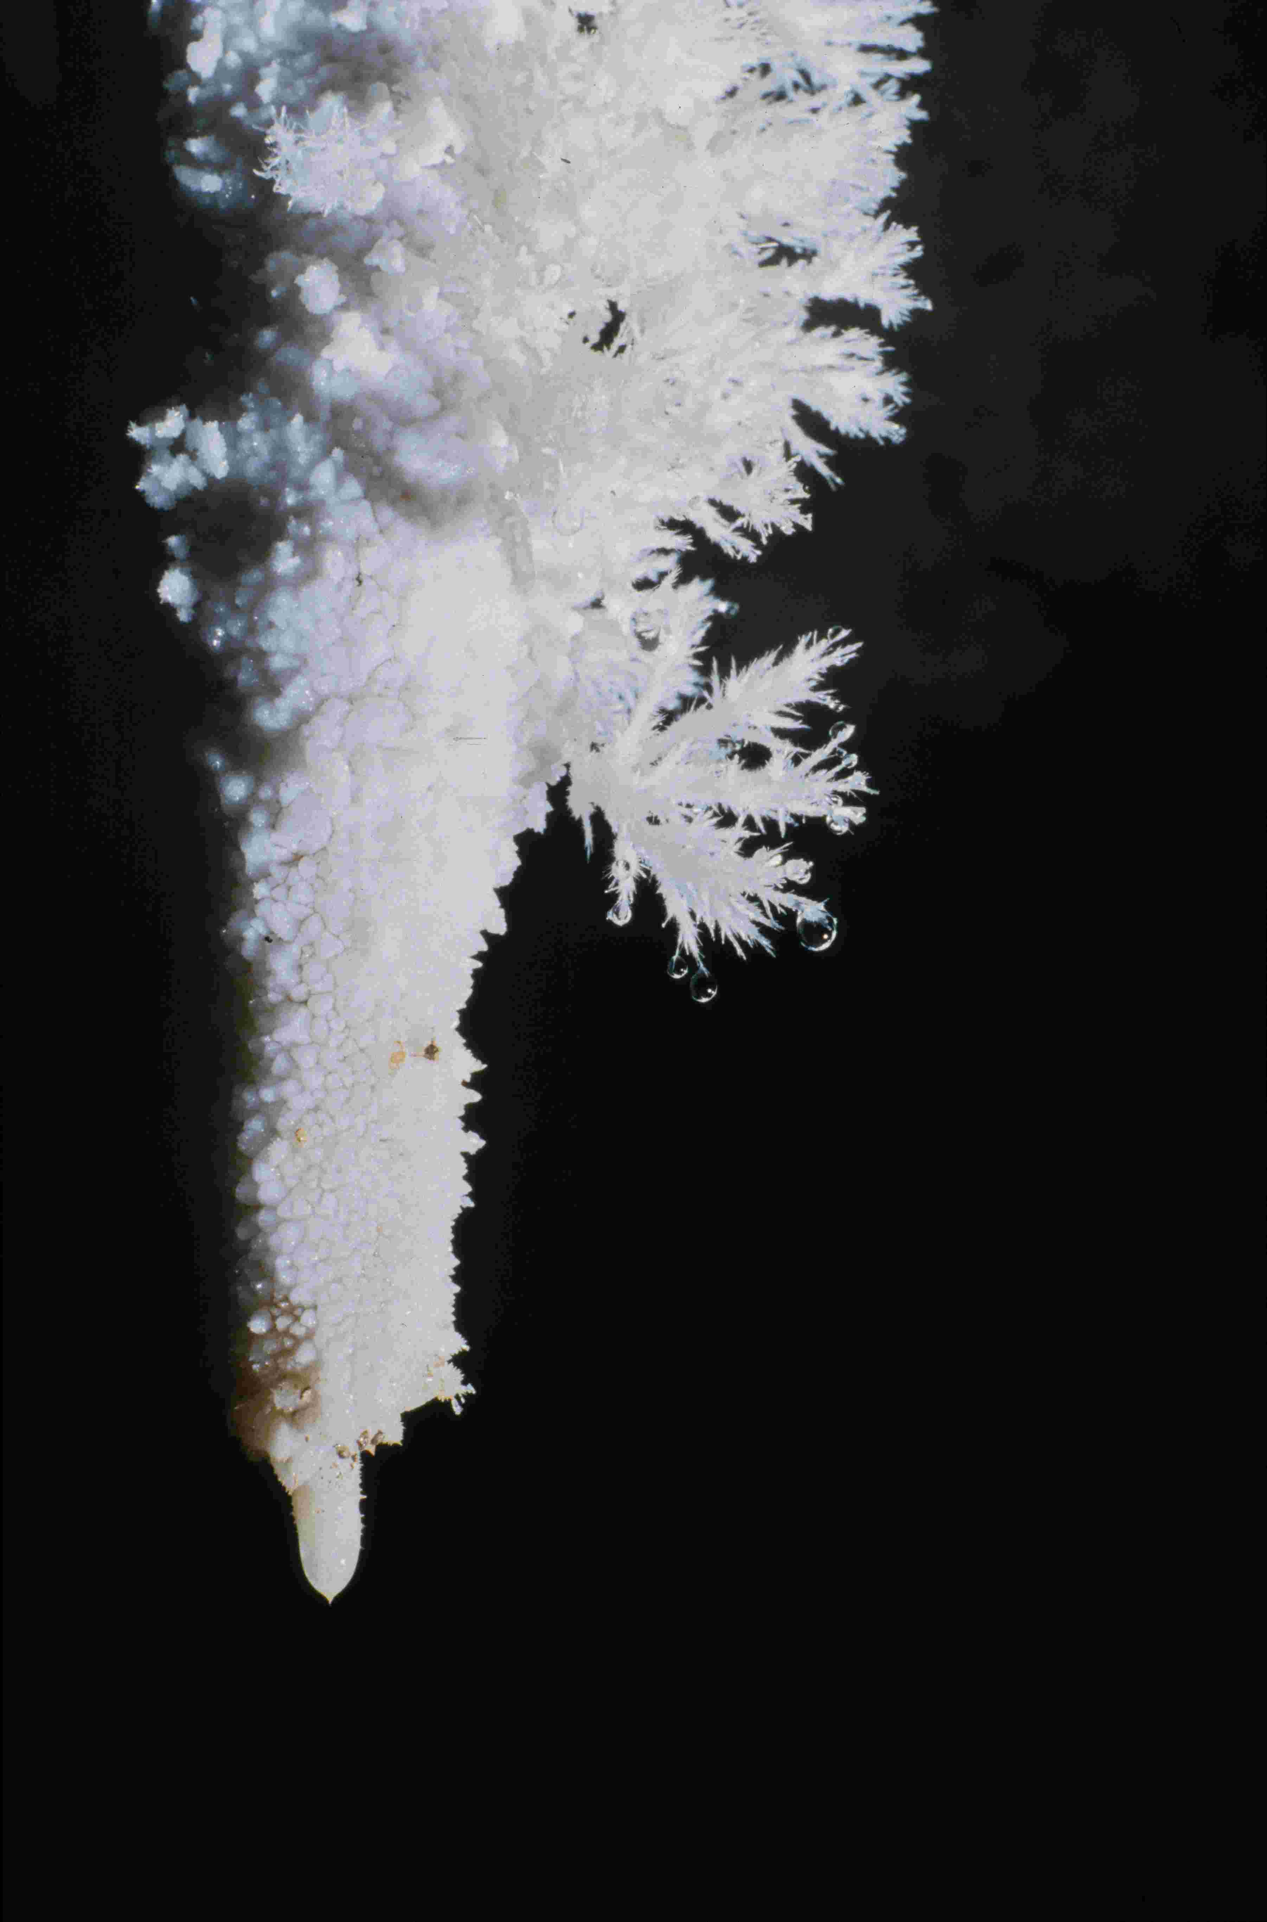  Figure 1. Aragonite frostwork grows from substrate protrusions where evaporation is concentrated, such as on the sides of this inactive stalactite. | 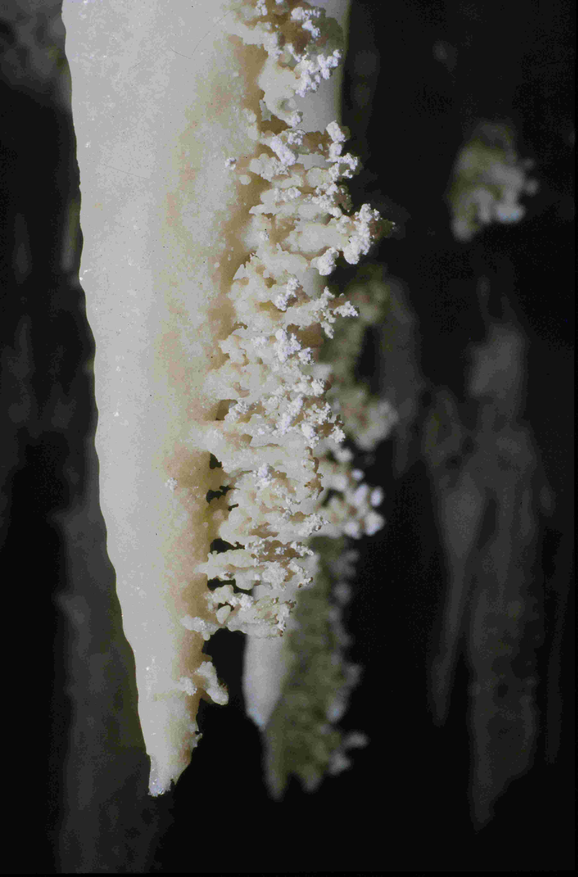  Figure 3. The dissymmetry of a strong seasonal wind causes evaporation on one side of this stalactite and the growth of corallites directly into this wind.
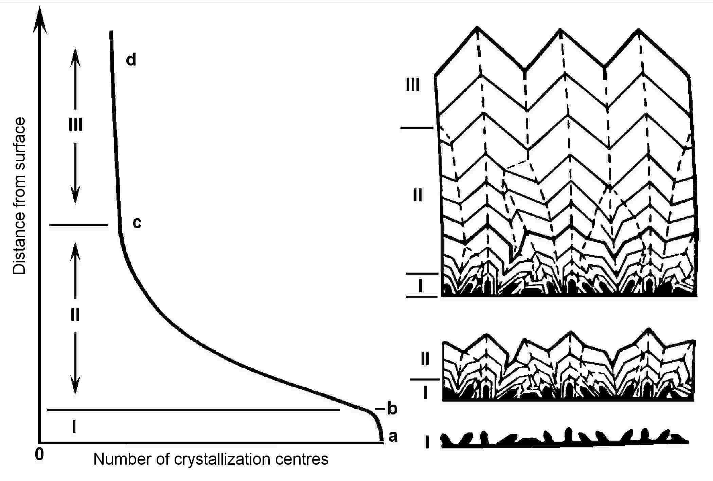  Figure 2. Growth of a parallel-columnar aggregate (from Grigor’ev, 1961). The dissymmetry of geometric selection changes spherical to cylindrical symmetry. | 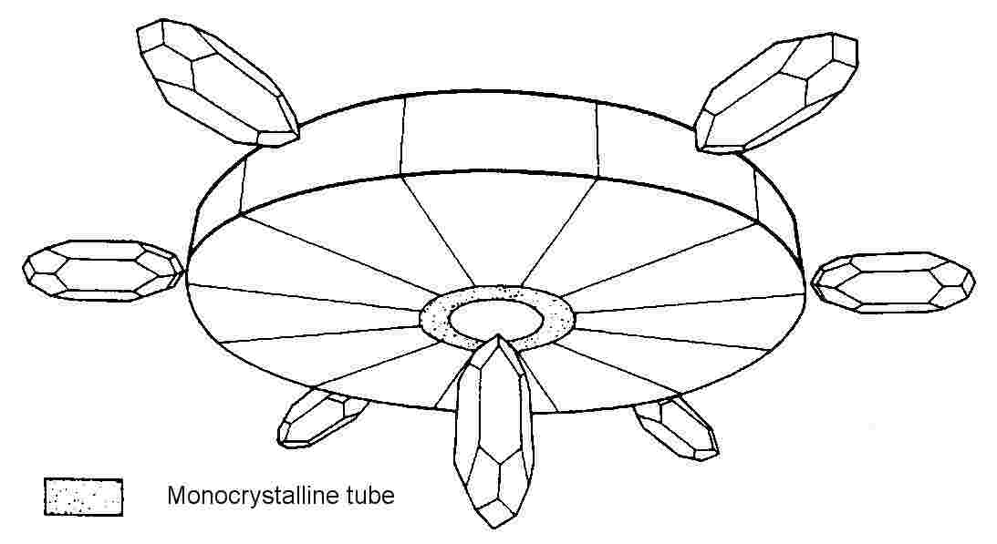  Figure 4. Schematic cross-section through a conical stalactite (from Moore, 1962). The monocrystalline tube grows by axial supply, the overgrowth by bulk supply.

STALACTITES - a case study

A stalactite is the world’s most widely recognised speleothem type, but its internal construction is actually quite complicated. In its outer part, it is the same type of aggregate as flowstone, draperies and stalagmites. This explains why these aggregates all grow together in the gravitational water environment. However, a regular stalactite also has a monocrystalline tube running through its centre (Figure 4). When examined closely, the drip point of this tube has a crown of skeleton crystals. A stalactite therefore has three textures and is a polytextural multiaggregate (Self and Hill, 2003).

It is important to understand that stalactites are not soda straws overgrown by a later surface crust - the three textures form together and simultaneously. Maltsev (1999) has shown that the central tube appears as a consequence of the growth mechanism, not as a cause; stalactites are not supplied with solutions down the central tube. Stalactites therefore grow entirely as a result of water oversaturated with carbonate running down the outside and dripping from the tip.

According to Maltsev (1999), the reason for the growth of skeleton crystals is mechanical agitation of the solution at the tip of the stalactite as the drip disconnects. Carbonate solutions are very sensitive to local changes in pressure, caused by such vibrations, and respond by releasing CO₂ and depositing calcite. Typically, mechanical degassing produces skeleton crystals (Shafranovskiy, 1961). If we look at the symmetry of this, the solution itself has spherical symmetry but rapid degassing at the phase boundary causes a local dissymmetry at the surface of the drip. This is in agreement with the observation that skeleton crystals form in a ring and grow only in the plane of the phase boundary.

The second texture, the monocrystalline tube, has its greatest growth vector oriented vertically and is a result of recrystallization. It cannot have formed by the growing together of the skeleton crystals because too much energy is tied up in all the crystal edges and faces. The most likely trigger for this recrystallization is the shock wave that travels vertically up the solution column, inside the central tube, when each drip is released. These first two textures are extremely local in extent and only develop in the special environment of the drip point.

The third texture, which comprises the rest of the stalactite, is the overgrowth around the central tube. This forms from the bulk supply of solution running down the side of the stalactite, which itself has no dissymmetries. Many small crystals grow with random orientation, then competition and selection leads to sub-parallel crystal growth (as in Figure 2). However, because the substrate is sharply curved, this becomes a variation of parallel-columnar texture known as a spherulitic aggregate (Stepanov, 1998). The result is a radiating fan of crystals around the central tube.

REFERENCES

Curie, P., 1894, Sur la symetrie dans les phenomenes physique, symetrie d'un champ electrique et d'un champ magnitique: Journal de Physics, ser. 3, v. 3, p. 395-415.
Grigor'ev, D. P., 1961, Ontogeny of minerals: Lvov, Izdatel'stvo L'vovskogo Univ. In Russian. English translation 1965, Israel Program for Scientific Translations, 250 p.
Hill, C. A., & Forti, P., 1997, Cave minerals of the world (2nd ed.): National Speleological Society, Huntsville, Alabama, 463 p.
Maltsev, V. A., 1999 (for 1998), Stalactites with “internal” and “external” feeding: Proceedings of the University of Bristol Spelaeological Society, v. 21, n. 2, p.149-158.
Moore, G. W., 1962, The growth of stalactites: National Speleological Society Bulletin, v. 24, n. 2, p. 95-106.
Self, C.A., 2004, The internal organization of speleothems: Acta Carsologica, v. 33, n. 1, p. 245-255.
Self, C.A., & Hill, C.A., 2003, How speleothems grow: An introduction to the ontogeny of cave minerals: Journal of Cave and Karst Studies, v. 65, n. 2, p. 130-151.
Self, C. A., & Maltsev, V. A., 1999, Translators’ note: Cave Geology, v. 2, n. 4, p. 193-195.
Shafranovskiy, I. I., 1961, Crystals of minerals: curved-faced, skeletal and granular forms: “Gosgeoltekhizdrt”, Moscow, 230 p. In Russian.
Stepanov, V. I., 1998 (for 1997), Notes on mineral growth from the archive of V. I. Stepanov (1924-1988): Proceedings of the University of Bristol Spelaeological Society, v. 21, n. 1, p. 25-42.

