Speleogenesis and landscape evolution in Tromsdalen karst, Verdal, Norway.

Asbjørn Øystese, Frode Johannesen & Stein-Erik Lauritzen,
¹Department of Earth Science, Bergen University,
Allegaten 41, N-5007 Bergen, Norway

Abstract
Pronounced fluvial landscape elements of Tromdsal north of Trondheim, Norway allude to that these elements may be preglacial and little altered by Quaternary ice erosion. The occurrence of karst caves with relatively clear morphology that points at adjustment to former base-levels makes it interesting to test of landforms and cave development can be linked. This is done through cave surveying and speleogenetic analysis, formulated as two MSc. Projects.

Introduction
Verdal municipality is situated north of Trondheim in mid-Norway, Figure 1. Extensive marble outcrops are quarried in Tromsdalen, a tributary to Verdal proper. About 20 separate karst caves are known within the marbles, and the potential of the area is far from exhausted (Rian, 2002, 2003 and references therein). We have done preliminary assessment of the karst (Lauritzen 1999), and found that the topographic situation and cave morphology is sufficiently interesting to deserve a closer speleogenetic and geomorphological study. It was therefore decided to make two MSc projects for a closer study of two significant caves in the valley. These projects have just commenced, and we hope to present more material in the poster.

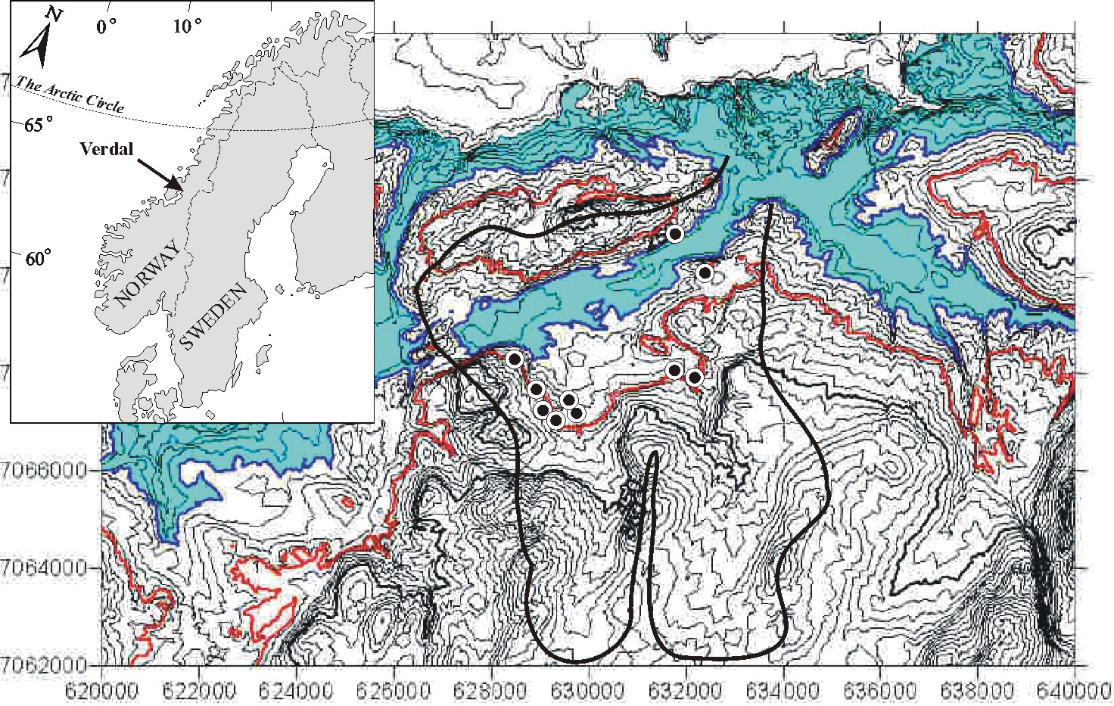
Figure 1. a) Key map to Verdal and Tromsdalen. b) Contour map of Tromsdalenwith enhaced contor levels at 200 and 300 m a.s.l. Areas between 100 and 200 m a.s.l. shaded. Black dots: approximate position of known caves. The thick black line depicts approximate drainage area of Tromsdal river. This basin drains eastwards, against the regional ice direction and is a relict, paleic fluvial system with little modification from glacial ice.

Problems
As can be seen in Figure 1, the topographic basin containing the marbles and caves display few glacial characteristics. First, as a tributary to the main E-W draining Verdal valley, it drains towards the East, opposite of regional ice streams during the Quaternary. The basin contain several ravine-shaped bedrock valleys that also show little glacial modification. Thick deposits of glacigenic sediments within the basin also allude to that the landform might have been filled with sediments and stagnant ice during long periods of time. Caves are distributed between 200 and 300 m a.s.l. Several of them display good morphological evidence of vadose/ phreatic transitions (e.g. Lauritzen & Lundberg 2000). One cave display superb invasion morphology in relation to glacial quarrying and infilling. It is therefore tempting to test if these cave levels may display clustering and/ or correlate with benches and shoulders elsewhere in the valley and surrounding landscape.

Preliminary results

Benkeberg Cave
This cave contain a relict, undulating phreatic tube with vadose incision. The diameter of this trunk passage is between 2 and 4 m. Upstream it is choked by glacigenic boulders and sumps downstream. This tube is invaded by a minor stream from the surface through a superbly meandring vadose canyon, forming a complete invasion system of quite rare morphological completeness. The upstream parts of the canyon cave is unroofed by glacial quarrying. A qualitative tracer test with Photin CU and cotton detectors was performed by T.Rian and S.E. Lauritzen in 2004, demonstrating direct hydrological connections to a major spring at the nearby river. Further work (by A. Øystese) will complete cave mapping, spelethem dating, etc. and we will also search for possible continuation of the phreatic trunk conduit. We believe that the relict phreatic tube is a subglacial or perhaps a pre-glacial feature which was much more extensive in the past. There is good chance to find continuation of this system in the form of fragments in the adjacent hillsides.

Ramsåsgrottene
This is a series of several extensive stream caves. They are all well-developed vadose caves with deep canyons, roof level oxbows an at least one distinct transition from vadose to phreatic morphology. Further work by F. Johannesen will hopefully provide a complete survey of the system.

Acknowledgements
We are indepted to Trond Rian and The Forestry Office in Verdal for enthusiastic support and accomodatiion.

References
Lauritzen, S.E. 1999: Befaringsrapport fra grotter i Verdal. Unpublished to Verdal Forestry Office, T. Rian.
Lauritzen, S.E. & Lundberg, J. 2000: Meso- and micromorphology of caves: Solutional and erosional morphology. pp. 408-426 in Klimchouk, A.B.; Ford, D.C.; Palmer, A.N. & Dreybrodt,W. (Eds.) Speleogenesis. Evolution of Karst Aquifers. National Speleological Society, USA, 527 pp.
Rian, T. 2002: Grottene i Verdal. Norsk Grotteblad (38), pp.18-19.
Rian,T. 2003: Kalkgrottene i Verdal. Unpublished manuscript, 10 pp. (Also available on Rian’s web page)

